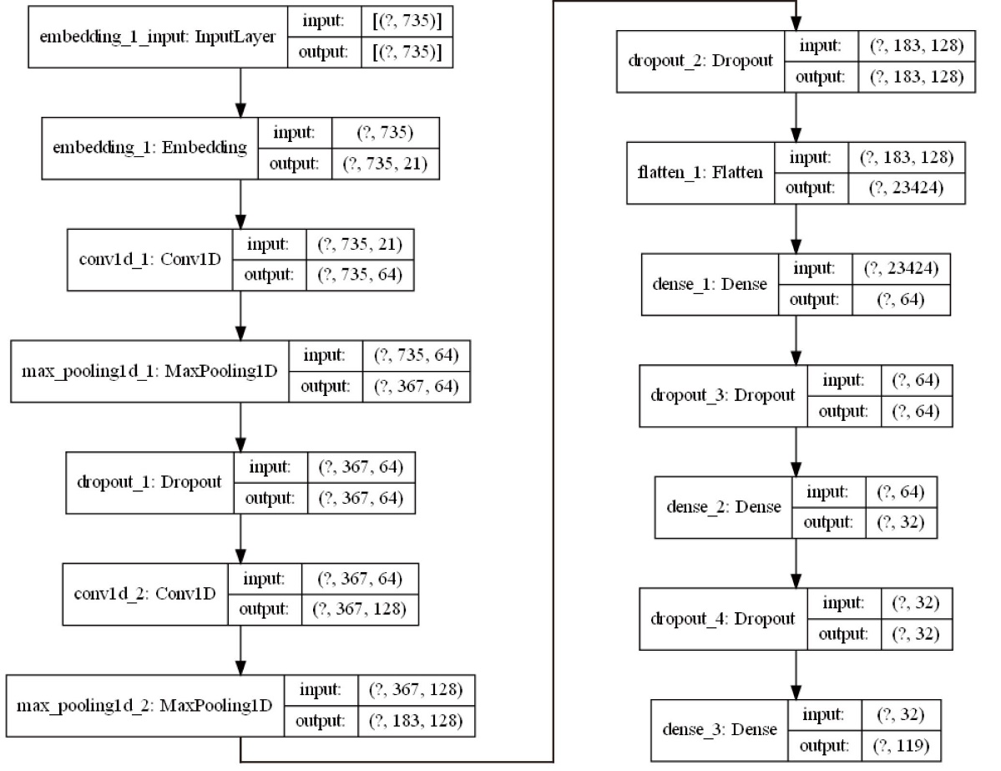
Figure S1 The detailed architecture of the model

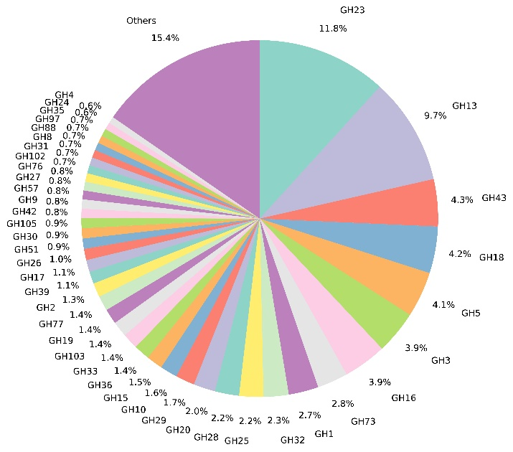
Figure S2 The proportion of glycoside hydrolases in the reclassified families

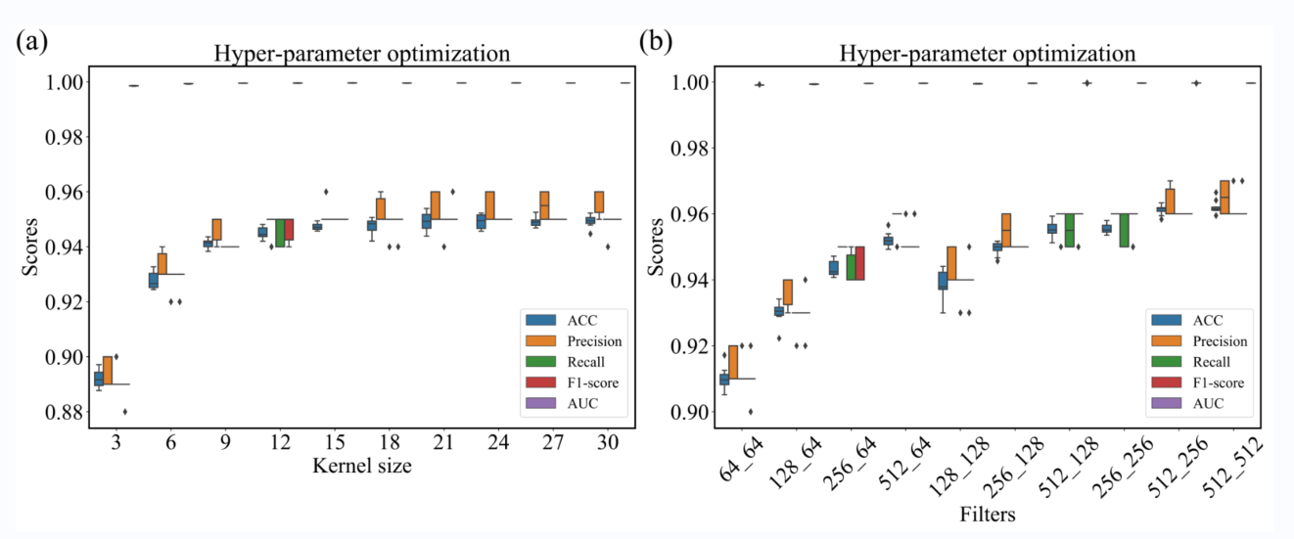
Figure S3 Optimized the size and number of the convolution kernels in DeepGH

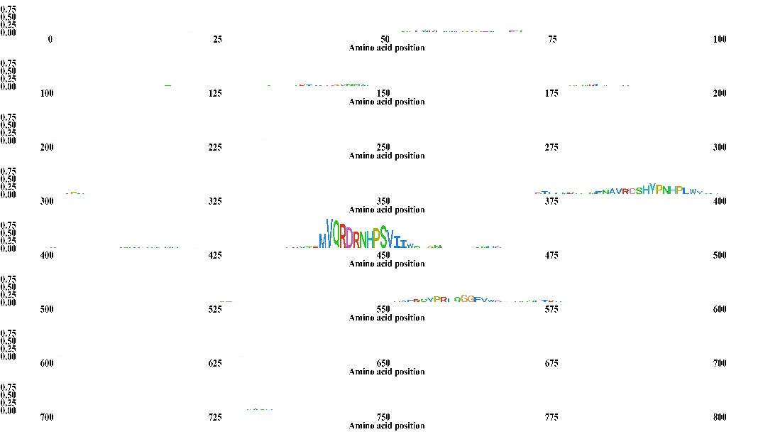
Figure S4 The classification features of β-galactosidase extracted by DeepGH

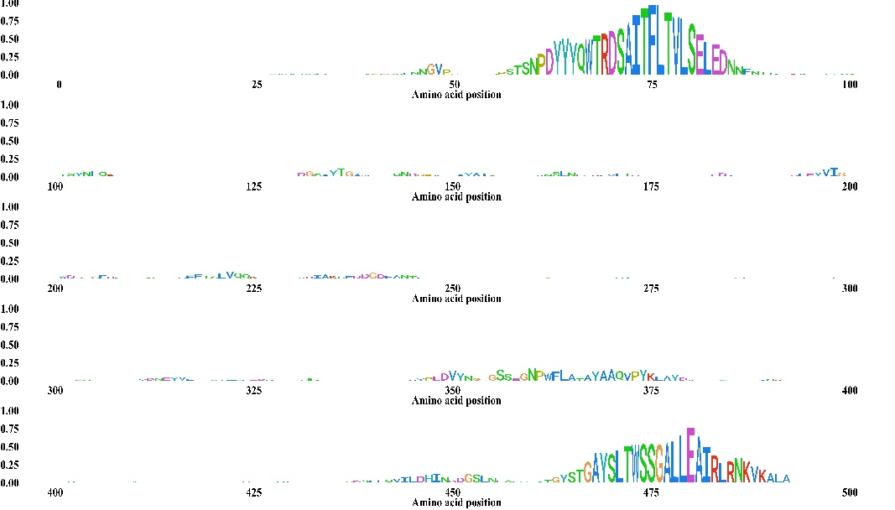
Figure S5 The classification features of glucoamylase extracted by DeepGH

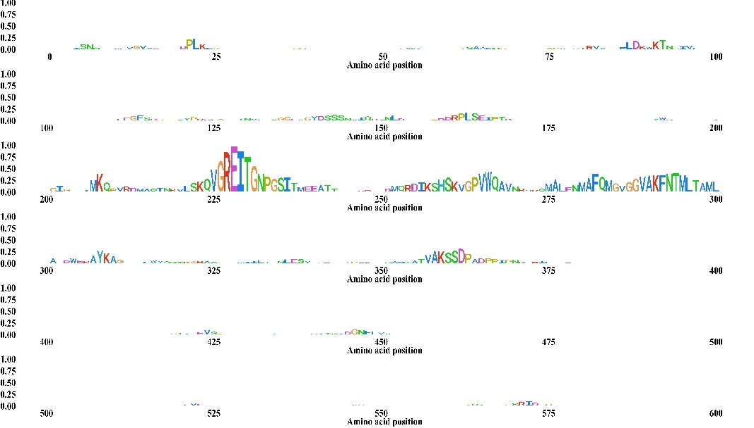
Figure S6 The classification features of lysozyme extracted by DeepGH

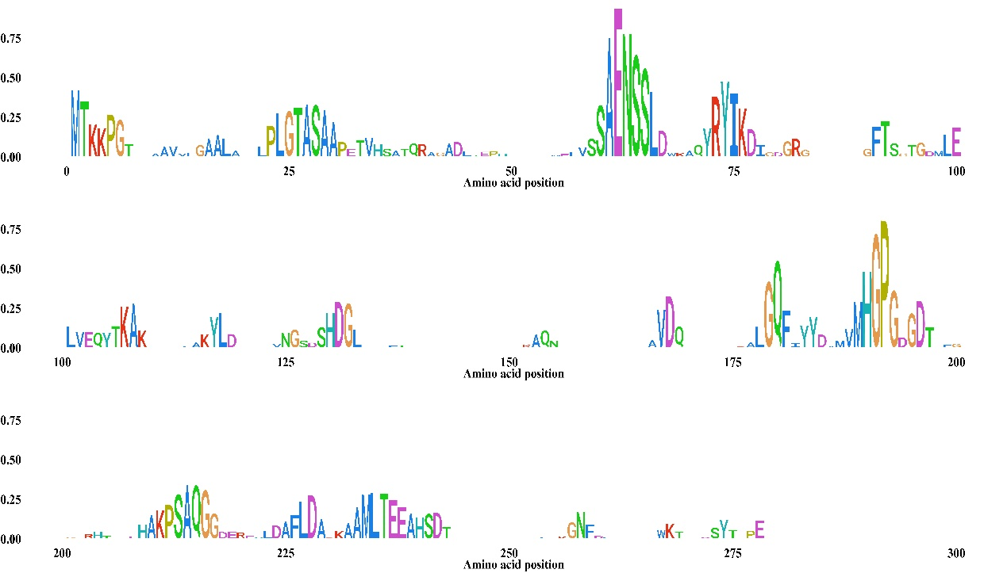
Figure S7 The classification features of CHIS1754 extracted by DeepGH

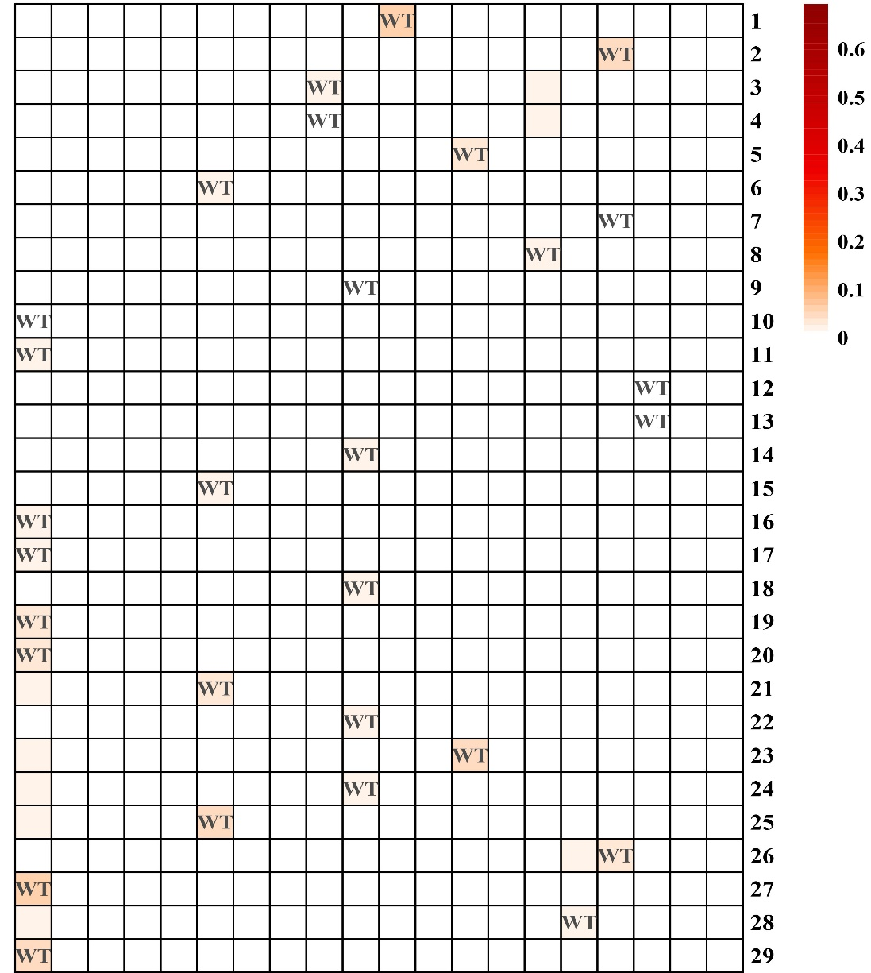
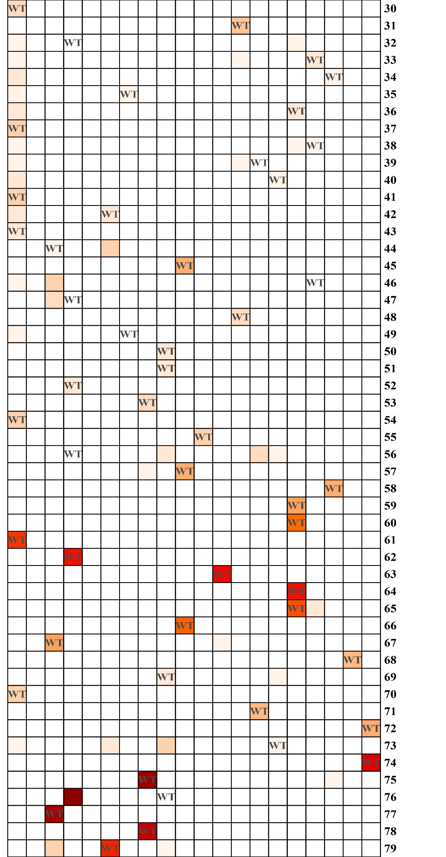
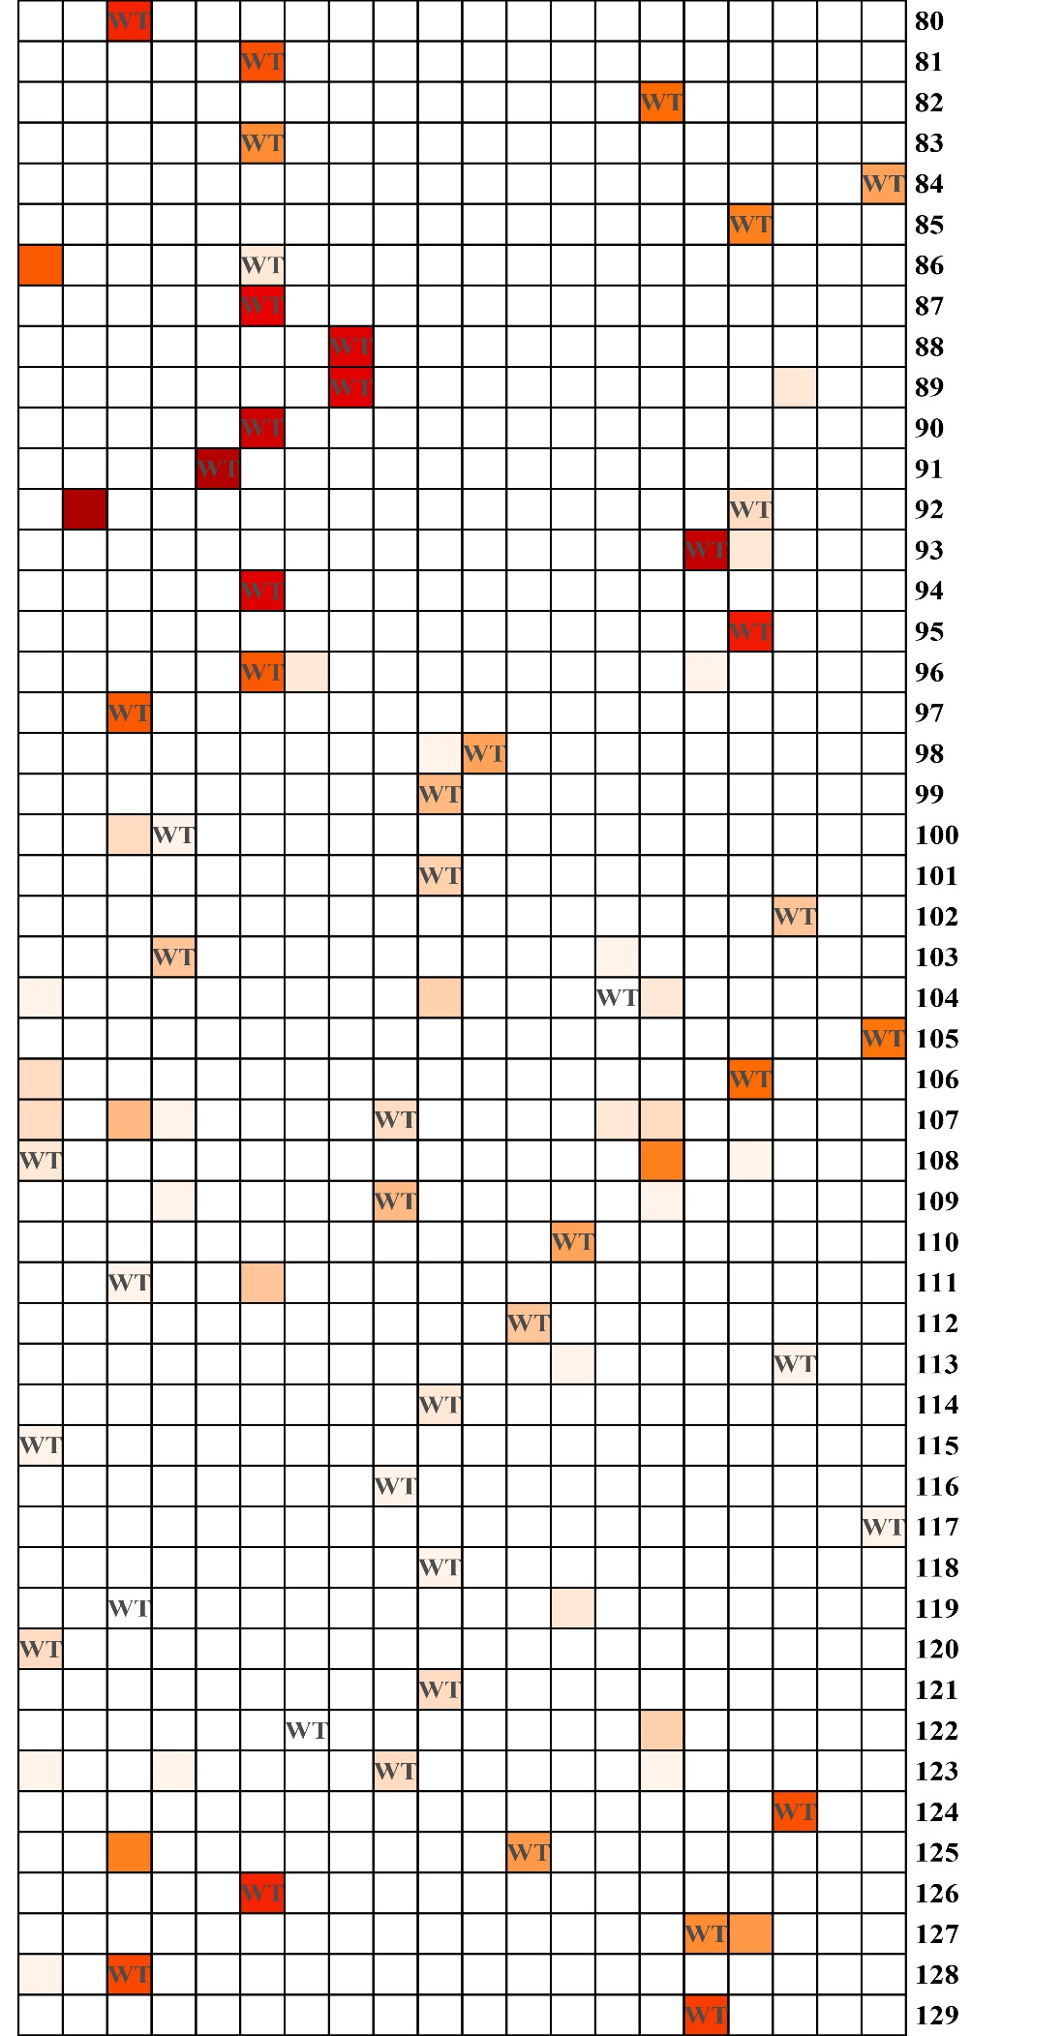
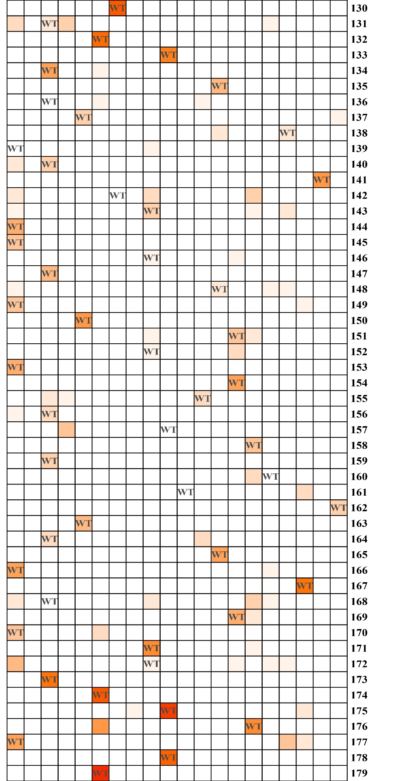
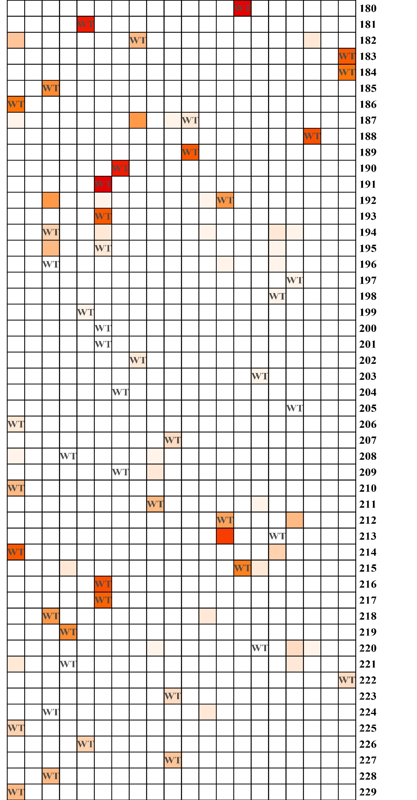
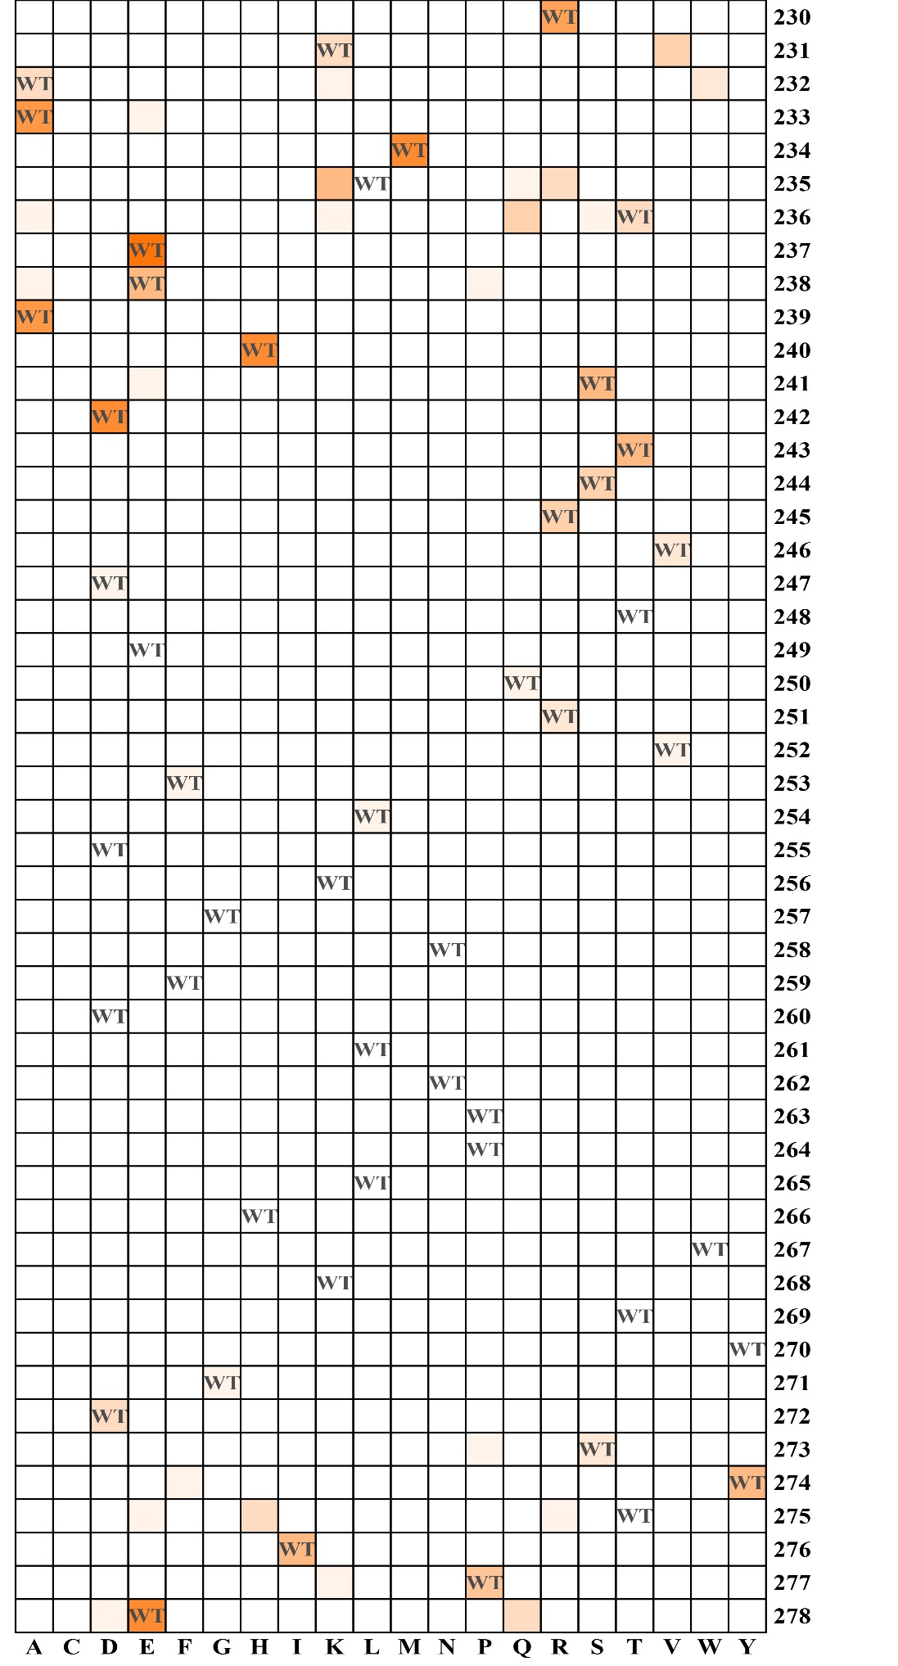
Figure S8 The feature score (P_{j,a}) of CHIS1754
“j” represented the residue number and “a” represented the 20 amino acids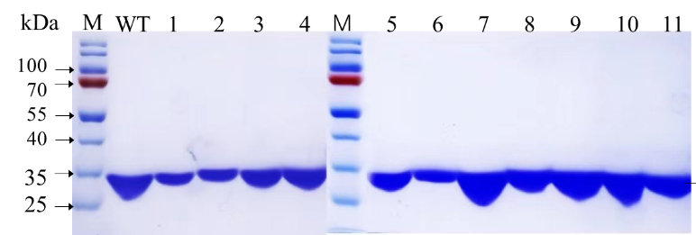
Figure S9 The SDS-PAGE of CHIS1754 and mutants
M：Marker, WT: CHIS1754 wild type, 1: K76E, 2: S213P, 3: H122R, 4: Q104L, 5: L157E, 6: S160R, 7: D119P, 8: E47D, 9: H142R, 10: MUT17, 11: MUT9.

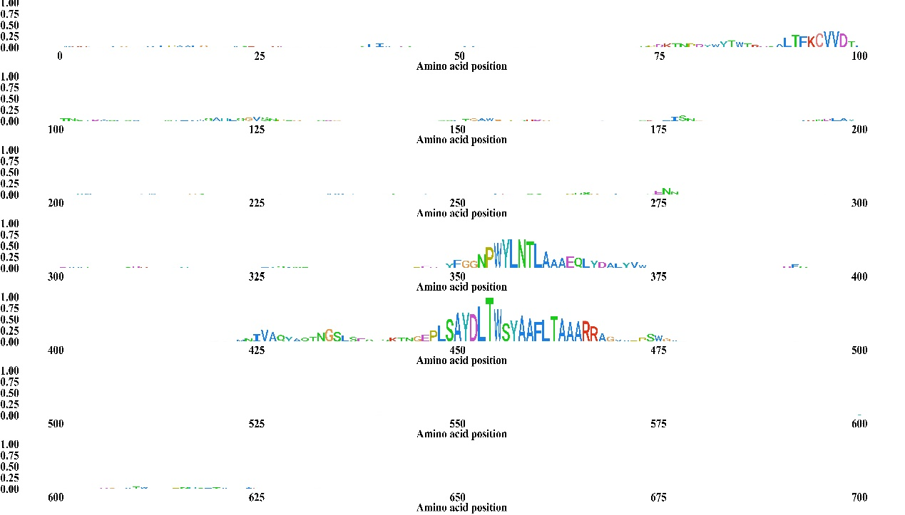
Figure S10 The classification features of GA51 extracted by DeepGH

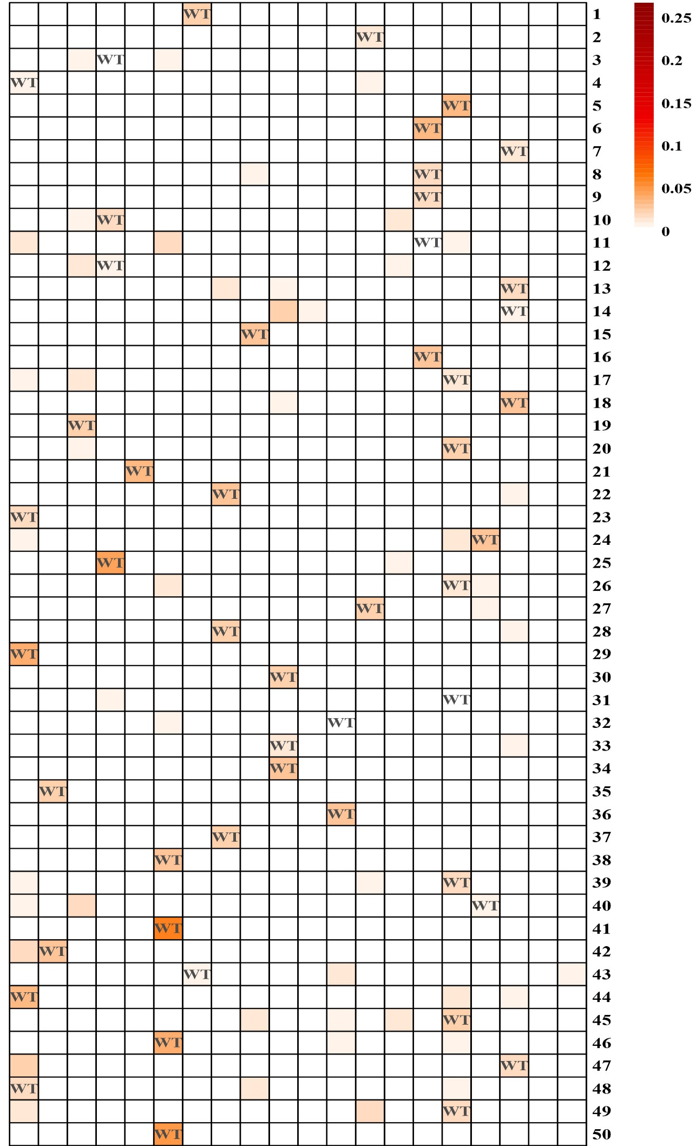
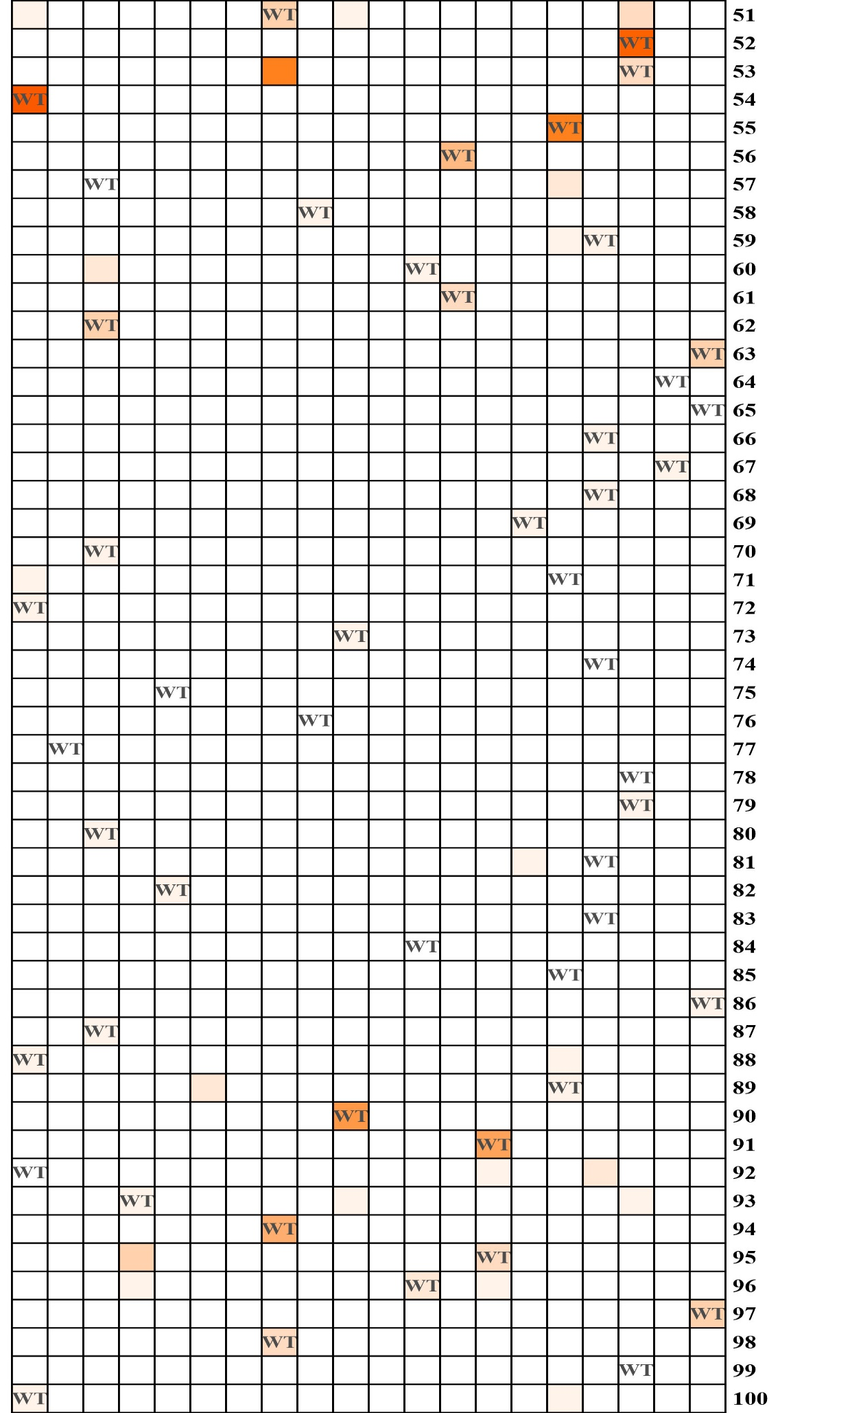
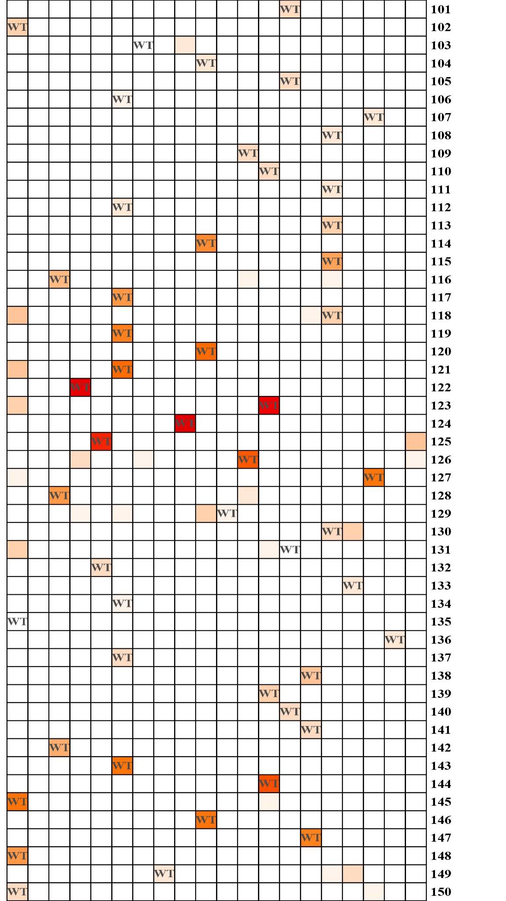
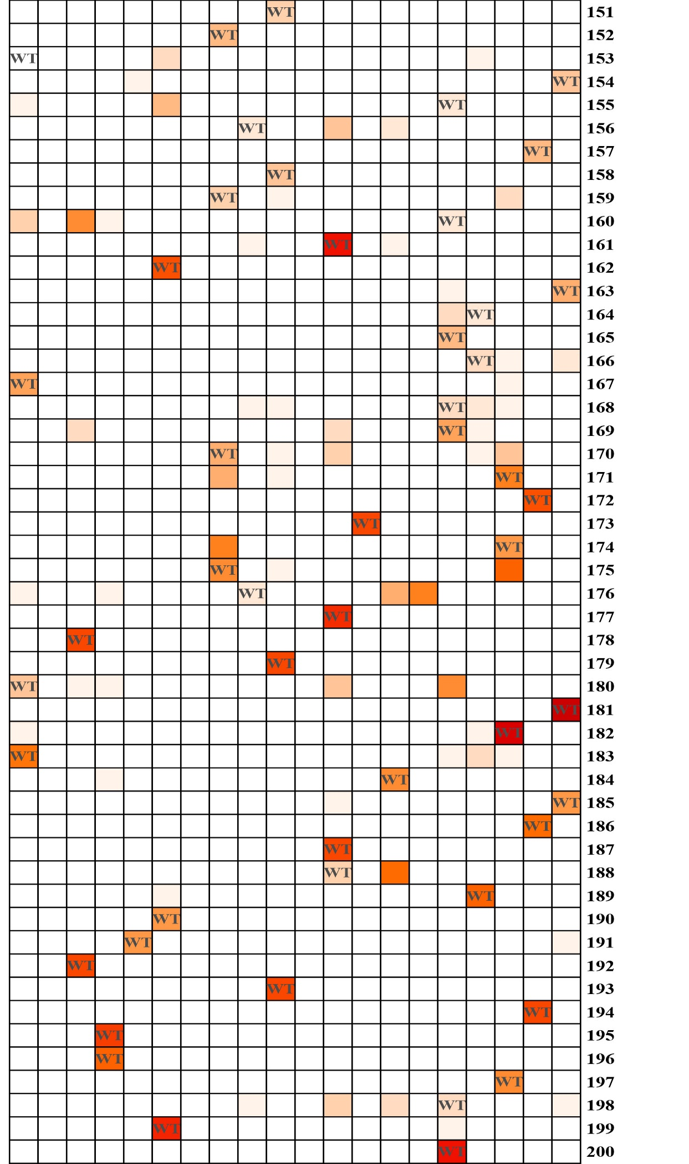
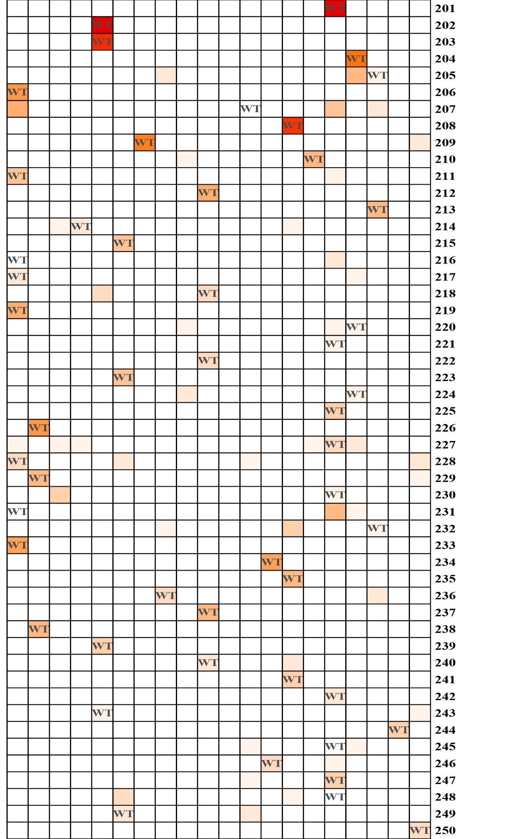
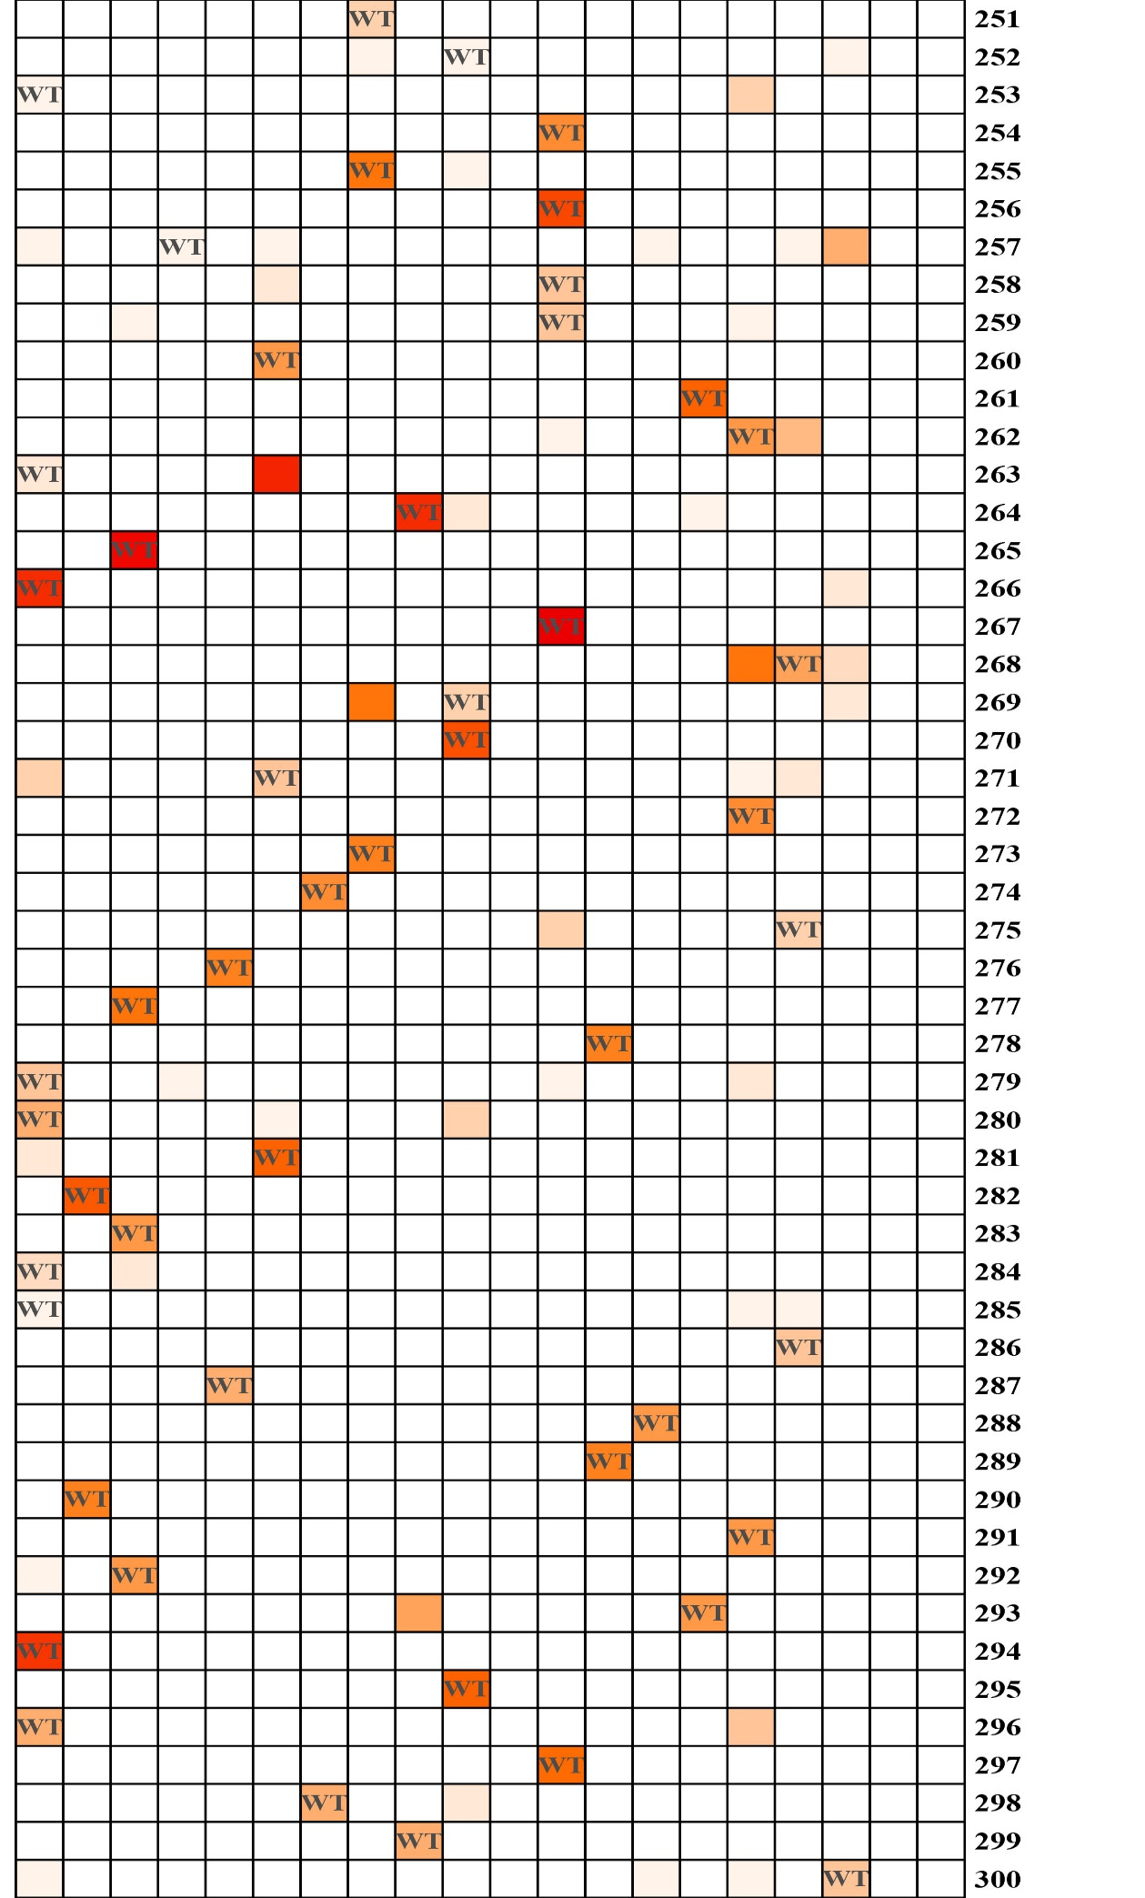
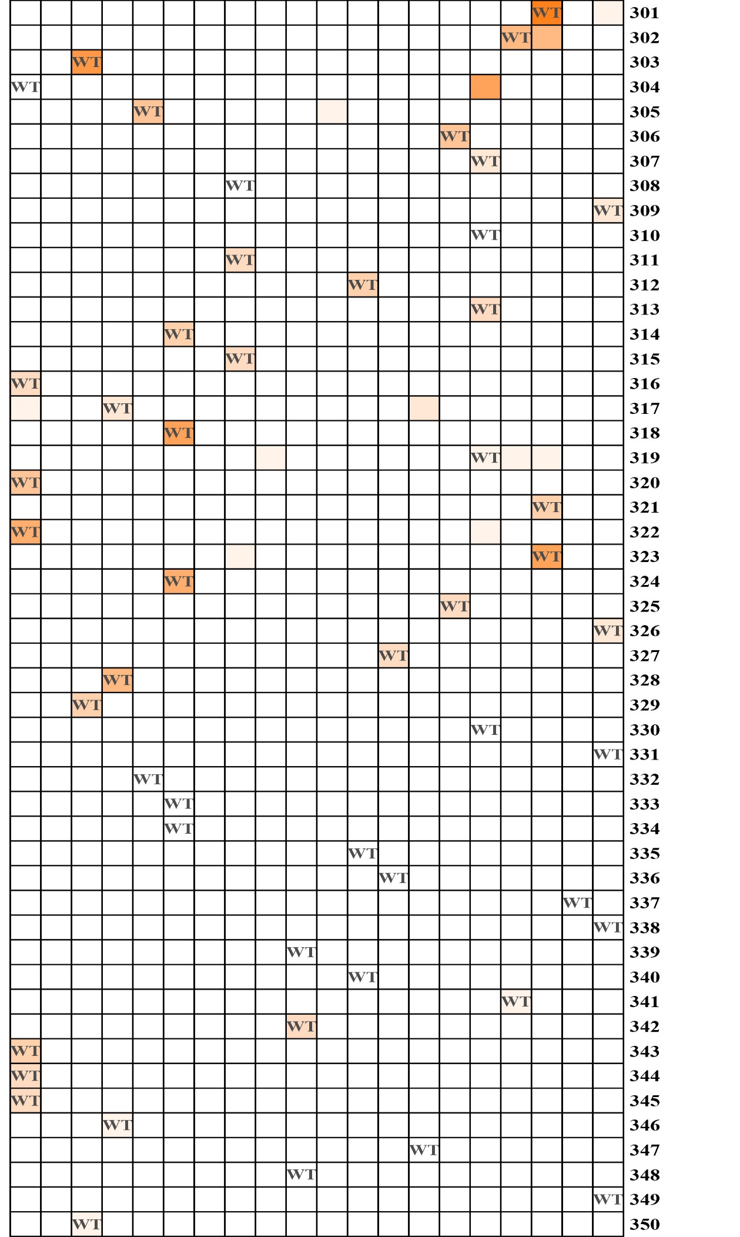
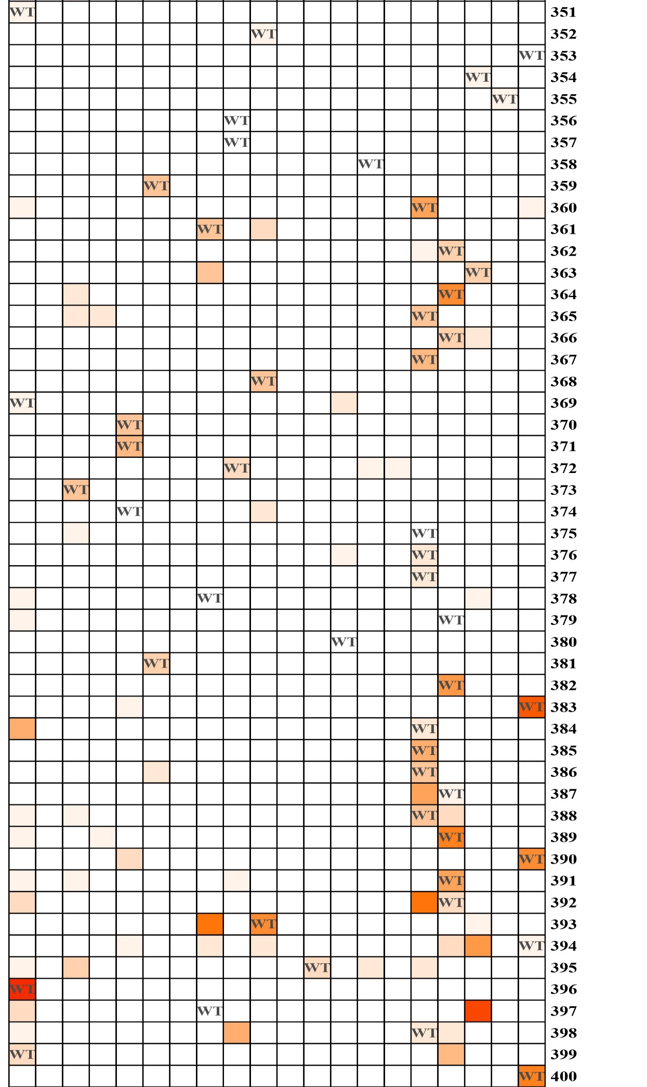
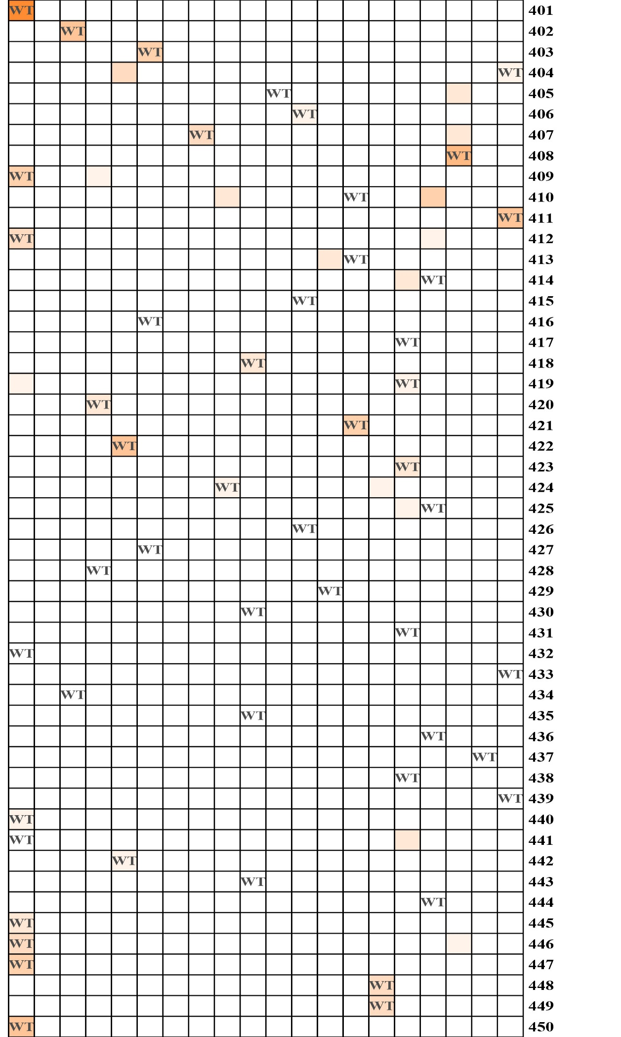
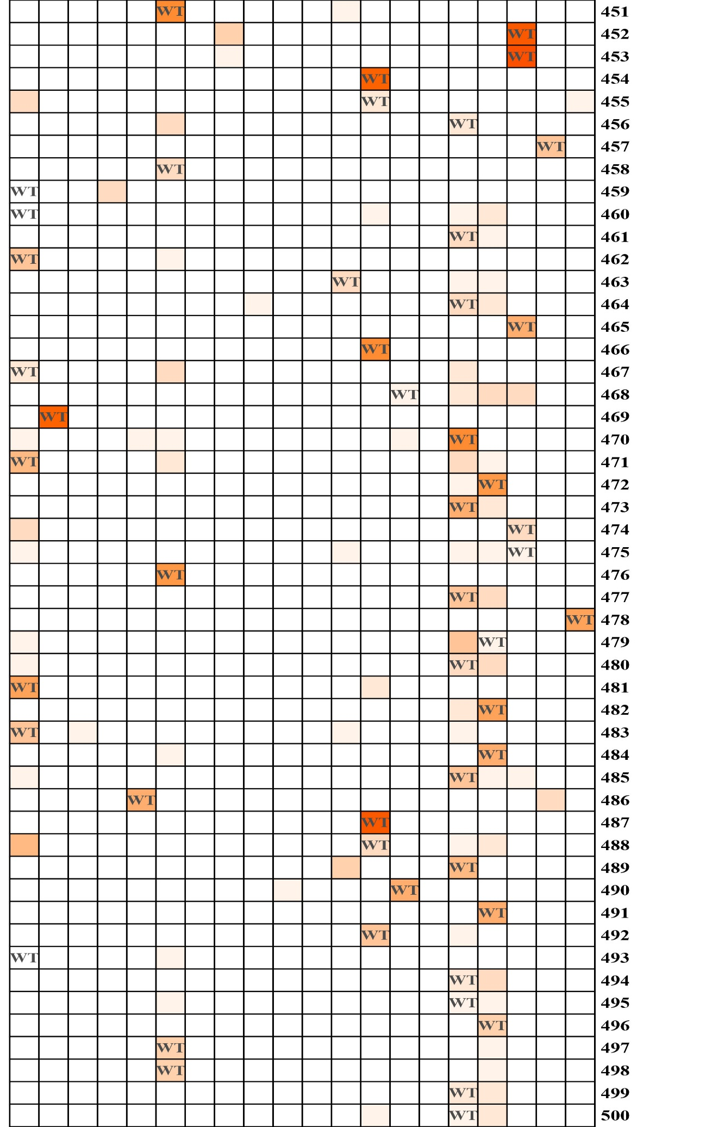
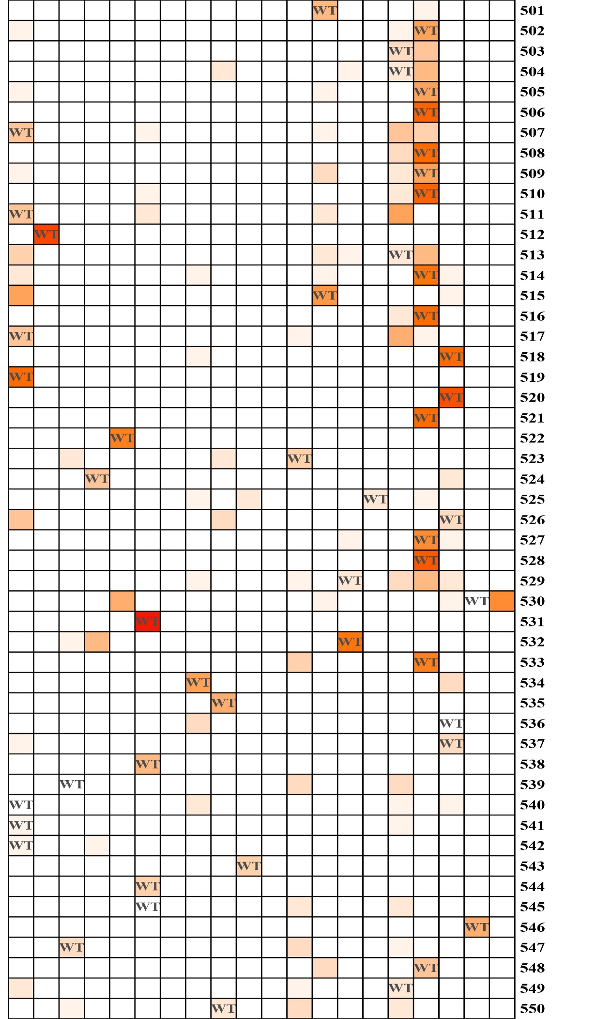
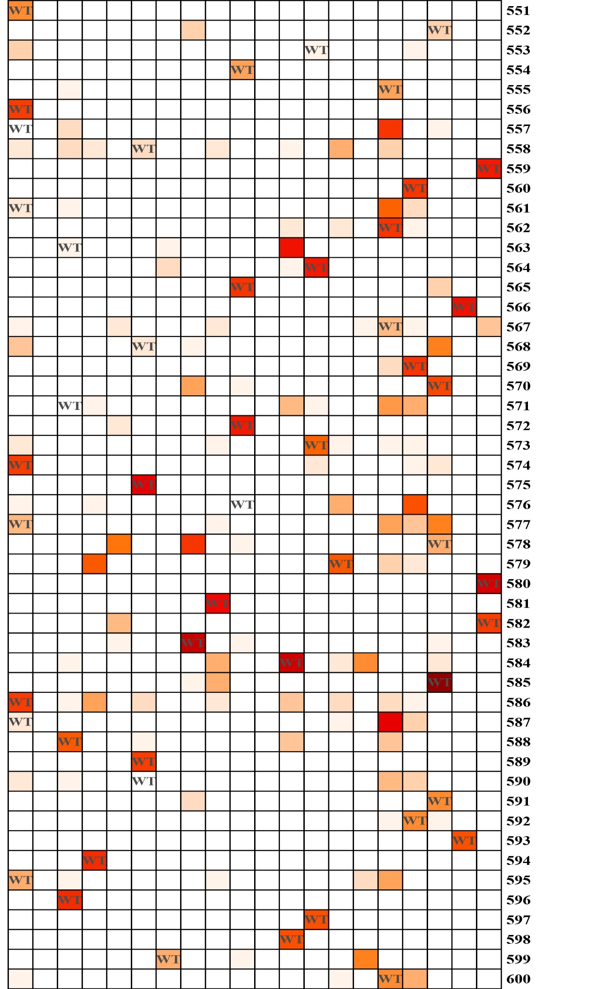
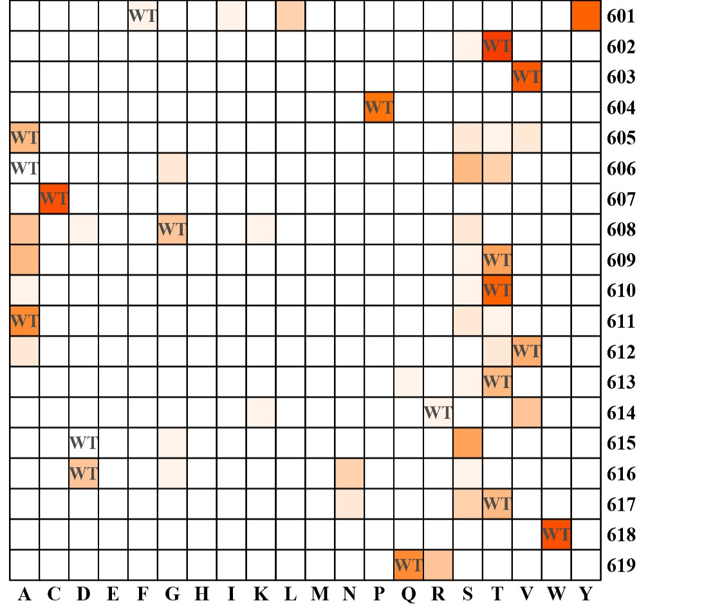
Figure S11 The feature score (P_{j,a}) of GA51
“j” represented the residue number and “a” represented the 20 amino acids

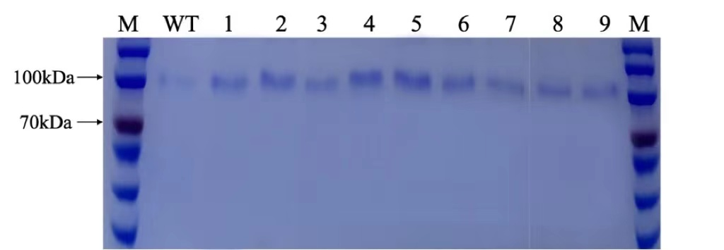
Figure S12 The SDS-PAGE of GA51 and mutants
M：Marker, WT: GA51 wild type, 1: A304S, 2: G590S, 3: A557S, 4: L576T, 5: I397V, 6: N207A, 7: A606S, 8: D563N, 9: D571S

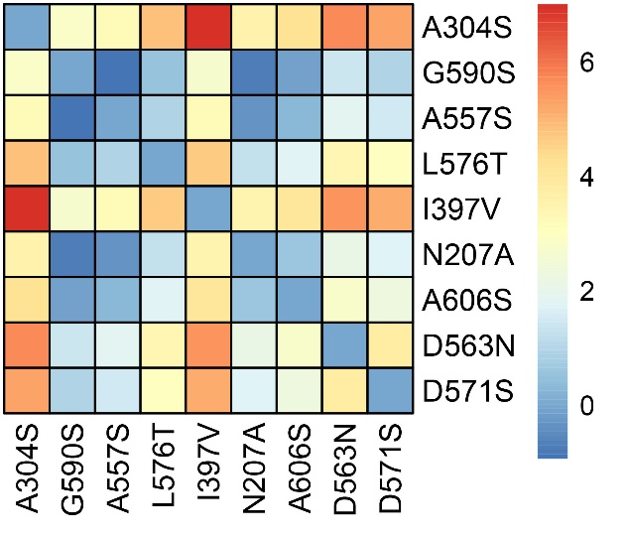
Figure S13 Co-evolutionary analysis of GA51

Table S1 Primers for mutants of CHIS1754
Primers | Sequences (5’-3’)
T7 | TAATACGACTCACTATAGGG
T7ter | TGCTAGTTATTGCTCAGCGG
1754-79-S213P-R | GTATTCGCGTTCGTCTCCGCCCTGCGCcggCGGTTTGGCGTGCTCGA
1754-1-K76E-R | CATCGCCGATGTCttcGATGTACCGGTAC
1754-3-H122R-R | GTTCACCTTgcgCAGTGCGTC
1754-5-D119P-R | CCTTGTGCAGTGCcggCAGGTATTTCGC
1754-81-Q104L-F | CTCGTCGAGctgTACACGAAAGC
1754-82-L157E-F | GGCGCAGAATGATgaaCGCGATTCAATG
1754-83-S160R-F | GATCTCCGCGATcgcATGTACTTCGATC
1754-84-E47D-F | GGATCTCACCgatCCGCACAAGAAAG
1754-85-H142R-F | GATTTCACCGCGGACTGGcgcAAAGCCGCGAAAGATC
1754-F | GACCAAAAAGCCGGGCACCCGCCTG
1754-R | CTCAAGACCCGTTTAGAGGCCCCAAGGGGTTATGCTAG
E157L-F | CCCAGAATGATctgCGTGATCGCATG
L104Q-F | CGGCGATATGCTGGAACTGGTTGAAcagTATACCAAAGCAAAACCGGATAATGTTCTGG
R142H-E157L-R | CATGCGATCACGcagATCATTCTGGGCTTTCTGAAAGGCCGGATCTTTGGCGGCTTTatgC  CAATCGGC
Note: All mutation sites are identified in lowercase letters.

Table S2 Primers used in this experiment
Primers | Sequences (5’-3’)
3’AOX | GGC AAA TGG CAT TC TGA CAT
5’AOX | GAC TGG TTC CAA TTG ACA AGC
A304S-F |  | AAAGTGGTGACCGATTCTTTTCGTAGCATCTAT
G590S-R |  | CTTCCCAGGTAACAGAGCCATCGGCTGCC
A557S-R |  | GTGCCGCTGAGTGCCTCTGGTTATACCGCAAG
L576T-R |  | GATCTGCCGGCCGGTACTGCAGTTCAGTATAAA
I397V-F |  | CCCTGTATAATGCCGTTAGTGCATATGCC

Table S3 The 119 remaining GH families
NO. | GH family | NO. | GH family | NO. | GH family | NO. | GH family
1 | GH1 | 31 | GH32 | 61 | GH75 | 91 | GH115
2 | GH2 | 32 | GH33 | 62 | GH76 | 92 | GH116
3 | GH3 | 33 | GH35 | 63 | GH77 | 93 | GH117
4 | GH4 | 34 | GH36 | 64 | GH78 | 94 | GH120
5 | GH5 | 35 | GH37 | 65 | GH79 | 95 | GH123
6 | GH6 | 36 | GH38 | 66 | GH81 | 96 | GH125
7 | GH7 | 37 | GH39 | 67 | GH82 | 97 | GH126
8 | GH8 | 38 | GH42 | 68 | GH83 | 98 | GH127
9 | GH9 | 39 | GH43 | 69 | GH84 | 99 | GH128
10 | GH10 | 40 | GH44 | 70 | GH85 | 100 | GH130
11 | GH11 | 41 | GH45 | 71 | GH86 | 101 | GH131
12 | GH12 | 42 | GH46 | 72 | GH87 | 102 | GH133
13 | GH13 | 43 | GH47 | 73 | GH88 | 103 | GH135
14 | GH14 | 44 | GH49 | 74 | GH89 | 104 | GH136
15 | GH15 | 45 | GH50 | 75 | GH92 | 105 | GH140
16 | GH16 | 46 | GH51 | 76 | GH93 | 106 | GH141
17 | GH17 | 47 | GH53 | 77 | GH94 | 107 | GH144
18 | GH18 | 48 | GH55 | 78 | GH95 | 108 | GH145
19 | GH19 | 49 | GH56 | 79 | GH97 | 109 | GH146
20 | GH20 | 50 | GH57 | 80 | GH99 | 110 | GH148
21 | GH22 | 51 | GH62 | 81 | GH102 | 111 | GH151
22 | GH23 | 52 | GH63 | 82 | GH103 | 112 | GH152
23 | GH24 | 53 | GH64 | 83 | GH104 | 113 | GH153
24 | GH25 | 54 | GH65 | 84 | GH105 | 114 | GH154
25 | GH26 | 55 | GH66 | 85 | GH106 | 115 | GH156
26 | GH27 | 56 | GH68 | 86 | GH108 | 116 | GH158
27 | GH28 | 57 | GH71 | 87 | GH109 | 117 | GH163
28 | GH29 | 58 | GH72 | 88 | GH110 | 118 | GH165
29 | GH30 | 59 | GH73 | 89 | GH113 | 119 | GH166
30 | GH31 | 60 | GH74 | 90 | GH114

Table S4 The result of hyperparameter optimization
kernel size | filters_1 | filters_2 | ACC | AUC | Precision | Recall | F1-score
12 | 512 | 512 | 96.46% | 99.97% | 97.00% | 96.00% | 96.00%
15 | 512 | 512 | 96.73% | 99.97% | 97.00% | 97.00% | 97.00%
18 | 512 | 512 | 96.48% | 99.96% | 97.00% | 96.00% | 97.00%
21 | 512 | 512 | 96.40% | 99.97% | 97.00% | 96.00% | 96.00%
24 | 512 | 512 | 96.41% | 99.96% | 97.00% | 96.00% | 96.00%
27 | 512 | 512 | 96.20% | 99.96% | 96.00% | 96.00% | 96.00%
30 | 512 | 512 | 96.02% | 99.96% | 96.00% | 96.00% | 96.00%
12 | 512 | 256 | 96.22% | 99.97% | 97.00% | 96.00% | 96.00%
15 | 512 | 256 | 96.33% | 99.97% | 97.00% | 96.00% | 96.00%
18 | 512 | 256 | 96.39% | 99.97% | 97.00% | 96.00% | 96.00%
21 | 512 | 256 | 96.13% | 99.97% | 97.00% | 96.00% | 96.00%
24 | 512 | 256 | 96.11% | 99.97% | 96.00% | 96.00% | 96.00%
27 | 512 | 256 | 96.11% | 99.97% | 97.00% | 96.00% | 96.00%
30 | 512 | 256 | 95.96% | 99.96% | 96.00% | 96.00% | 96.00%

