Supplementary materials

Supplementary Figure 1
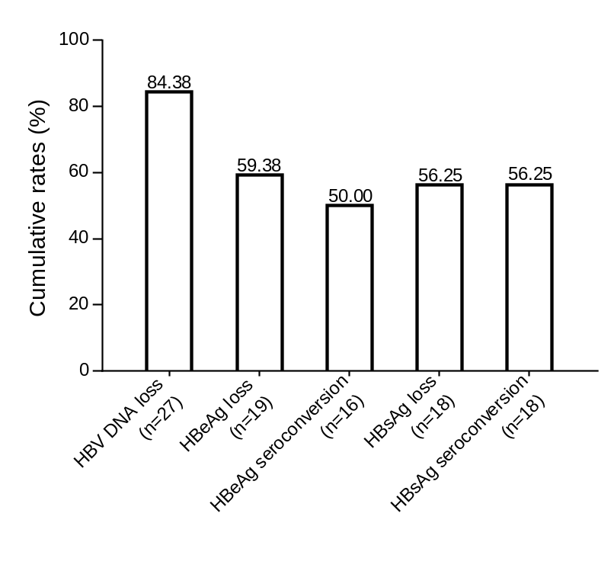
Supplementary Fig 1. Cumulative rate of serum full viral suppression, HBeAg loss and seroconversion, HBsAg loss and seroconversion among the 32 IT children with CHB after 36 months of antiviral treatment.

Supplementary Figure 2（a, b, c）
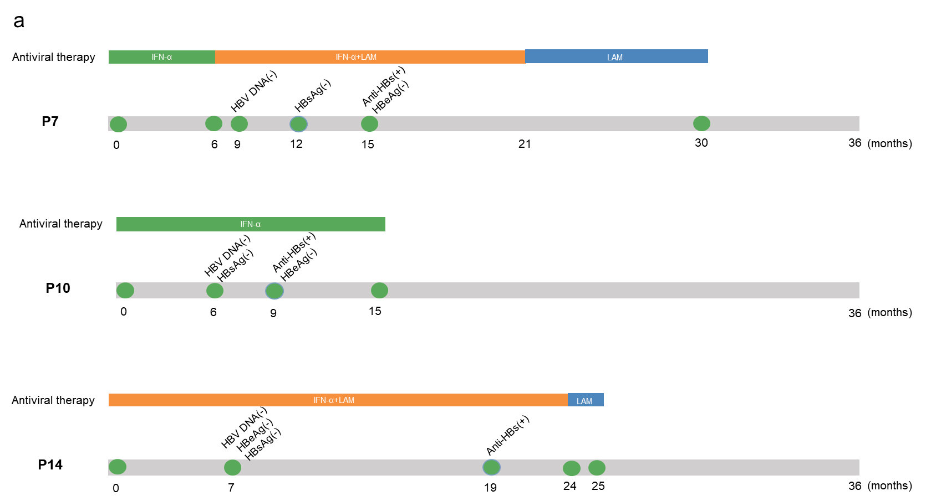

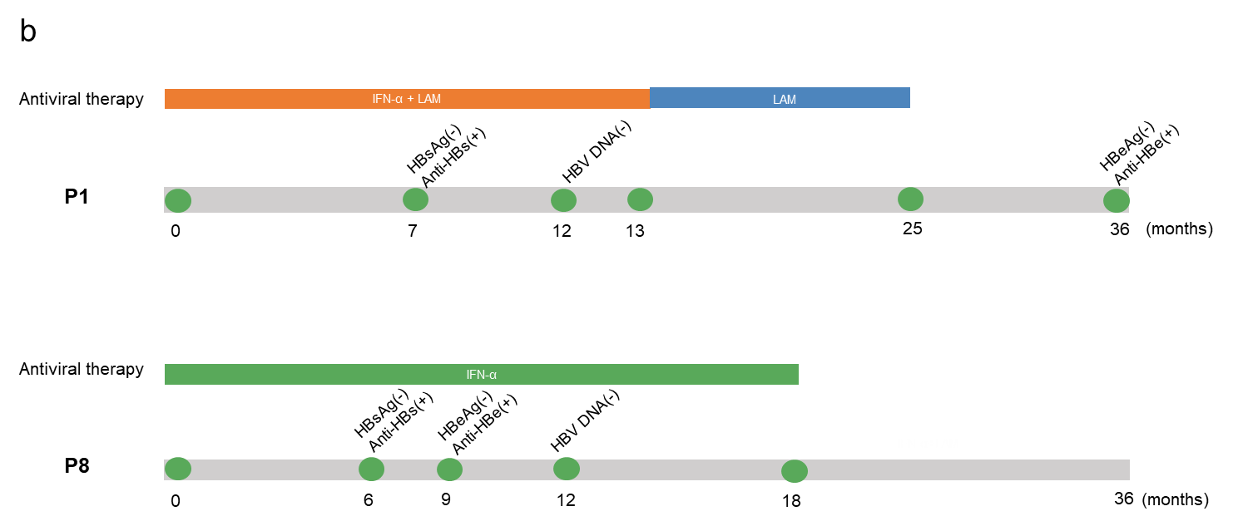
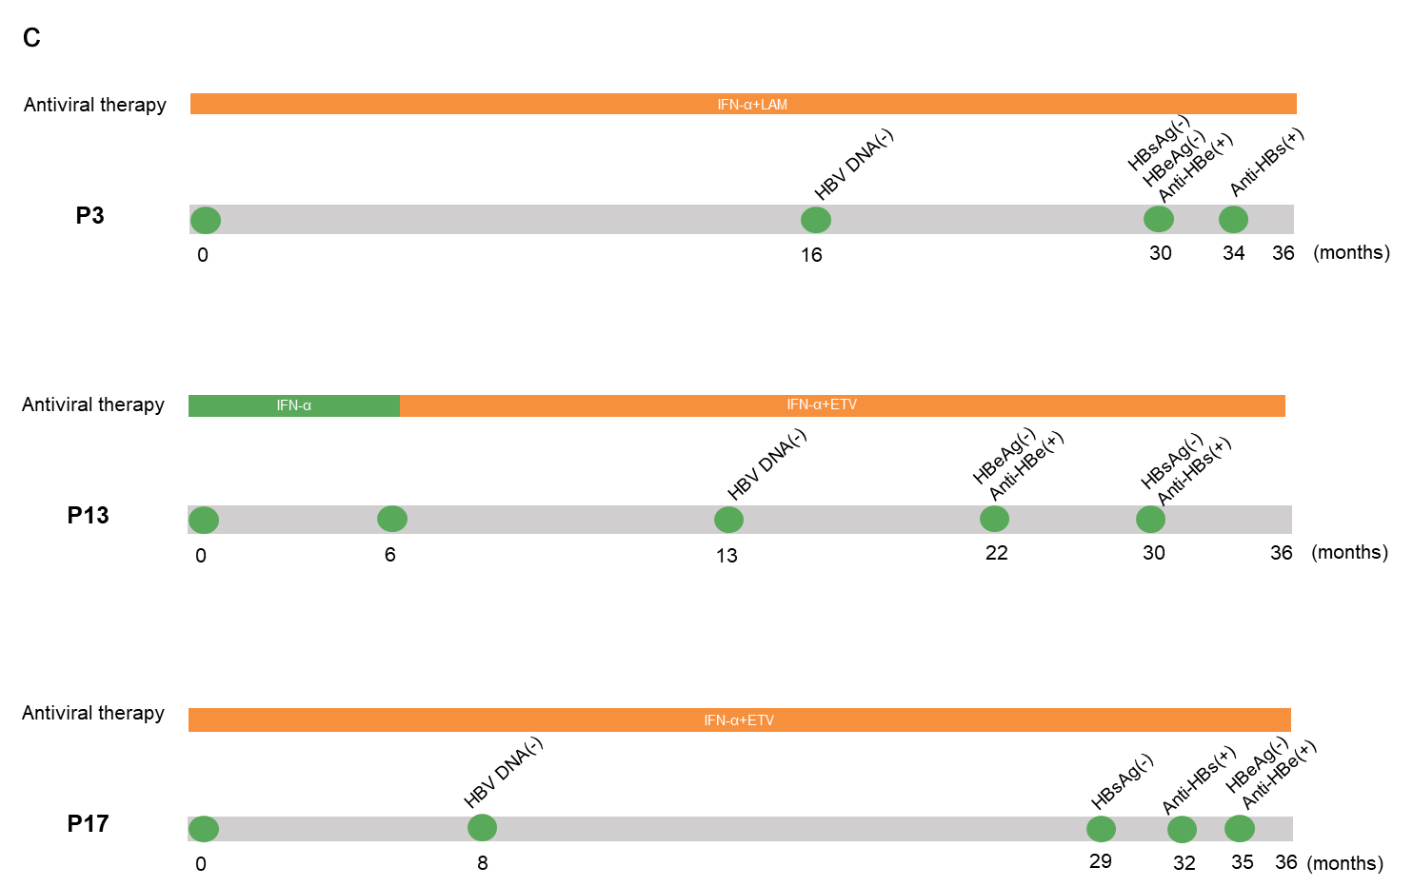

Supplementary Fig 2. The specific regimens, duration, and efficacy of antiviral treatment for 32 IT children enrolled in this retrospective study. (a) Three children (P7, P10, and P18) who showed HBsAg loss and seroconversion but did not achieve HBeAg seroconversion after 36 months of antiviral therapy. (b) Two children (P1, P8) who exhibited HBsAg seroconversion earlier than serum HBV DNA suppression and HBeAg loss. (c) Three children (P3, P13, P17) extended the duration of combined IFN-α and NA treatment to 36 months because of late HBsAg loss and anti-HBs appearance.

Supplementary Figure 3

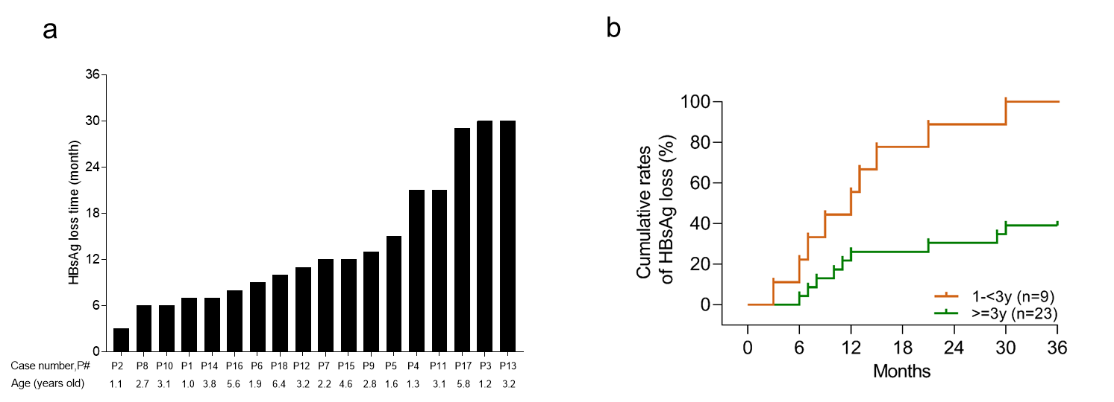

Supplementary Fig 3. Distribution of serum HBsAg loss time in cured cases (a) and cumulative rate of serum HBsAg loss inpatients aged 1-3 versus 3-13 years (b). As shown in (a), 11children showed HBsAg loss within 12 months. Six children (P1, P2, P8, P10, P14 and P16) showed HBsAg loss around 6 months from antiviral treatment initiation. In addition, 9 children aged under 3 years were cured (b, marked as orange line) and another 9 of the 23 cases aged 3-13 years were also cured (b, marked as green line).

Supplementary Figure 4

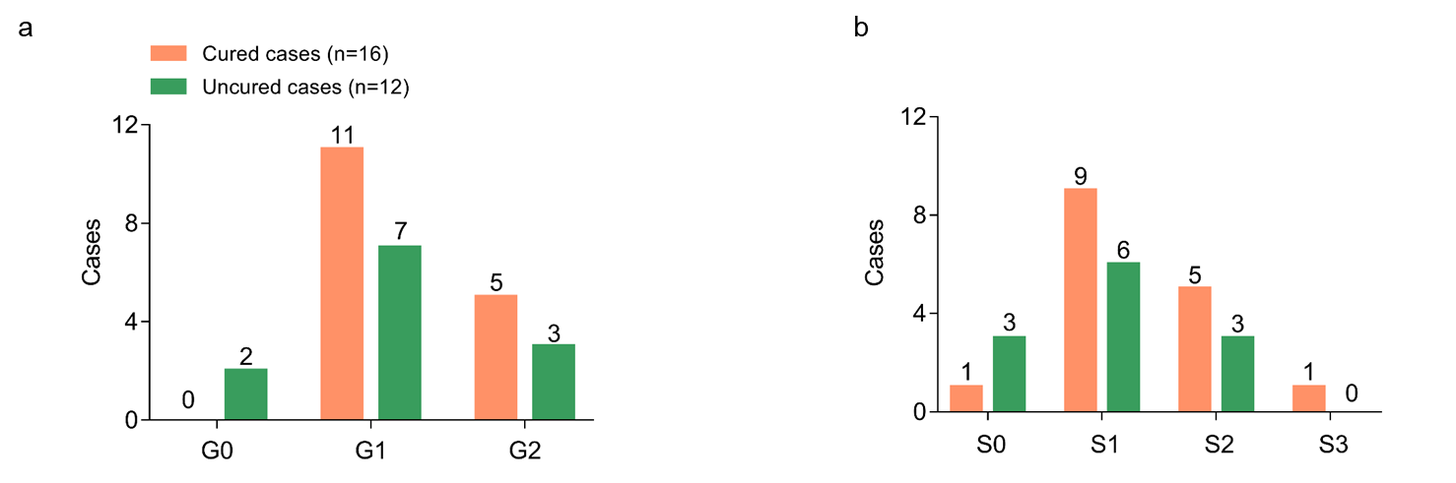
Supplementary Fig 4. Baseline levels of liver inflammation grades (a) and fibrosis stages (b) in the cured and uncured cases (marked as orange and green lines, respectively) of immune tolerant children with CHB.

Supplementary Figure 5
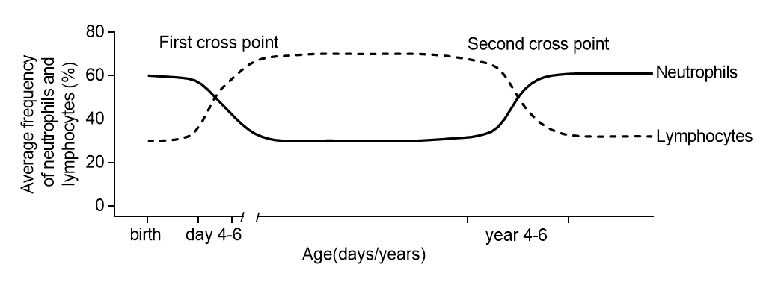
Supplementary Fig 5. Dynamic change in the prevalence of peripheral lymphocytes and neutrophils with age from birth to the adulthood. Neutrophils and lymphocytes account for 60%-65% and 30%-35% of peripheral leukocytes at birth, respectively. Their distribution changes with age and is approximately equal by 4-6 days after birth, which forms the first point of the blood neutrophil and lymphocyte curve. Lymphocytes predominate over neutrophils throughout infancy until 4-6 years of age, when their distribution equalizes again; this forms the second crossing point around 4-6 years of age. After 6 years of age, the prevalence of neutrophils continues to increase and that of lymphocytes gradually decreases to adult levels, with neutrophils around 65% and lymphocytes approximately 30%. (Modified from “Zhu Fu-Tang Practical Pediatrics” published in 2015, Chapter 28, page 1812; and Chapter 439, page 1605, from Nelson Textbook of Pediatrics published in 2007)

Supplementary Table 1：Baseline data of immune tolerant children with CHB in both cured and uncured cases at the end of 36 month of follow-up visit.

Case | sex | age | Transmission | HBV DNA  (log IU/mL) | HBsAg  (log IU/mL) | ALT  (IU/L) | Liver inflammation grades | Antiviral regimens | HBsAg loss time-point  (months) | Anti-HBs time-point  (months) | IFN therapy duration (months) | NAs Tx from beginning to stop (months)
Cured cases
P1 | F | 1.0 | Unknown | 7.26 | 3.92 | 50 | 1 | IFN-α-2b+LAM | 7 | 7 | 13 | 1 - 25
P2 | F | 1.1 | vertical | 7.84 | 4.11 | 41 | 1 | IFN-α-1b | 3 | 3 | 12 | -
P3 | F | 1.2 | vertical | 9.16 | 4.89 | 46 | 1 | IFN-α-1b+LAM | 30 | 34 | 36 | 1 - 36
P4 | F | 1.3 | vertical | 7.77 | 3.94 | 38 | 1 | IFN-α-1b+LAM | 21 | 21 | 24 | 1 - 36
P5 | M | 1.6 | vertical | 9.38 | 5.19 | 41 | 1 | IFN-α-1b+LAM | 15 | 18 | 24 | 1 - 33
P6# | F | 1.9 | vertical | 7.00 | 3.53 | 44 | 1 | IFN-α-2b+LAM | 9 | 12 | 18 | 1 - 27
P7#* | M | 2.2 | vertical | 8.00 | 4.69 | 44 | 2 | IFN-α-1b+LAM* | 12 | 15 | 21 | 7-30
P8 | F | 2.7 | vertical | 7.00 | 3.04 | 53 | 1 | IFN-α-1b | 6 | 6 | 18 | -
P9 | M | 2.8 | vertical | 7.47 | 4.7 | 45 | 1 | IFN-α-2b | 13 | 15 | 21 | -
P10 | F | 3.1 | vertical | 8.45 | 5.07 | 43 | none | IFN-α-1b | 6 | 9 | 15 | -
P11 | M | 3.1 | vertical | 7.61 | none | 56 | 2 | IFN-α-1b | 21 | 21 | 24 | -
P12 | M | 3.2 | vertical | 8.45 | 4.22 | 49 | 2 | IFN-α-1b+LAM | 11 | 11 | 17 | 1 - 29
P13* | F | 3.2 | Unknown | 7.57 | 4.41 | 30 | 1 | IFN-α-1b+ETV* | 30 | 30 | 36 | 7 - 36
P14 | M | 3.8 | vertical | 8.53 | 4.46 | 57 | 2 | IFN-α-1b+LAM | 7 | 19 | 24 | 1 - 25
P15 | M | 4.6 | vertical | 7.43 | 3.64 | 49 | 1 | IFN-α-1b+LAM | 12 | 12 | 18 | 1 - 30
P16 | F | 5.6 | vertical | 7.70 | 4.69 | 34 | none | IFN-α-1b+ETV | 8 | 8 | 14 | 1 - 26
P17 | F | 5.8 | vertical | 8.49 | 4.78 | 50 | 1 | IFN-α-1b+ETV | 29 | 32 | 36 | 1 - 36
P18# | M | 6.4 | vertical | 7.65 | 4.53 | 43 | 2 | IFN-α-1b+ETV | 10 | 10 | 16 | 1 - 28
Uncured cases
P19 | F | 3.0 | vertical | 8.63 | 5.24 | 26 | none | IFN-α-1b | - | - | 24 | -
P20* | M | 3.2 | vertical | 8.41 | 4.84 | 37 | 1 | IFN-α-1b+LAM* | - | - | 24 | 7- 36
P21 | M | 3.3 | vertical | 8.82 | none | 42 | 2 | Peg-IFN-α-2a | - | - | 12 | -
P22 | M | 3.4 | vertical | 9.06 | 5.35 | 18 | 1 | IFN-α-1b+LAM | - | - | 24 | 1 - 36
P23* | M | 3.5 | vertical | 8.00 | 4.64 | 54 | 2 | IFN-α-1b+ETV* | - | - | 24 | 7- 36
P24 | F | 3.7 | vertical | 8.00 | 5.03 | 43 | 1 | IFN-α-1b+ETV | - | - | 24 | 1- 36
P25* | M | 3.9 | vertical | 9.20 | 4.85 | 53 | 1 | IFN-α-2b+LAM* | - | - | 24 | 7- 36
P26 | F | 4.9 | vertical | 7.00 | 4.33 | 49 | 0 | IFN-α-1b+ETV | - | - | 24 | 1 - 36
P27 | M | 5.5 | vertical | 7.74 | 3.73 | 39 | none | IFN-α-1b+ETV | - | - | 24 | 1 - 36
P28 | M | 6.2 | occult | 9.05 | 4.64 | 26 | 1 | IFN-α-1b+LAM | - | - | 24 | 1 - 36
P29* | M | 7.9 | vertical | 7.75 | 4.52 | 43 | 2 | IFN-α-2b+LAM* | - | - | 24 | 7- 36
P30 | M | 8.9 | vertical | 8.78 | none | 30 | 1 | IFN-α-2b+LAM | - | - | 24 | 1 - 36
P31 | F | 10.2 | occult | 7.97 | none | 42 | 0 | IFN-α-2b+ETV | - | - | 24 | 1 - 36
P32 | M | 12.9 | vertical | 7.00 | 3.75 | 46 | 1 | IFN-α-1b+LAM | - | - | 24 | 1 - 36

IFN-α-2b (Schering-Plough, Innishannon County Cork, Ireland); IFN-α-1b (Kexing, Shenzhen, China),
Peg-IFN-α-2a (Roche Pharma, Basel, Schweiz), recommended course of treatment was 12 months. # P6, P7 and P18 cases received three doses of HBV vaccination; * P7, P13, P20, P23, P25 and P29 cases received IFN-α add on NAs therapy since the seventh month of this study.

Supplementary Table 2：COX regression analysis of independent influencing factors of HBsAg loss in immune tolerant children with CHB.

Parameters | Overall | Univariate analysis |  |  | Multivariate analysis
Parameters | Overall | HR (95% CI) | p Value |  | HR (95% CI) | p Value
N | 32
Age, years | 3.35 [2.77, 5.53] | 0.684 (0.508, 0.922) | 0.013 |  | 0.635 (0.373, 1.080) | 0.094
1- < 3 years | 9 (28.1)
3- < 7 years | 19 (59.4)
7- 13 years | 4 (12.5)
Male / Female | 18 / 14 | 2.051 (0.808, 5.209) | 0.131
qHBsAg, log₁₀IU/mL | 4.58 [4.07, 4.84] | 0.442 (0.182, 1.077) | 0.072
HBV DNA, log₁₀IU/mL | 7.99 [7.60, 8.55] | 0.598 (0.302, 1.184) | 0.140
Neutrophils count, 10⁹/L† (n=24) | 2.73 [1.99, 3.59] | 0.85 (0.569, 1.270) | 0.429
CD4⁺ T lymphocytes count, cells/μL† (n=24) | 1466.00 [1084.50, 1929.75] | 1 (0.999, 1.001) | 0.124
CD8⁺ T lymphocytes count, cells/μL† (n=24) | 862.50 [594.25, 1219.00] | 1.001 (1, 1.002) | 0.013 |  | 1.001 (0.999, 1.002) | 0.260
B lymphocytes count, cells/μL† (n=24) | 1008.00 [544.25, 1369.25] | 1.001 (1, 1.002) | 0.003 |  | 1.000 (0.998, 1.002) | 0.882
NK cells count, cells/μL† (n=24) | 334.50 [196.50, 447.75] | 1 (0.999, 1.002) | 0.804
HBV genotype, n (%)
B genotype | 5 (15.6) | 1
C genotype | 20 (62.5) | 0.608 (0.191, 1.938) | 0.400
Unknown | 7 (21.9) | 0.398 (0.088, 1.795) | 0.231
AST, IU/L | 48.00 [44.50, 56.25] | 1.041 (0.998, 1.086) | 0.061
ALT, IU/L | 43.00 [38.75, 49.00] | 1.055 (0.995, 1.118) | 0.072
Range (min, max) | (18, 57)
patients with normal level | 9 (28.1)
patients with 1-1.5 times ULN | 23 (71.9)
Inflammation grades* (n=28)
G0, n (%) | 2 (7.1) | 1
G1, n (%) | 18 (64.3) | 75869092 (0, Infinity) | 0.998
G2, n (%) | 8 (28.6) | 88019142 (0, Infinity) | 0.998
Fibrosis stages* (n=28)
S0, n (%) | 4 (14.3) | 1
S1, n (%) | 15 (53.6) | 3.425 (0.433, 27.076) | 0.243
S2, n (%) | 8 (28.6) | 3.361 (0.392, 28.830) | 0.269
S3, n (%) | 1 (3.6) | 14.668 (0.823, 261.433) | 0.068
Family history of HBV infection, n (%)
Mother with HBsAg positivity | 26 (81.2) | 1
Both parents with HBsAg positivity | 2 (6.2) | 1.163 (0.153, 8.834) | 0.884
Neither parent with HBsAg positivity | 4 (12.5) | 0.768 (0.175, 3.368) | 0.727
treatment, n (%)
IFN-α monotherapy | 7 (21.9) | 1
Initial IFN-α and NAs combination therapy | 19 (59.4) | 0.582 (0.202, 1.680) | 0.317
IFN-α add on NAs therapy | 6 (18.7) | 0.258 (0.050, 1.335) | 0.106

*Liver histology was performed in 28 of 32 children with CHB with a one-second needle biopsy; † Lymphocyte subsets were tested in 24 of 32 children with CHB; Categorical variables were expressed as numbers (percentages), continuous variable was expressed as median [interquartile range, IQR]. CI, Confidence Interval; qHBsAg, quantitative hepatitis B surface antigen; ALT, alanine aminotransferase; AST, Aspartate aminotransferase; IFN-α, Interferon α; NAs, nucleotide analogs; ULN, Upper Limits of Normal.

