[Supplementary Table 1] IMRT treatment plan dose goals³²
H&N case | Prostate case | C-shape easy case | C-shape hard case
- PTV  D90 > 5,000  D99 > 4,650  D20 < 5,500  - Cord  Dmax < 4,000  - Parotids  D50 < 2,000 | - PTV  D95 > 7,560  D5 < 8,300  - Rectum  D30 < 7,000  D10 < 7,500  - Bladder  D30 < 7,000  D10 < 7,500 | - PTV  D95 > 5,000  D10 < 5,500  - Cord  D5 < 2,500 | - PTV  D95 ≥ 5,000  D10 < 5,500  - Cord  D5 < 1,000
* PTV: radiotherapy planning target volume, *DX: dose received by X% of the volume at X values of 10, 20, 30, 90, 95, 99. *Dmax: maximum received dose of the volume

[Supplementary Table 2] Summary of the dosiomics indices^{38,39}
Order of extracted feature | Matrix | Index | Type
First order | Conventional features | - Mean dose | Global
First order | Histogram features | - Skewness,  - Kurtosis | Global
Second order | GLCM  (Gray-Level Co-occurrence based on concurrence Matrix) | - Homogeneity  - Energy  - Correlation  - Contrast  - Entropy  - Dissimilarity | Regional
Second order | GLRLM  (Gray-Level Run Length based on voxel-alignment Matrix) | - SRE (short-run emphasis)  - LRE (long-run emphasis)  - LGRE (low grey-level run emphasis)  - HGRE (high grey-level run emphasis)  - SRLGE (short-run low grey-level emphasis)  - SRHGE (short-run high grey-level emphasis)  - LRLGE (long-run low grey-level)  - LRHGE (long-run high grey-level emphasis)  - GLNUr (grey-level nonuniformity for the run)  - RLNU (run-length nonuniformity)  - RP (run percentage) | Regional
High order | NGLDM  (Neighborhood Gray-Level Different  based on neighborhood intensity-difference Matrix) | - Coarseness  - Contrast  - Busyness | Local
 | GLZLM  (Gray-Level Zone Length based on intensity–size–zone Matrix) | - SZE (short-zone emphasis)  - LZE (long-zone emphasis)  - LGZE (low grey-level zone emphasis)  - HGZE (high grey-level zone emphasis)  - SZLGE (short-zone low grey-level emphasis)  - SZHGE (short-zone high grey-level emphasis)  - LZLGE (long-zone low grey-level emphasis)  - LZHGE (long-zone high grey-level emphasis)  - GLNUz (grey-level nonuniformity for the zone)  - ZLNU (zone length nonuniformity)  - ZP (zone percentage) | Local
* Mean dose: mean of dose in the defined volume, *GLCM: Gray-Level Co-occurrence based on the concurrence matrix, *GLNUr: Gray-level nonuniformity for the run, *GLNUz: Gray-level nonuniformity for the zone, *GLRLM: Gray-Level Run Length based on the voxel-alignment Matrix, *LGRE: Low gray-level run emphasis, *LGZE: Low gray-level zone emphasis, *LRE: Long-run emphasis, *LRLGE: Long-run low gray-level, *LRHGE: Long-run high gray-level emphasis, *LZE: Long-zone emphasis, *LZLGE: Long-zone low gray-level emphasis, *LZHGE: Long-zone high gray-level emphasis, *HGRE: High gray-level run emphasis, *HGZE: High gray-level zone emphasis, *MTV: Metabolic tumor volume, *NGLDM: Neighborhood Gray-Level Different based on the neighborhood intensity-difference matrix, *RLNU: Run-length nonuniformity, *RP: Run percentage, *SRE: Short-run emphasis, *SRLGE: Short-run low gray-level emphasis, *SRHGE: Short-run high gray-level emphasis, *ZLNU: Zone length nonuniformity, *ZP: Zone percentage

[Supplementary Table 3] Mean gamma index (2 mm/3%), mean Structural Similarity (SSIM), and subcomponents luminance, contrast, structure index results for the prostate, c-shape easy, and c-shape hard

Prostate case |  | SSIM index | luminance | Contrast | Structure | Gamma index
Systematic | 0.5 | 0.9445 | 0.9987 | 0.9997 | 0.9992 | 0.993
Systematic | 1.0 | 0.9434 | 0.9986 | 0.9997 | 0.9992 | 0.888
Systematic | 1.5 | 0.9413 | 0.9985 | 0.9997 | 0.9992 | 0.769
Systematic | 2.0 | 0.9381 | 0.9983 | 0.9997 | 0.9991 | 0.645
Random | 0.0 | 0.9444 | 0.9986 | 0.9997 | 0.9992 | 1.000
Random | 0.5 | 0.9439 | 0.9986 | 0.9997 | 0.9992 | 0.967
Random | 1.0 | 0.9428 | 0.9986 | 0.9997 | 0.9992 | 0.894

C-shape easy |  | SSIM index | luminance | Contrast | Structure | Gamma index
Systematic | 0.5 | 0.9441 | 0.9987 | 0.9998 | 0.9993 | 1.000
Systematic | 1.0 | 0.9426 | 0.9987 | 0.9998 | 0.9993 | 0.905
Systematic | 1.5 | 0.9398 | 0.9985 | 0.9998 | 0.9993 | 0.688
Systematic | 2.0 | 0.9359 | 0.9982 | 0.9998 | 0.9992 | 0.530
Random | 0.0 | 0.9439 | 0.9987 | 0.9998 | 0.9993 | 1.000
Random | 0.5 | 0.9434 | 0.9987 | 0.9998 | 0.9993 | 0.989
Random | 1.0 | 0.9420 | 0.9986 | 0.9998 | 0.9993 | 0.876

C-shape hard |  | SSIM index | luminance | Contrast | Structure | Gamma index
Systematic | 0.5 | 0.9434 | 0.9998 | 0.9998 | 0.9992 | 0.942
Systematic | 1.0 | 0.9412 | 0.9987 | 0.9998 | 0.9991 | 0.710
Systematic | 1.5 | 0.9379 | 0.9985 | 0.9997 | 0.9990 | 0.611
Systematic | 2.0 | 0.9333 | 0.9983 | 0.9997 | 0.9988 | 0.447
Random | 0.0 | 0.9420 | 0.9987 | 0.9998 | 0.9991 | 0.991
Random | 0.5 | 0.9422 | 0.9987 | 0.9998 | 0.9991 | 0.954
Random | 1.0 | 0.9402 | 0.9986 | 0.9998 | 0.9991 | 0.728

[Supplementary Table 4] Spearman's rank correlation
A) Head and Neck
Error Class | Matrix Index | Spearman's rank correlation of the selected features
Class-I | GLCM_Energy, GLCM_Correlation, GLCM_Entropy_log10, GLCM_Dissimilarity, GLRLM_LRHGE, GLRLM_GLNU, GLRLM_RP | GLCM_Energy | GLCM_Correlation, GLCM_Entropy_log10, GLCM_Dissimilarity, GLRLM_GLNU, GLRLM_RP
Class-I |  | GLRLM_LRHGE
Class-II | GLCM_Energy, GLRLM_LRHGE, GLRLM_GLNU, GLRLM_RP, GLZLM_SZE, GLZLM_GLNU | GLCM_Energy | GLRLM_GLNU, GLRLM_RP, GLZLM_GLNU
Class-II |  | GLRLM_LRHGE
Class-II |  | GLZLM_SZE
Class-III | GLCM_Energy, GLCM_Correlation, GLZLM_SZE | GLCM_Energy | GLCM_Correlation
Class-III | GLCM_Energy, GLCM_Correlation, GLZLM_SZE | GLZLM_SZE

B) Prostate
Error Class | Matrix Index | Spearman's rank correlation of the selected features
Class-I | GLCM_Energy, GLCM_Entropy_log10, GLCM_Dissimilarity, GLRLM_SRE, GLRLM_LRE, GLRLM_SRLGE, GLRLM_LRHGE, GLRLM_RP, GLZLM_SZLGE, GLZLM_ZP | GLCM_Energy | GLCM_Entropy_log10, GLCM_Dissimilarity, GLRLM_SRE, GLRLM_LRE, GLRLM_RP, GLZLM_SZLGE, GLZLM_ZP
Class-I |  | GLRLM_SRLGE | GLRLM_LRHGE
Class-I |  | GLZLM_SZLGE
Class-II | GLRLM_HGRE, GLRLM_SRLGE, GLRLM_LRHGE | GLRLM_HGRE | GLRLM_SRLGE, GLRLM_LRHGE
Class-III | GLCM_Energy, GLCM_Dissimilarity, GLRLM_SRE, GLRLM_LRE, GLRLM_LRHGE | GLCM_Energy | GLCM_Dissimilarity, GLRLM_SRE, GLRLM_LRE
Class-III |  | GLRLM_LRHGE

C) C-shape Easy
Error Class | Matrix Index | Spearman's rank correlation of the selected features
Class-I | GLCM_Energy, GLCM_Entropy_log10, GLCM_Dissimilarity, GLRLM_RP,  GLZLM_SZE,  GLZLM_ZP | GLCM_Energy | GLCM_Entropy_log10, GLCM_Dissimilarity, GLRLM_RP
Class-I |  | GLZLM_SZE | GLZLM_ZP
Class-II | GLCM_Energy, GLCM_Entropy_log10,  GLRLM_LRE, GLRLM_LRHGE, GLZLM_ZP | GLCM_Energy | GLCM_Entropy_log10, GLRLM_LRE, GLZLM_ZP
Class-II |  | GLRLM_LRHGE
Class-III | Skewness, GLCM_Energy, GLCM_Correlation, GLCM_Entropy_log10, GLCM_Dissimilarity, GLRLM_LRE, GLRLM_LRHGE, GLRLM_RP, GLZLM_SZE, GLZLM_ZP | GLCM_Energy | GLCM_Correlation, GLCM_Entropy_log10, GLCM_Dissimilarity, GLRLM_LRE, GLRLM_RP, GLZLM_ZP
Class-III |  | Skewness
Class-III |  | GLRLM_LRHGE
Class-III |  | GLZLM_SZE

D) C-shape Hard
Error Class | Matrix Index | Spearman's rank correlation of the selected features
Class-I | Skewness, GLCM_Energy, GLCM_Correlation, GLCM_Entropy_log10, GLRLM_LRE, GLRLM_GLNU | GLCM_Energy | GLCM_Correlation, GLCM_Entropy_log10, GLRLM_LRE
Class-I |  | Skewness
Class-I |  | GLRLM_GLNU
Class-II | GLCM_Energy, GLCM_Correlation, GLRLM_LRE, GLRLM_LRHGE, GLRLM_GLNU, GLRLM_RP | GLCM_Energy | GLCM_Correlation, GLRLM_LRE, GLRLM_RP
Class-II |  | GLRLM_LRHGE
Class-II |  | GLRLM_GLNU
Class-III | GLRLM_LRE, GLZLM_SZE, GLZLM_GLNU | GLZLM_GLNU | GLRLM_LRE, GLZLM_SZE

[Supplementary Table 5] Performance of the logistic regression models
A) Head and Neck
Error Class | Ratio of training data set (%) | Matrix Index | Accuracy | Precision | Sensitivity | Specificity | AUC
Class-I | 65 | GLRLM_RP | 0.94 | 0.91 | 0.92 | 0.95 | 0.99
Class-I | 70 | GLRLM_LRHGE + GLRLM_GLNU | 0.93 | 0.94 | 0.9 | 0.94 | 0.99
Class-II | 75 | GLRLM_RP | 0.92 | 0.92 | 0.92 | 0.92 | 0.99
Class-II | 75 | GLZLM_SZE | 0.92 | 0.92 | 0.92 | 0.92 | 0.97
Class-II | 75 | GLRLM_GLNU + GLRLM_LRHGE | 0.96 | 1 | 1 | 0.92 | 0.97
Class-III | 80 | GLCM_Correlation | 0.86 | 0.8 | 0.83 | 0.89 | 0.9

B) Prostate
Error Class | Ratio of training data set (%) | Matrix Index | Accuracy | Precision | Sensitivity | Specificity | AUC
Class-I | 70 | GLRLM_SRE | 0.92 | 0.94 | 0.89 | 0.94 | 0.91
Class-II | 90 | GLRLM_HGRE | 0.83 | 0.8 | 0.89 | 0.92 | 0.95
Class-III | 80 | GLRLM_SRE | 0.88 | 0.86 | 0.89 | 0.86 | 0.9

C) C-shape Easy
Error Class | Ratio of training data set (%) | Matrix Index | Accuracy | Precision | Sensitivity | Specificity | AUC
Class-I | 65 | GLCM_Entropy_log10 | 0.91 | 0.95 | 0.83 | 0.95 | 0.96
Class-I | 65 | GLZLM_ZP | 0.88 | 0.91 | 0.83 | 0.91 | 0.96
Class-I | 80 | GLCM_Entropy_log10 + GLZLM_ZP | 0.84 | 0.91 | 0.86 | 0.83 | 0.94
Class-II | 75 | GLRLM_LRE | 0.92 | 0.92 | 0.92 | 0.92 | 0.98
Class-II | 65 | GLCM_Energy + GLRLM_LRHGE | 0.97 | 1 | 1 | 0.94 | 0.98
Class-II | 65 | GLCM_Entropy_log10 + GLRLM_LRHGE | 70.97 | 1 | 1 | 0.94 | 1.0
Class-III | 80 | GLRLM_LRHGE | 0.86 | 0.88 | 0.92 | 0.78 | 0.92
Class-III | 80 | GLCM_Correlation + GLRLM_LRHGE + GLZLM_SZE | 0.95 | 1 | 1 | 0.89 | 0.98

D) C-shape Hard
Error Class | Ratio of training data set (%) | Matrix Index | Accuracy | Precision | Sensitivity | Specificity | AUC
Class-I | 65 | GLCM_Entropy_log10 | 0.94 | 0.88 | 0.92 | 0.95 | 0.98
Class-I | 70 | GLCM_Entropy_log10 + GLRLM_GLNU | 0.89 | 1 | 1 | 0.83 | 0.94
Class-II | 75 | GLCM_Entropy_log10 | 0.92 | 0.92 | 0.92 | 0.92 | 0.99
Class-III | 80 | GLZLM_GLNU | 0.76 | 0.75 | 0.83 | 0.67 | 0.92

a) Head and Neck systematic error
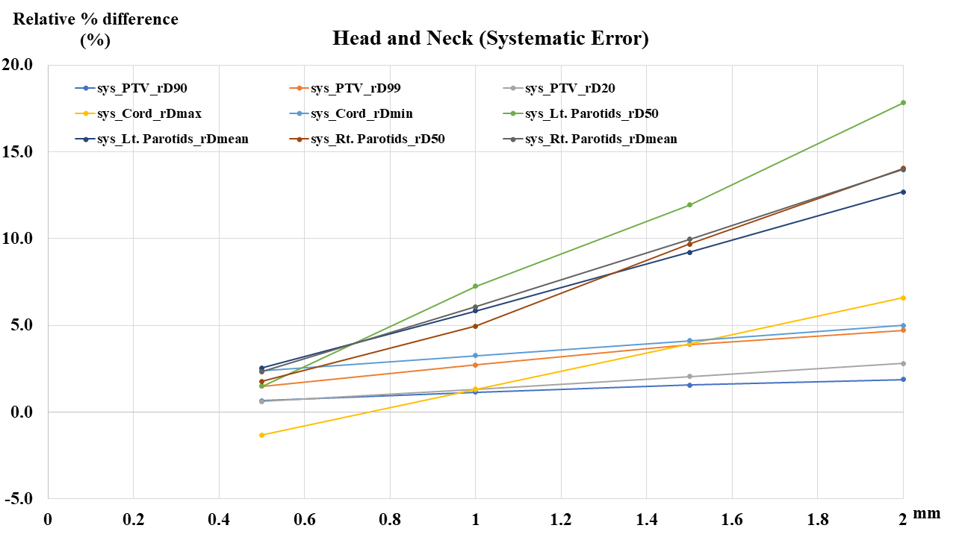

b) Head and Neck random error
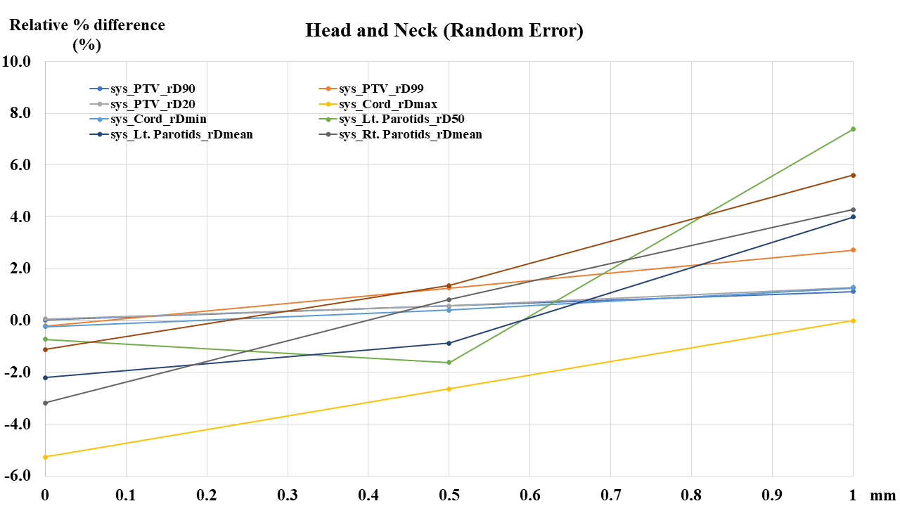
c) Prostate systematic error
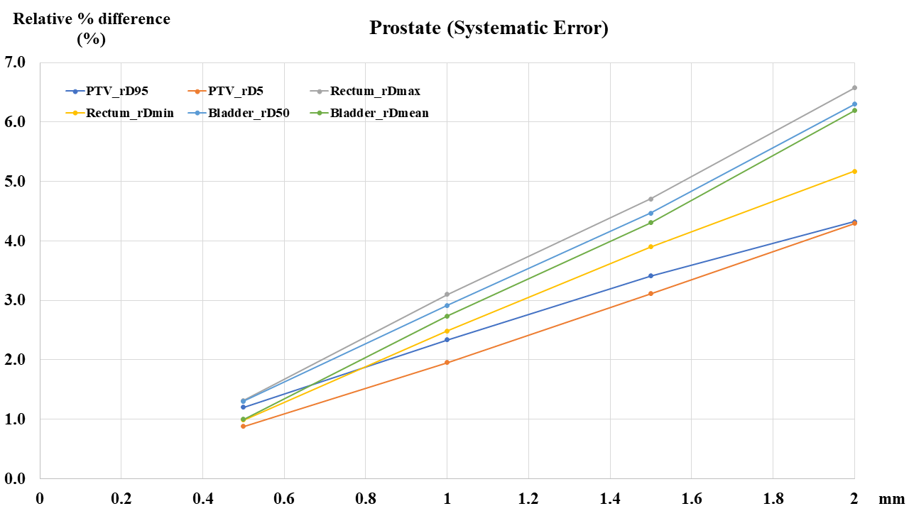

d) Prostate random error
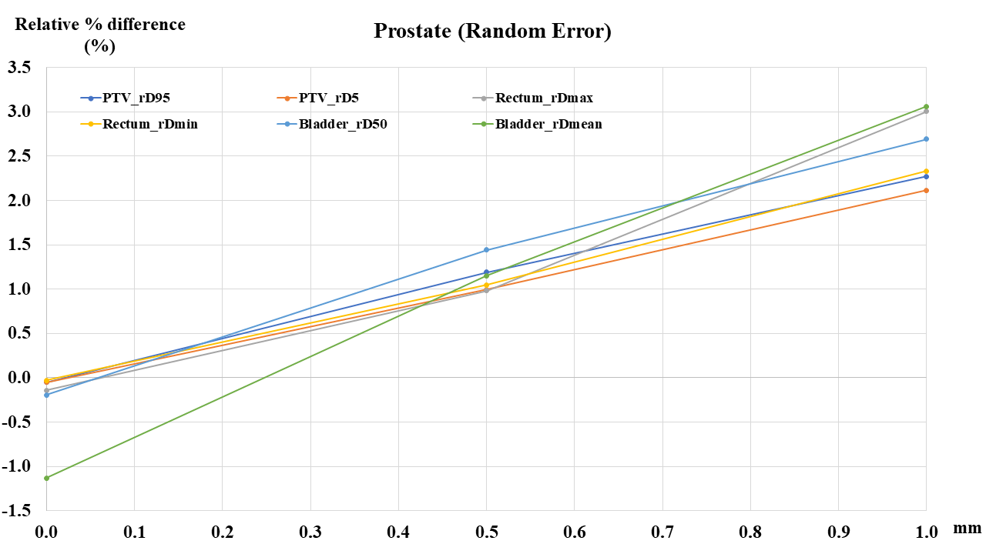
e) C-Shape Easy systematic error
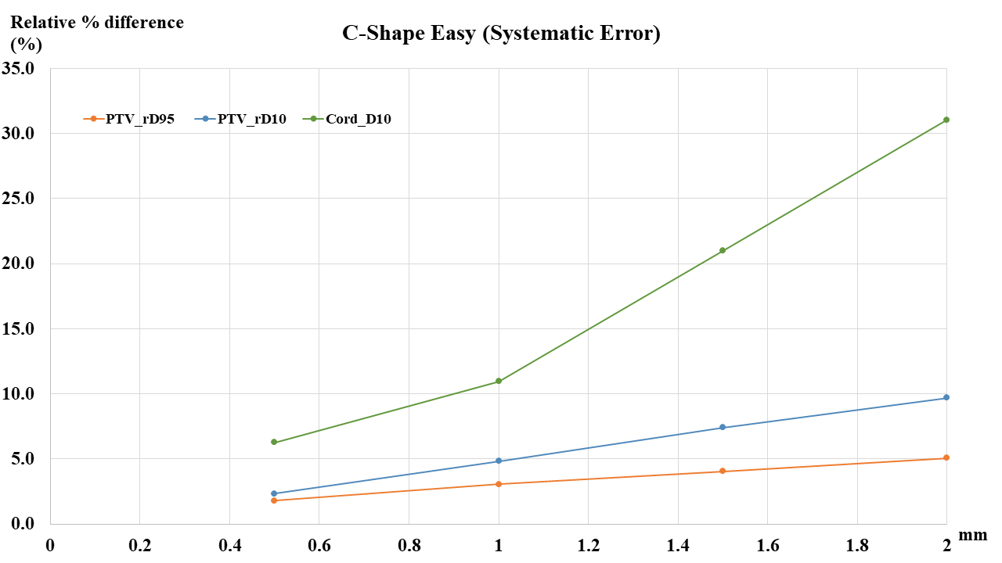

f) C-Shape Easy random error

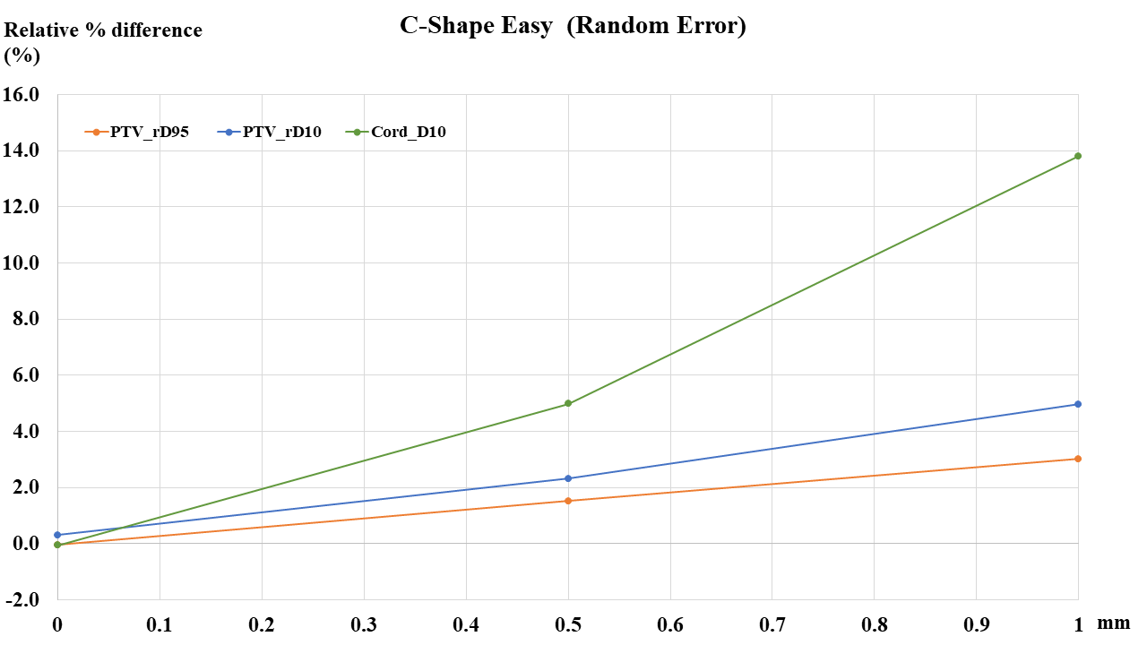

g) C-Shape Hard systematic error

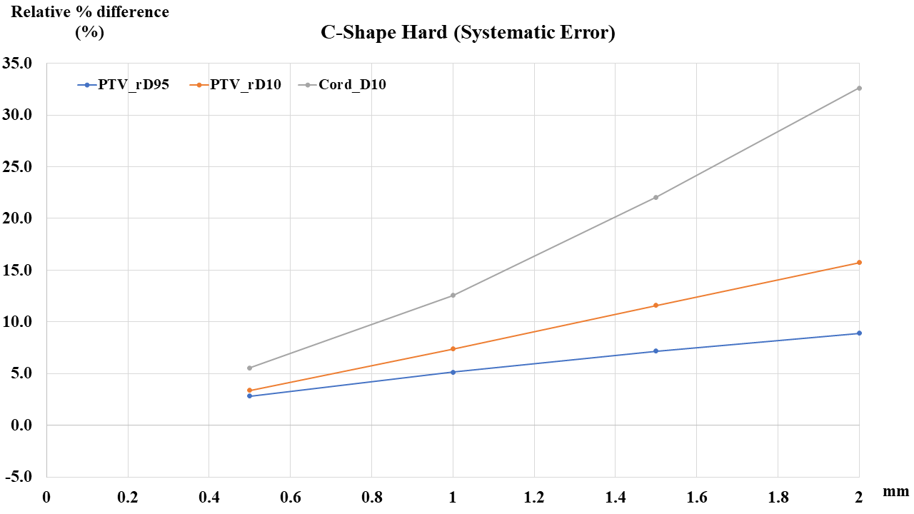

h) C-Shape Hard random error

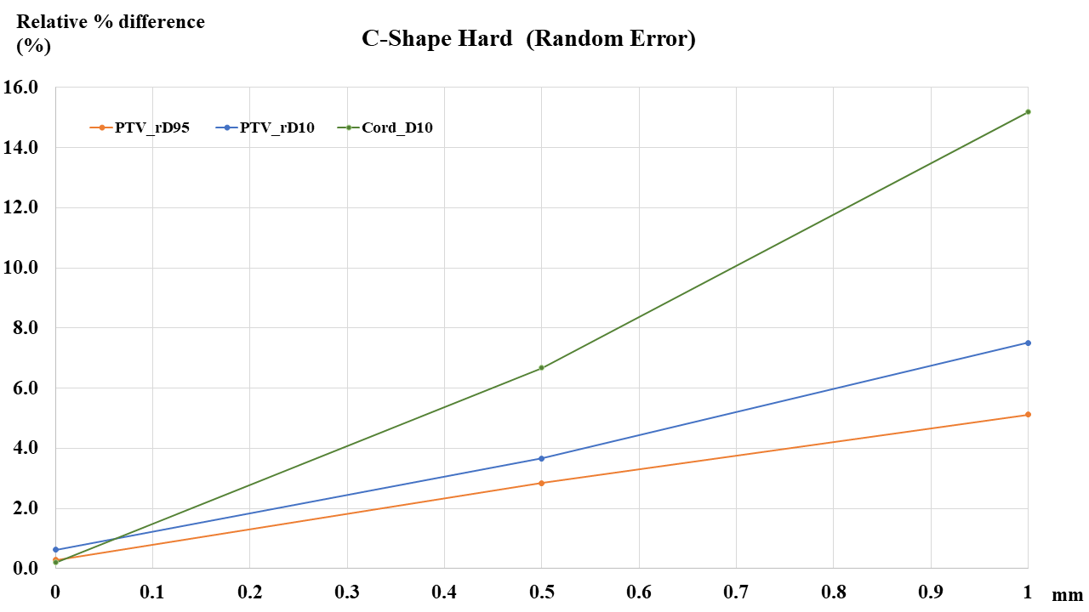

[Supplementary Figure 1] DVH Relative % difference between error-free and error-simulated data
* Unit of x-axis in random error is Gaussian distribution of mean value in random error.

