Supporting information for manuscript

Nano-Encapsulation: Overcoming Conductivity Limitations by Growing MOF Nanoparticles in Meso-Porous Carbon Enables High Electrocatalytic Performance
Krishnamoorthy Sathiyan^{1,†}, Asmita Dutta^{1,†}, Vered Marks¹, Ohad Fleker², Tomer Zidki¹, Richard D. Webster³, Arie Borenstein^{1,}*

Table S1. Electrocatalysis performances of different MOF-based cathodes for CO₂ electroreduction.
Cathode | j, E ª | Electrochemical coverage ^{b} | Main product | Reference
MOF-545 Fe/CB | 1.2, -0.6 | 3 | CO | ¹
Al₂(OH)₂TCCP-Co | 1, -1.7 | 18 | CO | ²
COF-367-Co | 3.3, -0.67 | 2 | CO | ³
MOF-1992/CB | 16.5, -0.63 | 270 | CO | ⁴
Fe-N‐C | 20, -0.8 | 0.11 | CO | ⁵
Fe-TPP | 3, -1.0 | 0.1 | CO | ⁶
Bi₂O₃-carbon | 7.5, -1.0 | N.A. ^{c} | HCOOH | ⁷
Pb | 0.8, -1.6 | N.A. ^{c} | HCOO^{ˉ} | ⁸
Co₃O₄ | 0.75, -0.9 | 0.65 | HCOO^{ˉ} | ⁹
CuPc | 2.8, -1.6 | N.A. ^{c} | C₂H₄ | ¹⁰
Cu₃(BTC)₂ | 6, -1.5 | N.A. ^{c} | CH₄, CH₂O₂ | ¹¹
Cu-C | 2.5, -0.8 | N.A. ^{c} | HCOO^{ˉ}, CH₃OH | ¹²
HKUST-1/carbon | 18, -1.0 | 155 | HCOO^{ˉ} | This work

Table S2. Composition of C 1s, O 1s, Cu 2p obtained from the XPS quantitative analysis.
Catalyst | Atomic %
Catalyst | C 1s | O 1s | Cu 2p
HKUST-1 | 68.47 | 29.25 | 2.28
HKUST-1/C | 91.23 | 8.27 | 0.49
Activated Carbon | 96.02 | 3.98 | -

Table S3. Atomic percentage extracted from the XPS spectra of C 1s, O 1s, and Cu 2p.
Peak | Functional groups | Atomic %
Peak | Functional groups | HKUST-1 | HKUST-1/C | Activated Carbon
C 1s | C-C | 44.18 | 28.38 | 78.79
 | O-C=O | 29.60 | 37.16 | 7.47
 | C=O | 20.88 | 11.20 | -
O 1s | C-O | 53.05 | 24.99 | 51.97
 | O-C=O | 27.43 | 41.58 | 39.23
 | C-OH | 19.48 | 33.43 | -
Cu 2p | Cu ⁺ | 13.89 | 19.09 | -
 | Cu ²⁺ | 86.11 | 80.19 | -

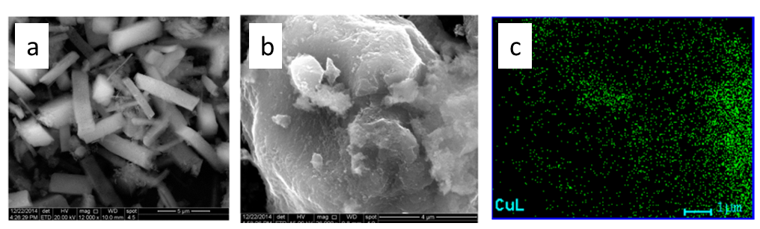
Figure S1. SEM images of pristine HKUST-1 (a), and HKUST-1/carbon composition (b). In the image, a typical activated carbon particle is seen uncovered with only a small amount of MOF sediments on it, proving that the MOF is resent inside the pores and not on the outer surface of the carbon particles. This is also revealed by the corresponding EDX for copper mapping of the same area showing a dispersion of the Cu-based MOF all over the carbon particle. Note: The images of the same material were published in ref. ¹³

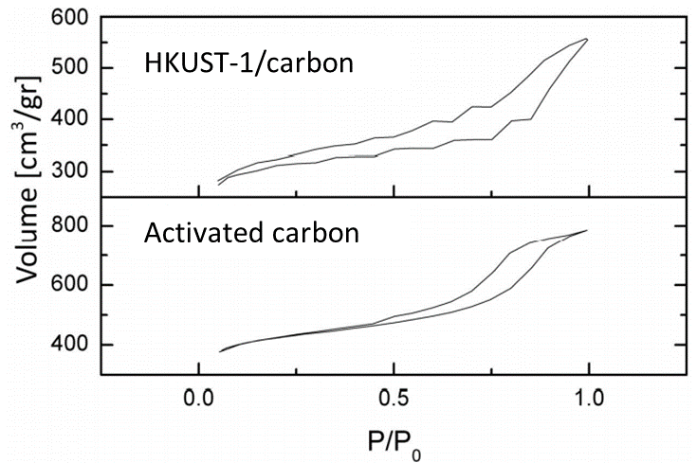
Figure S2. Gas adsorption isotherms for activated carbon and the HKUST-1/carbon composite. Some degree of stepwise behavior is monitored for composite 2, typical for multilayer adsorption on a uniform non-porous surface. Note: The images of the same material were published in ref. ¹³

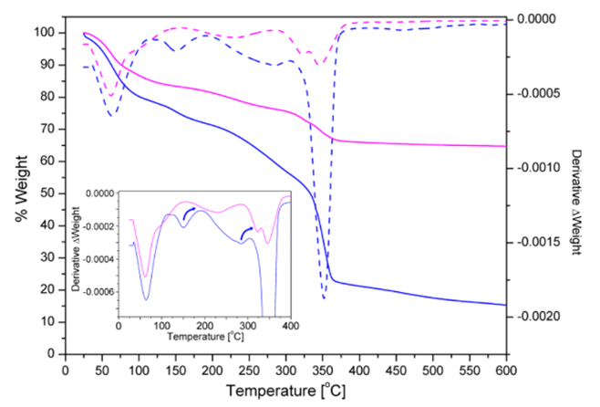
Figure S3. TGA (solid line) of HKUST-1 (blue) and composite 2 (pink) and their corresponding first derivatives (dashed lines). Similar weight loss steps are marked with arrows (inset). The TGA peaks shift toward higher temperatures indicate higher thermal resistivity gained by the stabilization effect of the MOF-carbon interactions. Note: The images of the same material were published in ref. ¹³

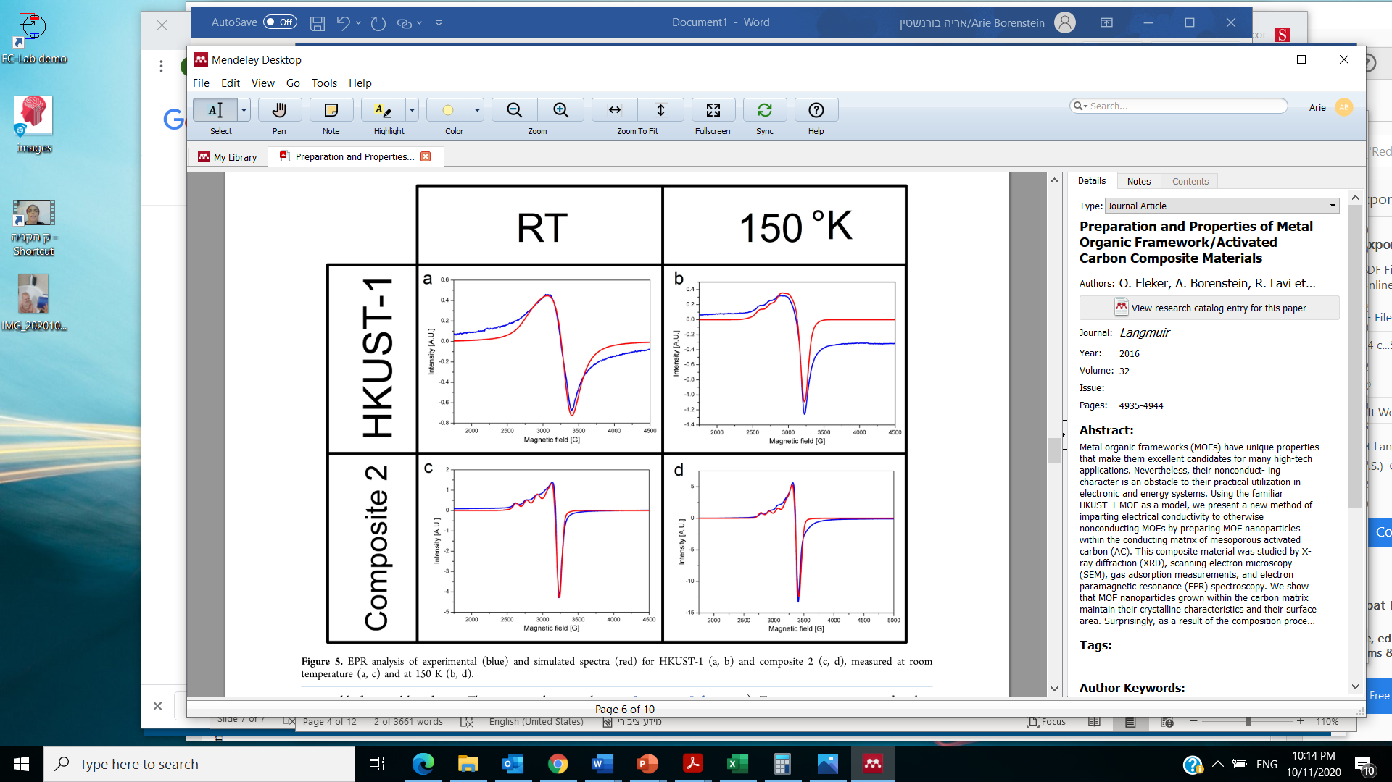
a
b

Figure S4. EPR analysis of experimental (blue) and simulated spectra (red) for HKUST-1 (a) and composite 2 (b), measured at room temperature.

Electron Paramagnetic Resonance.
Paramagnetic Cu(II) species have an electron spin of S = 1/2 and a nuclear spin of I = 3/2 and should have an EPR signal. However, the antiferromagnetic nature of HKUST- 1 caused by its dimeric Cu(II) species and fast relaxation processes due to high local Cu(II) concentrations makes obtaining a clear EPR signal for HKUST-1 difficult at low temperatures. Attempts to obtain a characteristic EPR signal have resulted in only limited success.¹⁴ Figure S4 shows the EPR spectra recorded at room temperature (298 K) for HKUST-1 and the HKUST-1/carbon composite. The CW-EPR measurements for HKUST-1 yielded data consistent with published results, displaying broad convoluted Cu(II) peaks. In contrast, the EPR measurements of the composite produced much more indicative spectra. First, the signals obtained were completely different from those of the bulk HKUST-1 sample. Owing to the spin dilution effect of the AC matrix, the spectrum is much more resolved. Second, shifts in the g_{iso} values as well as in the hyperfine coupling (A values) were revealed. Importantly, the EPR signal of the HKUST-1/carbon composition is significantly different from that of the mixture of AC and HKUST-1. Unlike the EPR signal of the composition, the mixture of AC and HKUST-1 preserves the dual signals of AC and HKUST-1, emphasizing the differences between a homogeneous mixture of MOF and AC (where MOF particles are located outside of AC particles) with respect to the composition where MOF particles are prepared inside the AC porous matrix.
A more detailed analysis of the EPR spectra and their interpolation on the composition product can be found in ref. 1.

Figure S5. XPS Survey spectra of HKUST-1, HKUST-1/C, and Carbon.

In HKUST-1, the Cu²⁺ species seems to dominate over its surface with a minor amount of Cu⁺ species. In HKUST-1/C, the Cu+ content increases, leading to a change in the chemical environment and shifting the binding energy towards a higher value. The Cu 2p peak shows some satellite peaks corresponding to the electronic shake-up, which further supports the presence of Cu²⁺.

Figure S6. Cyclic voltammetry of HKUST-1-carbon cathode in 0.5 M KHCO₃ aqueous solution. Electroactive coverage was calculated by integrating the marked area of the reduction peak.
The electroactive coverage of HKUST-1-carbon was evaluated by applying the formula
𝛤 (mol·cm⁻² ) = Q/ (n × S × F)
where Q is the charge under the reduction wave ( -0.2 V < E < -0.2 V) subtracting the double layer capacitance (marked as dotted trapezoid above the wave), n is the number of electrons involved in the electron transfer (1 e–), S is the geometric surface area of the electrode (1 cm²), and F is Faraday’s constant.

Figure S7. LSV curves of HKUST-1/C at different scan rates in CO₂-saturated 0.5 M KHCO₃ solution.
Figure S8. XRD measurements of HKUST-1/C before and after chronoamperometry stability test. (The peak at 2θ = 26⁰ belongs to carbon from the carbon paper substrate).

Figure S9. H-NMR spectra of the electrolyte solution at potential -0.3 vs RHE and the malonic acid added manually to check the unknown product formed at ~3.0 ppm.

Figure S10. Concentration of Formic acid with different time intervals during chronoamperometric measurement.

Figure S11. Faradaic efficiencies for the CO₂ electroreduction products as a function of potential.

References
1. Dong, B. X. et al. Electrochemical Reduction of CO2 to CO by a Heterogeneous Catalyst of Fe-Porphyrin-Based Metal-Organic Framework. ACS Appl Energy Mater 1, 4662–4669 (2018).
2. Kornienko, N. et al. Metal-Organic Frameworks for Electrocatalytic Reduction of Carbon Dioxide. J Am Chem Soc 137, 14129–14135 (2015).
3. Lin, S. et al. Covalent organic frameworks comprising cobalt porphyrins for catalytic CO2 reduction in water. Science (80- ) 349, 1208–1213 (2015).
4. Matheu, R. et al. Three-Dimensional Phthalocyanine Metal-Catecholates for High Electrochemical Carbon Dioxide Reduction. J Am Chem Soc 141, 17081–17085 (2019).
5. Varela, A. S. et al. Metal-Doped Nitrogenated Carbon as an Efficient Catalyst for Direct CO 2 Electroreduction to CO and Hydrocarbons . Angew Chemie 127, 10908–10912 (2015).
6. Hod, I. et al. Fe-Porphyrin-Based Metal-Organic Framework Films as High-Surface Concentration, Heterogeneous Catalysts for Electrochemical Reduction of CO2. ACS Catal 5, 6302–6309 (2015).
7. Liu, S., Lu, X. F., Xiao, J., Wang, X. & Lou, X. W. Bi2O3 Nanosheets Grown on Multi-Channel Carbon Matrix to Catalyze Efficient CO2 Electroreduction to HCOOH. Angew Chemie - Int Ed 58, 13828–13833 (2019).
8. Innocent, B. et al. Electro-reduction of carbon dioxide to formate on lead electrode in aqueous medium. J Appl Electrochem 39, 227–232 (2009).
9. Gao, S. et al. Ultrathin Co3O4 Layers Realizing Optimized CO2 Electroreduction to Formate. Angew Chemie - Int Ed 55, 698–702 (2016).
10. Kusama, S., Saito, T., Hashiba, H., Sakai, A. & Yotsuhashi, S. Crystalline Copper(II) Phthalocyanine Catalysts for Electrochemical Reduction of Carbon Dioxide in Aqueous Media. ACS Catal 7, 8382–8385 (2017).
11. Qiu, Y. L. et al. Selective Electrochemical Reduction of Carbon Dioxide Using Cu Based Metal Organic Framework for CO2 Capture. ACS Appl Mater Interfaces 10, 2480–2489 (2018).
12. Zhao, K., Liu, Y., Quan, X., Chen, S. & Yu, H. CO 2 Electroreduction at Low Overpotential on Oxide-Derived Cu/Carbons Fabricated from Metal Organic Framework. ACS Appl Mater Interfaces 9, 5302–5311 (2017).
13. Fleker, O. et al. Preparation and Properties of Metal Organic Framework/Activated Carbon Composite Materials. Langmuir 32, 4935–4944 (2016).
14. Gul-E-Noor, F. et al. Formation of mixed metal Cu 3-xZn x(btc) 2 frameworks with different zinc contents: Incorporation of Zn 2+ into the metal-organic framework structure as studied by solid-state NMR. J Phys Chem C 116, 20866–20873 (2012).

