SUPPLEMENTARY FIGURES

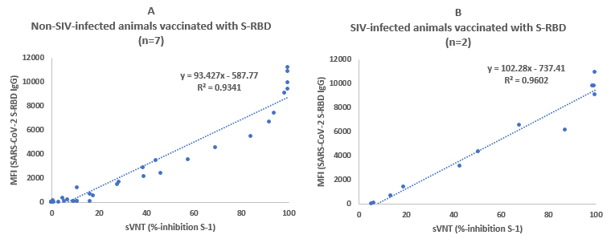
Supplementary Figure S1. Correlations between neutralizing antibody titers and total IgG in adult macaques immunized with adenoviral vector vaccines expressing S-RBD (A) non-SIV infected (n=7) and (B) SIV-infected animals (n=2). % inhibition data obtained using the sVNT assay for SARS-CoV-2 S-1 protein plotted against IgG (MFI values) determined by multiplex assays for the same samples. Longitudinal data for each animal is shown. R² values are shown as an indicator of correlation between the neutralization potency and IgG.

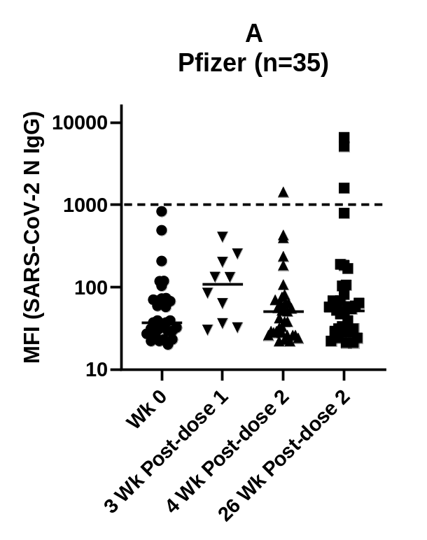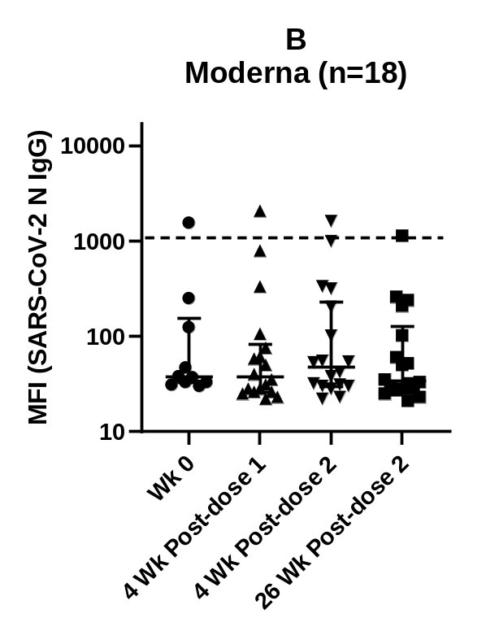
Supplementary Figure S2. Antibodies (IgG) against SARS-CoV-2 S N in humans immunized with mRNA vaccines. A) Pfizer, and B) Moderna (n=18). Description of the multiplex antibody assay is as in Fig. 1. Description of samples is as in Fig 3. The dotted line indicates the assay cut-off level calculated using healthy controls (n=101).

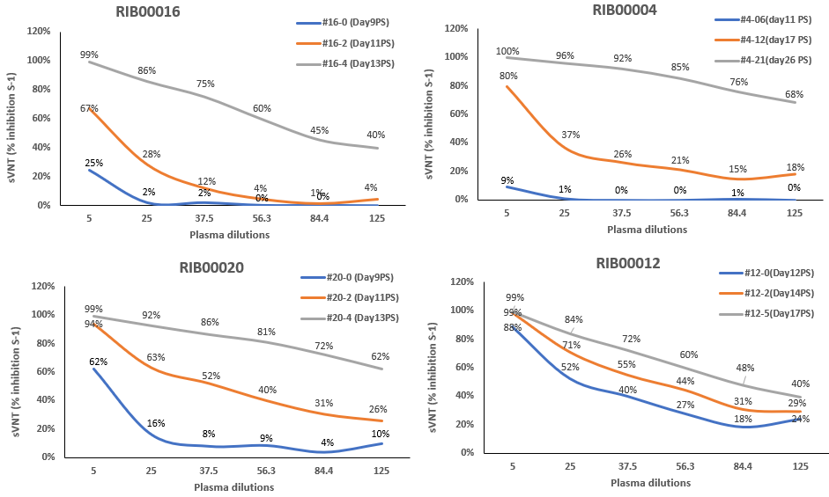

Supplementary Figure S3. Determination of optimal sample dilution for sVNT assay. % inhibition data obtained using the sVNT assay for SARS-CoV-2 S1 protein plotted against the dilution series for patient samples. Four COVID-19 patient plasma samples are shown each at three different time points post-symptoms (PS).

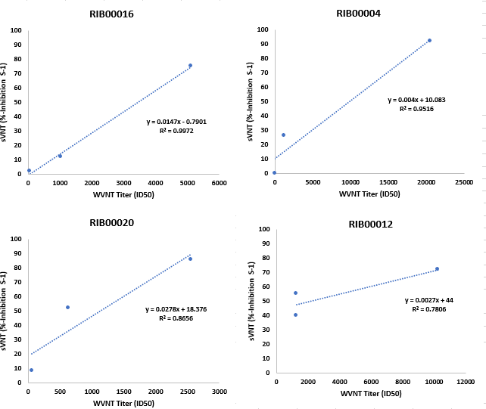
Supplementary Figure S4. Correlation between whole virus neutralization titers (WVNT) ID80 with % inhibition of neutralizing antibodies against SARS-CoV-2 S1 in sVNT assay in human COVID-19 patients. Description of samples is as in Supplementary Fig. S3. R² values are shown as an indicator of correlation between the WVNT and sVNT.

