Supplementary Information

Risk Factors and Geographic Disparities in Premature Cardiovascular Mortality in US Counties: A Machine Learning Approach

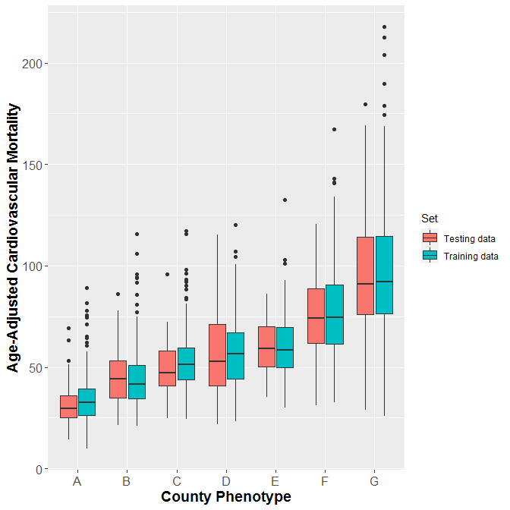

Supplementary Figure S1. Comparisons of premature cardiovascular mortality rates between counties from the training (n=2008) and test (n=501) datasets by county phenotype identified by CART with 200 minimum counties at a terminal node.

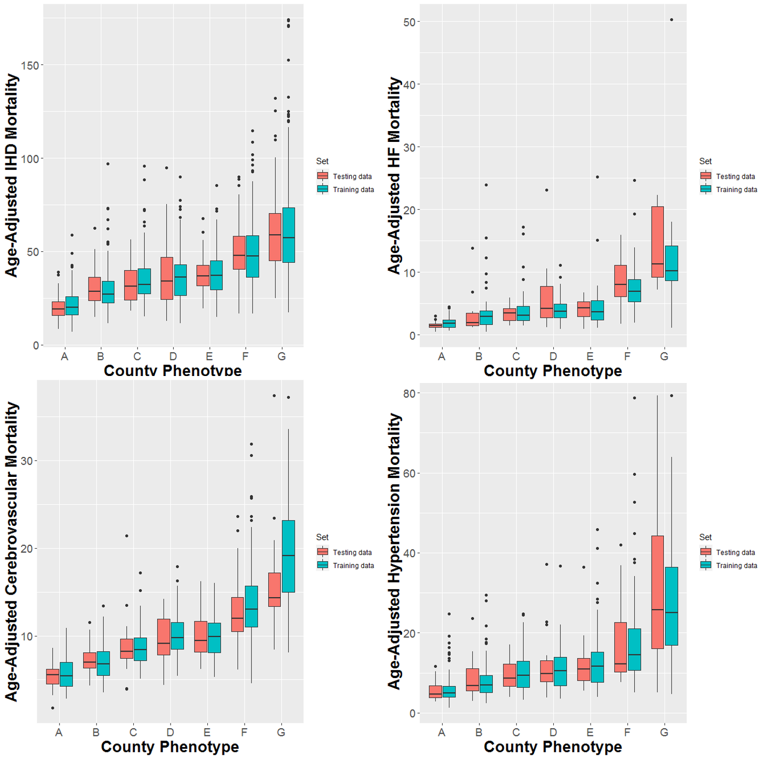

Supplementary Figure S2. Comparisons of subtypes of premature cardiovascular mortality rates between counties from the training (n=2008) and test (n=501) datasets by county phenotype identified by CART with 200 minimum counties at a terminal node.

Supplementary Figure S3. Classification and regression tree analysis (100 minimum counties at a terminal node) to predict county-level premature cardiovascular mortality.
Notes: Each path down to a terminal node represents a county phenotype. Box plots in the terminal nodes represent age-adjusted premature cardiovascular mortality (per 100,000 people).

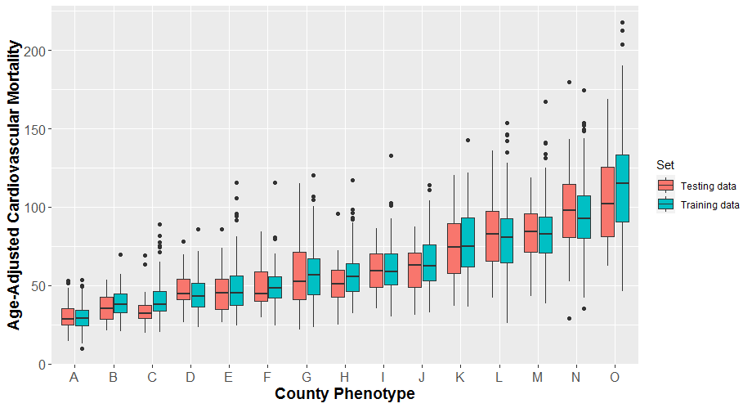
Supplementary Figure S4. Comparisons of premature cardiovascular mortality rates between counties from the training (n=2008) and test (n=501) datasets by county phenotype identified by CART with 100 minimum counties at a terminal node.

Supplementary Figure S5. Scatterplot of observed vs predicted county-level premature cardiovascular mortality rates in the test dataset from the CART model. Notes:
No limitation on the minimum number of counties in the terminal node for the CART model; The correlation coefficient observed vs predicted county-level premature cardiovascular mortality rates in this scatterplot is 0.718.

