Supporting information
Programmable shape-morphing microrobots for localized cancer cells treatment
Chen Xin¹, Dongdong Jin², Yanlei Hu¹, Liang Yang⁴, Rui Li¹,Li Wang³, Zhongguo Ren¹, Dawei Wang¹, Shengyun Ji¹, Kai Hu¹, Deng Pan¹, Hao Wu¹, Wulin Zhu¹, Zuojun Shen³, Yucai Wang³, Jiawen Li¹*, Li Zhang²*, Dong Wu¹*, and Jiaru Chu¹

¹Hefei National Laboratory for Physical Sciences at the Microscale, Key Laboratory of Precision Scientific Instrumentation of Anhui Higher Education Institutes, CAS Key Laboratory of Mechanical Behavior and Design of Materials, Department of Precision Machinery and Precision Instrumentation, University of Science and Technology of China, Hefei 230026, China.

²Department of Mechanical and Automation Engineering, The Chinese University of Hong Kong, Shatin NT, Hong Kong 999077, China

³Intelligent Nanomedicine Institute, The First Aﬃliated Hospital of USTC, Division of Life Sciences and Medicine and Division of Molecular Medicine, the CAS Key Laboratory of Innate Immunity and Chronic Disease, School of Life Sciences, University of Science and Technology of China, Hefei 230026, China

⁴Institute of Nanotechnology Karlsruhe Institute of Technology (KIT), Karlsruhe 76128, Germany

E-mail: dongwu@ustc.edu.cn and lizhang@mae.cuhk.edu.hk and jwl@ustc.edu.cn

 | Shape morphing capability | 3D Structures | Propulsion  mode | Method | Biomedical application
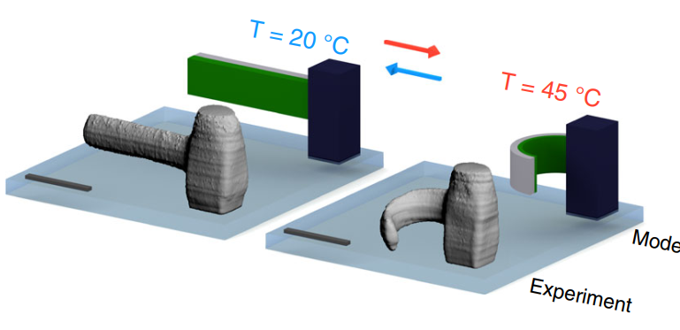  Nature communications, 2019, 10(1): 1-8. | Shape morphing by heat | Single micro cantilever | No | One-step  (direct laser writing) | No
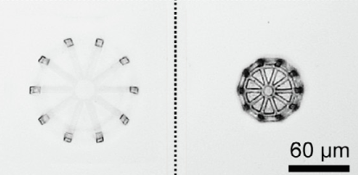  Materials Today, 2020, 32: 19-25. | Shape morphing by pH | 3D structures | No | One-step  (direct laser writing) | No
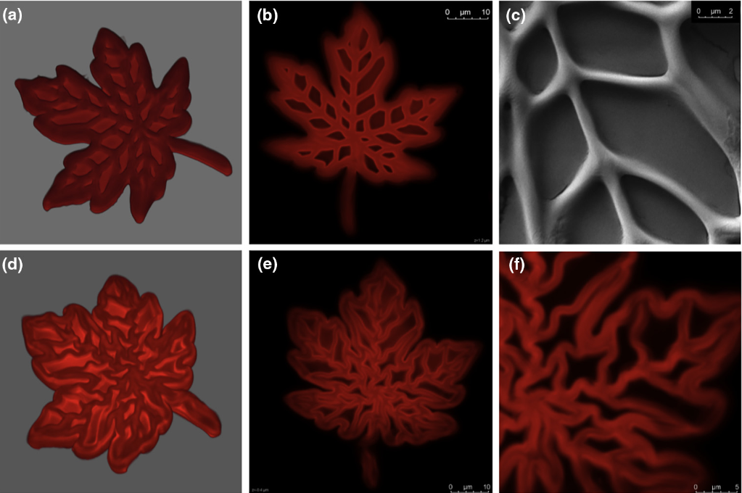  Materials Today, 2018, 21(8): 807-816. | Shape morphing by heat | 3D structures | No | One-step  (direct laser writing) | No
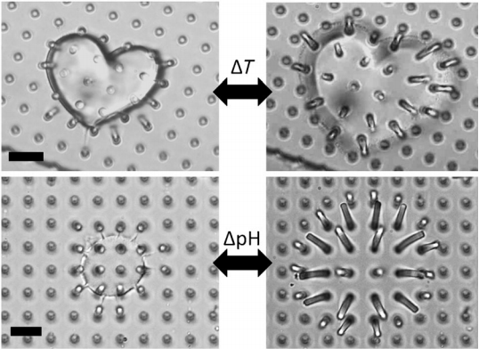  Angewandte Chemie, 2011, 123(40): 9528-9532. | Shape morphing by heat or pH | 2D structures | No | One-step  (direct laser writing) | No
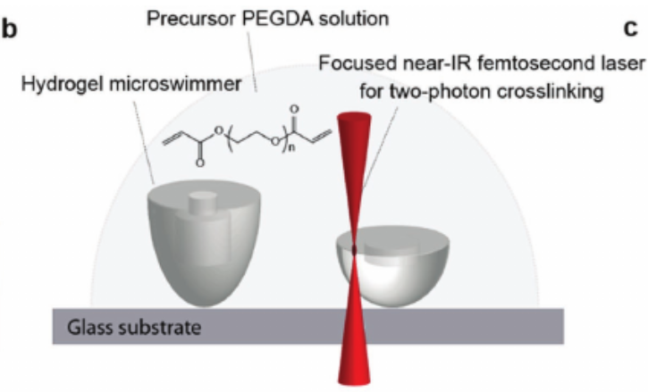  Advanced Materials, 2017, 29(9): 1605072. | No | 3D structures | Single  (bubbles) | One-step  (direct laser writing) | No
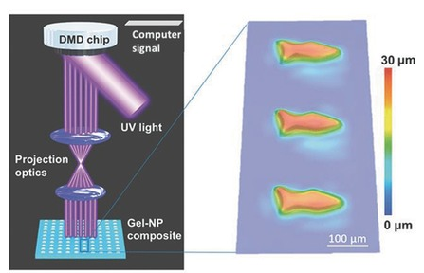  Advanced materials, 2015, 27(30): 4411-4417. | No | 2D microfish (>100 μm) | Hybrid  (bubbles and  magnetic field) | Mask less lithography， | No
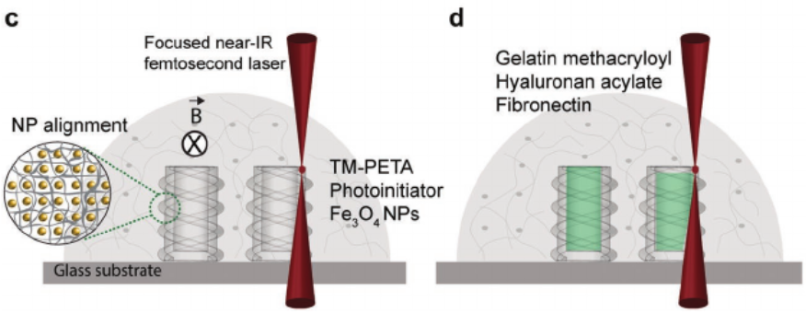  Advanced Functional Materials, 2019, 29(17): 1808992. | No | 3D structures | Single  (magnetic field) | Direct laser writing  (One-step) | Active stem cell delivery
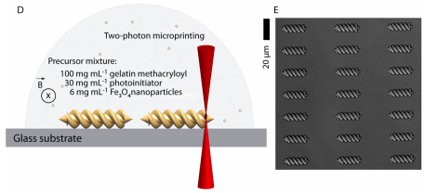ACS nano, 2019, 13(3): 3353-3362. | No | Micro helix | Single  (magnetic field) | Direct laser writing  (One-step) | Theranostic cargo delivery and release  (Enzymatically controlled drug release)
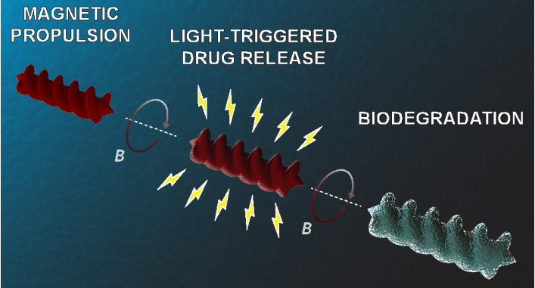  ACS nano, 2018, 12(9): 9617-9625. | No | Micro helix | Single  (magnetic field) | Direct laser writing  (One-step) | No
Microrockets  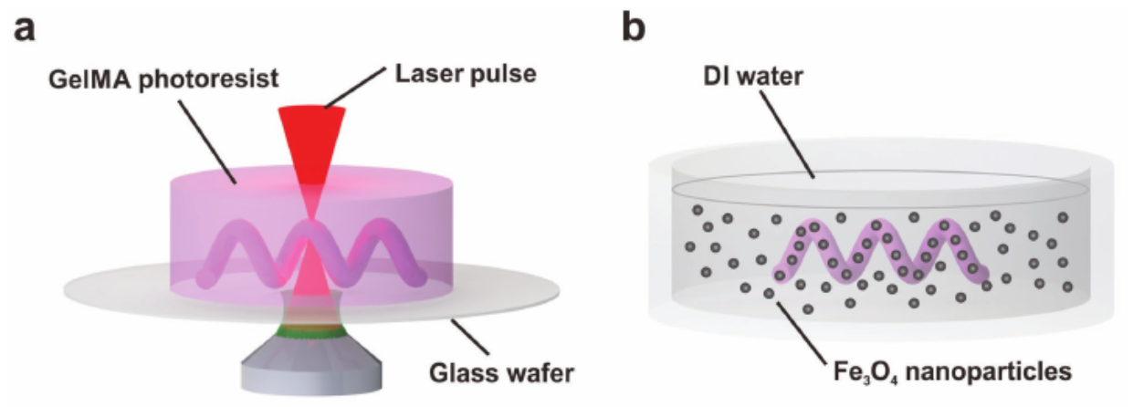  Advanced Functional Materials, 2018, 28(45): 1804107. | No | Simple microhelix | Single  (magnetic field) | Direct laser writing  (One-step) | No
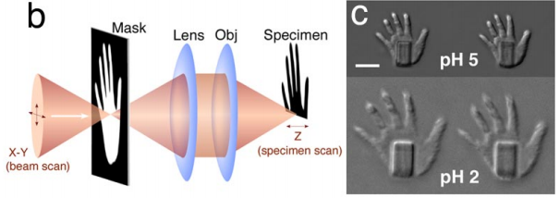  Proceedings of the National Academy of Sciences, 2008, 105(26): 8850-8854. | Shape morphing by pH () | 2D Micro hands | No | Direct laser writing  (One-step) | Dynamic cell enclosures
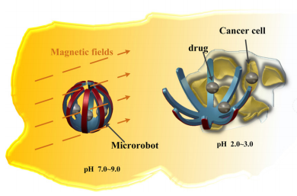  Smart Materials and Structures, 2016, 25(2): 027001. | Shape morphing by pH  (multi-materials) | 2D Micro gripper (>5 mm) | Single  (magnetic field) | 2D multi-steps mask UV lithography | Cells treatment  (risk of drugs leakage)
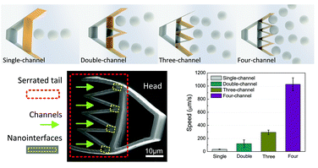  Nanoscale, 2018, 10(42): 19673-19677. | No | 3D structures (>100 μm) | Single  (bubbles) | direct laser writing  (One-step) | Particle manipulation
This work | Shape morphing by one kind of home-made responsive hydrogel | Programmable 3D magnetic microrobots  (~50 μm) | Multiple  (hybrid bubbles and magnetic) | direct laser writing  (One-step) | Drug (DOX) encapsulation/controllable release and  localized Hela cells treatment
Table 1 Capabilities and applications of existing microrobots.

Specific process of 4D laser printing
Firstly, the hydrogel is placed on a 304 °C hot plate for 10 minutes to prevent fluidity. Then, processing is performed using femtosecond laser direct writing technology. The polymer molecular chains at the laser focus are polymerized. The processed sample is immersed in a developing solution (ethanol) for 15 minutes to remove the uncured hydrogel. The developed sample is taken out and placed under an inverted microscope for in-situ observation. In order to avoid the fast evaporation of ethanol, pure water is dripped around the sample. When the NaOH solution is dropped, the sample swells, and then dilute hydrochloric acid is added dropwise to make the sample shrink.
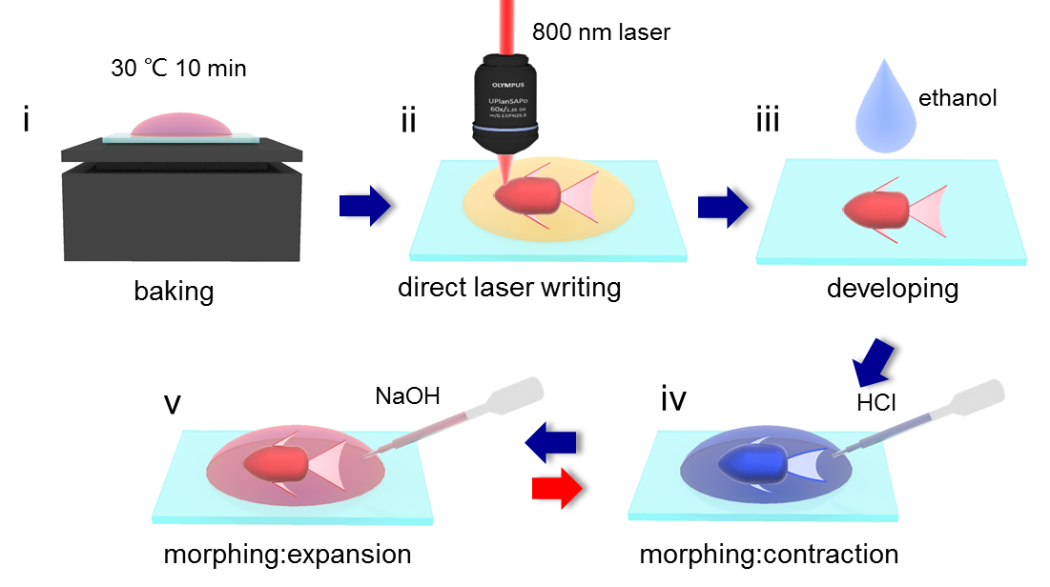
Figure S1 4D laser printing process and shape morphing test.

Scanning path design in 4D printing
Although we add additive materials PVP to enhance the support, scanning path is still important to form complete SMMRs. Particularly, the design of scanning path is crucial to dangling part in SMMRs. Here, we always try to scan along the short side to prevent the structure collapse due to too long length. For example, we show scanning path of a typical microfish tail (Figure S1). The SMMF firstly is scanned along with the short axis X direction, and then is scanned along with the Z direction until the XZ plane is scanned. At last, we scan the SMMF along with the Y axis until the entire structure is completed. If we change the order of scanning direction, delamination of tail occurs until fracture.
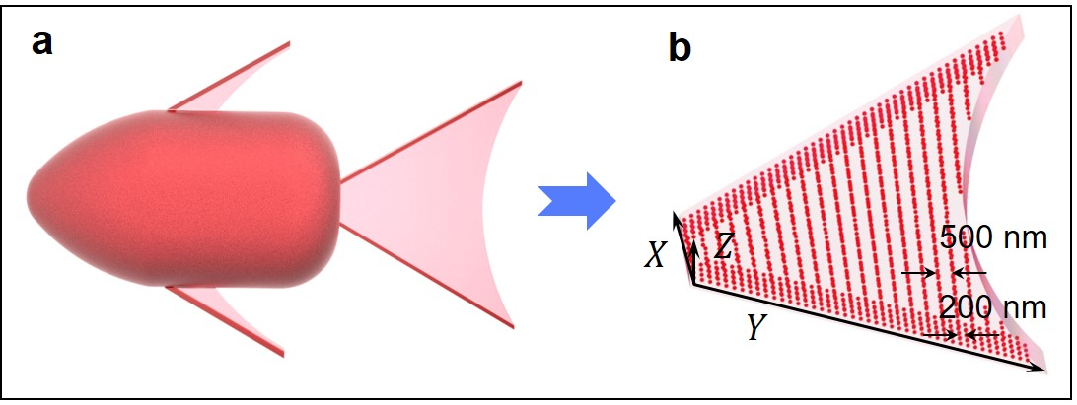
Figure S2 a-b Scanning path of microfish tail follows the order of X, Z, Y direction.

Calculation of nano pore area and porosity by Image J
Porosity is defined as ratio of pore volume to total material volume, which is between 0% and 100%. The material porosity directly represents the density of the material. A high porosity indicates a small degree of compaction. For our pH responsive hydrogel, higher porosity indicates bigger shape morphing. Image J is one of the common software to calculate porosity. Firstly, we reset the scale bar in setting and converting image to 8-bit format. Then, we adjust the threshold to select the pores by software. Finally, we measure the porosity in set measurement.
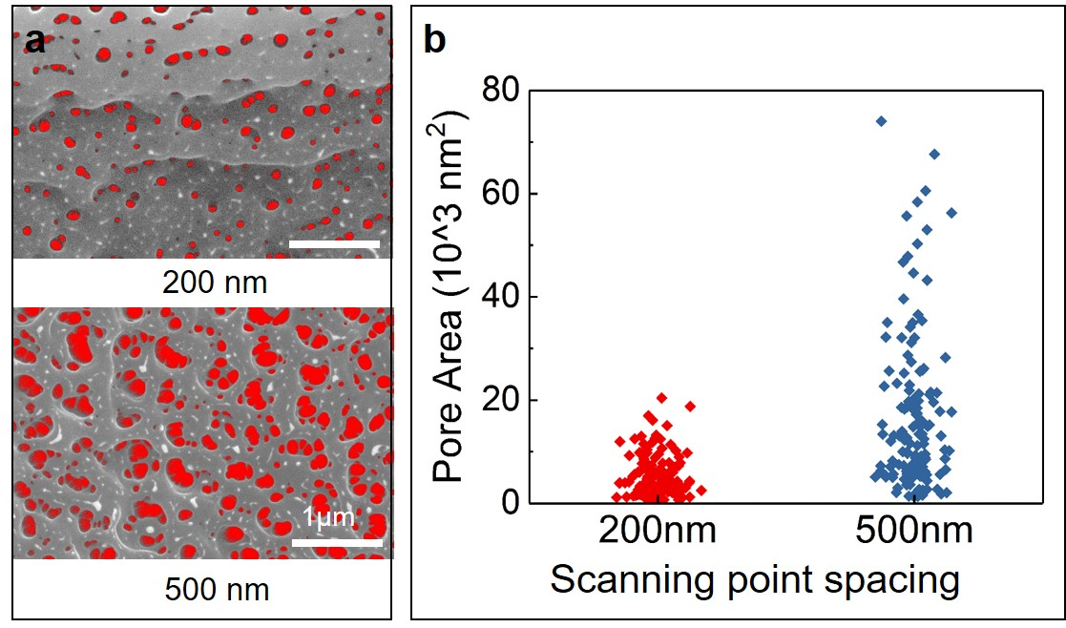
Figure S3 a SEM images of nanopores in shrinking and swelling states after image identification. b Multiple pore areas in different scanning point spacing part (200 nm and 500 nm) corresponding to SEM in a.

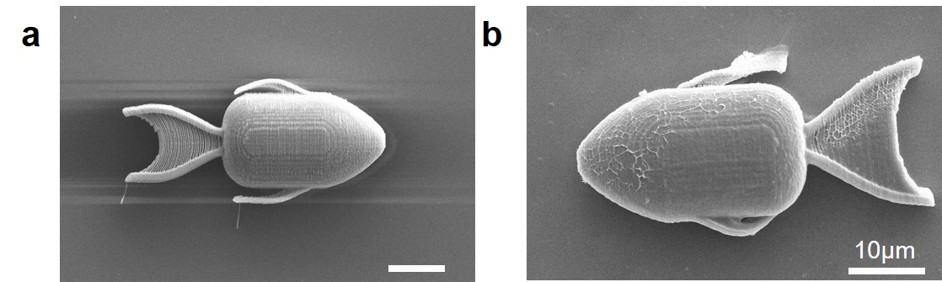
Figure S4 a-b 90° titled SEM images of microfish in shrinking and swelling states after supercritical drying and freeze-drying process, respectively. The width of body increases by less than 10% while the width of tail increases by 85%.

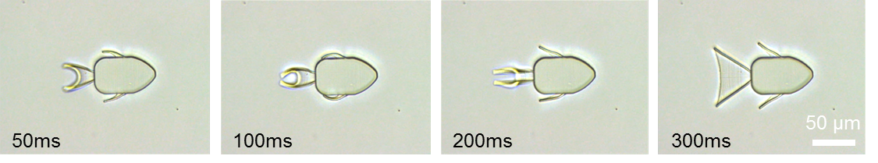
Figure S5 Time-lapse images of SMMF morphing within 300ms.

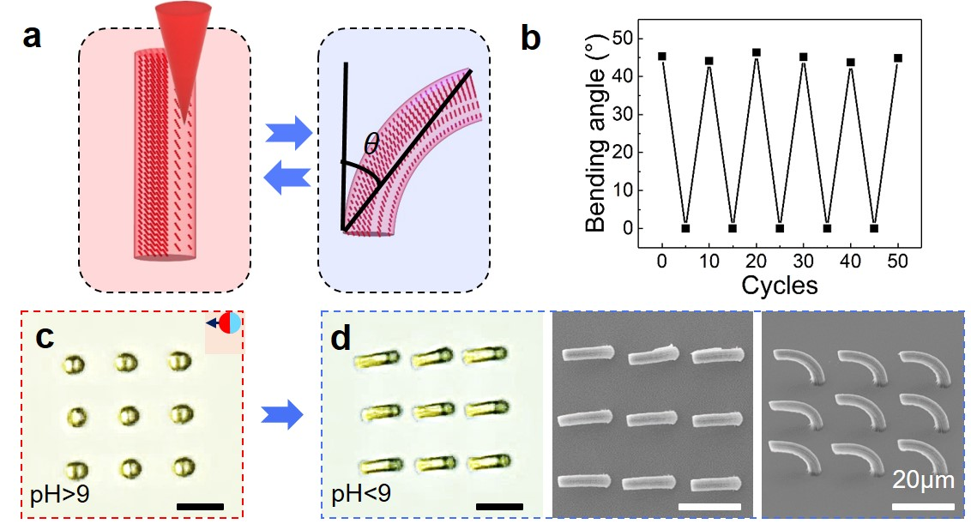
Figure S6 Repeatable shape morphing of microstructures. a Schematic illustration of micropillars with encoding scanning point density. b Stable repetition tests of micropillars between swelling and shrinking over 50 cycles are realized, where θ is the bending angle. c-d represent the corresponding swelling and shrinking states, where SEM images are micropillars in contraction states (90°and 45° titled).

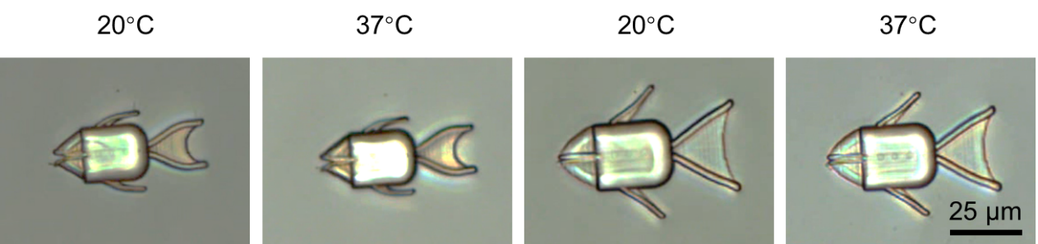
Figure S7 Influence of temperature on the shape morphing of SMMRs under contraction and expansion, respectively.

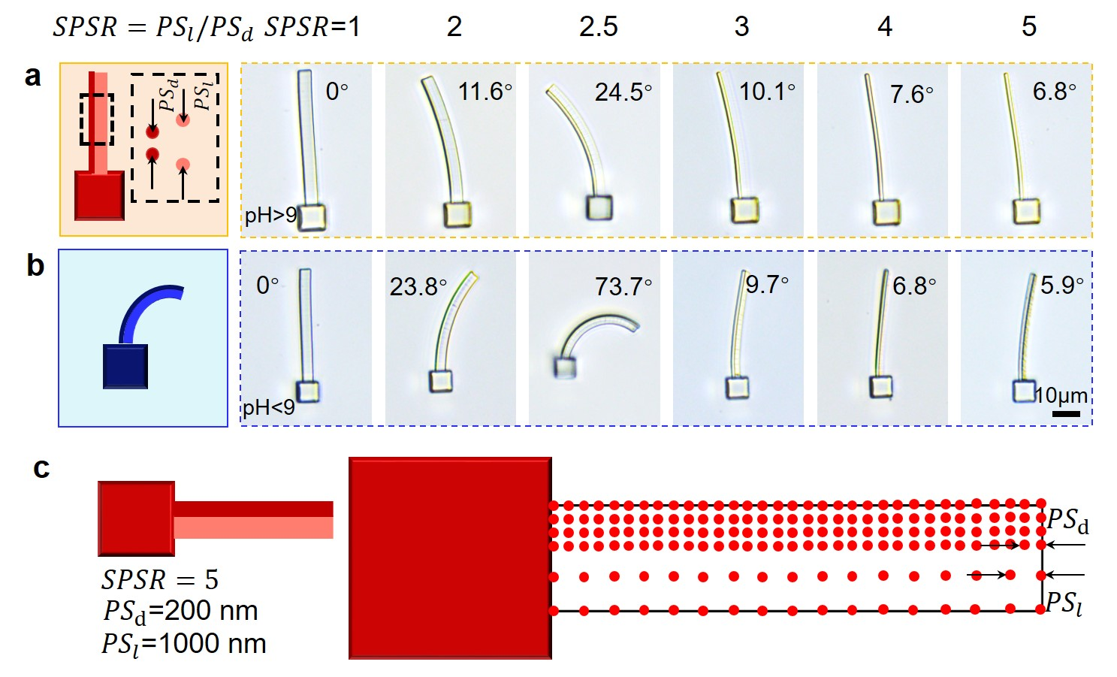
Figure S8 a Microcantilevers with different scanning point spacing ratio (SPSR) are fabricated and corresponding bright field images show swelling cantilever. b Corresponding bright field images show shrinking cantilever. c Adjacent points (${PS}_{l}$=1000 nm) cannot effectively connect together to provide enough shrinkage when the SPSR value is 5.

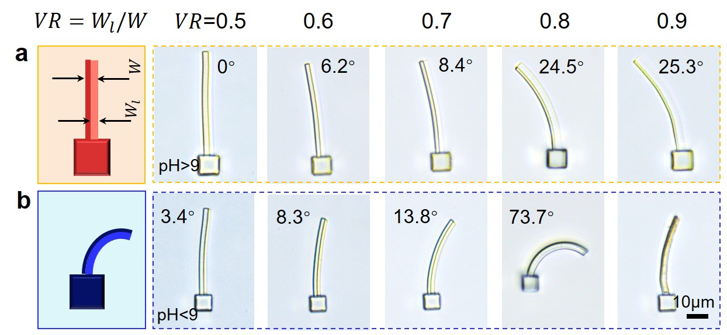
Figure S9 a Microcantilevers with different loose parts to total volume ratio (VR) are fabricated and corresponding bright field images show swelling cantilever. B Corresponding bright field images show shrinking cantilever, where the cantilever with 0.9 VR is destroyed.

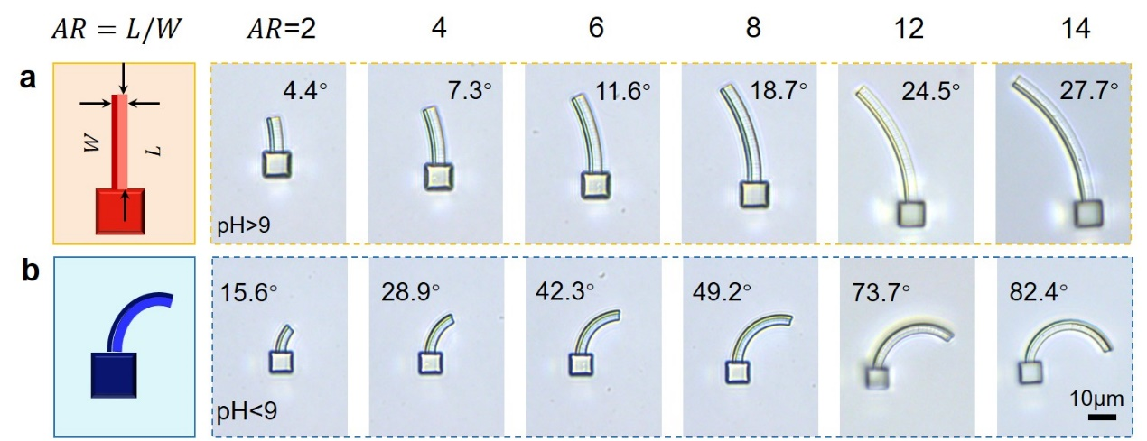
Figure S10 a Microcantilever with different aspect ratio (AR) are fabricated and corresponding bright field images show swelling cantilever. b Corresponding bright field images show shrinking cantilever.

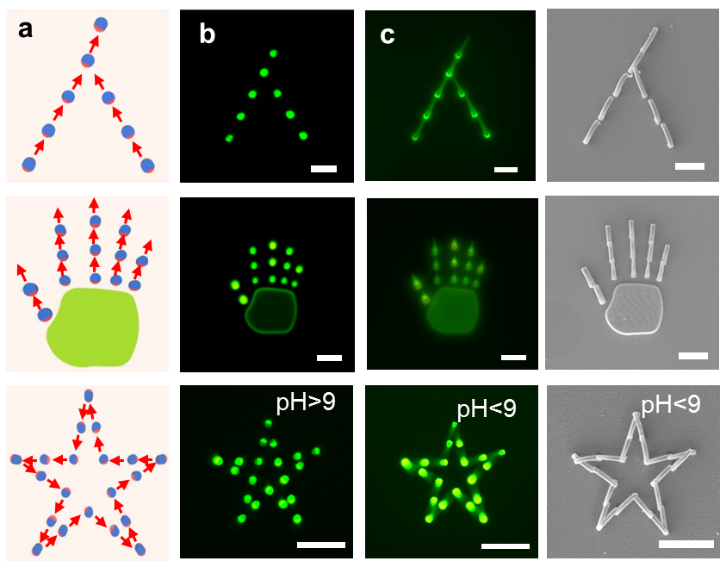
Figure S11 a Schematic illustration of the assembling of complex microstructures. b-c Patterns of Chinese characters “people”, human hand and pentagram separating and assembling with the change of pH value, respectively (Video 4).
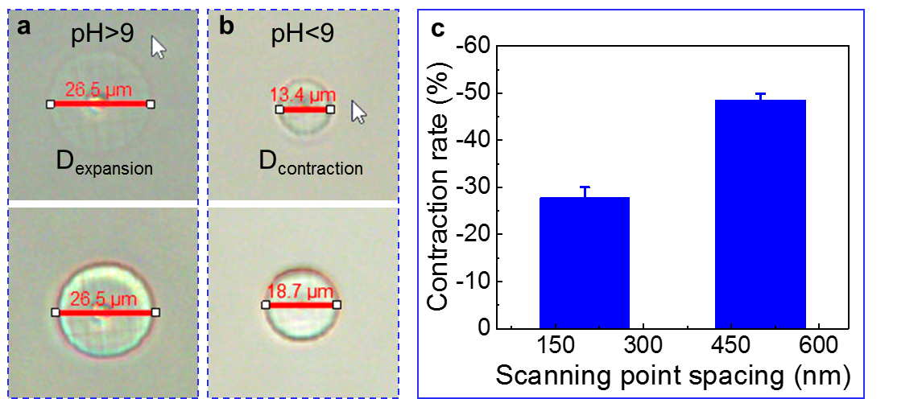Figure S12 a-b Circular plates (PS=500nm and 200nm) expansion and contraction size. c Contraction ratio of mcirocircular plates, which calculated as $αΑ=\frac{D_{constraction}-D_{expansion}}{D_{expansion}}$. D_{expansion} and D_{constaction} are diameters when circular plates swell and shrink.

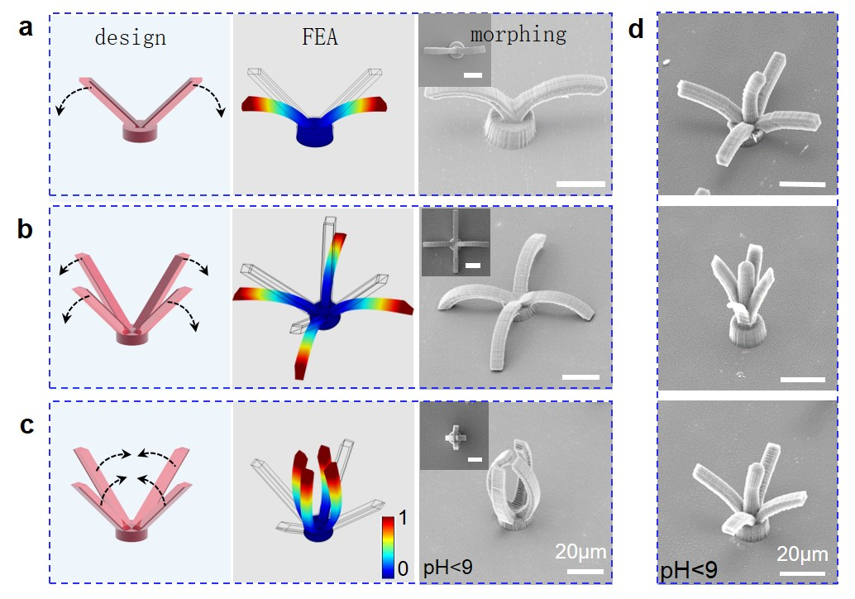
Figure S13 a-c Inward and outward microstructures are realized by designing converse scanning point density, where SEM images are shrinking states corresponding to the designed structures. d Inspired by peeling the banana, different degree of peeling can be demonstrated by designing micro-banana.

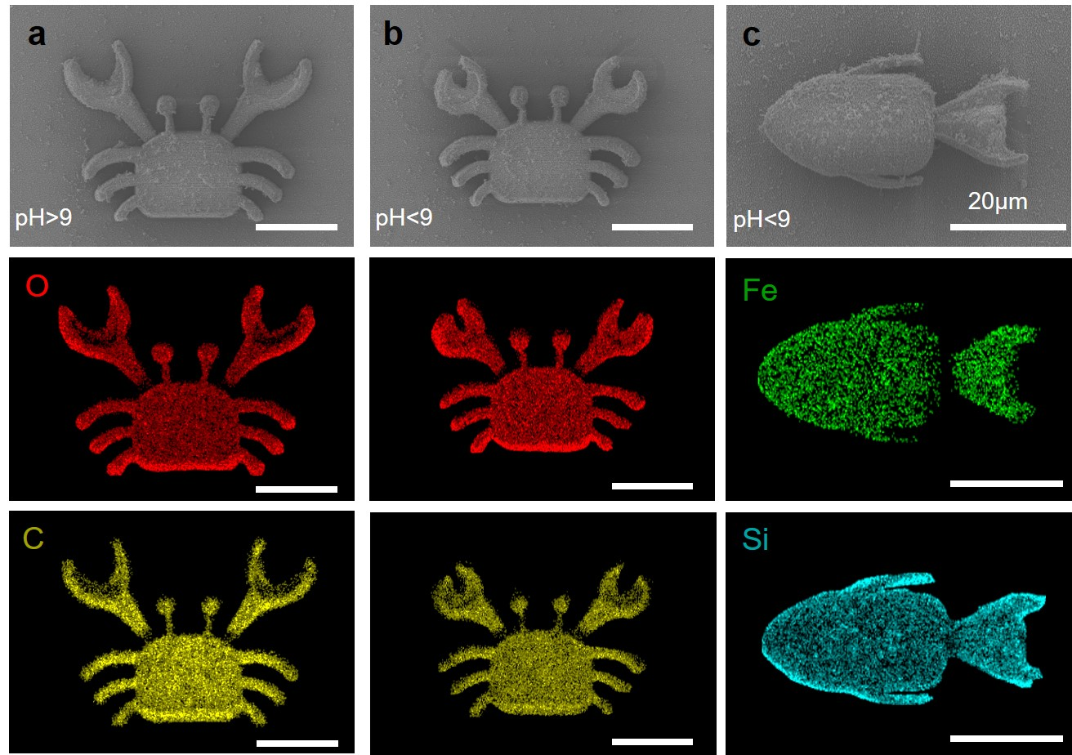
Figure S14 a-b SEM and EDS images show magnetic actuated SMMCs corresponding to swelling and shrinking states. c SEM and EDS images show hybrid actuated SMMFs in shrinking state.

.

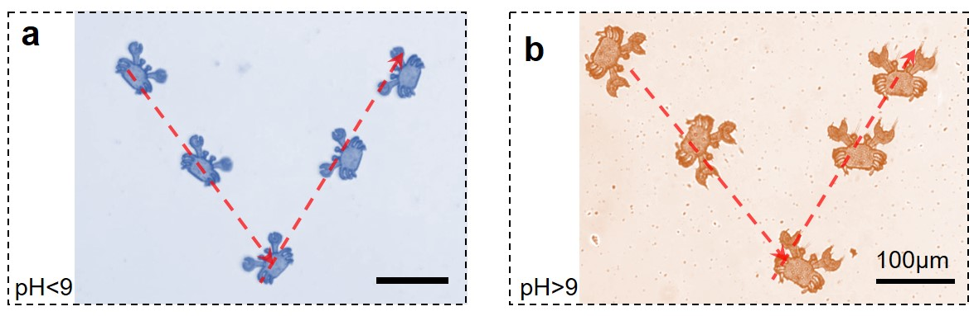
Figure S15 a-b Accurate motions manipulation of the shrinking and swelling microcrab to form “V” patterns are realized by external magnetic field.

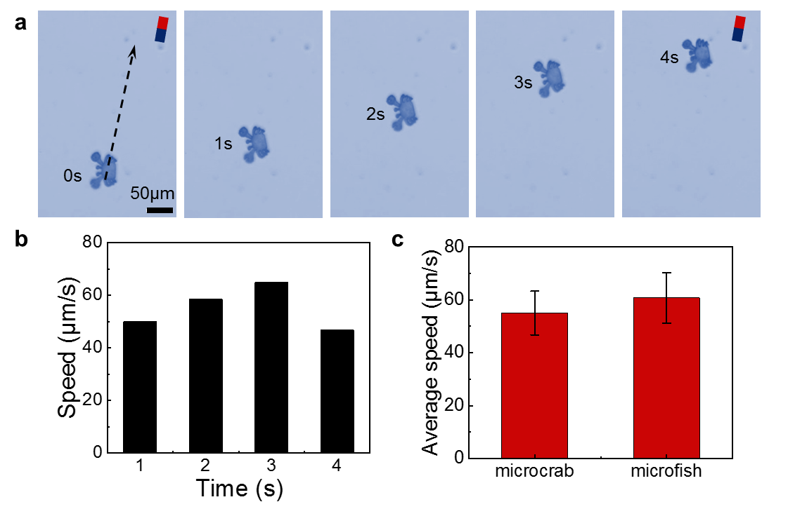
Figure S16 swimming speed test of magnetic propelling SMMRs. a The time-lapse images of magnetic actuated SMMC within 4 s. b Swimming speed of SMMC in each second. c Average speed tests of SMMC and SMMF.

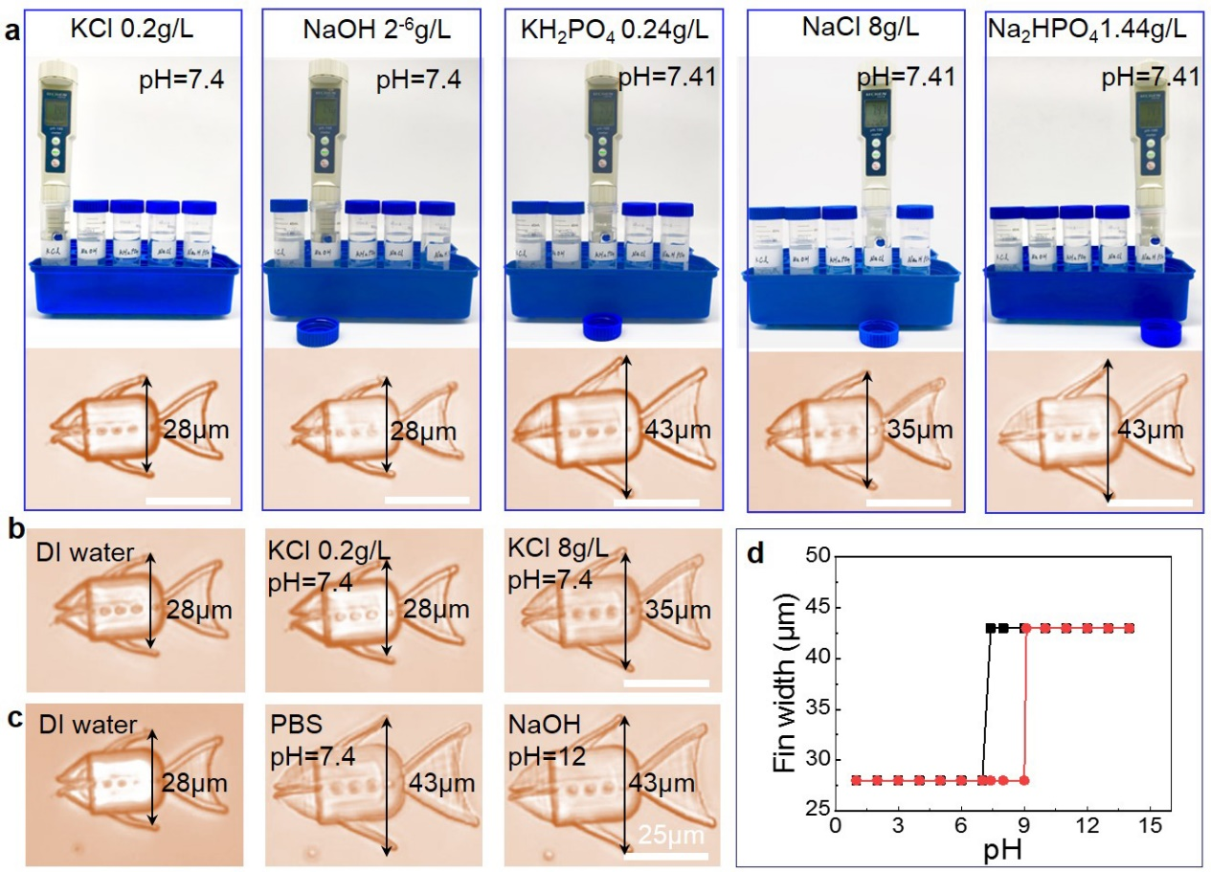Figure S17 Morphing test of SMMR in different solution. a The pH value test of KCl, NaOH, KH₂PO₄, NaCl, and Na₂HPO₄ and the SMMF swells in KH₂PO₄ and Na₂HPO₄ (pH=7.4). b The SMMF shape in DI water, KCl (0.2g/L) and KCl (8g/L). c The SMMF swell in PBS (~7.4) and NaOH (~12), respectively. d The critical shape conversion pH decreases from NaOH(~9) to PBS (=7.4).

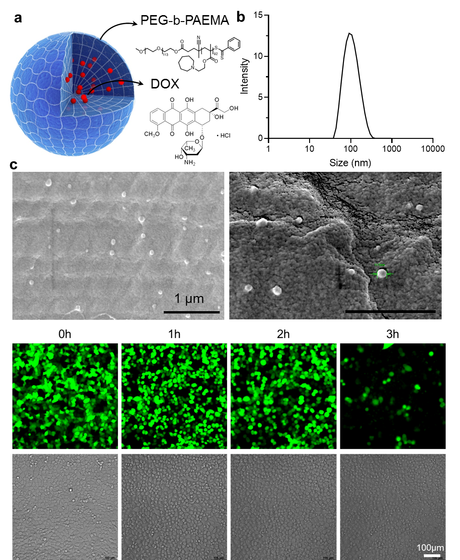
Figure S18 Analysis of nanodrugs. a The main components of drug NPs including PEG-b-PAEMA and DOX molecules. b The size distribution of drug NPs (~120 nm). c SEM images of drug NPs. d the DOX treatment effect test within 3 hours.

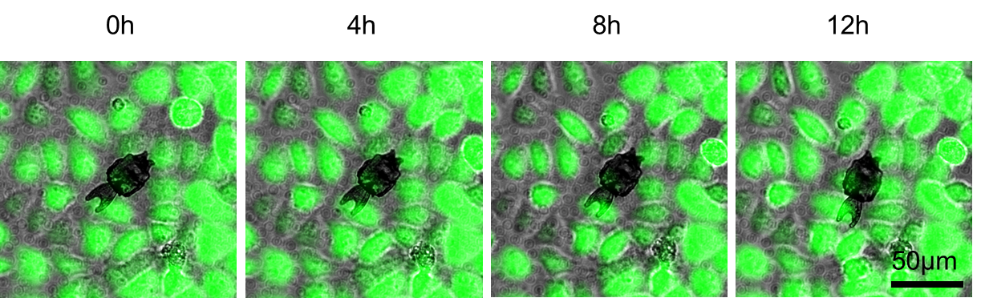
Figure S19 Biocompatible tests of homemade hydrogel.

