Supporting Information
Medicinal Chemistry Research
Synthesis and initial in vitro evaluation of PSMA-targeted ligands with optimized structural motifs
Anastasiia A. Uspenskaya^{a,*,#}, Ekaterina A. Nimenko^{a,#}, Radik R. Shafikov^{a,b,#}, Nikolay Y. Zykª, Sergei A. Evteev^{c}, Natalia S. Dashkovaª, Yan A. Ivanenkov^{a, c, d, e}, Alexander G. Majouga^{a, d, f}, Dmitry A. Skvortsovª, Anastasiia S. Garanina^{d}, Elena K. Beloglazkinaª, , Aleksei E. Machulkinª
a. Lomonosov Moscow State University, Chemistry Dept., Leninskie Gory, Building 1/3, GSP-1, Moscow, 119991, Russian Federation
b. Shemyakin and Ovchinnikov Institute of Bioorganic Chemistry Russian Academy of Sciences, GSP-7, Ulitsa Miklukho-Maklaya, 16/10, Moscow, 117997, Russian Federation.
c. The Federal State Unitary Enterprise Dukhov Automatics Research Institute, st. Sushchevskaya, 22, Moscow, 127055, Russia
d. National University of Science and Technology «MISiS», Leninskiy Prospekt, 4, Moscow, 119049, Russia
e. Institute of Biochemistry and Genetics Ufa Science Centre Russian Academy of Sciences (IBG RAS), Oktyabrya Prospekt 71, Ufa, 450054, Russian Federation
f. Dmitry Mendeleev University of Chemical Technology of Russia, Miusskaya Sq. 9, Moscow, 125047, Russian Federation
* Corresponding author, uspenskaya.n@gmail.com
# - equial contribution

Synthesis
The synthesis strategy was taken from earlier research in our research group^{1,2}. In the syntheses, Boc-protection was chosen because the removal of this group occurs at the last stage of the synthesis in an acidic conditions³. An intermediate of activated phenylalanine ester was initially obtained using the reagent system EDC-HCl (N-(3-dimethylaminopropyl)-N'-ethylcarbodiimyl hydrochloride) and PfpOH. This intermediate is highly reactive with respect to the amino group and is resistant to standard organic synthesis procedures. Its subsequent interaction with a free amino acid in the presence of the DIPEA synthesized dipeptide fragment.
The carboxyl group of compounds 1S was repeatedly activated by the agents HOBt and HBTU followed by interaction with azidopropylamine for 24 hours at room temperature in dimethylformamide. Boc-deprotection was performed by the action of a 10% solution of trifluoroacetic acid in anhydrous dichloromethane (Scheme S1).

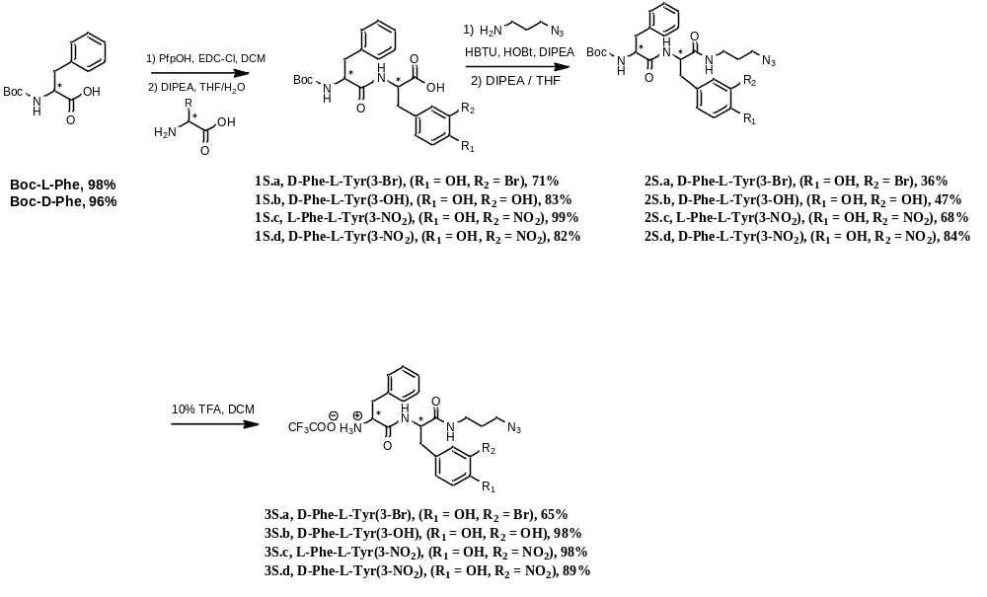
Scheme S1. Dipeptide chain synthesis
The modified vector molecule DCL and the obtained dipeptides 3S were reacted with the activating reagents HBTU/HOBt and DIPEA (Scheme S2). The obtained ligands require free carboxyl groups to bind to PSMA⁴. The conversion of tert-butyl esters to carboxylic acids was performed in the following solution: 46.25% TFA, 46.25% DCM, 5% water, and 2.5% TIPS
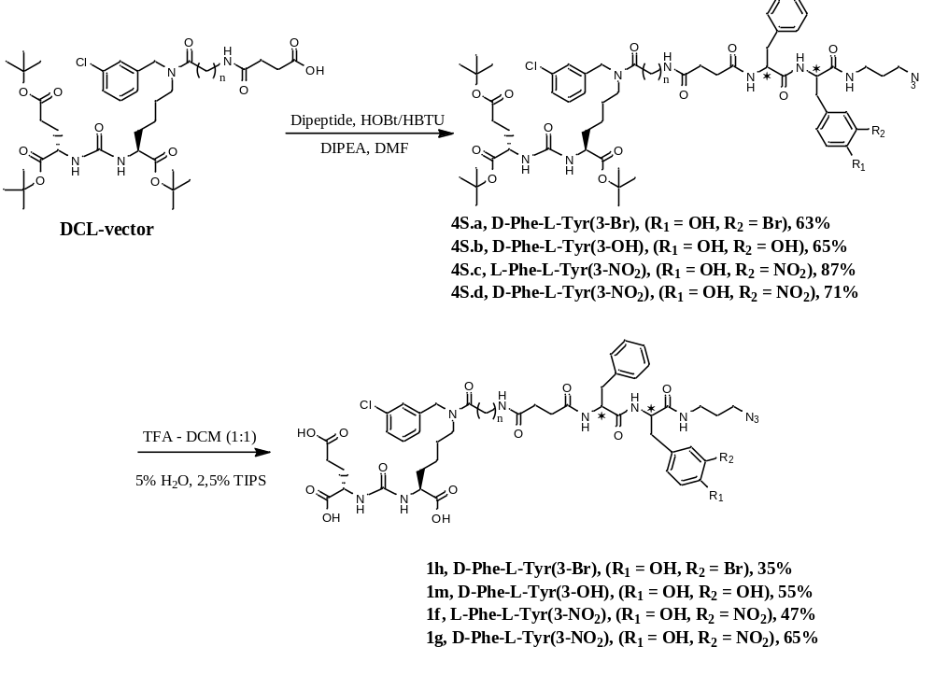
Scheme S2. Synthesis of ligands in the liquid phase.

When trying to introduce the amino acid tyrosine from the N-terminus of the dipeptide by liquid-phase synthesis methods, several difficulties were found. First, the poor solubility of tyrosine in aprotonic solvents, which led to a significant decrease in the yield at the stage of the Boc-group production. Second, difficulties arose at the subsequent stage of dipeptide production due to an increasing number of side reactions. This is due to the fact that in the structure of tyrosine. The hydroxyl group in the para-position enters into side reactions. As a result, the yield of the reaction in this method fell below 20%, which is highly unsatisfactory and makes it impossible to use it in the future. The variant with prior protection of the hydroxyl group of tyrosine implies an increase in the number of stages and complication of the purification of the obtained compounds.
As a result, the solid-phase method of synthesis was taken. This approach is easy to perform and has a number of advantages, such as high selectivity of the reactions, absence of racemization (if the solid-phase carrier is chosen correctly), fast reactions, which allows to "assemble" the desired structure within a short time (up to several hours)⁵.
In this work, 2-chlorothylic resin in chloride form (2-CTC) was chosen as a solid-phase carrier. This type of resin for peptide synthesis is very convenient to use because it prevents the racemization of C-terminus amino acid residues and implies the possibility of using a wide variety of side chains. It is also important to note the conditions of removal of the obtained chains from the resin^{6,7}. The weakly acidic conditions (0.5% trifluoroacetic acid solution in dichloromethane) allow us to preserve the tert-butyl protecting groups present in the structure of both the vector molecule and the linker structure (Scheme S3-S4).
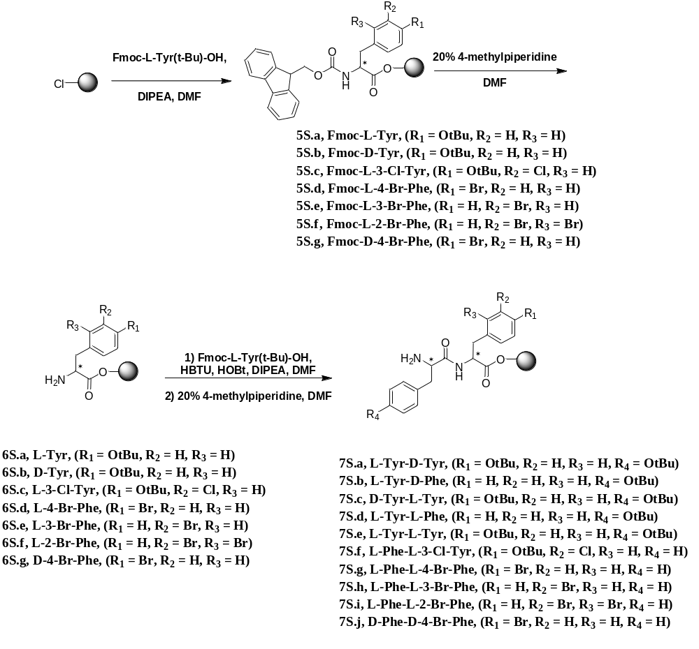
Scheme S3. Synthesis of Tyr/Phe dipeptide chains by solid-phase synthesis methods
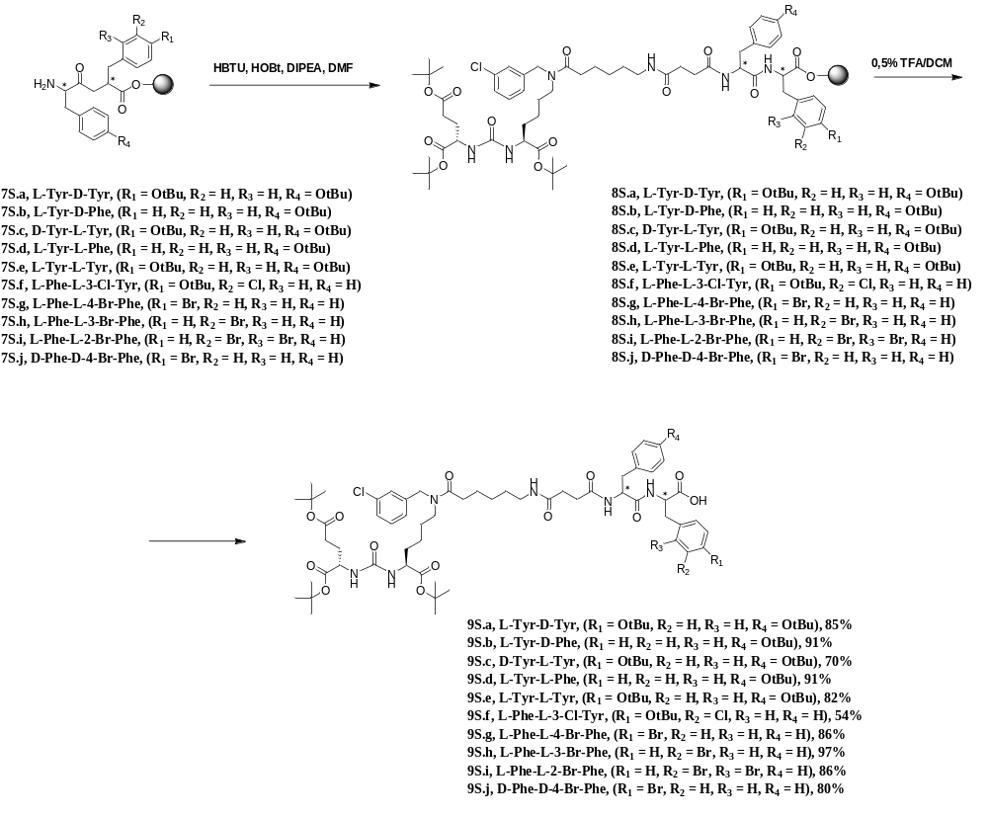
Scheme S4. Synthesis of ligands by solid-phase synthesis methods
Since the azide-alkyne cycloaddition requires a free azide group in the ligand structure, the next step in the synthesis is the reaction with 3-aminopropylazide (Scheme S5). In order to avoid racemization and minimize the number of byproducts as much as possible, it is important to consider the order of mixing of the reagents. Aminopropylazide, HOBt, HBTU, and DIPEA are sequentially added to the ligand solution in dimethylformamide. The reaction is performed without pre-activation and at a reduced temperature (0 °C).⁸
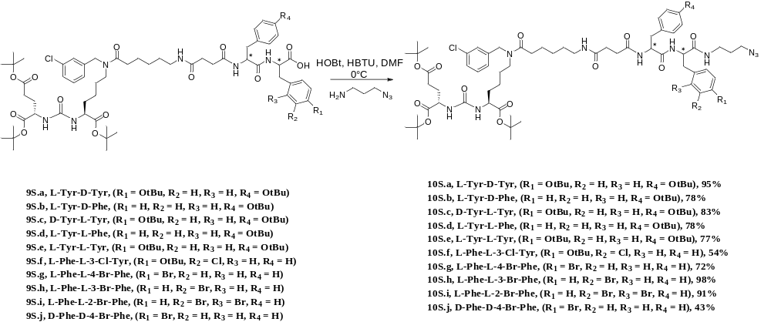
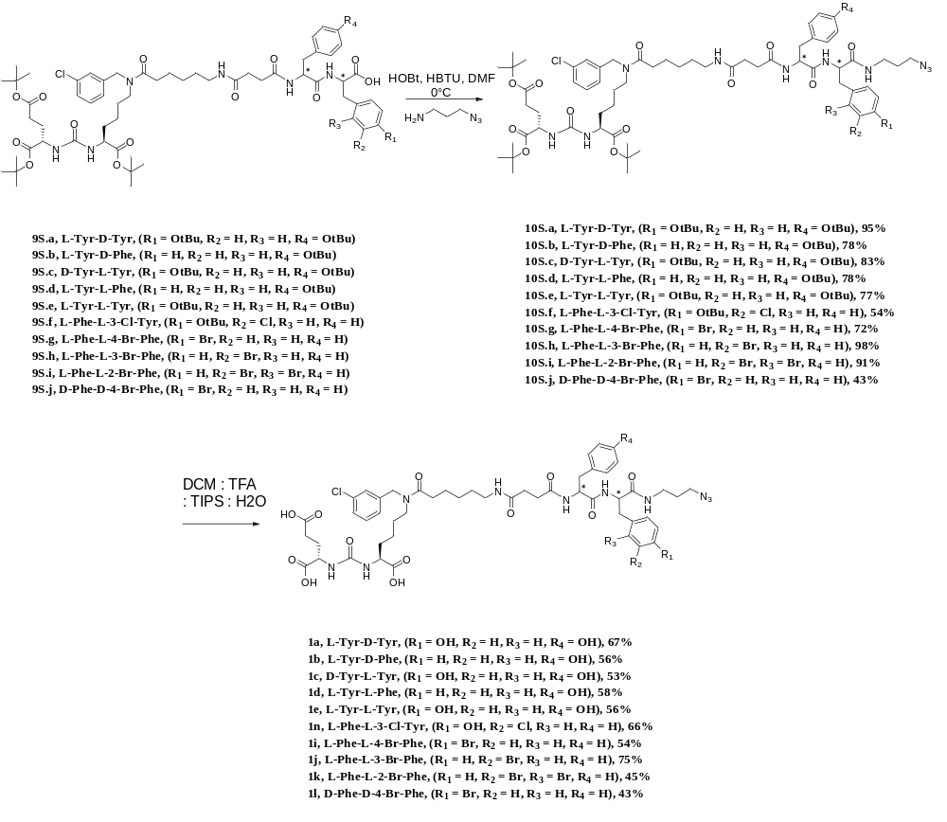
Scheme S5. Synthesis of ligands
The final removal of the tert-butyl protecting groups was performed as described above using a mixture of 46.25% TFA, 46.25% DCM, 5% water, and 2.5% TIPS, in liquid-phase ligand synthesis methods.
The azide-alkyl cycloaddition reaction catalyzed by copper (I) salts has many advantages, such as: high selectivity of the affected groups, good reaction yields.^{9,10}

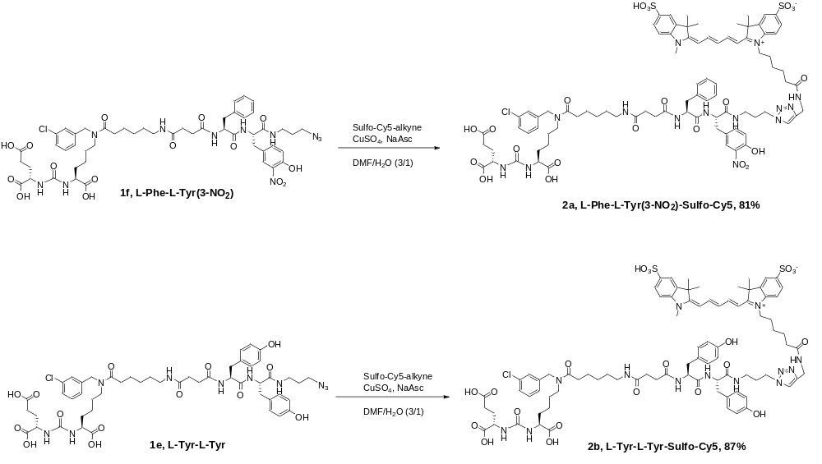
Similarly, the therapeutic conjugate was obtained.¹¹
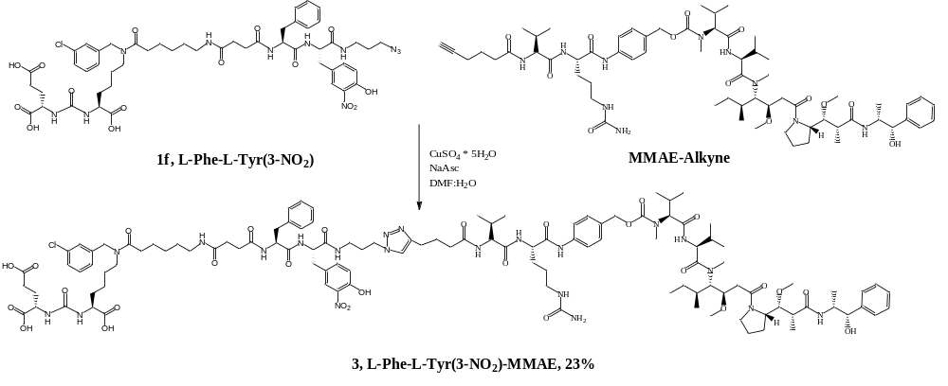
Characterization
Conventional ¹Н and ¹³С NMR spectra were registered on a Bruker Avance 400 spectrometer (400 MHz for ¹H and 101 MHz for ¹³C) in CDCl₃ or DMSO-d₆. Preparative column chromatography was performed on an INTERCHIM puriFlash 430. For analysis of samples, we used a Shimadzu Prominence LC-20 system with a Phenomenex Luna C18 100A (150 x 4.6 mm) column in a column oven at 40ºC and a fraction collector coupled to single quadrupole mass spectrometer Shimadzu LCMS-2020 with a dual DUIS-ESI-APCI ionization source. The mobile phases were A – 0.1% formic acid in water, B – 10 mM ammonium formate in water, and D – acetonitrile. The liquid chromatography (LC) parameters for analysis were a gradient flow of 1 ml/min (0–0.5 min with 5% D, 0.5–10.5 min with 5% to 100% D, 10.5–12 min with 100% D, 12–14.5 min with 100% to 5% D). The MS parameters were drying gas 15.0 L/min, nebulizing gas 1.5 L/min, desolvation line temperature 250ºC, heat block temperature 400ºC, interface voltage -3.5 kV, and corona needle voltage -3.5 kV. Positive ions (mass range 250–2000 Da, in some cases 155–2000 Da) and negative ions (mass range 100–2000 Da) were registered simultaneously. LC-MS method was used to determine the purity of synthesized ligands and conjugates, purity of all compounds investigated in vitro and/or in vivo were ≥95%. LCMS results presented as three chromatograms: top - base peak chromatogram of the sample; middle - extracted-ion chromatogram of the targeted ion; bottom - base peak chromatogram of a blank sample. High-resolution mass spectra (HR-MS) were registered on an Orbitrap Elite mass spectrometer (Thermo Scientific) with an ESI ionization source. Compounds with a concentration of 0.1–10 µg/ml (in 1% formic acid in acetonitrile) were directly infused into the ion source with a syringe pump (5 µl/min). We did not use auxiliary and sheath gases, the spray voltage was +-3.5 kV, and the capillary temperature was set to 275ºC. The MS spectra were registered on an Orbitrap analyzer with 480000 resolution (1 microscan, AGC target value of 1e6, max inject time 1000 ms, averaged on 10 spectra, MS range 100–2000 Da, in some cases 200–4000 Da). We used DMSO and di-iso-octyl phthalate as internal calibration signals (m/z 157.03515 and 413.26623) in positive mode and dodecyl sulfate (m/z 265.14790) in negative mode.
General procedure for the synthesis of compounds 1S
EDC*HCl (1.12 eq.), PfpOH (1.12 eq.) were added to a solution of Boc-amino acids (1 eq.) in 50 ml of dichloromethane and stirred for 12 hours at room temperature. Then silica gel (10 times excess of Boc-amino acid) was added to the reaction mixture and the resulting suspension was chromatographed on a column with silica gel (eluent: dichloromethane). Then product was isolated by precipitation with petroleum ether/chloroform (1:1) in the mixture at low temperature. The obtained substance was dissolved in 60 ml of THF-water mixture (5:1) and amino acid (2 eq.) was added. DIPEA (2 eq.) was added to the obtained solution and stirred for 12 hours at room temperature. At the end of the reaction, mixture was concentrated under reduced pressure. The aqueous residue was acidified with 1M HCl solution to pH = 2 and extracted with ethyl acetate (3*50 ml). The combined organic phase was washed with saturated solutions of NaHCO₃ and NaCl, dried over Na₂SO₄ and concentrated under reduced pressure. The obtained substance was dissolved in minimum volume of diethyl ether and precipitated with equal volume of petroleum ether.
(S)-3-(3-bromo-4-hydroxyphenyl)-2-((R)-2-((tert-butoxycarbonyl)amino)-3-phenylpropanamido)propanoic acid (1S.a)
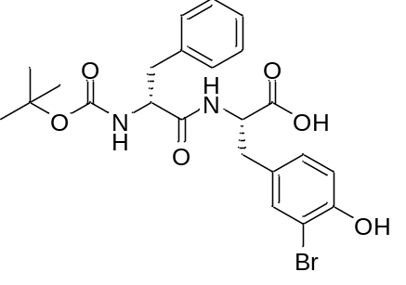
White amorphous solid (415 mg, 71%). ¹H NMR (400 MHz, DMSO-d₆, δ, ppm): 12.83 (br.s., 1 H, COOH), 10.02 (br.s., 1 H), 8.30 (d, J=8.25 Hz, 1 H), 7.34 (d, J=1.71 Hz, 1 H,), 7.18 - 7.25 (m, 3 H,), 7.11 - 7.18 (m, 3 H,), 7.00 (dd, J=8.19, 1.83 Hz, 1 H,), 6.81 (d, J=8.25 Hz, 1 H,), 6.72 (d, J=8.80 Hz, 1 H), 4.39 (m, 1 H), 4.17 (m, 1 H), 2.92 - 3.00 (m, 1 H), 2.65 - 2.78 (m, 2 H), 1.26 (s, 10 H).ESI-APCI-MS for C₂₃H₂₇N₂BrO₆: m/z calcd [M+H]⁺: 507.11, found: 507.00.
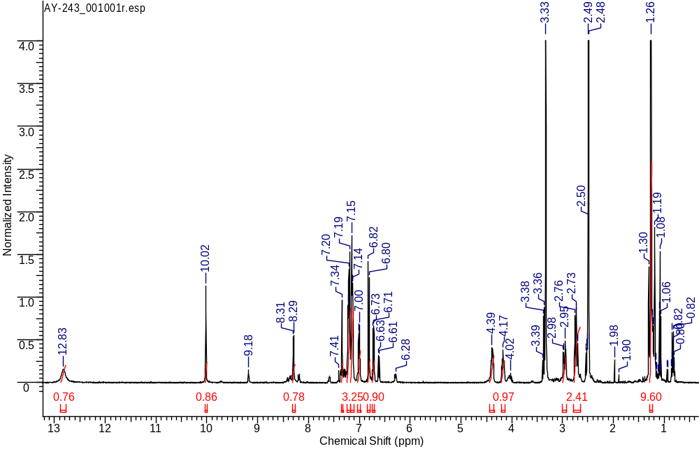
¹H NMR
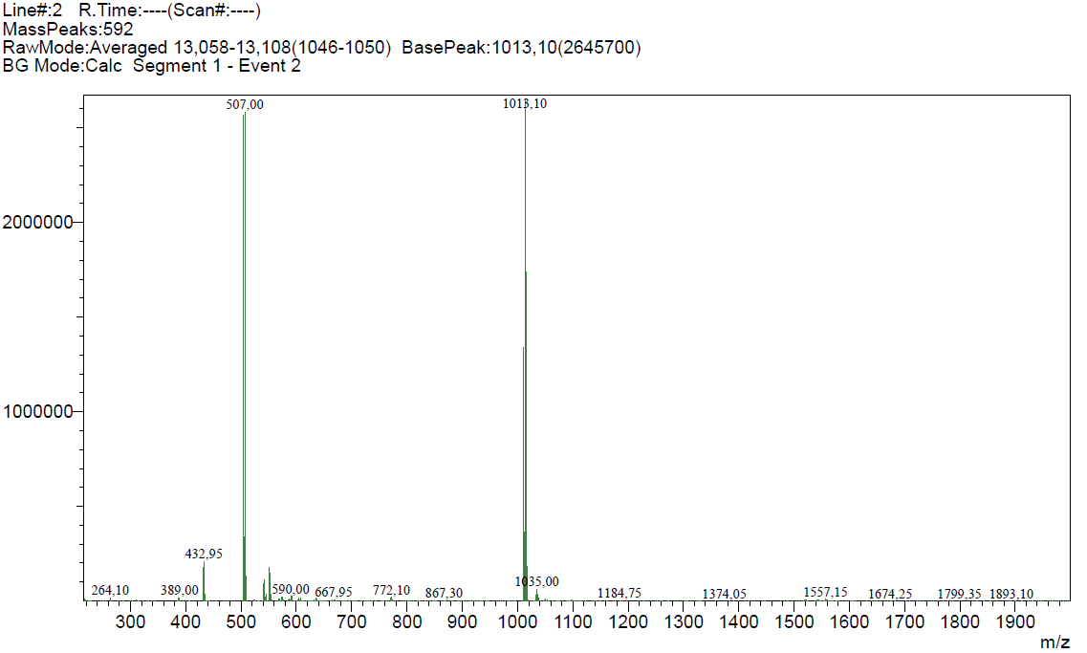
ESI-APCI-MS spectrum
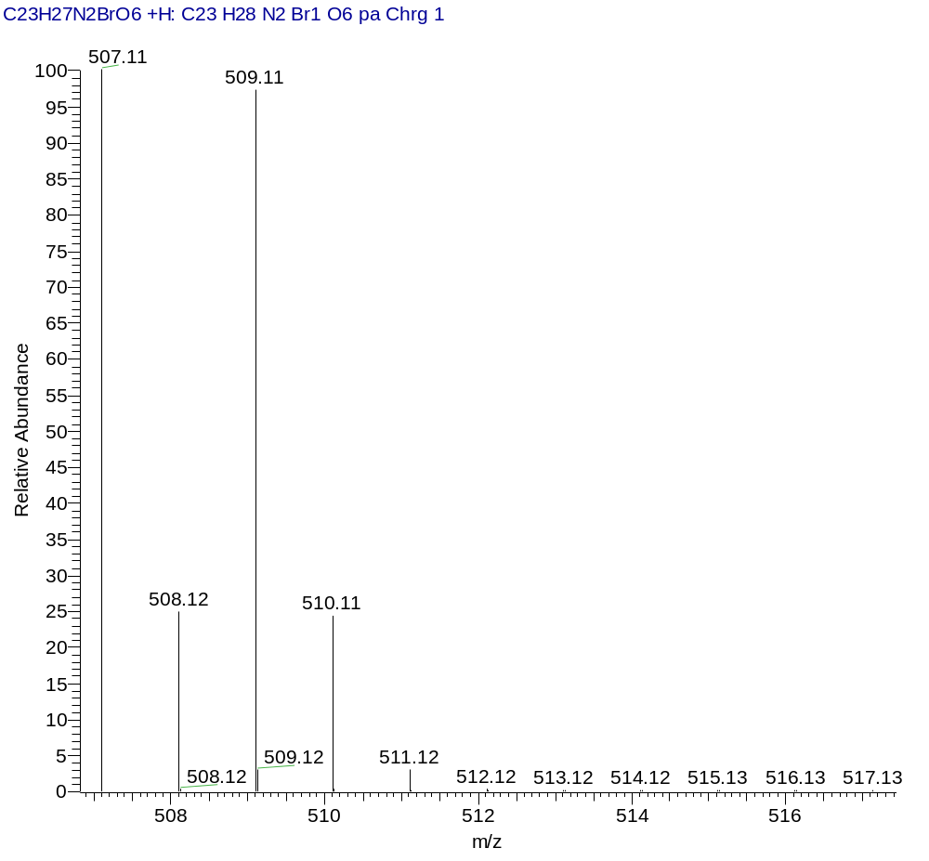
ESI-APCI-MS (Calcd.)
(S)-2-((R)-2-((tert-butoxycarbonyl)amino)-3-phenylpropanamido)-3-(3,4-dihydroxyphenyl)propanoic acid (1S.b)
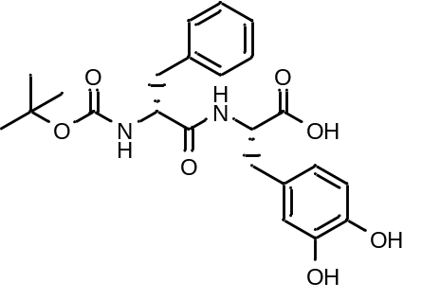
White amorphous solid (862 mg, 83%). ¹H NMR (400 MHz, DMSO-d₆, δ, ppm): 12.76 (s, 1H), 8.73 (d, 1 H), 8.22 (d, J = 8.13 Hz, 1 H), 7.20 – 7.11 (m, 5 H), 6.69 (d, J = 8.74 Гц, 1 H), 6.58 (d, J=7.95 Гц, 1 H), 6.46 (d, 1 H), 6.27 - 6.25 (m, 1H), 4.38 (m, J = 8.31 Гц, 1 H, CH), 4.19 (m, 1 H), 2.89 – 2.75 (m, 2 H), 2.69 – 2.48 (m, 2 H), 1.30 (s, 9 H).
ESI-APCI-MS: m/z for C₂₃H₂₈N₂O₇ calcd: [M+H⁺]: 444.20, found: 445.20.
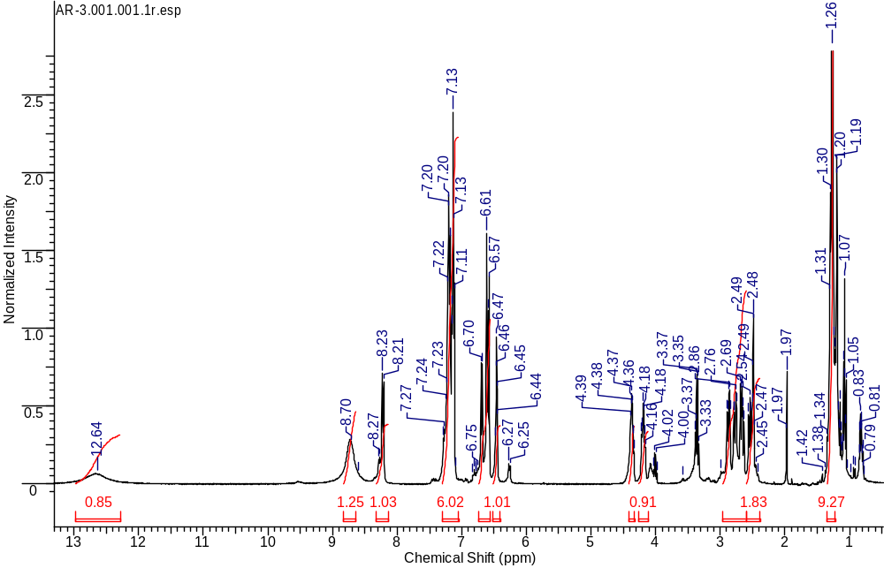
¹H NMR
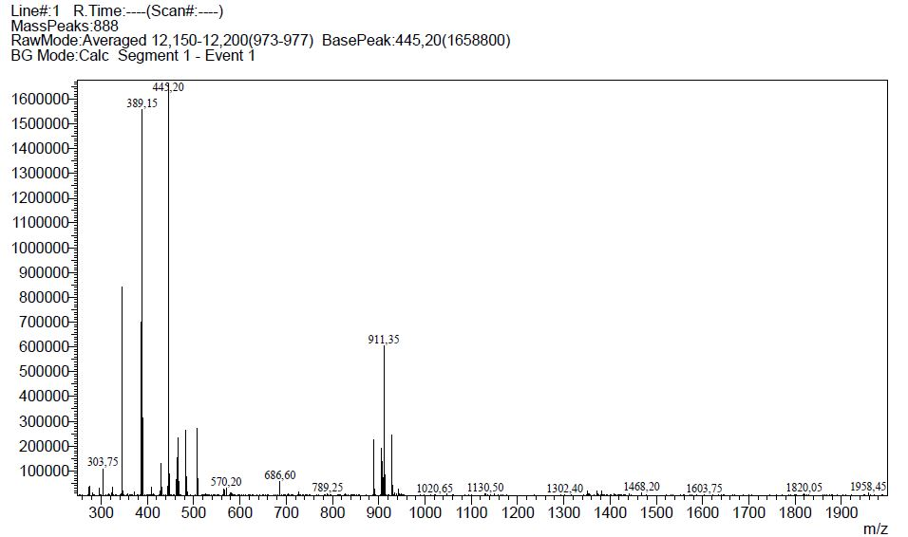
ESI-APCI-MS spectrum
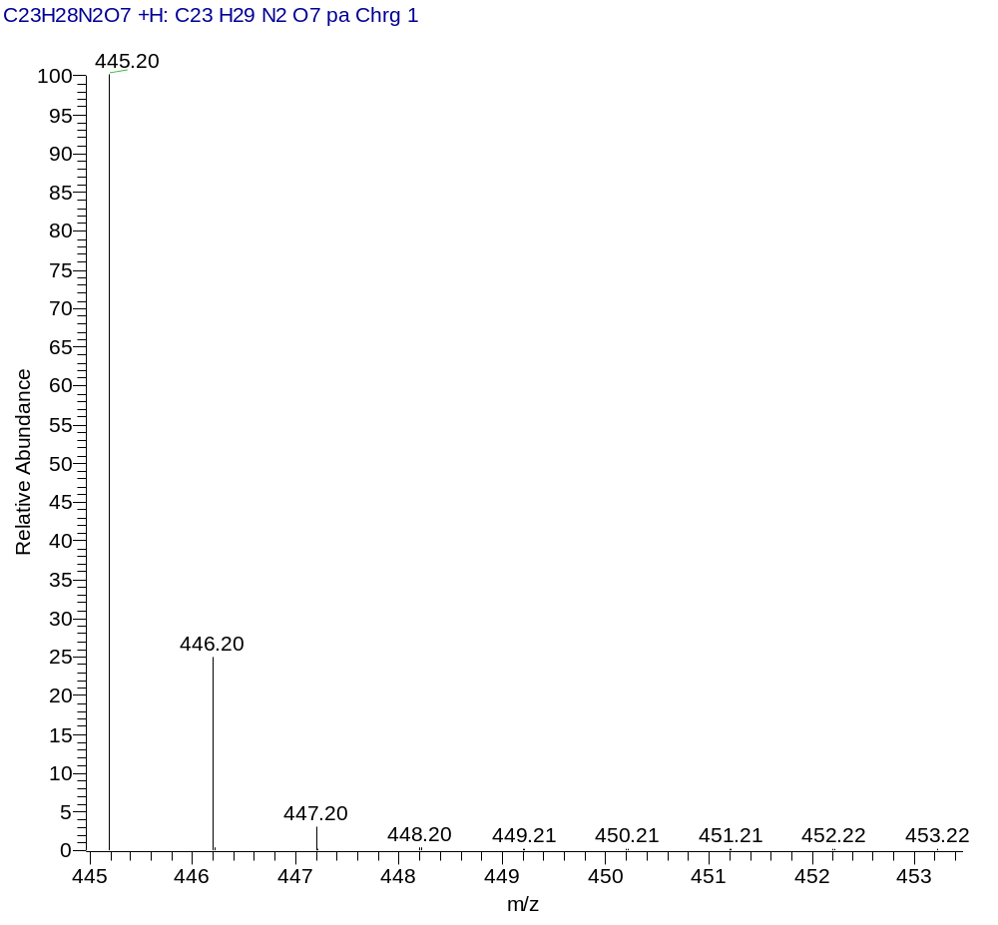
ESI-APCI-MS (Calcd.)
(S)-2-((S)-2-((tert-butoxycarbonyl)amino)-3-phenylpropanamido)-3-(4-hydroxy-3-nitrophenyl)propanoic acid (1S.c)
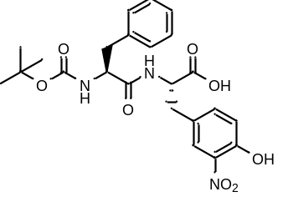
White amorphous solid (2320 mg, 86%). ¹H NMR (400 MHz, DMSO-d₆, δ, ppm): 12.54 (br.s., 1H), 10.81 (br.s., 1 H), 8.07 (d, J=7.89 Hz, 1 H), 7.75 (s, 1 H), 7.41 (m, 1 H), 7.21 - 7.27 (m, 2 H), 7.13 - 7.21 (m, 3 H), 7.03 (d, J=8.50 Hz, 1 H), 6.85 (d, J=8.68 Hz, 1 H), 4.45 (m, 1 H), 4.11 (m, 1 H), 3.07 (m, 1 H), 2.88 - 2.94 (m, 1 H), 2.82 - 2.88 (m, 1 H), 2.64 (m, 1 H), 1.25 (s, 9 H).
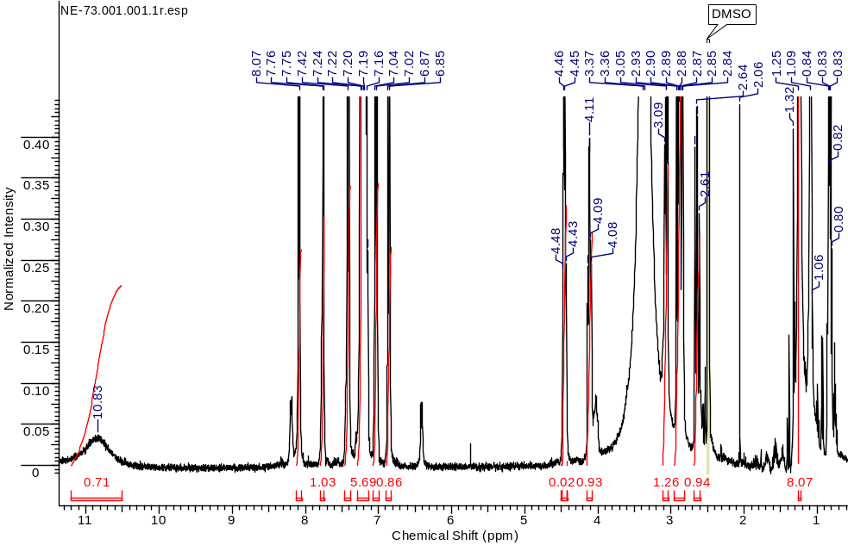
¹H NMR
(S)-2-((R)-2-((tert-butoxycarbonyl)amino)-3-phenylpropanamido)-3-(4-hydroxy-3-nitrophenyl)propanoic acid (1S.d)
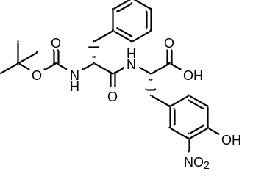
White amorphous solid (600 mg, 82%). ¹H NMR (400 MHz, DMSO-d₆, δ, ppm): 12.78 (br.s., 1H), 10.79 (уш.s., 1 H), 8.30 (s, 1 H), 7.75 (s, 1 H), 7.39 (s, 1 H), 7.10 - 7.23 (m, 5 H), 7.02 (d, 1 H, d, J=8.44 Hz), 6.72 (s, 1 H), 4.46 (m, 1 H, CH), 4.15 (m, 1 H), 3.05 (m, 1 H), 2.85 (d, 1 H, d, J=9.66 Hz), 2.70 (m, 1 H, CH₂), 1.25 (s, 10 H).
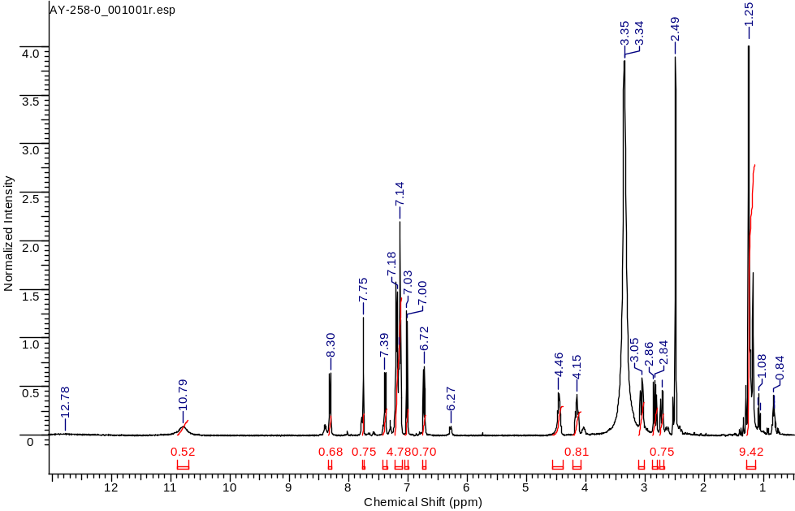
¹H NMR
General procedure for the synthesis of compounds 2S
Boc-dipeptide (1 eq.) was dissolved in 20 ml DMFA. HBTU (1.2 eq.), HOBT (1.2 eq.) and DIPEA (2 eq.) and 3-azido-1-propanamine (1.5 eq.) were added to the solution. The reaction mixture was stirred for 16 hours. Then solvent was removed under reduced pressure. The product was isolated using the column chromatography method (Puriflash 15μ 25g F0025, ethyl acetate/petroleum ether system, ethyl acetate 5% to 40% in 6 minutes, 40% to 60 in 15 minutes, 60% to 100% in 6 minutes, 100% in 3 minutes).
tert-butyl ((R)-1-(((S)-1-((3-azidopropyl)amino)-3-(3-bromo-4-hydroxyphenyl)-1-oxopropan-2-yl)amino)-1-oxo-3-phenylpropan-2-yl)carbamate (2S.a)
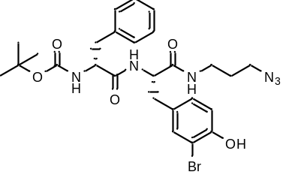
White amorphous solid (151 mg, 36%). ¹H NMR (400 MHz, DMSO-d₆, δ, ppm): 9.99 (s, 1 H, OH), 8.32 (d, J=8.55 Hz, 1 H), 7.98 (t, J=5.56 Hz, 1 H), 7.34 (s, 1 H), 7.20 (t, J=6.96 Hz, 3 H), 7.10 - 7.17 (m, 3 H), 6.99 (d, J=9.65 Hz, 1 H), 6.79 (d, J=8.28 Hz, 2 H), 4.32 - 4.39 (m, 1 H), 4.09 - 4.17 (m, 1 H), 3.29 (t, J=6.71 Hz, 3 H), 3.06 - 3.14 (m, 2 H), 2.85 (dd, J=13.73, 4.63 Hz, 1 H), 2.59 - 2.75 (m, 3 H), 2.50 - 2.57 (m, 1 H), 1.57 - 1.66 (m, 2 H), 1.28 (s, 9 H₃), 1.22 (s, 1 H), 1.17 (s, 2 H). . ESI-APCI-MS m/z 591.10 (calcd 591.17 for C₂₆H₃₃BrN₆O₅ [M+H]⁺).
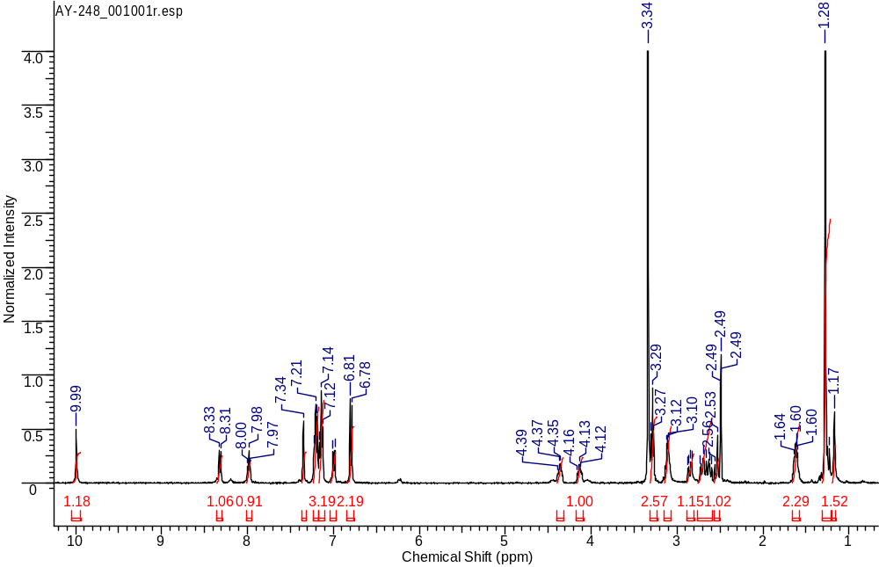
¹H NMR
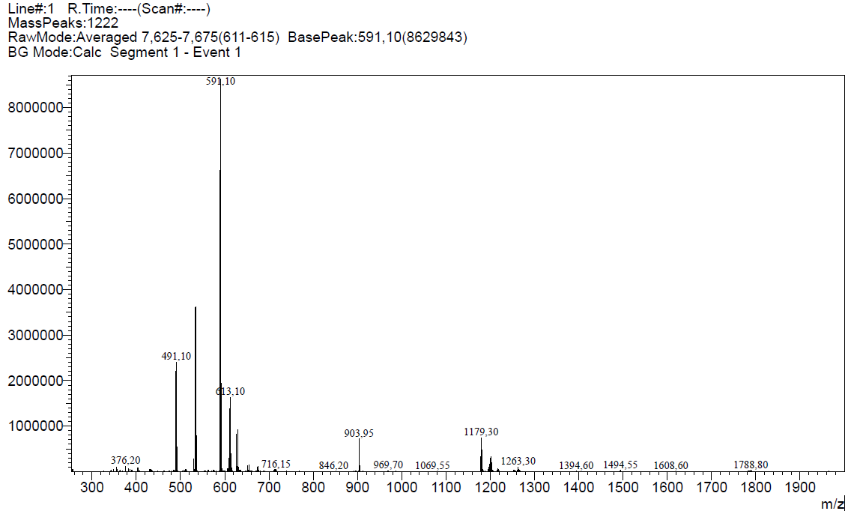
ESI-APCI-MS spectrum
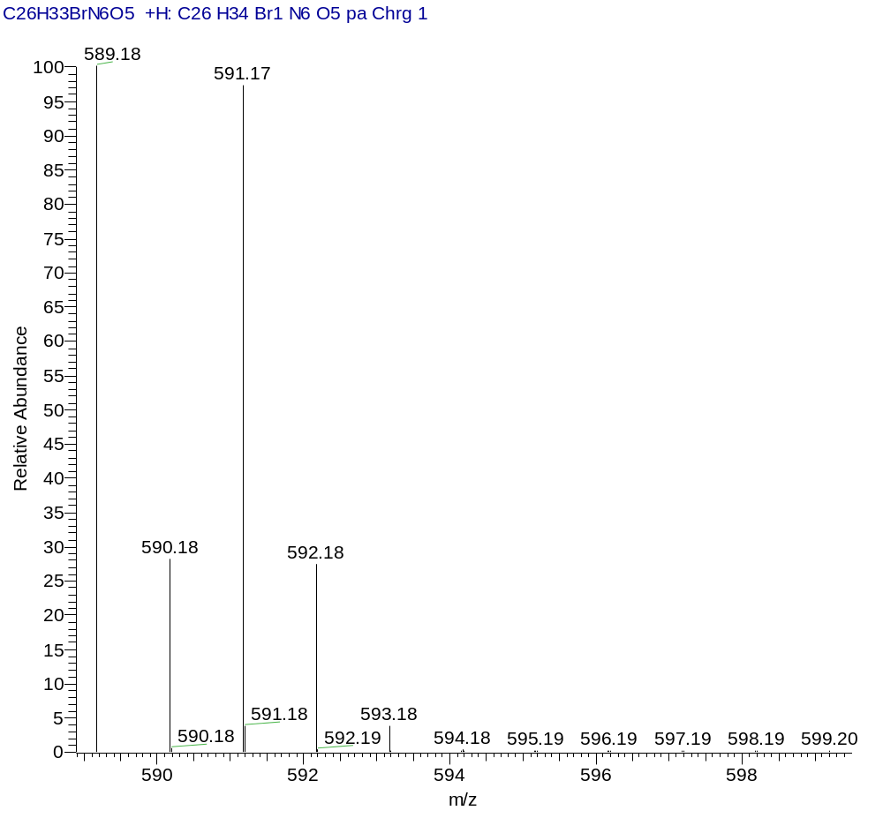
ESI-APCI-MS (Calcd.)
tert-butyl ((S)-1-(((R)-1-((3-azidopropyl)amino)-3-(3,4-dihydroxyphenyl)-1-oxopropan-2-yl)amino)-1-oxo-3-phenylpropan-2-yl)carbamate (2S.b)
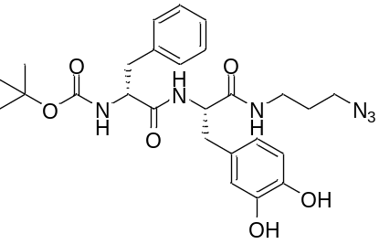
White amorphous solid (1300 mg, 47%). ¹H NMR (400 MHz, DMSO-d₆, δ, ppm): 8.67 (d, J=8.93 Hz , 2 H), 7.90 - 7.97 (m, 1 H,), 7.87 (d, J=8.07 Hz ,1 H), 7.19 - 7.27 (m, 2 H), 7.16 (m, 3 H), 6.91 (d, J=8.50 Hz, 1 H), 6.54 - 6.62 (m, 2 H), 6.40 - 6.48 (m, 1 H), 4.31 (m, 1 H), 4.09 (m, 1 H), 3.18 - 3.25 (m, 2 H), 2.96 - 3.13 (m, 2 H), 2.82 - 2.91 (m, 1 H), 2.70 - 2.78 (m, 1 H), 2.65 (m, 2 H), 1.50 - 1.60 (m, 2 H), 1.28 (s, 9 H). ¹³C NMR (101 MHz, DMSO-d₆, δ, ppm): 171.15, 170.84, 155.19, 144.89, 143.80, 138.08, 129.19, 128.14, 128.01, 126.16, 119.98, 116.69, 115.19, 78.22, 56.00, 54.37, 38.28, 37.51, 35.73, 28.27, 28.12.
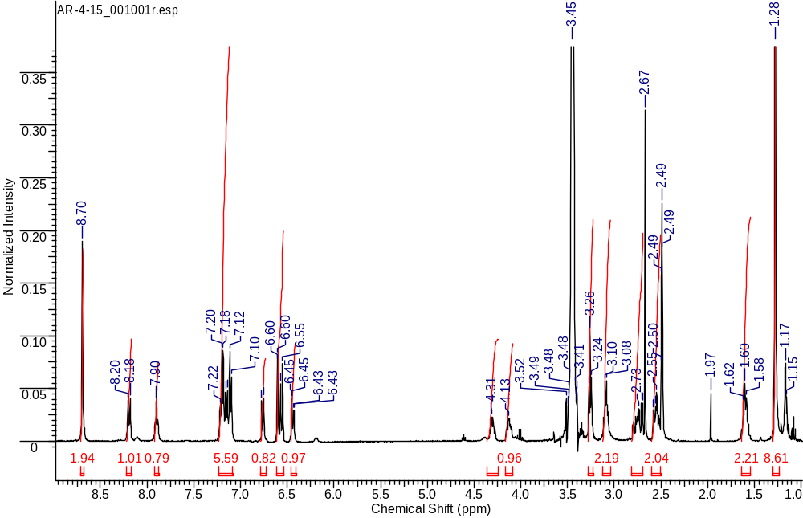
¹H NMR
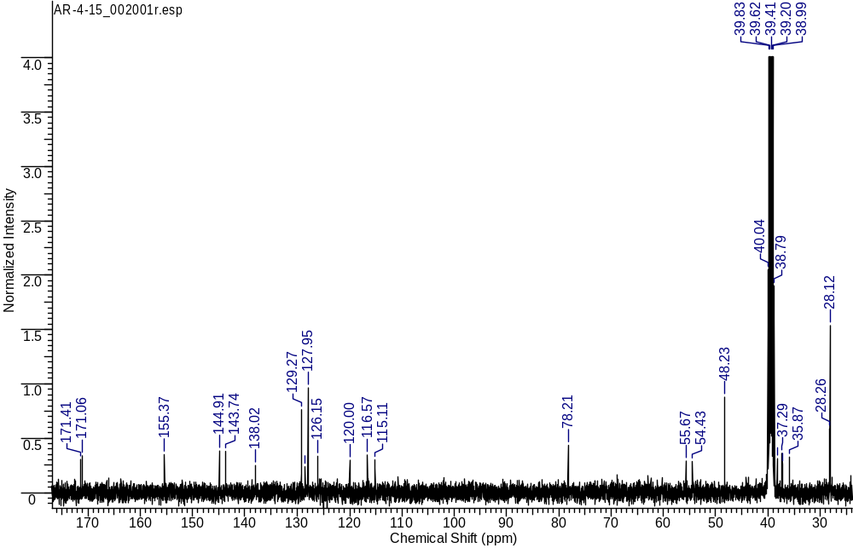
¹H NMR
tert-butyl ((S)-1-(((S)-1-((3-azidopropyl)amino)-3-(4-hydroxy-3-nitrophenyl)-1-oxopropan-2-yl)amino)-1-oxo-3-phenylpropan-2-yl)carbamate (2S.c)
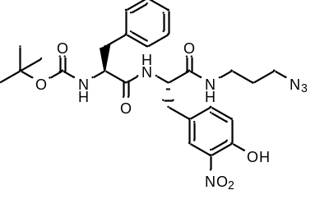
White amorphous solid (581 mg, 68%). ¹H NMR (400 MHz, DMSO-d₆, δ, ppm): 10.81 (s, 1 H), 8.02 - 8.07 (m, 1 H), 7.98 (d, J=8.19 Hz, 1 H), 7.74 (s, 1 H), 7.37 – 7.39 (m, 1 H), 7.20 - 7.24 (m, 2 H), 7.14 - 7.17 (m, 3 H), 7.02 (d, J=8.50 Hz, 1 H), 6.91 (d, J=8.44 Hz,1 H), 4.42 (m, 1 H), 4.06 (m, 1 H), 3.24 (t, J=6.82 Hz, 2 H), 3.06 - 3.17 (m, 1 H), 2.88 - 2.97 (m, 2 H), 2.75 - 2.85 (m, 2 H), 2.60-2.66 (m, 1 H), 1.57 (m, 2 H), 1.26 (s, 9 H). ¹³C NMR (101 MHz, DMSO-d₆, δ, ppm): 171.44, 170.42, 155.19, 150.99, 137.98, 136.58, 136.05, 129.09, 128.70, 128.05, 126.24, 125.56, 118.89, 78.30, 56.00, 53.64, 48.20, 38.79, 37.42, 35.83, 28.24, 28.08.
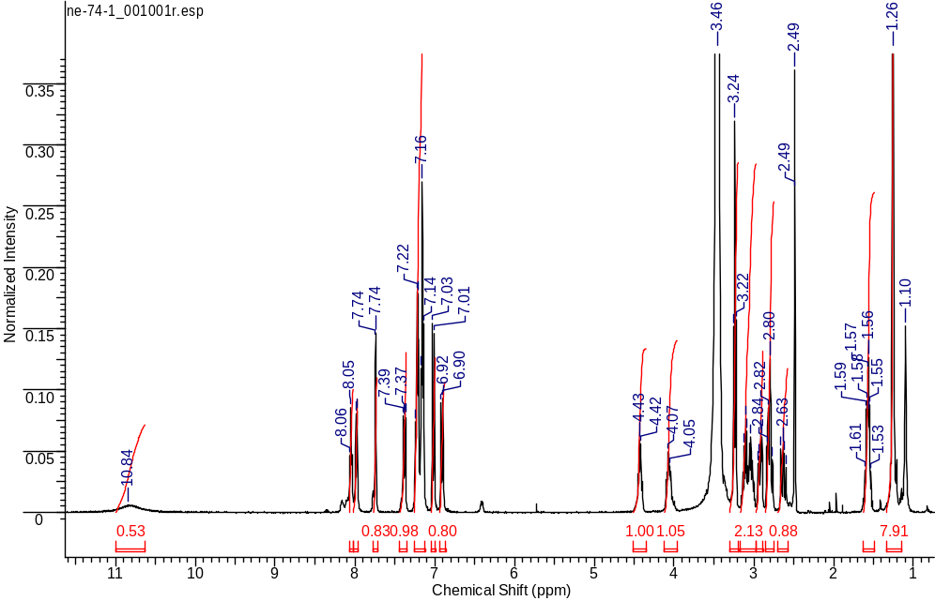
¹H NMR
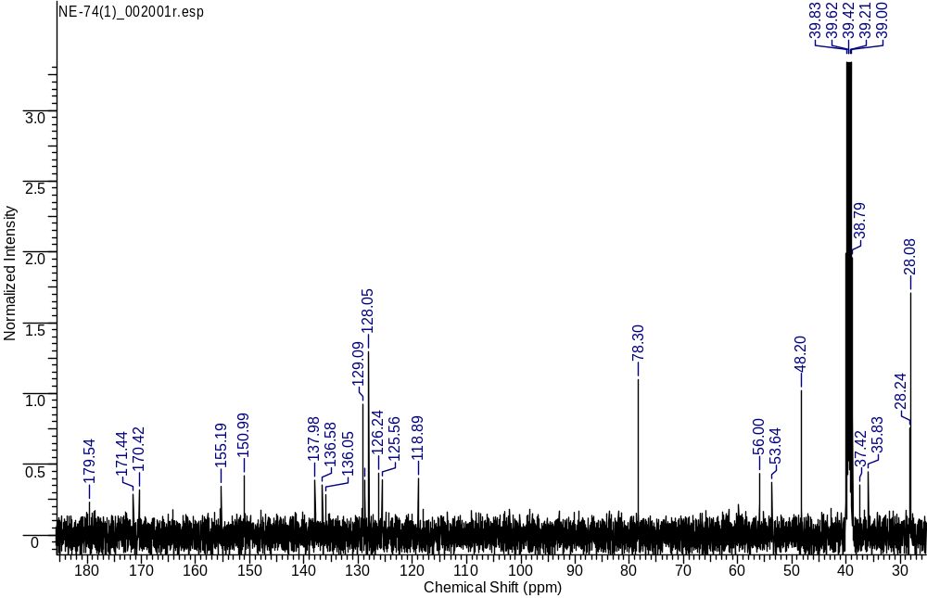
¹³C NMR
tert-butyl ((R)-1-(((S)-1-((3-azidopropyl)amino)-3-(4-hydroxy-3-nitrophenyl)-1-oxopropan-2-yl)amino)-1-oxo-3-phenylpropan-2-yl)carbamate (2S.d)
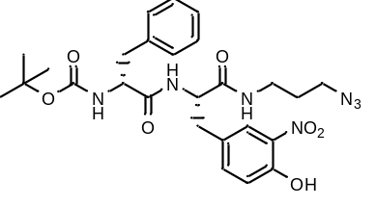
White amorphous solid (600 mg, 84%). ¹H NMR (400 MHz, DMSO-d₆, δ, ppm): 10.77 (s, 1 H), 8.36 (d, 1 H, J=8.56 Hz), 8.02 (s, 1 H), 7.75 (d, 1 H, J=1.96 Hz), 7.36 (dd, 1 H, J=8.56, 2.02 Hz), 7.09 - 7.24 (m, 6 H), 7.00 (d, 1 H, J=8.56 Hz), 6.85 (d, 1 H, J=8.07 Hz), 4.37 - 4.47 (m, 1 H), 4.07 - 4.15 (m, 1 H), 3.25 - 3.31 (m, 2 H), 3.08 - 3.15 (m, 2 H), 2.90 - 2.98 (m, 1 H), 2.68 - 2.74 (m, 2 H), 1.62 (m, 2 H, J=6.74, 3.21 Hz), 1.23 - 1.30 (s, 9 H). ¹³C NMR (101 MHz, DMSO-d₆, δ, ppm): 171.59, 170.58, 155.40, 150.93, 137.99, 136.49, 136.06, 129.18, 129.03, 127.90, 126.16, 126.15, 125.50, 78.14, 55.74, 48.23, 40.12, 38.87, 38.28, 37.33, 36.46, 35.90, 28.29, 28.12, 27.74.
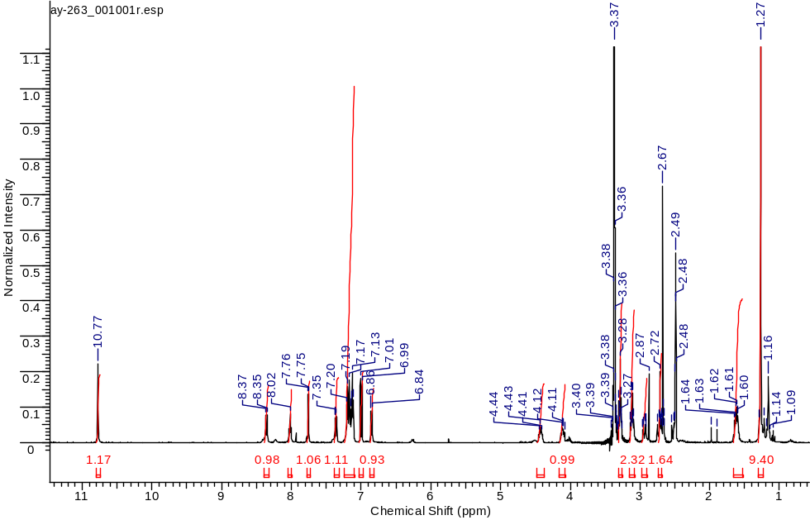
¹H NMR
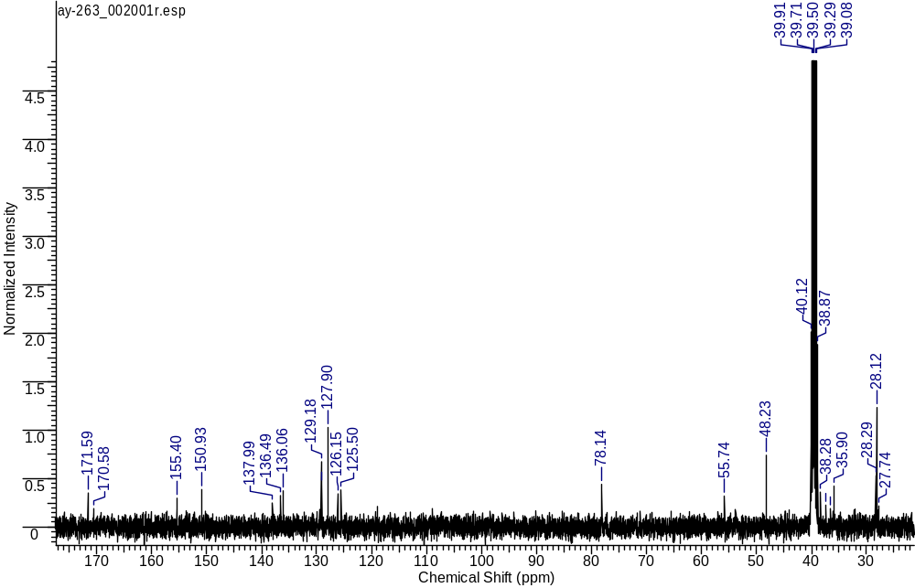
¹³C NMR
General procedure for the synthesis of compounds 3S
A 10% solution of trifluoroacetic acid in dichloromethane (10 ml) was added to Boc-dipeptide and 3-azido-1-propanamine solution and the reaction solution was stirred at room temperature for 3 hours. The control was carried out using the TLC method. After that the solvent was removed at reduced pressure and then product was re-evaporated several times from DCM. The product was isolated by resuspension in 50 ml of diethyl ether.
(R)-1-(((S)-1-((3-azidopropyl)amino)-3-(3-bromo-4-hydroxyphenyl)-1-oxopropan-2-yl)amino)-1-oxo-3-phenylpropan-2-aminium 2,2,2-trifluoroacetate (3S.a)
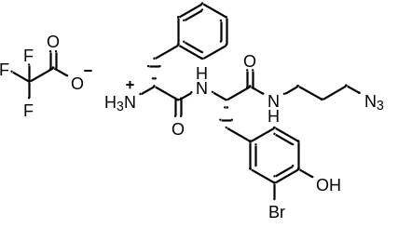
White amorphous solid (154 mg, 65%). ¹H NMR (400 MHz, DMSO-d₆, δ, ppm): 10.06 (br. s., 1 H), 8.86 (d, J=8.55 Hz, 1 H), 8.26 (t, J=5.59 Hz, 1 H), 7.97 (br. s., 3 H), 7.16 - 7.28 (m, 3 H), 6.91 - 7.04 (m, 3 H), 6.82 (d, J=8.22 Hz, 1 H), 4.40 - 4.52 (m, 1 H), 3.93 - 4.07 (m, 2 H), 3.28 (t, J=6.69 Hz, 2 H), 3.10 - 3.22 (m, 1 H), 3.06 (d, J=6.14 Hz, 1 H), 2.87 - 3.00 (m, 1 H), 2.73 - 2.87 (m, 1 H), 2.52 - 2.73 (m, 3 H), 1.56 - 1.68 (m, 2 H). HRMS (ESI) m/z 489.1253 (calcd 489.1244 for C₂₁H₂₅BrN₆O₃ [M+H]⁺).
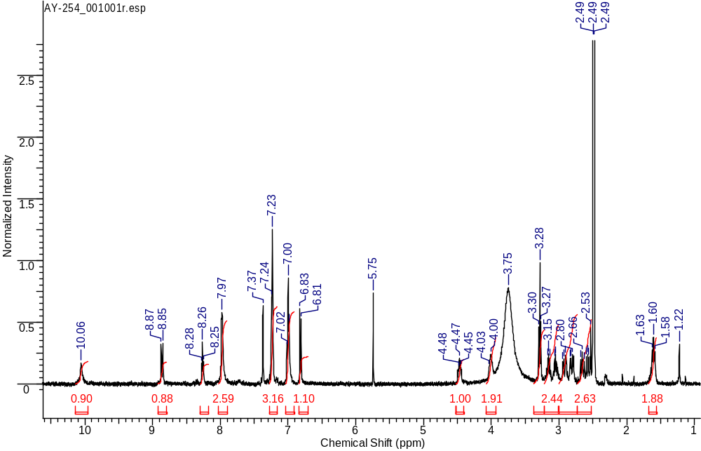
¹H NMR
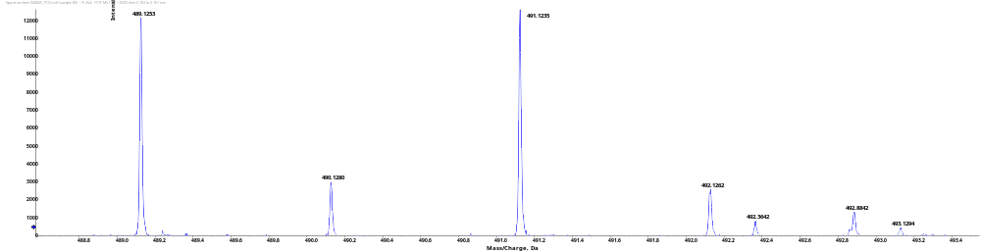
HRMS
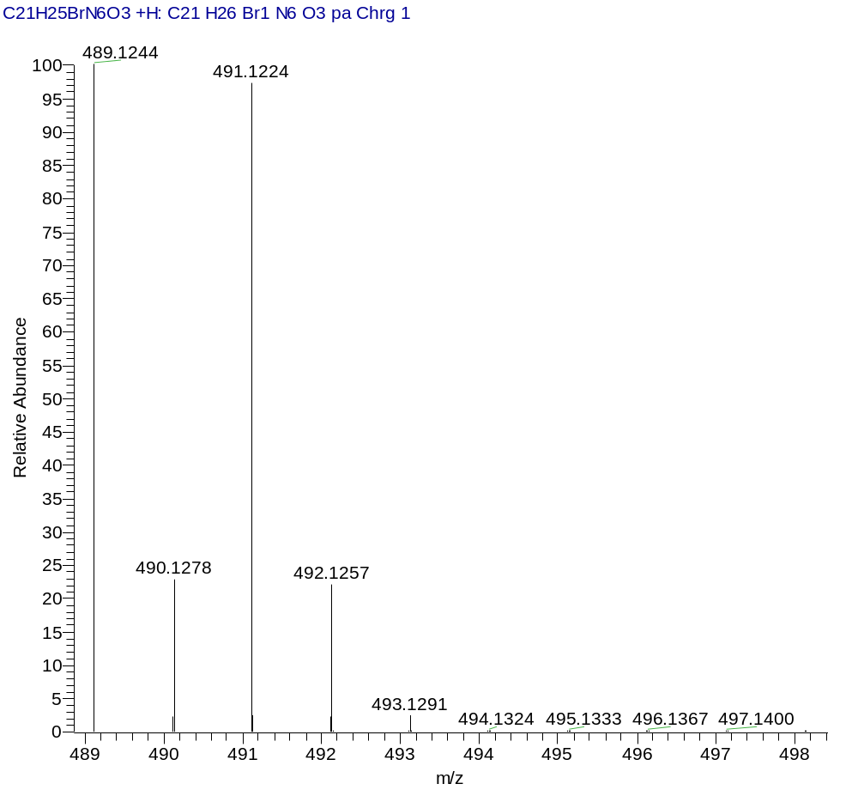
HRMS (Calcd.)
(R)-1-(((S)-1-((3-azidopropyl)amino)-3-(3,4-dihydroxyphenyl)-1-oxopropan-2-yl)amino)-1-oxo-3-phenylpropan-2-aminium 2,2,2-trifluoroacetate (3S.b)
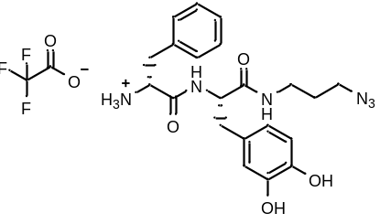
White amorphous solid (421 mg, 98%). ¹H NMR (400 MHz, DMSO-d₆, δ, ppm): 8.79 (s, 1 H, d, J=8.62 Hz), 8.22 (m, 1 H), 7.99 (br.s., 3 H), 7.18 - 7.29 (m, 3 H), 6.99 (m, 2 H), 6.55 - 6.65 (m, 2 H), 6.46 (m, 1 H), 4.43 (m, 1 H), 4.01 (m, 1 H), 3.27 (m, 2 H), 3.09 - 3.20 (m, 1 H), 3.02 (m, 1 H), 2.84 - 2.94 (m, 1 H), 2.70 - 2.82 (m, 1 H), 1.59 (m, 2 H).
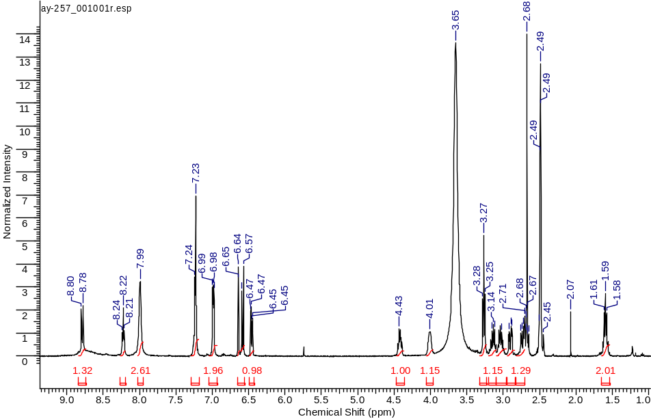
¹H NMR
(S)-1-(((S)-1-((3-azidopropyl)amino)-3-(4-hydroxy-3-nitrophenyl)-1-oxopropan-2-yl)amino)-1-oxo-3-phenylpropan-2-aminium 2,2,2-trifluoroacetate (3S.c)
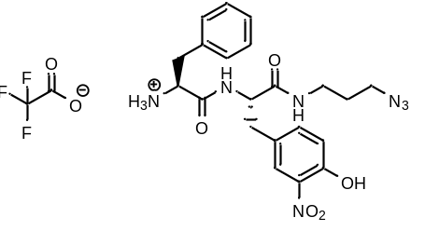
White amorphous solid (552 mg, 98%). ¹H NMR (400 MHz, DMSO-d₆, δ, ppm): 10.98 (s., 1 H), 8.84 (d, J=8.25 Hz, 1 H), 8.19 (t, J=5.69 Hz, 1 H), 8.09 (br.s., 3 H), 7.75 (d, J=2.14 Hz, 1 H), 7.38 (dd, J=8.56, 2.20 Hz, 1 H), 7.26 - 7.33 (m, 3 H), 7.21 - 7.25 (m, 2 H), 7.03 - 7.08 (m, 1 H), 4.38 - 4.55 (m, 1 H), 4.02 (br.s., 1 H), 3.23 (t, J=6.82 Hz, 2 H), 3.02 - 3.15 (m, 3 H), 2.89-2.96 (m, 2 H), 2.77 - 2.85 (m, 1 H), 1.46 - 1.68 (m, 2 H). ¹³C NMR (101 MHz, DMSO-d₆, δ, ppm): 169.87, 167.78, 151.07, 136.30, 134.67, 129.60, 128.51, 128.33, 125.42, 119.01, 54.21, 53.09, 48.17, 35.79, 28.27.
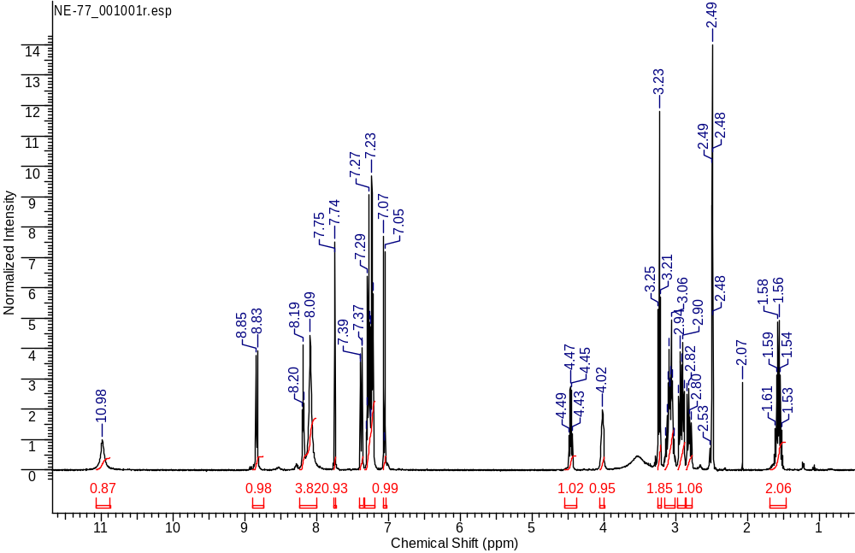
¹H NMR
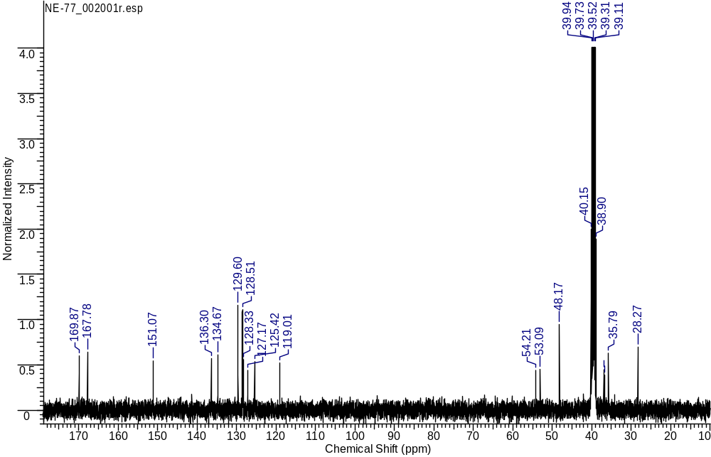
¹³C NMR
(R)-1-(((S)-1-((3-azidopropyl)amino)-3-(4-hydroxy-3-nitrophenyl)-1-oxopropan-2-yl)amino)-1-oxo-3-phenylpropan-2-aminium 2,2,2-trifluoroacetate (3S.d)
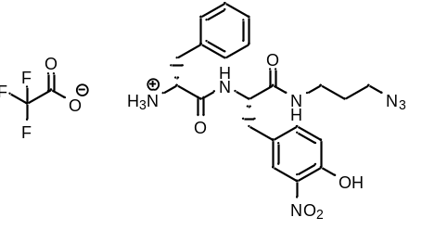
White amorphous solid (537 mg, 89%). ¹H NMR (400 MHz, DMSO-d₆, δ, ppm): 10.93 (s, 1 H), 8.92 (d, 1 H, d, J=8.62 Hz), 8.29 (m, 1 H, t, J=5.62 Hz), 8.03 (s, 3 H), 7.77 (m, 1 H, d, J=2.02 Hz), 7.37 (dd, 1 H, dd, J=8.53, 2.05 Hz), 7.17 - 7.27 (m, 3 H), 6.97 - 7.07 (m, 3 H), 4.44 - 4.57 (m, 1 H), 4.02 (m, 1 H), 3.28 (m, 2 H, t, J=6.79 Hz), 3.11 - 3.22 (m, 1 H), 2.97 - 3.11 (m, 1 H), 2.82 - 2.97 (m, 2 H), 2.60 - 2.75 (m, 2 H), 1.60 (m, 2 H, J=9.61, 6.84 Hz). ¹³C NMR (101 MHz, DMSO-d₆, δ, ppm): 170.79, 170.18, 167.79, 151.09, 142.06, 136.46, 136.36, 136.26, 134.67, 129.45, 129.04, 128.53, 128.44, 127.16, 126.84, 118.99, 53.99, 53.30, 48.23, 40.15, 37.01, 35.85, 28.27.
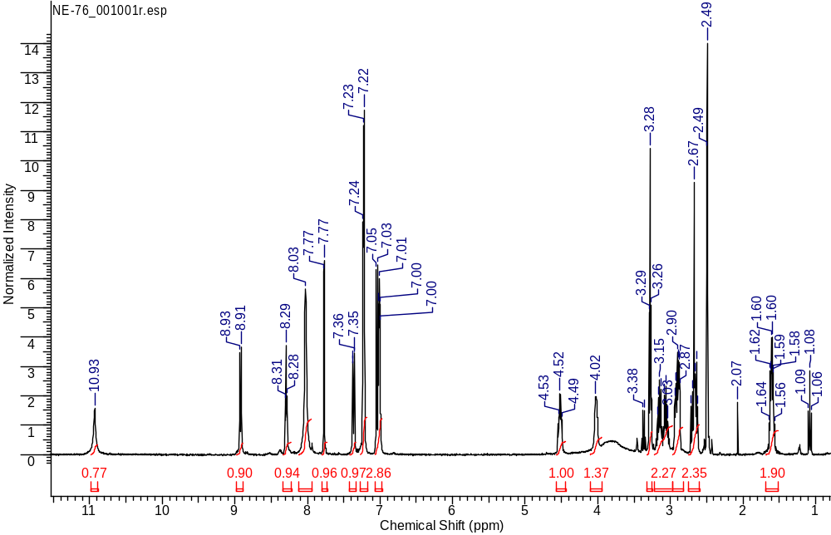
¹H NMR
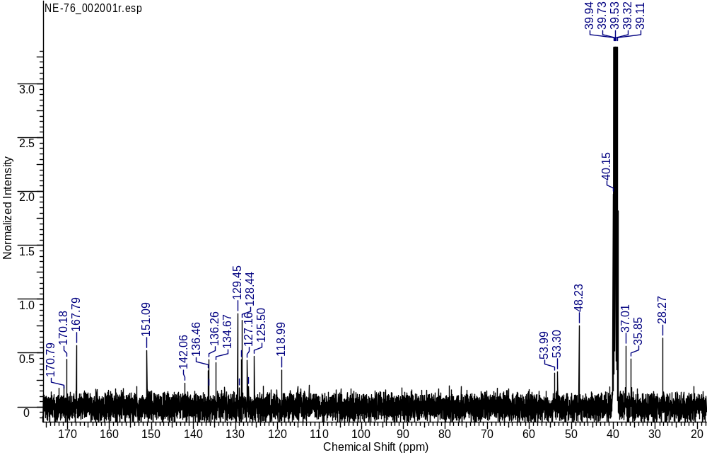
¹³C NMR
General procedure for the synthesis of compounds 9S
- Resin activation
2-chlorotrityl chloride resin (100-200 mesh, capacity 1 -1.5 mmol/g) 300 mg was mixed in 3 ml of DCM for 10 minutes. After that 77 µl of thionyl chloride was added to the solution. After 3-4 minutes the catalytic amount of DMF was added. The solution was stirred for 4 hours at 40 °S. After activation, the resin was washed 3 times with 3 ml of DMF for 1 minute, then 3 times with 3 ml of DCM for 1 minute. Excess solvent was removed, but the resin was not dried fully to prevent reaction with moisture from air.
2) Addition of the first amino acid residue
3 ml of DMF was added to activated resin and the mixture was stirred for 5 minutes. Then Fmoc-protected amino acid was added. The amino acid was taken in double excess of the upper limit of the resin capacity. Then DIPEA was added in 5 times excess. The reaction mixture was stirred for 2 hours. At the end of the reaction solvent was removed from the reactor and resin was washed 3 times with 3 ml of methanol for 1 minute, 3 times with 3 ml of DCM for 1 minute, 3 times with 3 ml of DMF for 1 minute and twice with 3 ml of DCM for 1 minute. Then the resin was dried.
3) Removal of the Fmoc protection group
The resin was washed twice with 3 ml of DMF for 1 minute. After that 5 ml 20% solution of 4-methylpiperidin in DMF was added to the resin and stirred for 15 minutes. Then the resin was filtered and washed twice with 3 ml of DMF for 1 minute, then 3 times with 3 ml of DCM for 1 minute. After the resin was dried.
4) Addition of a second amino acid residue
Dried resin was washed with twice with 3 ml of DMF for 1 minute. Then 3 ml of DMF, the second amino acid residue (2 eq.), HOBt (0.5 eq.), HBTU (2 eq.) and DIPEA (3 eq.) were added. Then the mixture was stirred for 2 hours. After solvent was removed and resin was washed 3 times with 3 ml of DMF for 1 minute and 3 times with 3 ml of DCM for 1 minute. The Fmoc protective group was removed in the same way as described in paragraph 3 of this procedure.
5) Urea-based vector-molecule attachment
Dried resin was washed twice with 3 ml of DMF for 1 minute. Then 3 ml of DMF, (7S,11S)-7,11-bis(tert-butoxycarbonyl)-16-(3-chlorobenzyl)-2,2-dimethyl-4,9,17-trioxo-3-oxa-8,10,16-triazadocosan-22-oic acid (2 eq.), HOBt (0.5 eq.), HBTU (2 eq.) and DIPEA (3 eq.) were added. Then the mixture was stirred for 2 hours. After solvent was removed and resin was washed 3 times with 3 ml of DMF for 1 minute and 3 times with 3 ml of DCM for 1 minute. Then the resin was dried.
6) Removing the ligand from the resin.
Resin was washed twice with 3 ml of DCM for 1 minute. Then the resin was placed in 5 ml of 0.5% trifluoroacetic acid solution for 15 minutes. Then solvent from resulting filtrate was removed under reduced pressure and several times re-evaporated from DCM. The product was isolated using the column chromatography method with the reverse phase.
(2R,5S,23S,27S)-2,5-bis(4-(tert-butoxy)benzyl)-23,27-bis(tert-butoxycarbonyl)-18-(3-chlorobenzyl)-32,32-dimethyl-4,7,10,17,25,30-hexaoxo-31-oxa-3,6,11,18,24,26-hexaazatritriacontan-1-oic acid (9S.a)
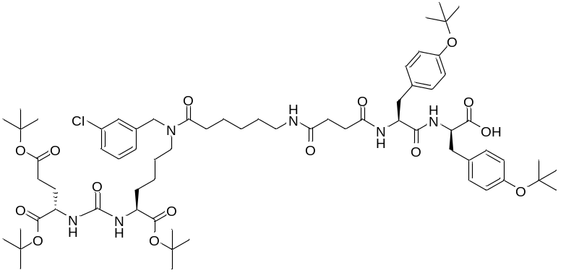
White amorphous solid (376 mg, 85%). ¹H NMR (400 MHz, DMSO-d₆, δ, ppm): 12.78 (br.s., 1 H), 8.38 (d, J=8.31 Hz, 1 H), 7.97 (d, J=8.07 Hz, 1 H), 7.70 - 7.79 (m, 1 H), 7.26 - 7.41 (m, 2 H), 7.21 - 7.24 (m, 1 H), 7.08 - 7.16 (m, 3 H), 6.97 (d, J=7.70 Hz, 2 H), 6.82 (d, J=8.19 Hz, 2 H), 6.77 (d, J=7.52 Hz, 2 H), 6.22 - 6.33 (m, 2 H), 4.54 (s, 1 H), 4.46 (s, 1 H), 4.39 - 4.45 (m, 2 H), 3.89 - 4.06 (m, 2 H), 3.12 - 3.23 (m, 2 H), 2.98 - 3.06 (m, 1 H), 2.89 - 2.98 (m, 2 H), 2.77 (dd, J=13.33, 10.27 Hz, 1 H), 2.58 (d, J=10.88 Hz, 1 H), 2.30 - 2.42 (m, 2 H), 2.09 - 2.27 (m, 7 H), 1.79 - 1.90 (m, 1 H), 1.62 – 1.67 (m, 1 H), 1.53 – 1.57 (m, 1 H), 1.46 – 1.52 (m, 3 H), 1.40 - 1.45 (m, 2 H), 1.33 - 1.38 (m, 30 H), 1.20 - 1.23 (m, 11 H), 1.16 - 1.19 (m, 10 H). ESI-APCI-MS m/z 1263.70 (calcd 1263.69 for C₆₇H₉₉ClN₆O₁₅ [M+H]⁺).
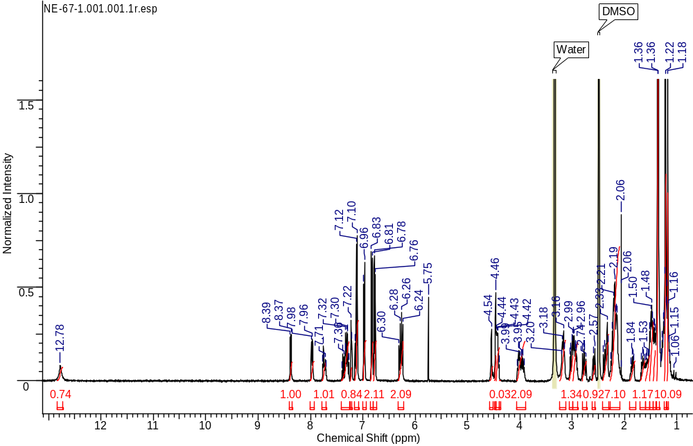
¹H NMR
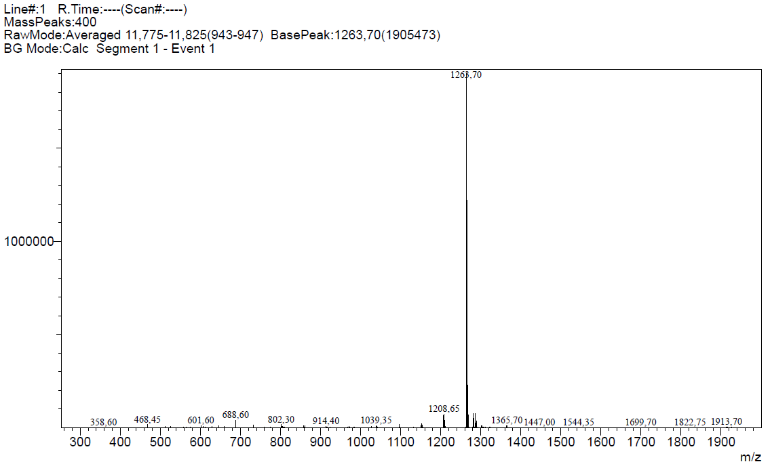
ESI-APCI-MS spectrum
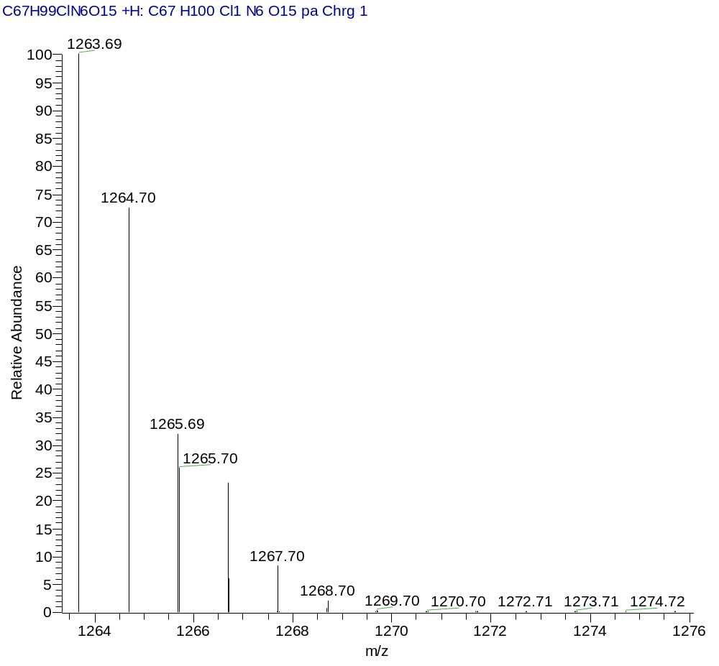
ESI-APCI-MS (Calcd.)
(2R,5S,23S,27S)-2-benzyl-5-(4-(tert-butoxy)benzyl)-23,27-bis(tert-butoxycarbonyl)-18-(3-chlorobenzyl)-32,32-dimethyl-4,7,10,17,25,30-hexaoxo-31-oxa-3,6,11,18,24,26-hexaazatritriacontan-1-oic acid (9S.b)
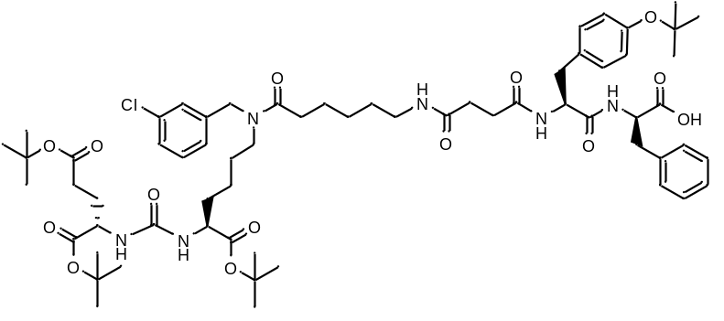
White amorphous solid (308 mg, 74%). ¹H NMR (400 MHz, DMSO-d₆, δ, ppm): 12.78 (br.s.., 1 H), 8.36 (d, J=7.64 Hz, 1 H), 8.00 (d, J=7.40 Hz, 1 H), 7.69 - 7.79 (m, 1 H), 7.36 – 7.40 (m, 1 H), 7.28 - 7.34 (m, 1 H), 7.23 - 7.28 (m, 1 H), 7.17 - 7.23 (m, 4 H), 7.08 - 7.17 (m, 2 H), 6.98 (d, J=8.07 Hz, 2 H), 6.77 (d, J=8.13 Hz, 2 H), 6.20 - 6.32 (m, 2 H), 4.54 (c, 1 H), 4.46 (c, 1 H), 4.40 – 4.44 (m, 2 H), 3.89 - 4.05 (m, 2 H), 3.11 - 3.23 (m, 2 H), 2.89 - 3.07 (m, 2 H), 2.83 (dd, J=12.99, 9.81 Hz, 1 H), 2.67 (d, J=13.02 Hz, 1 H), 2.38 - 2.44 (m, 1 H), 2.29 - 2.36 (m, 1 H), 2.09 - 2.28 (m, 7 H), 1.79 - 1.90 (m, 1 H), 1.60 - 1.70 (m, 1 H), 1.53 – 1.59 (m, 1 H), 1.45 - 1.53 (m, 3 H), 1.39 - 1.45 (m, 2 H), 1.37 (s, 29 H), 1.24 - 1.30 (m, 2 H), 1.22 (s, 12 H₃ + SH₂). ESI-APCI-MS m/z 1191.65 (calcd 1191.64 for C₆₃H₉₁ClN₆O₁₄ [M+H]⁺).
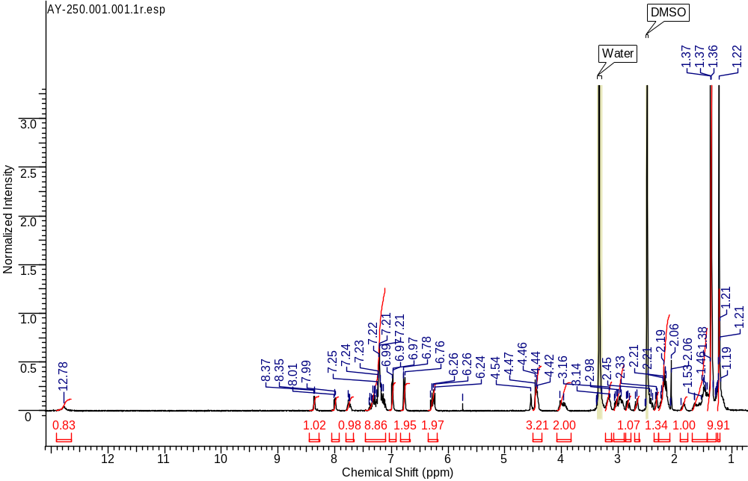
¹H NMR
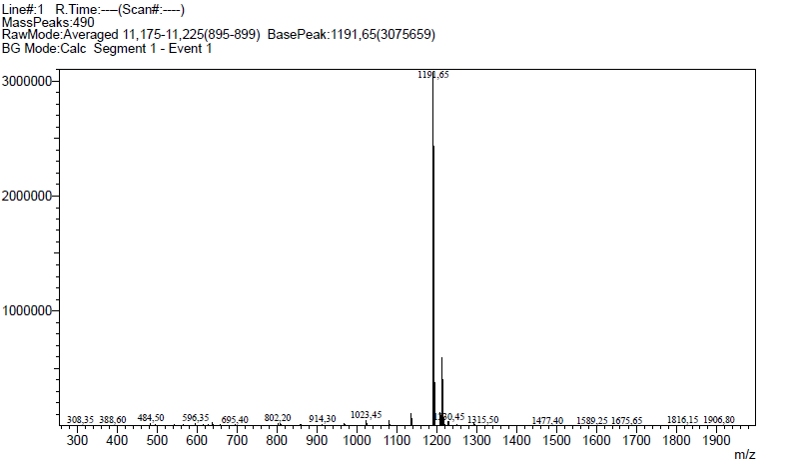
ESI-APCI-MS spectrum
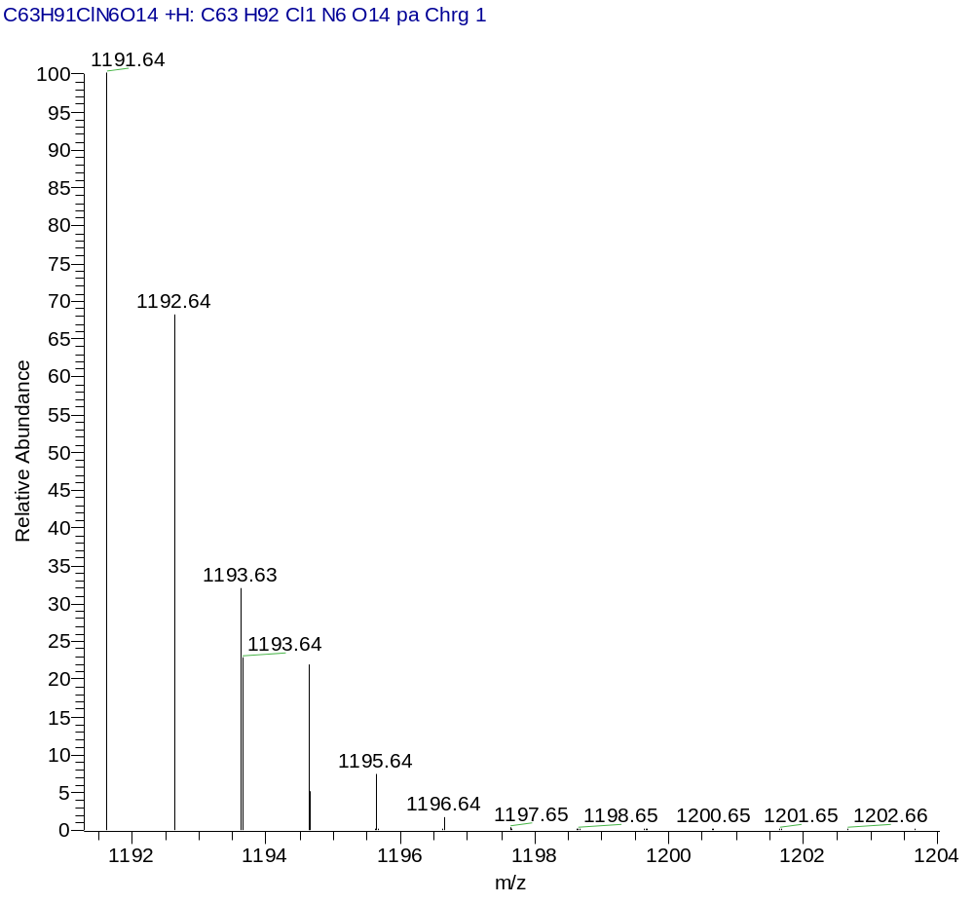
ESI-APCI-MS (Calcd.)
(2S,5R,23S,27S)-2,5-bis(4-(tert-butoxy)benzyl)-23,27-bis(tert-butoxycarbonyl)-18-(3-chlorobenzyl)-32,32-dimethyl-4,7,10,17,25,30-hexaoxo-31-oxa-3,6,11,18,24,26-hexaazatritriacontan-1-oic acid (9S.c)
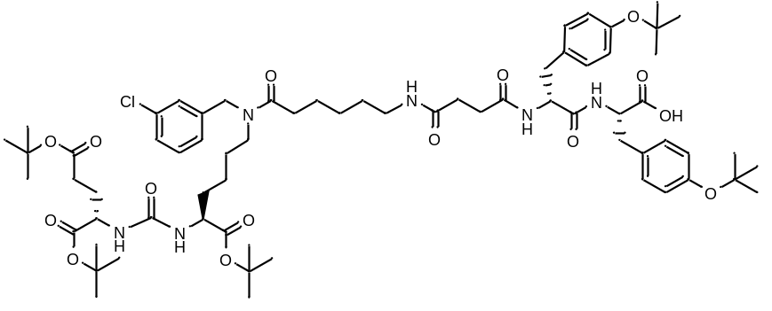
White amorphous solid (310 mg, 70%). ¹H NMR (400 MHz, DMSO-d₆, δ, ppm): 12.77 (br. s., 1 H), 8.37 (d, J=8.38 Hz, 1 H), 7.97 (d, J=8.62 Hz, 1 H), 7.68 - 7.78 (m, 1 H), 7.26 - 7.40 (m, 2 H), 7.19 - 7.23 (m, 1 H), 7.08 - 7.16 (m, 3 H), 6.96 – 6.98 (m, 2 H), 6.82 (d, J=8.31 Hz, 2 H), 6.77 (d, J=8.01 Hz, 2 H), 6.20 - 6.33 (m, 2 H), 4.54 (s, 1 H), 4.46 (s, 1 H), 4.39 - 4.45 (m, 2 H), 3.92 - 4.05 (m, 2 H), 3.11 - 3.25 (m, 2 H), 2.89 - 3.06 (m, 3 H), 2.77 (dd, J=13.57, 10.27 Hz, 1 H), 2.59 (d, J=10.58 Hz, 1 H), 2.29 - 2.42 (m, 2 H), 2.08 - 2.28 (m, 7 H), 1.80 – 1.87 (m, 1 H), 1.60 - 1.70 (m, 1 H), 1.54 – 1.59 (m, 1 H), 1.41 – 1.52 (m, 4 H), 1.29 - 1.41 (m, 29 H), 1.19 - 1.29 (m, 13 H), 1.10 - 1.19 (m, 10 H). ESI-APCI-MS m/z 1263.70 (calcd 1263.69 for C₆₇H₉₉ClN₆O₁₅ [M+Na]⁺).
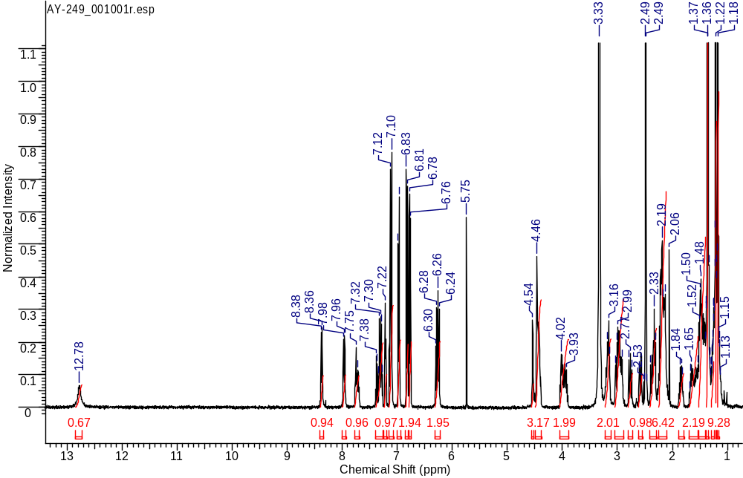
¹H NMR
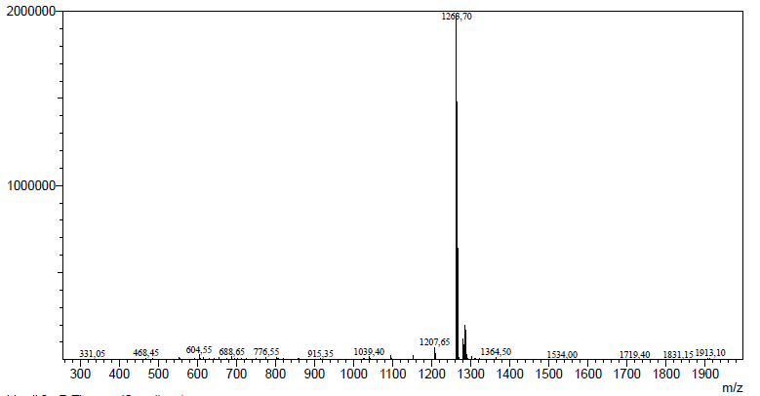
ESI-APCI-MS spectrum
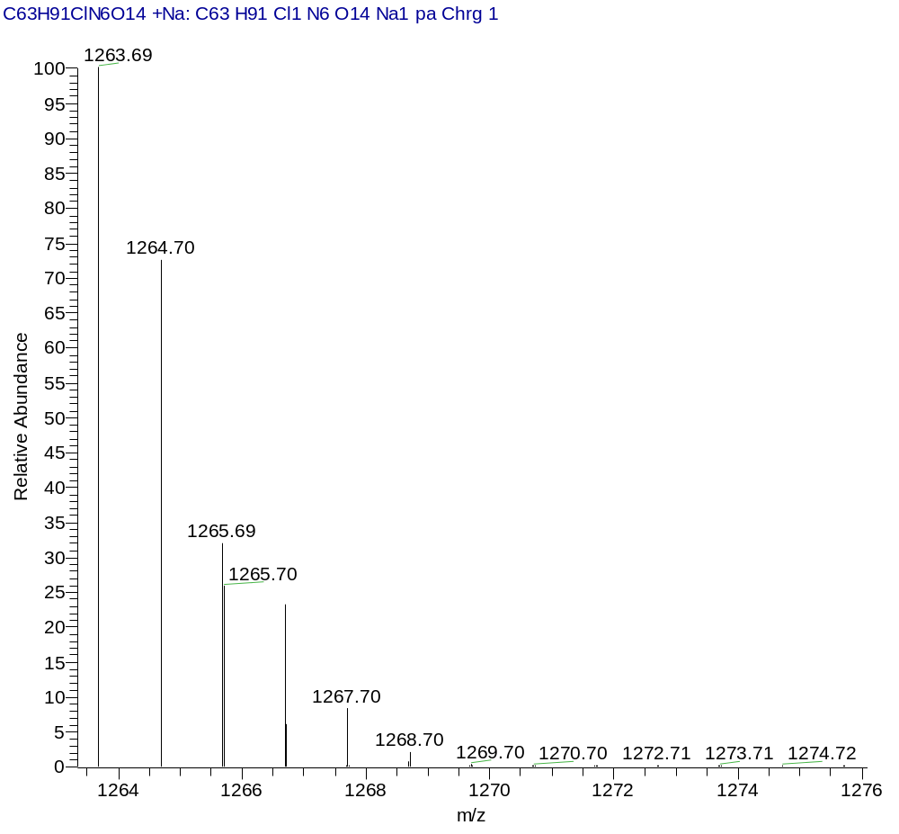
ESI-APCI-MS (Calcd.)
(2S,5S,23S,27S)-2-benzyl-5-(4-(tert-butoxy)benzyl)-23,27-bis(tert-butoxycarbonyl)-18-(3-chlorobenzyl)-32,32-dimethyl-4,7,10,17,25,30-hexaoxo-31-oxa-3,6,11,18,24,26-hexaazatritriacontan-1-oic acid (9S.d)
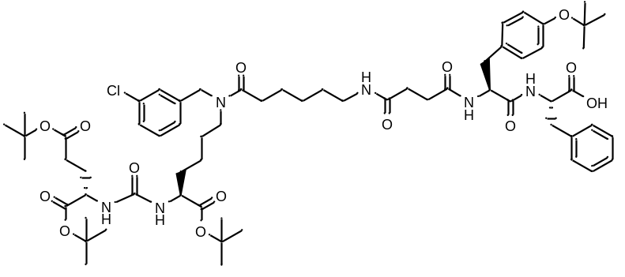
White amorphous solid (380 mg, 91%). ¹H NMR (400 MHz, CDCl₃, δ, ppm): 7.43 (d, J=7.82 Hz, 1 H), 7.36 (d, J=7.27 Hz, 1 H), 7.20 - 7.25 (m, 3 H), 7.12 - 7.20 (m, 4 H), 7.07 - 7.12 (m, 1 H), 7.02 (d, J=8.38 Hz, 2 H), 6.85 (d, J=8.01 Hz, 2 H), 6.68 (t, J=8.07 Hz, 1 H), 5.83 (d, J=8.01 Hz, 1 H), 5.75 (d, J=7.95 Hz, 1 H), 5.65 (dd, J=14.43, 8.19 Hz, 1 H), 4.71 - 4.82 (m, 1 H), 4.63 - 4.71 (m, 1 H), 4.44 - 4.59 (m, 2 H), 4.33 – 4.35 (m, 1 H), 4.26 - 4.27 (m, 1 H), 3.34 – 3.35 (m, 1 H), 3.21 - 3.32 (m, 2 H), 3.18 (t, J=7.61 Hz, 1 H), 2.99 - 3.12 (m, 3 H), 2.85 (dt, J=14.53, 7.50 Hz, 1 H), 2.49 - 2.61 (m, 1 H), 2.25 - 2.44 (m, 6 H), 2.00 - 2.11 (m, 1 H), 1.82 – 1.87 (m, 1 H), 1.73 – 1.76 (m, 1 H), 1.48 - 1.66 (m, 5 H), 1.39 - 1.48 (m, 30 H), 1.33 - 1.38 (m, 2 H), 1.31 (m, 11 H). HRMS (ESI) m/z 1191.6414 (calcd 1191.6355 for C₆₃H₉₁ClN₆O₁₄ [M+H]⁺); 1214.6267 (calcd 1214.6208 for C₆₃H₉₁ClN₆O₁₄ [M+Na]⁺).
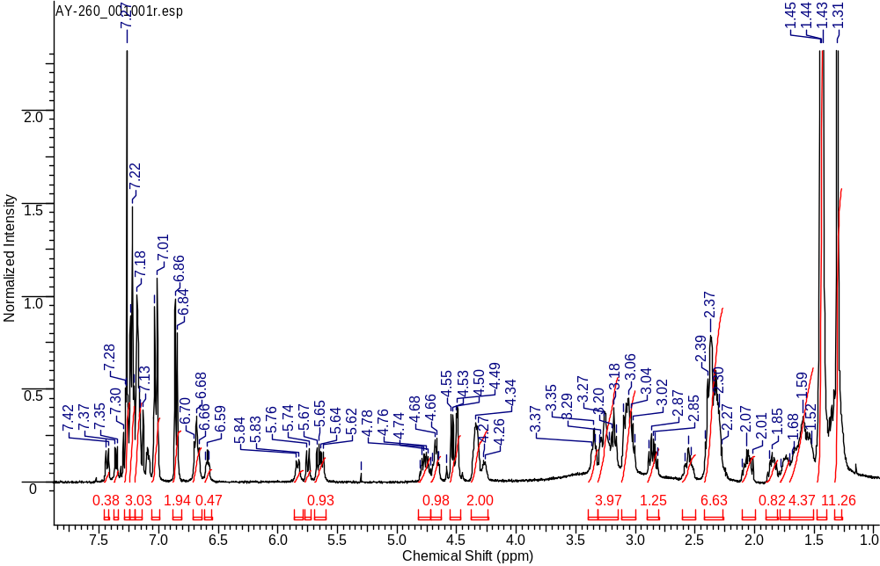
¹H NMR
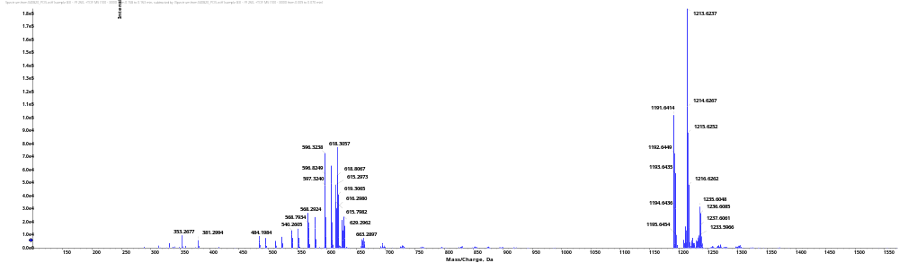
HRMS [M+Na]⁺
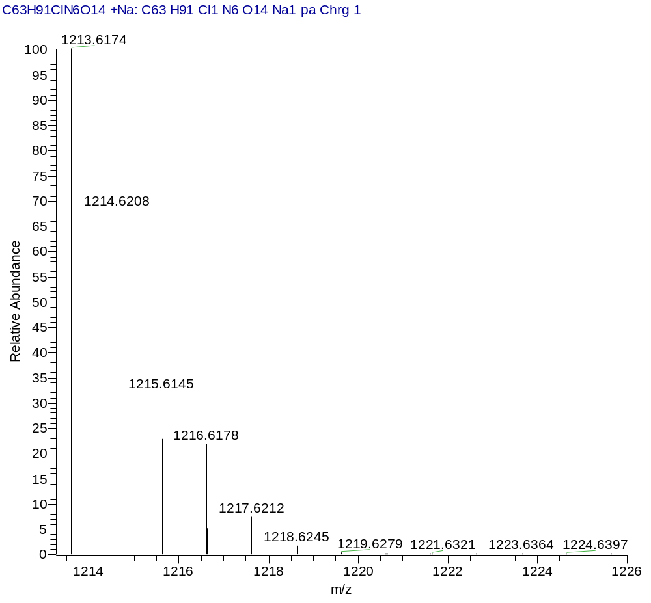
HRMS (Calcd.)
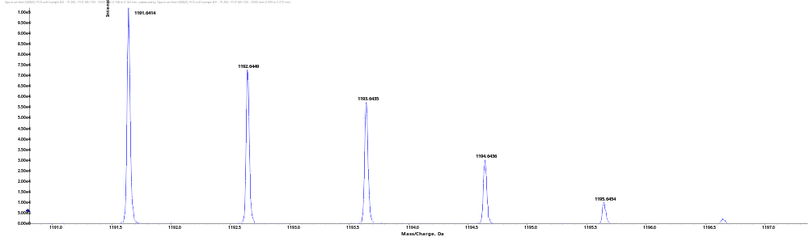
HRMS [M+H]⁺
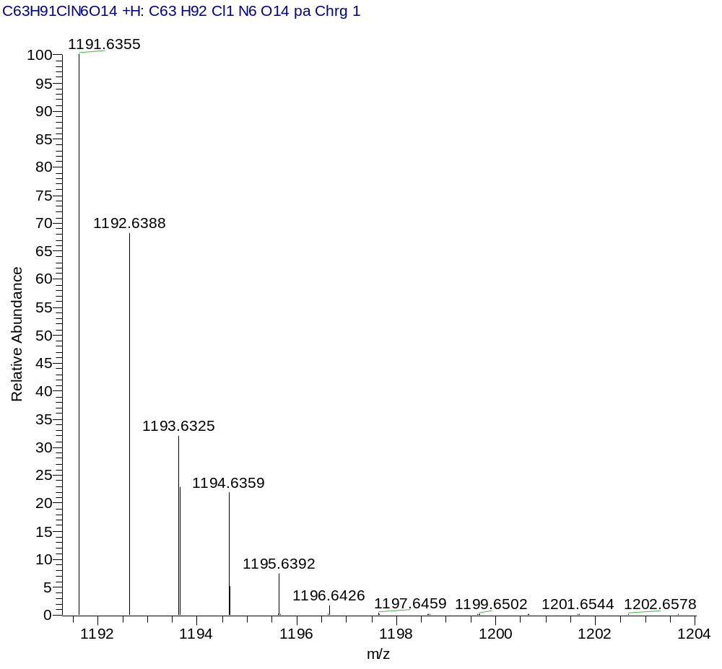
HRMS (Calcd.)
(2S,5S,23S,27S)-2,5-bis(4-(tert-butoxy)benzyl)-23,27-bis(tert-butoxycarbonyl)-18-(3-chlorobenzyl)-32,32-dimethyl-4,7,10,17,25,30-hexaoxo-31-oxa-3,6,11,18,24,26-hexaazatritriacontan-1-oic acid (9S.e)
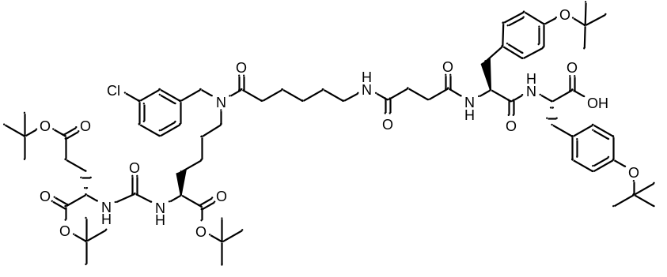
White amorphous solid (370 mg, 82%). ¹H NMR (400 MHz, DMSO-d₆, δ, ppm): 7.41 (d, J=7.89 Hz, 1 H), 7.30 - 7.36 (m, 1 H), 7.20 - 7.25 (m, 1 H), 7.18 (s, 1 H), 7.13 (s, 1 H), 7.06 - 7.11 (m, 2 H), 7.04 (d, J=8.62 Hz, 3 H), 6.87 (dd., J=8.38, 1.71 Hz, 4 H), 6.64 - 6.71 (m, 1 H), 6.54 - 6.60 (m, 1 H), 5.73 (dd., J=8.07 Hz, 1 H), 5.62 (dd., J=13.24, 8.04 Hz, 1 H), 4.67 - 4.76 (m, 1 H), 4.59 - 4.67 (m, 1 H), 4.52 (dd., J=13.51, 6.72 Hz, 2 H), 4.29 - 4.38 (m, 2 H), 3.32 - 3.41 (m, 1 H), 3.14 - 3.32 (m, 3 H), 2.97 - 3.13 (m, 3 H), 2.79 - 2.88 (m, 1 H), 2.50 - 2.63 (m, 1 H), 2.25 - 2.44 (m, 6 H), 2.02 - 2.11 (m, 1 H), 1.79 - 1.92 (m, 1 H), 1.69 - 1.78 (m, 1 H), 1.49 - 1.69 (m, 6 H), 1.40 - 1.49 (m, 29 H), 1.34 - 1.40 (m, 2 H), 1.31 (d, J=1.34 Hz, 20 H). HRMS (ESI) m/z 1263.6944 (calcd 1263.6930 for C₆₇H₉₉ClN₆O₁₅ [M+H]⁺).
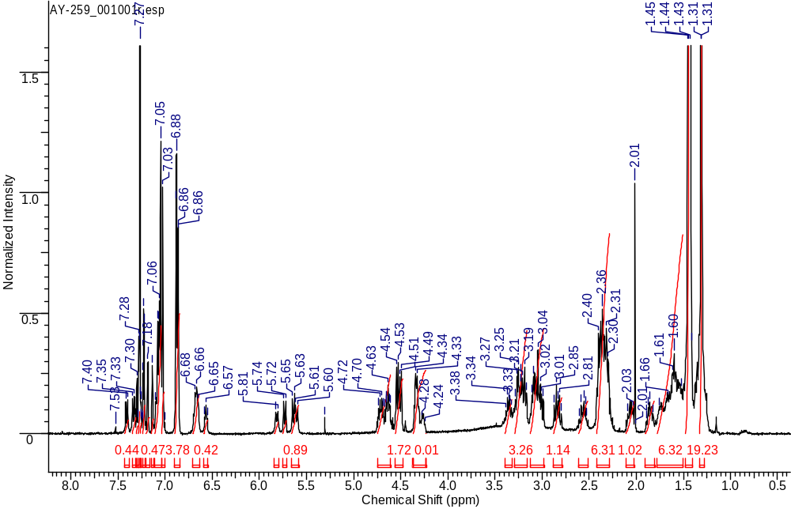
¹H NMR
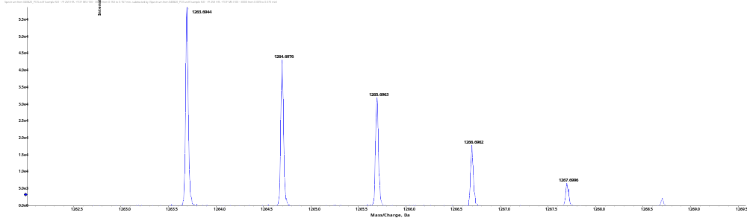
HRMS
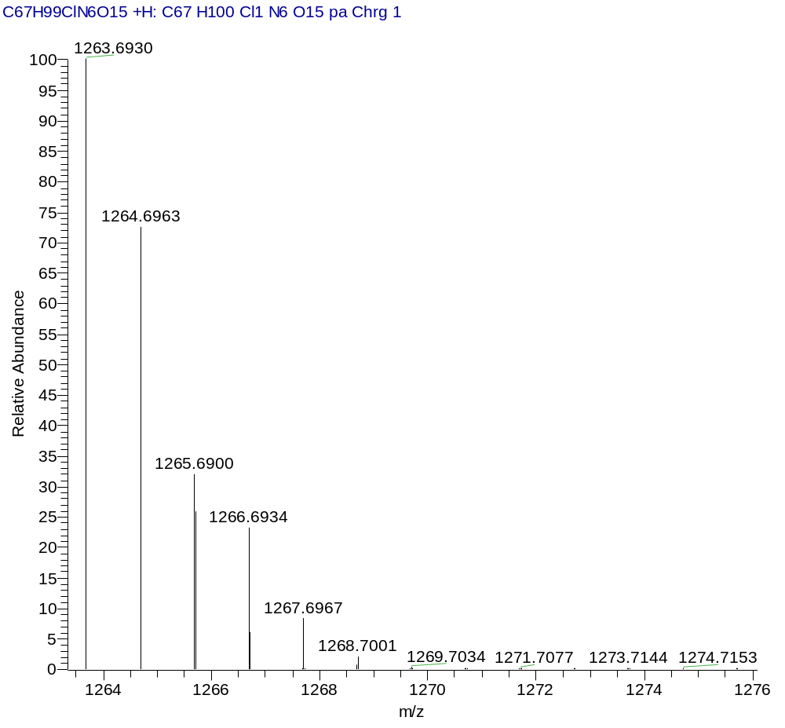
HRMS (Calcd.)
(2S,5S,23S,27S)-5-benzyl-2-(4-(tert-butoxy)-3-chlorobenzyl)-23,27-bis(tert-butoxycarbonyl)-18-(3-chlorobenzyl)-32,32-dimethyl-4,7,10,17,25,30-hexaoxo-31-oxa-3,6,11,18,24,26-hexaazatritriacontan-1-oic acid (9S.f)
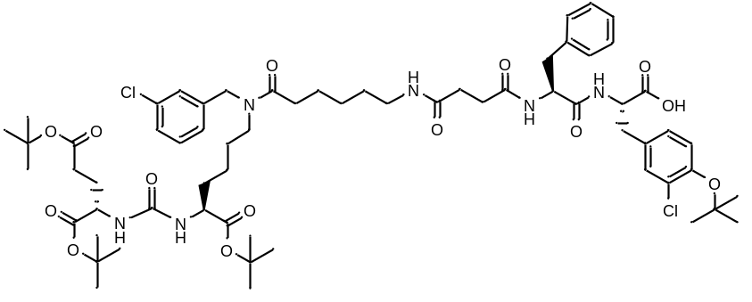
White amorphous solid (145 mg, 54%). ¹H NMR (400 MHz, DMSO-d₆, δ, ppm): 12.70 (br.s., 1 H), 9.97 (s, 1H), 8.22 (d, J=7.40 Hz, 1 H), 8.05 (d, J=8.31 Hz, 1 H), 7.70 - 7.77 (m, 1 H), 7.25 - 7.41 (m, 2 H), 7.09 - 7.24 (m, 8 H), 6.98 (d, J=8.01 Hz, 1 H), 6.84 (d, J=8.25 Hz, 1 H), 6.20 - 6.33 (m, 2 H), 4.54 (m, 1 H), 4.47 (m, 2 H), 4.27 - 4.36 (m, 1 H), 3.96 - 4.06 (m, 1 H), 3.92 (m, 1 H), 3.12 - 3.23 (m, 2 H), 2.91 - 3.01 (m, 4 H), 2.79 - 2.87 (m, 1 H), 2.61 - 2.69 (m, 1 H), 2.34 (m, 1 H), 2.17 - 2.27 (m, 4 H), 2.14 (m, 2 H), 1.81 - 1.90 (m, 1 H), 1.55 - 1.69 (m, 2 H), 1.41 - 1.55 (m, 5 H), 1.37 (c, 26 H), 1.14 - 1.30 (m, 5 H). ESI-APCI-MS m/z 1169.55 (calcd 1169.53 for C₅₉H₈₂Cl₂N₆O₁₄ [M+H]⁺);
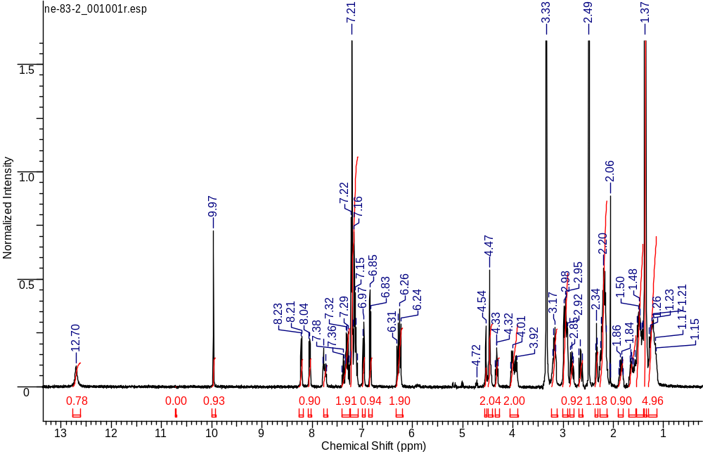
¹H NMR
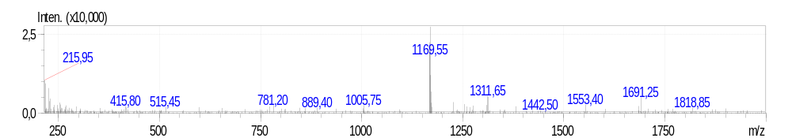
ESI-APCI-MS spectrum
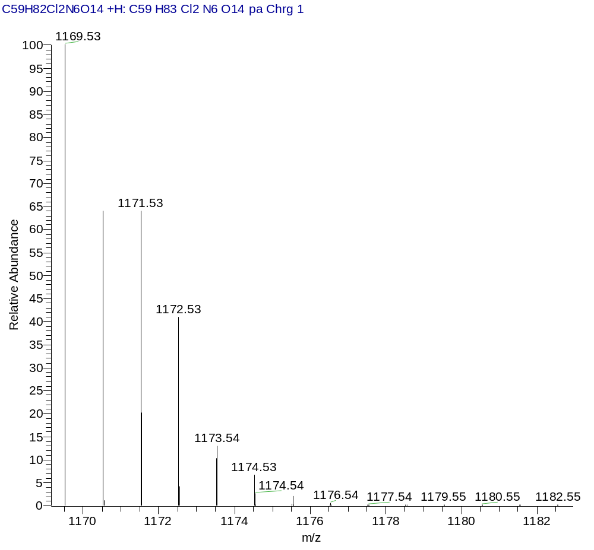
ESI-APCI-MS (Calcd.)
(2S,5S,23S,27S)-5-benzyl-2-(4-bromobenzyl)-23,27-bis(tert-butoxycarbonyl)-18-(3-chlorobenzyl)-32,32-dimethyl-4,7,10,17,25,30-hexaoxo-31-oxa-3,6,11,18,24,26-hexaazatritriacontan-1-oic acid (9S.g)
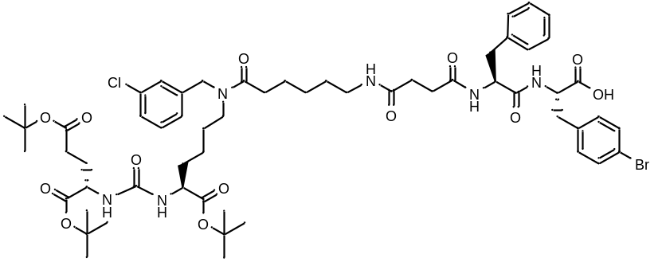
White amorphous solid (235 mg, 72%). ¹H NMR (400 MHz, CDCl₃, δ, ppm): 7.60 (d, J=7.82 Hz, 1 H), 7.48 (d, J=6.60 Hz, 1 H), 7.31 - 7.37 (m, 2 H), 7.31 (d, 1 H), 7.28 - 7.30 (m, 1 H), 7.22 - 7.26 (m, 4 H), 7.12 - 7.19 (m, 3 H), 6.99 - 7.10 (m, 3 H), 4.76 (m, 1 H), 4.70 (m, 1 H), 4.40 - 4.57 (m, 2 H), 4.32 (m, 1 H), 3.34 (m, 1 H), 3.16 - 3.26 (m, 3 H), 3.00 - 3.12 (m, 4 H), 2.69 (m, 1 H), 2.49 - 2.58 (m, 1 H), 2.37 - 2.47 (m, 2 H), 2.23 - 2.37 (m, 3 H), 1.84 – 1.74 (m, 1 H), 1.59 (m, 4 H), 1.40 - 1.47 (m, 31 H), 1.27-1.24 (m, 8 H), 1.17 - 1.25 (m, 2 H). ESI-APCI-MS m/z 1197.45 (calcd 1197.49 for C₅₉H₈₂BrClN₆O₁₂ [M+H]⁺).
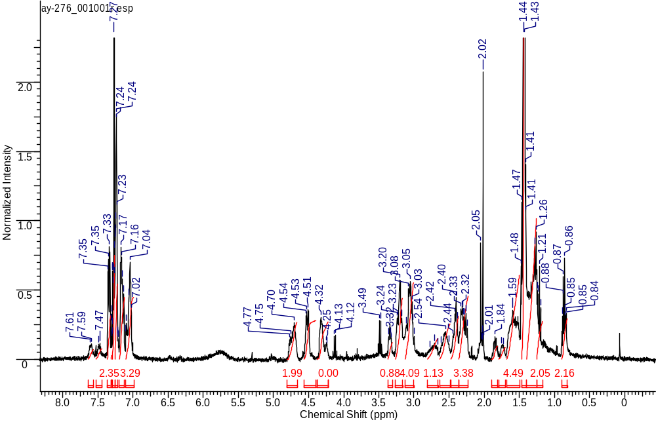
¹H NMR
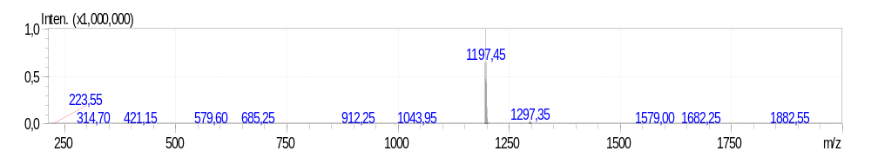
ESI-APCI-MS
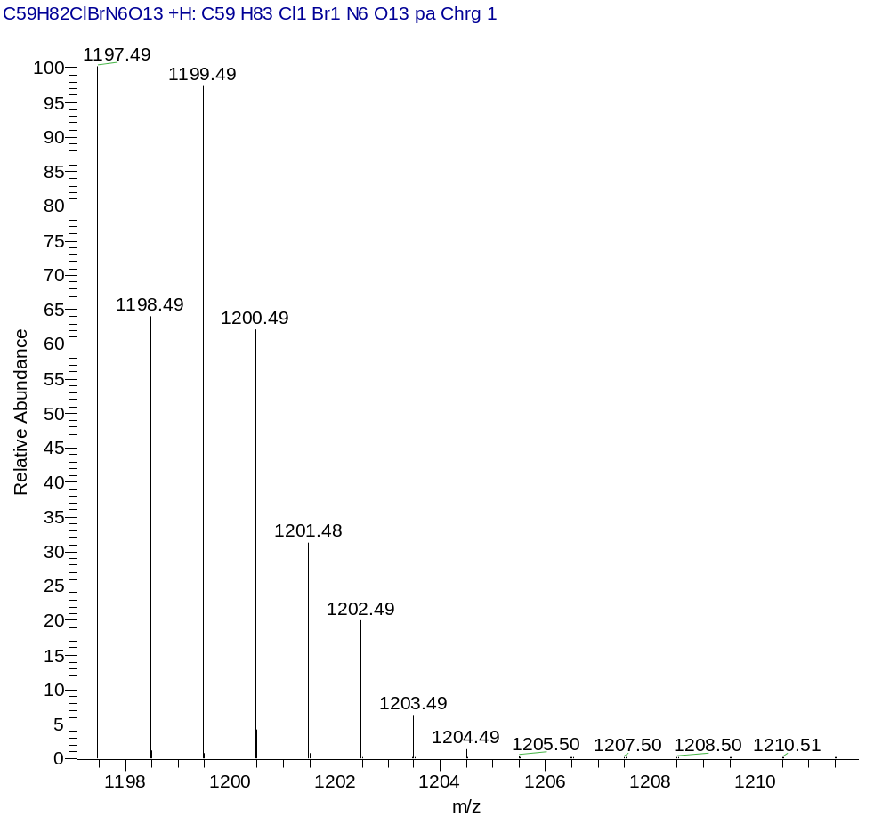
ESI-APCI-MS (Calcd.)
(2S,5S,23S,27S)-5-benzyl-2-(3-bromobenzyl)-23,27-bis(tert-butoxycarbonyl)-18-(3-chlorobenzyl)-32,32-dimethyl-4,7,10,17,25,30-hexaoxo-31-oxa-3,6,11,18,24,26-hexaazatritriacontan-1-oic acid (9S.h)
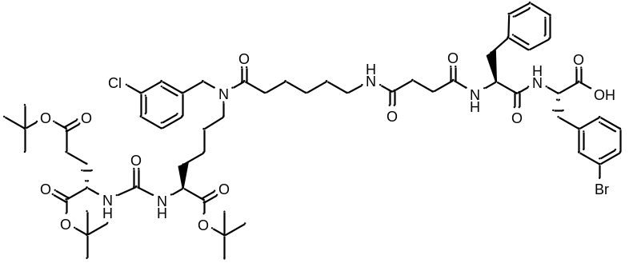
White amorphous solid (417 mg, 98%). ¹H NMR (400 MHz, DMSO-d₆, δ, ppm): 12.72 (уш. s., 1 H), 8.40 (d, J=8.07 Hz, 1 H), 8.02 (d, J=8.62 Hz, 1 H), 7.73 - 7.81 (m, 1 H), 7.57 (d, J=7.95 Hz, 1 H), 7.38 (m, 1 H), 7.25 - 7.35 (m, 4 H), 7.09 - 7.24 (m, 8 H), 6.20 - 6.34 (m, 2 H, NHC(O)NH), 4.39 - 4.57 (m, 4 H), 4.03 (m, 1 H), 3.94 (m, 1 H), 3.25 (m, 1 H), 3.13 - 3.22 (m, 2 H), 2.91 - 3.05 (m, 4 H), 2.58 - 2.67 (m, 1 H), 2.33 (m, 1 H), 2.10 - 2.25 (m, 6 H), 1.80 - 1.90 (m, 1 H), 1.66 - 1.57 (m, 1 H), 1.52 (m, 2 H), 1.45 (m, 3 H), 1.37 (s, 27H), 1.28 (m, 2 H), 1.21 (m, 2 H), 1.15 (m, 1 H). ESI-APCI-MS m/z 1197.40 (calcd 1197.49 for C₆₂H₈₈ClBrN₁₀O₁₃ [M+H]⁺).
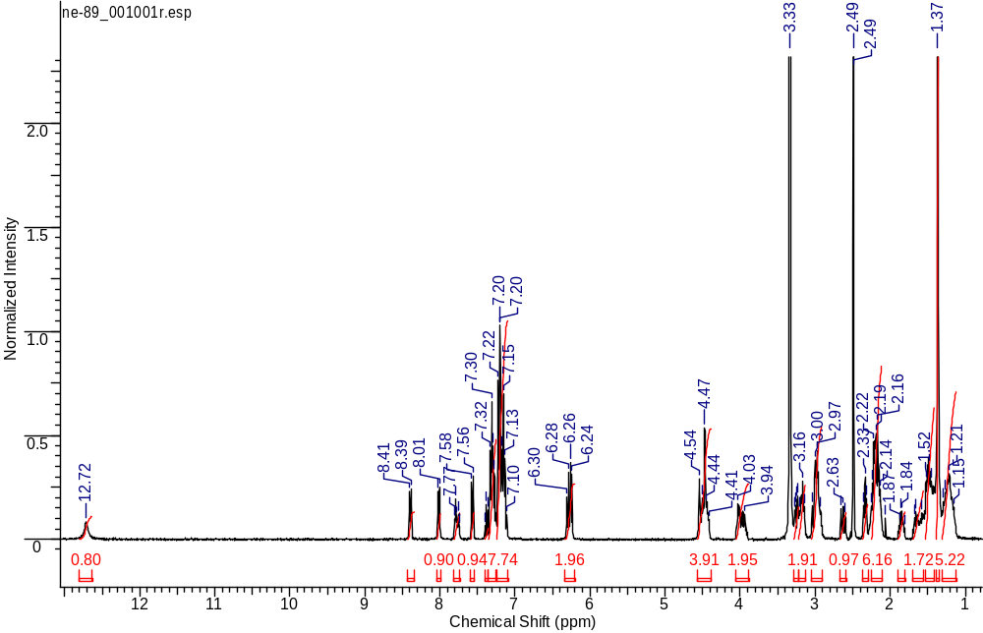
¹H NMR
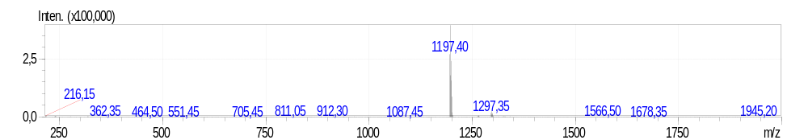
ESI-APCI-MS spectrum
HRMS (Calcd.)
(2S,5S,23S,27S)-5-benzyl-2-(2-bromobenzyl)-23,27-bis(tert-butoxycarbonyl)-18-(3-chlorobenzyl)-32,32-dimethyl-4,7,10,17,25,30-hexaoxo-31-oxa-3,6,11,18,24,26-hexaazatritriacontan-1-oic acid (9S.i)
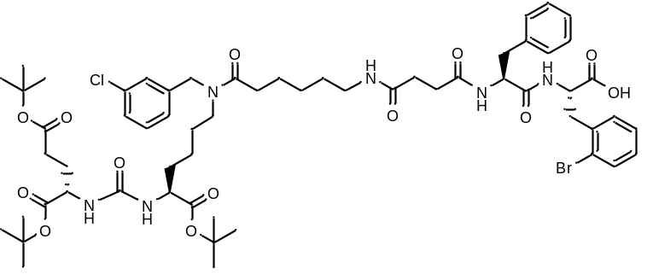
White amorphous solid (373 mg, 91%). ¹H NMR (400 MHz, DMSO-d₆, δ, ppm): .): 12.77 (br.s., 1 H), 8.29 (d, J=7.89 Hz, 1 H, NHC(O)), 8.05 (d, J=8.68 Hz, 1 H, NHC(O)), 7.72 - 7.79 (m, 1 H), 7.43 – 7.42 (m, 1 H), 7.35 - 7.41 (m, 1 H), 7.26 - 7.34 (m, 2 H), 7.21 (d, J=7.15 Hz, 7 H), 7.09 - 7.17 (m, 2 H), 6.22 - 6.31 (m, 2 H), 4.54 (m, 1 H), 4.47 (m, 2 H), 4.37 - 4.44 (m, 1 H, CH), 4.02 (d, J=5.62 Hz, 1 H), 3.92 (m., 1 H), 3.13 - 3.23 (m, 2 H), 3.07 (m, J=13.48, 5.29 Hz, 1 H), 2.90 - 3.01 (m, 4 H), 2.61 - 2.69 (m, 1 H), 2.34 (t, J=7.24 Hz, 1 H), 2.12 - 2.28 (m, 7 H), 2.06 (m, 1 H), 1.79 - 1.91 (m, 1 H), 1.57 - 1.71 (m, 1 H), 1.47 (m, 5 H), 1.37 (s, 29 H₃ + SH₂), 1.27 (m, J=7.58 Hz, 2 H), 1.21 - 1.15 (m, 1 H). ESI-APCI-MS m/z 1197.40 (calcd 1197.49 for C₅₉H₈₂ClBrN₆O₁₃ [M+H]⁺).
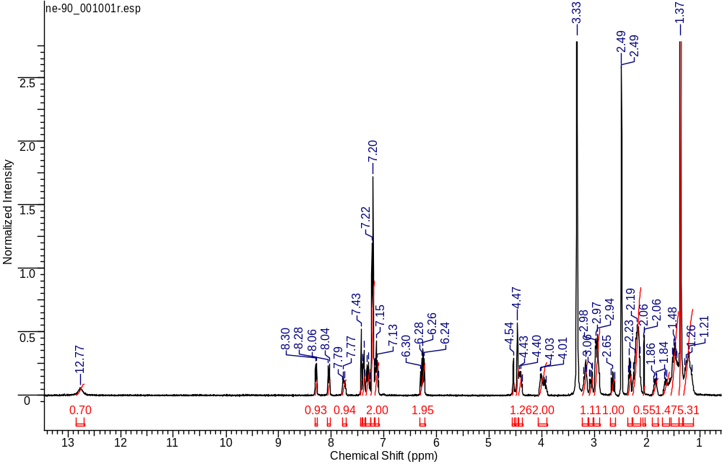
¹H NMR
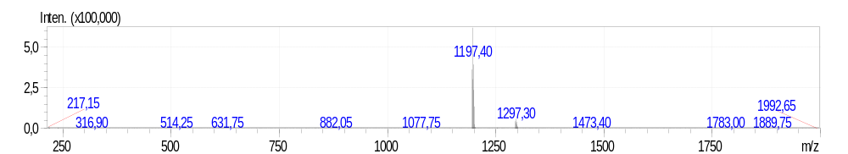
ESI-APCI-MS spectrum
ESI-APCI-MS (Calcd.)
(2R,5R,23S,27S)-5-benzyl-2-(4-bromobenzyl)-23,27-bis(tert-butoxycarbonyl)-18-(3-chlorobenzyl)-32,32-dimethyl-4,7,10,17,25,30-hexaoxo-31-oxa-3,6,11,18,24,26-hexaazatritriacontan-1-oic acid (9S.j)
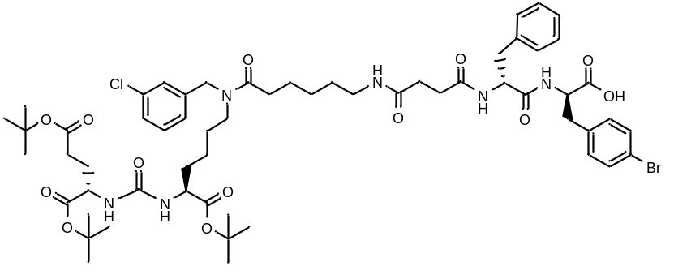
White amorphous solid (157 mg, 43%). ¹H NMR (400 MHz, DMSO-d₆, δ, ppm): 8.29 (d, J=7.21 Hz, 1 H), 8.18 (d, J=8.07 Hz, 1 H), 7.90 - 7.98 (m, 1 H), 7.55 - 7.66 (m, 1 H), 7.45 (d, J=8.01 Hz, 2 H), 7.35 - 7.40 (m, 1 H), 7.27 - 7.34 (m, 2 H), 7.18 - 7.25 (m, 4 H), 7.05 - 7.18 (m, 6 H), 6.21 - 6.33 (m, 2 H), 4.54 (s, 1 H), 4.46 (s, 1 H), 4.33 - 4.40 (m, 1 H), 4.28 – 4.26 (m, 1 H), 3.82 - 4.05 (m, 2 H), 3.11 - 3.27 (m, 4 H), 2.81 - 3.11 (m, 8 H), 2.61 - 2.69 (m, 1 H), 2.09 - 2.38 (m, 9 H), 1.80 - 1.89 (m, 1 H), 1.67 (m., 1 H), 1.59 – 1.56 (d, J=6.97 Hz, 3 H), 1.50 - 1.41 (m, 2 H), 1.36 (s, 28 H), 1.30 (m, 1 H), 1.22 (m, 3 H), 1.16 (m, 1 H). ESI-APCI-MS m/z 1197.4 (calcd 1197.5 for C₆₂H₈₈ClBrN₁₀O₁₃ [M+H]⁺).
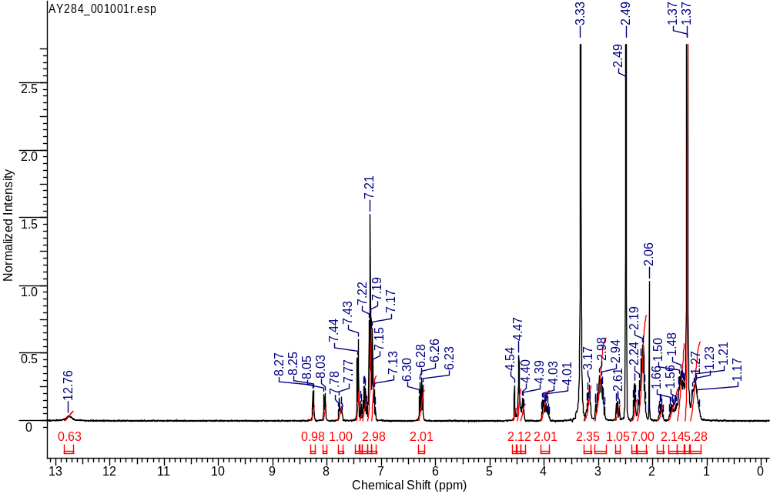
¹H NMR
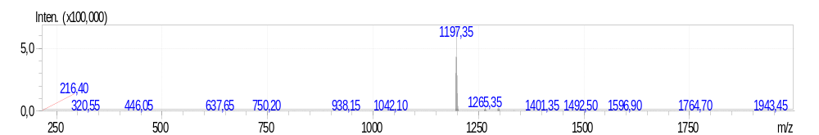
HRMS
General procedure for the synthesis of compounds 4S
Ligand without APA-fragment was dissolved in 30 ml of DMF and cooled to 0°C. The order of adding reagents in this reaction is crucial, thus eliminating the side reaction of terminal amino acid residue racemization. Reagents were added in the following sequence: 3-azido-1-propanamine (1.5 eq.), HOBt (1.2 eq.), HBTU (1.2 eq.), DIPEA (1.5 eq.). Reaction mixture was stirred for 24 hours. At the end of the reaction solvent was removed under reduced pressure and extracted using the system DCM : water. Then the solvent was removed under reduced pressure and the product was isolated using the column chromatography method with the reverse phase.
(3S,7S,25R,28S)-tri-tert-butyl 33-azido-25-benzyl-28-(3-bromo-4-hydroxybenzyl)-12-(3-chlorobenzyl)-5,13,20,23,26,29-hexaoxo-4,6,12,19,24,27,30-heptaazatritriacontane-1,3,7-tricarboxylate (4S.a)
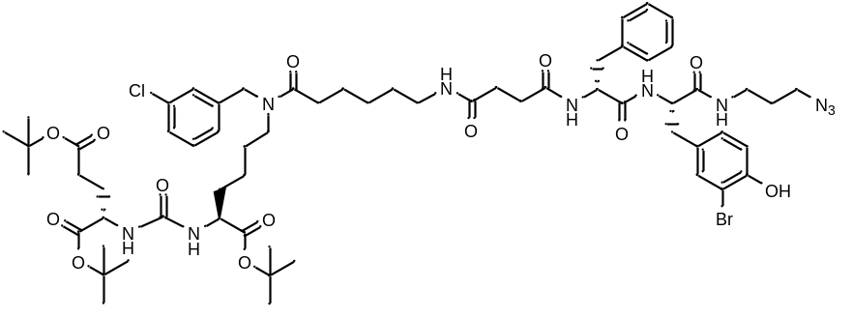
White amorphous solid (200 mg, 63%). ¹H NMR (400 MHz, DMSO-d₆, δ, ppm): 7.72 – 7.47 (m, 2 H), 7.02 - 7.24 (m, 7 H), 6.87 - 7.02 (m, 2 H), 4.45 - 4.54 (m, 2 H), 4.25 - 4.40 (m, 2 H), 3.10 - 3.38 (m, 8 H), 2.97 (s, 3 H), 2.22 - 2.43 (m, 4 H), 1.99 - 2.12 (m, 2 H), 1.67 - 1.80 (m, 3 H), 1.50 - 1.67 (m, 6 H), 1.38 - 1.47 (m, 29 H), 1.18 - 1.38 (m, 6 H), 1.18 - 1.38 (m, 5 H), 1.18 - 1.38 (m, 5 H). HRMS (ESI) m/z 1295.5523 (calcd 1295.5477 for C₆₂H₈₈ClBrN₁₀O₁₃ [M+H]⁺).
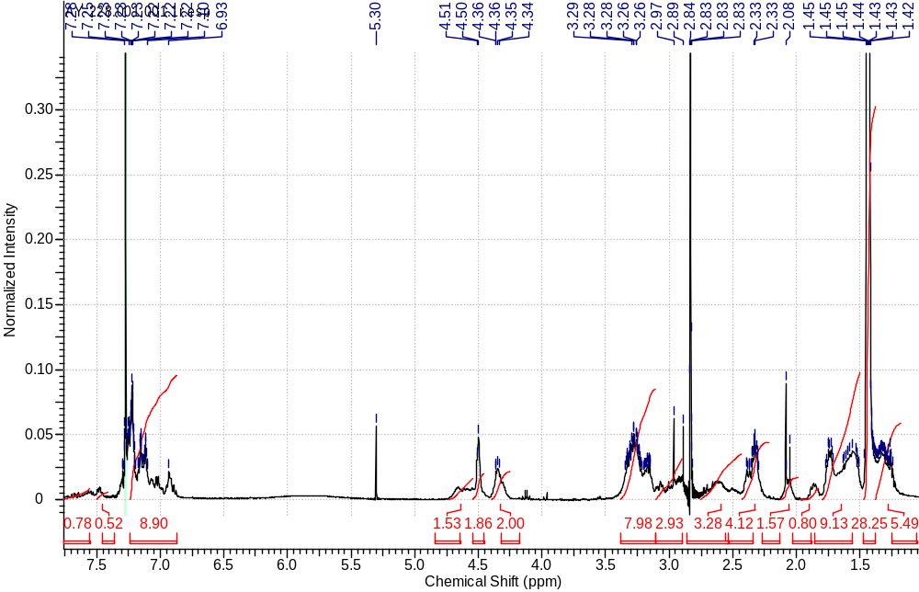
¹H NMR
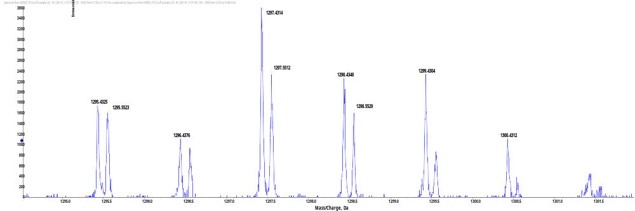
HRMS
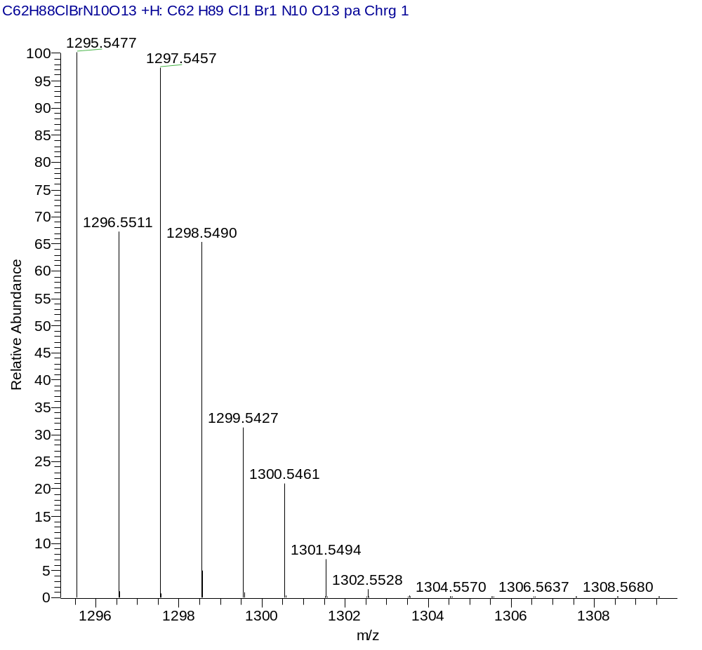
(3S,7S,25R,28S)-tri-tert-butyl 33-azido-25-benzyl-12-(3-chlorobenzyl)-28-(3,4-dihydroxybenzyl)-5,13,20,23,26,29-hexaoxo-4,6,12,19,24,27,30-heptaazatritriacontane-1,3,7-tricarboxylate (4S.b)
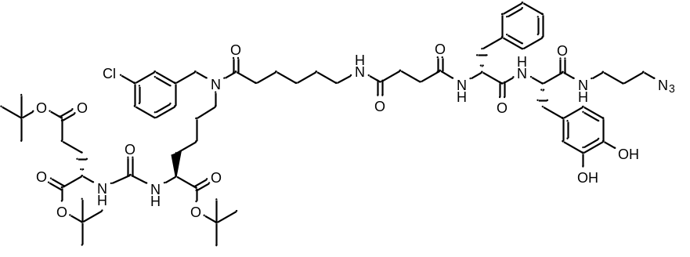
White amorphous solid (240 mg, 65%). ¹H NMR (400 MHz, DMSO-d₆, δ, ppm): 7.18 - 7.25 (m, 3 H), 7.11 - 7.18 (m, 3 H), 6.48 (m, 1 H), 5.71 (m, 1 H), 4.51 (m, 3 H), 4.35 (m, 2 H), 3.25 (m, 5 H), 3.12 (m, 3 H), 3.03 (m, 1 H), 2.52 (m, 2 H), 2.31 (m, 6 H), 1.73 (m, 4 H), 1.59 (m, 5 H), 1.40 - 1.47 (m, 28 H), 1.29 (m, 4 H). HRMS (ESI) m/z 1255.6180 (calcd 1255.6140 for C₆₂H₈₉ClN₁₀O₁₄ [M+Na]⁺).
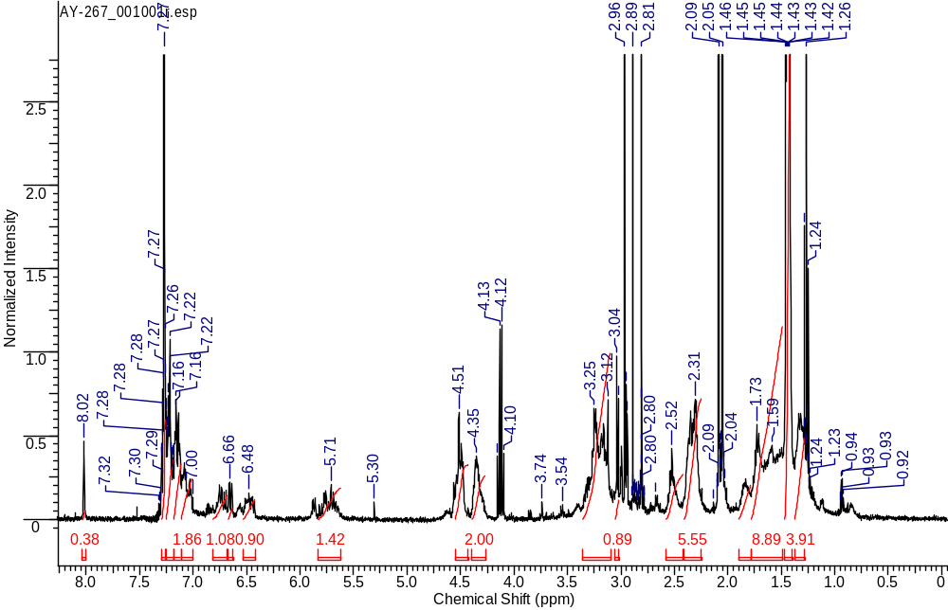
¹H NMR
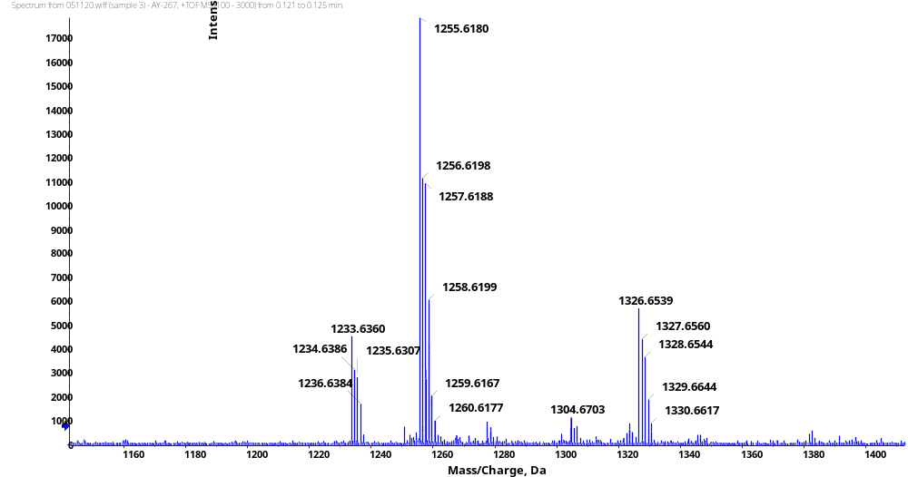
HRMS
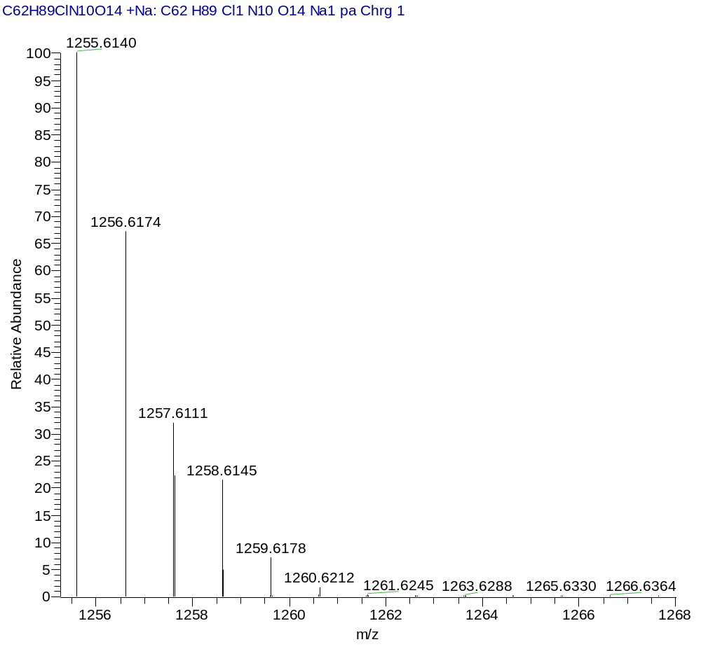
HRMS (Calcd.)
(3S,7S,25S,28S)-tri-tert-butyl 33-azido-25-benzyl-12-(3-chlorobenzyl)-28-(4-hydroxy-3-nitrobenzyl)-5,13,20,23,26,29-hexaoxo-4,6,12,19,24,27,30-heptaazatritriacontane-1,3,7-tricarboxylate (4S.c)
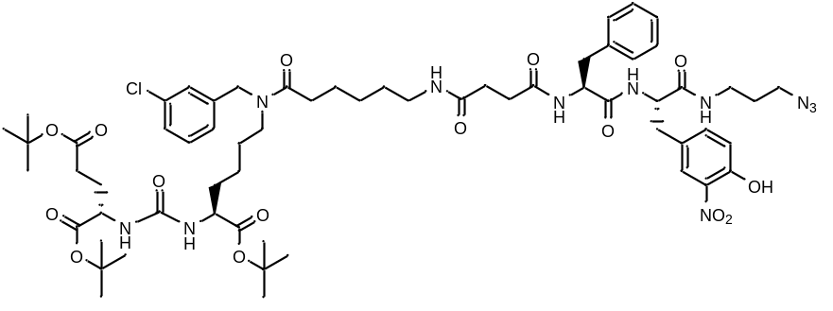
White amorphous solid (333 mg, 87%). ¹H NMR (400 MHz, DMSO-d₆, δ, ppm): 10.78 (s, 1 H), 8.24 (d., J=7.3 Hz, 1 H), 8.19 (d., J=8.3 Hz, 1 H), 7.89 – 7.94 (m, 1 H), 7.73 (br.s., 1 H), 7.67 (m, 1 H), 7.38 (d, J=3.18 Hz, 1 H), 7.26 - 7.36 (m, 2 H), 7.18 - 7.25 (m, 3 H), 7.15 (d, J=5.38 Hz, 4 H), 7.03 (d, J=8.50 Hz, 1 H), 6.28 – 6.30 (m, 1 H), 6.25 (d, J=8.4 Hz, 1 H), 4.54 (s, 1 H), 4.46 (s, 1 H), 4.35 – 4.36 (m, 1 H), 4.28 – 4.33 (m, 1 H), 3.99 – 4.04 (m, 1 H), 3.94 – 3.97 (m, 1 H), 3.22 - 3.29 (m, 2 H), 3.15 – 3.20 (m, 2 H), 3.02 - 3.12 (m, 3 H), 2.95 - 3.01 (m, 3 H), 2.85 – 2.91 (m, 3 H), 2.66 – 2.69 (m, 2 H), 2.27 - 2.38 (m, 3 H), 2.11 - 2.27 (m, 5 H), 1.82 – 1.88 (m, 1 H), 1.57 – 1.67 (m, 4 H), 1.45 (m, 5 H), 1.31 - 1.41 (m, 27 H), 1.21 – 1.30 (m, 4 H). HRMS (ESI) m/z 1262.6244 (calcd 1262.6223 for C₆₂H₈₈ClN₁₁O₁₅ [M+H]⁺).
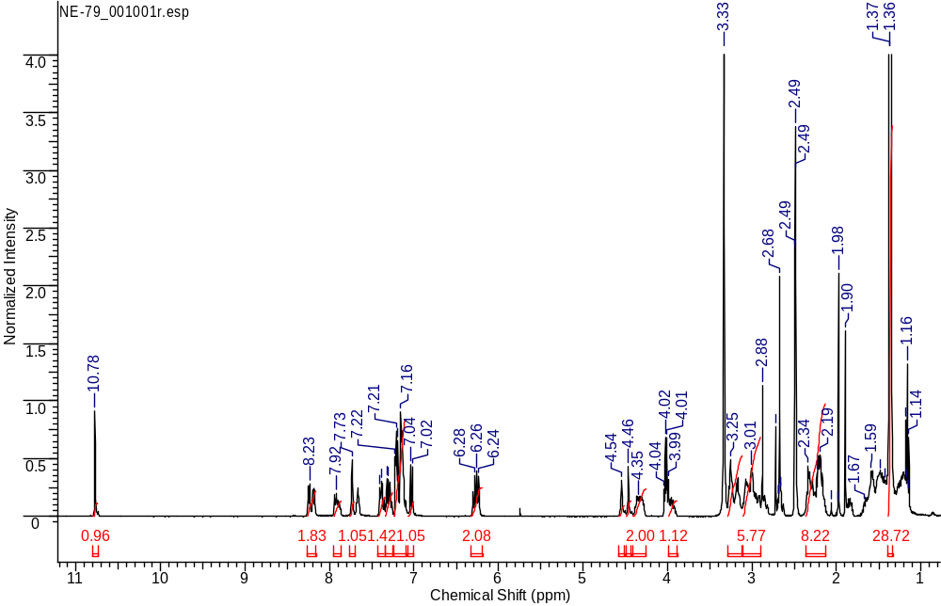
¹H NMR
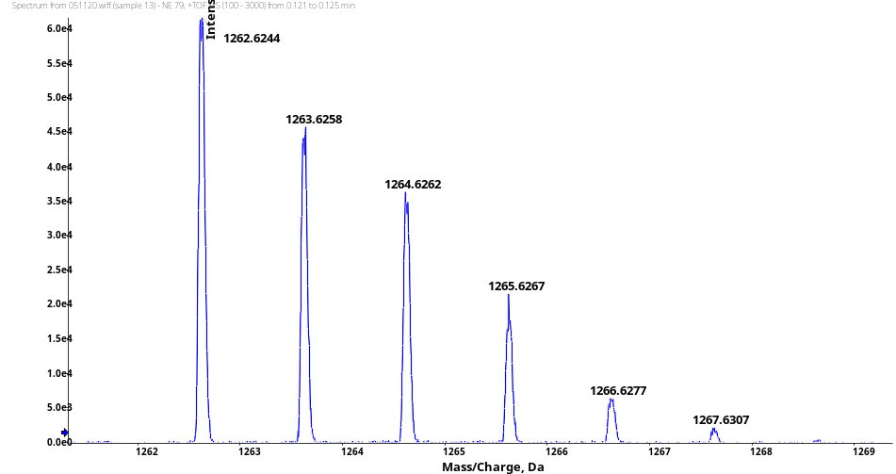
HRMS
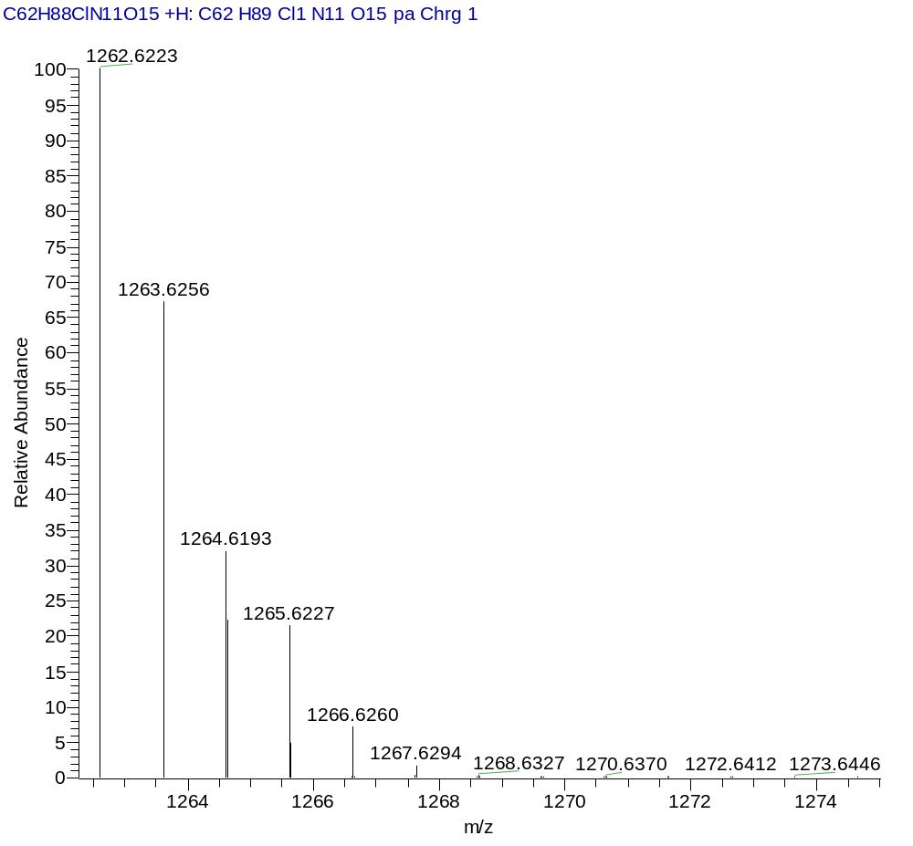
HRMS (Calcd.)
(3S,7S,25R,28R)-tri-tert-butyl 33-azido-25-benzyl-12-(3-chlorobenzyl)-28-(4-hydroxy-3-nitrobenzyl)-5,13,20,23,26,29-hexaoxo-4,6,12,19,24,27,30-heptaazatritriacontane-1,3,7-tricarboxylate (4S.d)
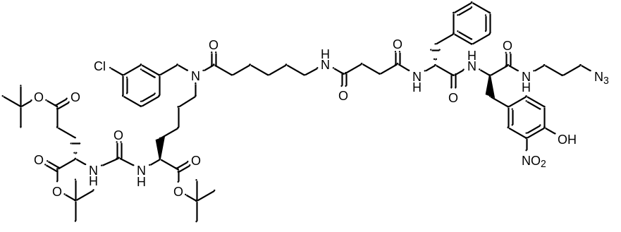
White amorphous solid (273 mg, 71%). ¹H NMR (400 MHz, DMSO-d₆, δ, ppm): 10.75 (s, 1 H), 8.42 (d, 1 H), 8.10 (d, 1 H), 7.99 (d, 1 H), 7.71 - 7.83 (m, 2 H), 7.26 - 7.39 (m, 3 H), 7.22 (m, 1 H), 7.06 - 7.19 (m, 6 H), 6.99 (d, 1 H, d, J=8.50 Hz), 6.22 - 6.32 (m, 2 H), 4.54 (m, 1 H), 4.46 (m, 1 H), 4.35 (m, 2 H), 3.29 (m, 2 H), 3.16 (m, 4 H), 2.95 (m, 3 H), 2.33 (m, 1 H), 2.13 - 2.27 (m, 7 H), 1.36 (m, 29 H). HRMS (ESI) m/z 1262.6278 (calcd 1262.6227 for C₆₂H₈₈ClN₁₁O₁₅ [M+H]⁺).
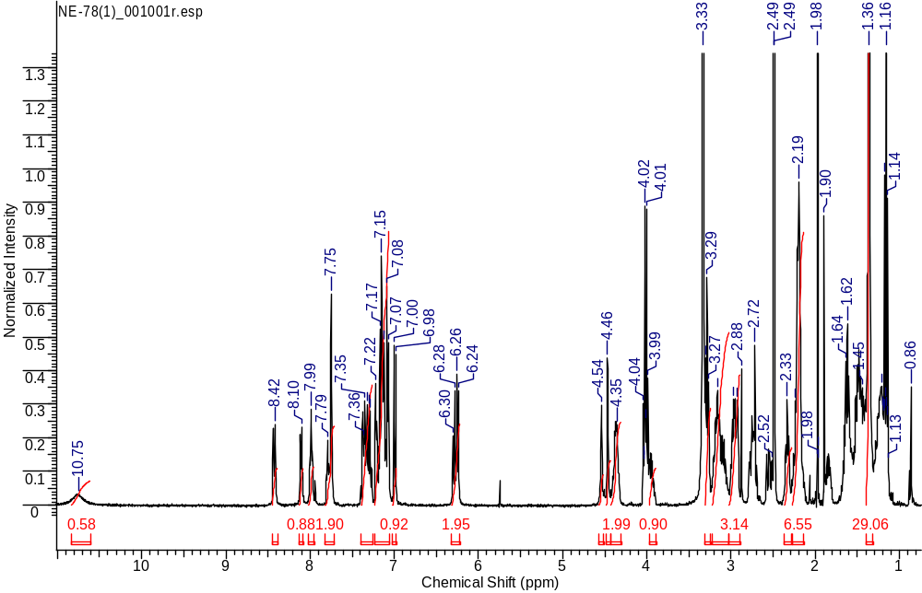
¹H NMR
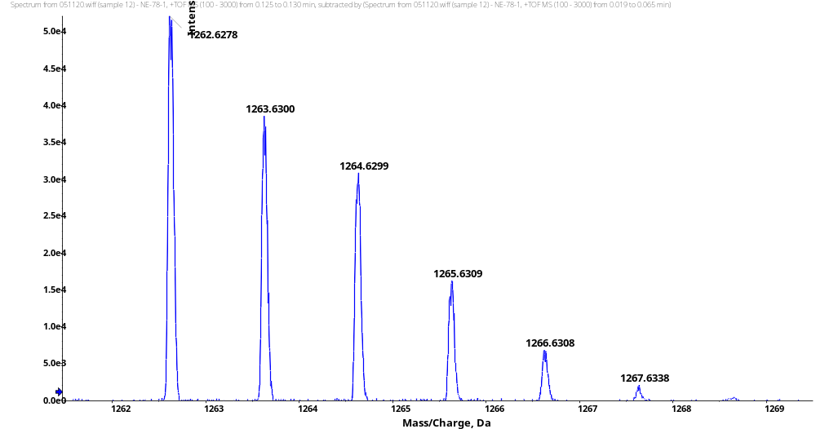
HRMS
HRMS (Calcd.)
General procedure for the synthesis of compounds 10S
tBu-ligand (1 eq.) was dissolved in a solution of trifluoroacetic acid, DCM, distilled water and triisopropylsilane (46.25 : 46.25 : 5 : 2.5) and stirred for 3 hours at room temperature. The solvent was removed under reduced pressure. The resulting substance was re-evaporated 3 times from DCM. To the resulting oily residue 5 ml of diethyl ether was added. As a result white solid product was released. The ether was decanted and the procedure was repeated 2 times. The product was isolated using the column chromatography method with the reverse phase (Puriflash C18 15μ 20g, eluent: acetonitrile-water system: from 10% acetonitrile to 100% in 20 minutes).
(2R,5S,23S,27S)-2,5-bis(4-(tert-butoxy)benzyl)-23,27-bis(tert-butoxycarbonyl)-18-(3-chlorobenzyl)-32,32-dimethyl-4,7,10,17,25,30-hexaoxo-31-oxa-3,6,11,18,24,26-hexaazatritriacontan-1-oic acid (10S.a)
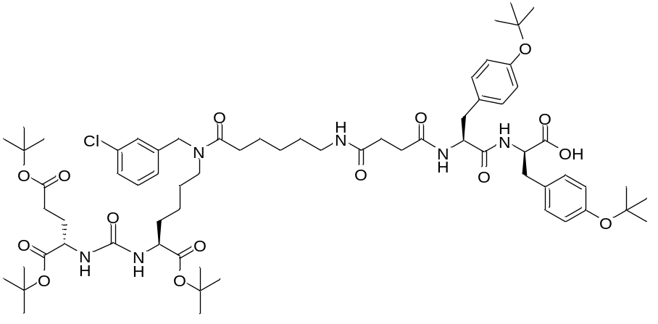
White amorphous solid (186 mg, 95%). ¹H NMR (400 MHz, DMSO-d₆, δ, ppm): 8.36 (d, J=8.38 Hz, 1 H, NHC(O)), 8.05 (d, J=7.76 Hz, 1 H, NHC(O)), 7.96 (t, J=5.59 Hz, 1 H, NHC(O)), 7.72 - 7.80 (m, 1 H, NHC(O)), 7.26 - 7.41 (m, 2 H), 7.19 - 7.23 (m, 1 H), 7.08 - 7.15 (m, 3 H), 6.98 (d, J=8.01 Hz, 2 H), 6.78 (d, J=8.19 Hz, 2 H), 6.82 (d, J=8.31 Hz, 2 H), 6.78 (d, J=8.2 Hz, 2 H), 6.21 - 6.32 (m, 2 H), 4.54 (c, 1 H), 4.46 (c, 1 H), 4.31 - 4.43 (m, 2 H), 3.89 - 4.07 (m, 2 H), 3.27 (t, J=6.79 Hz, 2 H), 3.14 - 3.19 (m, 2 H), 3.02 – 3.09 (m, 1 H), 2.96 – 2.98 (m, 1 H), 2.91 – 2.93 (m, 2 H), 2.65 - 2.73 (m, 1 H), 2.58 - 2.65 (m, 1 H), 2.30 - 2.36 (m, 1 H), 2.20 - 2.24 (m, 3 H), 2.12 - 2.20 (m, 4 H), 1.79 - 1.90 (m, 1 H), 1.56 - 1.69 (m, 4 H), 1.44 – 1.52 (m, 4 H), 1.40 - 1.45 (m, 2 H), 1.33 - 1.39 (m, 28 H), 1.13 - 1.30 (m, 23 H). HRMS (ESI) m/z 1345.7594 (calcd 1345.7573 for C₇₀H₁₀₅ClN₁₀O₁₄ [M+H]⁺); m/z 1367.7422 (calcd 1367.7392 for C₇₀H₁₀₅ClN₁₀O₁₄ [M+Na]⁺).

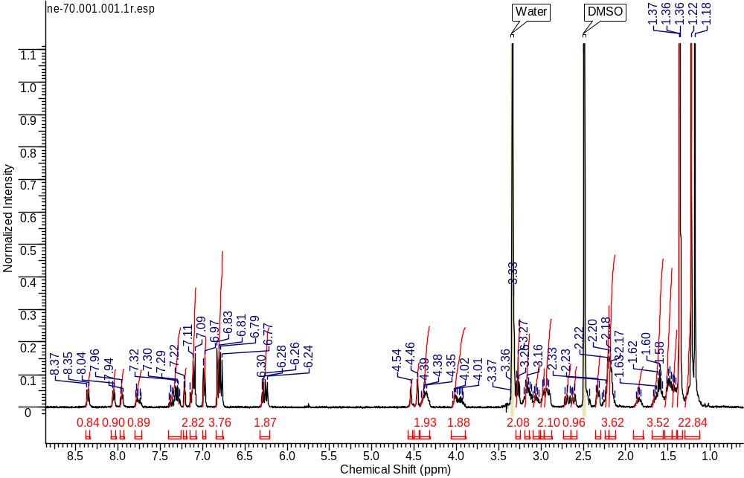
¹H NMR
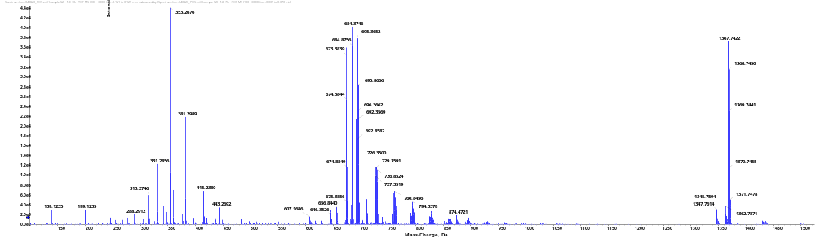
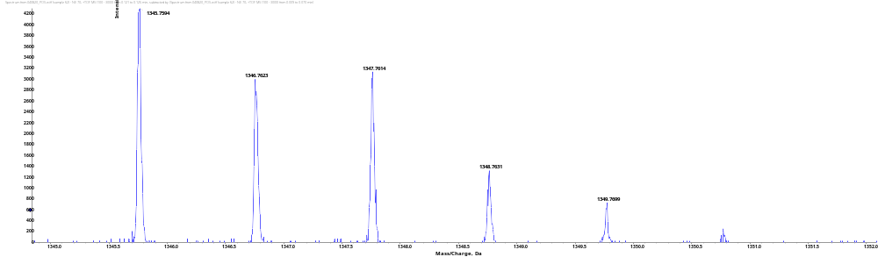
HRMS
(3S,7S,25S,28R)-tri-tert-butyl 33-azido-28-benzyl-25-(4-(tert-butoxy)benzyl)-12-(3-chlorobenzyl)-5,13,20,23,26,29-hexaoxo-4,6,12,19,24,27,30-heptaazatritriacontane-1,3,7-tricarboxylate (10S.b)
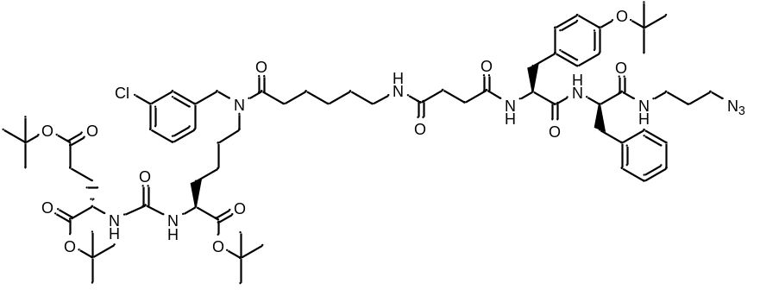
White amorphous solid (121 mg, 95%). ¹H NMR (400 MHz, DMSO-d₆, δ, ppm): 7.18 - 7.26 (m, 4 H), 7.15 – 7.17 (m, 2 H), 7.03 - 7.12 (m, 4 H), 6.97 - 7.03 (m, 2 H), 6.86 – 6.90 (m, 1 H), 6.73 (m, 1 H), 6.57 (m, 1 H), 5.98 (d, J=8.07 Hz, 1 H), 5.74 - 5.88 (m, 1 H), 4.62 – 4.70 (m, 1 H), 4.44 - 4.55 (m, 2 H), 4.35 - 4.44 (m, 1 H), 4.28 - 4.35 (s, 1 H), 4.25 – 4.29 (m, 1 H), 3.69 - 3.76 (m, 1 H), 3.51 - 3.57 (m, 1 H), 3.29 - 3.40 (m, 2 H), 3.20 - 3.29 (m, 1 H), 3.10 - 3.20 (m, 4 H), 2.97 - 3.10 (m, 2 H), 2.93 - 2.97 (m, 1 H), 2.84 - 2.93 (m, 1 H), 2.41 - 2.54 (m, 3 H), 2.32 - 2.41 (m, 2 H), 2.21 - 2.32 (m, 2 H), 1.97 - 2.12 (m, 2 H), 1.78 - 1.90 (m, 1 H), 1.69 - 1.78 (m, 1 H), 1.63 - 1.69 (m, 3 H), 1.55 - 1.63 (m, 2 H), 1.47 - 1.55 (m, 3 H), 1.39 - 1.47 (m, 27 H), 1.33 - 1.39 (m, 1 H), 1.28 – 1.33 (m, 12 H). HRMS (ESI) m/z 1273.7041 (calcd 1273.6998 for C₆₆H₉₇ClN₁₀O₁₃ [M+H]⁺); m/z 1295.6870 (calcd 1295.6817 for C₆₆H₉₇ClN₁₀O₁₃ [M+Na]⁺).
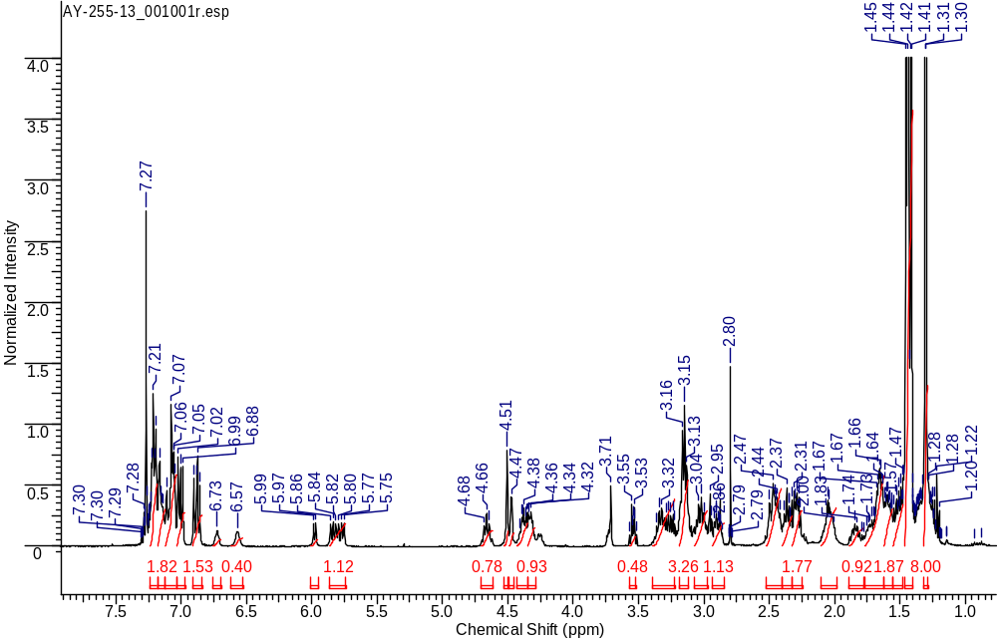
¹H NMR
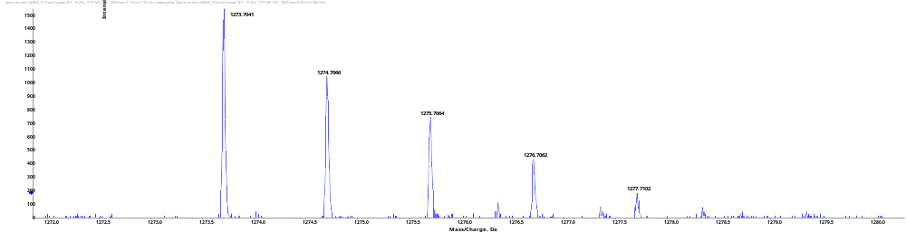
HRMS [M+H]⁺
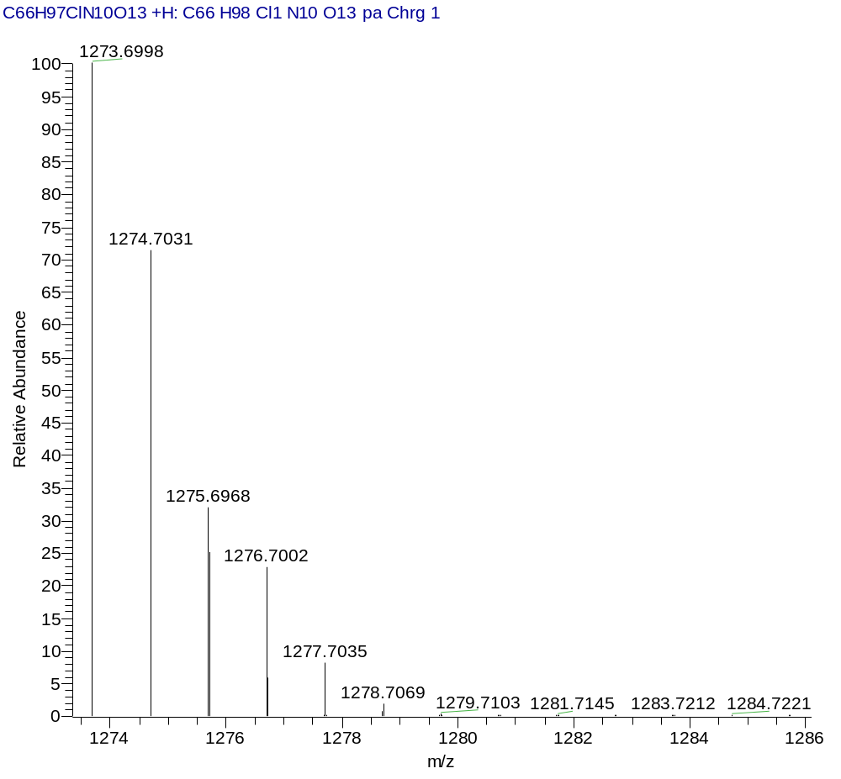
HRMS (Calcd.)
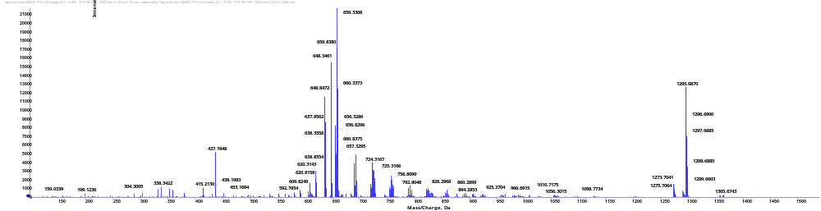
HRMS [M+Na]⁺
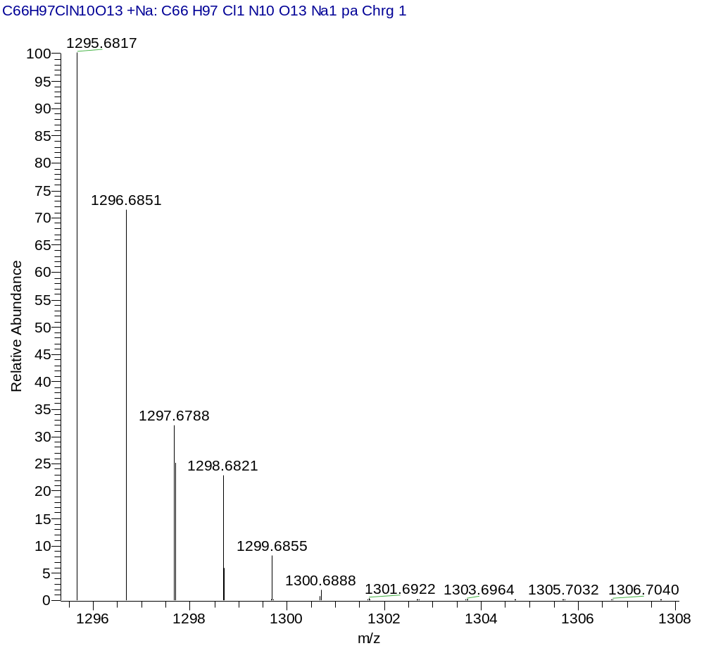
HRMS (Calcd.)
(3S,7S,25R,28S)-tri-tert-butyl 33-azido-25,28-bis(4-(tert-butoxy)benzyl)-12-(3-chlorobenzyl)-5,13,20,23,26,29-hexaoxo-4,6,12,19,24,27,30-heptaazatritriacontane-1,3,7-tricarboxylate (10S.c)
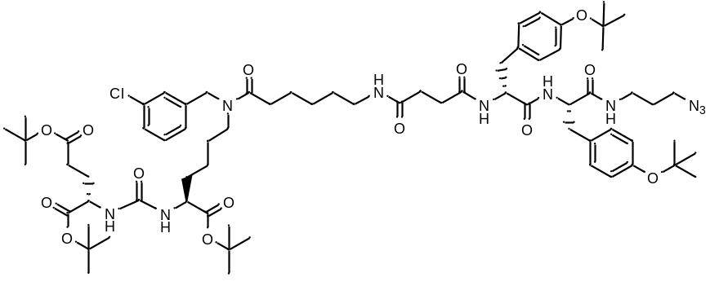
White amorphous solid (181 mg, 83%). ¹H NMR (400 MHz, DMSO-d₆, δ, ppm): 8.27 (d, J=6.65 Hz, 1 H), 8.00 (d, J=8.22 Hz, 1 H), 7.88 (m., 1 H), 7.70 (d, J=14.48 Hz, 1 H), 7.22 - 7.38 (m, 2 H), 7.18 – 7.20 (m, 1 H), 7.04 - 7.14 (m, 3 H), 6.97 (d, J=8.22 Hz, 2 H), 6.79 (d, J=8.61 Hz, 2 H), 6.76 (d, J=8.22 Hz, 2 H), 6.17 - 6.28 (m, 2 H), 4.52 (s, 1 ), 4.45 (s, 1 H), 4.28 - 4.41 (m, 2 H), 3.88 - 4.05 (m, 2 H), 3.08 - 3.19 (m, 4 H), 3.01 – 3.07 (m, 2 H), 2.86 - 3.01 (m, 4 H), 2.57 - 2.72 (m, 3 H), 2.31 (t, J=7.24 Hz, 2 H), 2.08 - 2.25 (m, 8 H), 1.77 - 1.89 (m, 2 H), 1.53 - 1.69 (m, 5 H), 1.40 - 1.53 (m, 6 H), 1.35 (s, 27 H), 1.21 (s, 9 H), 1.17 (s, 9 H). ESI-APCI-MS m/z 1345.8 (calcd 1345.8 for C₇₀H₁₀₅ClN₁₀O₁₄ [M+H]⁺).
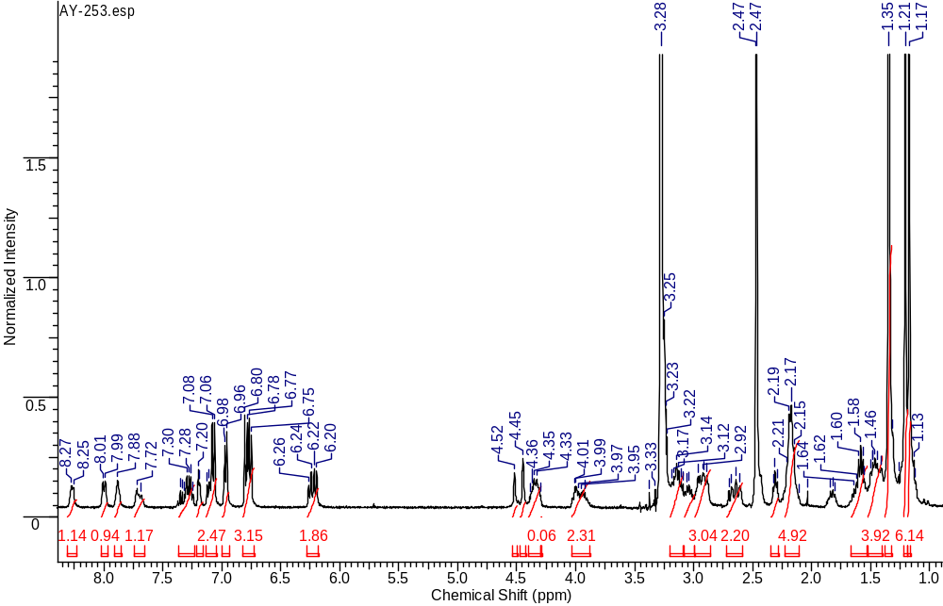
¹H NMR
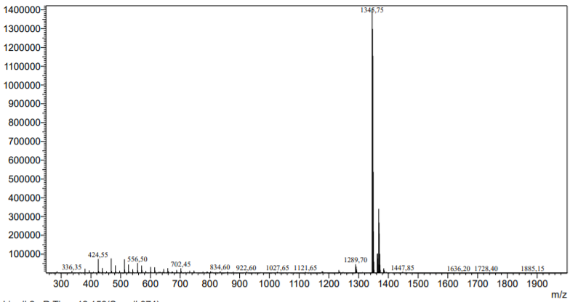
ESI-APCI-MS
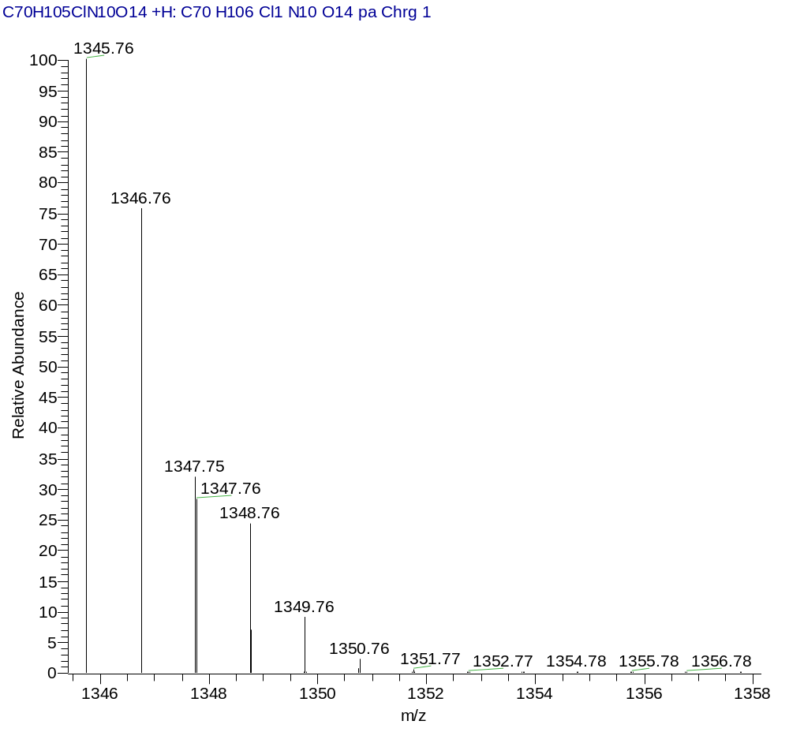
ESI-APCI-MS (Calcd)
(3S,7S,25S,28S)-tri-tert-butyl 33-azido-28-benzyl-25-(4-(tert-butoxy)benzyl)-12-(3-chlorobenzyl)-5,13,20,23,26,29-hexaoxo-4,6,12,19,24,27,30-heptaazatritriacontane-1,3,7-tricarboxylate (10S.d)
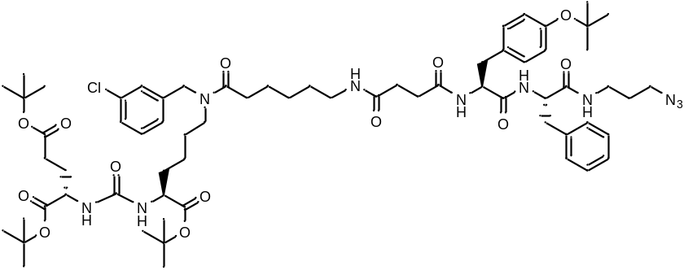
White amorphous solid (144 mg, 78%). ¹H NMR (400 MHz, CDCl₃, δ, ppm): 7.83 (d, J=6.05 Hz, 1 H), 7.18 - 7.26 (m, 3 H), 7.11 – 7.16 (m, 1 H), 7.04 - 7.10 (m, 1 H), 7.01 – 7.03 (m, 1 H), 6.91 - 6.99 (m, 3 H), 6.83 (d, J=8.31 Hz, 2 H), 4.66 - 4.75 (m, 1 H), 4.43 - 4.56 (m, 2 H), 4.31 - 4.39 (m, 2 H), 4.25 - 4.31 (m, 1 H), 3.27 - 3.41 (m, 4 H), 3.10 - 3.27 (m, 5 H), 2.95 - 3.07 (m, 2 H), 2.66 - 2.84 (m, 2 H), 2.48 – 2.56 (m, 1 H), 2.23 - 2.45 (m, 5 H), 2.02 - 2.13 (m, 1 H), 1.80 - 1.91 (m, 1 H), 1.66 - 1.80 (m, 4 H), 1.47 - 1.66 (m, 4 H), 1.33 - 1.47 (m, 31 H), 1.22 - 1.33 (m, 11 H). ). HRMS (ESI) m/z 1274.7055 (calcd 1274.7031 for C₆₆H₉₇ClN₁₀O₁₃ [M+H]⁺); m/z 1295.6874 (calcd 1295.6817 for C₆₆H₉₇ClN₁₀O₁₃ [M+Na]⁺).
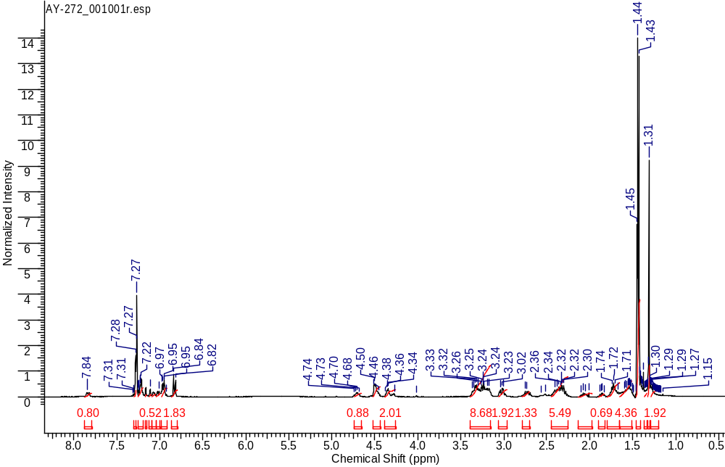
¹H NMR
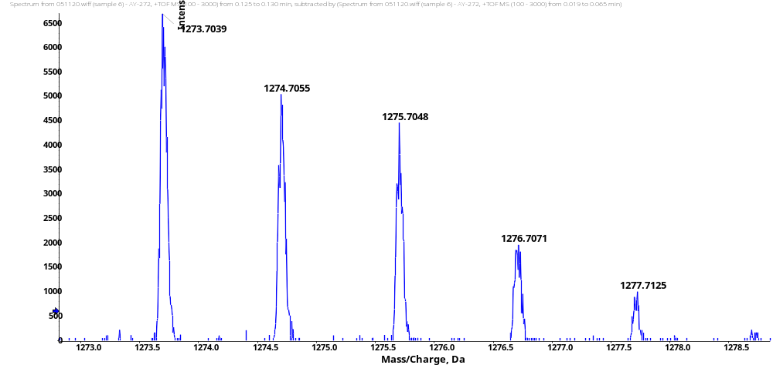
HRMS [M+H]⁺
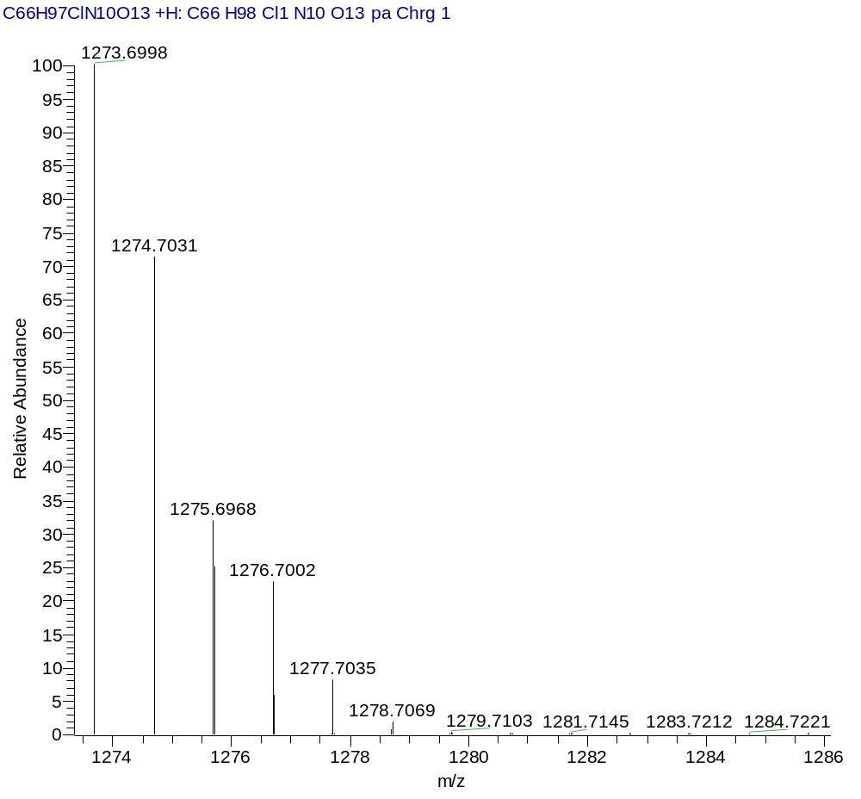
HRMS (Calcd.)
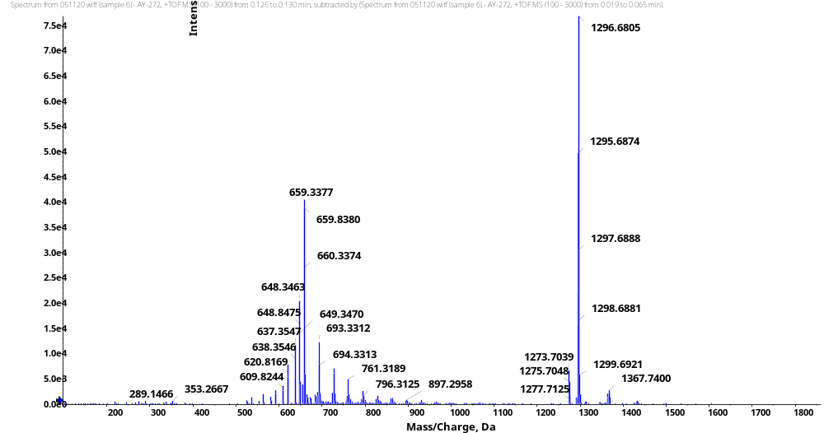
HRMS [M+Na]⁺
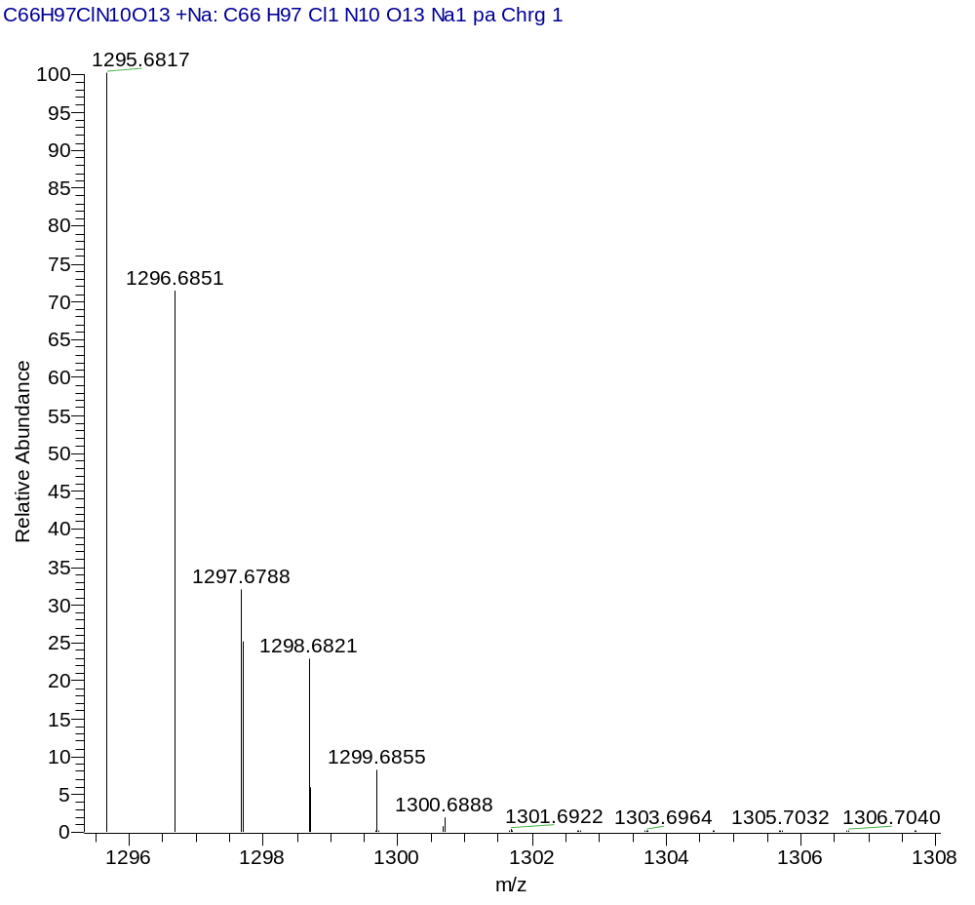
HRMS (Calcd.)
(3S,7S,25S,28S)-tri-tert-butyl 33-azido-25,28-bis(4-(tert-butoxy)benzyl)-12-(3-chlorobenzyl)-5,13,20,23,26,29-hexaoxo-4,6,12,19,24,27,30-heptaazatritriacontane-1,3,7-tricarboxylate (10S.e)
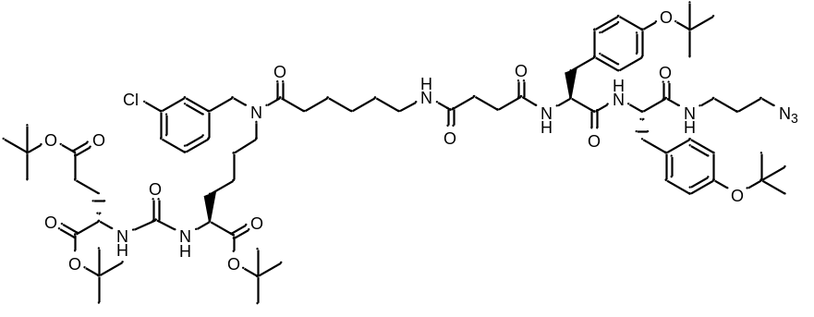
White amorphous solid (130 mg, 77%). ¹H NMR (400 MHz, CDCl₃, δ, ppm): 7.80 (t, J=9.41 Hz, 1 H), 7.20 - 7.25 (m, 1 H), 7.18 (d, J=8.50 Hz, 2 H), 7.05 - 7.15 (m, 2 H), 7.03 (d, J=6.72 Hz, 1 H), 6.98 (d, J=8.13 Hz, 2 H), 6.91 (dd., J=8.34, 1.25 Hz, 2 H), 6.84 - 6.89 (m, 2 H), 4.61 - 4.70 (m, 1 H), 4.47 - 4.57 (m, 2 H), 4.43 – 4.47 (m, 1 H), 4.30 - 4.39 (m, 2 H), 3.25 - 3.40 (m, 6 H), 3.14 - 3.25 (m, 4 H), 2.92 - 3.10 (m, 2 H), 2.64 - 2.73 (m, 2 H), 2.43 - 2.60 (m, 2 H), 2.28 - 2.43 (m, 5 H), 2.01 - 2.12 (m, 1 H), 1.82 - 1.92 (m, 1 H), 1.66 - 1.80 (m, 4 H), 1.48 - 1.66 (m, 4 H), 1.40 - 1.48 (m, 28 H), 1.34 - 1.40 (m, 2 H), 1.24 - 1.34 (m, 20 H). HRMS (ESI) m/z 1345.7580 (calcd 1345.7573 for C₇₀H₁₀₅ClN₁₀O₁₄ [M+H]⁺); m/z 1367.7420 (calcd 1367.7392 for C₇₀H₁₀₅ClN₁₀O₁₄ [M+Na]⁺).

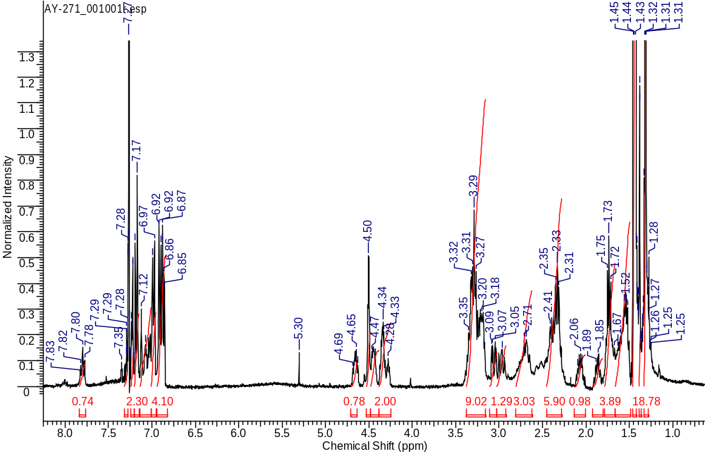
¹H NMR
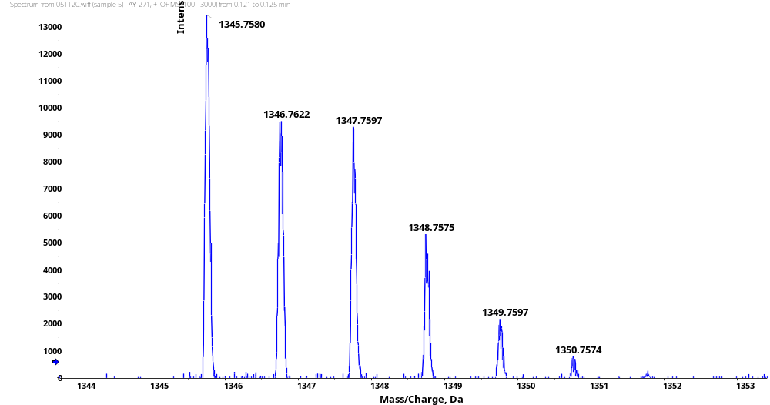
HRMS [M+H]⁺

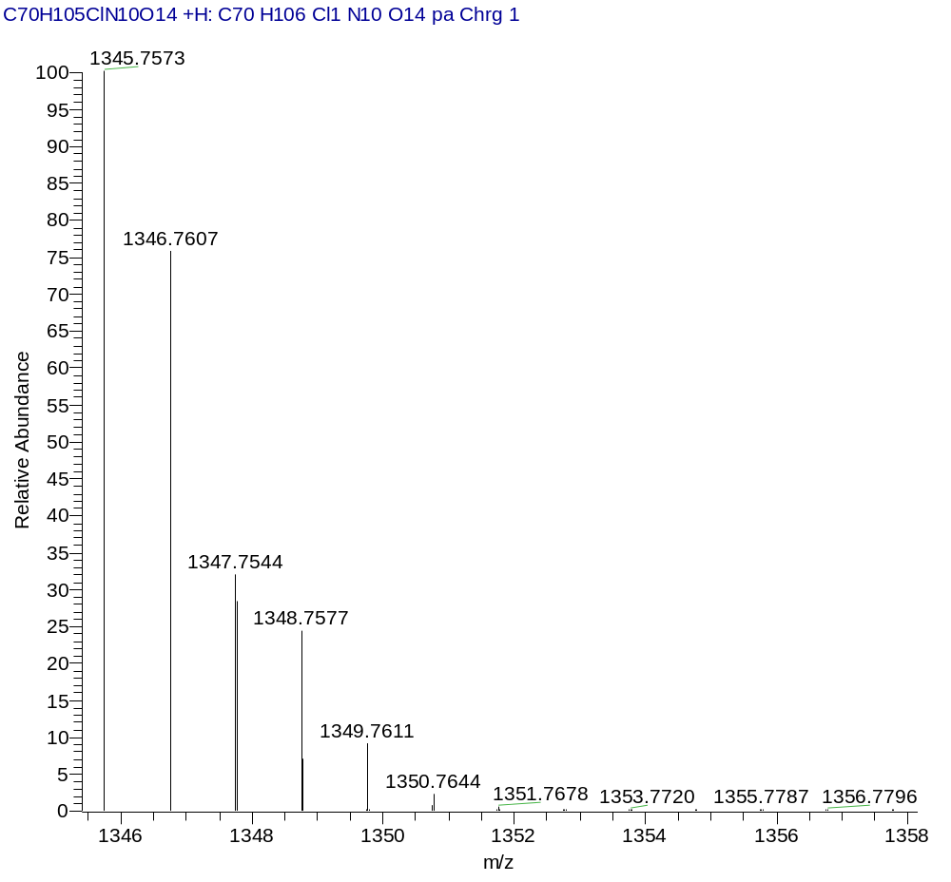
HRMS (Calcd.)
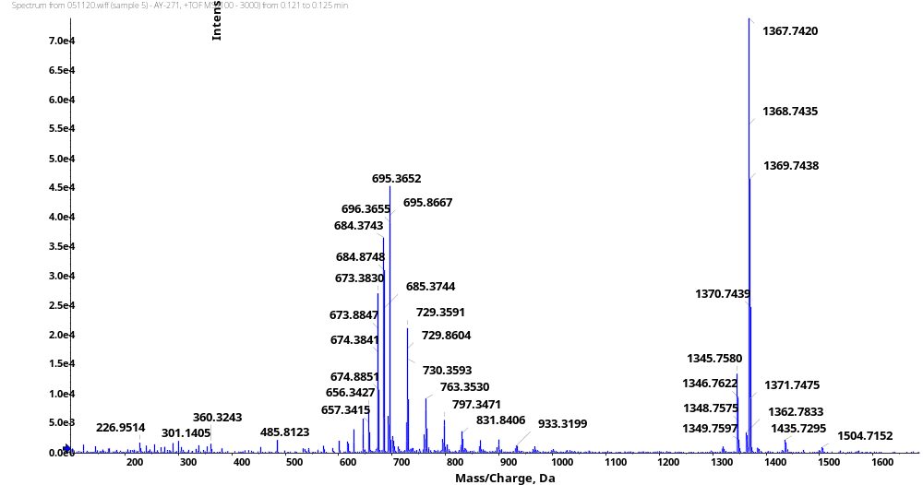
HRMS [M+Na]⁺
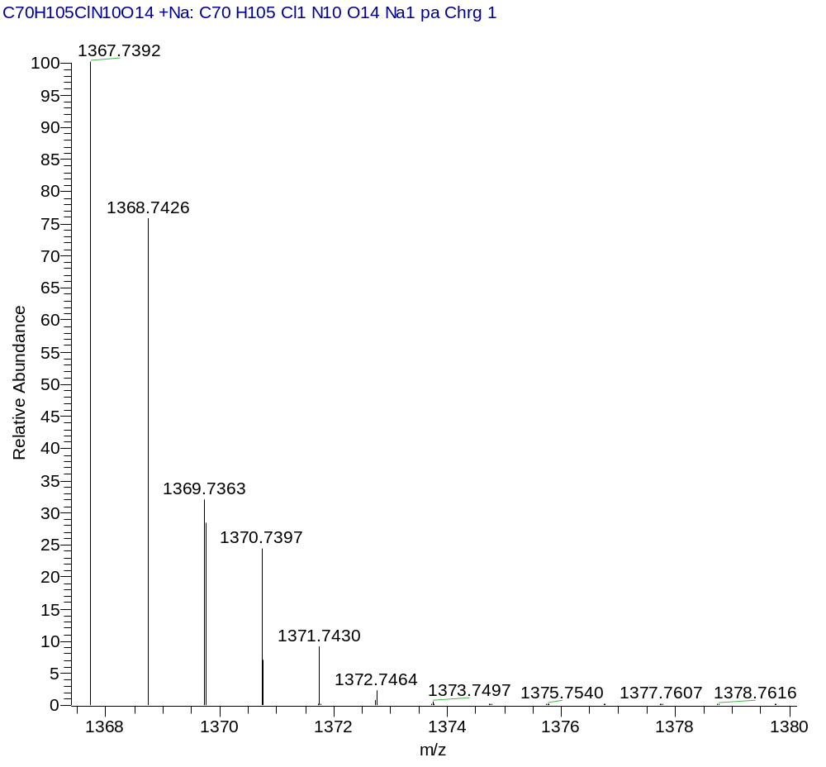
HRMS (Calcd.)
(3S,7S,25S,28S)-tri-tert-butyl 33-azido-25-benzyl-28-(4-(tert-butoxy)-3-chlorobenzyl)-12-(3-chlorobenzyl)-5,13,20,23,26,29-hexaoxo-4,6,12,19,24,27,30-heptaazatritriacontane-1,3,7-tricarboxylate (10S.f)
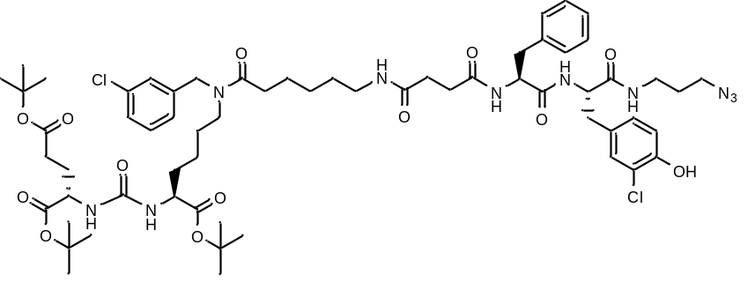
White amorphous solid (80 mg, 94%). ¹H NMR (400 MHz, DMSO-d₆, δ, ppm): 9.94 (s, 1 H), 8.29 (d, J=7.40 Hz, 1 H), 8.13 (d, J=8.44 Hz, 1 H), 7.91 (m, 1 H), 7.59 - 7.64 (m, 1 H), 7.25 - 7.35 (m, 2 H), 7.22 (d, J=4.59 Hz, 3 H), 7.10 - 7.18 (m, 5 H), 6.94 - 7.00 (m, 1 H), 6.85 (d, J=8.25 Hz, 1 H), 6.22 - 6.32 (m, 2 H), 4.54 (s, 1 H), 4.47 (s, 1 H), 4.25 - 4.34 (m, 2 H), 3.88 - 4.06 (m, 2 H), 3.22 - 3.28 (m, 2 H), 3.13 - 3.22 (m, 2 H), 2.87 - 3.12 (m, 6 H), 2.71 - 2.81 (m, 1 H), 2.67 (m, 1 H), 2.26 - 2.38 (m, 4 H), 2.12 - 2.25 (m, 4 H), 1.80 - 1.92 (m, 1 H), 1.54 - 1.70 (m, 4 H), 1.41 - 1.54 (m, 5 H), 1.34 - 1.40 (m, 29 H), 1.13 - 1.33 (m, 5 H). HRMS (ESI) m/z 1252.6042 (calcd 1252.6016 for C₆₂H₈₈Cl₂N₁₀O₁₃ [M+H]⁺).

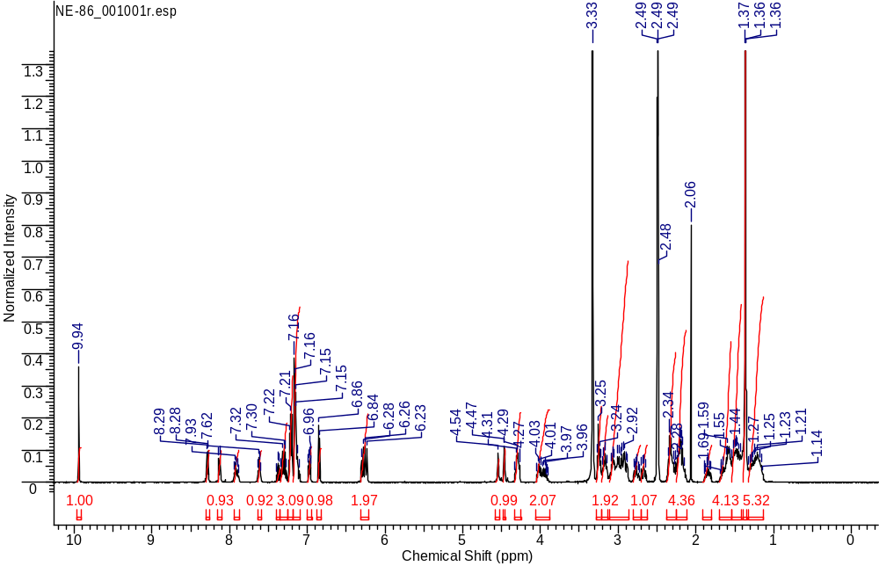
¹H NMR
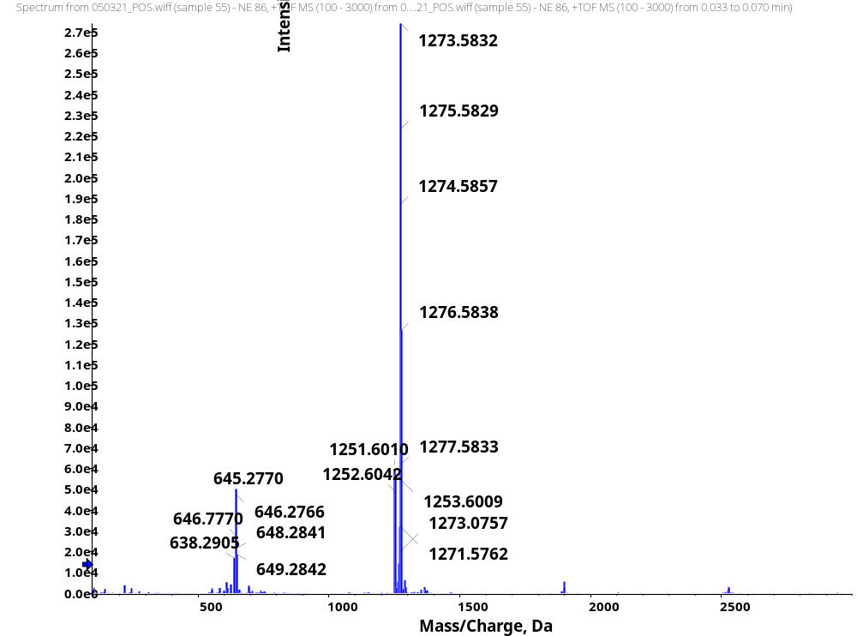
HRMS
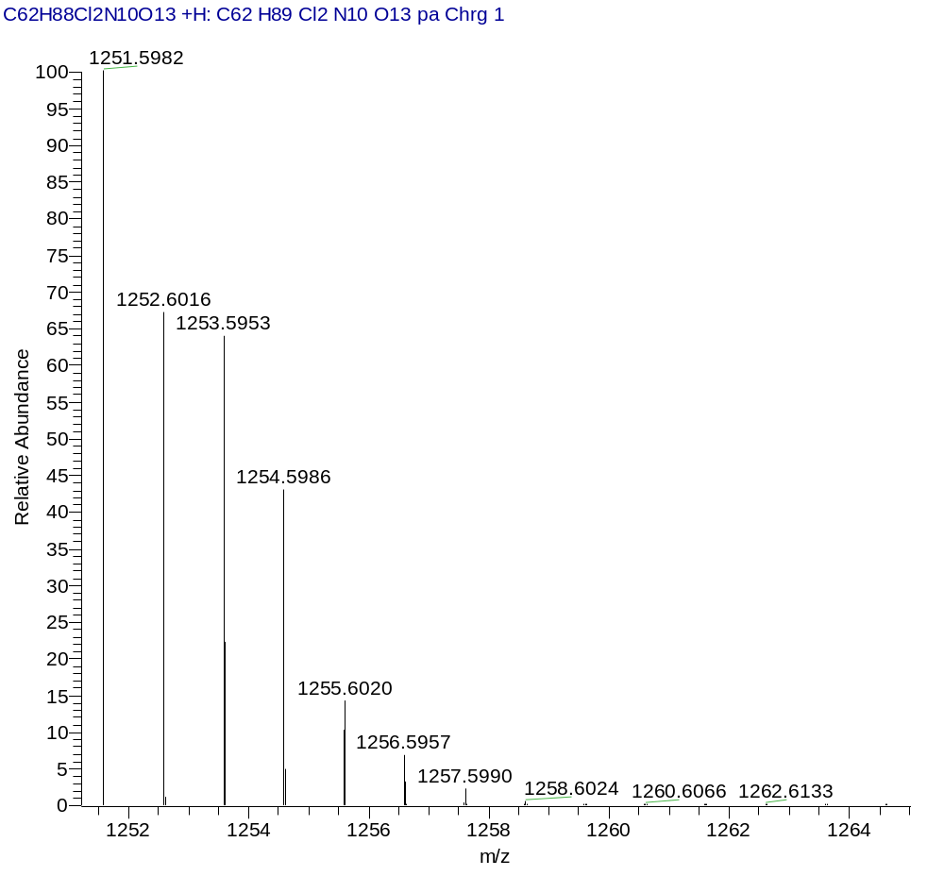
HRMS (Calcd.)
(3S,7S,25S,28S)-tri-tert-butyl 33-azido-25-benzyl-28-(4-bromobenzyl)-12-(3-chlorobenzyl)-5,13,20,23,26,29-hexaoxo-4,6,12,19,24,27,30-heptaazatritriacontane-1,3,7-tricarboxylate (10S.g)
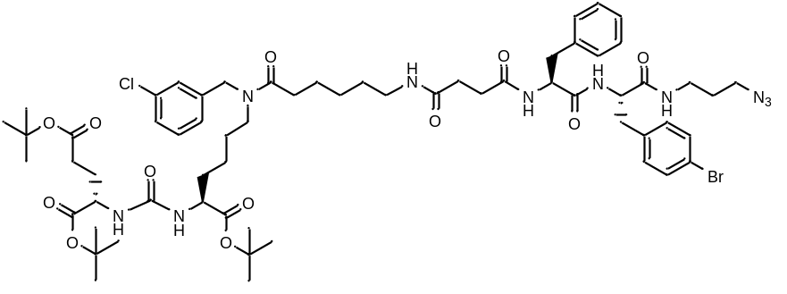
White amorphous solid (235 mg, 72%). ¹H NMR (400 MHz, DMSO-d₆, δ, ppm): 8.29 (d, J=7.34 Hz, 1 H), 8.18 (d, J=8.50 Hz, 1 H), 7.89 - 7.96 (m, 1 H), 7.57 - 7.64 (m, 1 H), 7.45 (d, J=8.19 Hz, 2 H), 7.26 - 7.41 (m, 2 H), 7.09 - 7.25 (m, 9 H), 6.20 - 6.32 (m, 2 H), 4.54 (s, 1 H), 4.47 (m, 1 H), 4.36 – 4.33 (m, 1 H), 4.29 – 4.27 (m, 1 H), 4.03 (m, 1 H), 3.93 (d, J=5.62 Hz, 1 H), 3.11 - 3.28 (m, 4 H), 3.01 (m, 5 H), 2.90 (m, 2 H), 2.58 - 2.70 (m, 1 H), 2.29 - 2.42 (m, 3 H), 2.16 - 2.28 (m, 4 H), 1.80 - 1.90 (m, 1 H), 1.67 (m, 1 H), 1.58 – 1.59 (m, J=3.91 Hz, 4 H), 1.44 (m, 4 H), 1.32 - 1.41 (m, 28 H), 1.19 - 1.28 (m, 3 H), 1.12 - 1.19 (m, 1 H). HRMS (ESI) m/z 1279.5548 (calcd 1279.5528 for C₆₂H₈₈ClBrN₁₀O₁₂[M+H]⁺).
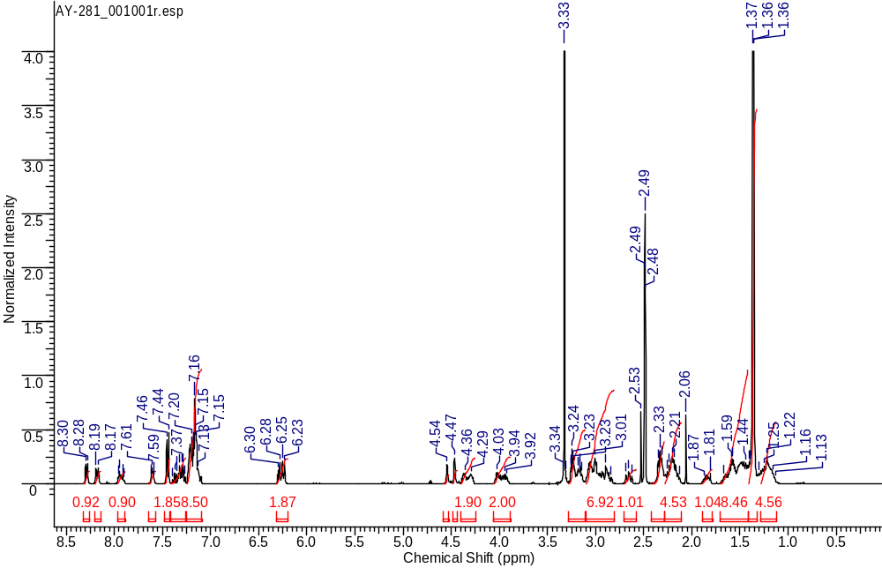
¹H NMR
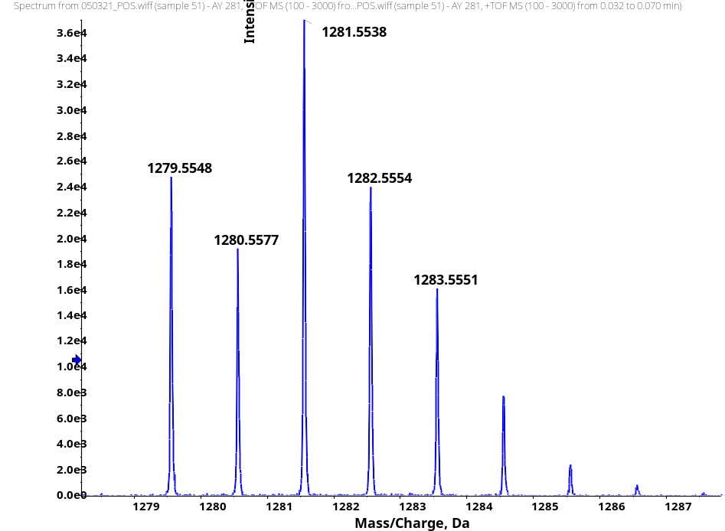
HRMS
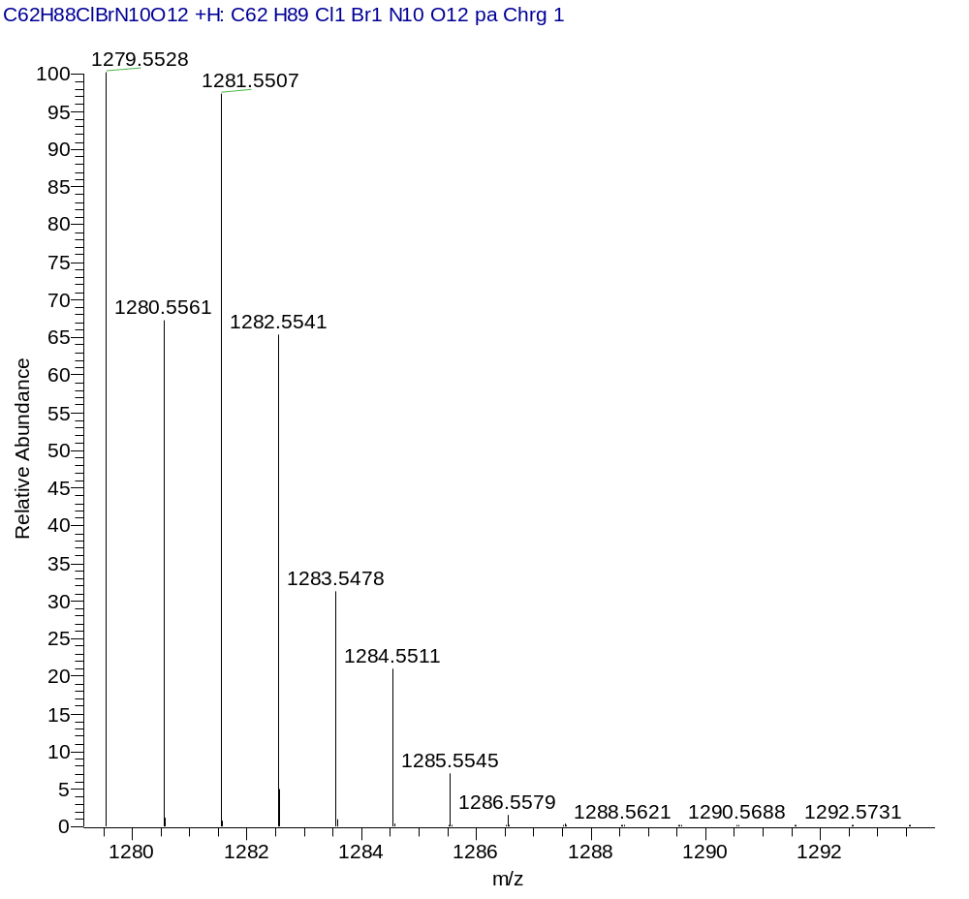
HRMS (Calcd.)
(3S,7S,25S,28S)-tri-tert-butyl 33-azido-25-benzyl-28-(3-bromobenzyl)-12-(3-chlorobenzyl)-5,13,20,23,26,29-hexaoxo-4,6,12,19,24,27,30-heptaazatritriacontane-1,3,7-tricarboxylate (10S.h)
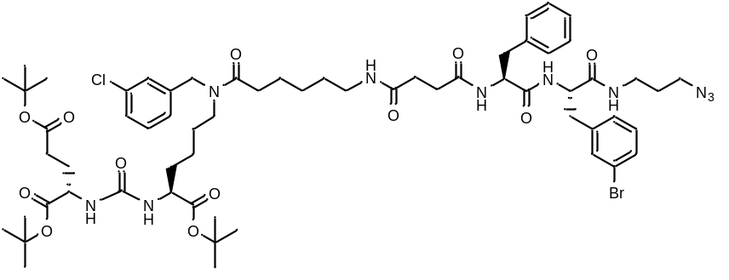
White amorphous solid (417 mg, 98%). ¹H NMR (400 MHz, DMSO-d₆, δ, ppm): 8.41 (d, J=6.54 Hz, 1 H), 8.30 (d, J=8.19 Hz, 1 H), 7.97 - 8.07 (m, 1 H), 7.58 (d, J=8.01 Hz, 1 H), 7.34 - 7.46 (m, 1 H), 7.26 - 7.34 (m, 4 H), 7.22 – 7.20 (m, 3 H), 7.09 - 7.19 (m, 5 H), 6.20 - 6.33 (m, 2 H), 4.48 - 4.58 (m, 2 H), 4.46 (m, 1 H), 4.18 - 4.27 (m, 1 H), 3.96 - 4.05 (m, 1 H), 3.95 – 3.92 (m, 1 H), 3.21 - 3.30 (m, 2 H), 3.12 - 3.21 (m, 2 H), 3.08 – 3.06 (m, 3 H), 2.95 - 3.04 (m, 2 H), 2.93 – 2.88 (m, 1 H), 2.63 (t, J=12.20 Hz, 1 H), 2.25 - 2.43 (m, 4 H), 2.11 - 2.25 (m, 4 H), 1.80 - 1.90 (m, 1 H), 1.67 (m, 1 H), 1.54 - 1.64 (m, 3 H), 1.41 - 1.54 (m, 5 H), 1.36 (s, 29 H), 1.14 - 1.31 (m, 5 H). ESI-APCI-MS m/z 1281.5 (calcd 1281.6 for C₆₂H₈₈ClBrN₁₀O₁₂ [M+H]⁺).
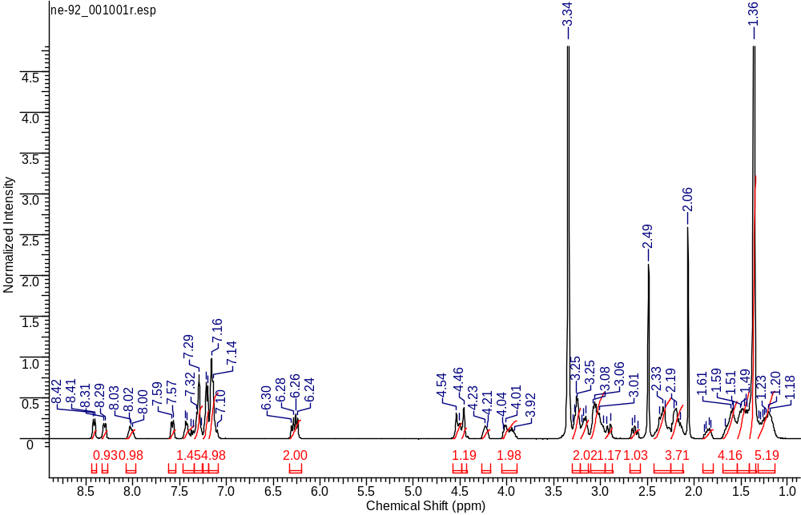
¹H NMR
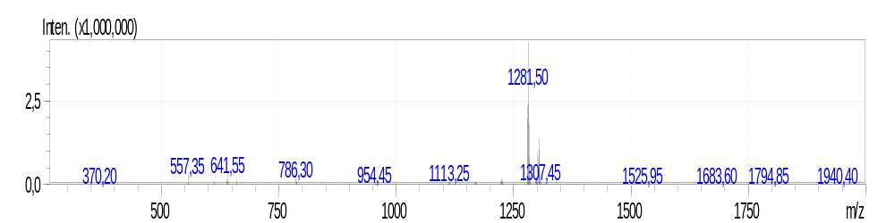
ESI-APCI-MS
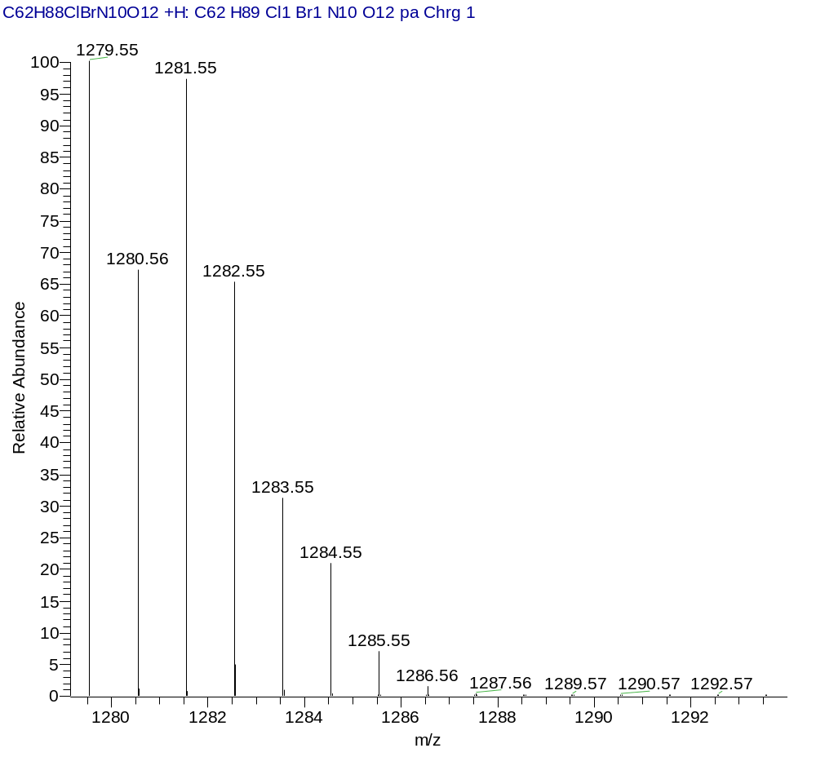
ESI-APCI-MS (Calcd)
(3S,7S,25S,28S)-tri-tert-butyl 33-azido-25-benzyl-28-(2-bromobenzyl)-12-(3-chlorobenzyl)-5,13,20,23,26,29-hexaoxo-4,6,12,19,24,27,30-heptaazatritriacontane-1,3,7-tricarboxylate (10S.i)
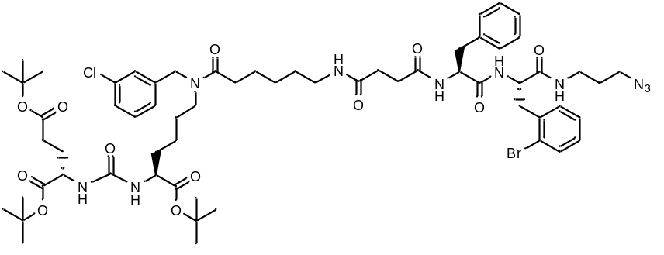
White amorphous solid (373 mg, 91%). ¹H NMR (400 MHz, DMSO-d₆, δ, ppm): 8.30 (d, J=3.73 Hz, 1 H), 8.21 (d, J=7.52 Hz, 1 H), 7.89 - 7.98 (m, 1 H), 7.61 - 7.68 (m, 1 H), 7.40 (d, J=10.82 Hz, 2 H), 7.30 (d, J=17.06 Hz, 2 H), 7.22 (m, 5 H), 7.15 (m, 4 H), 6.30 – 6.23 (m, 2 H), 4.55 – 4.53 (m, 1 H), 4.48 – 4.46 (m, 1 H), 4.34 - 4.42 (m, 1 H), 4.30 - 4.28 (m, 1 H), 4.01 - 3.93 (m, 1 H, CH), 3.24 – 3.23 (m, 3 H), 3.17 – 3.15 (m, 2 H), 3.08 – 2.98 (m, 5 H), 2.91 – 2.88 (m, 2 H), 2.66 (t, J=11.92 Hz, 1 H), 2.32 (m, 4 H), 2.21 (m, 5 H), 1.79 - 1.91 (m, 1 H), 1.64 (m, 1 H), 1.58 (m, 3 H), 1.52 (m, 2 H), 1.46 (m, 3 H), 1.36 (s, 29 H), 1.28 (m, 2 H), 1.11 - 1.24 (m, 3 H). ESI-APCI-MS m/z 1281.50 (calcd 1281.55 for C₆₂H₈₈ClBrN₁₀O₁₂ [M+H]⁺).
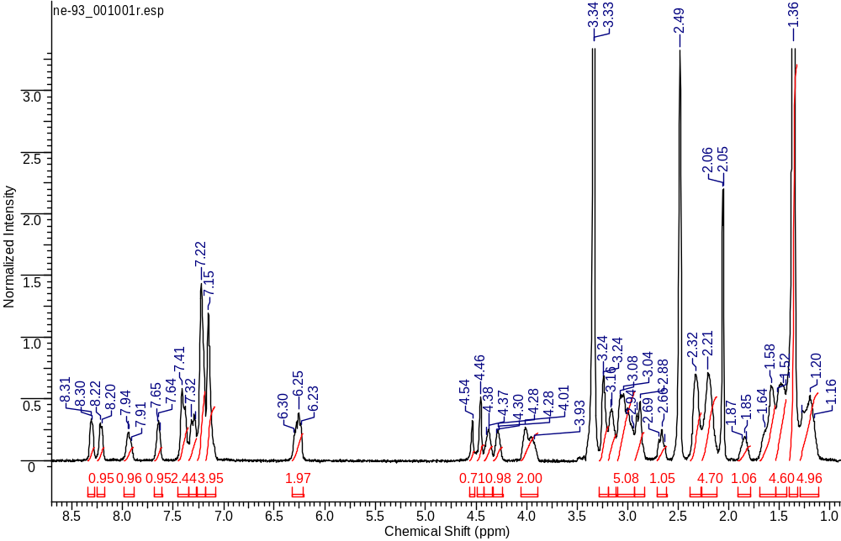
¹H NMR
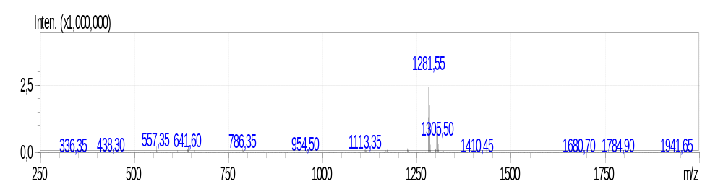
ESI-APCI-MS
ESI-APCI-MS (Calcd)
(3S,7S,25R,28R)-tri-tert-butyl 33-azido-25-benzyl-28-(4-bromobenzyl)-12-(3-chlorobenzyl)-5,13,20,23,26,29-hexaoxo-4,6,12,19,24,27,30-heptaazatritriacontane-1,3,7-tricarboxylate (10S.j)
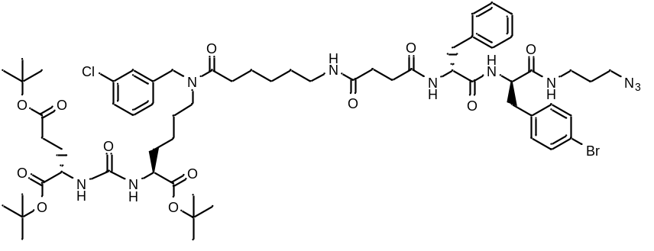
White amorphous solid (157 mg, 43%). ¹H NMR (400 MHz, DMSO-d₆, δ, ppm): 8.29 (d, J=7.21 Hz, 1 H), 8.18 (d, J=8.07 Hz, 1 H), 7.90 - 7.98 (m, 1 H), 7.55 - 7.66 (m, 1 H), 7.45 (d, J=8.01 Hz, 2 H), 7.35 - 7.40 (m, 1 H), 7.27 - 7.34 (m, 2 H), 7.18 - 7.25 (m, 4 H), 7.05 - 7.18 (m, 6 H), 6.21 - 6.33 (m, 2 H), 4.54 (s, 1 H), 4.46 (s, 1 H), 4.33 - 4.40 (m, 1 H, CH), 4.28 – 4.26 (m, 1 H), 3.82 - 4.05 (m, 2 H), 3.11 - 3.27 (m, 4 H), 2.81 - 3.11 (m, 8 H), 2.61 - 2.69 (m, 1 H), 2.09 - 2.38 (m, 9 H), 1.80 - 1.89 (m, 1 H), 1.67 (m., 1 H), 1.59 – 1.56 (d, J=6.97 Hz, 3 H), 1.50 - 1.41 (m, 2 H), 1.36 (s, 28 H), 1.30 (m, 1 H), 1.22 (m, 3 H), 1.16 (m, 1 H). HRMS (ESI) m/z 1279.5544 (calcd 1279.5528 for C₆₂H₈₈ClBrN₁₀O₁₂ [M+H]⁺).
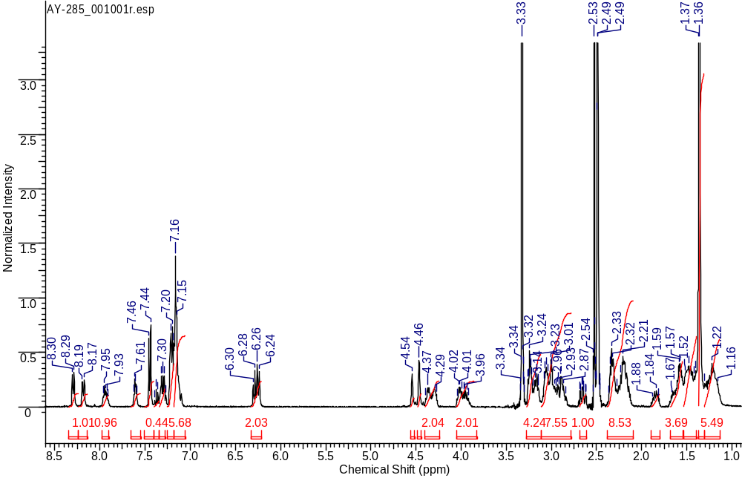
¹H NMR
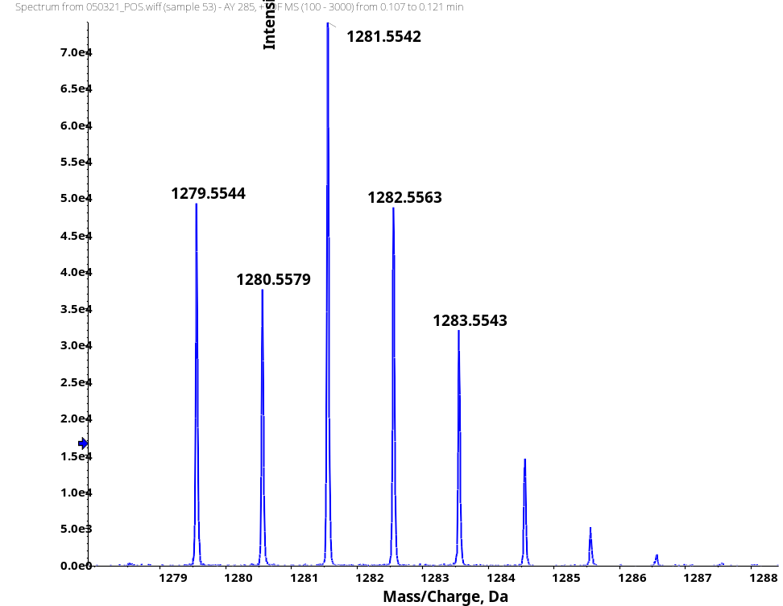
HRMS
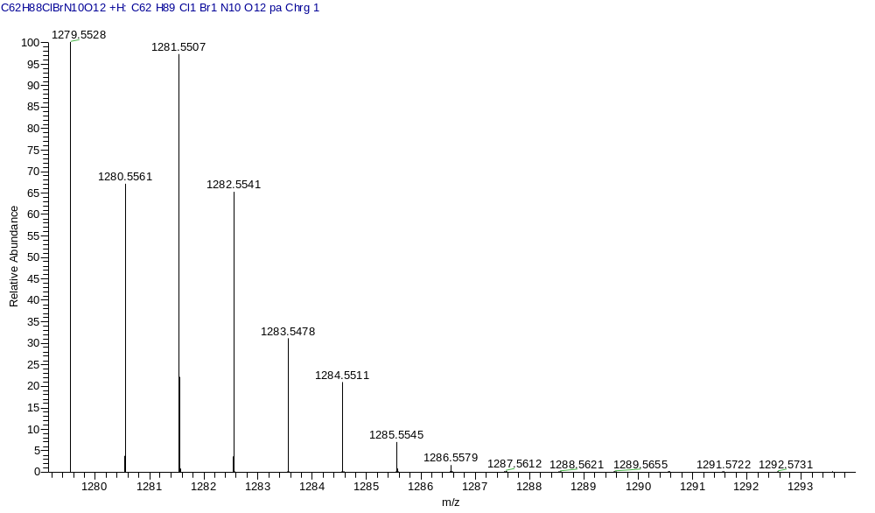
HRMS (Calcd)
General procedure for the synthesis of compounds 1a – 1n
In a solution of trifluoroacetic acid, DCM, distilled water and triisopropylsilane (46.25 : 46.25 : 5 : 2.5) tBu-ligand 4S, 10S (1 eq.) was dissolved and stirred for 3 hours at room temperature. The solvent was removed under reduced pressure. The resulting substance was reevaporated 3 times from DCM. Diethyl ether was added to the resulting oily precipitate, resulting in a white amorphous product. The diethyl ether was decanted, the procedure was repeated 2 more times. The product was then purified by reverse phase column chromatography, using 0.1% trifluoroacetic acid in water : acetonitrile (Puriflash C18-HP, 15μ, 20g, eluent: acetonitrile-0.1% trifluoroacetic acid in water system: 10% acetonitrile to 100% in 20 minutes) as eluent. [α]_{D} values are given in 10⁻¹deg cm²g⁻¹.
(3S,7S,25S,28R)-33-azido-12-(3-chlorobenzyl)-25,28-bis(4-hydroxybenzyl)-5,13,20,23,26,29-hexaoxo-4,6,12,19,24,27,30-heptaazatritriacontane-1,3,7-tricarboxylic acid (1a)
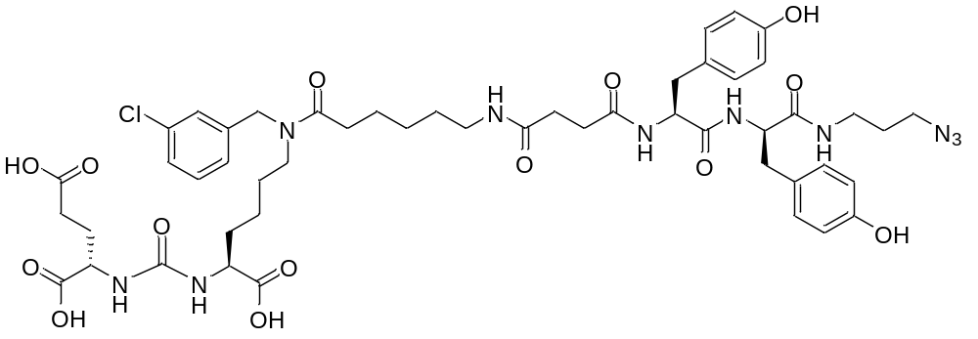
White amorphous solid (98 mg, 67%). ¹H NMR (400 MHz, DMSO-d₆, δ, ppm): 12.45 (br.s., 3H), 9.16 (s, 2 H), 8.23 (dd, J=8.31, 3.61 Hz, 1 H), 8.01 (d, J=7.70 Hz, 1 H), 7.85 - 7.92 (m, 1 H), 7.73 - 7.84 (m, 1 H), 7.26 - 7.41 (m, 2 H), 7.19 - 7.24 (m, 1 H), 7.08 - 7.19 (m, 1 H), 6.98 (d, J=8.38 Hz, 2 H), 6.87 (d, J=8.38 Hz, 2 H), 6.54 - 6.65 (m, 4 H), 6.25 - 6.37 (m, 2 H), 4.54 (c, 1 H), 4.46 (c, 1 H), 4.21 - 4.33 (m, 2 H), 3.97 - 4.13 (m, 2 H), 3.04 - 3.22 (m, 5 H), 2.89 - 3.02 (m, 2 H), 2.84 (d.d., J=13.66, 4.74 Hz, 1 H), 2.59 - 2.68 (m, 1 H), 2.44 – 2.46 (m, 1 H), 2.29 - 2.38 (m, 1 H), 2.12 - 2.29 (m, 6 H), 1.83 - 1.96 (m, 1 H), 1.64 - 1.77 (m, 1 H), 1.56 – 1.63 (m, 3 H), 1.31 - 1.54 (m, 5 H), 1.16 - 1.31 (m, 5 H). ¹³C NMR (101 MHz, DMSO-d₆, δ, ppm): 174.50, 174.21, 173.80, 172.22, 171.82, 171.23, 171.16, 171.09, 157.30, 155.80, 155.69, 141.21, 140.82, 133.40, 133.05, 130.63, 130.27, 130.12, 130.09, 128.08, 128.03, 127.18, 126.85, 126.29, 126.07, 124.98, 114.85, 114.81, 54.71, 54.63, 52.26, 52.14, 51.67, 48.23, 47.16, 46.88, 45.31, 38.55, 36.77, 36.42, 35.86, 31.87, 31.78, 30.73, 30.65, 29.94, 29.10, 28.98, 28.20, 27.78, 27.56, 26.24, 26.16, 24.74, 24.59, 22.49, 22.33. LCMS purity: 97%; retention time: 11.6 min. HRMS (ESI) m/z 1065.4467 (calcd 1065.4443 for C₅₀H₆₅ClN₁₀O₁₄ [M+H]⁺). [α]_{D} 2 (c 1 in acetonitrile : water 3 : 1). IR (ZnSe) 3294, 3022, 2931, 2863, 2097, 1716, 1612, 1544, 1513, 1224 cm⁻¹.
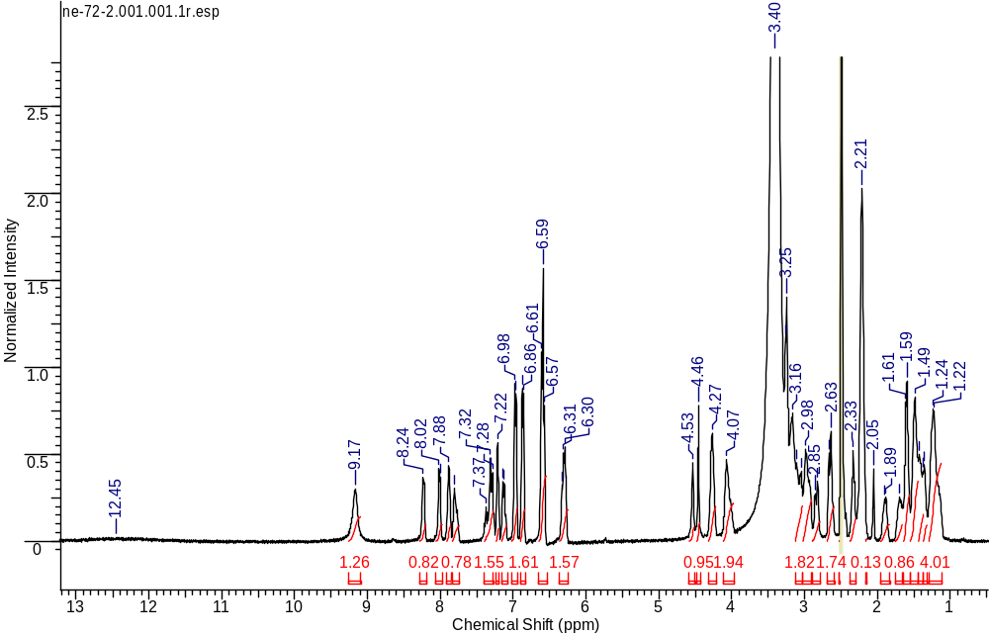
¹H NMR
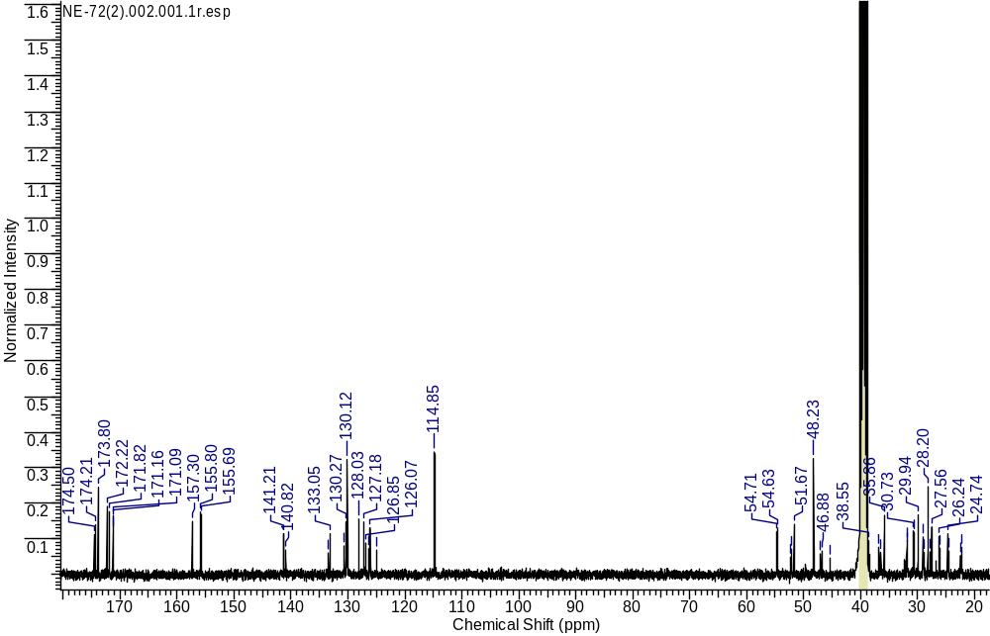
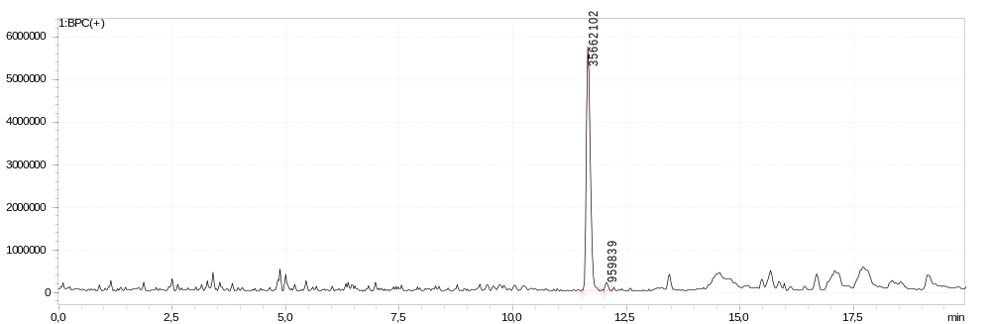
¹³C NMR
LCMS sample
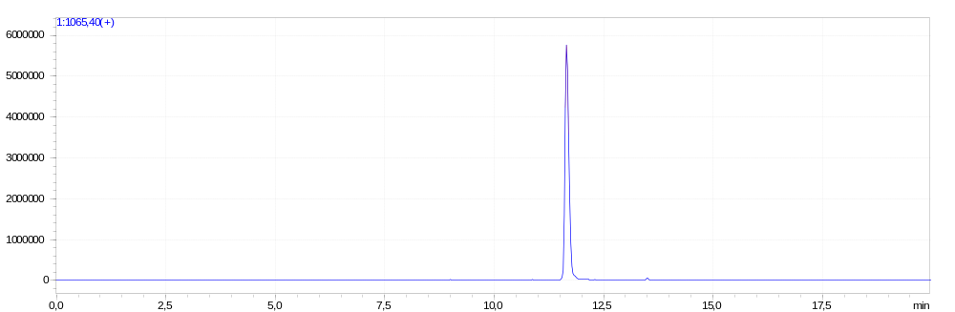
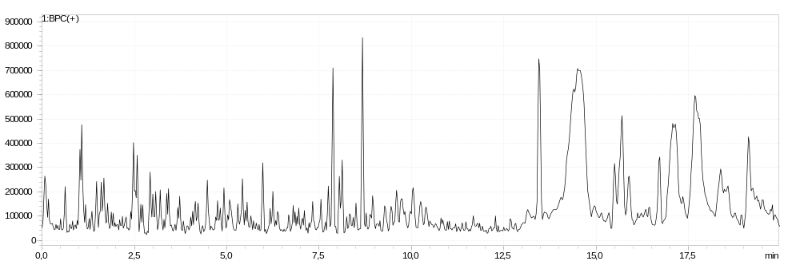
LCMS extracted-ion
LCMS blank
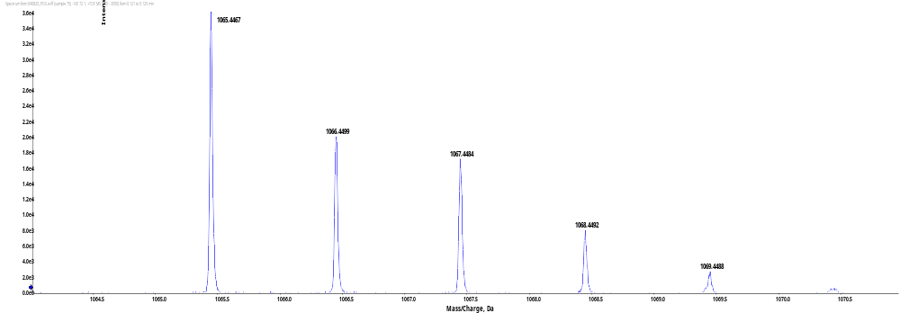
HRMS (ESI)
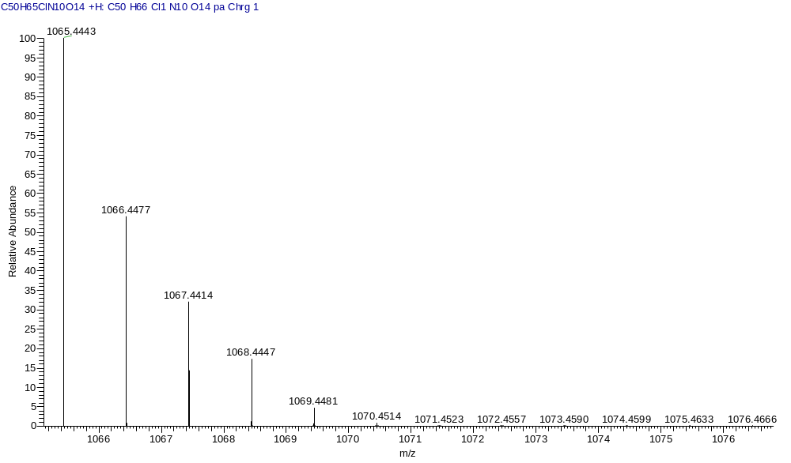
HRMS (Calcd)
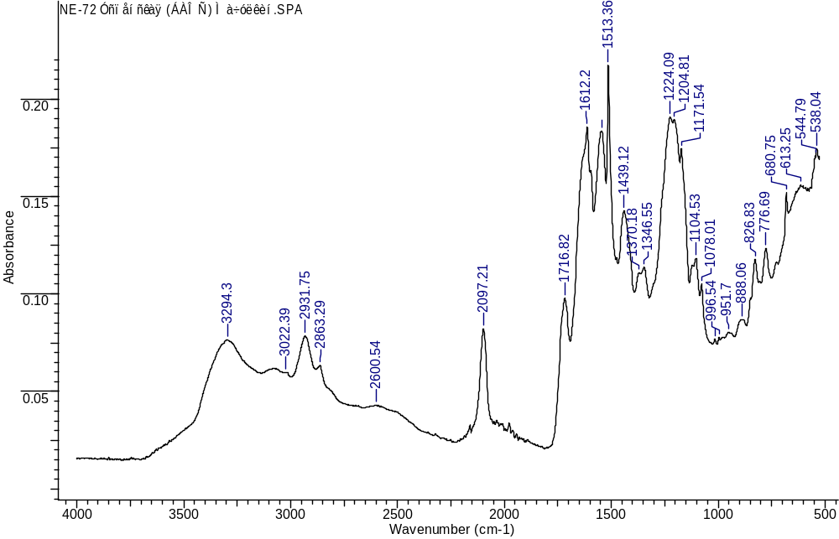
IR
(3S,7S,25S,28R)-33-azido-28-benzyl-12-(3-chlorobenzyl)-25-(4-hydroxybenzyl)-5,13,20,23,26,29-hexaoxo-4,6,12,19,24,27,30-heptaazatritriacontane-1,3,7-tricarboxylic acid (1b)
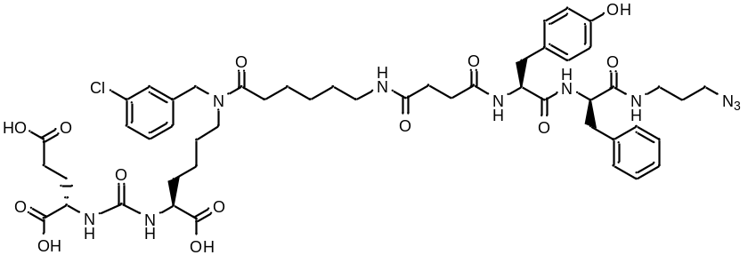
White amorphous solid (56 mg, 56%). ¹H NMR (400 MHz, DMSO-d₆, δ, ppm): 12.45 (br.s., 3 H), 9.13 (br.s., 1 H), 8.31 - 8.35 (m, 1 H), 8.03 (d, J=6.80 Hz, 1 H), 7.89 – 7.96 (m, 1 H), 7.74 – 7.83 (m, 1 H), 7.25 - 7.40 (m, 2 H), 7.09 - 7.25 (m, 7 H), 6.85 (d, J=7.62 Hz, 2 H), 6.57 (d, J=7.67 Hz, 2 H), 6.25 – 6.36 (m, 2 H), 4.54 (c, 1 H), 4.46 (s, 1 H), 4.35 – 4.39 (m, 1 H), 4.21 – 4.30 (m, 1 H), 3.98 – 4.12 (m, 2 H), 3.20 – 3.27 (m, 2 H), 3.09 – 3.19 (m, 3 H), 3.02 – 3.08 (m, 1 H), 2.89 – 2.99 (m, 3 H), 2.69 - 2.82 (m, 1 H), 2.58 – 2.68 (m, 1 H), 2.29 – 2.39 (m, 2 H), 2.13 - 2.27 (m, 6 H), 1.85 – 1.96 (m, 1 H), 1.70 (br. s., 1 H), 1.54 – 1.76 (m, 4 H), 1.31 – 1.49 (m, 7 H), 1.10 – 1.31 (m, 5 H). LCMS purity: 100%; retention time: 12.2 min. HRMS (ESI) m/z 1071.4349 (calcd 1071.4313 for C₅₀H₆₅ClN₁₀O₁₃ [M+Na]⁺). [α]_{D} 6 (c 1 in acetonitrile : water 3 : 1). IR (ZnSe) 3294, 3062, 2931, 2863, 2096, 1715, 1620, 1548, 1514, 1203 cm⁻¹.
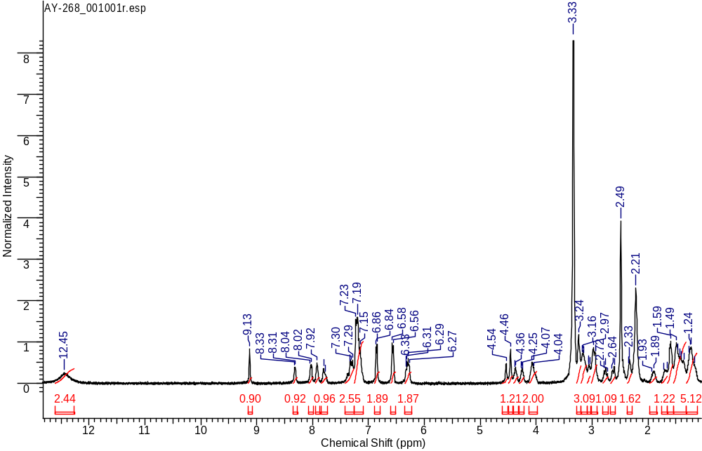
¹H NMR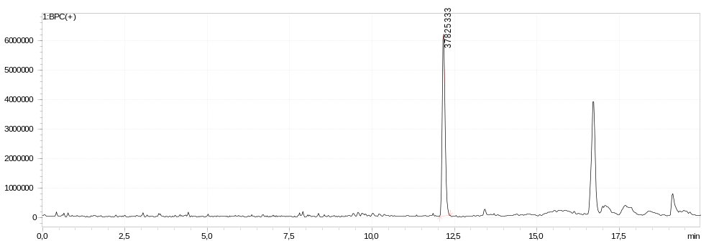
LCMS sample
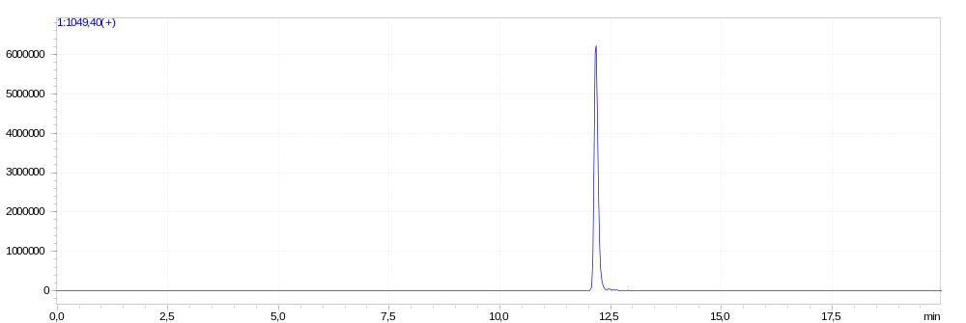
LCMS extracted-ion
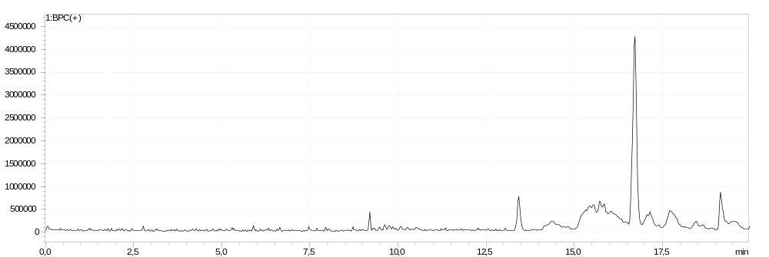
LCMS blank
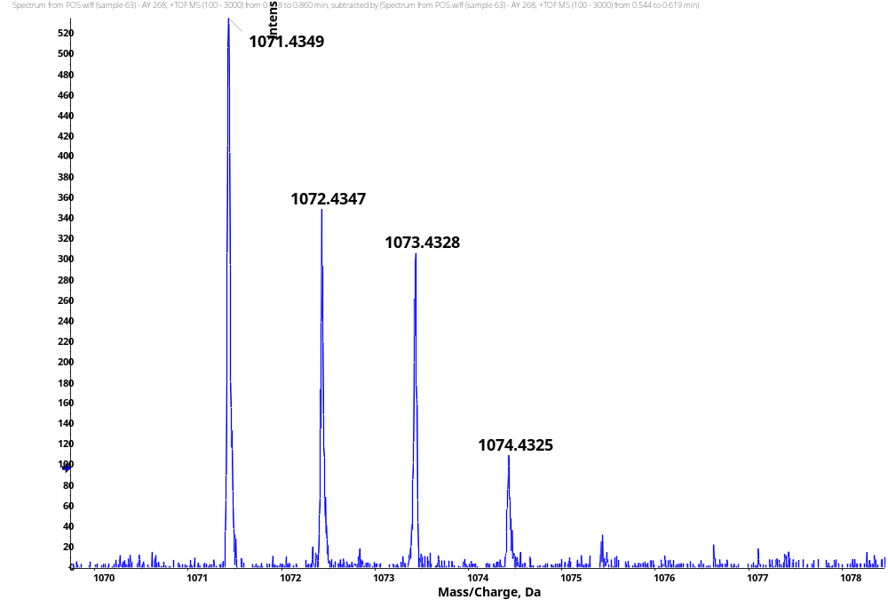
HRMS
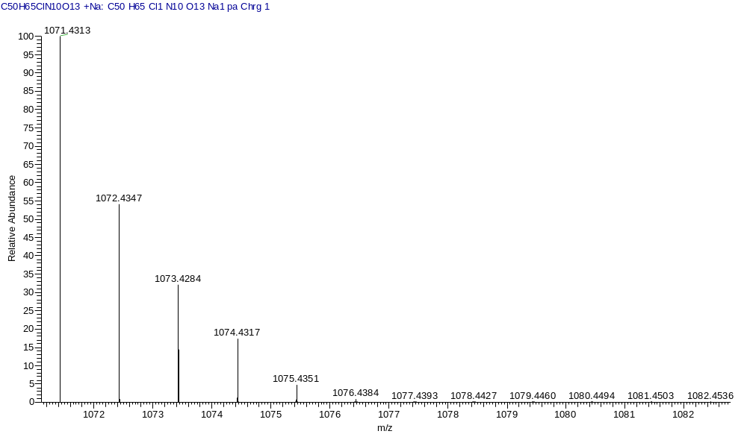
HRMS (Calcd)
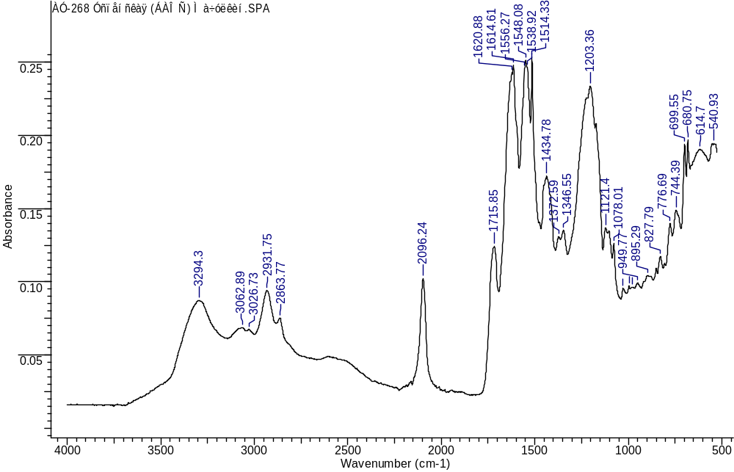
IR
(3S,7S,25R,28S)-33-azido-12-(3-chlorobenzyl)-25,28-bis(4-hydroxybenzyl)-5,13,20,23,26,29-hexaoxo-4,6,12,19,24,27,30-heptaazatritriacontane-1,3,7-tricarboxylic acid (1c)
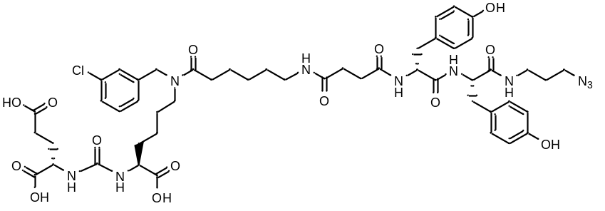
White amorphous solid (76 mg, 53%). ¹H NMR (400 MHz, DMSO-d₆, δ, ppm): 12.45 (br.s., 3 H), 9.14 (br.s., 2 H), 8.22 – 8.27 (m, 1 H), 7.98 – 8.05 (m, 1 H), 7.85 – 7.92 (m, 1 H), 7.73 - 7.84 (m, 1 H), 7.25 - 7.35 (m, 2 H), 7.19 – 7.24 (m, 1 H), 7.09 - 7.17 (m, 1 H), 6.97 (d, J=6.96 Hz, 2 H), 6.87 (d, J=7.24 Hz, 2 H), 6.55 - 6.64 (m, 4 H), 6.26 – 6.34 (m, 2 H), 4.54 (s, 1 H), 4.46 (s, 1 H), 4.23 – 4.32 (m, 2 H), 3.98 - 4.11 (m, 2 H), 3.22 – 3.28 (m, 2 H), 3.12 – 3.22 (m, 2 H), 3.03 – 3.11 (m, 2 H), 2.89 – 3.02 (m, 3 H), 2.79 – 2.87 (m, 1 H), 2.60 – 2.69 (m, 2 H), 2.30 – 2.37 (m, 1 H), 2.16 – 2.27 (m, 7 H), 1.85 – 1.94 (m, 1 H), 1.64 – 1.76 (m, 1 H), 1.55 – 1.62 (m, 3 H), 1.44 – 1.54 (m, 3 H), 1.39 – 1.43 (m, 2 H), 1.32 – 1.38 (m, 2 H), 1.10 – 1.29 (m, 5 H). LCMS purity: 100%; retention time: 11.7 min. HRMS (ESI) m/z 1065.4487 (calcd 1065.4443 for C₅₀H₆₅ClN₁₀O₁₄ [M+H]⁺), 1087.4310 (calcd 1087.4262 for C₅₀H₆₅ClN₁₀O₁₄ [M+Na]⁺). [α]_{D} -1 (c 1 in acetonitrile : water 3 : 1). IR (ZnSe) 3290, 3019, 2931, 2864, 2098, 1715, 1613, 1548, 1513, 1224 cm⁻¹.
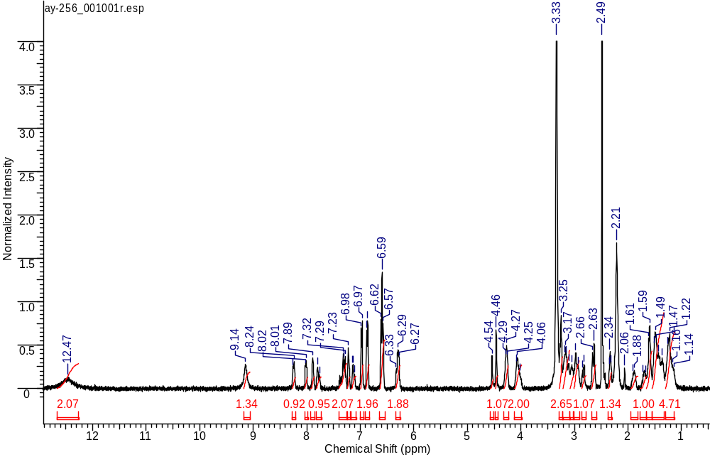
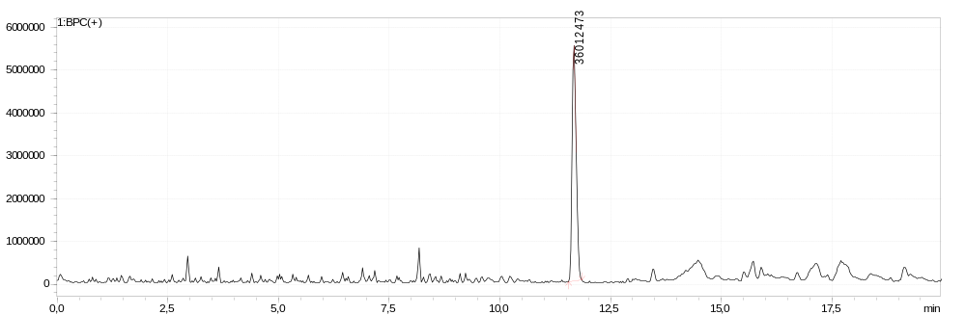
¹H NMR
LCMS sample
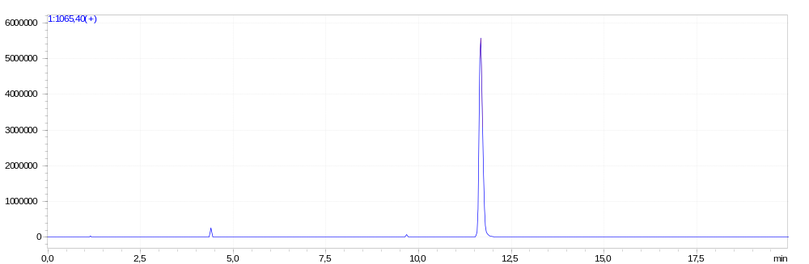
LCMS extracted-ion
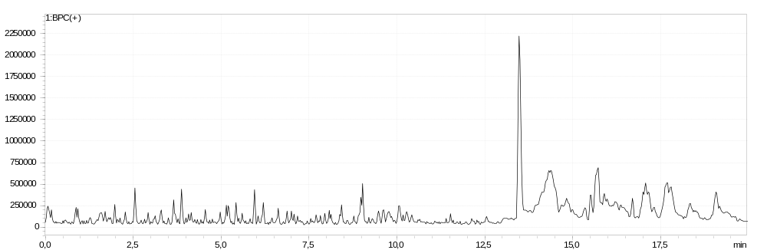
LCMS blank
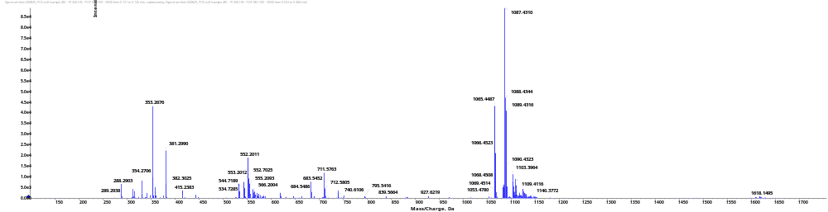
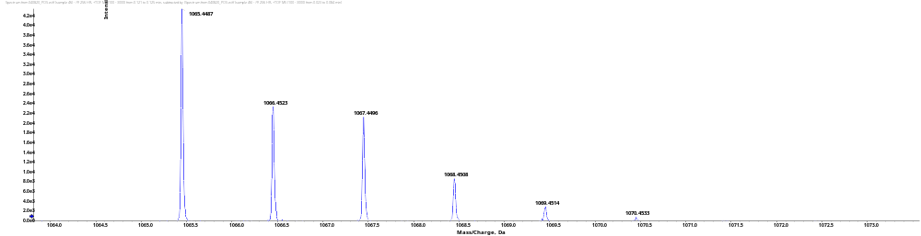
HRMS
HRMS (Calcd)
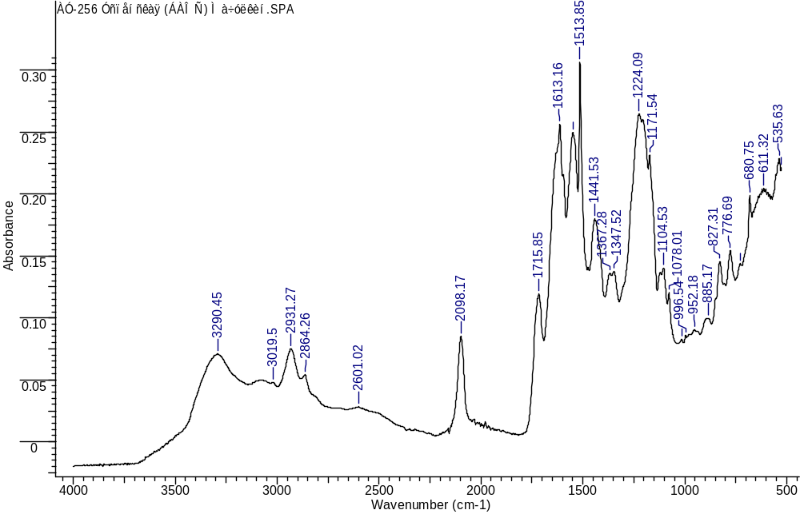
IR
(3S,7S,25S,28S)-33-azido-28-benzyl-12-(3-chlorobenzyl)-25-(4-hydroxybenzyl)-5,13,20,23,26,29-hexaoxo-4,6,12,19,24,27,30-heptaazatritriacontane-1,3,7-tricarboxylic acid (1d)
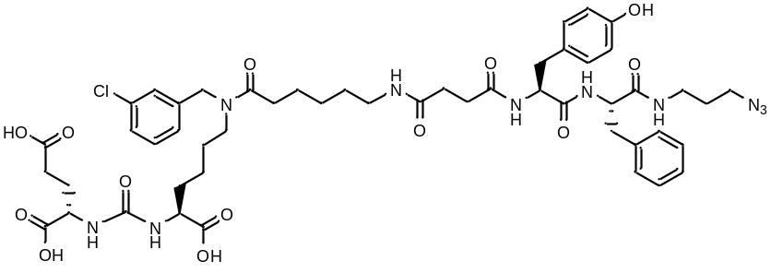
White amorphous solid (59 mg, 58%). ¹H NMR (400 MHz, DMSO-d₆, δ, ppm): 12.43 (s, 3 H), 9.16 (s, 1 H), 8.22 – 8.28 (m, 1 H), 8.10 – 8.18 (m, 1 H), 7.90 – 8.02 (m, 1 H), 7.50 – 7.58 (m, 1 H), 7.25 – 7.38 (m, 3 H), 7.06 - 7.24 (m, 6 H), 6.93 (d, J=7.67 Hz, 2 H), 6.58 (d, J=6.96 Hz, 2 H), 6.24 – 6.36 (m, 2 H), 4.54 (c, 1 H), 4.45 (c, 1 H), 4.32 – 4.40 (m, 1 H), 4.13 – 4.21 (m, 1 H), 3.97 – 4.12 (m, 2 H), 3.11 – 3.27 (m, 5 H), 2.95 - 3.10 (m, 5 H), 2.84 – 2.93 (m, 1 H) 2.72 – 2.81 (m, 1 H), 2.27 – 2.41 (m, 4 H), 2.10 – 2.26 (m, 4 H), 1.84 – 1.96 (m, 1 H), 1.54 – 1.75 (m, 4 H), 1.34 – 1.52 (m, 7 H), 1.10 – 1.33 (m, 5 H). ¹³C NMR (101 MHz, DMSO-d₆, δ, ppm): 13C NMR (101 MHz, DMSO-d₆) δ ppm 174.51, 174.20, 173.85, 173.15, 172.36, 171.80, 171.35, 170.86, 157.37, 155.69, 141.10, 138.02, 133.41, 133.06, 130.63, 130.28, 129.95, 128.99, 128.21, 127.95, 127.12, 126.87, 126.36, 126.23, 126.04, 124.95, 114.91, 55.57, 54.48, 51.66, 48.11, 38.67, 35.90, 31.70, 30.60, 30.48, 29.88, 28.97, 28.07, 27.47, 26.23, 24.70. LCMS purity: 100%; retention time: 11.6 min. HRMS (ESI) m/z 1049.4524 (calcd 1049.4494 for C₅₀H₆₅ClN₁₀O₁₃ [M+H]⁺); m/z 1071.4360 (calcd 1071.4313 for C₅₀H₆₅ClN₁₀O₁₃ [M+Na]⁺). [α]_{D} -11 (c 1 in acetonitrile : water 3 : 1). IR (ZnSe) 3295, 3066, 2931, 2863, 2096, 1715, 1614, 1547, 1514, 1201 cm⁻¹.
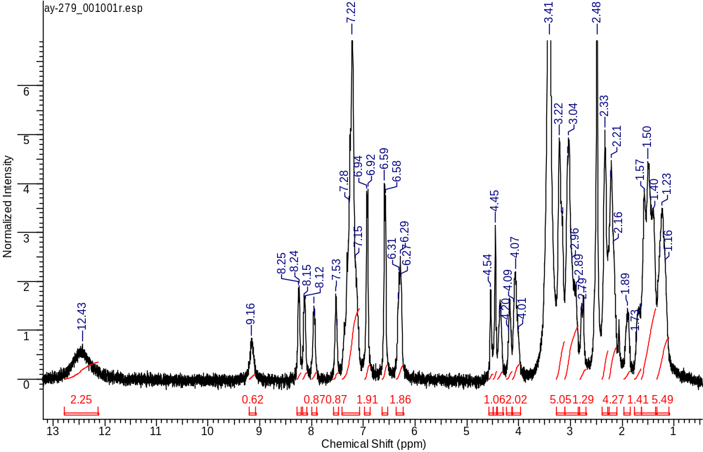
¹H NMR
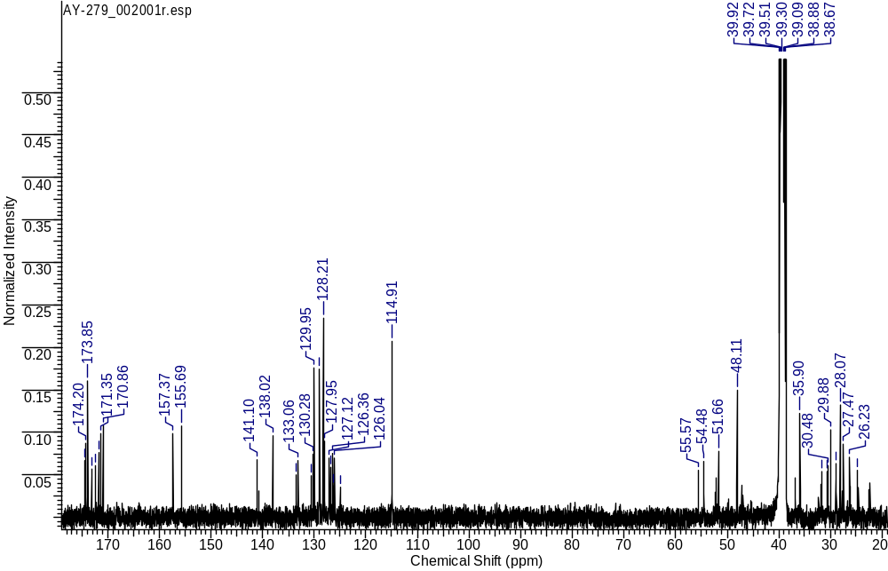
¹³C NMR
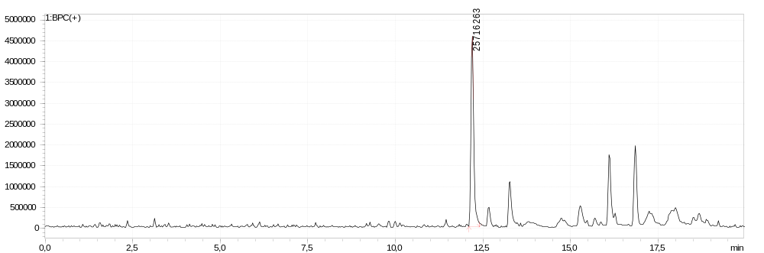
LCMS sample
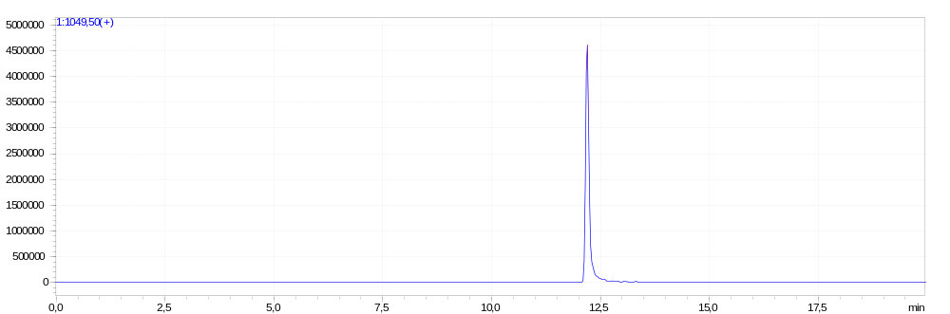
LCMS extracted-ion
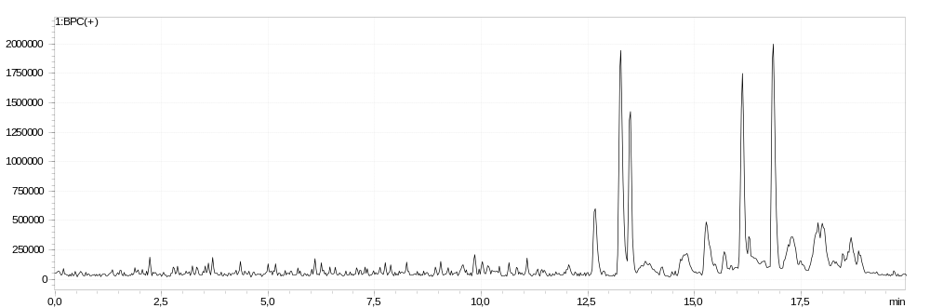
LCMS blank
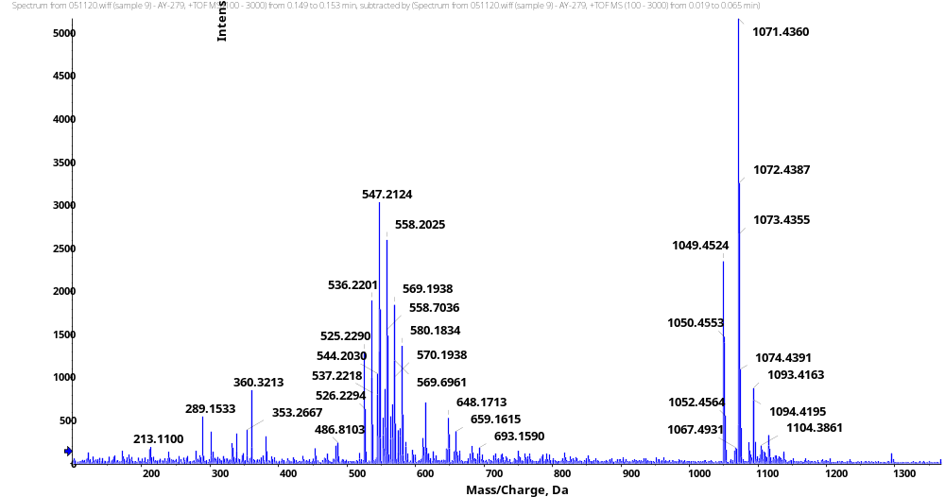
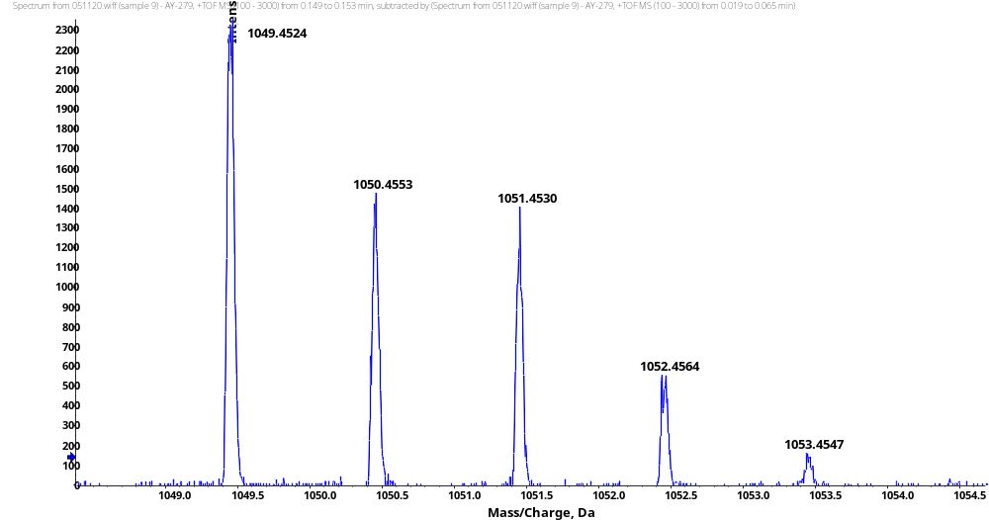
HRMS
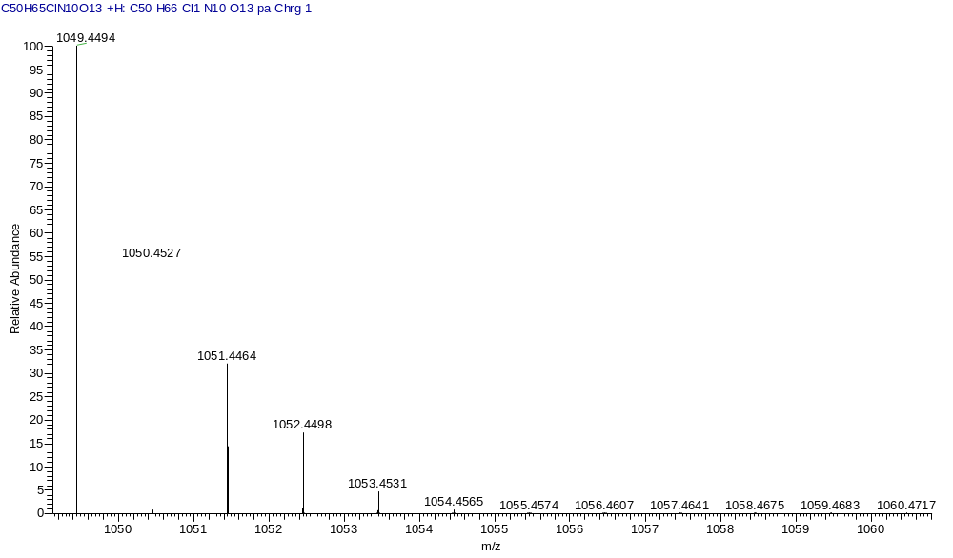
HRMS (Calcd)
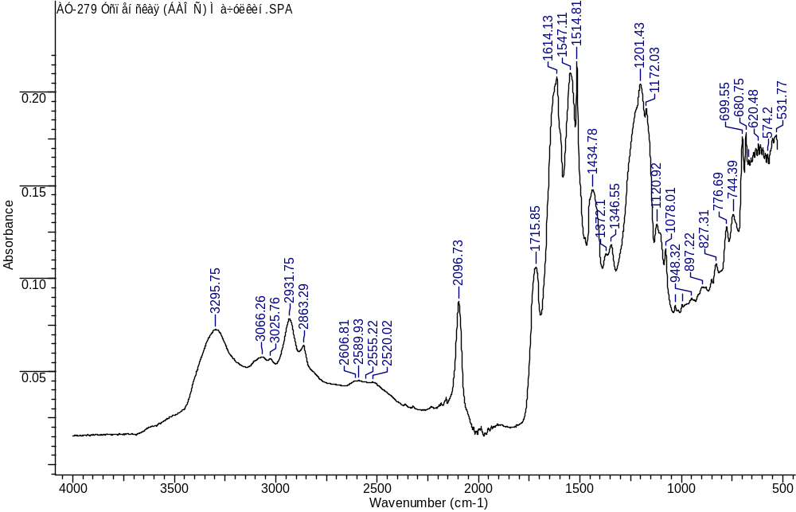
IR
(3S,7S,25S,28S)-33-azido-12-(3-chlorobenzyl)-25,28-bis(4-hydroxybenzyl)-5,13,20,23,26,29-hexaoxo-4,6,12,19,24,27,30-heptaazatritriacontane-1,3,7-tricarboxylic acid (1e)
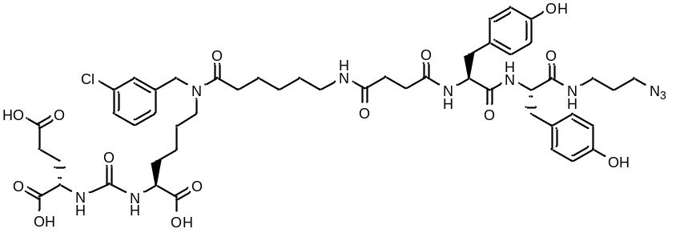
White amorphous solid (45 mg, 56%). ¹H NMR (400 MHz, DMSO-d₆, δ, ppm): 12.51 (br.s., 3 H), 9.19 (br.s., 2 H), 8.25 (d., J=7.28 Hz, 1 H), 8.07 (d., J=8.62 Hz, 1 H), 7.89 - 7.99 (m, 1 H,), 7.47 - 7.56 (m, 1 H), 7.26 - 7.41 (m, 2 H), 7.19 - 7.24 (m, 1 H), 7.09 - 7.17 (m, 1 H), 6.91 - 7.04 (m, 4 H), 6.59 (d., J=8.38 Hz, 2 H), 6.64 (d., J=8.31 Hz, 2 H), 6.24 - 6.37 (m, 2 H), 4.54 (c, 1 H), 4.46 (c, 1 H), 4.22 - 4.31 (m, 1 H), 4.13 - 4.22 (m, 1 H), 3.98 - 4.13 (m, 2 H), 3.12 - 3.26 (m, 4 H), 2.88 - 3.10 (m, 5 H), 2.71 - 2.83 (m, 2 H), 2.28 - 2.40 (m, 4 H), 2.11 - 2.28 (m, 5 H), 1.85 - 1.95 (m, 1 H), 1.65 - 1.75 (m, 1 H), 1.53 - 1.65 (m, 3 H), 1.46 - 1.53 (m, 3 H), 1.33 - 1.46 (m, 3 H), 1.11 - 1.33 (m, 5 H). ¹³C NMR (101 MHz, DMSO-d₆, δ, ppm): 174.52,174.22, 173.79, 172.81, 172.15, 171.58, 171.20, 170.88, 157.28, 155.81, 155.75, 141.23, 140.83, 133.39, 133.04, 130.62, 130.26, 129.97, 128.11, 128.05, 127.19, 126.85, 126.30, 126.08, 124.97, 114.95, 114.87, 55.45, 54.77, 52.13, 51.63, 48.14, 47.14, 46.86, 36.10, 35.82, 31.79, 30.65, 30.53, 29.90, 29.06, 28.95, 28.16, 27.79, 27.53, 26.76, 26.29, 24.72, 24.59, 22.34. LCMS purity: 100%; retention time: 11.6 min. HRMS (ESI) m/z 1065.4493 (calcd 1065.4443 for C₅₀H₆₅ClN₁₀O₁₄ [M+H]⁺). IR (ZnSe) 3289, 3075, 2925, 2863, 2097, 1718, 1635, 1545, 1513, 1226 cm⁻¹.
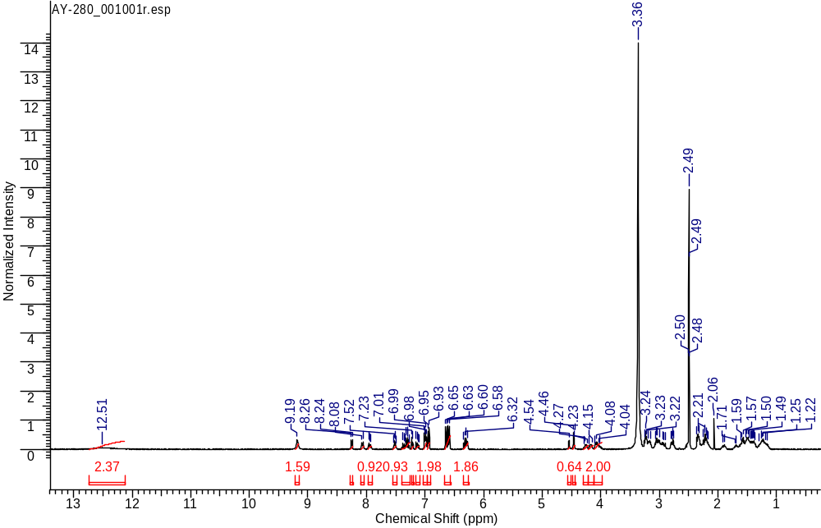
¹H NMR
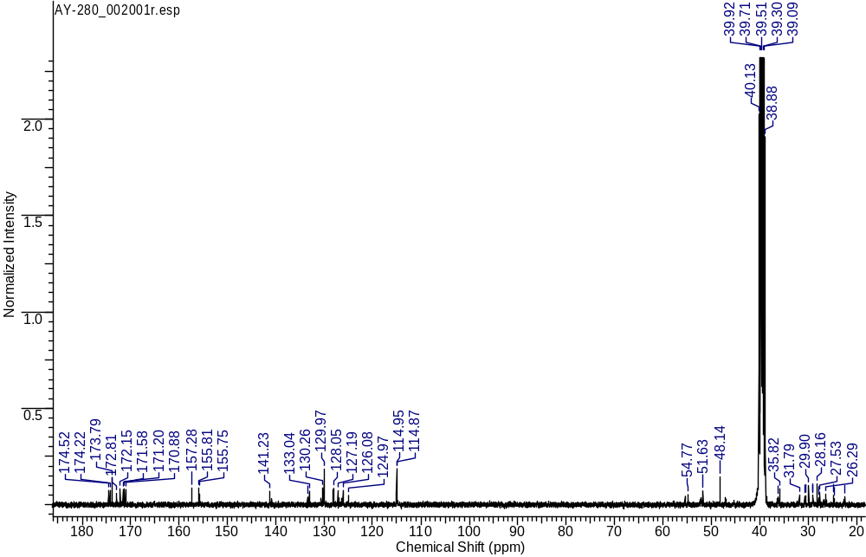
¹³C NMR
LCMS sample
LCMS extracted-ion
LCMS blank
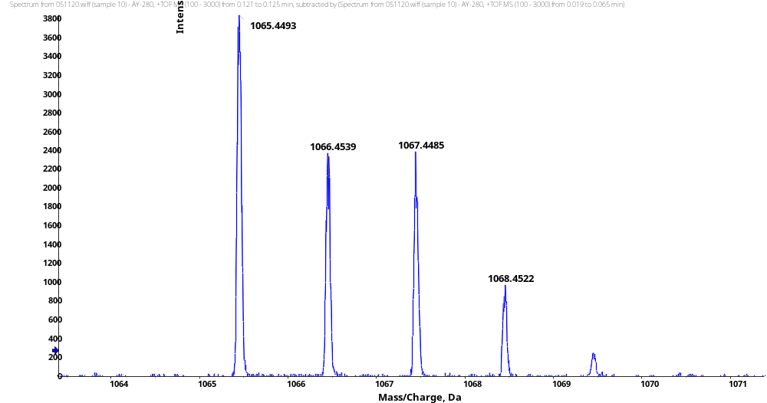
HRMS (ESI)
HRMS (Calcd)
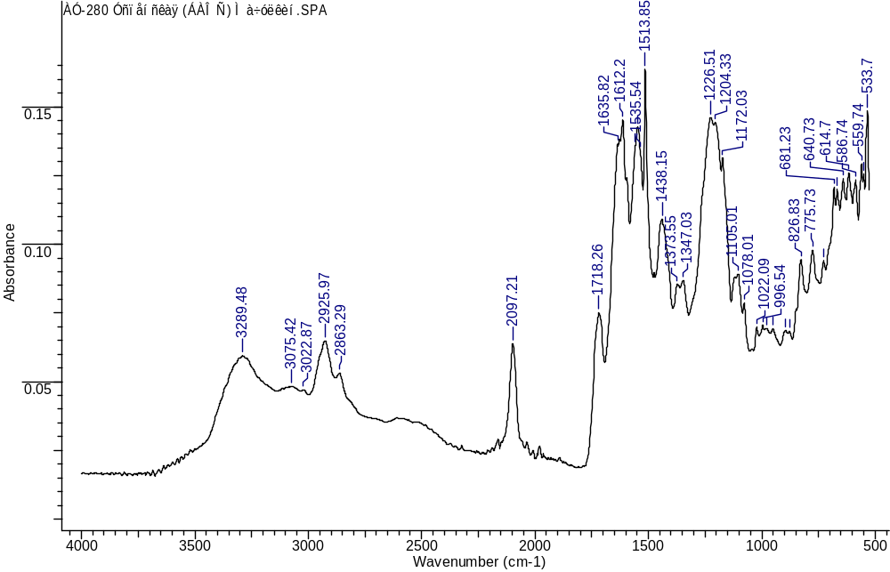
IR
(3S,7S,25S,28S)-33-azido-25-benzyl-12-(3-chlorobenzyl)-28-(4-hydroxy-3-nitrobenzyl)-5,13,20,23,26,29-hexaoxo-4,6,12,19,24,27,30-heptaazatritriacontane-1,3,7-tricarboxylic acid (1f)
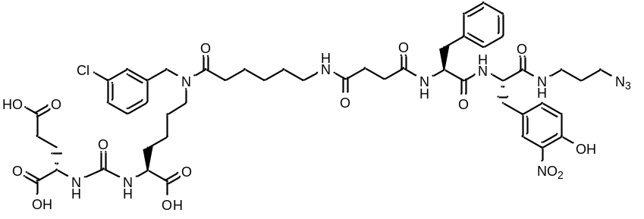
Yellow amorphous solid (126 mg, 47%). ¹H NMR (400 MHz, DMSO-d₆, δ, ppm): 12.49 (br.s., 3 H), 10.75 (br.s. 1 H), 8.43 (d, J=8.80 Hz, 1 H), 8.10 (d, J=7.83 Hz, 1 H), 7.96 - 8.02 (m, 1 H), 7.72 - 7.77 (m, 1 H), 7.32 - 7.41 (m, 2 H), 7.25 - 7.32 (m, 1 H), 7.18 - 7.25 (m, 1 H), 7.11 - 7.18 (m, 4 H), 7.04 - 7.11 (m, 3 H), 7.00 (d, J=8.50 Hz, 1 H), 6.25 - 6.35 (m, 2 H), 4.54 (s, 1 H), 4.46 (s, 1 H), 4.32 - 4.42 (m, 2 H), 3.98 - 4.13 (m, 2 H), 3.29 (t, J=6.69 Hz, 2 H), 3.13 - 3.23 (m, 3 H), 3.03 - 3.13 (m, 2 H), 2.89 - 3.02 (m, 3 H), 2.68 - 2.80 (m, 2 H), 2.52 - 2.60 (m, 1 H), 2.29 - 2.38 (m, 2 H), 2.13 - 2.29 (m, 6 H), 1.85 - 1.96 (m, 1 H), 1.66 - 1.76 (m, 1 H), 1.56 - 1.66 (m, 3 H), 1.46 - 1.56 (m, 3 H), 1.39 - 1.46 (m, 2 H), 1.31 - 1.39 (m, 1 H), 1.16 - 1.31 (m, 4 H). ¹³C NMR (101 MHz, DMSO-d₆, δ, ppm): 174.53, 174.50, 174.21, 173.77, 172.16, 171.80, 171.17, 170.64, 157.27, 150.90, 141.24, 140.84, 137.88, 136.45, 136.08, 133.40, 133.04, 130.25, 129.10, 127.92, 127.20, 126.84, 126.16, 126.09, 125.45, 118.90, 54.28, 54.04, 51.65, 48.25, 38.53, 37.35, 36.27, 35.9, 31.87, 31.79, 30.68, 30.62, 29.91, 29.12, 28.23, 27.80, 27.55, 26.25, 26.16, 24.74. LCMS purity: 100%; retention time: 3.9 min. HRMS (ESI) m/z 1094.4349 (calcd 1094.4345 for C₅₀H₆₄ClN₁₁O₁₅ [M+H]⁺), 1116.4183 (calcd 1116.4164 for C₅₀H₆₄ClN₁₁O₁₅ [M+Na]⁺). IR (ZnSe) 3281, 3065, 2931, 2865, 2097, 1721, 1632, 1537, 1427, 1166 cm⁻¹.

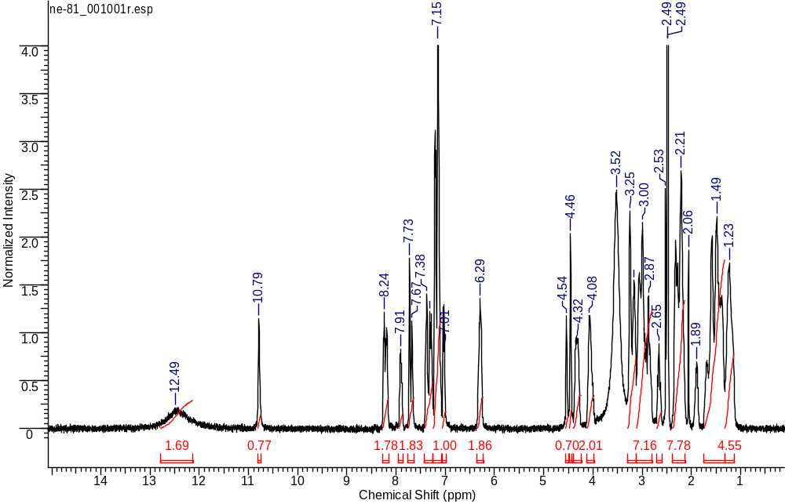
¹H NMR
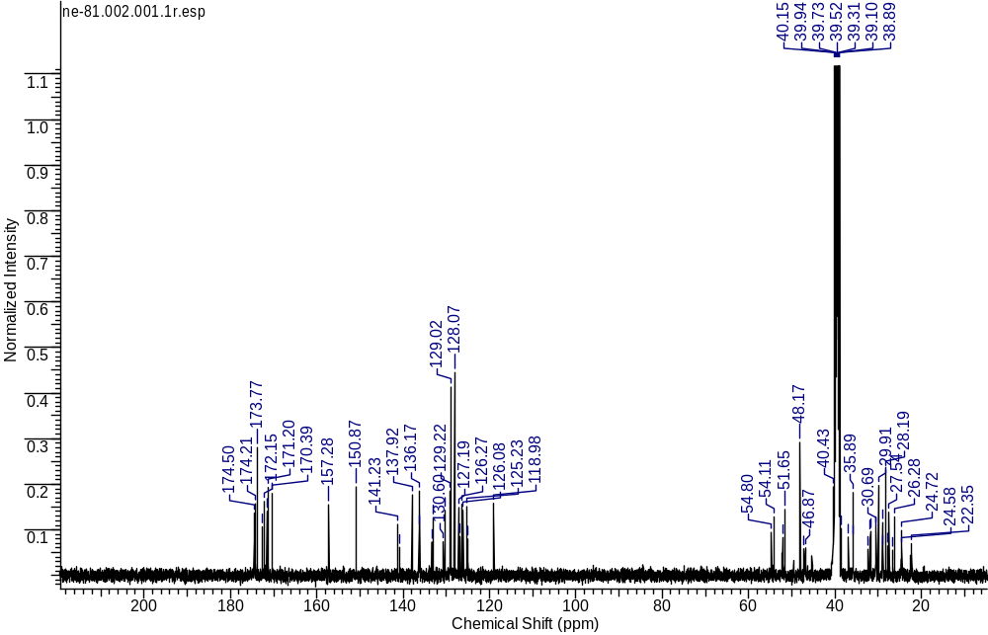
¹³C NMR
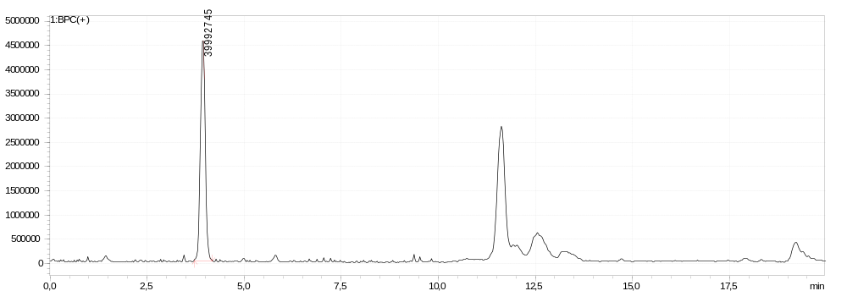
LCMS sample
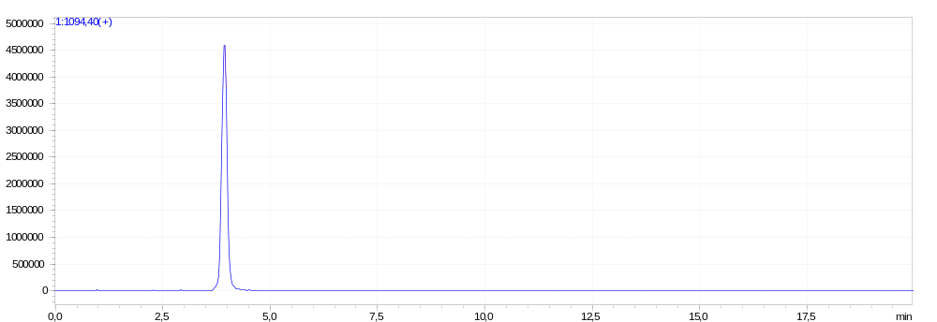
LCMS extracted-ion
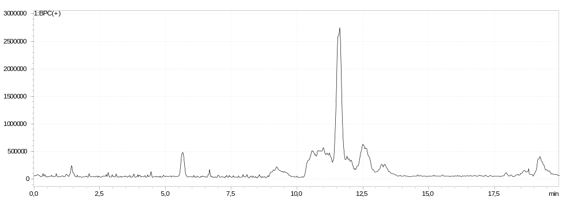
LCMS blank
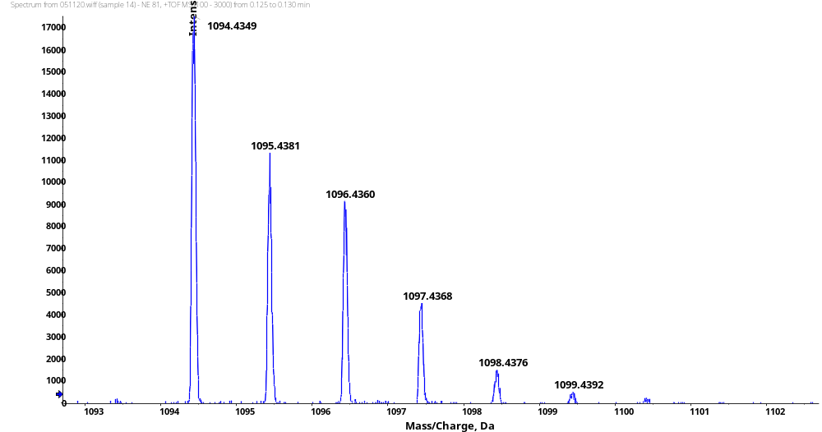
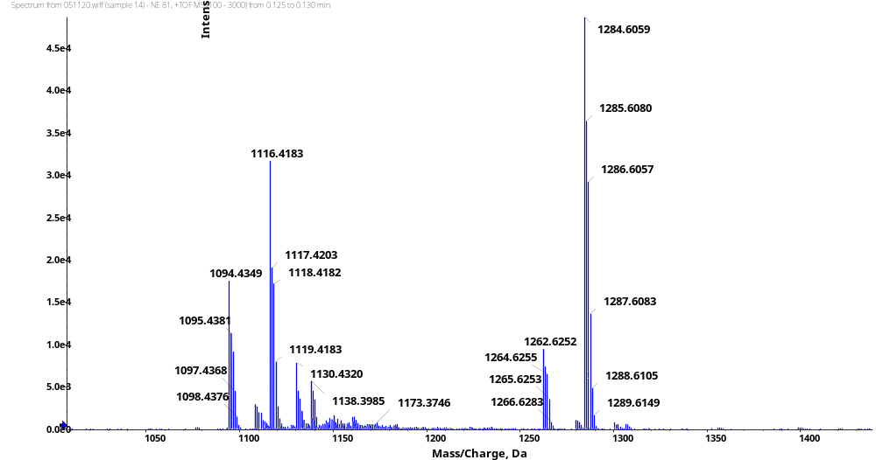
HRMS (ESI)
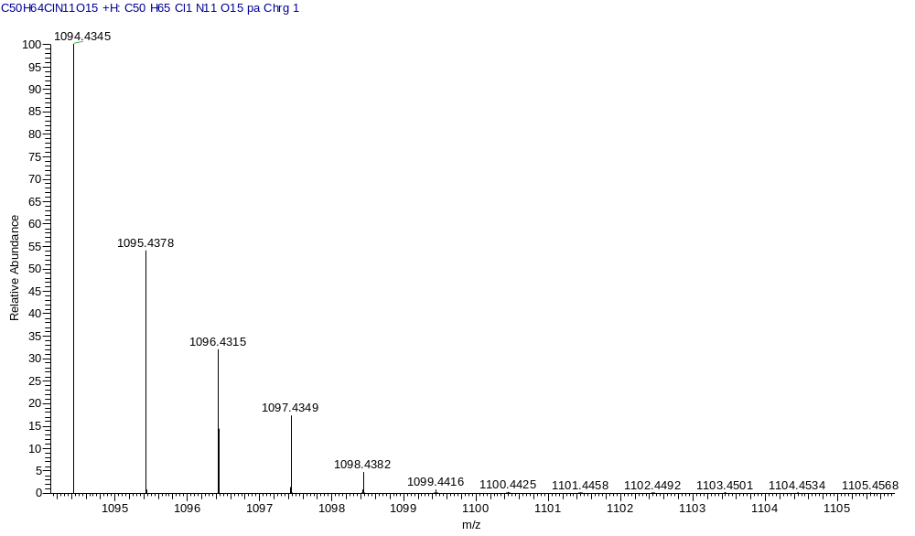
HRMS (Calcd)
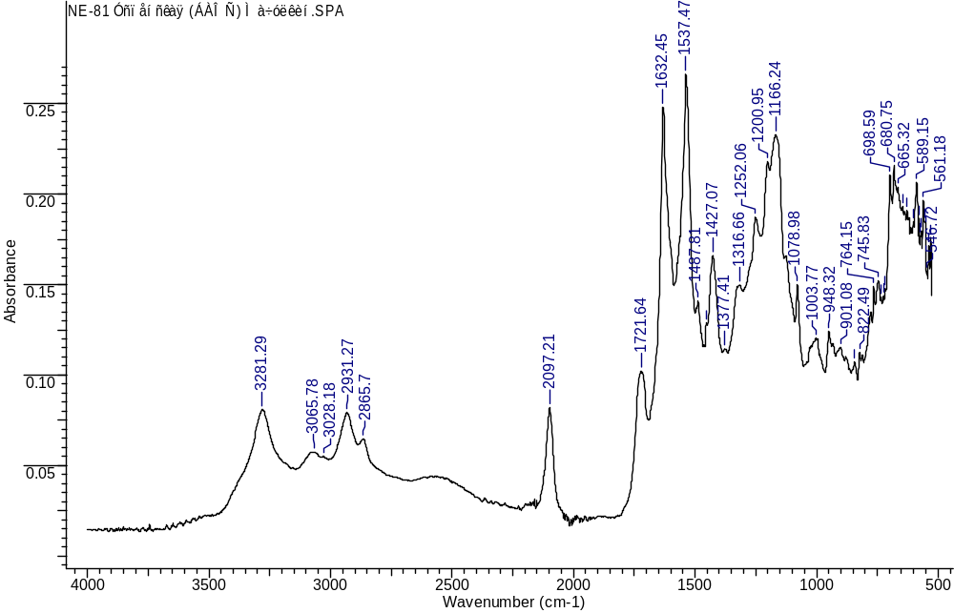
IR
(3S,7S,25R,28S)-33-azido-25-benzyl-12-(3-chlorobenzyl)-28-(4-hydroxy-3-nitrobenzyl)-5,13,20,23,26,29-hexaoxo-4,6,12,19,24,27,30-heptaazatritriacontane-1,3,7-tricarboxylic acid (1g)
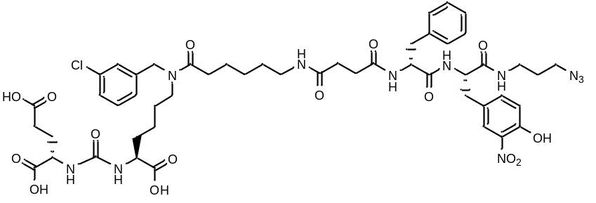
Yellow amorphous solid (142 mg, 65%). ¹H NMR (400 MHz, DMSO-d₆, δ, ppm): 12.47 (br.s., 3 H), 10.75 (s, 1 H), 8.43 (d, J=8.80 Hz, 1 H), 8.10 (d, J=7.83 Hz, 1 H), 7.99 – 7.95 (m, 1 H), 7.72 - 7.80 (m, 2 H), 7.25 - 7.38 (m, 3 H), 7.19 - 7.24 (m, 1 H), 7.09 - 7.19 (m, 4 H), 7.08 (d, J=7.15 Hz, 2 H), 7.00 (d, J=8.50 Hz, 1 H), 6.24 - 6.35 (m, 2 H), 4.54 (s, 1 H), 4.46 (s, 1 H), 4.38 (d, J=8.01 Hz, 2 H), 4.08 (m, 1 H), 3.98 - 4.05 (m, 1 H), 3.29 (t, J=6.69 Hz, 3 H), 3.18 – 3.15 (m, 3 H), 3.04 - 3.13 (m, 2 H), 2.90 - 3.02 (m, 3 H), 2.67 - 2.78 (m, 2 H), 2.58 – 2.54 (m, 1 H), 2.34 (t, J=7.21 Hz, 2 H), 2.14 - 2.26 (m, 6 H), 1.77 - 1.94 (m, 1 H), 1.72 – 1.68 (m, 1 H), 1.57 - 1.66 (m, 3 H), 1.43 - 1.57 (m, 4 H), 1.41 – 1.36 (m, 2 H), 1.19 - 1.33 (m, 4 H), 1.15 (m, 1 H). ¹³C NMR (101 MHz, DMSO-d₆, δ, ppm): 174.50, 174.21, 173.77, 172.16, 171.80, 171.17, 170.64, 157.27, 150.90, 141.24, 140.84, 137.88, 136.45, 136.08, 133.40, 133.04, 130.25, 129.22, 129.10, 127.92, 127.20, 127.13, 126.84, 126.30, 126.16, 126.09, 125.45, 118.90, 54.28, 54.04, 51.65, 48.25, 35.91, 31.87, 31.79, 30.68, 30.62, 29.91, 29.12, 28.99, 28.23, 27.80, 27.55, 26.25, 26.16, 24.74, 22.34. LCMS purity: 100%; retention time: 3.9 min. HRMS (ESI) m/z 1094.4342 (calcd 1094.4345 for C₅₀H₆₄ClN₁₁O₁₅ [M+H]⁺), 1116.4159 (calcd 1116.4164 for C₅₀H₆₄ClN₁₁O₁₅ [M+Na]⁺). IR (ZnSe) 3295, 3067, 2931, 2864, 2097, 1715, 1650, 1556, 1426, 1174 cm⁻¹.
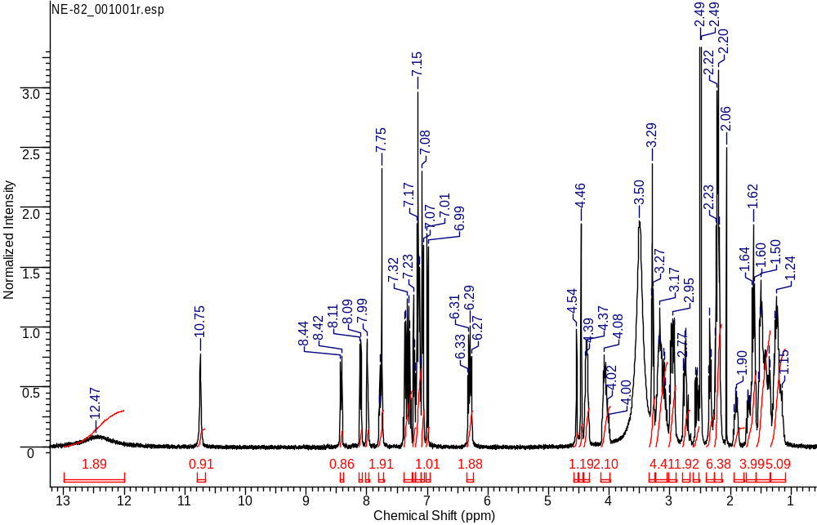
¹H NMR
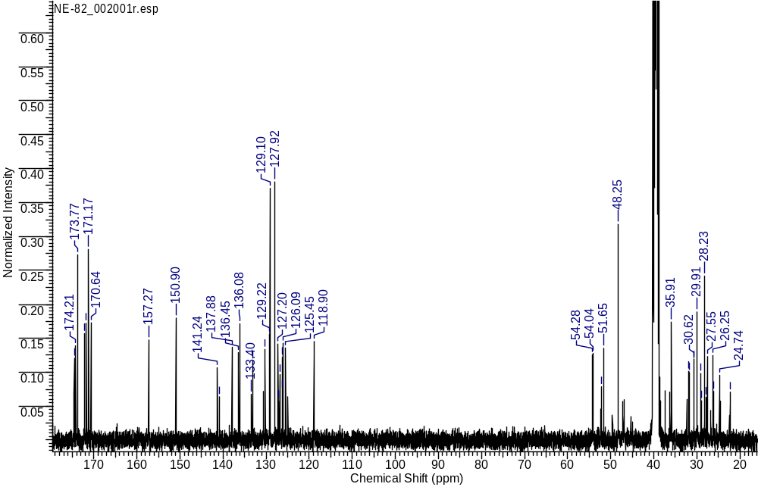
¹³C NMR
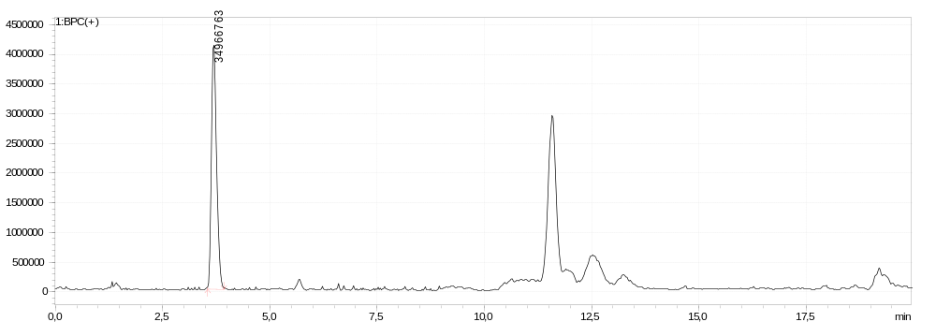
LCMS sample
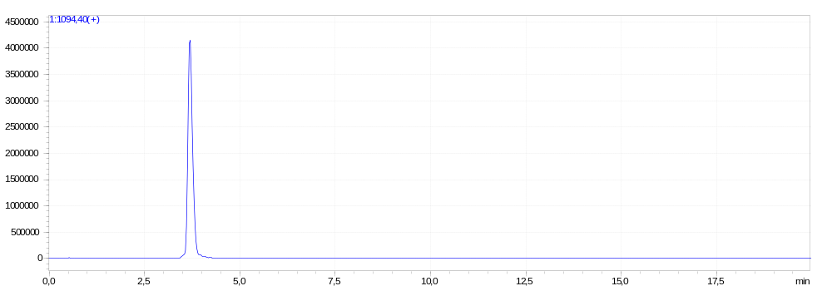
LCMS extracted-ion
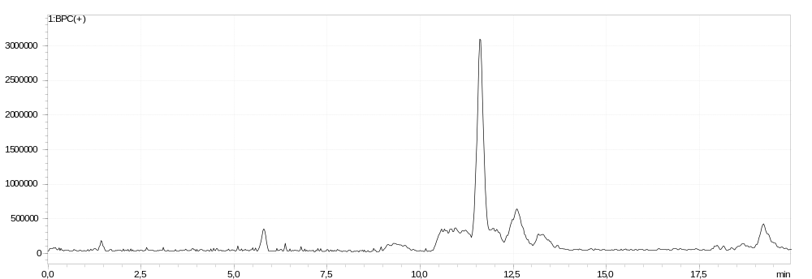
LCMS blank
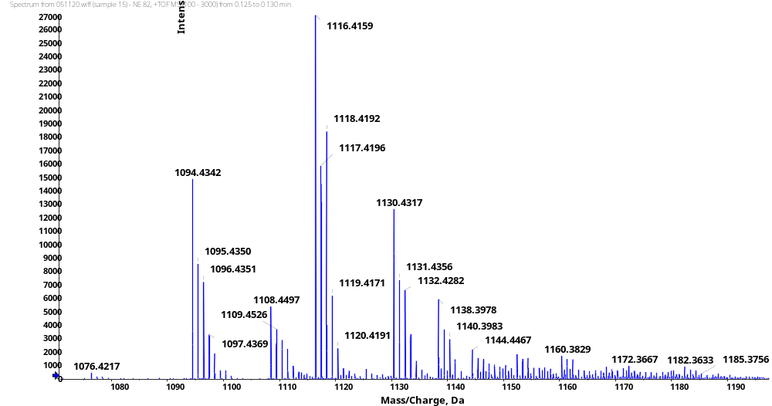
HRMS (ESI)
HRMS (Calcd)
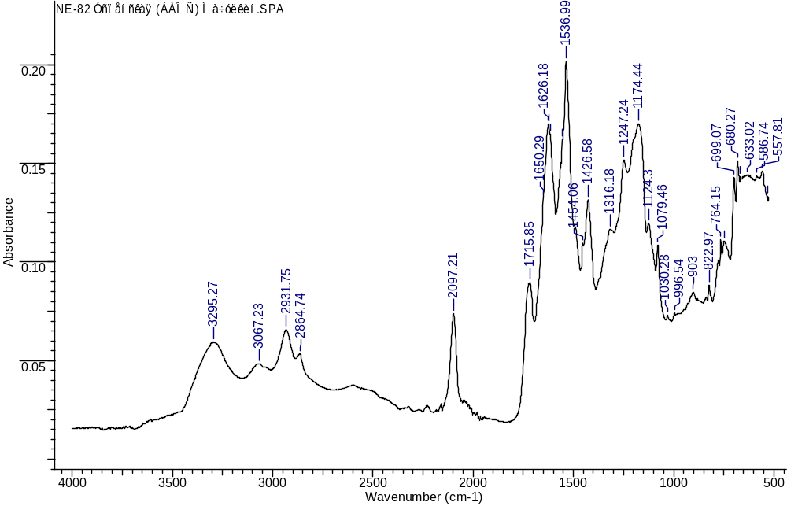
IR
(3S,7S,25R,28S)-33-azido-25-benzyl-28-(3-bromo-4-hydroxybenzyl)-12-(3-chlorobenzyl)-5,13,20,23,26,29-hexaoxo-4,6,12,19,24,27,30-heptaazatritriacontane-1,3,7-tricarboxylic acid (1h)
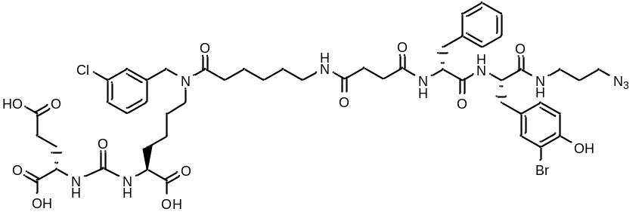
White amorphous solid (35 mg, 35%). ¹H NMR (400 MHz, DMSO-d₆, δ, ppm): 12.42 (br.s., 3 H), 10.00 (s, 1 H), 8.38 (d, J=8.50 Hz, 1 H), 8.06 (d, J=7.89 Hz, 1 H), 7.97 (m, 1 H), 7.72 - 7.80 (m, 1 H), 7.25 - 7.41 (m, 3 H), 7.19 – 7.13 (m, 5 H), 7.08 (d, J=7.21 Hz, 2 H), 7.00 (d, J=8.56 Hz, 1 H), 6.80 (d, J=8.25 Hz, 1 H), 6.24 - 6.35 (m, 2 H), 4.54 (s, 1 H), 4.46 (s, 1 H), 4.35 - 4.43 (m, 1 H), 4.27 - 4.35 (m, 1 H), 3.98 - 4.12 (m, 2 H), 3.20 – 3.12 (m, 3 H), 3.10 – 3.07 (m, 1 H), 3.07 (d, J=4.83 Hz, 1 H), 2.90 - 3.02 (m, 2 H), 2.88 – 2.83 (m, 1 H), 2.79 – 2.76 (m, 1 H), 2.66 – 2.64 (m, 1 H), 2.59 – 2.56 (m, 1 H), 2.34 (t, J=7.43 Hz, 1 H), 1.86 - 1.95 (m, 1 H), 1.67 - 1.78 (m, 1 H), 1.58 - 1.67 (m, 3 H), 1.31 - 1.56 (m, 6 H), 1.20 - 1.31 (m, 4 H), 1.15 (m, 1 H). ¹³C NMR (101 MHz, DMSO-d₆, δ, ppm): 174.53, 174.49, 174.20, 173.77, 172.19, 171.76, 171.17, 171.07, 170.89, 157.28 (NHC(O)), 152.53, 141.23, 137.96, 133.33, 133.05, 130.26, 130.13, 129.50, 129.18, 127.95, 127.19, 126.08, 115.93, 108.86, 54.41, 54.24, 52.14, 51.66, 48.25, 35.89, 31.87, 31.79, 30.70, 30.66, 29.91, 29.11, 28.99, 28.25, 27.79, 27.54, 26.76, 26.24, 26.16, 24.74, 24.59, 22.49, 22.33. LCMS purity: 97%; retention time: 12.5 min. HRMS (ESI) m/z 1127.3644 (calcd 1127.3599 for C₅₀H₆₄ClBrN₁₀O₁₃ [M+H]⁺), [α]_{D} -1 (c 1 in acetonitrile : water 3 : 1). IR (ZnSe) 3293, 3061, 2930, 2863, 2097, 1716, 1621, 1547, 1418, 1201 cm⁻¹.
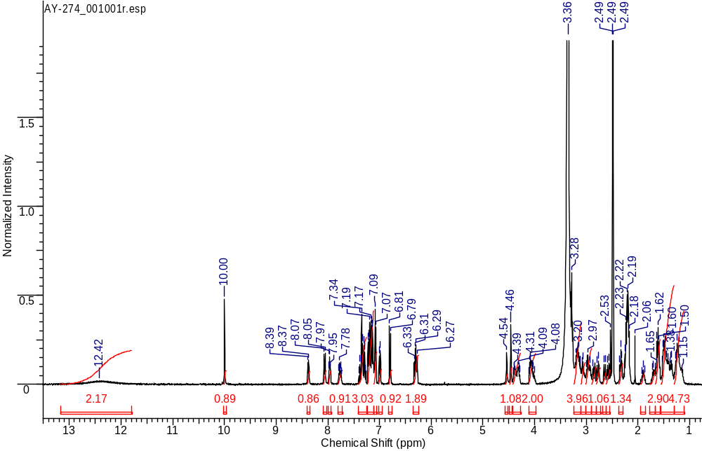
¹H NMR
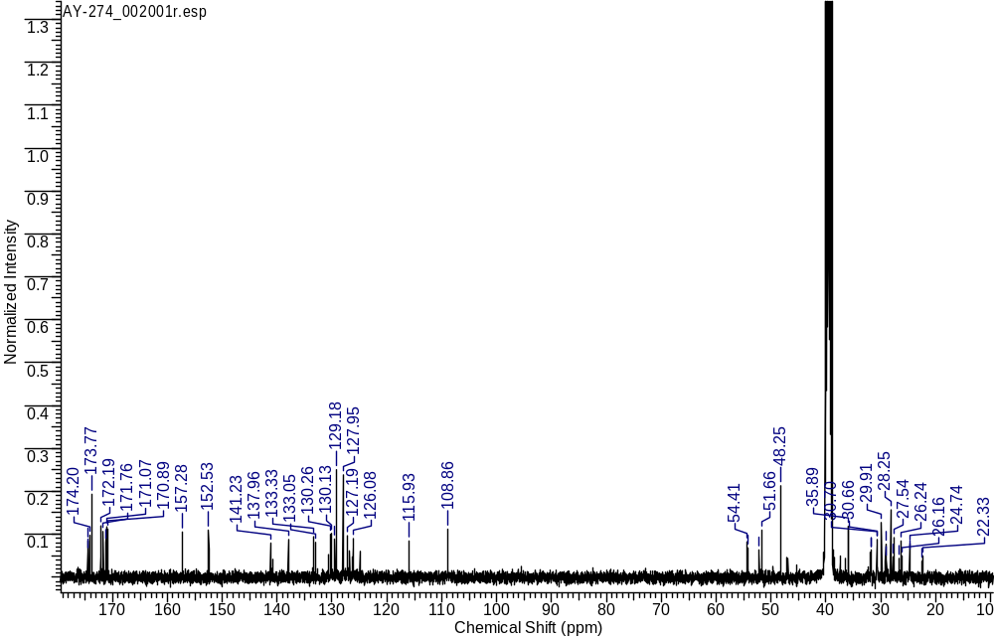
¹³C NMR
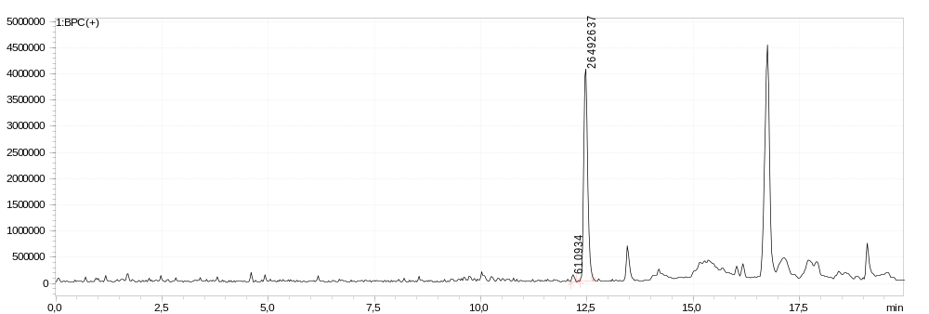LCMS sample
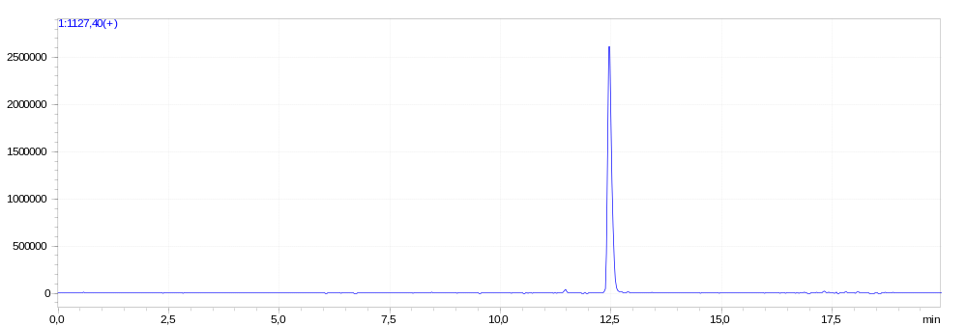
LCMS extracted-ion
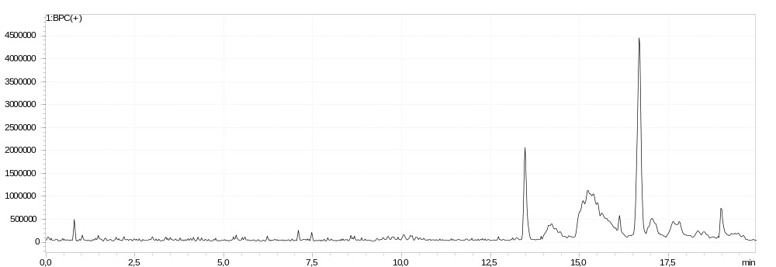
LCMS blank
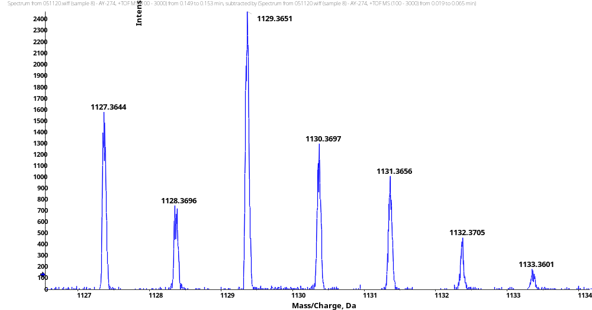
HRMS (ESI)
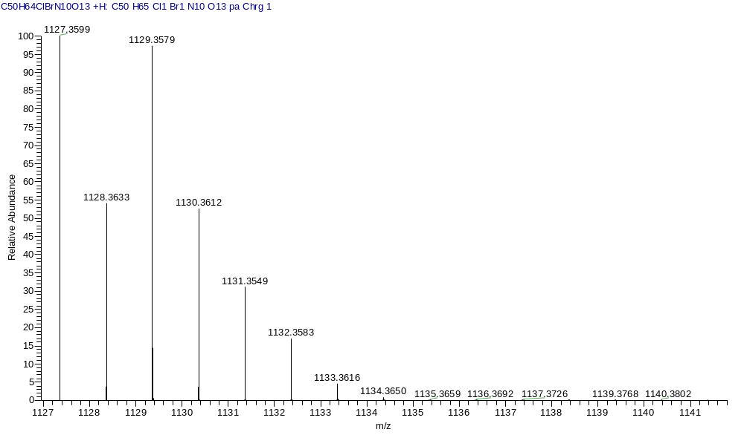
HRMS (Calcd)
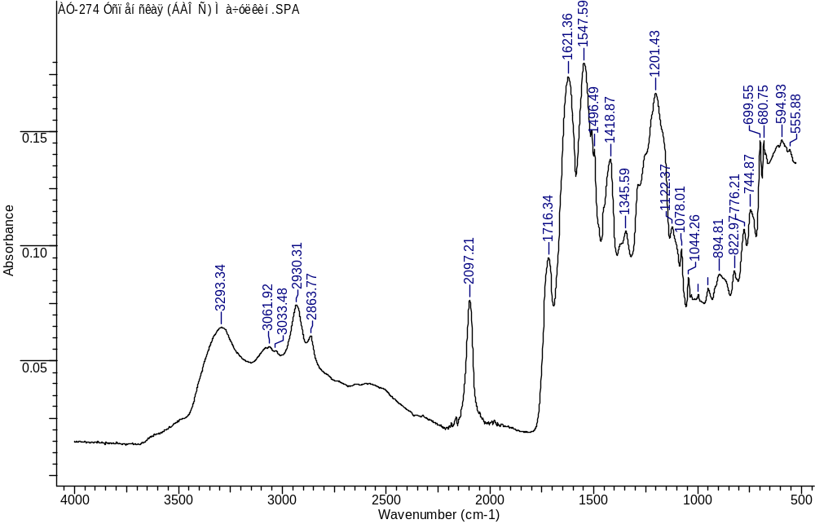
IR
(3S,7S,25S,28S)-33-azido-25-benzyl-28-(4-bromobenzyl)-12-(3-chlorobenzyl)-5,13,20,23,26,29-hexaoxo-4,6,12,19,24,27,30-heptaazatritriacontane-1,3,7-tricarboxylic acid (1i)
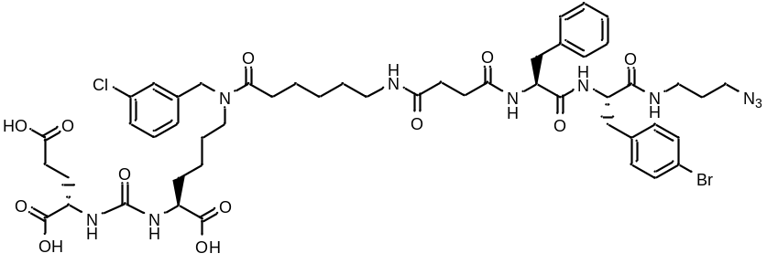
White amorphous solid (112 mg, 54%). ¹H NMR (400 MHz, DMSO-d₆, δ, ppm): 12.50 (br. s., 2 H), 8.29 (d, J=7.03 Hz, 1 H), 8.19 (d, J=8.44 Hz, 1 H), 7.94 (t, J=4.77 Hz, 1 H), 7.61 (d, J=4.83 Hz, 1 H), 7.45 (d, J=7.76 Hz, 2 H), 7.28 - 7.37 (m, 2 H), 7.17 - 7.24 (m, 4 H), 7.16 – 7.14 (m, J=2.81 Hz, 4 H), 6.25 - 6.34 (m, 2 H), 4.46 (s, 1 H), 4.36 (s, 1 H), 4.30 (m, 1 H), 4.04 - 4.11 (m, 1 H), 3.25 (d, J=18.28 Hz, 5 H), 3.17 (d, J=11.37 Hz, 2 H), 3.08 (m, 2 H), 3.01 (m, 3 H), 2.91 (d, J=17.42 Hz, 3 H), 2.25 - 2.37 (m, 4 H), 2.11 - 2.25 (m, 4 H), 1.84 - 1.95 (m, 1 H), 1.64 - 1.74 (m, 1 H), 1.59 (m, 3 H), 1.50 (m, 4 H), 1.38 (m, 3 H), 1.28 (m, 2 H), 1.22 (m, 2 H), 1.17 (m, 1 H). HRMS (ESI) m/z 1135.3408 (calcd 1135.3449 for C₅₀H₆₄ClBrN₁₀O₁₂ [M+Na]⁺). [α]_{D} -6 (c 1 in acetonitrile : water 3 : 1). IR (ZnSe) 3289, 2921, 2868, 2097, 1718, 1632, 1539, 1201 cm⁻¹.
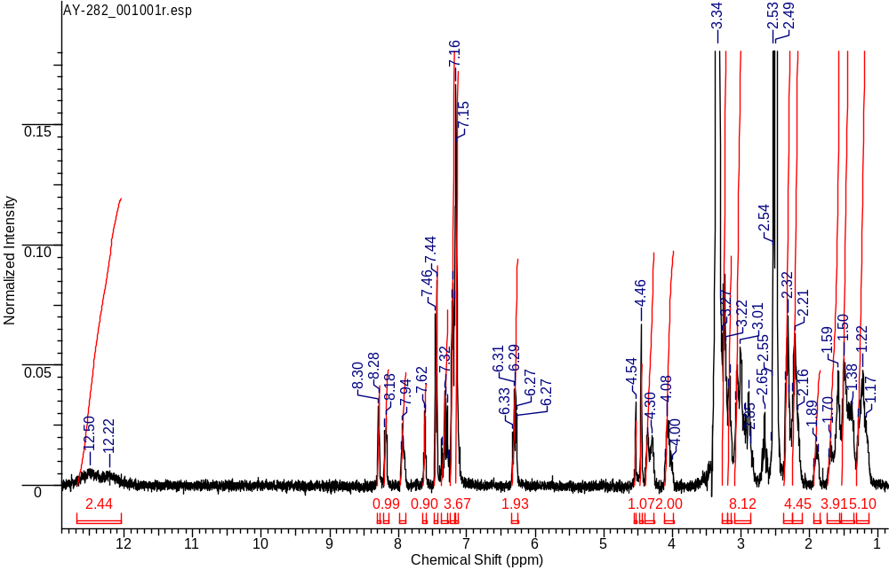
¹H NMR
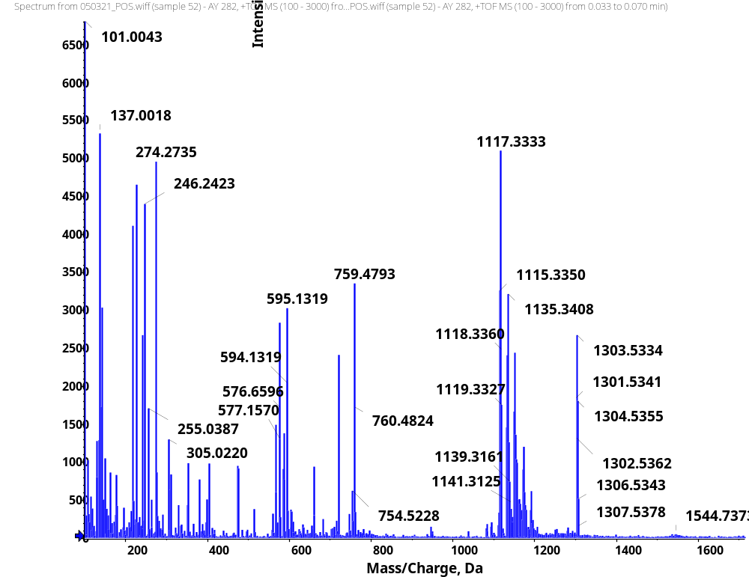
HRMS
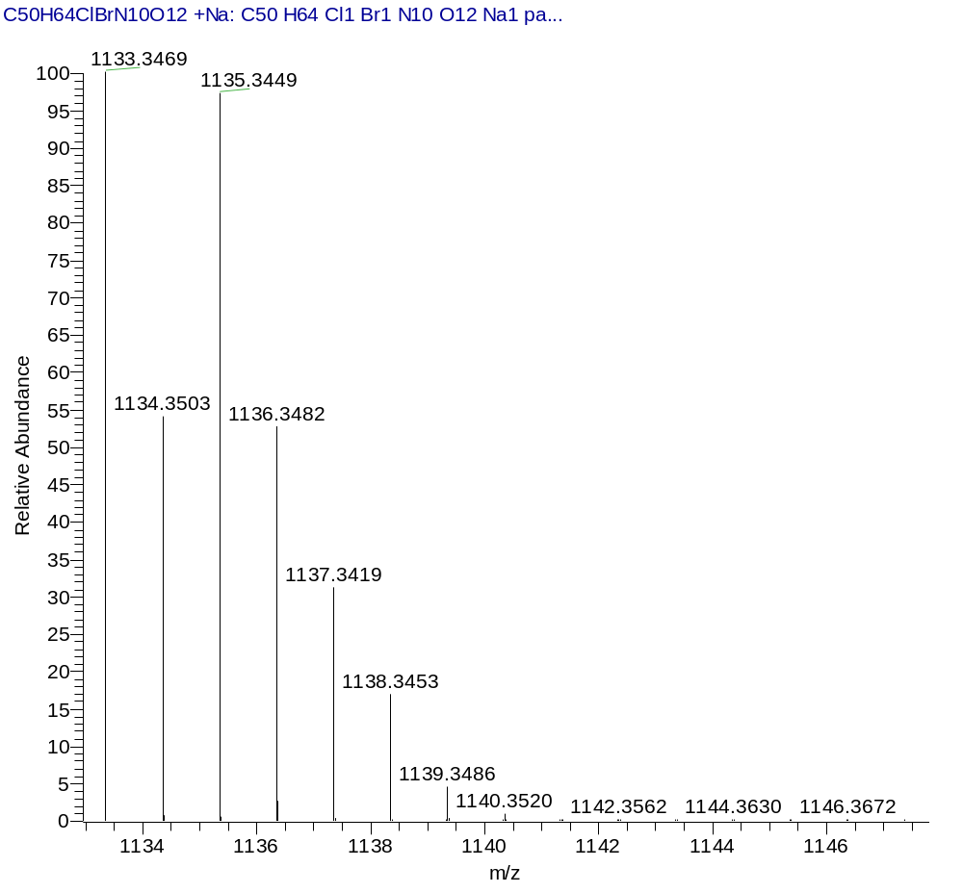
HRMS (Calcd)
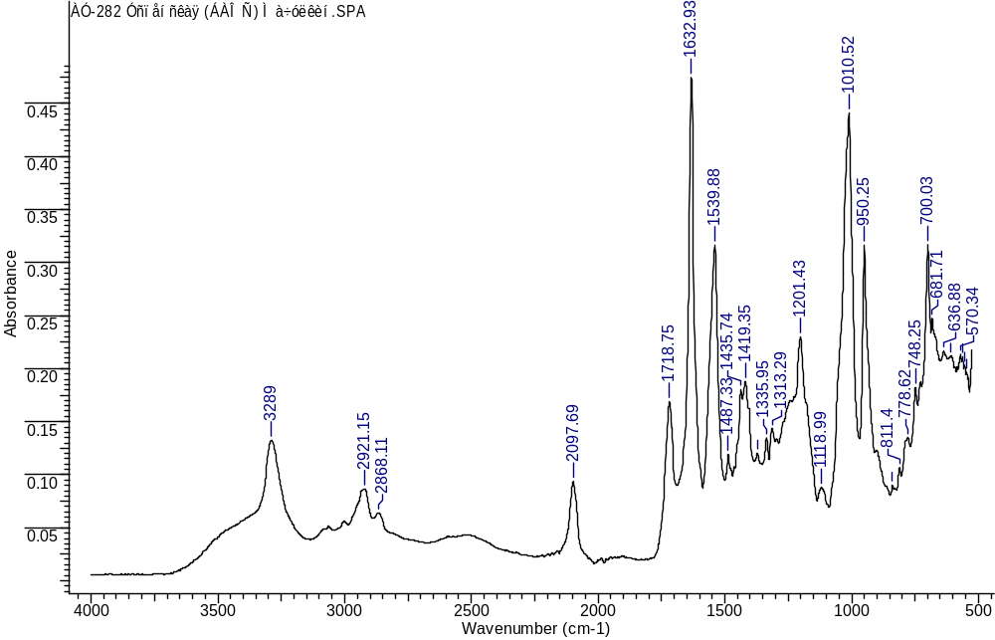
IR
(3S,7S,25S,28S)-33-azido-25-benzyl-28-(3-bromobenzyl)-12-(3-chlorobenzyl)-5,13,20,23,26,29-hexaoxo-4,6,12,19,24,27,30-heptaazatritriacontane-1,3,7-tricarboxylic acid (1j)
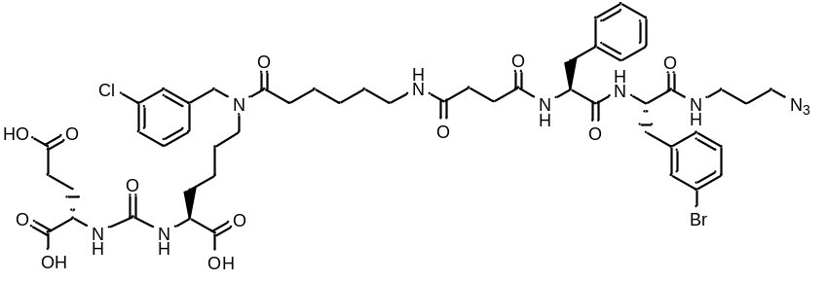
White amorphous solid (56 mg, 75%). ¹H NMR (400 MHz, DMSO-d₆, δ, ppm): 12.44 (br.s., 1 H), 8.30 (d, J=7.21 Hz, 1 H), 8.22 (d, J=8.44 Hz, 1 H), 7.94 (d, 1 H), 7.66 (d, J=5.62 Hz, 1 H), 7.40 (d, J=17.30 Hz, 2 H), 7.26 - 7.37 (m, 2 H), 7.19 - 7.25 (m, 5 H), 7.15 (d, J=3.24 Hz, 4 H), 6.31 (dd, J=15.89, 8.01 Hz, 2 H), 4.54 (s, 1 H), 4.46 (s, 1 H), 4.38 (d, J=5.69 Hz, 1 H), 4.28 (m, 1 H), 4.08 (m, 1 H), 4.03 (m, 1 H), 3.21 - 3.28 (m, 3 H), 3.16 (m, 3 H), 3.07 (d, J=11.74 Hz, 3 H), 3.00 (m, 2 H), 2.90 (m, 2 H), 2.63 - 2.71 (m, 1 H), 2.33 (d, J=8.31 Hz, 4 H), 2.12 - 2.27 (m, 5 H), 1.91 (d, J=6.97 Hz, 1 H), 1.70 (m, 1 H), 1.59 (m, 3 H), 1.51 (m, 7 H), 1.22 (m, 5 H). ¹³C NMR (101 MHz, DMSO-d₆, δ, ppm): 174.50, 174.20, 173.77, 173.31, 172.13, 171.76, 171.18, 170.35, 157.28, 141.23, 140.83, 137.99, 137.21, 133.41, 133.05, 132.54, 131.05, 131.00, 130.25, 128.98, 128.58, 128.14, 127.55, 127.20, 127.14, 126.85, 126.32, 126.28, 126.09, 124.96, 124.24, 55.37, 52.25, 52.14, 51.65, 48.18, 36.94, 36.64, 36.02, 32.29, 31.88, 31.80, 30.61, 30.46, 29.91, 29.05, 28.95, 28.12, 27.81, 27.55, 26.31, 26.24, 24.73, 24.58, 22.35. LCMS purity: 100%; retention time: 12.6 min. HRMS (ESI) m/z 1111.3677 (calcd 1111.3650 for C₅₀H₆₄ClBrN₁₀O₁₂ [M+H]⁺). [α]_{D} -10.5 (c 1 in acetonitrile : water 3 : 1). IR (ZnSe) 3286, 3066, 2931, 2864, 2099, 1716, 1633, 1539, 1430, 1199 cm⁻¹.
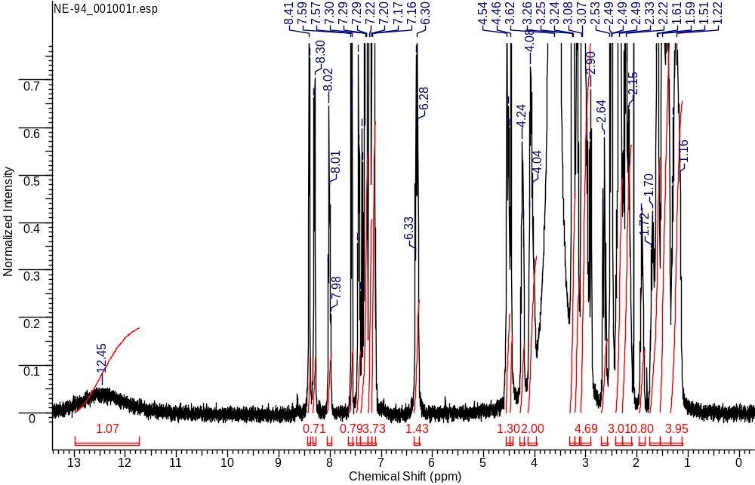
¹H NMR
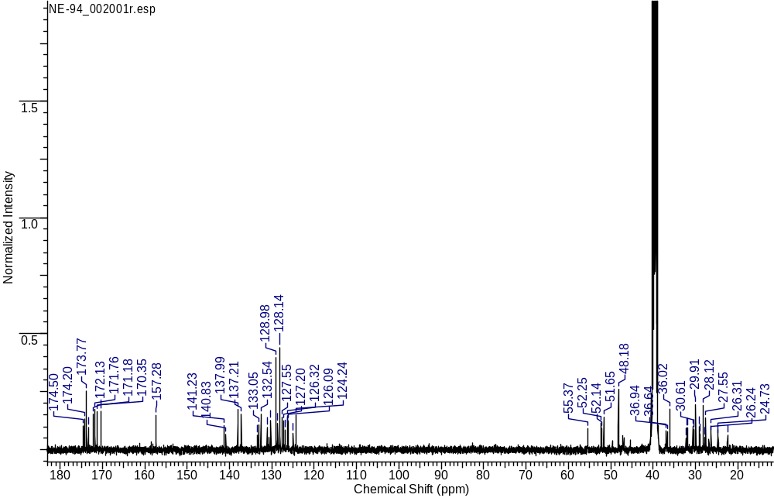
¹³C NMR
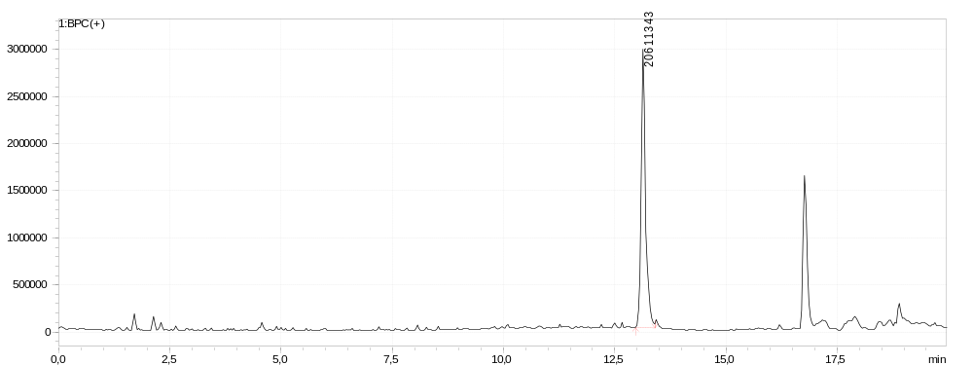
LCMS sample
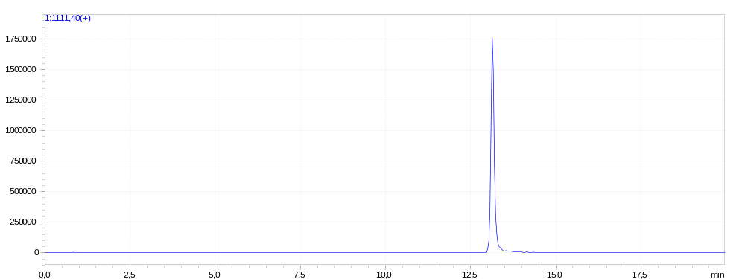
LCMS extracted-ion
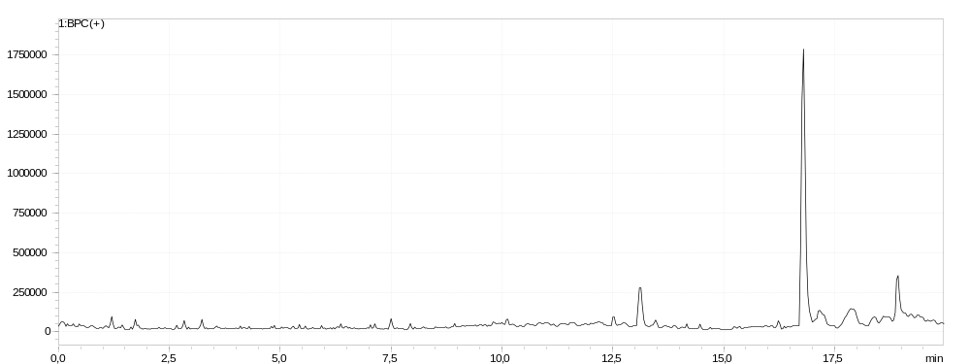
LCMS blank
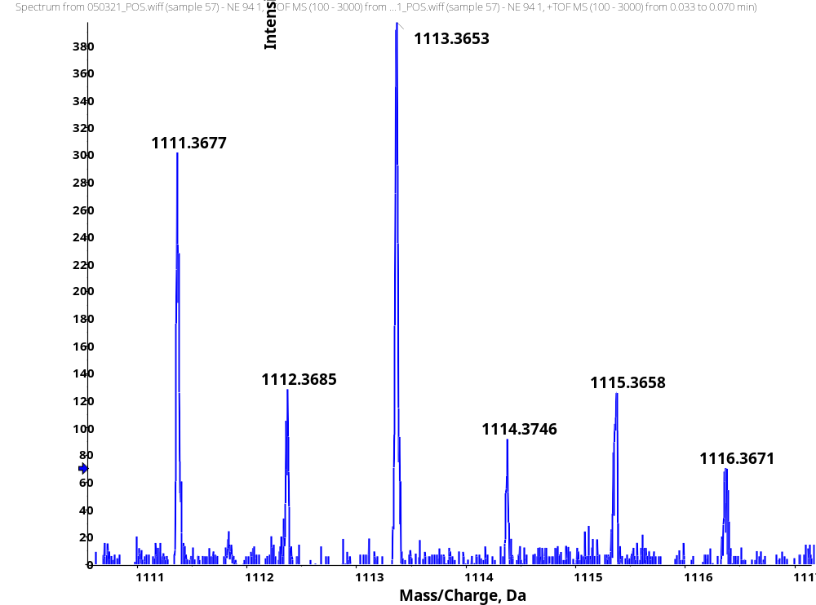
HRMS
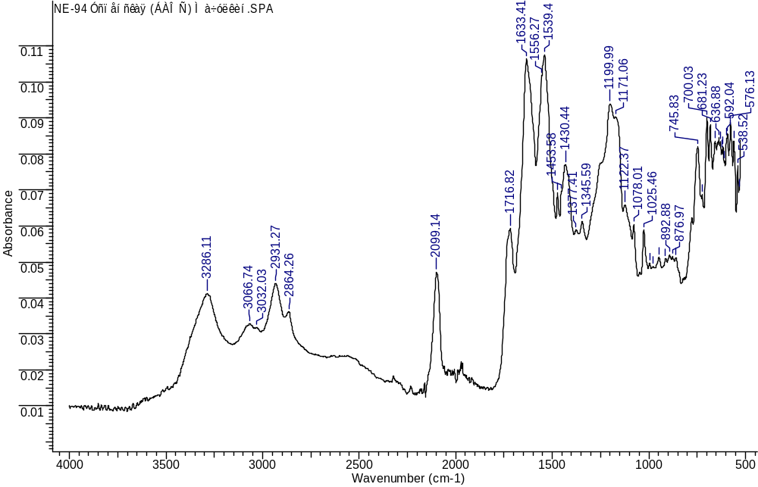
IR
(3S,7S,25S,28S)-33-azido-25-benzyl-28-(2-bromobenzyl)-12-(3-chlorobenzyl)-5,13,20,23,26,29-hexaoxo-4,6,12,19,24,27,30-heptaazatritriacontane-1,3,7-tricarboxylic acid (1k)
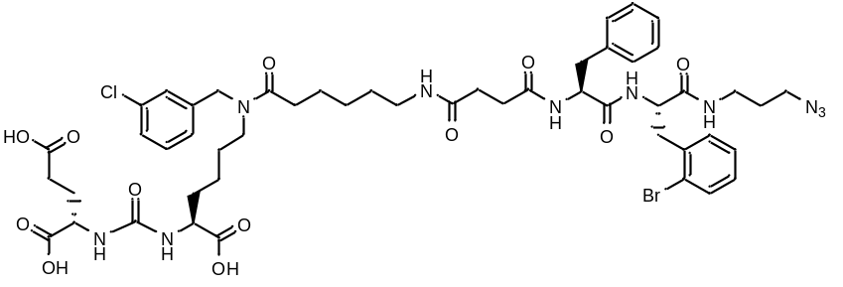
White amorphous solid (139 mg, 45%). ¹H NMR (400 MHz, DMSO-d₆, δ, ppm): 12.44 (br. s., 1 H), 8.30 (d, J=7.21 Hz, 1 H), 8.22 (d, J=8.44 Hz, 1 H), 7.94 (br. s., 1 H), 7.66 (d, J=5.62 Hz, 1 H), 7.40 (d, J=17.30 Hz, 2 H), 7.26 - 7.37 (m, 2 H), 7.19 - 7.25 (m, 5 H), 7.15 (d, J=3.24 Hz, 4 H), 6.31 (dd, J=15.89, 8.01 Hz, 2 H), 4.54 (s, 1 H), 4.46 (s, 1 H), 4.38 (d, J=5.69 Hz, 1 H), 4.28 (s., 1 H), 4.08 (s., 1 H), 4.03 (s., 1 H), 3.21 - 3.28 (m, 3 H), 3.16 (m, 3 H), 3.07 (d, J=11.74 Hz, 3 H), 3.00 (m, 2 H), 2.90 (m, 2 H), 2.63 - 2.71 (m, 1 H), 2.33 (d, J=8.31 Hz, 4 H), 2.12 - 2.27 (m, 5 H), 1.91 (d, J=6.97 Hz, 1 H), 1.70 (m, 1 H), 1.59 (m, 3 H), 1.51 (m, 7 H), 1.22 (m, 5 H). ¹³C NMR (101 MHz, DMSO-d₆, δ, ppm): 174.50, 174.20, 173.78, 172.76, 172.15, 171.56, 171.20, 170.41, 157.28, 141.23, 140.92, 140.83, 137.93, 133.40, 133.05, 131.72, 130.61, 130.33, 130.25, 129.29, 129.03, 128.23, 128.21, 128.09, 127.19, 127.14, 126.85, 126.29, 126.09, 124.97, 121.52, 54.96, 54.07, 52.25, 52.13, 51.65, 47.15, 46.86, 36.94, 36.66, 35.89, 31.87, 31.80, 30.68, 30.55, 29.91, 29.06, 28.95, 28.19, 27.80, 27.55, 26.29, 26.22, 24.73, 24.59, 22.51, 22.34. LCMS purity: 100%; retention time: 13. min. HRMS (ESI) m/z 1111.3690 (calcd 1111.3649 for C₅₀H₆₄ClBrN₁₀O₁₂ [M+H]⁺). [α]_{D} -12 (c 1 in acetonitrile : water 3 : 1). IR (ZnSe) 3286, 3067, 2932, 2862, 2097, 1715, 1633, 1539, 1427, 1200 cm⁻¹.
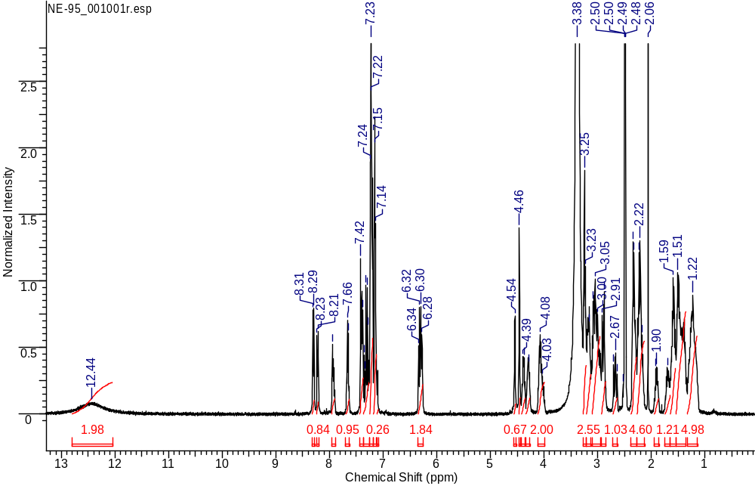
¹H NMR
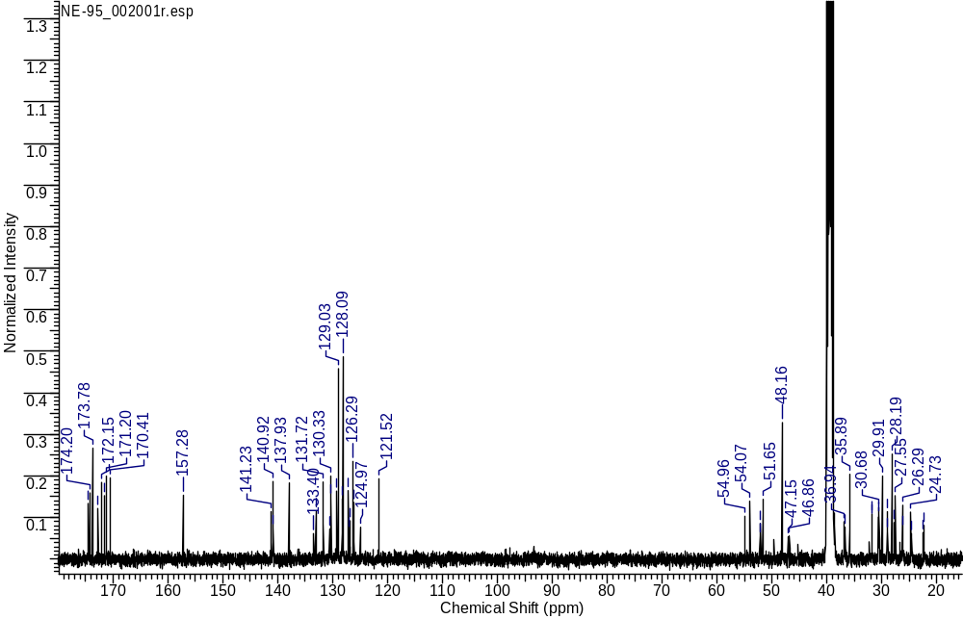
¹³C NMR
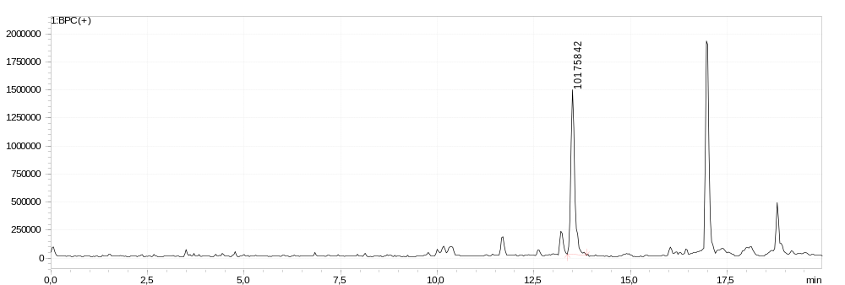
LCMS sample
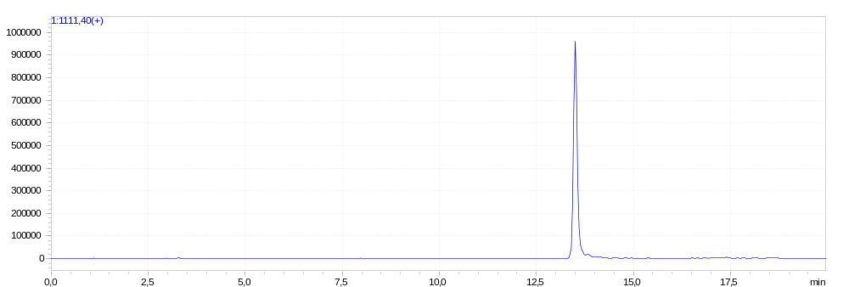
LCMS extracted-ion
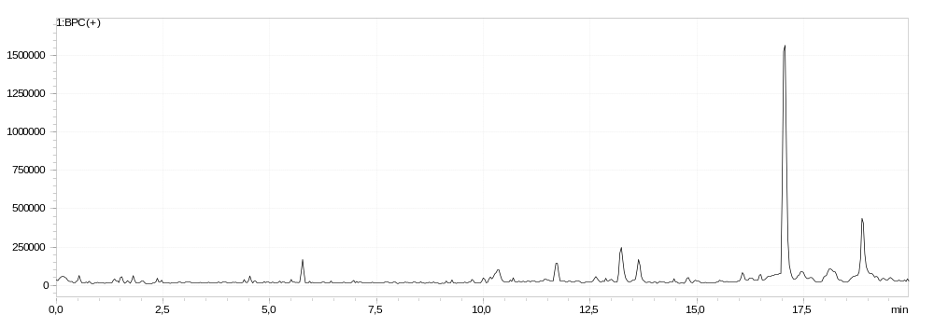
LCMS blank
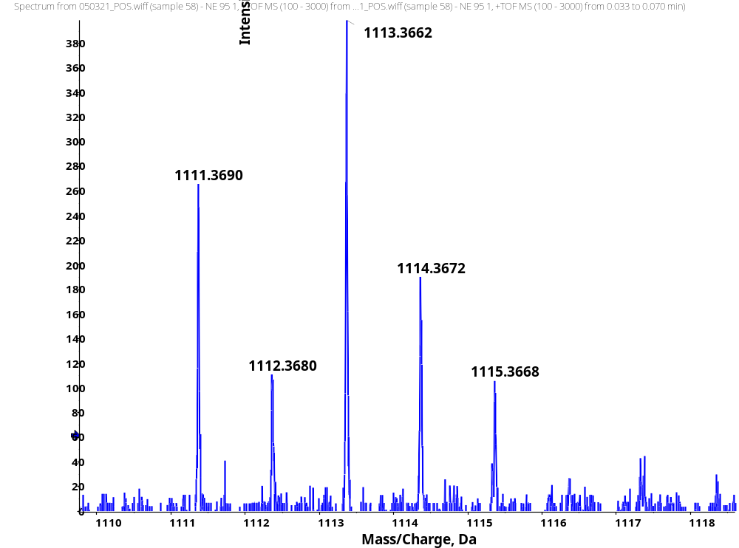
HRMS
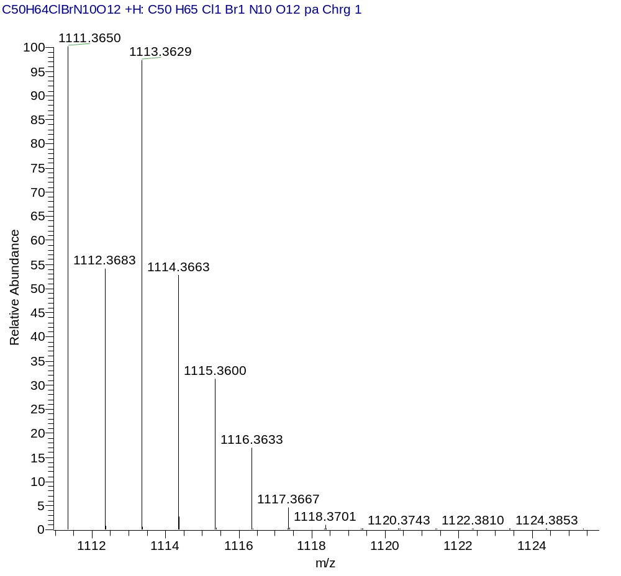
HRMS (Calcd)
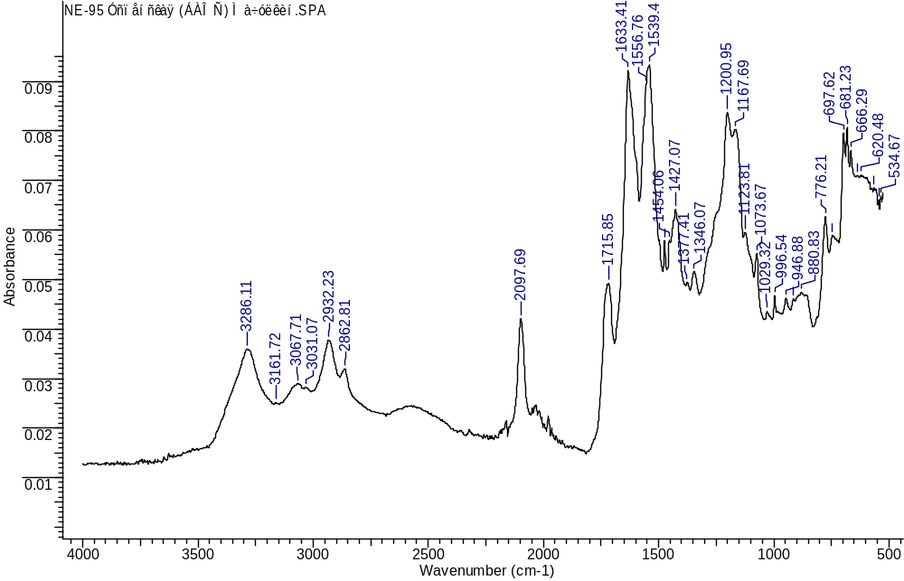
IR
(3S,7S,25R,28R)-33-azido-25-benzyl-28-(4-bromobenzyl)-12-(3-chlorobenzyl)-5,13,20,23,26,29-hexaoxo-4,6,12,19,24,27,30-heptaazatritriacontane-1,3,7-tricarboxylic acid (1l)
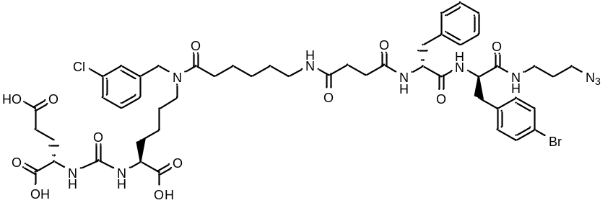
White amorphous solid (59 mg, 43%). ¹H NMR (400 MHz, DMSO-d₆, δ, ppm): 12.59 (br.s., 3 H, COOH), 8.31 - 8.41 (m, 1 H), 7.92 - 7.98 (m, 1 H), 7.24 - 7.40 (m, 3 H), 7.13 - 7.24 (m, 8 H), 7.09 – 7.07 (m, 1 H), 6.33 – 6.29 (m, J=8.28 Hz, 2 H), 4.46 (s, 1 H), 4.37 (s, 1 H), 3.97 - 4.10 (m, 2 H), 3.12 - 3.23 (m, 6 H), 3.06 – 3.03 (m, 2 H), 2.99 – 2.95 (m, 4 H), 2.75 (d, J=13.08 Hz, 1 H), 2.32 (d, J=5.14 Hz, 1 H), 2.21 – 2.16 (m, 4 H), 1.87 – 1.85 (m, 1 H), 1.71 (d, J=10.09 Hz, 1 H), 1.60 – 1.55 (m, 2 H), 1.49 – 1.43 (m, 5 H), 1.22 (m, 4 H). HRMS (ESI) m/z 1111.3674 (calcd 1111.3650 for C₅₀H₆₄ClBrN₁₀O₁₂ [M+H]⁺); 1134.3515 (calcd 1134.3503 for C₅₀H₆₄ClBrN₁₀O₁₂ [M+Na]⁺). [α]_{D} -18 (c 1 in acetonitrile : water 3 : 1). IR (ZnSe) 3283, 3062, 2928, 2862, 2097, 1722, 1632, 1538, 1538, 1422, 1199 cm⁻¹.
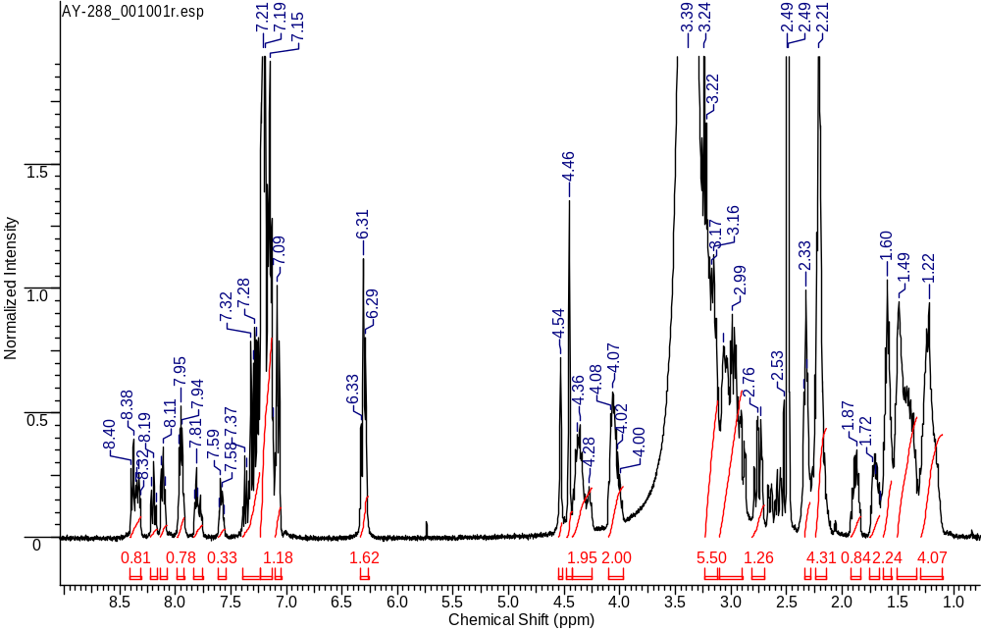
¹H NMR
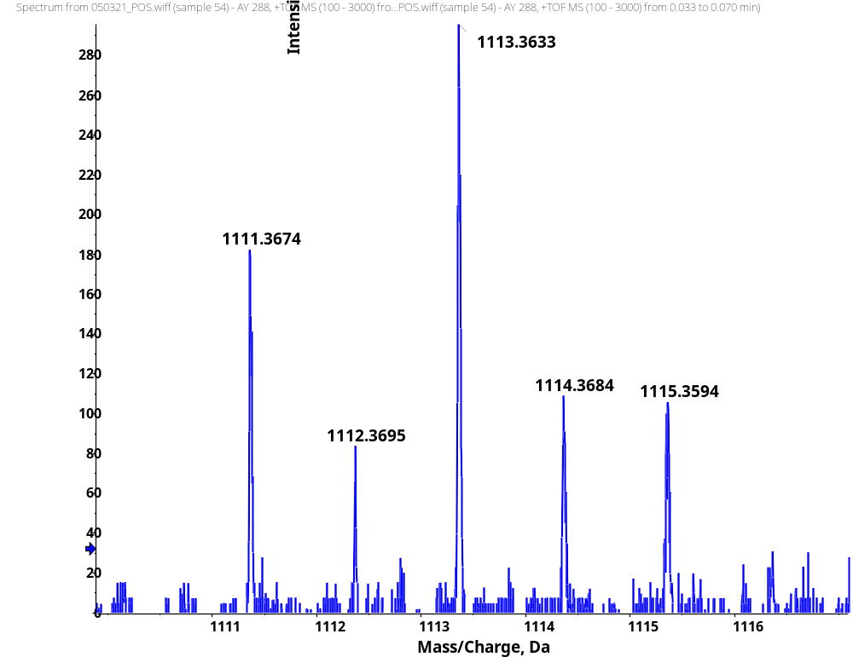
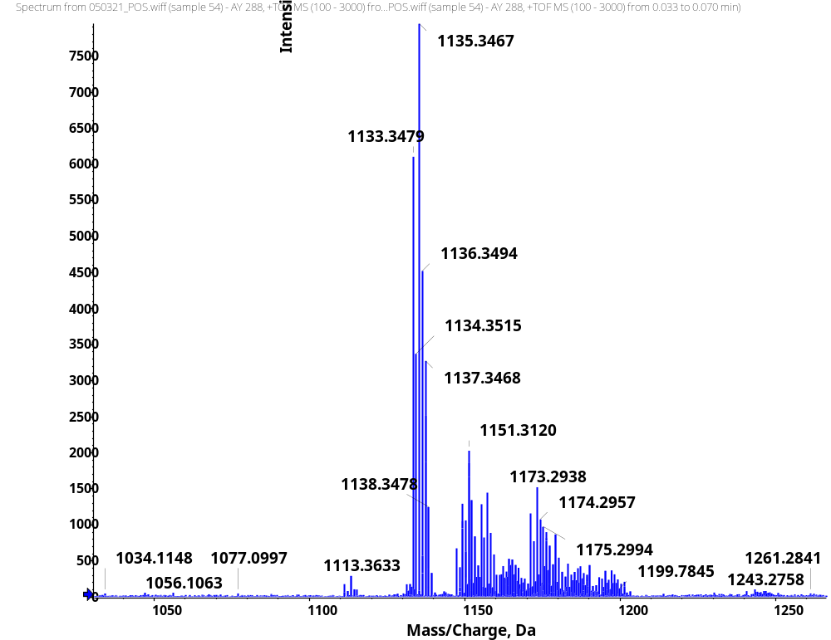
HRMS
HRMS (Calcd)
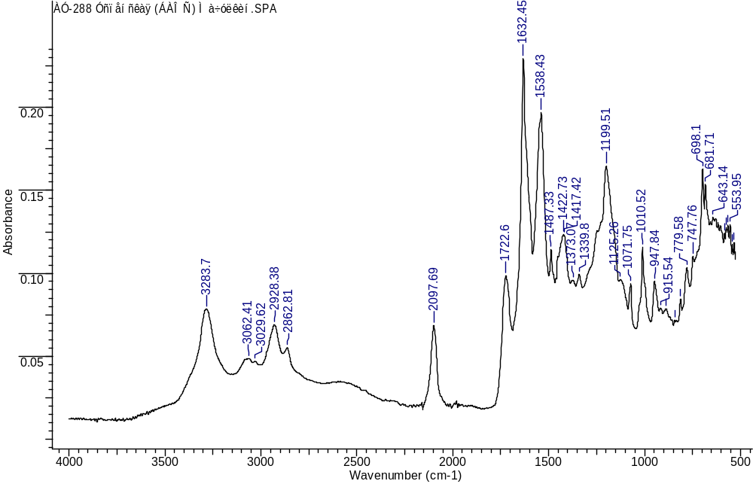
IR
(3S,7S,25R,28S)-33-azido-25-benzyl-12-(3-chlorobenzyl)-28-(3,4-dihydroxybenzyl)-5,13,20,23,26,29-hexaoxo-4,6,12,19,24,27,30-heptaazatritriacontane-1,3,7-tricarboxylic acid (1m)
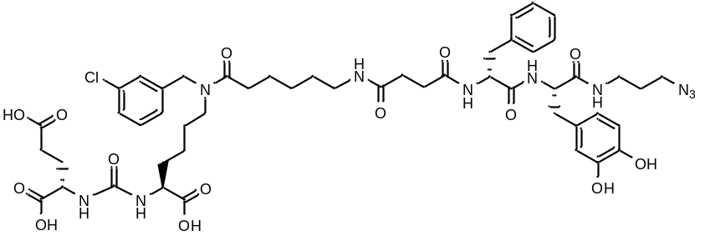
White amorphous solid (70 mg, 55%). ¹H NMR (400 MHz, DMSO-d₆, δ, ppm): 12.52 (br.s., 2 H), 9.35 (s, 1 H), 8.36 (d, J=7.85 Hz, 1 H), 8.16 (d, J=9.05 Hz, 1 H), 7.91 (d, J=3.07 Hz, 1 H), 7.74 - 7.82 (m, 1 H), 7.25 - 7.35 (m, 2 H), 7.16 - 7.24 (m, 4 H), 7.13 (t, J=7.74 Hz, 4 H), 6.72 – 6.71 (m, 1 H), 6.31 – 6.29 (m, 2 H), 4.54 (s, 1 H), 4.46 (s, 1 H), 4.27 - 4.40 (m, 2 H), 3.96 - 4.13 (m, 2 H), 3.14 - 3.22 (m, 3 H), 3.11 (m, 1 H), 3.06 (m, 1 H), 2.62 - 2.70 (m, 2 H), 2.57 (m, 1 H), 2.34 (d, J=14.59 Hz, 2 H), 2.16 - 2.27 (m, 7 H), 1.90 – 1.88 (m, 1 H), 1.71 – 1.68 (m, 1 H), 1.62 – 1.59 (m, 4 H), 1.49 -1.43 (m, 3 H), 1.42 – 1.33 (m, 3 H), 1.33 - 1.29 (m, 2 H), 1.27 (m, 4 H). LCMS purity: 100%; retention time: 12.3 min. HRMS (ESI) m/z 1065.4467 (calcd 1065.4443 for C₅₀H₆₅ClN₁₀O₁₄ [M+H]⁺); m/z 1065.4478 (calcd 1065.4443 for C₅₀H₆₅ClN₁₀O₁₄ [M+H]⁺). IR (ZnSe) 3286, 3062, 2930, 2863, 2097, 1715, 1650, 1615, 1556, 1434, 1198 cm⁻¹.
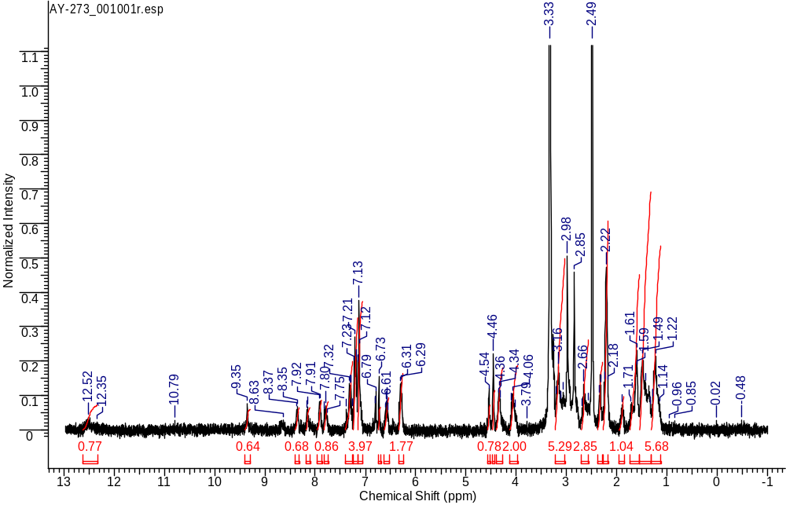
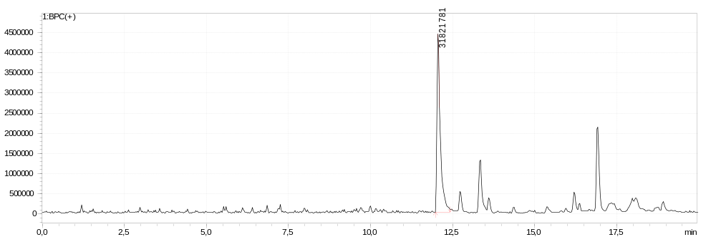
¹H NMR
LCMS sample
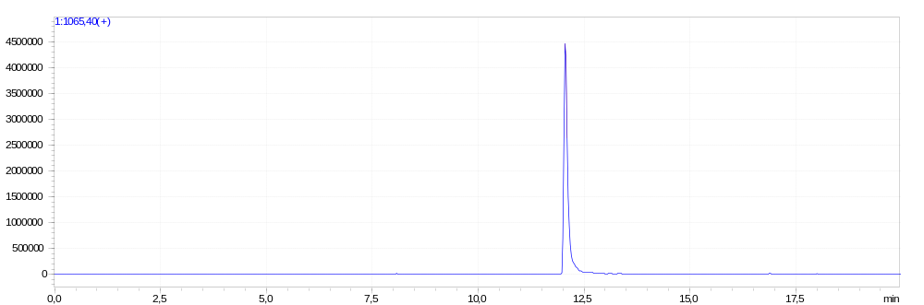
LCMS extracted-ion
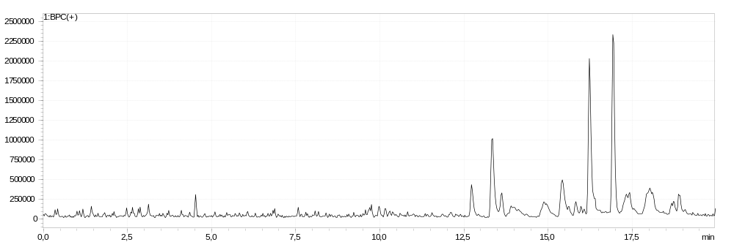
LCMS blank
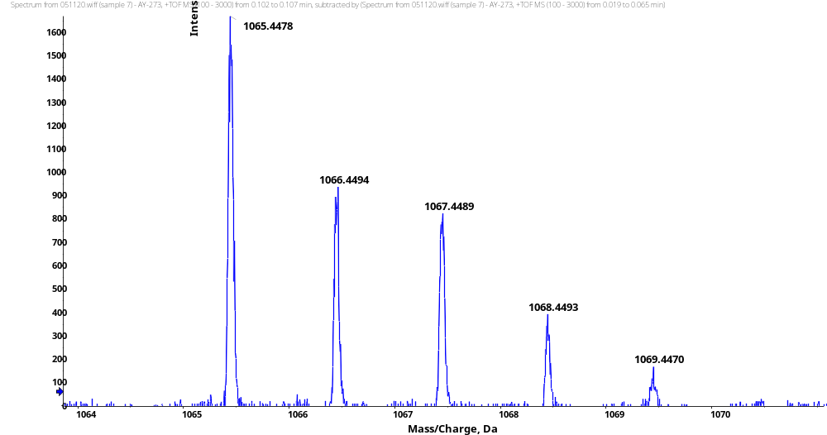
HRMS (ESI)
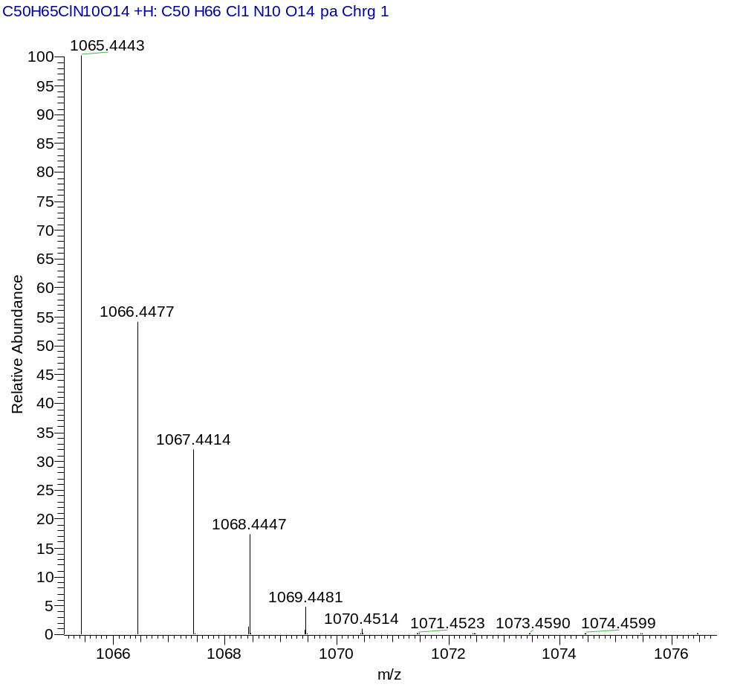
HRMS (Calcd)
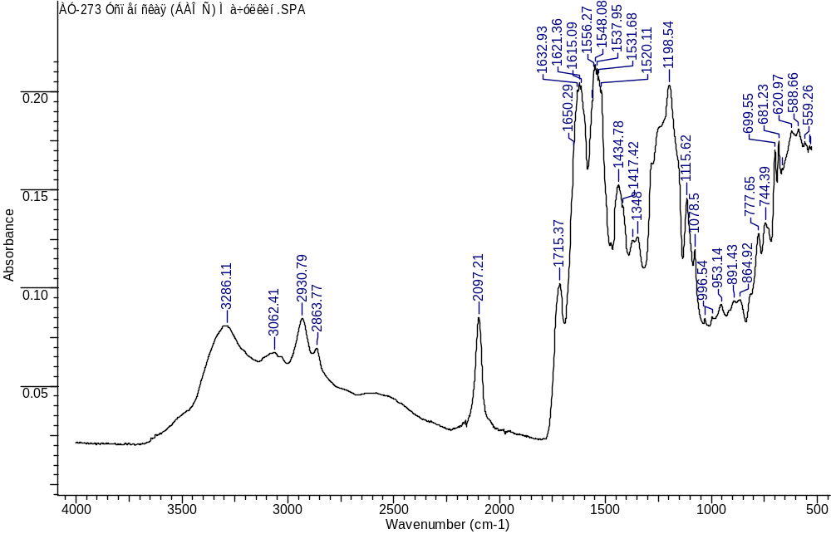
IR
(3S,7S,25S,28S)-33-azido-25-benzyl-28-(3-chloro-4-hydroxybenzyl)-12-(3-chlorobenzyl)-5,13,20,23,26,29-hexaoxo-4,6,12,19,24,27,30-heptaazatritriacontane-1,3,7-tricarboxylic acid (1n)
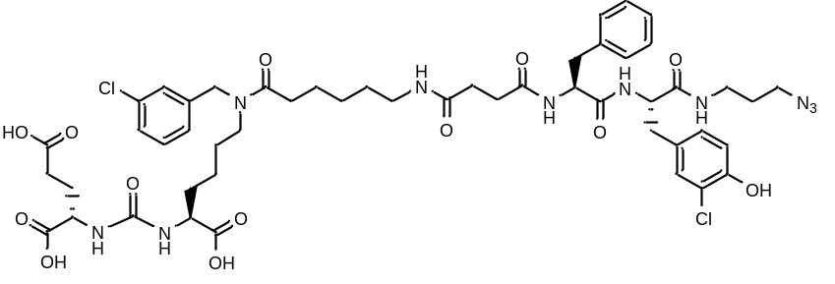
White amorphous solid (48 mg, 66%). ¹H NMR (400 MHz, DMSO-d₆, δ, ppm): 12.46 (br. s., 2 H), 9.96 (s, 1 H), 8.29 (d, J=7.40 Hz, 1 H), 8.14 (d, J=8.31 Hz, 1 H), 7.88 - 7.96 (m, 1 H), 7.63 (d, J=5.69 Hz, 1 H), 7.26 - 7.40 (m, 2 H), 7.19 - 7.25 (m, 3 H), 7.16 (d, J=3.67 Hz, 5 H), 6.95 - 6.99 (m, 1 H), 6.85 (d, J=8.19 Hz, 1 H), 6.26 - 6.35 (m, 2 H), 4.54 (s, 1 H), 4.46 (s, 1 H), 4.30 (m, 2 H), 3.99 - 4.11 (m, 2 H), 3.22 - 3.28 (m, 3 H), 3.16 (m, 2 H), 2.97 - 3.11 (m, 4 H), 2.86 - 2.97 (m, 3 H), 2.78 (d, J=13.69 Hz, 1 H), 2.68 (d, J=13.51 Hz, 1 H), 2.33 (d, J=9.60 Hz, 4 H), 2.15 - 2.27 (m, 5 H), 1.90 (d, J=5.26 Hz, 1 H), 1.70 (m, 1 H), 1.59 (m, 3 H), 1.50 (d, J=7.64 Hz, 3 H), 1.34 - 1.46 (m, 3 H), 1.19 - 1.32 (m, 4 H), 1.15 (m, 1 H). ¹³C NMR (101 MHz, DMSO-d₆, δ, ppm): 174.54, 174.50, 174.21, 173.78, 172.69, 172.16, 171.53, 171.12, 170.62, 157.28, 151.53, 141.23, 137.95, 133.40, 133.05, 130.61, 130.25, 130.19, 129.72, 129.04, 128.65, 128.08, 127.19, 126.85, 126.30, 126.27, 126.08, 124.97, 119.19, 116.37, 54.92, 54.47, 51.65, 48.16, 36.95, 35.99, 35.86, 32.29, 31.87, 31.80, 30.69, 30.58, 29.91, 29.06, 28.94, 28.20, 27.80, 27.54, 26.28, 26.21, 24.73, 24.59, 22.51, 22.34. LCMS purity: 98%; retention time: 12.5 min. HRMS (ESI) m/z 1083.4109 (calcd 1083.4104 for C₅₀H₆₄Cl₂N₁₀O₁₃ [M+H]⁺); m/z 1105.3923 (calcd 1105.3928 for C₅₀H₆₄Cl₂N₁₀O₁₃ [M+Na]⁺). IR (ZnSe) 3284, 3063, 2930, 2864, 2096, 1715, 1621, 1547, 1538, 1423, 1198 cm⁻¹.
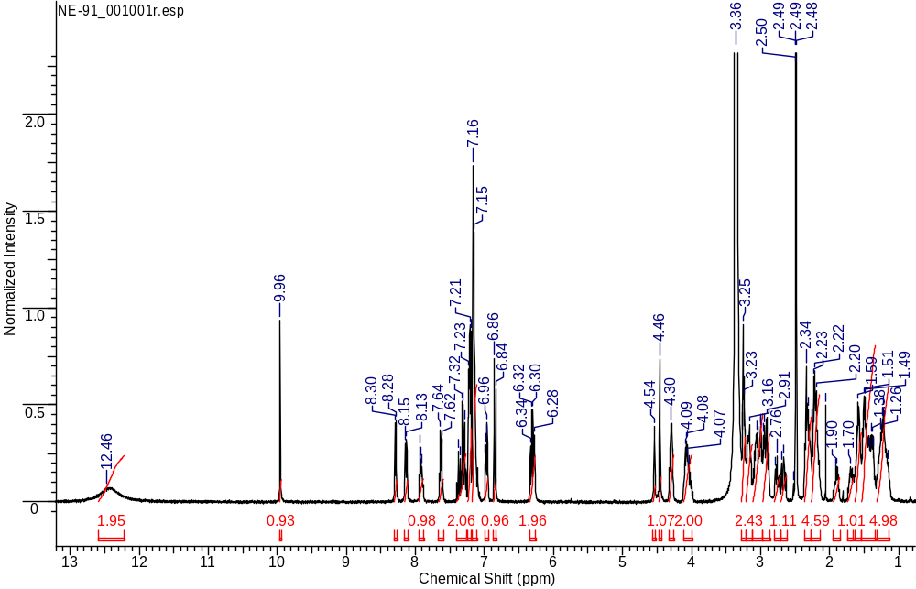
¹H NMR
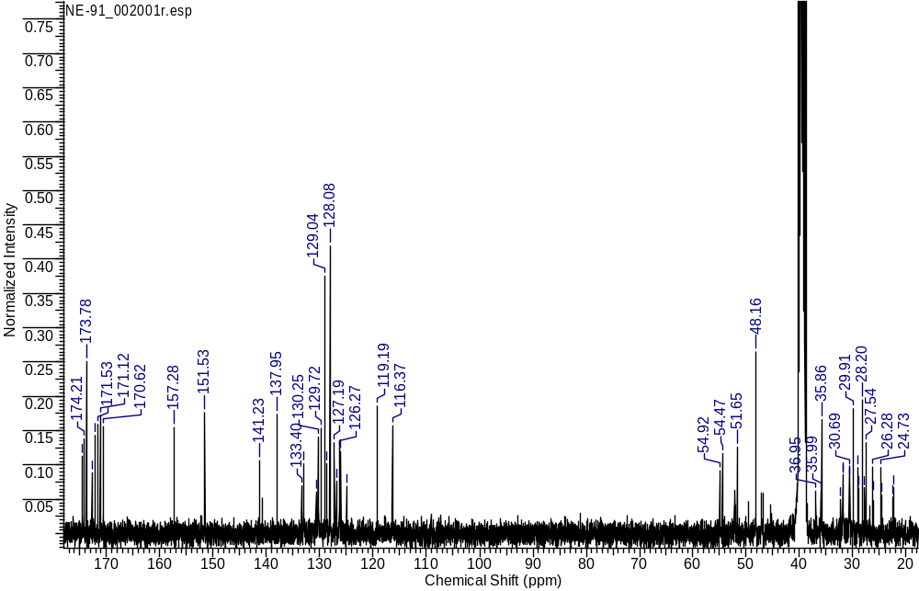
¹³C NMR
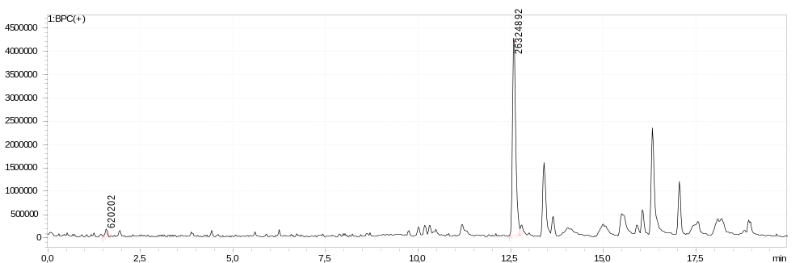
LCMS sample
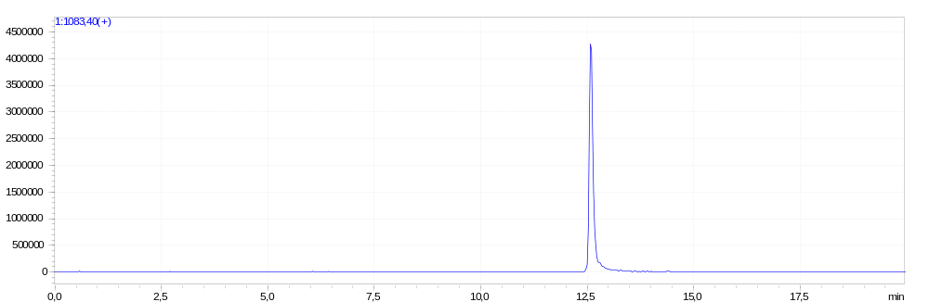
LCMS extracted-ion
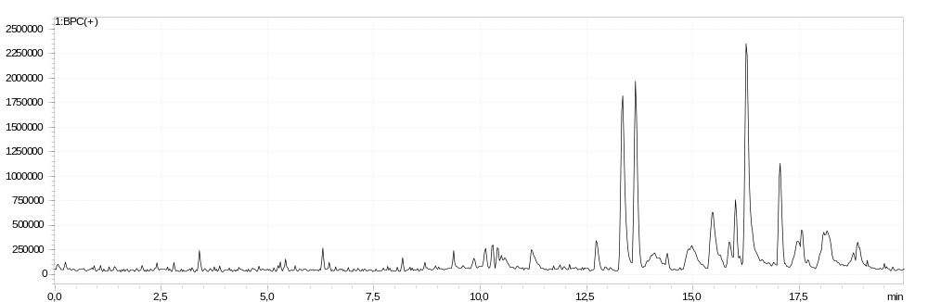
LCMS blank
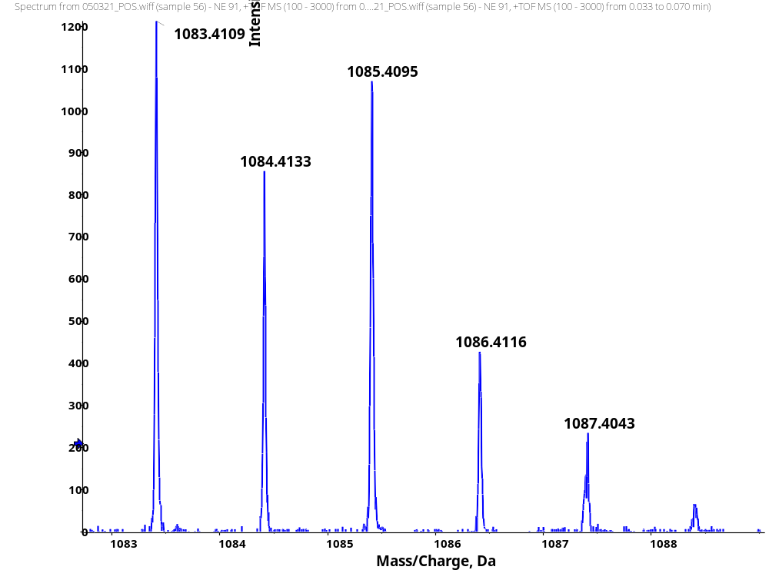
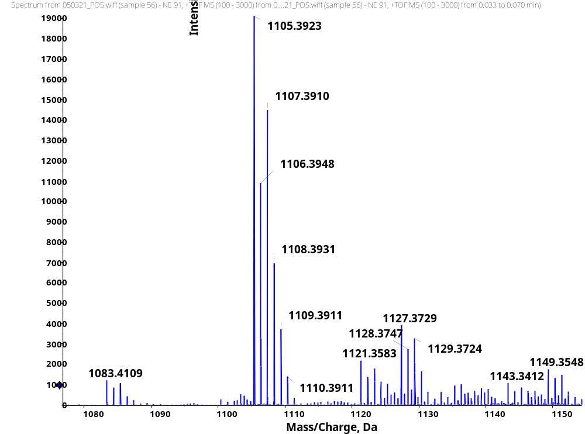
HRMS
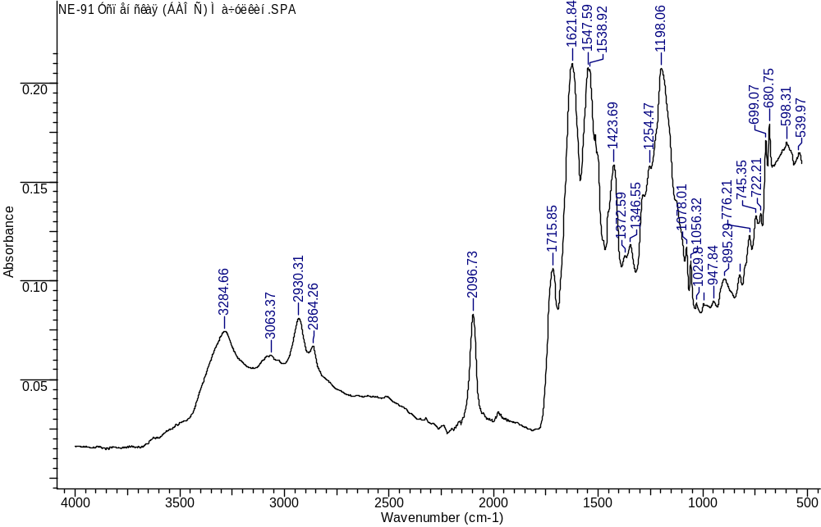
IR
General procedure for the synthesis of compounds 2a – 2b, 3
The fluorescent label Sulfo-Cy5-alkyne (1 eq.) (or monomethyl auristatine (1 eq.)) and the corresponding compounds 1f or 1e (1.05 eq.) were dissolved in DMF/H2O solution (3:1). The reaction was carried out in an argon atmosphere. Then CuSO₄*5H2O (0.4 eq.) and sodium ascorbate (1.2 eq.) were added. The mixture was stirred for 24 hours. After that EDTA (0.8 eq.) was added to the system and stirred for 3 hours. The reaction mixture was filtered off the EDTA and the solvent was removed under reduced pressure. The target compound was isolated by reverse phase column chromatography (Puriflash C18-HP, 15μ, 20g, eluent: acetonitrile / 0.1% trifluoroacetic acid solution in water: 10% acetonitrile to 100% in 15 min, 100% acetonitrile in 5 min).
1-(6-(((1-((3S,7S,25S,28S)-25-benzyl-1,3,7-tricarboxy-12-(3-chlorobenzyl)-28-(4-hydroxy-3-nitrobenzyl)-5,13,20,23,26,29-hexaoxo-4,6,12,19,24,27,30-heptaazatritriacontan-33-yl)-1H-1,2,3-triazol-4-yl)methyl)amino)-6-oxohexyl)-3,3-dimethyl-2-((1E,3E,5E)-5-(1,3,3-trimethyl-5-sulfoindolin-2-ylidene)penta-1,3-dien-1-yl)-3H-indol-1-ium-5-sulfonate (2a)
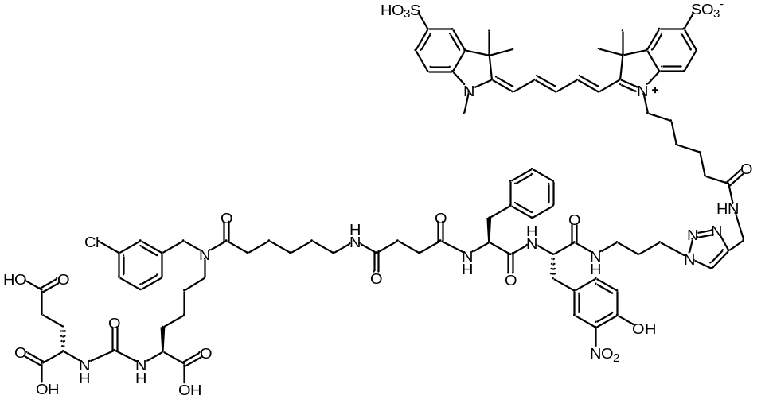
White amorphous solid (80 mg, 78%). ¹H NMR (400 MHz, DMSO-d₆, δ, ppm): 10.76 (1H, s), 8.33 (2H, t, J=13.0 Hz), 8.21 (3H, dt, J=16.4, 5.1 Hz), 7.91 – 7.77 (4H, m), 7.74 (2H, s), 7.62 (2H, d, J=8.4 Hz), 7.38 (1H, t, J=7.2 Hz), 7.29 (4H, dt, J=12.3, 3.7 Hz), 7.16 (8H, dd, J=18.0, 7.6 Hz), 7.06 (1H, s), 7.02 (4H, d, J=8.5 Hz), 6.54 (2H, t, J=12.2 Hz), 6.32 – 6.20 (5H, m), 4.53 (1H, s), 4.45 (1H, s), 4.33 (1H, s), 4.24 (4H, d, J=5.6 Hz), 4.04 (3H, s), 3.16 (2H, s), 2.99 (3H, s), 2.87 (3H, s), 2.65 (1H, s), 2.28 – 2.13 (1H, m), 2.05 (1H, d, J=6.4 Hz), 1.87 (2H, s), 1.66 (11H, s), 1.50 (3H, s), 1.31 (2H, s), 1.22 (3H, s), 1.13 (2H, s). LCMS purity: 99%; retention time: 4.7 min. HRMS (ESI) m/z 885.3256 (calcd 885.3245 for C₈₅H₁₀₅ClN₁₄O₂₂S₂ [M-2H]²⁻). IR (ZnSe) 3286, 3062, 2929, 2863, 1721, 1632, 1491, 1455, 1365, 1326, 1214, 1148, 1090, 1009, 922. cm⁻¹.
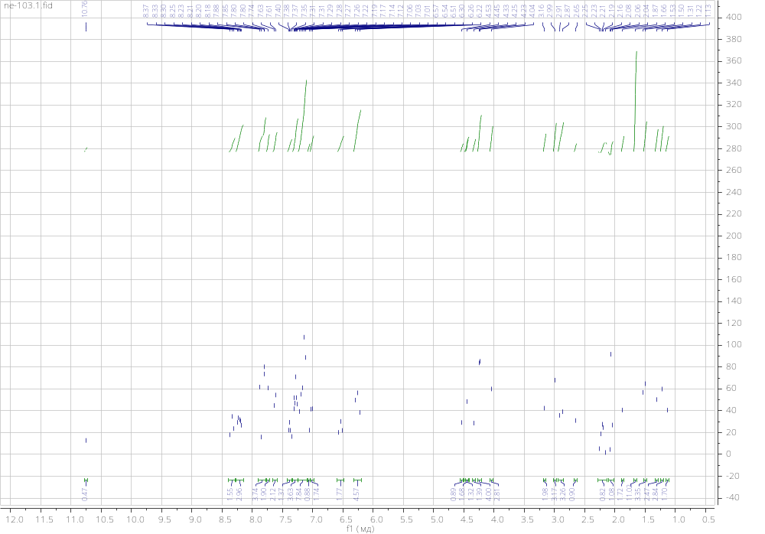
NMR ¹H
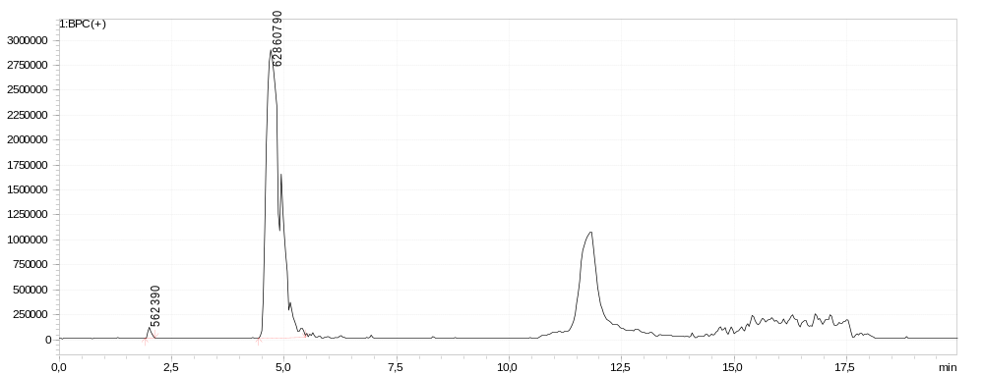
LCMS sample
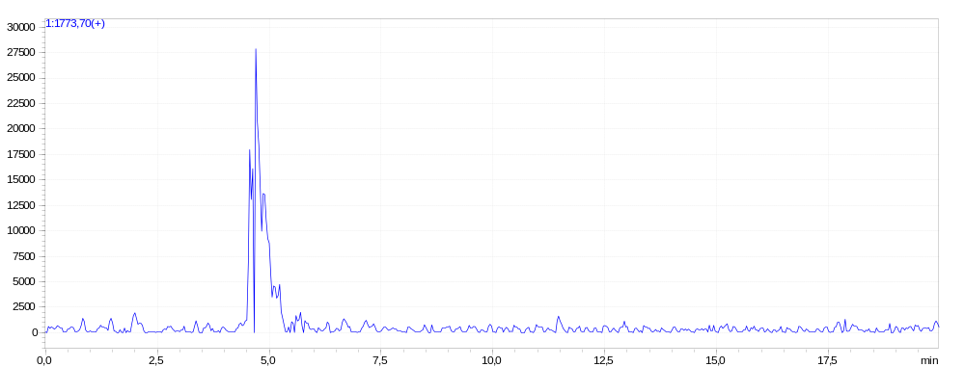
LCMS extracted-ion
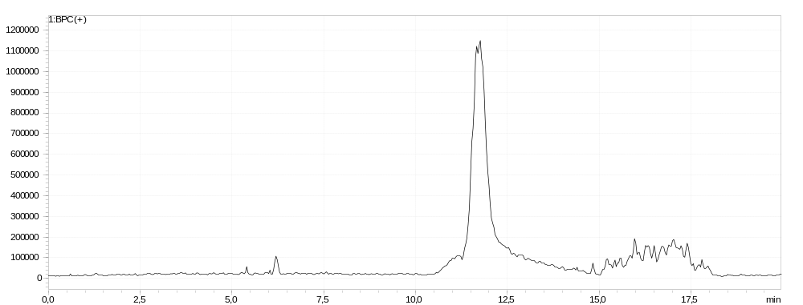
LCMS blank
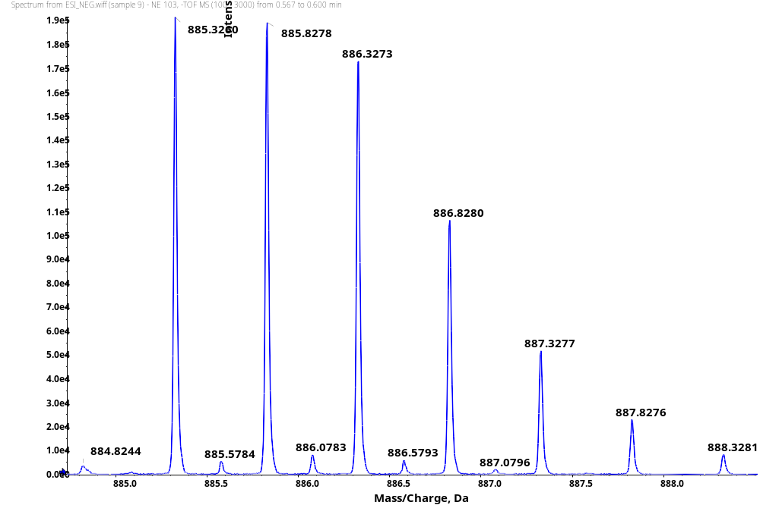
HRMS
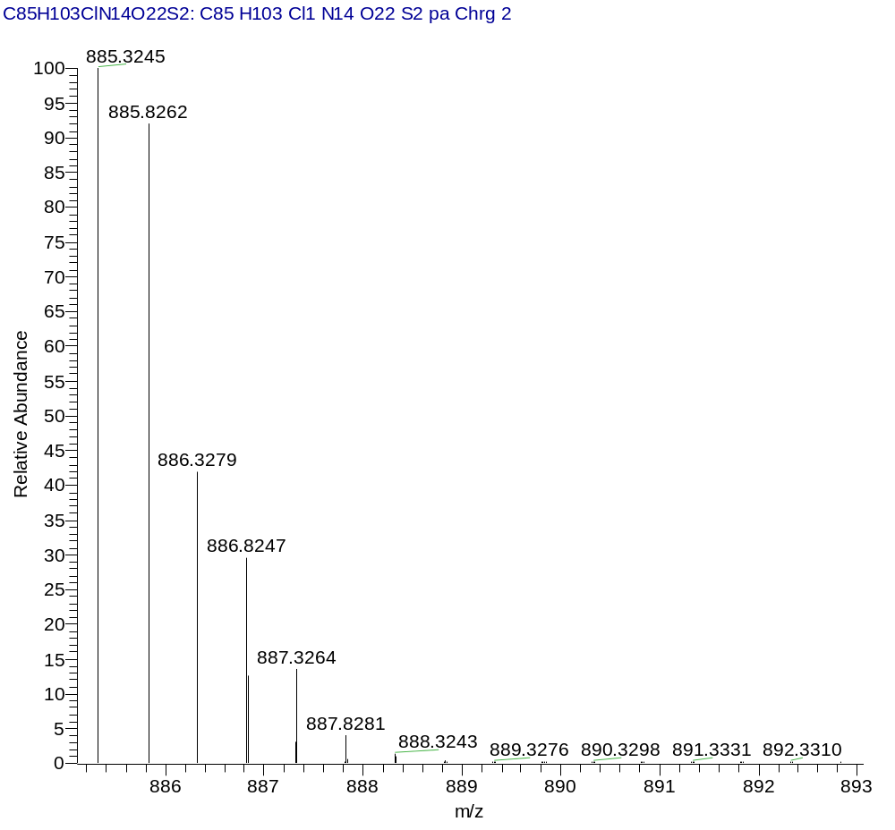
HRMS (Calcd)
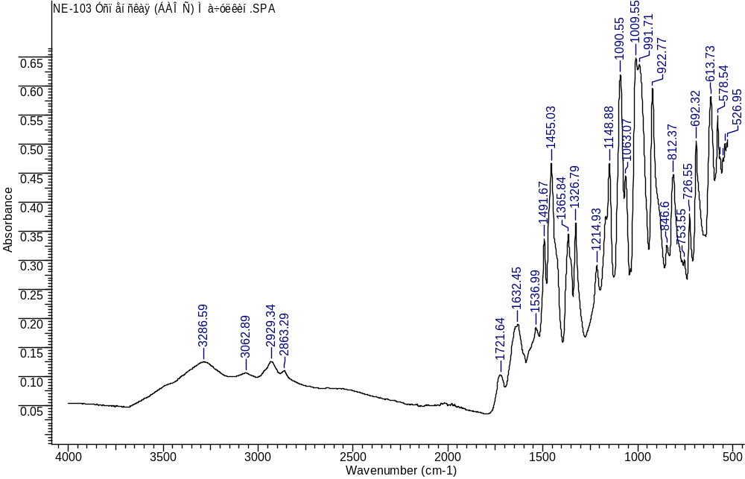
IR
3,3-dimethyl-1-(6-oxo-6-(((1-((3S,7S,25S,28S)-1,3,7-tricarboxy-12-(3-chlorobenzyl)-25,28-bis(4-hydroxybenzyl)-5,13,20,23,26,29-hexaoxo-4,6,12,19,24,27,30-heptaazatritriacontan-33-yl)-1H-1,2,3-triazol-4-yl)methyl)amino)hexyl)-2-((1E,3E,5E)-5-(1,3,3-trimethyl-5-sulfoindolin-2-ylidene)penta-1,3-dien-1-yl)-3H-indol-1-ium-5-sulfonate (2b)
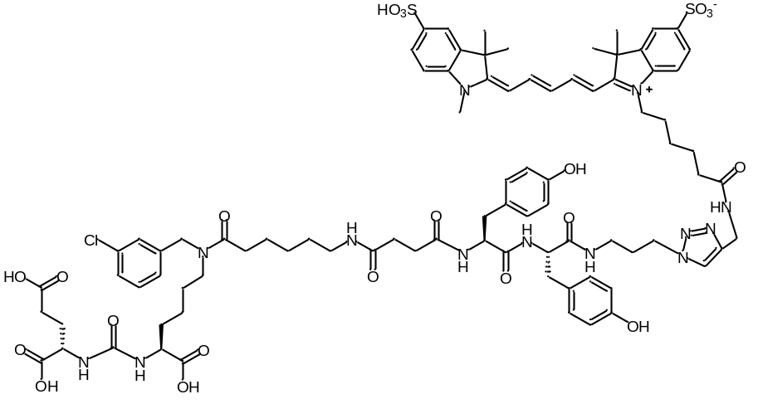
White amorphous solid (47 mg, 87%). ¹H NMR (400 MHz, DMSO-d₆, δ, ppm): 8.21 - 8.42 (m, 3 H), 8.05 (d, J=7.87 Hz, 1 H), 7.76 - 7.97 (m, 3 H), 7.63 (d, J=7.38 Hz, 2 H), 7.18 - 7.41 (m, 3 H), 6.90 - 7.17 (m, 3 H), 6.53 - 6.70 (m, 3 H), 6.18 - 6.41 (m, 2 H), 4.39 - 4.59 (m, 3 H), 4.24 (d, J=4.99 Hz, 6 H), 4.01 – 4.10 (m, 5 H), 3.10 – 3.18 (m, 1 H), 2.87 - 3.09 (m, 3 H), 2.76 - 2.81 (m, 1 H), 2.13 - 2.40 (m, 4 H), 2.02 - 2.12 (m, 1 H), 1.79 - 1.96 (m, 2 H), 1.55 - 1.69 (m, 10 H), 1.06 - 1.58 (m, 11 H). ¹³C NMR (101 MHz, DMSО-d6, δ, ppm): 174.50, 174.21, 173.78, 172.82, 172.19, 171.94, 171.57, 171.28, 171.05, 157.30, 155.80, 155.73, 154.24, 145.23, 144.99, 144.80, 142.77, 142.10, 141.22, 140.47, 133.04, 130.26, 129.97, 128.08, 128.02, 127.19, 126.07, 122.97, 119.88, 114.97, 114.87, 110.11, 103.68, 52.16, 51.66, 48.90, 46.89, 36.20, 34.93, 34.14, 31.76, 30.67, 29.91, 29.75, 29.05, 27.51, 27.12, 26.93, 26.28, 25.75, 24.85. LCMS purity: 100%; retention time: 13.4 min. HRMS (ESI) m/z 870.8305 (calcd 870.8294 for C₈₅H₁₀₆ClN₁₃O₂₁S₂ [M-2H]⁻). IR (ZnSe) 3286, 3064, 2930, 2862, 1721, 1636, 1491, 1455, 1365, 1326, 1214, 1148, 1089, 1009, 922. cm⁻¹.
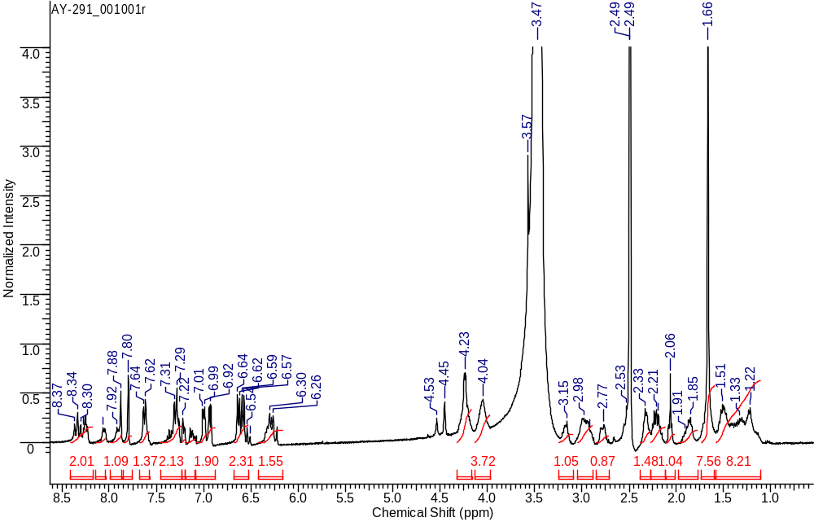
¹H NMR
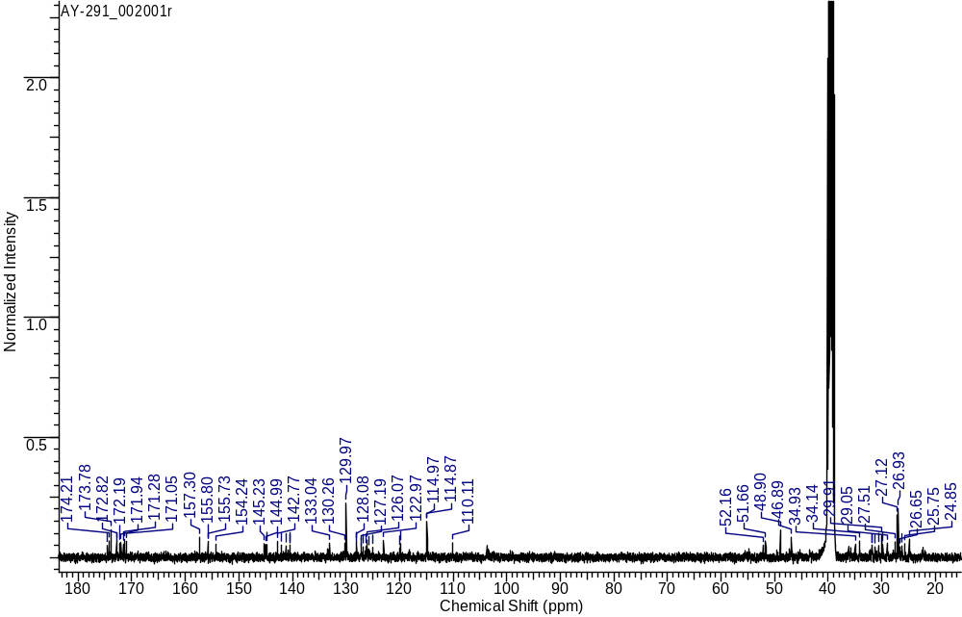
¹³C NMR
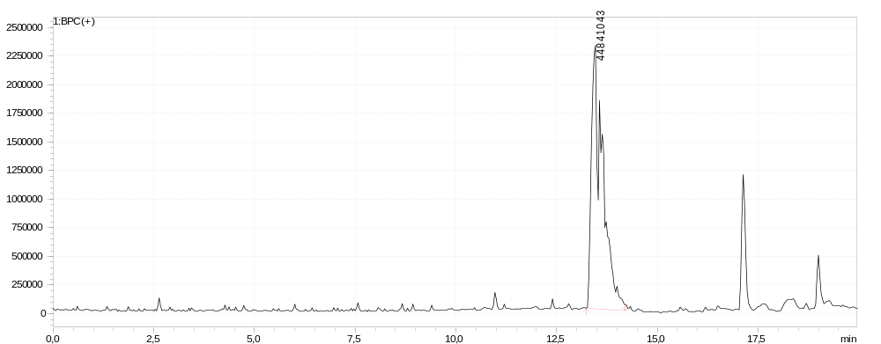
LCMS sample
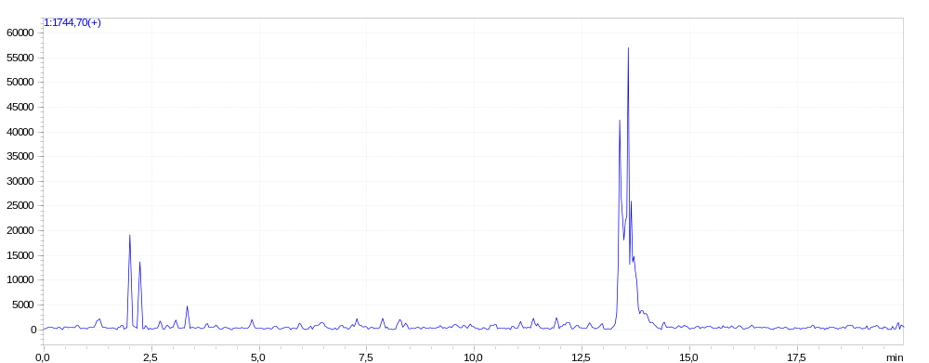
LCMS extracted-ion
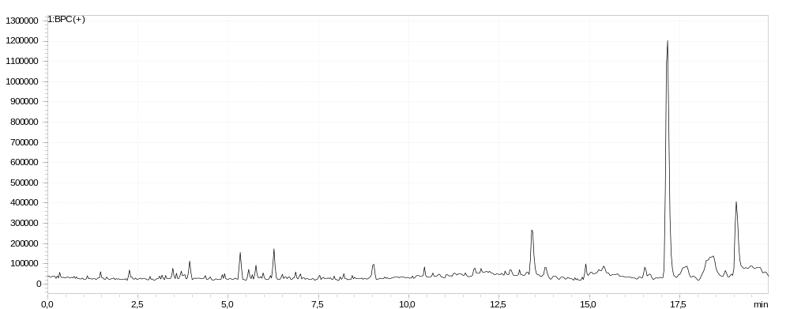
LCMS blank
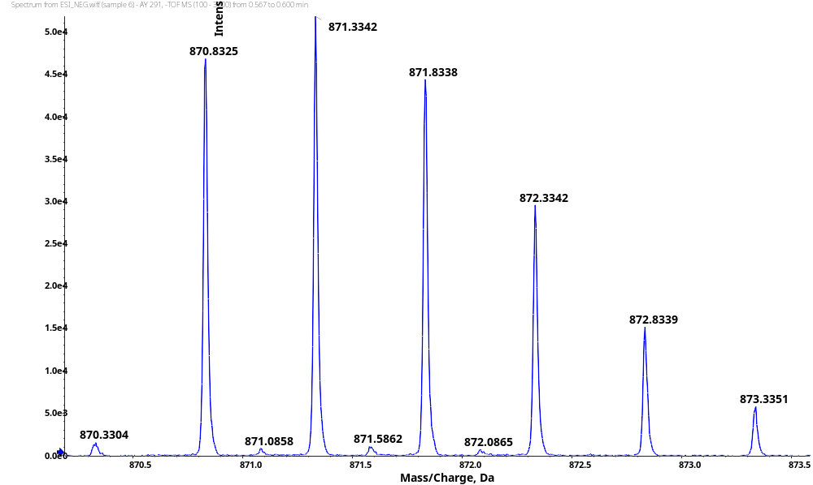
HRMS
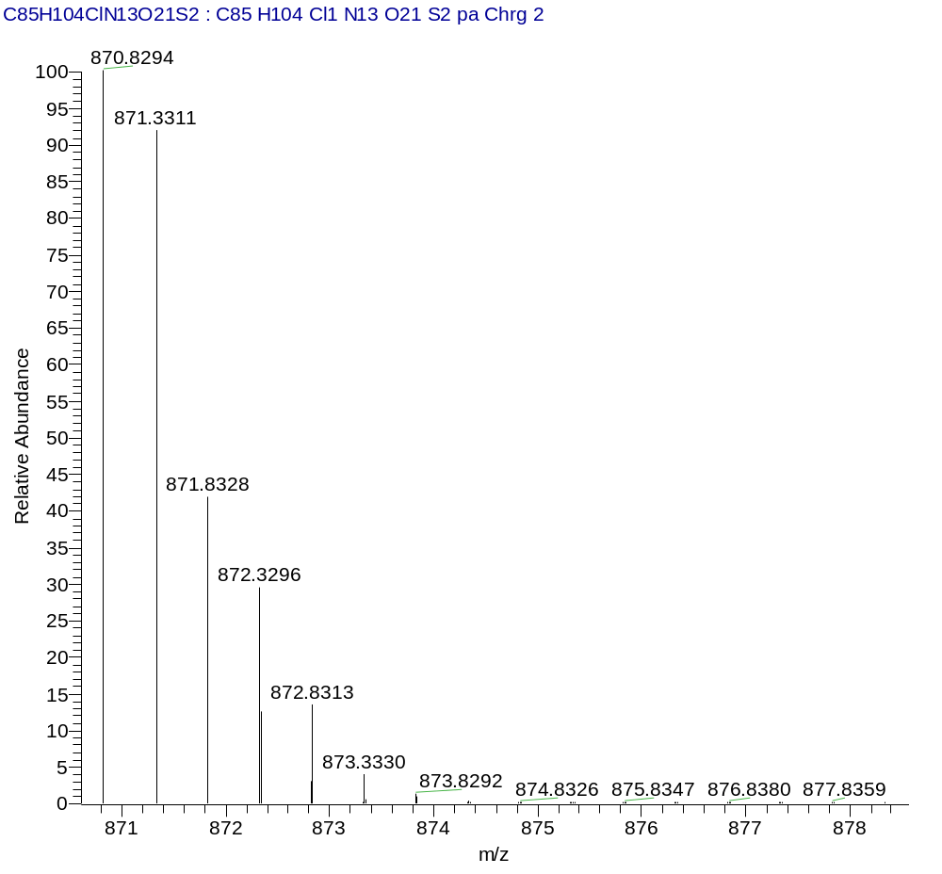
HRMS (Calcd)
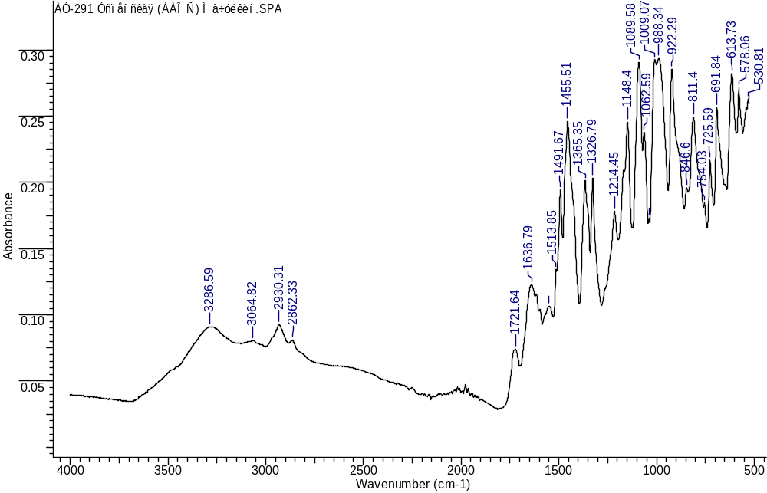
IR
(3S,7S,25S,28S)-25-benzyl-33-(4-(4-(((R)-1-(((S)-1-((4-((5S,8S,11S,12R)-11-((S)-sec-butyl)-12-(2-((S)-2-((1R,2R)-3-(((1S,2R)-1-hydroxy-1-phenylpropan-2-yl)amino)-1-methoxy-2-methyl-3-oxopropyl)pyrrolidin-1-yl)-2-oxoethyl)-5,8-diisopropyl-4,10-dimethyl-3,6,9-trioxo-2,13-dioxa-4,7,10-triazatetradecyl)phenyl)amino)-1-oxo-5-ureidopentan-2-yl)amino)-3-methyl-1-oxobutan-2-yl)amino)-4-oxobutyl)-1H-1,2,3-triazol-1-yl)-12-(3-chlorobenzyl)-28-(4-hydroxy-3-nitrobenzyl)-5,13,20,23,26,29-hexaoxo-4,6,12,19,24,27,30-heptaazatritriacontane-1,3,7-tricarboxylic acid (3)
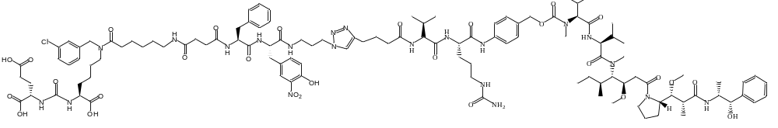
White amorphous solid (35 mg, 23%). ¹H NMR (400 MHz, DMSO-d₆, δ, ppm): 10.77 (s, 1 H), 9.99 (s, 1 H), 8.18 - 8.37 (m, 1 H), 8.15 (d, J=5.93 Hz, 1 H), 8.09 (m, 1 H), 7.87 (t, J=9.71 Hz, 1 H), 7.81 (s, 1 H), 7.75 (m, 1 H), 7.63 (d, J=7.68 Hz, 1 H), 7.56 (m., 1 H), 7.39 (d, J=10.71 Hz, 1 H), 7.28 (m., 3 H), 7.11 - 7.23 (m, 3 H), 7.02 (d, J=8.88 Hz, 1 H), 6.26 - 6.36 (m, 1 H), 5.98 (s, 1 H), 5.42 (s, 1H) 5.03 (m, 1 H), 4.54 (s, 1 H), 4.46 (s, 1 H), 4.32 - 4.42 (m, 2 H), 4.18 - 4.27 (m, 2 H), 3.92 - 4.12 (m, 1 H), 3.14 - 3.24 (m, 4 H), 3.10 (m, 1 H), 2.98 (d, J=14.72 Hz, 3 H), 2.80 - 2.89 (m, 2 H), 2.61 - 2.70 (m, 1 H), 2.57 (t, J=7.38 Hz, 1 H), 2.30 - 2.39 (m, 1 H), 2.16 - 2.28 (m, 3 H), 1.87 (m, 1 H), 1.79 (m, 1 H), 1.63 - 1.74 (m, 1 H), 1.49 (m, 3 H, CH₃), 1.22 (m, 2 H, CH₃), 0.95 - 1.05 (m, 2 H, CH₂), 0.80 (m, 6 H, CH₃), 0.75 (m, 4 H, CH₂). LCMS purity: 100%; retention time: 7.6 min. HRMS (ESI) m/z 1154.5850 (calcd 1154.5805 for C₁₁₄H₁₆₄ClN₂₁O₂₈ [M-2H]²⁻). IR (ZnSe) 3280, 3064, 2962, 2875, 1656, 1632, 1537, 1454, 1303, 1159, 997, 822. cm⁻¹.
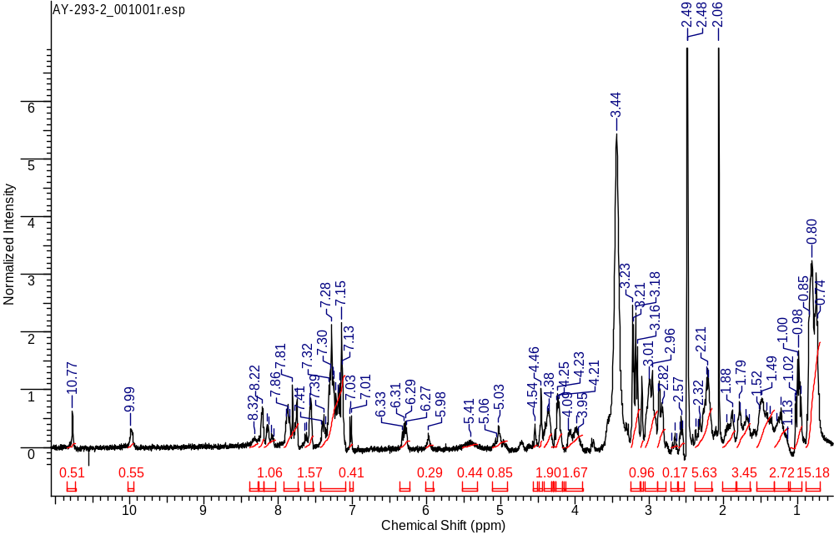
¹H NMR
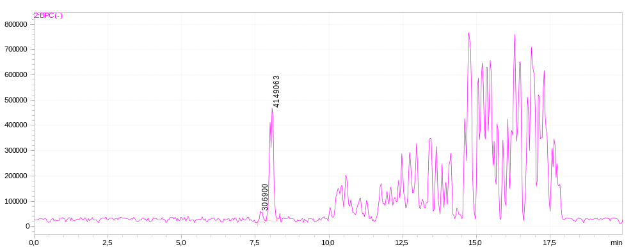
LCMS sample
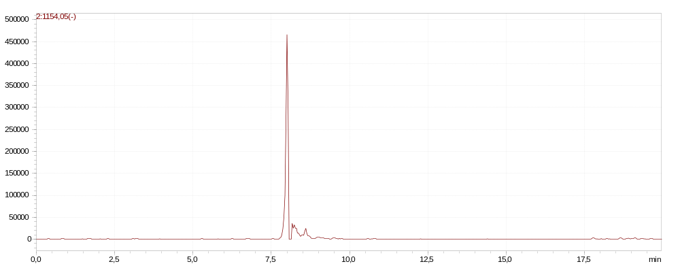
LCMS extracted-ion
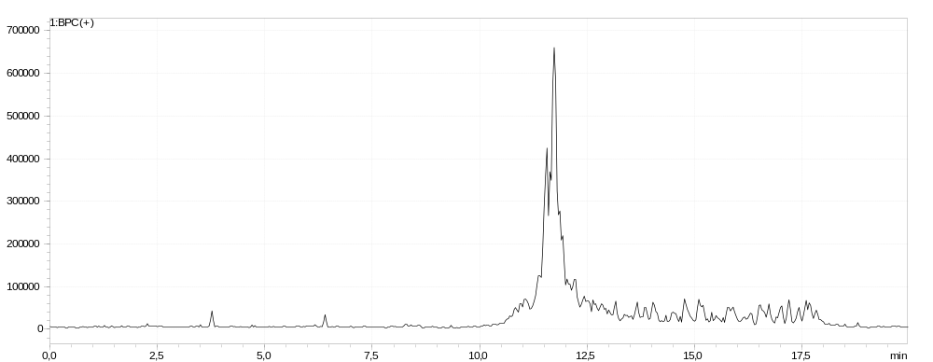
LCMS blank
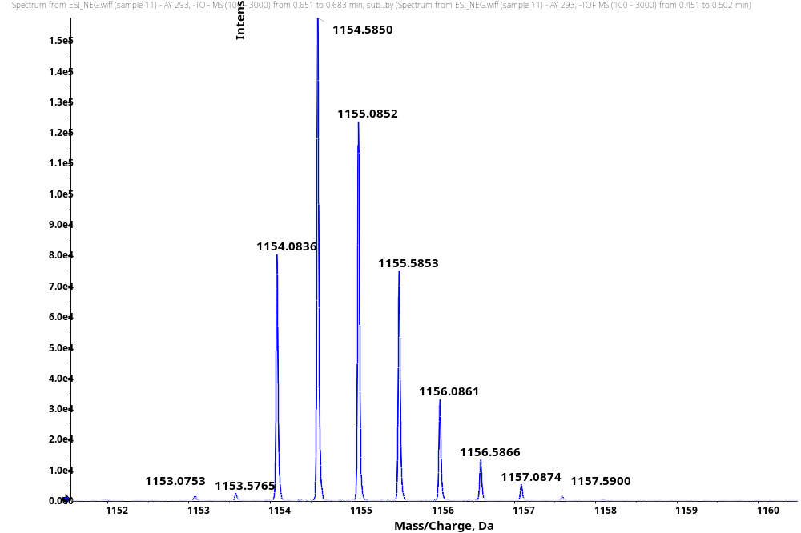
HRMS
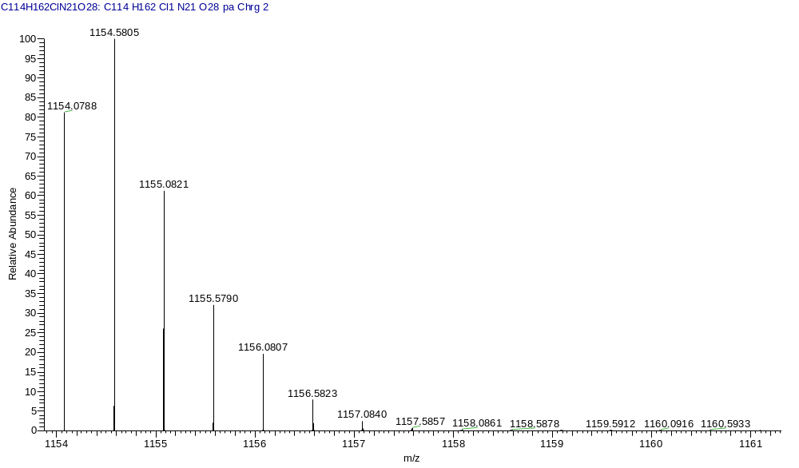
HRMS (Calcd)
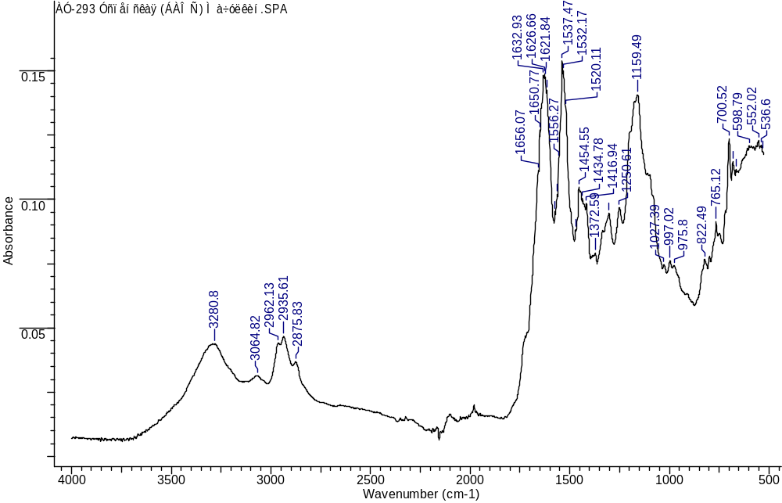
IR
Scheme of synthesis of ZJ-43
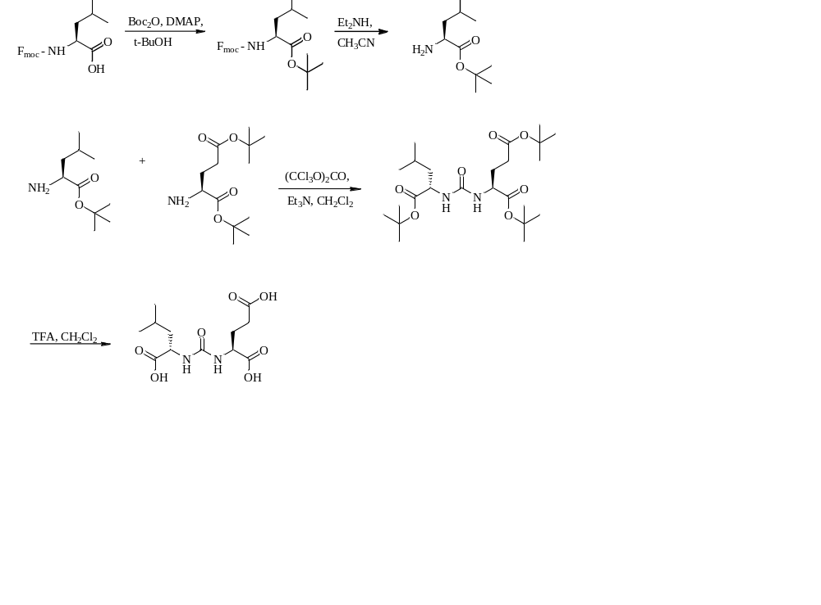
The final conjugate was obtained by setting the tretbutyl protection on the carboxyl group of Fmoc-L-leucine. Then, Fmoc-protection group was removed to form the tret-butyl ester of L-leucine. The formation of urea from the previously obtained tretbutyl ester of L-leucine and the ditrebutylated ester of L-glutamic acid using triphosgene followed. Further removal of the tretbutyl groups yielded the final conjugate ZJ-43. ¹H NMR (400 MHz, DMSO-d₆, δ, ppm): 6.27 - 6.33 (1 H, m), 6.24 (1 H, d, J=8.31 Hz), 4.04 (2 H, br. s.), 2.22 (2 H, t, J=7.83 Hz), 1.81 (1 H, d, J=2.93 Hz), 1.73 (1 H, br. s.), 1.61 (1 H, dd, J=7.58, 5.14 Hz), 1.32 - 1.50 (2 H, m), 0.82 - 0.90 (6 H, m) LCMS purity: 100%; retention time: 1.8 min. HRMS (ESI) m/z 304.1233 (calcd 304.1271 for C₁₂H₂₀N₂O₇ [M+H]⁺).
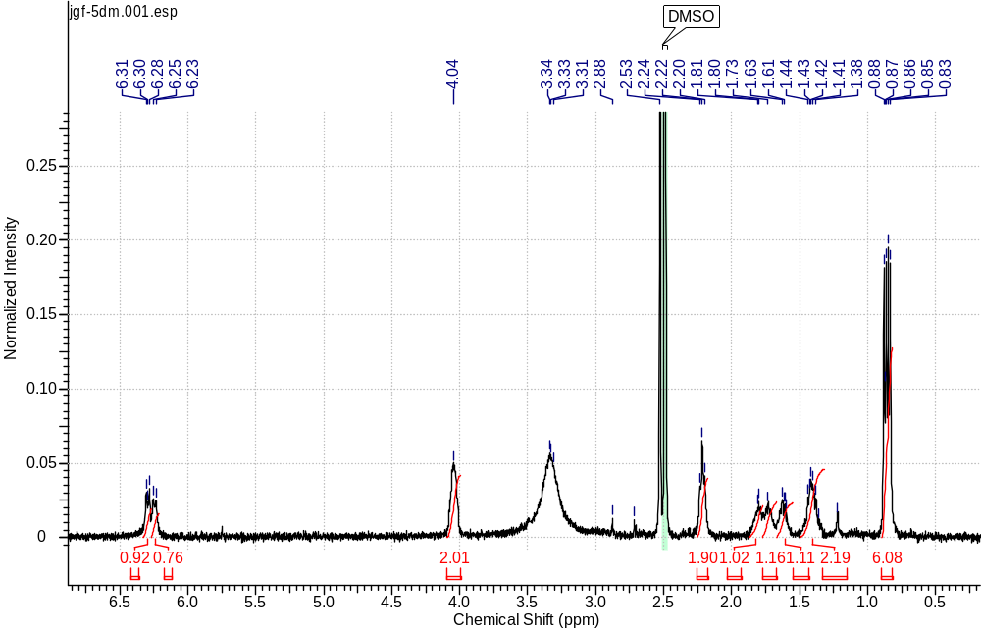
¹H NMR
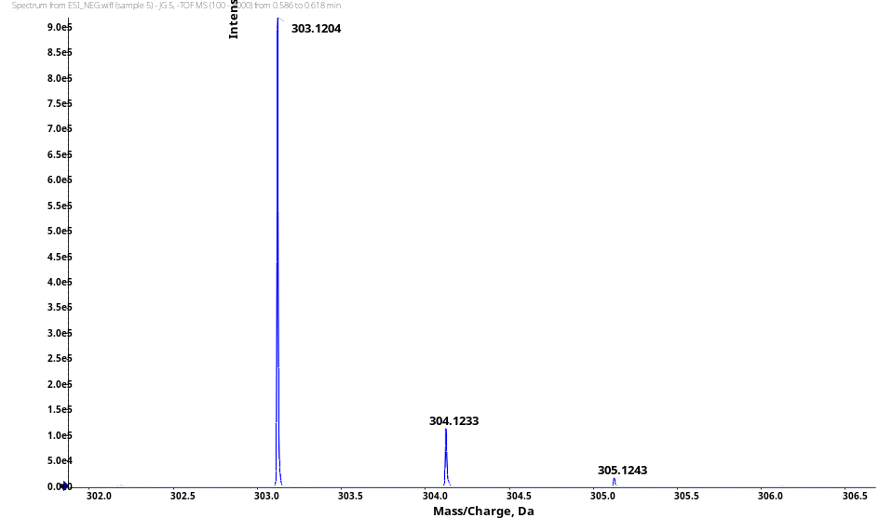
HRMS
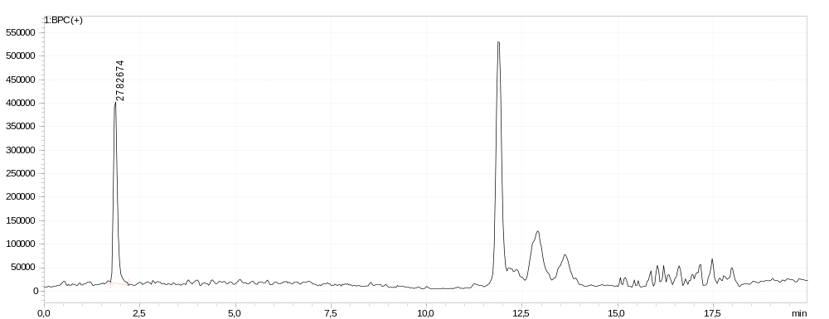
LCMS sample
Table S1. High-resolution mass spectrometry results for all target compounds
№ | Linker structure | m/z | Found | Calcd
1a | L-Tyr-D-Tyr | [M+H]⁺ | 1065,4467 | 1065,4443
1b | L-Tyr-D-Phe | [M+Na]⁺ | 1071,4349 | 1071,4313
1c | D-Tyr-L-Tyr | [M+H]⁺ | 1065,4487 | 1065,4443
1d | L-Tyr-L-Phe | [M+Na]⁺ | 1049,4524 | 1049,4494
1e | L-Tyr-L-Tyr | [M+H]⁺ | 1065,4493 | 1065,4443
1f | L-Phe-L-Tyr(3-NO₂) | [M+H]⁺ | 1094,4349 | 1094,4345
1g | D-Phe-L-Tyr(3-NO₂) | [M+H]⁺ | 1094,4342 | 1094,4345
1h | D-Phe-L-Tyr(3-Br) | [M+H]⁺ | 1127,3644 | 1127,3599
1i | L-Phe-L-Phe(4-Br) | [M+Na]⁺ | 1135,3408 | 1135,3449
1j | L-Phe-L-Phe(3-Br) | [M+H]⁺ | 1111,3677 | 1111,3650
1k | L-Phe-L-Phe(2-Br) | [M+H]⁺ | 1111,3690 | 1111,3650
1l | D-Phe-D-Phe(4-Br) | [M+H]⁺ | 1111,3674 | 1111,3650
1m | D-Phe-L-Tyr(3-OH) | [M+H]⁺ | 1065,4478 | 1065,4443
1n | L-Phe-L-Tyr(3-Cl) | [M+H]⁺ | 1083,4109 | 1083,4104
2a | L-Phe-L-Tyr(3-NO₂)-Sulfo-Cy5 | [M-2H]²⁻ | 885,3256 | 885,3245
2b | L-Tyr-L-Tyr-Sulfo-Cy5 | [M-2H]²⁻ | 870,8305 | 870,8294
3 | L-Phe-L-Tyr(3-NO₂)-MMAE | [M-2H]²⁻ | 1154,5850 | 1154,5805

Molecular modeling
Model preparation
The docking model was prepared using Protein Preparation Wizard (Schrodinger Suite 2021-2)¹². Ligand-protein complex from PDB entry 2XEG¹³ was chosen as a starting point for docking model development. Several other PDB entries (2XEF, 2XEI, 4X3R, 3BI1, 5O5R, 5O5T, 5O5U, 6HKZ, 7BFZ) were aligned to the complex of interest to identify conservative water molecules. For obtained co-crystal structure, preprocessing and energy minimization with OPLS3 force field were performed using standard settings. Energy grid was built based on reference ligand position. As additional constraint, hydrogen atom within amino group of Lys699 side chain was marked as mandatory binding point (hydrogen bond donor) during docking procedure. Model was validated by redocking of co-crystalized ligand from PDB entry 2XEG.

Ligands preparation
Ligands were prepared using standard settings of LigPrep (Schrodinger Suite 2021-2).¹⁴

Docking procedure
Ligands were docked into PSMA model using Glide (Schrodinger Suite 2021-2)¹⁵ standard precision flexible docking. Number of poses for the initial phase of docking and number of poses for energy minimization were increased up to 5000 and 500 respectively. Also, conformational sampling was increased by 2 times and bias sampling of torsions was set for all predefined functional groups. Up to 50 binding poses were written for expert analysis. Finally, poses were selected based on both binding mode visual analysis as well as calculated docking score.

Visualization
Docking results were analyzed using UCSF Chimera version 1.13.1 software.¹⁶

Table S2. Docking score values for proposed structures and reference ligands

Name | Docking Score
2xeg | -13.7
1a | -12.6
1b | -13.2
1c | -13.5
1d | -14.0
1e | -14.9
1f | -13.8
1g | -13.6
1h | -13.7
1i | -14.1
1j | -15.1
1k | -15.4
1l | -12.3
1m | -13.6
1n | -14.5
PSMA-617 | -13.2
In vitro evaluation
LNCaP cells were cultured in RPMI medium with 10% FBS (Gibco), 1xGlutamax (Gibco), and 1x penicillin-streptomycin mixture (Gibco). To suspend the cells, growth medium was removed from the 25 cm² vial, the cells were washed with PBS buffer, and incubated for 5 minutes with 0.25% trypsin (1 mL). Trypsin was inactivated with complete growth medium (2 ml), washed with PBS, transferred 106 cells to a test tube, and 500 μl of lysis buffer (0.5% Triton X-100, 50 mM Tris-HCl (pH 7.5), 1x Proteinase Inhibition cocktail) was added. The suspension was incubated for 30 min on ice and sonicated (7 times 7 sec at 20-30 sec intervals) on ice to avoid overheating. The suspension was centrifuged for 10 min at 1000g at 4°C and the supernatant was used in further analysis.
The inhibition by PSMA ligands was analyzed using a non-radioactive protocol with detection of the glutamate released during the reaction. LNCaP cell line extract (10 μL) was mixed with 2 μL of the appropriate compound preparation. A series of dilutions of 2 nM-100 μM compounds was used for initial testing, with dilution steps of 3-5 times. To the resulting mixture, 1 μL of 100 μM NAAG solution was added. The mixture was incubated for 2 hours at 37°C. After incubation, the mixture was doubled with reaction buffer (13 μL) from the Amplex Red Glutamic Acid Kit (Molecular Probes Inc., Eugene) and the multi-component glutamate detection reaction mixture prepared according to the manufacturer's protocol (26 μL) was added. Amplex Red stock solution: 5 μL Amplex® Red reagent stock solution, 1.25 μL HRP stock solution, 8 μL L-glutamate oxidase, 2.5 μL L-glutamate pyruvate transaminase, 0.5 μL L-alanine, 483 μL 1X reaction buffer. Incubation was performed for 1 hour at 37°C. The fluorescence of resorufin produced by conjugated glutamate detection kit reactions was detected on a VICTORX5 multidetector plate (Perkin Elmer Inc.) at an excitation length of 555 nm and detection at 580 nm. As a control for endogenous glutamate levels with replacement of the NAAG solution with water.
The results obtained in our earlier studies are included in Table S2.
Table S3. Results of in vitro evaluation of inhibition of the N-acetylaspartylglutamate cleavage reaction
№ | Linker structure | IC₅₀ ± SD, nM | K_{i} ± SD, nM | References
Control
DCL | - | 546 ± 388 | 56,4 ± 40,1
ZJ-43 | - | 11,0 ± 2,6 | 1,14 ± 0,27
2-PMPA | - | 80,4 ± 23,6 | 8,29 ± 2,44
Ligand Series Gly/Phe
I | L-Phe-Gly | 114± 48 | 11,75 ± 3,95 | 2
II | Gly-L-Phe | 38 ± 10 | 3,89 ± 1,03 | 2
Ligand Series Phe-Tyr(Phe)
III | L-Phe-L-Tyr | 9,3 ± 3,0 | 0,96 ± 0,32 | 1
IV | D-Phe-D-Phe | 226,0 ± 97,0 | 23,33 ± 9,97 | 1
V | L-Phe-L-Phe | 55,0 ± 33,0 | 5,64 ± 3,43 | 1
VI | L-Phe-D-Phe | 36,0 ± 10,0 | 3,73 ± 1,05 | 2
VII | L-Phe-D-Tyr | 152,0 ± 53,0 | 15,66 ± 5,51 | 2
VIII | D-Phe-L-Phe | 70,0 ± 32,0 | 7,22 ± 3,25 | 2
IX | D-Phe-L-Tyr | 193,0 ± 96,0 | 19,91 ± 9,85 | 2
X | D-Phe-D-Tyr | 26,7 ± 14,2 | 2,75 ± 1,47 | 1
Ligand Series Tyr-Tyr(Phe)
1a | L-Tyr-D-Tyr | 99,0 ± 53,0 | 10,26 ± 5,44
1b | L-Tyr-D-Phe | 54,0 ± 16,0 | 6,00 ± 2,00
1c | D-Tyr-L-Tyr | 41,0 ± 14,0 | 4,20 ± 1,40
XI | D-Tyr-L-Phe | 102,0 ± 36,0 | 10,55 ± 3,67 | 2
1d | L-Tyr-L-Phe | 2,6 ± 0,8 | 0,27 ± 0,08
1e | L-Tyr-L-Tyr | 2,10 ± 1,24 | 0,22 ± 0,13
Ligand Series with substituted Phe/Tyr – NO₂ group
XII | L-Phe-L-Phe(4-NO₂) |  | 13,59 ± 3,31 | 2
  132,0 ± 32,0
1f | L-Phe-L-Tyr(3-NO₂) | 1,5 ± 0,9 | 0,16 ± 0,09
1g | D-Phe-L-Tyr(3-NO₂) | 1,6 ± 1,1 | 0,17 ± 0,11
Ligand Series with substituted Phe/Tyr – Br group
XIII | D-Phe-D-Tyr(3-Br) | 80,0 ± 50,0 | 8,27 ± 5,18 | 1
XIV | L-Phe-L-Tyr(3-Br) | 196,0 ± 102,0 | 20,17 ± 10,49 | 2
1h | D-Phe-L-Tyr(3-Br) | 4,9 ± 2,6 | 0, 50 ± 0,27
1i | L-Phe-L-Phe(4-Br) | 1,9 ± 0,8 | 0,19 ± 0,09
1j | L-Phe-L-Phe(3-Br) | 3,1 ± 0,9 | 0,32 ± 0,10
1k | L-Phe-L-Phe(2-Br) | 4,6 ± 1,3 | 0,47 ± 0,13
1l | D-Phe-D-Phe(4-Br) | 12,2 ± 2,08 | 1,25 ± 0,21
Ligand Series with substituted Phe/Tyr – Cl and OH groups
XV | L-Phe-L-Tyr(3-OH) | 892 ± 368 | 91,98 ± 37,97 | 2
1m | D-Phe-L-Tyr(3-OH) | 17,3 ± 3,3 | 1,78 ± 0,34
1n | L-Phe-L-Tyr(3-Cl) | 3,6 ± 0,9 | 0,37 ± 0,09

Flow cytometry
The cells LNCaP were seeded in a 12-well plate (2 × 105 cells per well in 800 μl RPMI medium) and incubated under standard conditions overnight. The cells were then washed with RPMI medium containing 1% fetal bovine serum. Next, a mixture of 720 μl of RPMI medium (1% FBS) containing 80 μl of the assay conjugate at a concentration of 40 μM (DMSO solution) was added to each well to reach a final concentration of 4 μM, 40 μM, and 150 μM per well. Incubation was performed under standard culture conditions for 30 min. Control samples included cells that were incubated with RPMI medium (1% FBS) with equivalent DMSO content for 30 min. After incubation, cells were washed three times with RPMI medium (1% FBS). The cells were then trypsinized, and trypsin inactivation was performed with PBS containing 10% FBS. The cells were centrifuged, washed twice in PBS (10% FBS), and resuspended in 500 μl PBS. Then, the cells were examined by flow cytometry (Becton Dickinson FACSAria I). Three iterations were performed for the cell line.
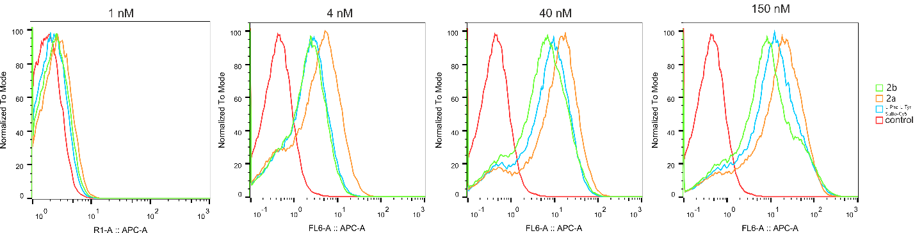
Cytotoxicity studies
Cells were seeded in the 96-well plates (Corning) at concentrations of 12 000 cells per well for LNCaP, 7 000 cells per well for PC-3, and 20 000 cells per well for 22Rv1 lines. An automatic EVE cell counter was used for cell counting. One day after planting in the medium, test conjugates in different concentrations were added to the cells and incubated for 72 hours. After that, culture medium was removed from the wells and a mixture of medium and MTS reagent (CellTiter 96 AQueous Non-Radioactive Cell Proliferation Assay, Promega) was added to the cells at the rate of 20 μl MTS per 100 μl of growth medium. The cells were incubated for 4 hours in the dark in a CO₂ incubator. The optical density of the obtained solutions was measured at 490 nm using a Thermo Scientific Multiskan GO spectrophotometer. Cells incubated in culture medium were used as negative control, cells incubated in medium with 20% DMSO added were used as positive control. The survival rate of cells incubated with conjugates was calculated as a percentage relative to cells cultured in growth medium. The MTS uptake value of the reagent in the culture medium without cells was taken to be zero.

3 L-Phe-L-Tyr(3-NO₂)-MMAE | IC50, nM | SI_IC50 (PC3/(Line) | SI_IC50 (A549/Line) | CC50, nM | SI_CC50 (PC3/(Line) | SI_CC50 (A549/Line)
22Rv1 | 49.6+-13.5 | 1,10 | 1,67 | 93.4+-16.1 | 0,84 | 2,37
A549 | 83.1+-22.7 | 0,66 | 1,00 | 221+-37.8 | 0,36 | 1,00
LNCaP | 39.6+-5.3 | 1,34 | 2,04 | 84.9+-8.5 | 0,92 | 2,58
PC3 | 61+-30.6 | 1,00 | 1,52 | 81.7+-25.7 | 1,00 | 2,81
PSMA-Val-Cit-PAB-MMAE | CC50, nM |  |  | CC50, nM
22Rv1 | 35+-6.6 | 0,65 | 0,88 | 37.5+-4.3 | 0,72 | 2,69
A549 | 30.9+-7.1 | 0,74 | 1,00 | 101.3+-16.5 | 0,27 | 1,00
LNCaP | 48.8+-5.6 | 0,46 | 0,62 | 50.3+-3.3 | 0,54 | 1,99
PC3 | 24.4+-9.9 | 1,00 | 1,34 | 27.8+-7.1 | 1,00 | 3,71
MMAE | CC50, pM |  |  | CC50, pM
22Rv1 | 21.2+-10.6 | 1,44 | 1,91 | 20.6+-4.1 | 0,11 | 0,51
A549 | 37.9+-14.2 | 0,76 | 1,00 | 11+-3.8 | 0,21 | 1,00
LNCaP | 56.9+-16 | 0,49 | 0,64 | 41.3+-4.9 | 0,05 | 0,25
PC3 | 89.7+-85.7 | 1,00 | 1,32 | 3.6+-2.9 | 1,00 | 4,80
Table S3. Results of in vitro evaluation of inhibition of cytotoxicity conjugates 3, PSMA-Val-Cit-PAB-MMAE and monomethyl auristatin E.

References
1. Machulkin AE, Shafikov RR, Uspenskaya AA, et al. Synthesis and Biological Evaluation of PSMA Ligands with Aromatic Residues and Fluorescent Conjugates Based on Them. J Med Chem. 2021;64(8):4532-4552. doi:10.1021/acs.jmedchem.0c01935
2. Uspenskaya A, Machulkin AE, Nimenko EA, et al. Influence of the dipeptide linker configuration on the activity of PSMA ligands. Mendeleev Commun. 2020;30(6):756-759. doi:10.1016/j.mencom.2020.11.022
3. Lundt BF, Johansen NL, Vølund A, Markussen J. REMOVAL OF t‐BUTYL AND t‐BUTOXYCARBONYL PROTECTING GROUPS WITH TRIFLUOROACETIC ACID: Mechanisms, Biproduct Formation and Evaluation of Scavengers. Int J Pept Protein Res. 1978;12(5):258-268. doi:10.1111/j.1399-3011.1978.tb02896.x
4. Kularatne SA, Zhou Z, Yang J, Post CB, Low PS. Design, synthesis, and preclinical evaluation of prostate-specific membrane antigen targeted 99mTc-radioimaging agents. Mol Pharm. 2009;6(3):790-800. doi:10.1021/mp9000712
5. Guillier F, Orain D, Bradley M. Linkers and cleavage strategies in solid-phase organic synthesis and combinatorial chemistry. Chem Rev. 2000;100(6):2091-2157. doi:10.1021/cr980040+
6. Chatzi O, Barlos K, Gatos D, Stavropoulos G. 2‐Chlorotrityl chloride resin: Studies on anchoring of Fmoc‐amino acids and peptide cleavage. Int J Pept Protein Res. 1991;37(6):513-520. doi:10.1111/j.1399-3011.1991.tb00769.x
7. Fujiwara Y, Akaji K, Yoshiaki; K. Racemization-Free Synthesis of C-Terminal Cysteine-Peptide Using 2-Chlorotrityl Resin. Chem Pharm Bull. 1994;42(3):724-726. http://www.mendeley.com/research/geology-volcanic-history-eruptive-style-yakedake-volcano-group-central-japan/
8. Petrov SA, Machulkin AE, Uspenskaya AA, et al. Polypeptide-based molecular platform for targeted delivery of bimodal agents to PSMA receptor and its Docetaxel/Sulfo-Cy5-containing conjugate. Molecules. 2020;25(24):1-21.
9. Tang W, Becker ML. “click” reactions: A versatile toolbox for the synthesis of peptide-conjugates. Chem Soc Rev. 2014;43(20):7013-7039. doi:10.1039/c4cs00139g
10. Ciuk AK, Lindhorst TK. Synthesis of carbohydrate-scaffolded thymine glycoconjugates to organize multivalency. Beilstein J Org Chem. 2015;11:668-674. doi:10.3762/bjoc.11.75
11. Senter PD, Sievers EL. The discovery and development of brentuximab vedotin for use in relapsed Hodgkin lymphoma and systemic anaplastic large cell lymphoma. Nat Biotechnol. 2012;30(7):631-637. doi:10.1038/nbt.2289
12. Protein Preparation Wizard; Epik, Schrödinger, LLC, New York, NY, 2021; Impact, Schrödinger, LLC, New York, NY; Prime, Schrödinger, LLC, New York, NY, 2021.
- Zhang AX, Murelli RP, Barinka C, Michel J, Cocleaza A, Jorgensen WL, Lubkowski J, Spiegel DA. A remote arene-binding site on prostate specific membrane antigen revealed by antibody-recruiting small molecules. J Am Chem Soc. 2010 Sep 15;132(36):12711-6. doi: 10.1021/ja104591m. PMID: 20726553; PMCID: PMC2965167.
- LigPrep, Schrödinger, LLC, New York, NY, 2021.
- Friesner RA, Banks JL, Murphy RB, Halgren TA, Klicic JJ, Mainz DT, Repasky MP, Knoll EH, Shelley M, Perry JK, Shaw DE, Francis P, Shenkin PS. Glide: a new approach for rapid, accurate docking and scoring. 1. Method and assessment of docking accuracy. J Med Chem. 2004 Mar 25;47(7):1739-49. doi: 10.1021/jm0306430. PMID: 15027865.
- Pettersen EF, Goddard TD, Huang CC, Couch GS, Greenblatt DM, Meng EC, Ferrin TE. UCSF Chimera--a visualization system for exploratory research and analysis. J Comput Chem. 2004 Oct;25(13):1605-12. doi: 10.1002/jcc.20084. PMID: 15264254.

