A Study on the Synergetic Effects of Self /Induced Crystallization and Nanoparticles on the Mechanical Properties of Semi-Crystalline Polymer Nanocomposites: Experimental and Analytical Approaches

Saeideh Hojatzadeh; Farshad Rahimpour*; Esmail Sharifzadeh*
Chemical Engineering Department, Faculty of Petroleum and Chemical Engineering, Razi University, Kermanshah 67144-14971, Iran.

Supplementary information
The schematic procedure of synthesis of the pure and surface-modified silica nanoparticles is given in Figures S1 and S2, respectively.
- 60 min
- Ultrasonic
- (Polymerization)
- 20 min Ultrasonic
- Hydrolysis
- 10 min
- Ultrasonic

Water + Ethanol
Adding TEOS
Ammonia: drop wise
Turbid white solution

Fig. S1 The procedure of synthesis of silica nanoparticles
- Ambient Temp.
- 24 hr
- 500°C

Calcination Nanosilica
Adding in EtOH
Adding 3-APTES
Centrifuge
Washing with EtOH

Fig. S2 The procedure of surface modification of silica nanoparticles

The morphology of the synthesized silica nanoparticles was evaluated using FE-SEM analysis and the images are given in Figure S3.
a)
b)

Fig. S3 FE-SEM images of silica nanoparticles at different scales of (a) 500 nm and (b) 1 μm
DSC analysis was performed on different samples of HDPE/PSN and HDPE/AMS nanocomposites and the results of each sample are given in Figures S4-S10.
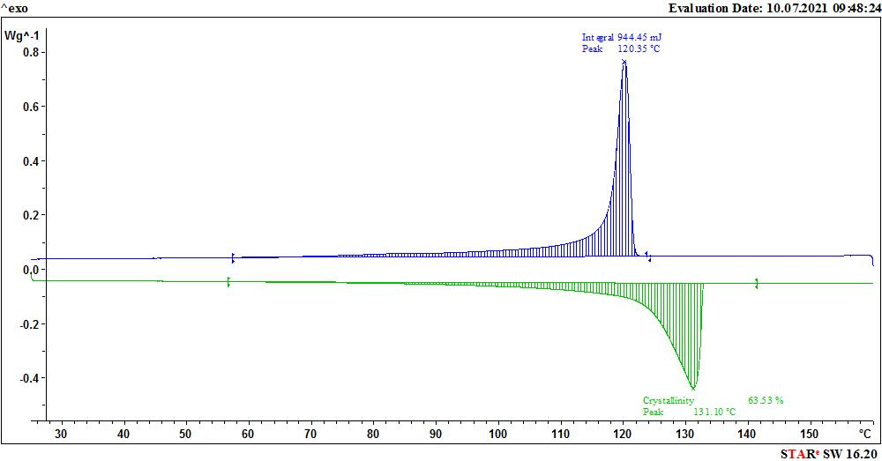
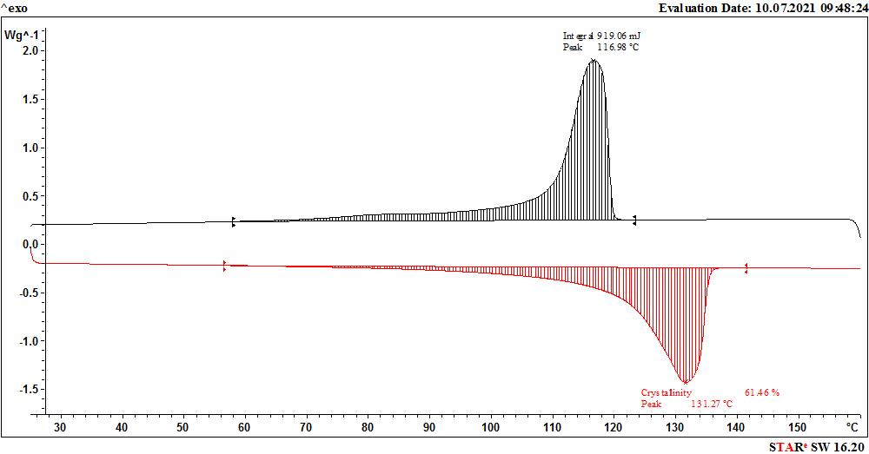
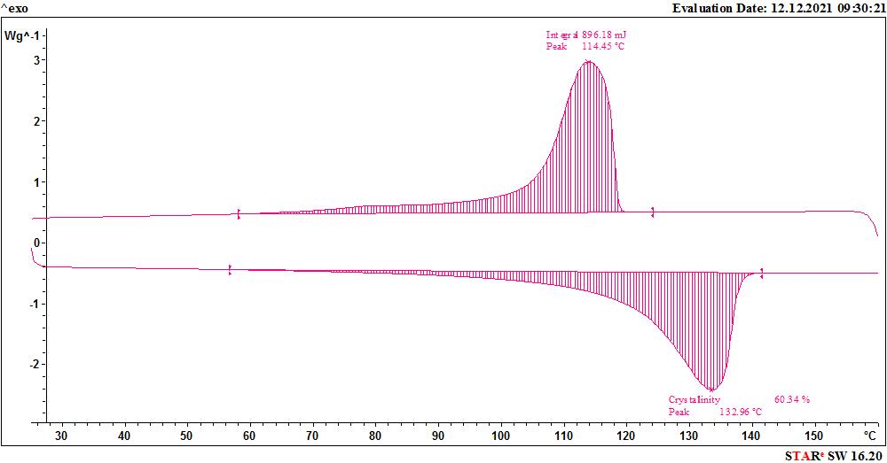
(a)
(b)
(c)

Fig. S4 DSC diagram of pure HDPE at the rate of (a) 1 K/min, (b) 5 K/min, and (c) 10 K/min.
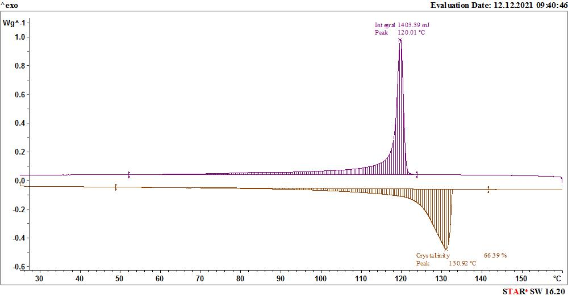
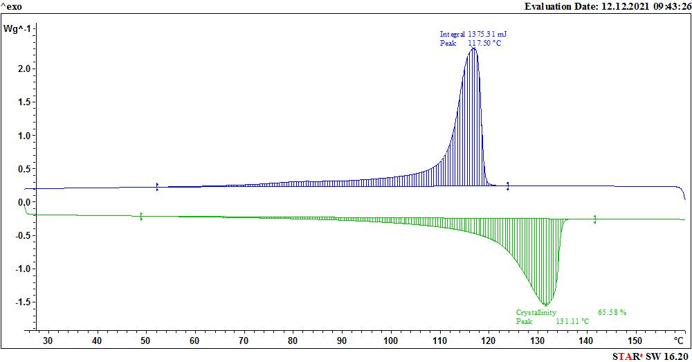
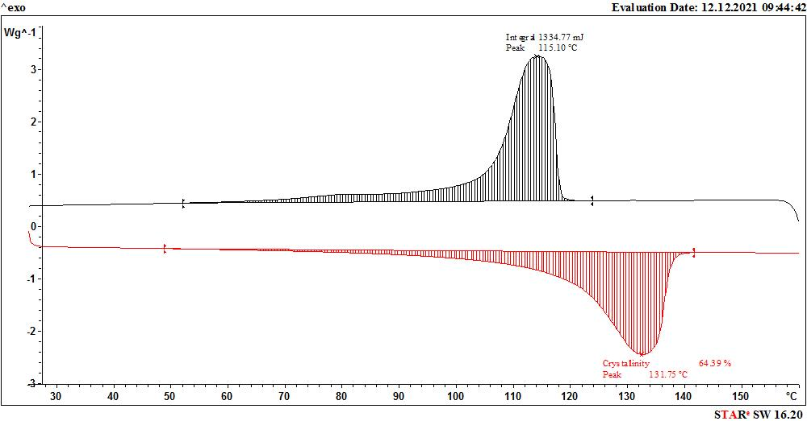
(a)
(b)
(c)

Fig. S5 DSC diagram of HDPE/PSN 0.5 at the rate of (a) 1 K/min, (b) 5 K/min, and (c) 10 K/min.

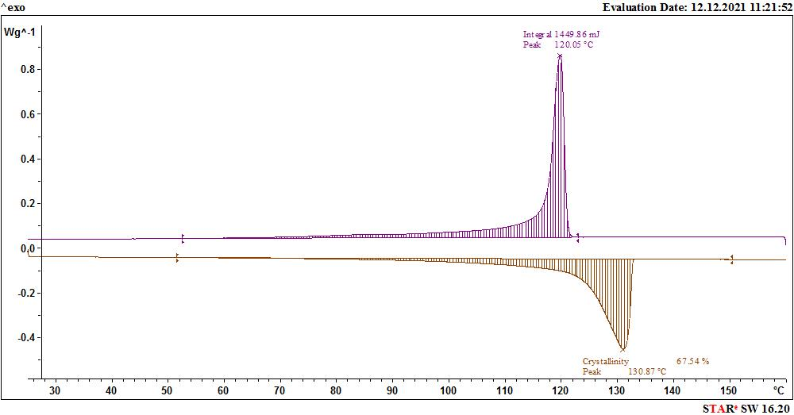
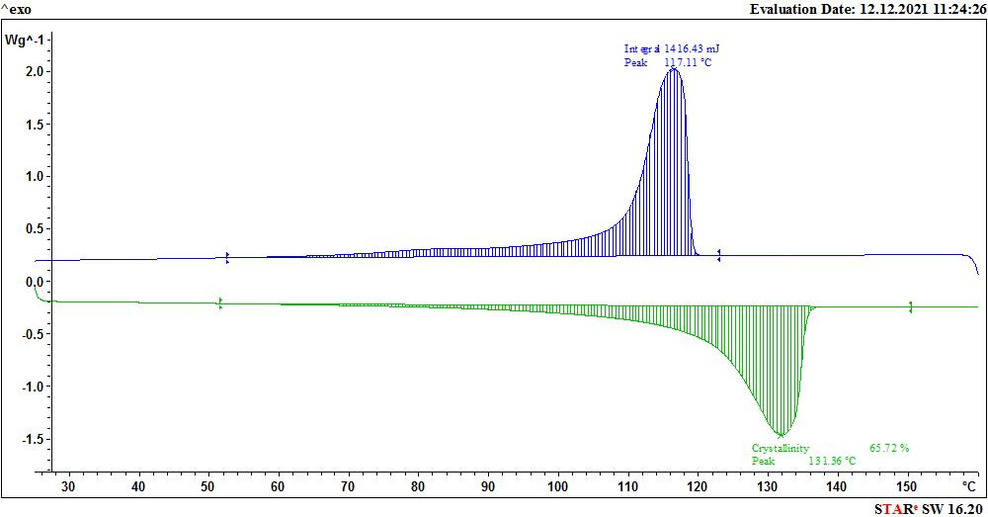
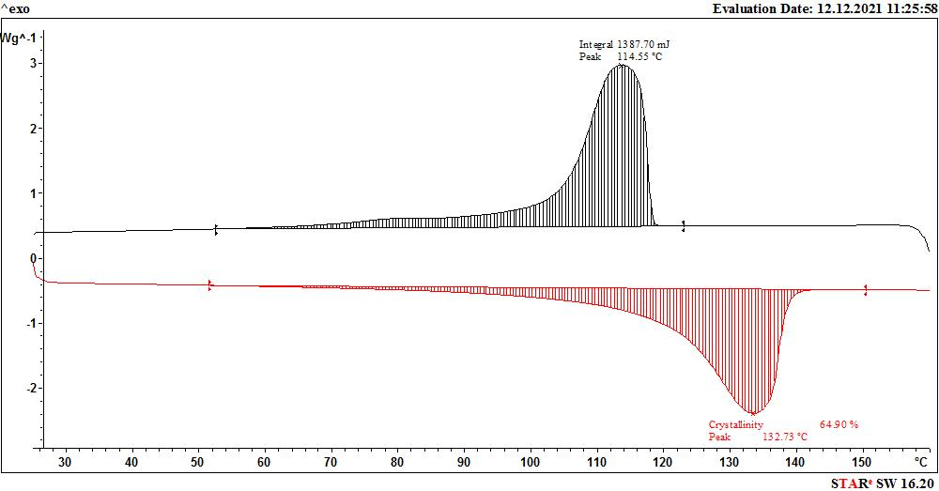
(a)
(b)
(c)

Fig. S6 DSC diagram of HDPE/PSN 0.75 at the rate of (a) 1 K/min, (b) 5 K/min, and (c) 10 K/min.

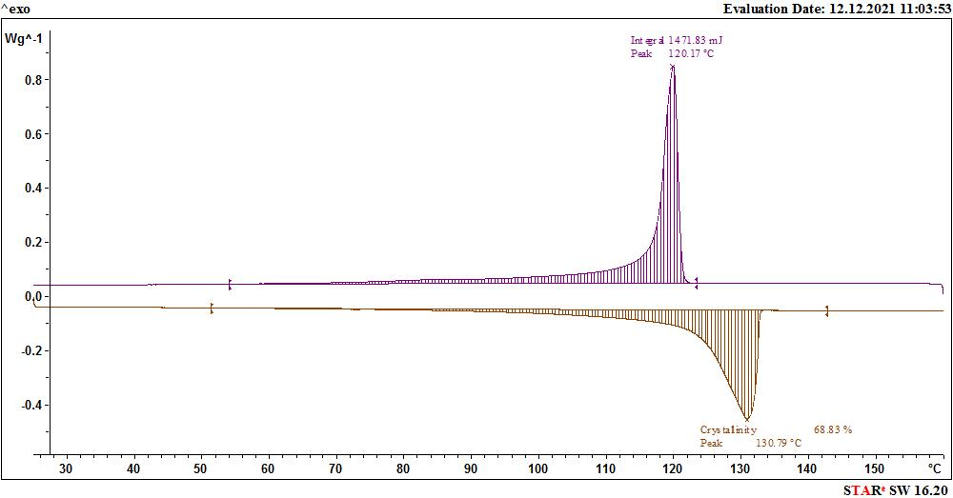
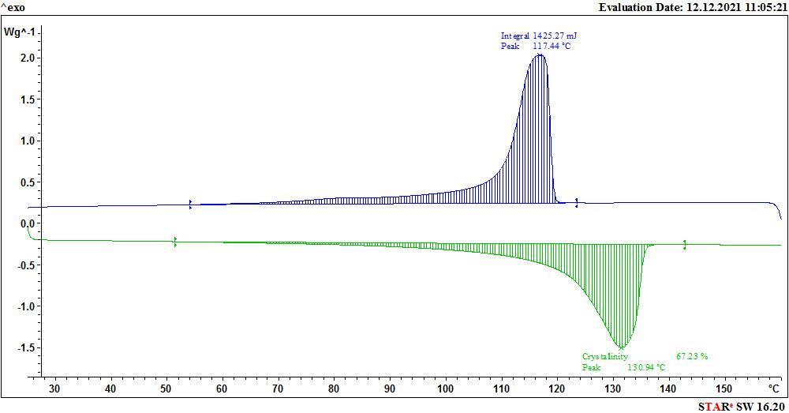
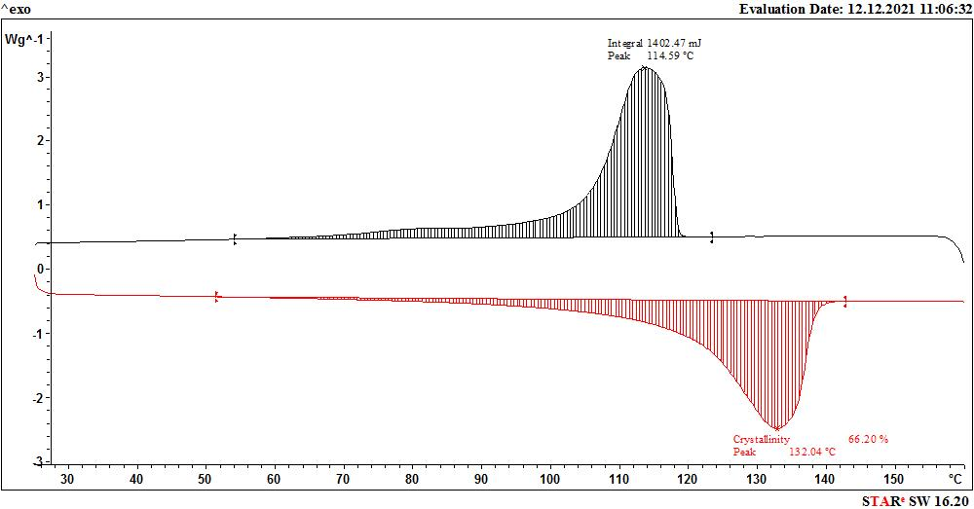
(a)
(b)
(c)

Fig. S7 DSC diagram of HDPE/PSN 2 at the rate of (a) 1 K/min, (b) 5 K/min, and (c) 10 K/min.

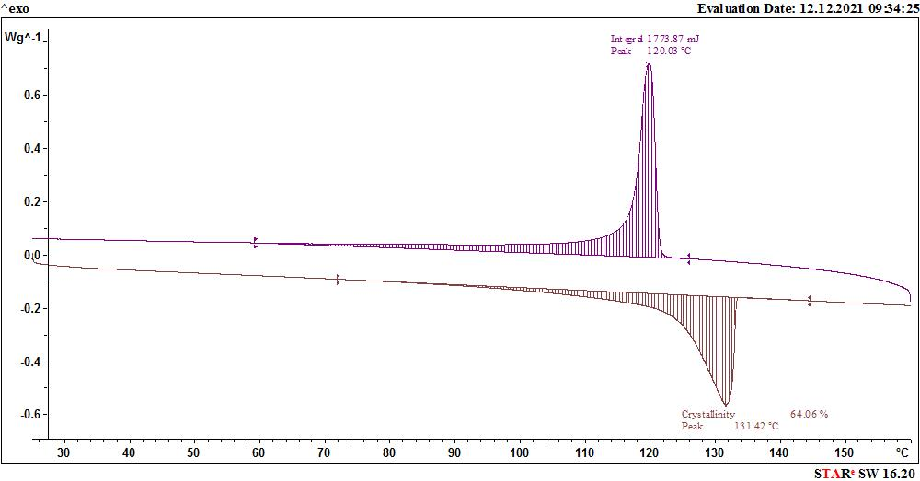
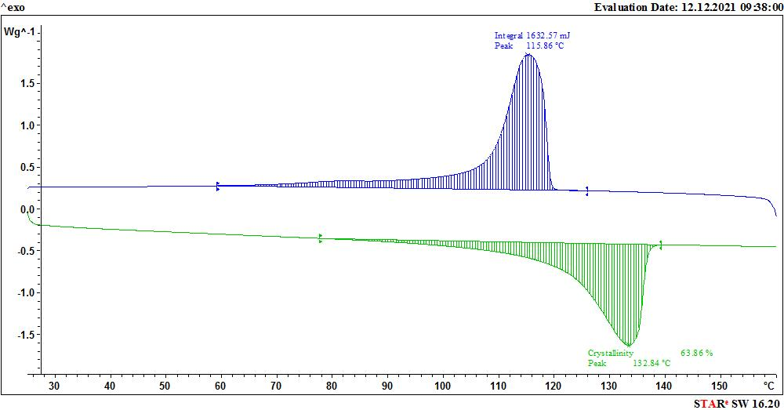
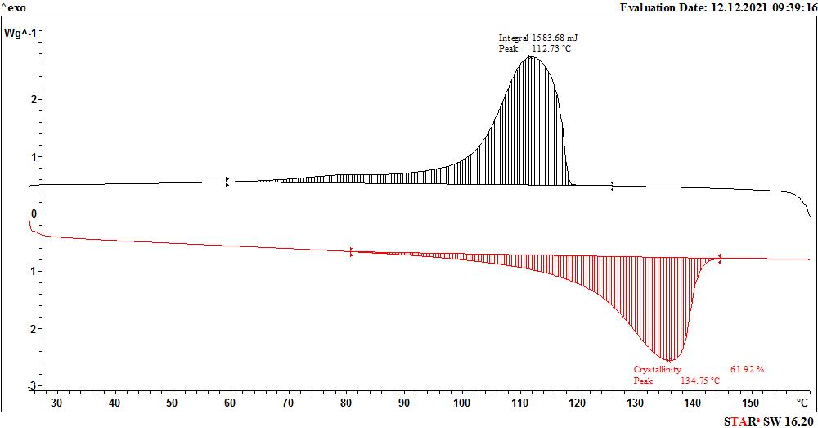
(a)
(b)
(c)

Fig. S8 DSC diagram of HDPE/AMS 0.5 at the rate of (a) 1 K/min, (b) 5 K/min, and (c) 10 K/min.

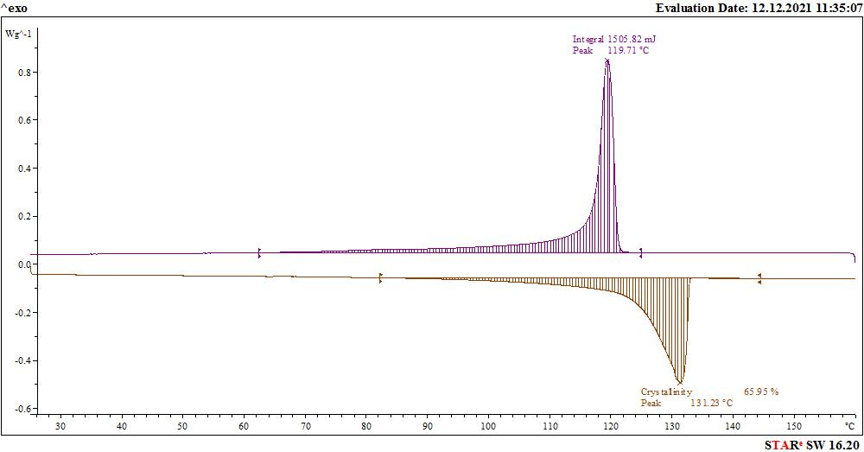
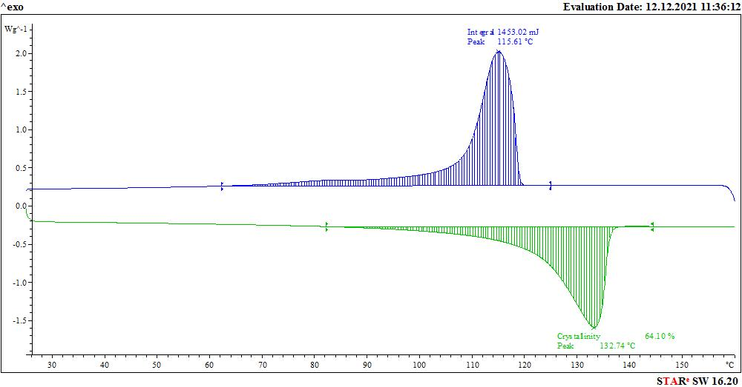
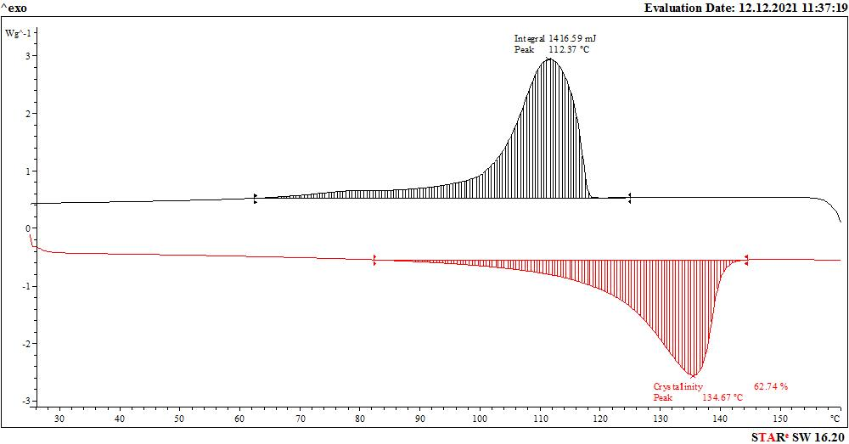
(a)
(b)
(c)

Fig. S9 DSC diagram of HDPE/AMS 0.75 at the rate of (a) 1 K/min, (b) 5 K/min, and (c) 10 K/min.

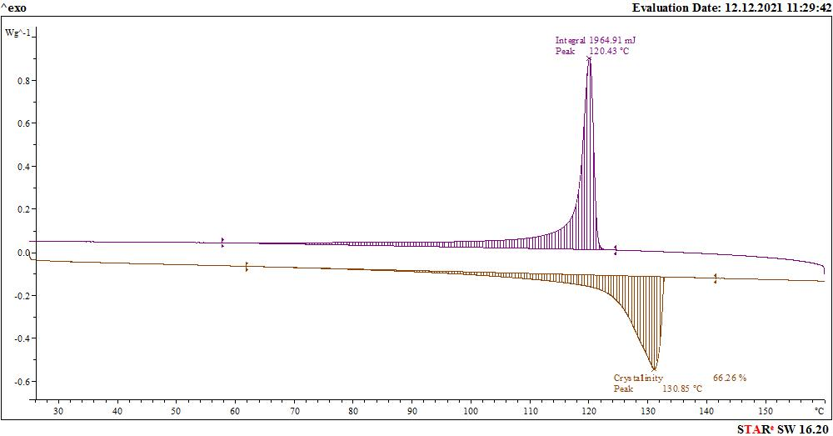
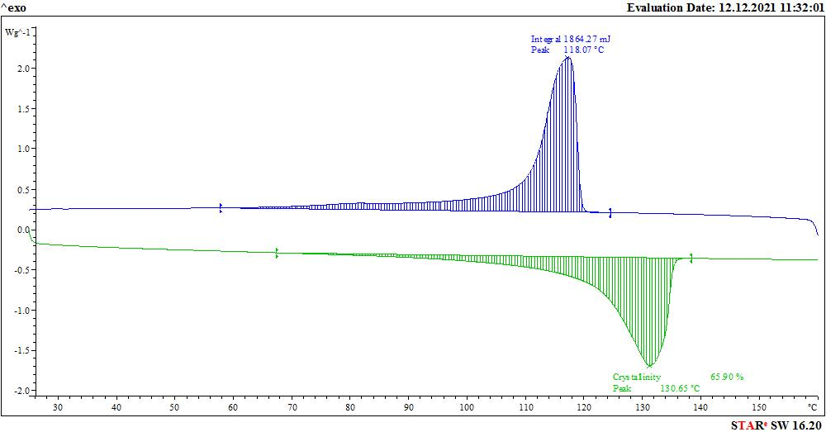
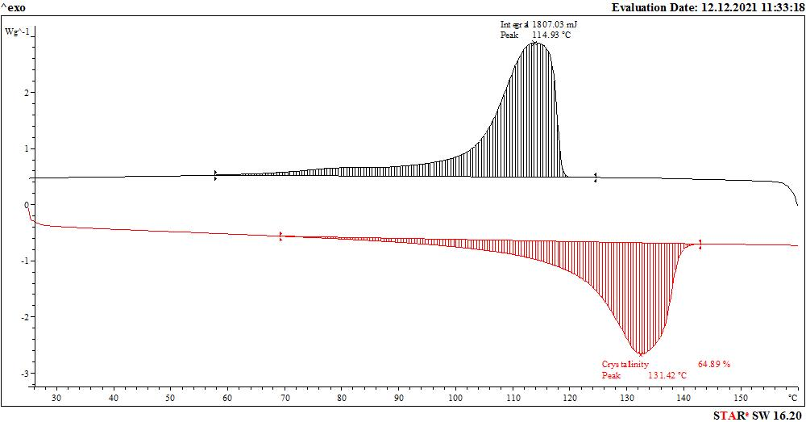
(a)
(b)
(c)

Fig. S10 DSC diagram of HDPE/AMS 2 at the rate of (a) 1 K/min, (b) 5 K/min, and (c) 10 K/min.

As mentioned in the text of the paper, Gutzow Dobreva's theory has been used to investigate the induced crystallinity in HDPE/PSN and HDPE/AMS nanocomposite samples. According to this theory, DSC analysis was performed for each nanocomposite sample at three rates of 1, 5, and 10 K/min, and the rate logarithm was plotted against . The slope obtained from the diagram for each nanocomposite represents the parameter , the difference of which with the parameter B in pure HDPE indicates the induced crystallinity. The related diagrams are given in Figures S11-S17.

Fig. S11 log (cooling rate) vs. 1/∆T² for pure HDPE

Fig. S12 log (cooling rate) vs. 1/∆T² for HDPE/PSN of 0.5

Fig. S13 log (cooling rate) vs. 1/∆T² for HDPE/PSN of 0.75
Fig. S14 log (cooling rate) vs. 1/∆T² for HDPE/PSN of 2.

Fig. S15 log (cooling rate) vs. 1/∆T² for HDPE/AMS of 0.5.

Fig. S16 log (cooling rate) vs. 1/∆T² for HDPE/AMS of 0.75.

Fig. S17 log (cooling rate) vs. 1/∆T² for HDPE/AMS of 2.

* Corresponding authors: Tel.: +98 83 34343345; Fax: +98 83 34343321; Email: f_rahimpour@razi.ac.ir; f_rahimpour65@yahoo.com (F. Rahimpour); e.sharifzadeh@razi.ac.ir (E. Sharifzadeh)

