Supporting online material

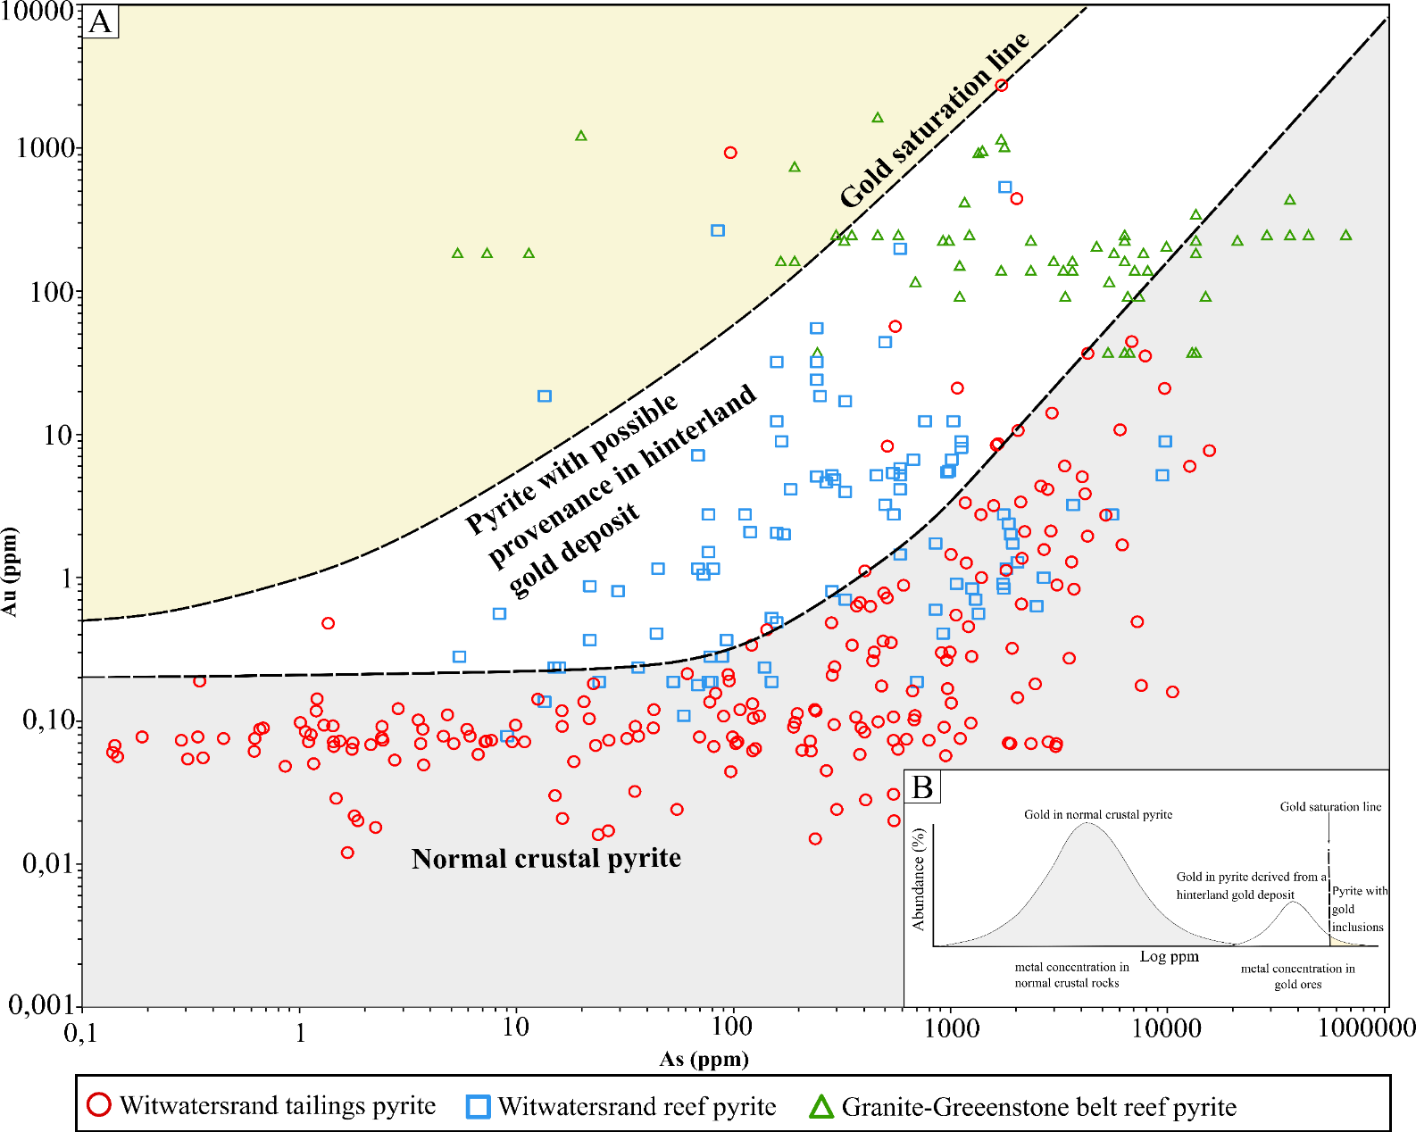
Figure S1 2: a) An arsenic/gold scatter plot with concentration points from the Witwatersrand tailings pyrite (this study), Witwatersrand reef pyrites (Large & Maslennikov, 2020; Morishita et al., 2019) and Granite-Greenstone belt auriferous pyrites (Agangi et al., 2014). The gold saturation line by Reich et al. (2005) represents the gold/arsenic limit in which gold occurs as free gold particles in pyrite. Inset diagram (b) uses the concept of a bi-modal distribution for metal grades, where Clarke values represent the broad main peak (reflecting normal crustal rocks), whereas the second peak represents the metal distribution specifically in ore deposits and occurrences. Here we suggest that our large LA ICP-MS dataset from heterogeneous tailings material provides a representative overview of normal crustal pyrites (e.g., authigenic pyrites, hydrothermal pyrites during modification, as well as detrital pyrites that are not derived from Au deposits), and from pyrites derived from hinterland Au deposits. We suggest that Au/As ratios falling in the grey field represent the signatures for normal crustal pyrites, whereas those in the white and yellow fields may have a provenance deriving from a hinterland Au deposit. The equation separating the normal crustal pyrite from ore-deposit associated detrital pyrite is given as ${\text{C}}_{\text{Au}}\text{=0,00}\text{22}\text{. }{\text{C}}_{\text{As}}\text{+0,2}$. Our LA ICP-MS data targeted the center of individual pyrite grains to limit any possible signal of increased Au at grain boundaries emanating from post-depositional hydrothermal modification (i.e., in accordance with the modified paleo-placer model). It is not ascertained whether the high number of “Witwatersrand reef pyrite” datapoints falling within the white field are an artefact of the spot location within grains evaluated in other studies.

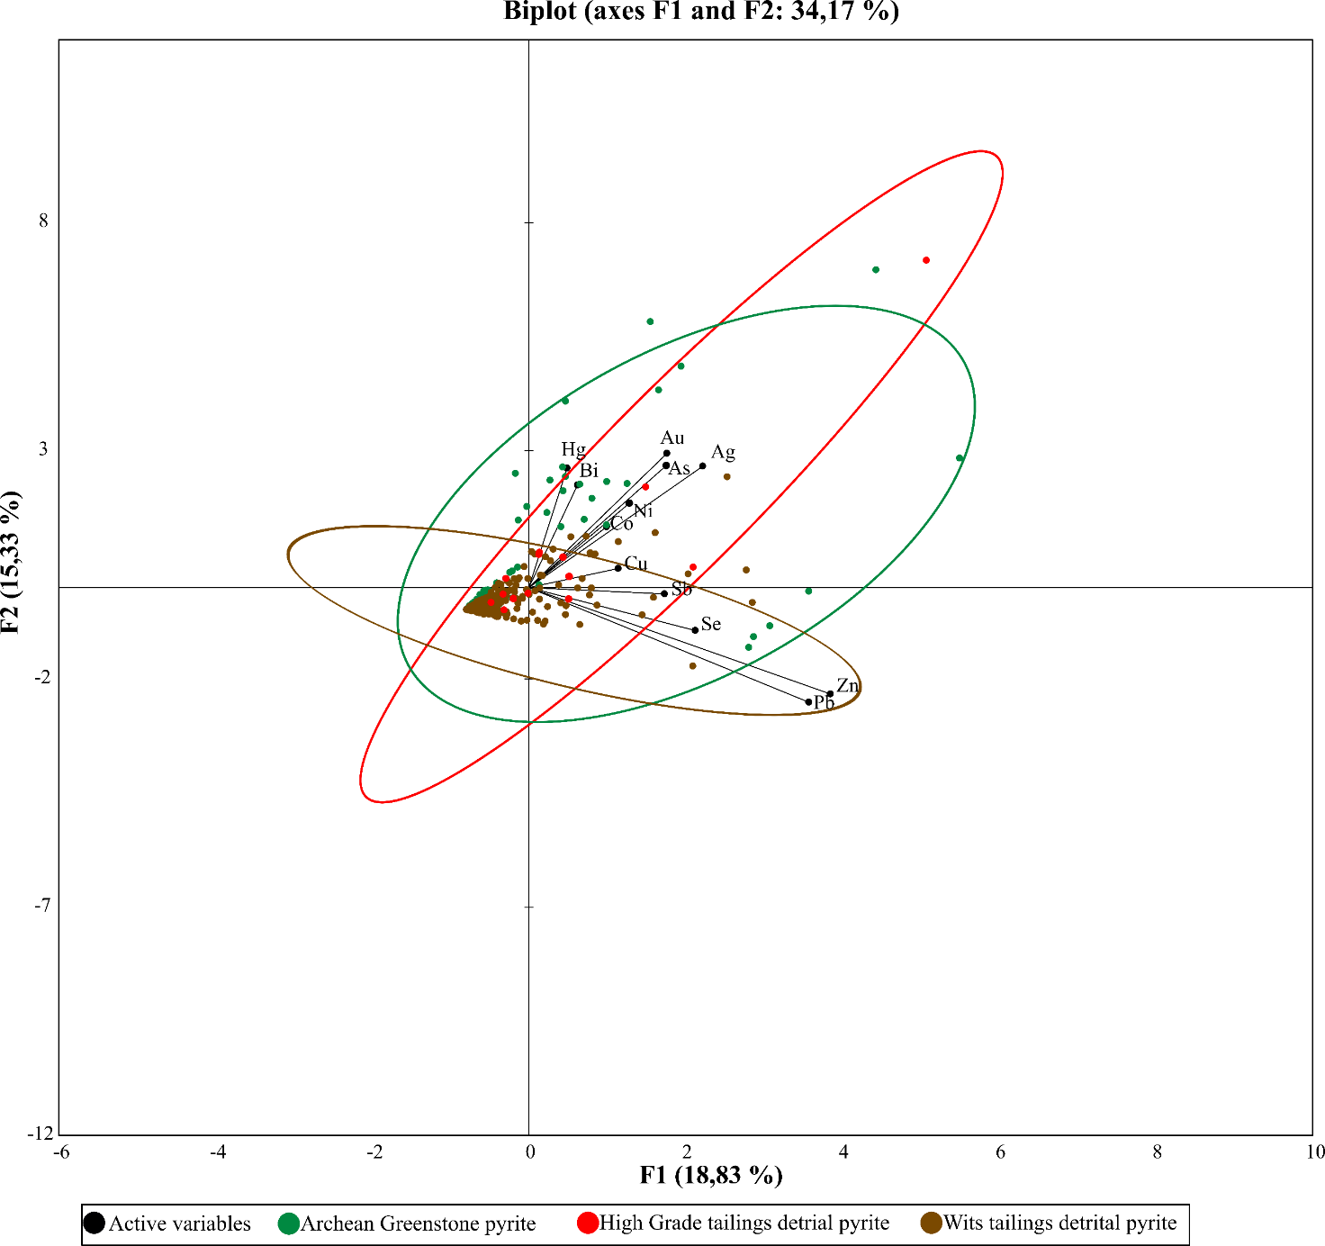
Figure S1 2: A multivariable analysis or principal component analysis (PCA) is used to determine the relationship between the detrital pyrite trace element data generated in this study with pyrite trace element data from Archean greenstone belt vestiges within the Kaapvaal craton (Agangi et al., 2014; Altigani, 2021a,b). The axes F1 and F2 were chosen to be displayed on the biplot, as these axes' dimensions represent the majority of the initial multivariable trace element data.
The active variables (black vectors) indicated the correlation between the different trace elements datasets used for the multivariate analysis. The lengths of the variables in the biplot represent the representativeness, and quality of trace element data within the investigated axes dimensions (F1 and F2). This means Au, As, Ag, Zn and Pb trace element data is best represented in the F1 and F2 dimensions. Gold and arsenic show a high positive correlation due to the vectors forming narrow angles. This indicates that arsenic is a relevant indicator of invisible gold within this trace element data set.
The high-grade gold tailings detrital pyrites that overlap with the Archean greenstone pyrites in figure 3a are plotted in different symbologies from the moderate to low-grade gold tailings detrital pyrites. The two of the high-grade detrital tailings (red dots in figure S1.) plot within the Archean Greenstone pyrite field, with one outlier plotting closely with one Archean greenstone pyrite outlier. Two high-grade Au tailings pyrites are plotting very close to the moderate Au grade pyrite boundary. The biplot indicates there is some relation between the high-grade pyrite in the tailings and the pyrites from the Archean Greenstone Belt vestiges.

