Supporting Information
Enhanced metal-support interaction boosted industrial electrocatalytic water splitting performance of supported Ru nanoparticles on Ni₃N/NiO heterojunction composite

Rui Liu^{1, #}, Mingzi Sun^{2, #}, Xiangjian Liu^{1, #}, Zunhang Lv¹, Xinyu Yu¹, Jinming Wang¹, Yarong Liu¹, Liuhua Li¹, Wenxiu Yang^{1*}, Bolong Huang^{2*}, Xiao Feng¹, and Bo Wang^{1*}

¹Key Laboratory of Cluster Science Ministry of Education, Beijing Key Laboratory of Photoelectronic/Electrophotonic Conversion Materials, Advanced Technology Research Institute (Jinan), Advanced Research Institute of Multidisciplinary Science, School of Chemistry and Chemical Engineering, Beijing Institute of Technology
No. 5, South Street, Zhongguancun, Haidian District, Beijing 100081, China

²Department of Applied Biology and Chemical Technology, The Hong Kong Polytechnic University, Hung Hom, Kowloon, Hong Kong SAR, China

# These authors contributed equally: Rui Liu, Mingzi Sun, Xiangjian Liu
*Correspondence author. Email: yangwx19@bit.edu.cn (W. Y.); bowang@bit.edu.cn (B. W.); bhuang@polyu.edu.hk (B. H.)

Supplementary figures and tables
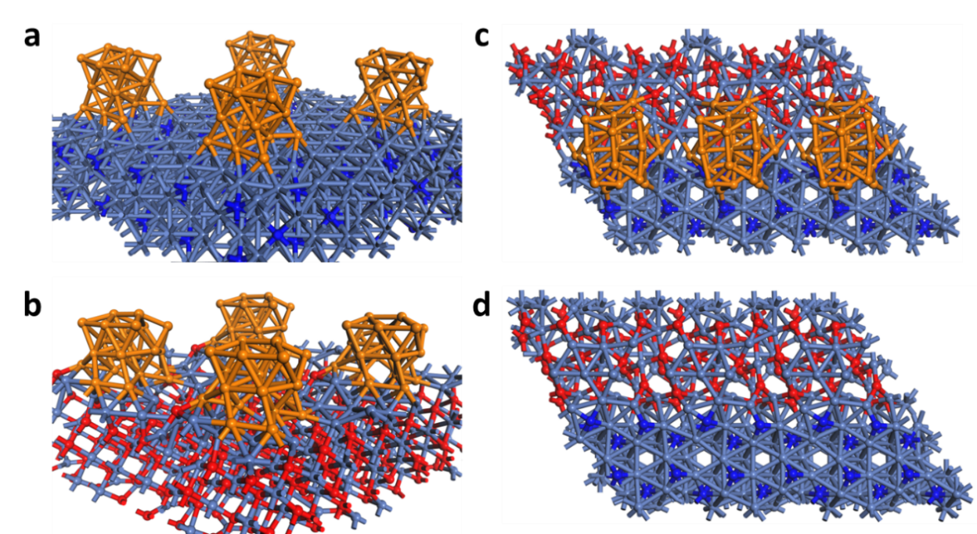
Supplementary Fig. 1 ǀ The structural models. The relaxed structure of (a) Ru-Ni₃N, (b) Ru-NiO, (c) Ru-Ni₃N/NiO, and (d) Ni₃N/NiO. Light balls = Ni, Orange balls= Ru, Dark blue balls = N, Red balls = O.

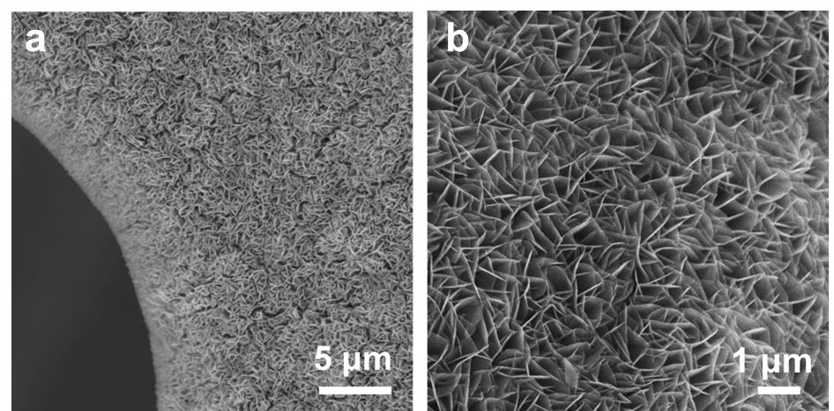
Supplementary Fig. 2 ǀ The SEM images of Ni(OH)₂. The image at low magnificationa (5 μm) shows that the nanosheets are tightly and uniformly grown on the NF substrate. After increasing the magnification (1 μm), it can be observed that the ultrathin nanosheets have a smooth surface.

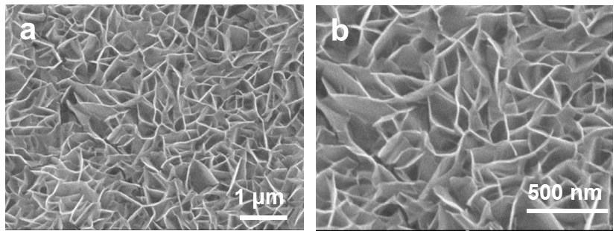
Supplementary Fig. 3 ǀ SEM images of Ni₃N/NiO. After calcination at low temperature (NH₃, 350 °C), the nanosheets are slightly wrinkled but still retain the structure of the nanosheets array grown vertically on the NF.

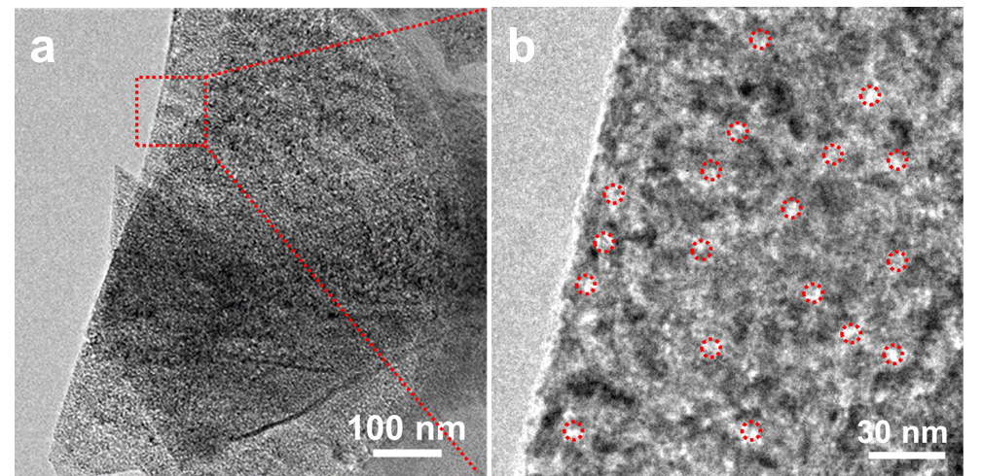
Supplementary Fig. 4 ǀ TEM images of Ni₃N/NiO. The nanosheet structure of Ru-Ni₃N/NiO can be observed in low-magnification transmission electron microscopy, and after NH₃ etching, the surface of the nanosheets produces abundant defects (red circles) that facilitate the adsorption of more metal ions and prevent their migration and aggregation.

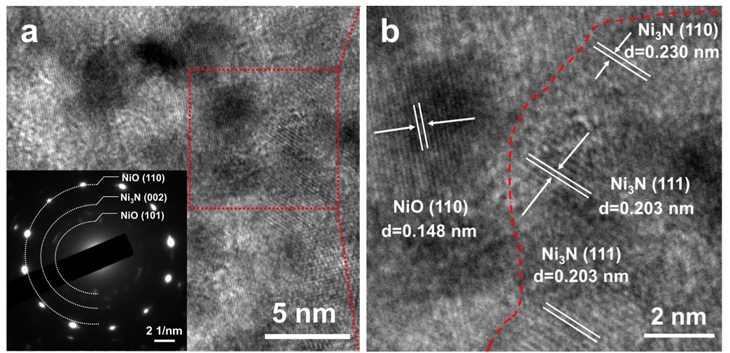
Supplementary Fig. 5 ǀ HRTEM images of Ni₃N/NiO (SAED patterns of the Ni₃N/NiO insert in Supplementary Fig. 5a). As shown in Supplementary Fig. 5a, the diffraction rings corresponding to NiO and Ni₃N can be observed in the SAED diffraction pattern. The red dashed line in Supplementary Fig. 5b corresponds to the obvious heterogeneous interface between NiO and Ni₃N, confirming successful synthesis of Ni₃N/NiO heterojunction nanosheets.

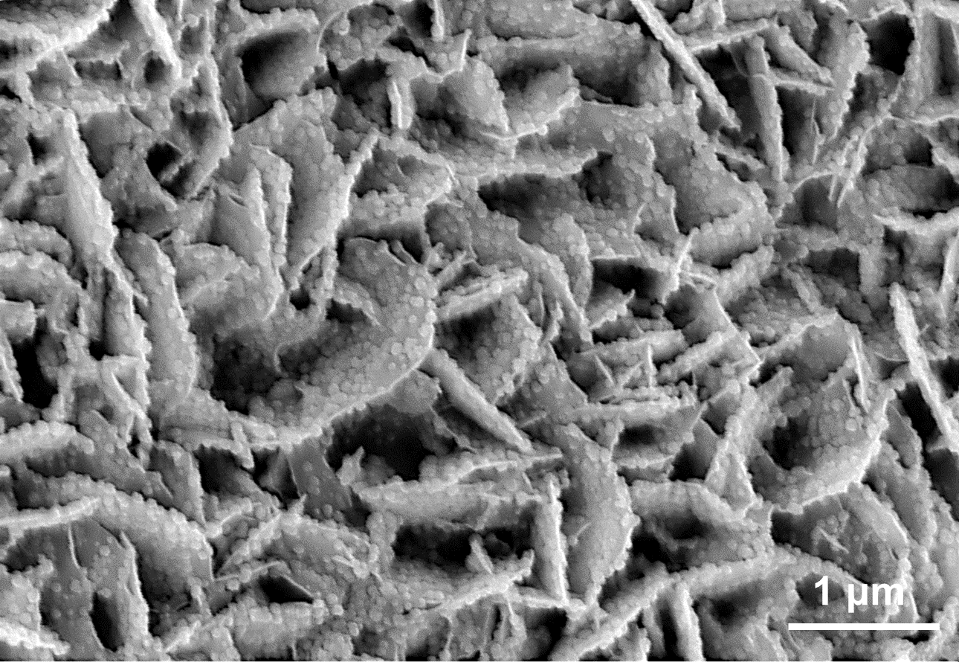
Supplementary Fig. 6 ǀ SEM image of Ru-Ni₃N/NiO at a low magnification. Rich and uniformly dispersed loading of Ru nanoparticles on the surface of the Ni₃N/NiO nanosheets, constituting high density and highly dispersed catalytic active sites.

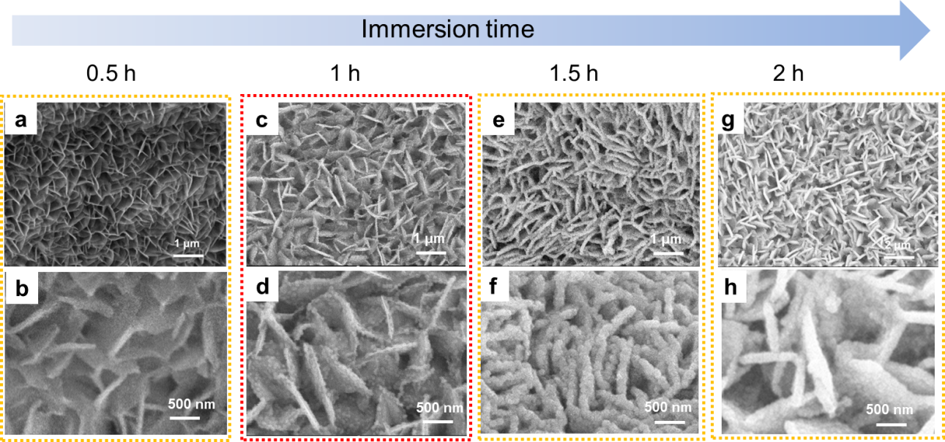
Supplementary Fig. 7 ǀ SEM images of Ni₃N/NiO in RuCl₃ solution for different immersion time. (a-b) Immersion for 0.5 h, (c-d) Immersion for 1 h, (e-f) Immersion for 1.5 h, and (g-h) Immersion for 2 h.
When the immersion time was less than 1 h, the catalyst still maintained the original nanosheet morphology of Ni₃N/NiO and no visible nanoparticles were observed on the surface. With the increasing of immersion time, the smooth surface of the nanosheets became rough and loaded with nanoparticles gradually. The nanosheets already show a significant thickening when the immersion time reaches 2 h. Therefore, Ni₃N/NiO nanosheets immersed in RuCl₃ for 1 h resulted in the most optimal morphological performance.

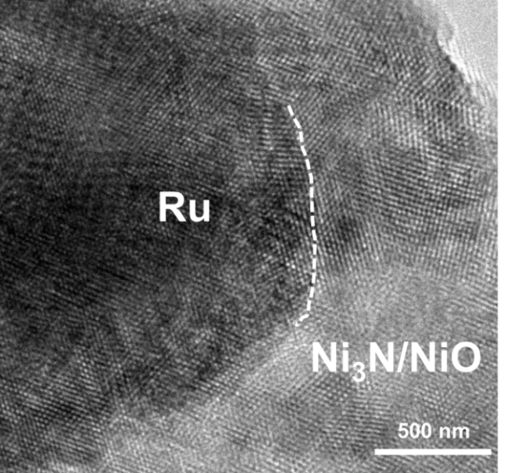
Supplementary Fig. 8 ǀ HRTEM image of Ru-Ni₃N/NiO. The white dashed line corresponds to the obvious heterogeneous interface between Ru nanoparticle and Ni₃N/NiO heterogeneous nanosheet.

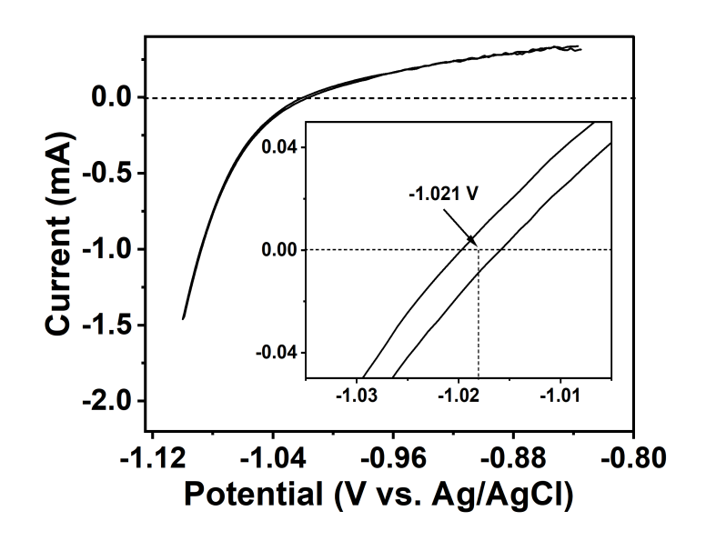
Supplementary Fig. 9 ǀ Correction of Ag/AgCl reference electrodes. The calibration result of Ag/AgCl reference electrode to RHE in H₂-saturated 1.0 M KOH.
The calibration of E_{Ag/AgCl} to E_{RHE} was conducted in H₂-saturated electrolyte by applying CV at a scan rate of 1 mV s⁻¹ on a pair of Pt wires, which served as the working electrode and counter electrode, respectively. The average of potential at which the cathodic current and the anodic current both crossed zero was considered as thermodynamic potential for the hydrogen electrode reactions. And the function of E_{RHE} about E_{Ag/AgCl} can be expressed as followed: E_{RHE} = E_{Ag/AgCl} + 1.021.

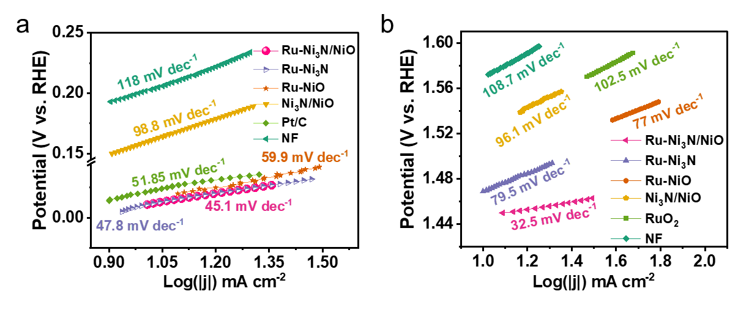Supplementary Fig. 10 ǀ Tafel slopes of various catalysts in 1.0 M KOH. The Tafel slopes of (a) HER and (b) OER were derived from corresponding polarization curves respectively.

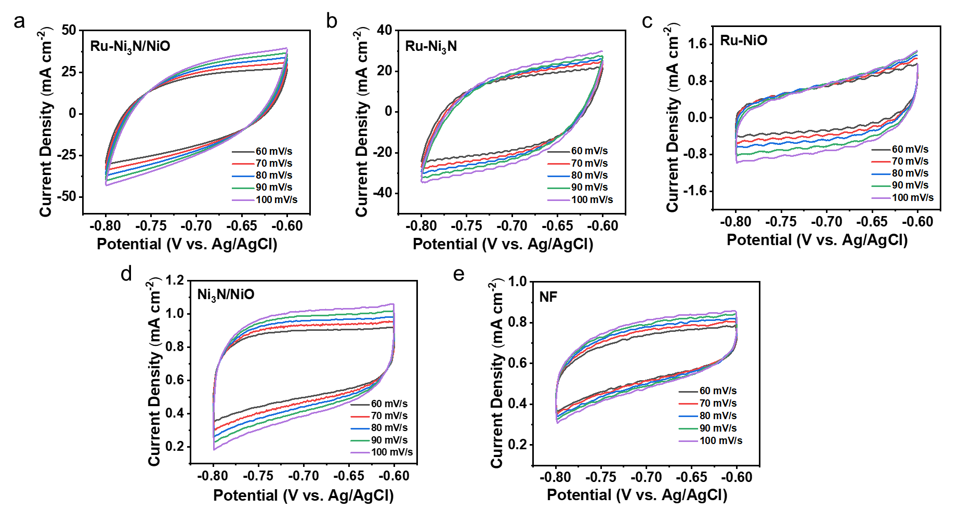Supplementary Fig. 11 ǀ CV measurement in non-Faraday regions. CV curves of (a) Ru-Ni₃N/NiO, (b) Ru-Ni₃N, (c) Ru-NiO, (d) Ni₃N/NiO, and (e) NF at scan rates ranging from 60 mV s⁻¹ to 100 mV s⁻¹.

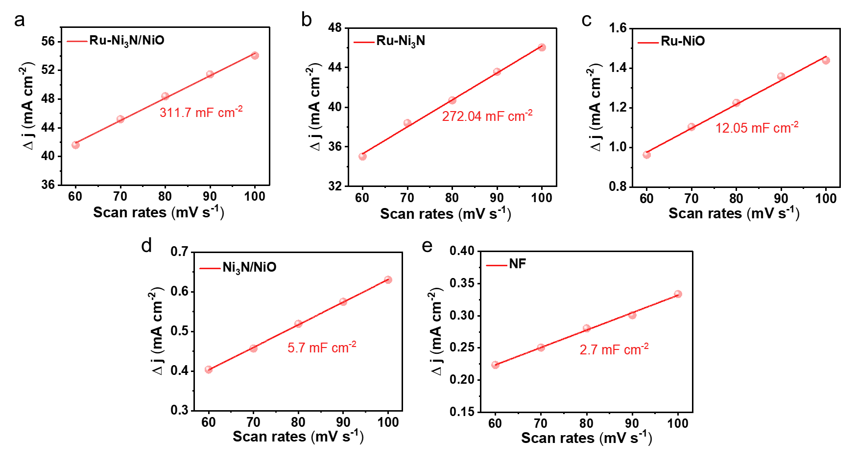
Supplementary Fig. 12 ǀ Calculation curve for C_{dl}. Capacitive current at middle potential of CV curves as function of scan rates for (a) Ru-Ni₃N/NiO, (b) Ru-Ni₃N, (c) Ru-NiO, (d) Ni₃N/NiO, and (e) NF.

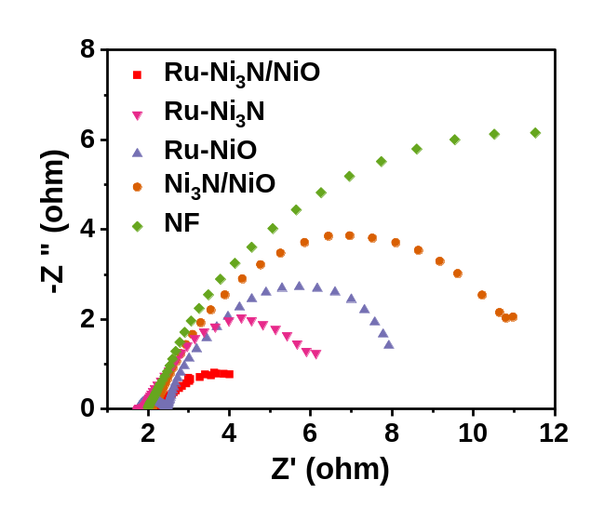
Supplementary Fig. 13 ǀ Nyquist plots of the impedance for obtained catalysts. EIS spectra of Ru-Ni₃N/NiO, Ru-Ni₃N, Ru-NiO, Ni₃N/NiO, and NF in 1.0 M KOH.

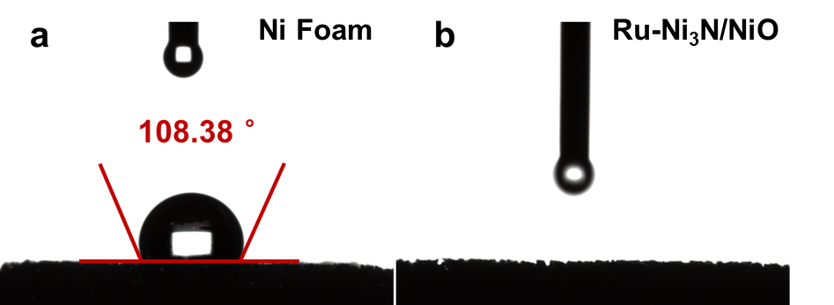
Supplementary Fig. 14 ǀ Contact angle test. The Contact angle images of (a) NF and (b) Ru-Ni₃N/NiO.

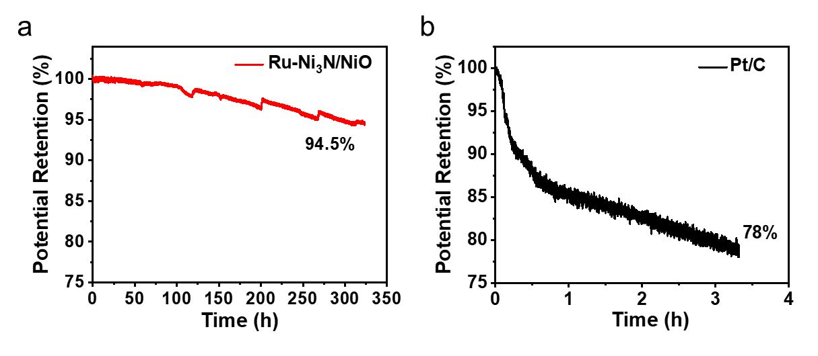
Supplementary Fig. 15 ǀ HER stability tests. Normalized CP curves of (a) Ru-Ni₃N/NiO and (b) Pt/C tested at a constant current density of 100 mA cm⁻² for 320 h and 3.4 h, respectively.

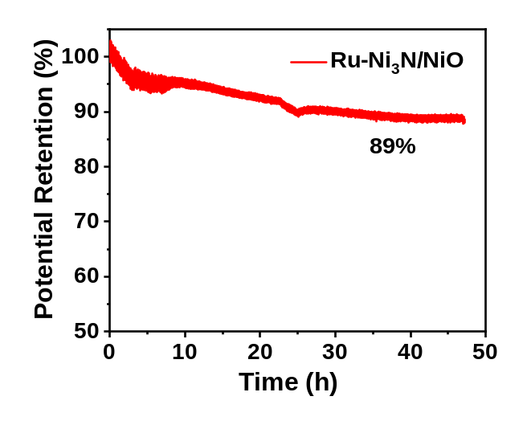
Supplementary Fig. 16 ǀ HER stability tests at industrial grade current densities. Normalized CP curve of Ru-Ni₃N/NiO tested at a constant current density of 500 mA cm⁻² for 48 h.

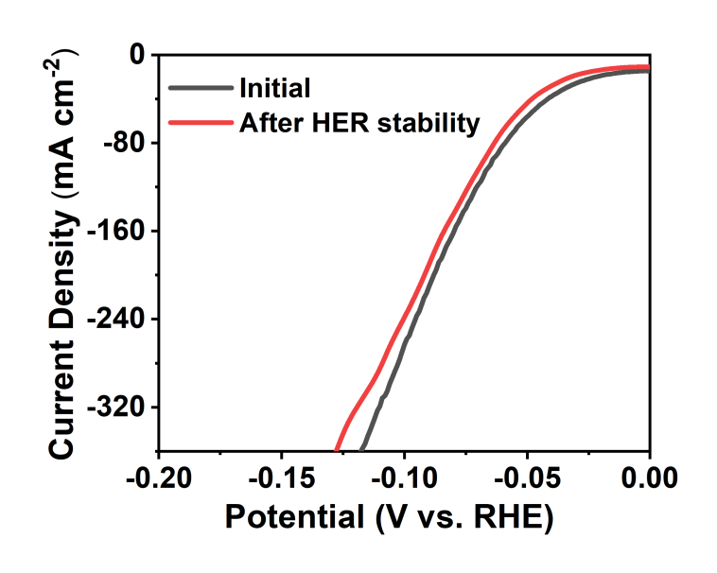
Supplementary Fig. 17 ǀ Polarization curves after HER stability test. Polarization curves of Ru-Ni₃N/NiO before and after HER stability test (48 h CP test at 500 mA cm⁻²).
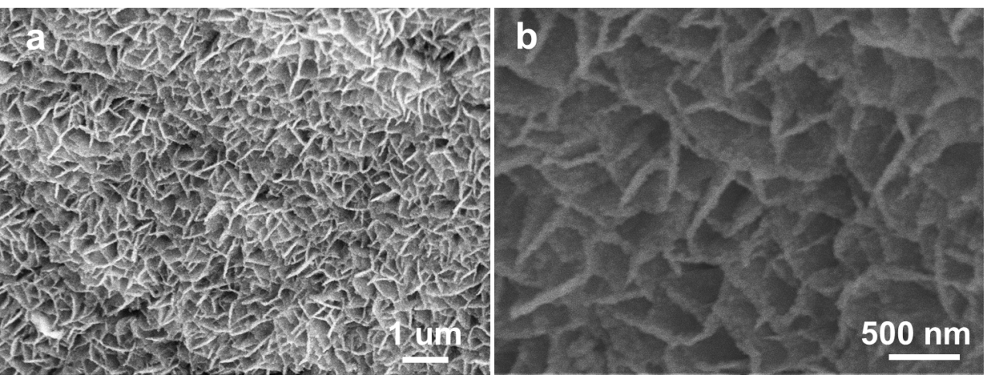
Supplementary Fig. 18 ǀ Morphological behaviour of Ru-Ni₃N/NiO after HER stability test. SEM images of Ru-Ni₃N/NiO after HER stability test (320 h CP test at 100 mA cm⁻²) with different magnifications.

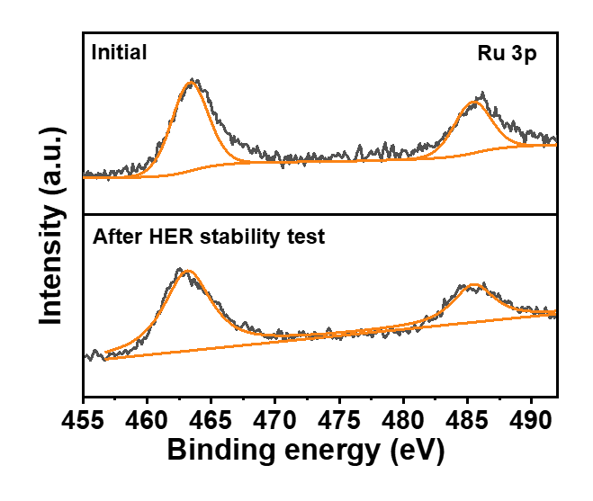
Supplementary Fig. 19 ǀ XPS spectra of Ru-Ni₃N/NiO after HER stability test. High-resolution XPS spectra of Ru 3p for Ru-Ni₃N/NiO before and after HER stability test.

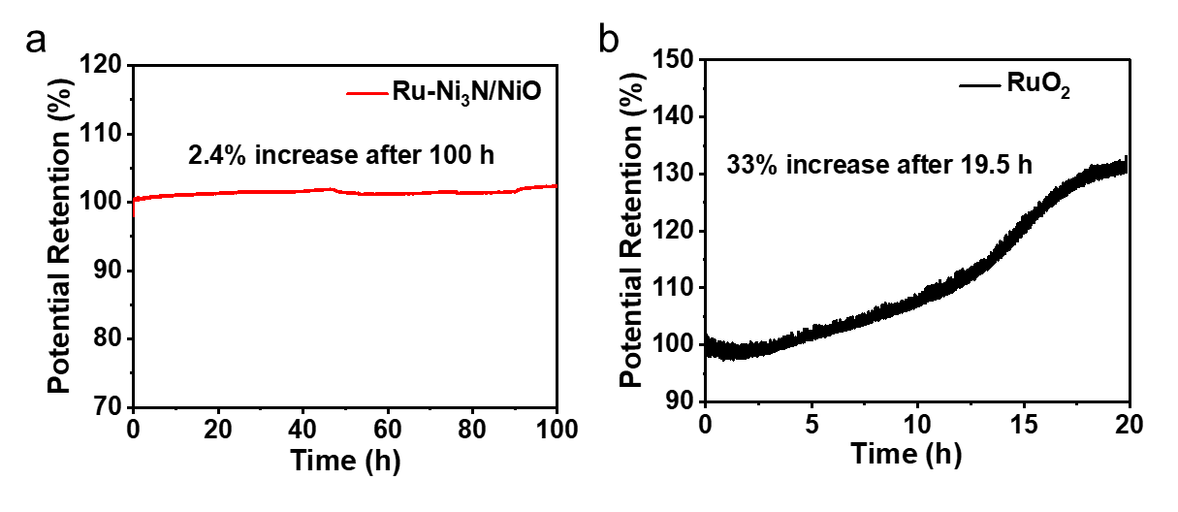
Supplementary Fig. 20 ǀ OER stability tests. Normalized CP curves of (a) Ru-Ni₃N/NiO and (b) RuO₂ tested at a constant current density of 100 mA cm⁻² for 100 h and 19.8 h, respectively.

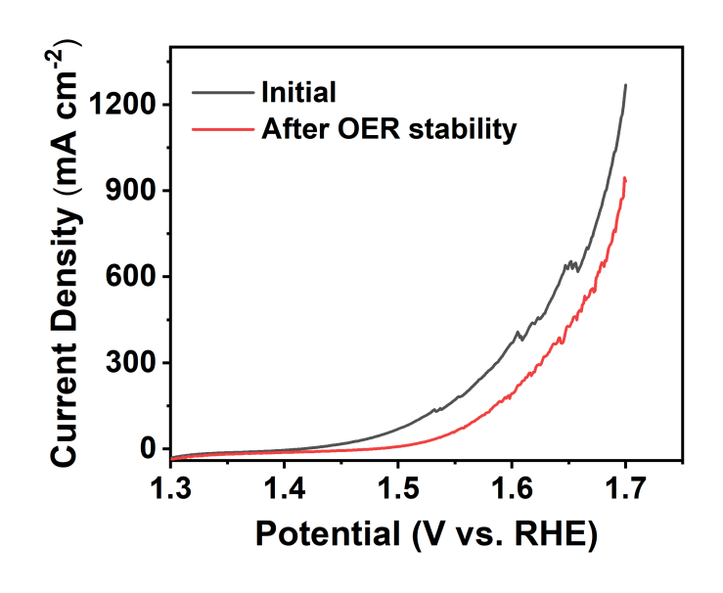
Supplementary Fig. 21 ǀ Polarization curves after OER stability test. Polarization curves of Ru-Ni₃N/NiO before and after OER stability test (100 h CP test at 100 mA cm⁻²).

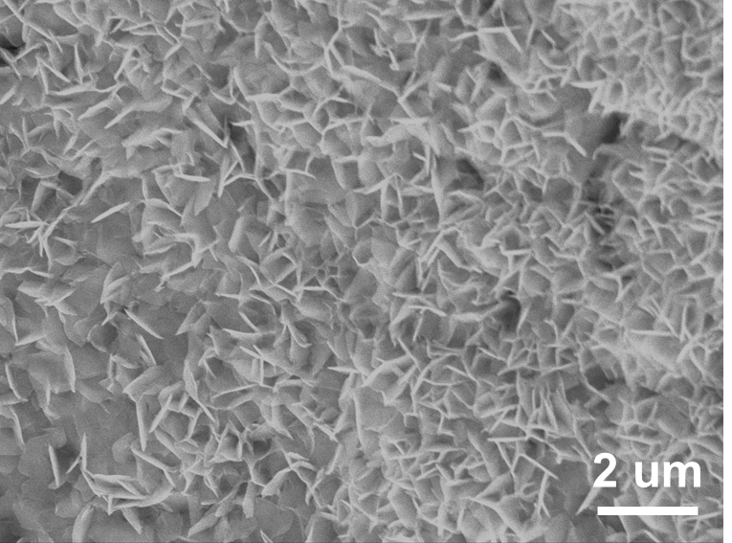
Supplementary Fig. 22 ǀ Morphological behaviour of Ru-Ni₃N/NiO after OER stability test. SEM image of Ru-Ni₃N/NiO after OER stability test (100 h CP test at 100 mA cm⁻²).

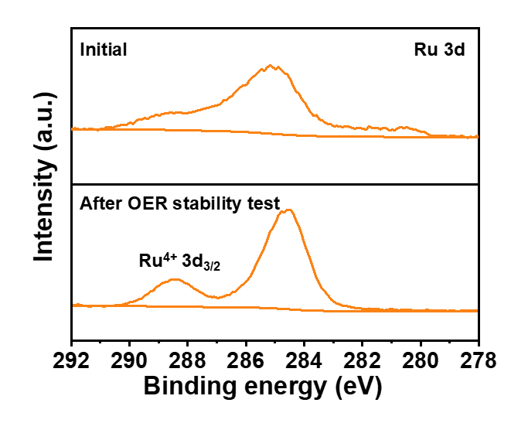
Supplementary Fig. 23 ǀ XPS spectra of Ru-Ni₃N/NiO after OER stability test. High-resolution XPS spectra of Ru 3d for Ru-Ni₃N/NiO before and after the OER stability test.

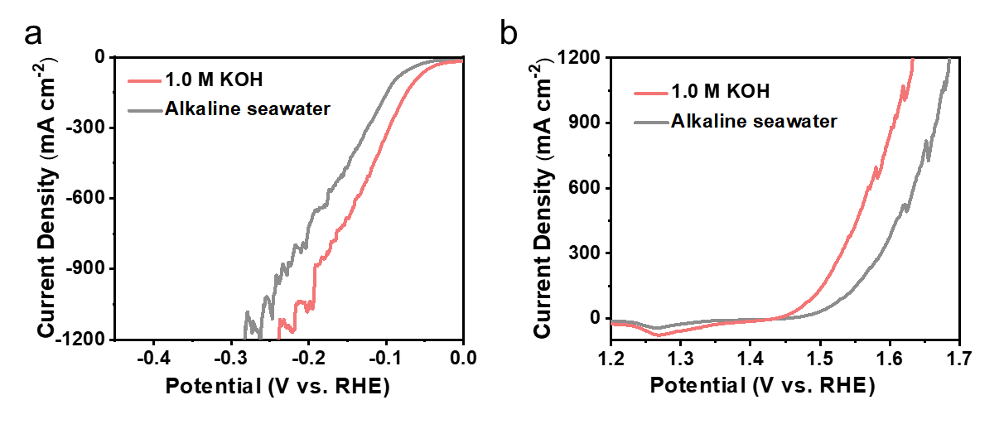
Supplementary Fig. 24 ǀ Electrocatalytic seawater Performance toward HER and OER. Polarization curves of Ru-Ni₃N/NiO for (a) HER and (b) OER in 1.0 M KOH, alkaline seawater.
The Ru-Ni₃N/NiO catalysts were tested in seawater to explore their practical application potential. Electrochemical performance tests were further conducted in 1.0 M KOH (pH ~ 13.78) and alkaline seawater (0.5 M KOH + seawater, pH ~ 13.5). Compare with the results in 1.0 M KOH solution, Ru-Ni₃N/NiO exhibits comparable HER and OER performance in the alkaline seawater.
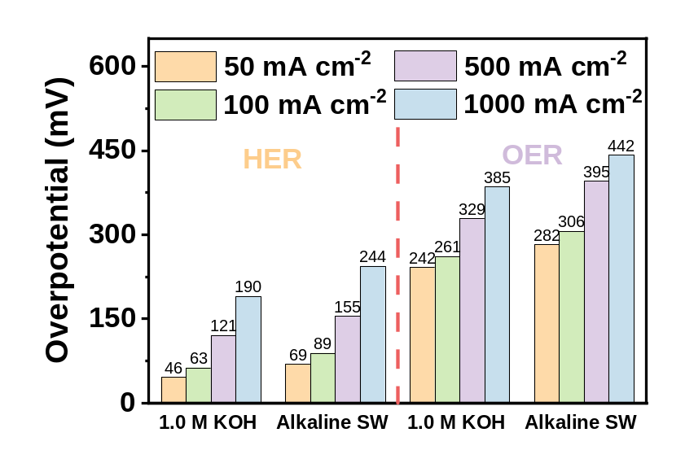
Supplementary Fig. 25 ǀ Comparison of electrochemical properties in alkaline seawater and 1.0 M KOH. Overpotentials required for the Ru-Ni₃N/NiO electrocatalyst at 50, 100, 500, and 1000 mA cm⁻² for OER and HER in 1.0 M KOH and alkaline seawater (SW) electrolytes.
As shown in the Supplementary Fig. 25, the HER overpotentials of Ru-Ni₃N/NiO in alkaline seawater are 46 mV (η₂₀), 69 mV (η₅₀), 89 mV (η₁₀₀), 155 mV (η₅₀₀), and 244 mV (η₁₀₀₀), respectively. And the OER of Ru-Ni₃N/NiO are 259 mV (η₂₀), 282 mV (η₅₀), 306 mV (η₁₀₀), 395 mV (η₅₀₀), and 442 mV (η₁₀₀₀), respectively.

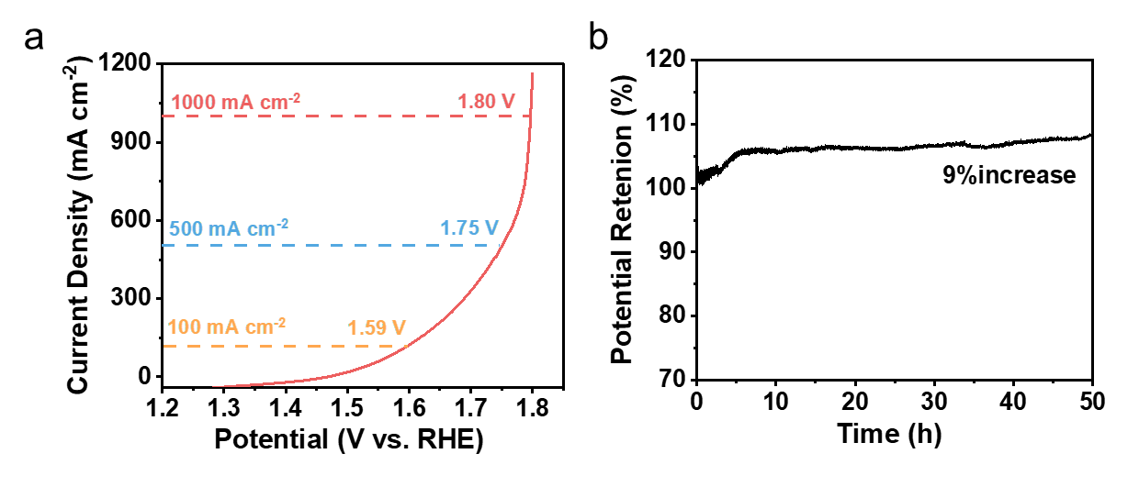
Supplementary Fig. 26 ǀ Overall seawater splitting performance and stability test for Ru-Ni₃N/NiO in Alkaline seawater.
The overall seawater splitting performance test of Ru-Ni₃N/NiO(+,-) electrolyzer in alkaline seawater. A current density of 500 mA cm⁻² can be achieved at a low cell voltage of 1.75 V with Ru-Ni₃N/NiO(+,-) and the cell voltage only increased by 9% during the CP measurements (@ 500 mA cm⁻², 50 h) stability test, demonstrates impressive performance.

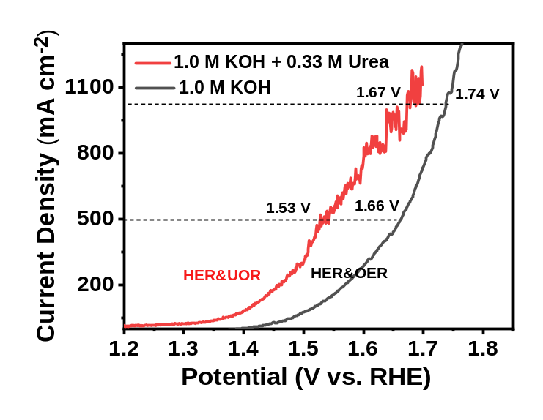
Supplementary Fig. 27 ǀ Electrocatalytic UOR performance. Polarization curves of Ru-Ni₃N/NiO(+,-) electrolyzer in 1.0 M KOH + 0.33 M urea and 1.0 M KOH.
OER requires a higher energy barrier to complete the water splitting because of the kinetic suppression of its four-electron transfer step, while the urea oxidation reaction (UOR) has a low thermodynamic potential and has become one of the promising replacement reactions for OER at present. The overall water splitting performance test of Ru-Ni₃N/NiO(+,-) electrolyzer in an electrolyte of 1.0 M KOH + 0.33 M urea. A current density of 500 mA cm⁻² can be achieved at a low cell voltage of 1.53 V with Ru-Ni₃N/NiO(+,-) electrolyzer, the excellent performance of the urea electrolytic cell was confirmed.

Supplementary Table 1 ǀ The element contents of Ru-Ni₃N/NiO and Ni₃N/NiO determined by XPS.
 | Ni (at%) | Ru (at%) | O (at%) | N (at%)
Ru-Ni₃N/NiO | 22.16 | 5.45 | 68.23 | 4.16
Ni₃N/NiO | 29.59 | N/A | 66.72 | 3.69

Supplementary Table 2 ǀ Comparison of HER performance among the Ru-Ni₃N/NiO catalyst and other reported HER electrocatalysts in 1.0 M KOH.
Catalysts | η10  (mV) | Tafel slope  (mV dec⁻¹) | References
Ru-Ni₃N/NiO | 11 | 57.24 | This work
(Ru-Co)O_{x} | 44.1 | 23.5 | [1]
NiMoO_{x}/NiMoS | 38 | 38 | [2]
Ru₂P/WO₃@NPC | 15 | 18 | [3]
Ru-Mo₂C@CNT | 15 | 26 | [4]
Ru@MWCNT | 17 | 27 | [5]
RuP₂@NPC | 52 | 69 | [6]
Ru-MoO₂ | 29 | 31 | [7]
Ni@Ni₂P-Ru | 31 | 41 | [8]
Co-Ni₃N | 194 | 156 | [9]
Ni₃N-Co₃N | 43 | 35.1 | [10]
Ni₃N-NiMoN | 31 | 46 | [11]
Ru/Co-N-C-800℃ | 19 | 27.8 | [12]
Ni₅P₄-Ru/CC | 54 | 52 | [13]
Ru-ZIF-900 | 51.6 | 78.4 | [14]
Ni-Fe NPs | 46 | 58 | [15]

Supplementary Table 3 ǀ Overpotential and tafel slope performance of Ru-Ni₃N/NiO, Ru-Ni₃N, Ru-NiO, Ni₃N/NiO, NF, Pt/C, and RuO₂ electrodes in 1.0 M KOH.
Catalysts | HER |  | OER
Catalysts | η₁₀₀ (mV) | Tafel slope  (mV dec⁻¹) | η₁₀₀ (mV) | Tafel slope  (mV dec⁻¹)
Ru-Ni₃N/NiO | η10 = 11  η100 = 63  η500 = 121  η1000 = 191 | 45.1 | η10 = 219  η100 = 261  η500 = 121  η1000 = 385 | 32.5
Ru-Ni₃N | 71 | 47.8 | 321 | 79.5
Ru-NiO | 83 | 59.9 | 337 | 77
Ni₃N/NiO | 255 | 98.8 | 379 | 96.1
 | 355 | 118 | 451 | 108.7
  NF
Pt/C | 81 | 51.85 | / | /
RuO₂ | / | / | 404 | 102.5

Supplementary Table 4 ǀ Performance of Ru-Ni₃N/NiO, Ru-Ni₃N, Ru-NiO, Ni₃N/NiO, and NF electrodes in 1.0 M KOH.
Catalysts | C_{dl}  (mF cm⁻²) | ECSA | R_{ct}
Ru-Ni₃N/NiO | 311.7 | 5195 | 1.52
Ru-Ni₃N | 272.05 | 4534 | 2.53
Ru-NiO | 12.05 | 201 | 3.25
Ni₃N/NiO | 5.7 | 95 | 4.98
 | 2.7 | 45 | 9.53
  NF

Supplementary Table 5 ǀ Comparison of OER performance among the Ru-Ni₃N/NiO catalyst and other reported OER electrocatalysts in 1.0 M KOH.
Catalysts | η10/mV | Tafel slope  (mV dec⁻¹) | References
Ru-Ni₃N/NiO | 181 | 42.7 | This work
Ru/CoFe-LDHs | 198 | 39 | [16]
NiMoO_{x}/NiMoS | 186 | 34 | [2]
np-Ir/NiFeO | 197 | 29.6 | [17]
Ru/Co-N-C-800℃ | 276 | 55.7 | [12]
RuNi-NCNFs | 290 | / | [18]
Ru₂Ni₂ SNs/C | 310 | 75 | [19]
FF-Na-Ni | 174 | 46 | [20]
ɑ-NiFeOH/NiFeP/NF | 199 | 39 | [21]
Ru/NiFe LDH-F/NF | 230 | 50.2 | [22]
RuO₂/N–C | 280 | 56 | [23]
Fe₂O₃/Pd | 383 | 41.9 | [24]
NF-Na-Fe-Pt | 261 | 39.68 | [25]
PdCo-300 | 350 | / | [26]

Supplementary Table 6 ǀ Comparison of overall water splitting activities.
Electrolyzers | Cell Voltage  at 100 mA cm⁻² | References
Ru-Ni₃N | 1.52 V |  | This work
Fe-CoP/NF | 1.62 V |  | [27]
FeP/Ni₂P | 1.64 V |  | [28]
(Ni-Fe)S_{x}/NiFe(OH)_{y}/NF | 1.65 V |  | [29]
Ni₂P-Fe₂P/NF | 1.682 V |  | [30]
CoSn₂/NF | 1.69 V |  | [31]
Sn-Ni₃S₂/NF | 1.7 V |  | [32]
NiCo@C-NiCoMoO/NF | 1.71 V |  | [33]
FeCoNi-HNTAs/NF | 1.725 V |  | [34]
Ni-ZIF/Ni-B/NF | 1.78 V |  | [35]
Mo-Ni₃S₂/Ni_{x}P_{y}/NF | 1.8 V |  | [36]
Fe-H₂ cat | 1.8 V |  | [37]
N-Ni₃S₂/NF | 1.815 V |  | [38]
Co-NC/CF | 1.858 V |  | [39]
Co₃S₄/EC-MOF/CC | 1.87 V |  | [40]
NiFe LDH@NiCoP/NF | 1.9 V |  | [41]
Ni_{0.2}Mo_{0.8}N/NF | 1.94 V |  | [42]
NiCo₂S₄/NF | 1.94 V |  | [43]
Co₁Mn₁CH/NF | 1.98 V |  | [44]

Supplementary Table 7 ǀ Comparison of overall water splitting activities of bifunctional electrocatalysts with high current at 500 mA cm⁻².
Electrolyzers | Cell Voltage  at 500 mA cm⁻² | References
Ru-Ni₃N | 1.66 V |  | This work
RFNOH-10||NiFe-LDH | 1.69 V |  | [45]
Ni NWs‖Ni_{0.8}Fe_{0.2}-AHNA | 1.702 V |  | [46]
FeP/Ni₂P | 1.72 V |  | [28]
NiMoN||NiMoN@NiFeN | 1.73 V |  | [47]
S-(Ni,Fe)OOH||NiMoN | 1.73 V |  | [48]
NiMoO_{x}/NiMoS | 1.75 V |  | [2]
(Ni_{x}Fe_{y}Co_{6-x-y})Mo₆C | 1.77 V |  | [49]
Ni_{2(1-x)}Mo_{2x}P||Cu@NiFeLDH | 1.82 V |  | [50]
FeCoNi(S) | 1.84 V |  | [51]
Ni₂P-Fe₂P/NF | 1.88 V |  | [30]
NFN-MOF/NF | 1.9 V |  | [52]
NiMoS||NiCoS | 1.95 V |  | [53]
MoNi₄/SSW‖SSW Rs-12h | 1.978 V |  | [54]

Supplementary References
- Wang C. & Qi L. Heterostructured inter-doped ruthenium-cobalt oxide hollow nanosheet arrays for highly efficient overall water splitting. Angew. Chem. Int. Ed. 59, 17219-17224 (2020).
- Zhai P. et al. Engineering active sites on hierarchical transition bimetal oxides/sulfides heterostructure array enabling robust overall water splitting. Nat. Commun. 11, 5462 (2020).
- Jiang X. et al. The heterostructure of Ru₂P/WO₃/NPC synergistically promotes H₂O dissociation for improved hydrogen evolution. Angew. Chem. Int. Ed. 60, 4110-4116 (2021).
- Wu X. et al. Solvent-free microwave synthesis of ultra-small Ru-Mo₂C@CNT with strong metal-support interaction for industrial hydrogen evolution. Nat. Commun. 12, 4018 (2021).
- Kweon D. H. et al. Ruthenium anchored on carbon nanotube electrocatalyst for hydrogen production with enhanced Faradaic efficiency. Nat. Commun. 11, 1278 (2020).
- Pu Z. et al. RuP₂-based catalysts with platinum-like activity and higher durability for the hydrogen evolution reaction at all pH values. Angew. Chem. Int. Ed. 56, 11559-11564 (2017).
- Jiang P. et al. Pt-like electrocatalytic behavior of Ru-MoO₂ nanocomposites for the hydrogen evolution reaction. J. Mater. Chem. A 5, 5475-5485 (2017).
- Liu Y. et al. Ru modulation effects in the synthesis of unique rod-like Ni@Ni₂P-Ru heterostructures and their remarkable electrocatalytic hydrogen evolution performance. J. Am. Chem. Soc. 140, 2731-2734 (2018).
- Zhu C. et al. In situ grown epitaxial heterojunction exhibits high-performance electrocatalytic water splitting. Adv. Mater. 30, 1705516 (2018).
- Qian Q. et al. Artificial heterointerfaces achieve delicate reaction kinetics towards hydrogen evolution and hydrazine oxidation catalysis. Angew. Chem. Int. Ed. 60, 5984-5993 (2021).
- Wu A. et al. Integrating the active OER and HER components as the heterostructures for the efficient overall water splitting. Nano Energy 44, 353-363 (2018).
- Rong C. et al. Electronic structure engineering of single-atom Ru sites via Co-N₄ sites for bifunctional pH-universal water splitting. Adv. Mater. 34, 2110103 (2022).
- He Q. et al. Achieving efficient alkaline hydrogen evolution reaction over a Ni₅P₄ catalyst incorporating single-atomic Ru sites. Adv. Mater. 32, 1906972 (2020).
- Xing L. et al. Atomically dispersed ruthenium sites on whisker-like secondary microstructure of porous carbon host toward highly efficient hydrogen evolution. J. Mater. Chem. A 8, 3203-3210 (2020).
- Suryanto, B. H. R. et al. Overall electrochemical splitting of water at the heterogeneous interface of nickel and iron oxide. Nat. Commun. 10, 5599 (2019).
- Li P. et al. Boosting oxygen evolution of single-atomic ruthenium through electronic coupling with cobalt-iron layered double hydroxides. Nat. Commun. 10, 1711 (2019).
- Jiang K. et al. Dynamic active-site generation of atomic iridium stabilized on nanoporous metal phosphides for water oxidation. Nat. Commun. 11, 2701 (2020).
- Li M. et al. RuNi nanoparticles embedded in N-doped carbon nanofibers as a robust bifunctional catalyst for efficient overall water splitting. Adv. Sci. 7, 1901833 (2020).
- Ding J. et al. Ruthenium-nickel sandwiched nanoplates for efficient water splitting electrocatalysis. Nano Energy 47, 1-7 (2018).
- Wu Z. et al. Corrosion engineering on iron foam toward efficiently electrocatalytic overall water splitting powered by sustainable energy. Adv. Funct. Mater. 31, 2010437 (2021).
- Liang H. et al. Amorphous NiFe-OH/NiFeP electrocatalyst fabricated at low temperature for water oxidation applications. ACS Energy Lett. 2, 1035-1042 (2017).
- Wang Y. et al. Interfacial synergy between dispersed Ru sub-nanoclusters and porous NiFe layered double hydroxide on accelerated overall water splitting by intermediate modulation. Nanoscale 12, 9669-9679 (2020).
- Yuan C. Z. et al. Molecule-assisted synthesis of highly dispersed ultrasmall RuO₂ nanoparticles on nitrogen-doped carbon matrix as ultraefficient bifunctional electrocatalysts for overall water splitting. ACS Sustain. Chem. Eng. 6, 11529-11535 (2018).
- He H. et al. Modulating the electrocatalytic performance of palladium with the electronic metal–support interaction: A case study on oxygen evolution reaction. ACS Catal. 8, 6617-6626 (2018).
- Zhao Y. et al. Trifle Pt coupled with NiFe hydroxide synthesized via corrosion engineering to boost the cleavage of water molecule for alkaline water-splitting. Appl. Catal. B-Environ. 297, 120395 (2021).
- Hu T. et al. Facile synthesis of PdO-doped Co₃O₄ nanoparticles as an efficient bifunctional oxygen electrocatalyst. Appl. Catal. B-Environ. 243, 175-182 (2019).
- Cao L. M. et al. Fe-CoP electrocatalyst derived from a bimetallic prussian blue analogue for large-current-density oxygen evolution and overall water splitting. Adv. Sci. 5, 1800949 (2018).
- Yu F. et al. High-performance bifunctional porous non-noble metal phosphide catalyst for overall water splitting. Nat. Commun. 9, 2551 (2018).
- Che Q. et al. One-step controllable synthesis of amorphous (Ni-Fe)S/NiFe(OH) hollow microtube/sphere films as superior bifunctional electrocatalysts for quasi-industrial water splitting at large-current-density. Appl. Catal. B-Environ. 246, 337-348 (2019).
- Wu L. et al. Heterogeneous bimetallic phosphide Ni₂P‐Fe₂P as an efficient bifunctional catalyst for water/seawater splitting. Adv. Funct. Mater. 31, 2006484 (2020).
- Menezes, P. W. et al. Structurally ordered intermetallic cobalt stannide nanocrystals for high-performance electrocatalytic overall water-splitting. Angew. Chem. Int. Ed. 57, 15237-15242 (2018).
- Jian J. et al. Sn-Ni₃S₂ ultrathin nanosheets as efficient bifunctional water-splitting catalysts with a large current density and low overpotential. ACS Appl. Mater. Interfaces 10, 40568-40576 (2018).
- Qian G. et al. N-doped graphene-decorated NiCo alloy coupled with mesoporous NiCoMoO nano-sheet heterojunction for enhanced water electrolysis activity at high current density. Nanomicro Lett. 13, 77 (2021).
- Li H. et al. Systematic design of superaerophobic nanotube-array electrode comprised of transition-metal sulfides for overall water splitting. Nat. Commun. 9, 2452 (2018).
- Xu H. et al. Boronization‐induced ultrathin 2D nanosheets with abundant crystalline-amorphous phase boundary supported on nickel foam toward efficient water splitting. Adv. Energy Mater. 10, 1902714 (2019).
- Luo X. et al. Interface engineering of hierarchical branched Mo‐doped Ni₃S₂/Ni_{x}P_{y} hollow heterostructure nanorods for efficient overall water splitting. Adv. Energy Mater. 10, 1903891 (2020).
- Zou X. et al. In Situ generation of bifunctional efficient Fe-based catalysts from mackinawite iron sulfide for water splitting. Chem 4, 1139-1152 (2018).
- Chen P. et al. 3D Nitrogen-anion-decorated nickel sulfides for highly efficient overall water splitting. Adv. Mater. 29, 1701584 (2017).
- Huang H. et al. Rapid and energy-efficient microwave pyrolysis for high-yield production of highly-active bifunctional electrocatalysts for water splitting. Energy Environ. Sci. 13, 545-553 (2020).
- Liu T. et al. Self-sacrificial template-directed vapor-phase growth of MOF assemblies and surface vulcanization for efficient water splitting. Adv. Mater. 31, 1806672 (2019).
- Zhang H. et al. Bifunctional heterostructure assembly of NiFe LDH nanosheets on NiCoP nanowires for highly efficient and stable overall water splitting. Adv. Funct. Mater. 28, 1706847 (2018).
- Zhou P. et al. High-efficient electrocatalytic overall water splitting over vanadium doped hexagonal Ni_{0.2}Mo_{0.8}N. Appl. Catal. B-Environ. 263, 118330 (2020).
- Kang Z. et al. Engineering an earth-abundant element-based bifunctional electrocatalyst for highly efficient and durable overall water splitting. Adv. Funct. Mater. 29, 1807031 (2019).
- Tang T. et al. Electronic and morphological dual modulation of cobalt carbonate hydroxides by Mn doping toward highly efficient and stable bifunctional electrocatalysts for overall water splitting. J. Am. Chem. Soc. 139, 8320-8328 (2017).
- Xiao X. et al. In Situ Growth of Ru Nanoparticles on (Fe,Ni)(OH)₂ to Boost hydrogen evolution activity at high current density in alkaline media. Small Methods 4, 1900796 (2020).
- Liang, C. et al. Exceptional performance of hierarchical Ni-Fe oxyhydroxide@NiFe alloy nanowire array electrocatalysts for large current density water splitting. Energy Environ. Sci. 13, 86-95 (2020).
- Yu L. et al. Non-noble metal-nitride based electrocatalysts for high-performance alkaline seawater electrolysis. Nat. Commun. 10, 5106 (2019).
- Yu L. Ultrafast room-temperature synthesis of porous S-doped Ni/Fe(oxy)hydroxide electrodes for oxygen evolution catalysis in seawater splitting. Energy Environ. Sci. 13, 3439-3446 (2020).
- He L. G. et al. (Ni_{x}Fe_{y}Co_{6-x-y})Mo₆C cuboids as outstanding bifunctional electrocatalysts for overall water splitting. Appl. Catal. B-Environ. 290, 120049 (2021).
- Yu L. Ternary Ni_{2(1-x)}Mo_{2x}P nanowire arrays toward efficient and stable hydrogen evolution electrocatalysis under large-current-density. Nano Energy 53, 492-500 (2018).
- Chen L., Wang Y., & Zhao X., et al. Trimetallic oxyhydroxides as active sites for large-current-density alkaline oxygen evolution and overall water splitting. J. Mater. Sci. Technol. 110, 128-135 (2021).
- Senthil, Raja. D. et al. In situ grown bimetallic MOF-based composite as highly efficient bifunctional electrocatalyst for overall water splitting with ultrastability at high current densities. Adv. Energy Mater. 8, 1801065 (2018).
- Wang C. et al. Heterogeneous bimetallic sulfides based seawater electrolysis towards stable industrial-level large current density. Appl. Catal. B-Environ. 291, 120071 (2021).
- Jothi, V. R. et al. Corrosion and alloy engineering in rational design of high current density electrodes for efficient water splitting. Adv. Energy Mater. 10, 1904020 (2020).

