Appendix 1 –
Strategy for tunning hiperparameters with all dataset.
Older Adults
Graphs for older adults selecting the best AUC
Step 1 – Tuning trees and learning rate
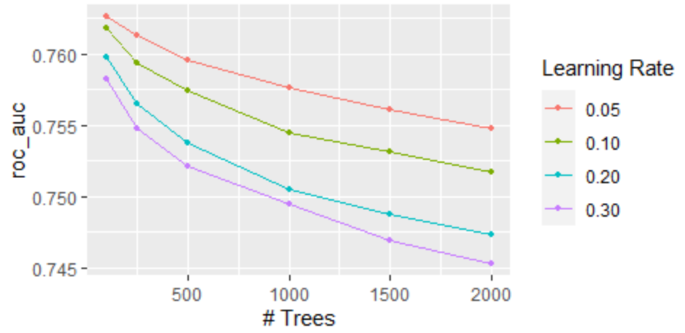
Step 2 - Tunning tree Deph and Minimal node size
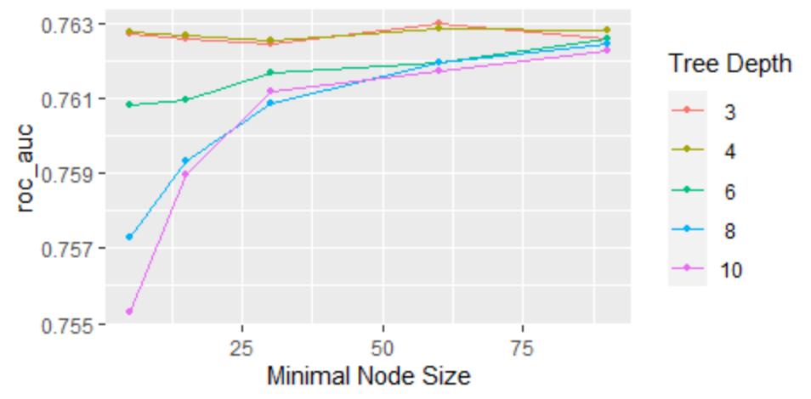
Step 3- Tunning minimal loss reduction
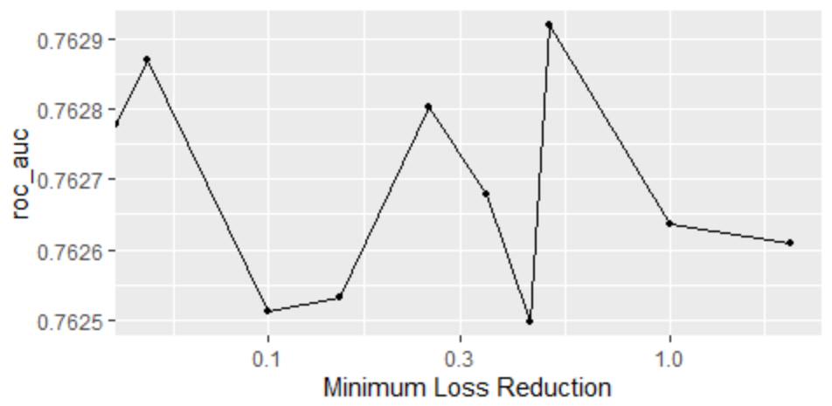

Step 4 – Tunning mtry and Sample Size
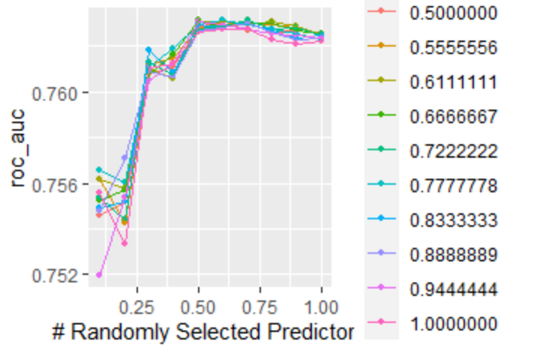
Step 5 – Learning rate and trees final again
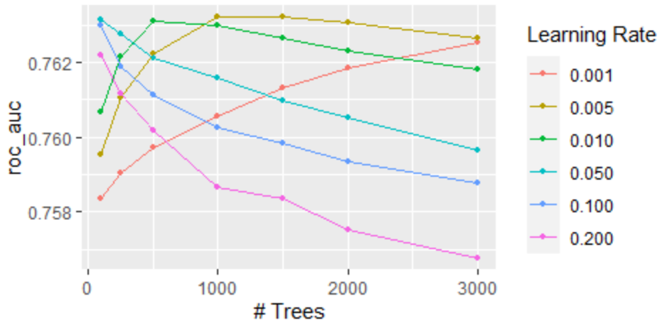

Step 6 - Collect_metrics in the test set.
.metric .estimator .estimate .config
<chr> <chr> <dbl> <fct>
1 accuracy binary 0.698 Preprocessor1_Model1
2 f_meas binary 0.686 Preprocessor1_Model1
3 ppv binary 0.712 Preprocessor1_Model1
4 npv binary 0.686 Preprocessor1_Model1
5 sens binary 0.661 Preprocessor1_Model1
6 spec binary 0.735 Preprocessor1_Model1
7 roc_auc binary 0.771 Preprocessor1_Model1

Step 7 - Importance of predictors
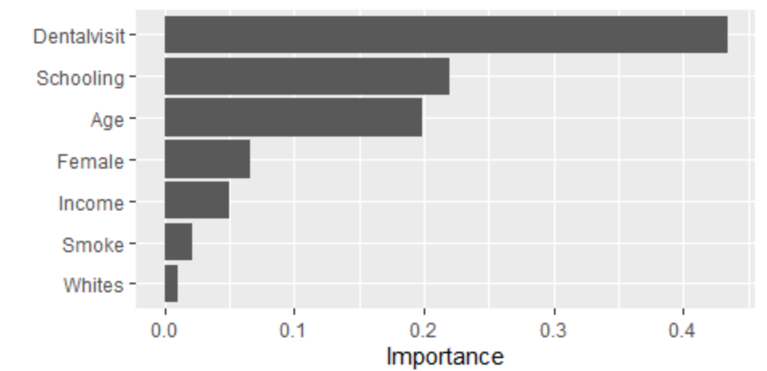

Step 8 – Roc –Curve
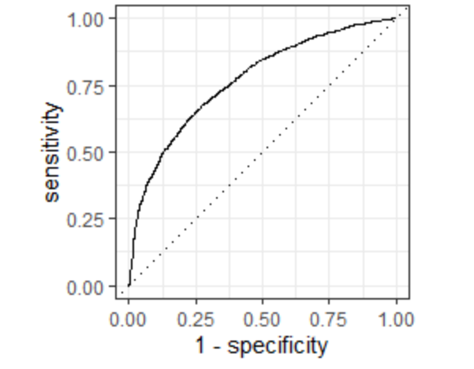

Adults

Step 1 - Tunning trees and learning rate
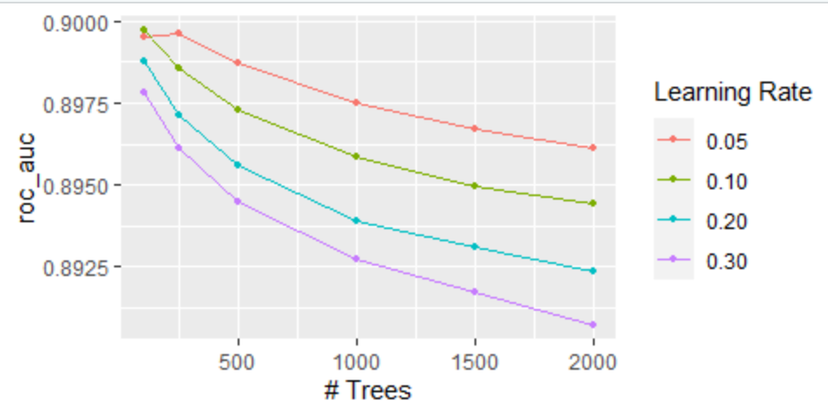
Step 2 - Tunning tree Deph and Minimal node size
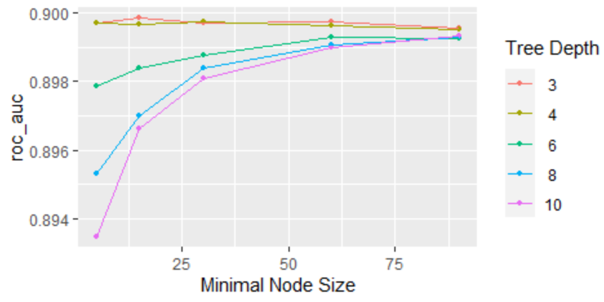
Step 3 – tunning minimal loss reduction
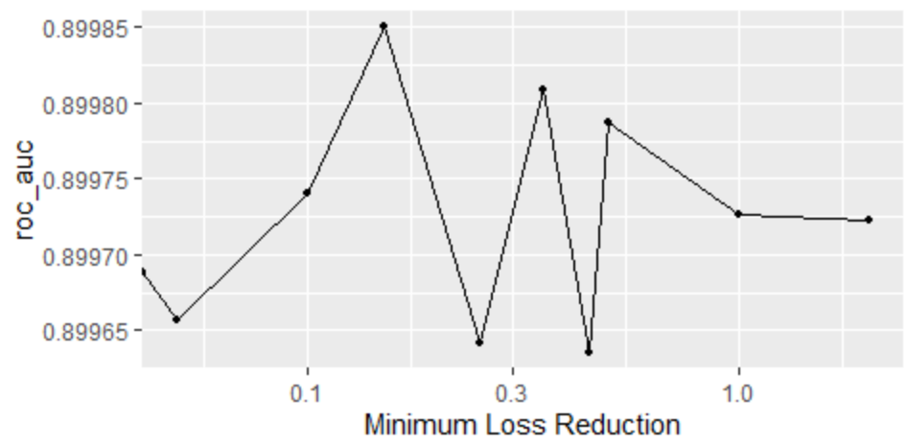

Step4 – tunning Mtry and sample size
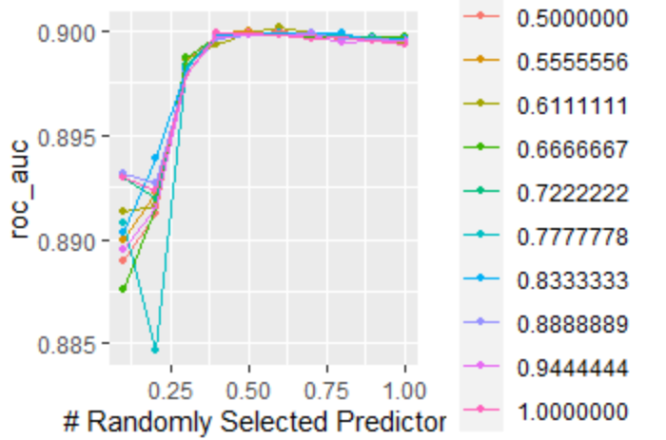

Step 5 – Learning rate and trees final again

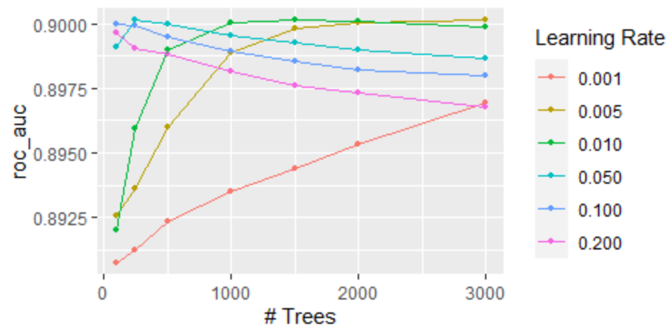

Step 6 - Collect_metrics in the test set. ( to detect lack of FD)
.metric .estimator .estimate .config
<chr> <chr> <dbl> <fct>
1 sens binary 0.379 Preprocessor1_Model1
2 spec binary 0.971 Preprocessor1_Model1
3 accuracy binary 0.898 Preprocessor1_Model1
4 ppv binary 0.632 Preprocessor1_Model1
5 f_meas binary 0.463 Preprocessor1_Model1
6 npv binary 0.918 Preprocessor1_Model1
7 roc_auc binary 0.897 Preprocessor1_Model1

Step 7 - Importance of predictors
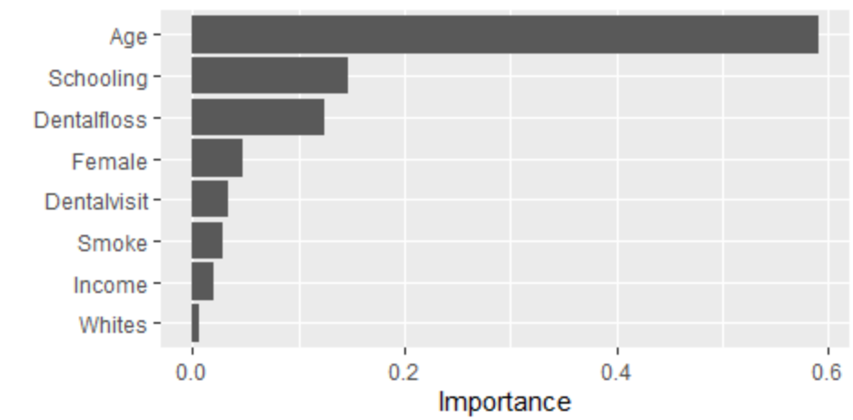

Step 8 - Roc Curve

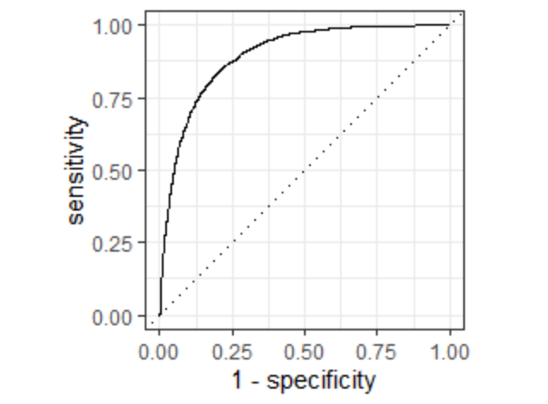

Sensitivity Analysis 1

Adults

North Region.
Step 1 - Tunning trees and learning rate
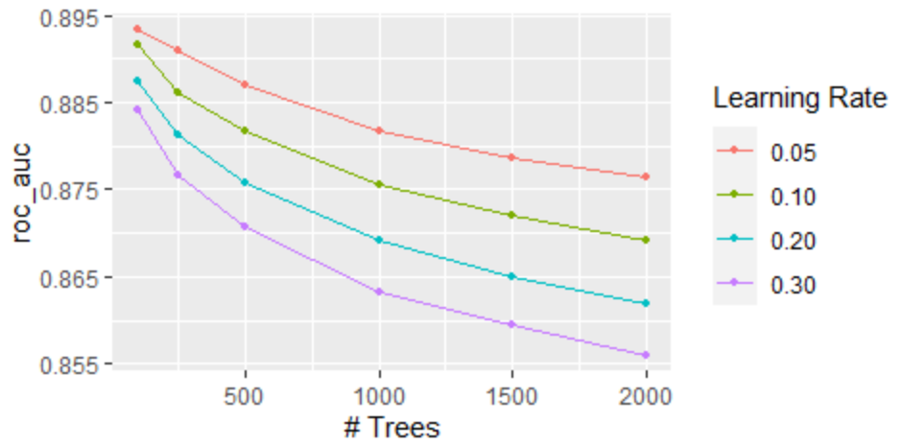

Step 2 Tunning tree Deph and Minimal node size
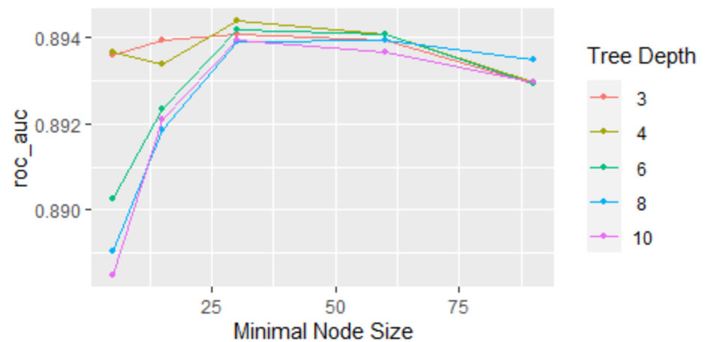

Step 3 tunning minimal loss reduction
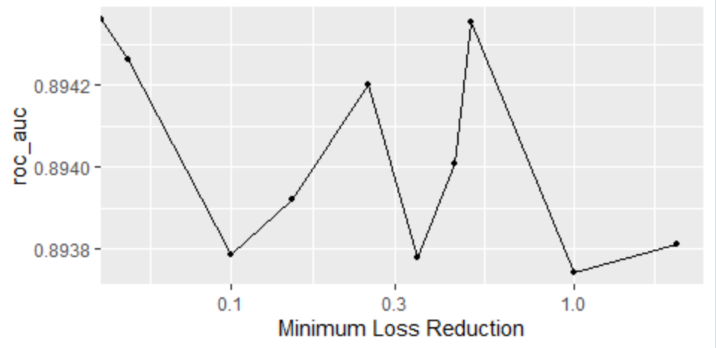

Step 4 Tunning mtry and Sample Size
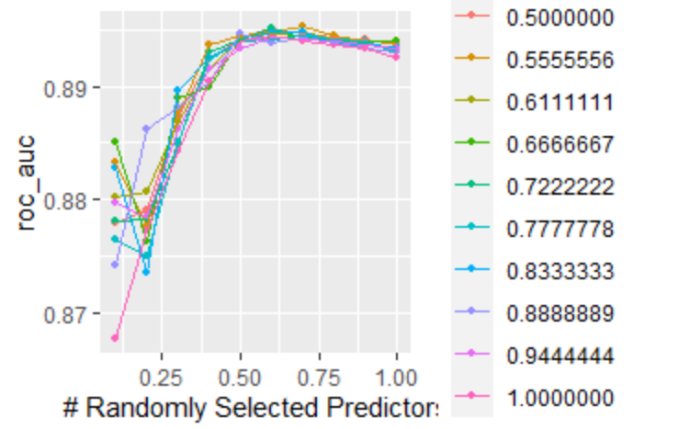

Step 5- Learning rate and trees final again
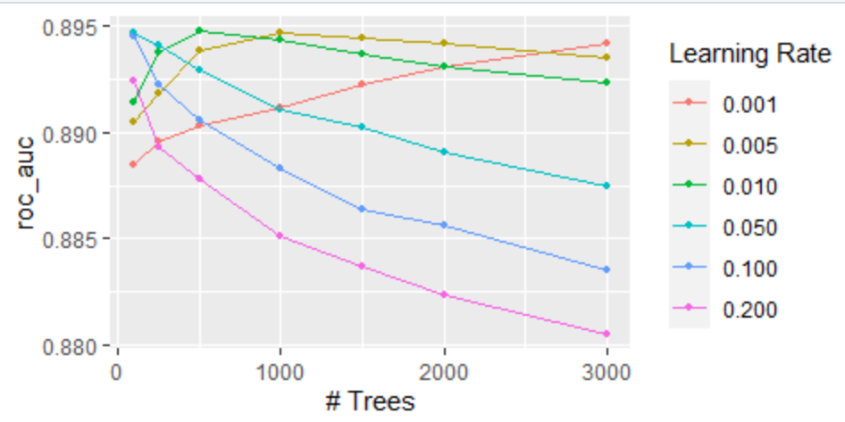

Step 6 - Collect_metrics in the test set.
1 sens binary 0.286 Preprocessor1_Model1
2 spec binary 0.968 Preprocessor1_Model1
3 accuracy binary 0.888 Preprocessor1_Model1
4 ppv binary 0.548 Preprocessor1_Model1
5 f_meas binary 0.376 Preprocessor1_Model1
6 npv binary 0.910 Preprocessor1_Model1
7 roc_auc binary 0.887 Preprocessor1_Model1
>

Step 7 - Importance of predictors
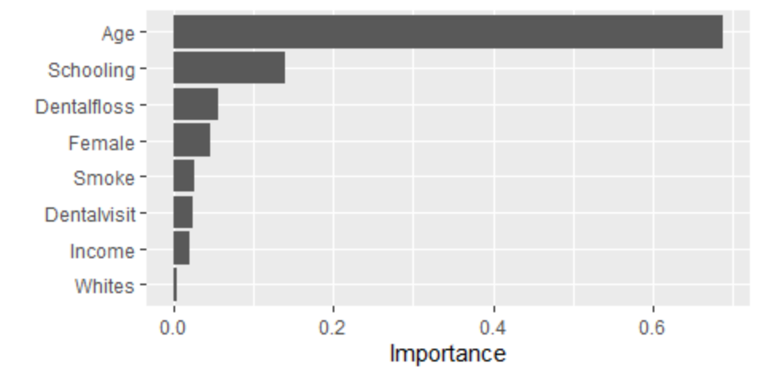
Step 8 – Roc –Curve
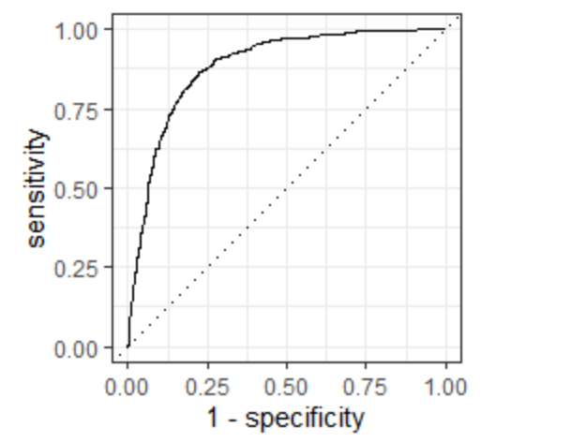

Southeast Region
Step 1 - Tunning trees and learning rate

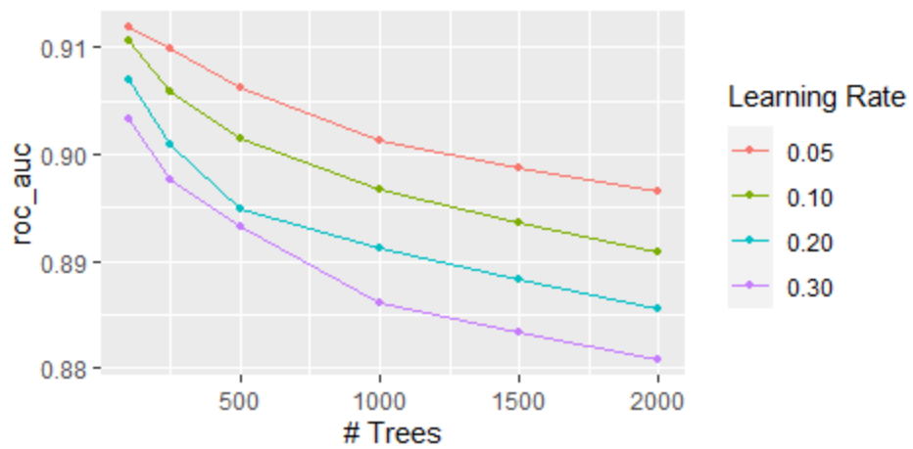

Step 2- Tunning tree Deph and Minimal node size
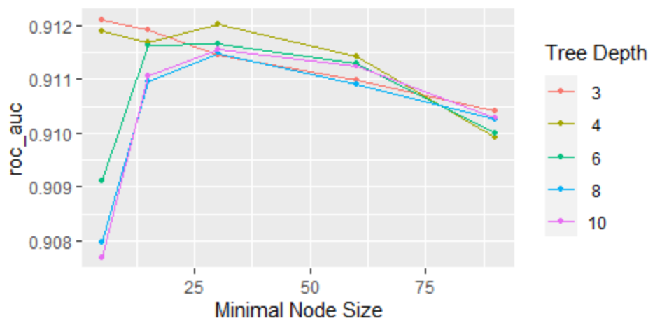
Step 3 Tunning minimal loss reduction
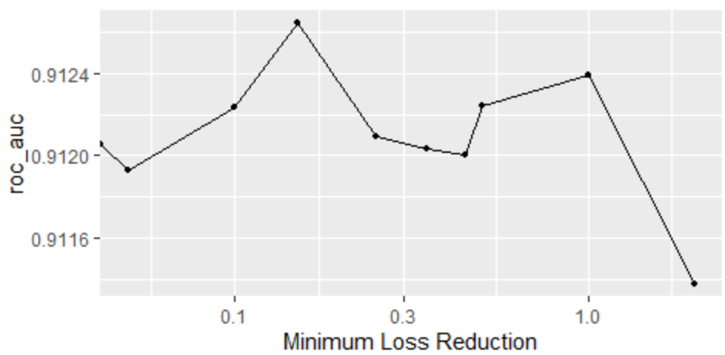
Step 4 Tunning mtry and Sample Size
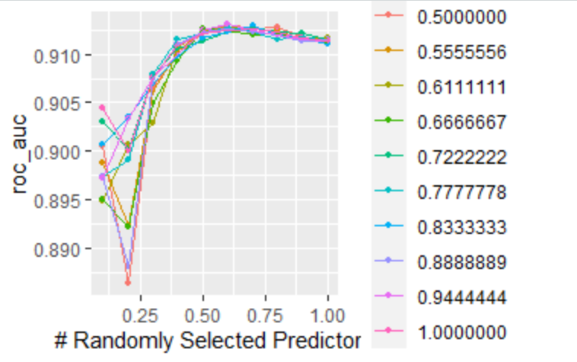
Step 5- Learning rate and trees final again
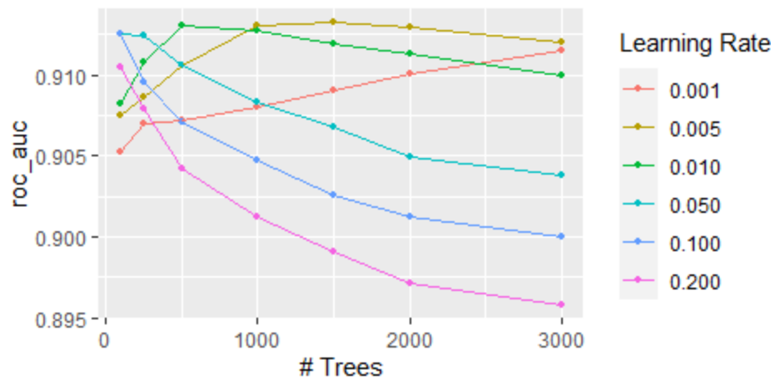

Step 6 - Collect_metrics in the test set.
1 sens binary 0.389 Preprocessor1_Model1
2 spec binary 0.979 Preprocessor1_Model1
3 accuracy binary 0.928 Preprocessor1_Model1
4 ppv binary 0.633 Preprocessor1_Model1
5 f_meas binary 0.482 Preprocessor1_Model1
6 npv binary 0.944 Preprocessor1_Model1
7 roc_auc binary 0.910 Preprocessor1_Model1

Step 7 - Importance of predictors
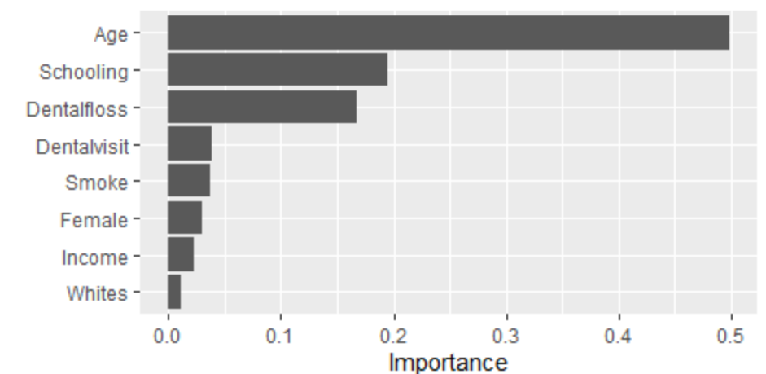
Step 8 – Roc –Curve
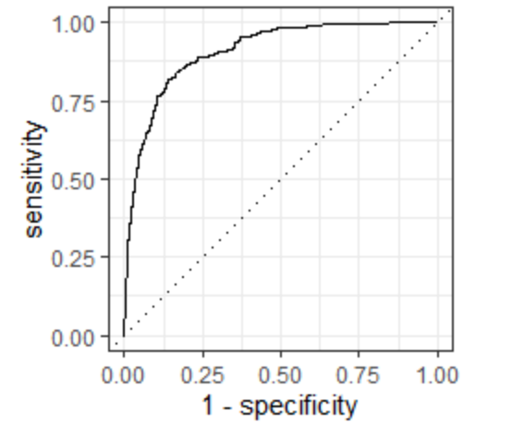
South Region
Step 1 - Tunning trees and learning rate
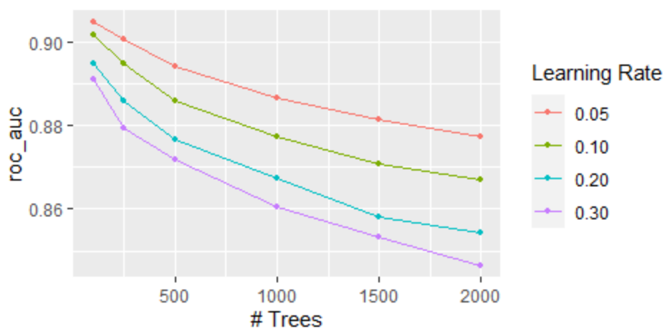
Step 2- Tunning tree Deph and Minimal node size
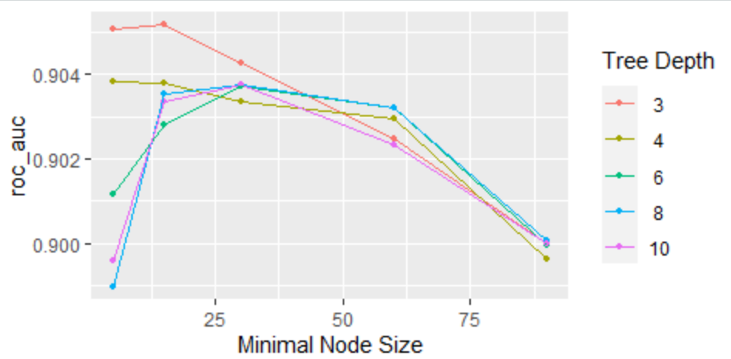
Step 3 Tunning minimal loss reduction
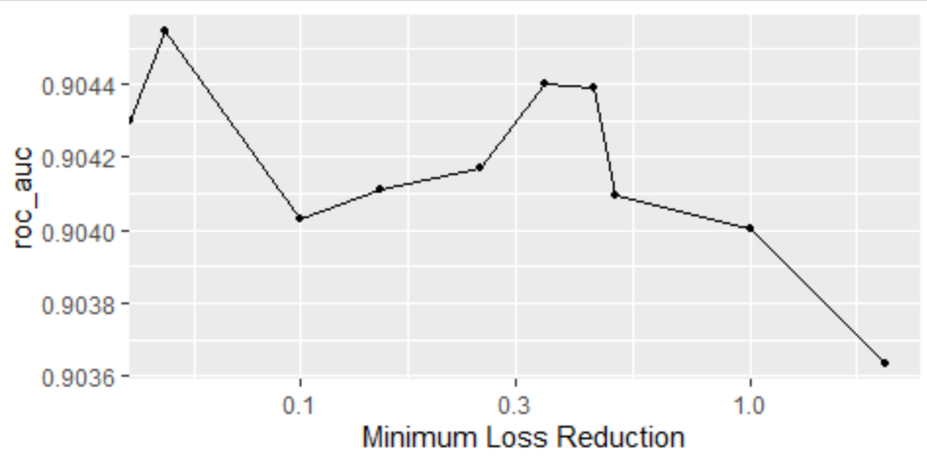
Step 4 Tunning mtry and Sample Size
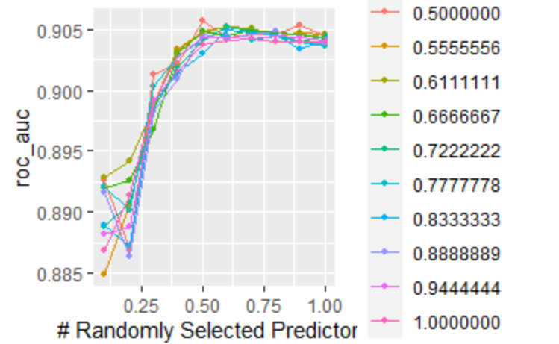
Step 5- Learning rate and trees final again
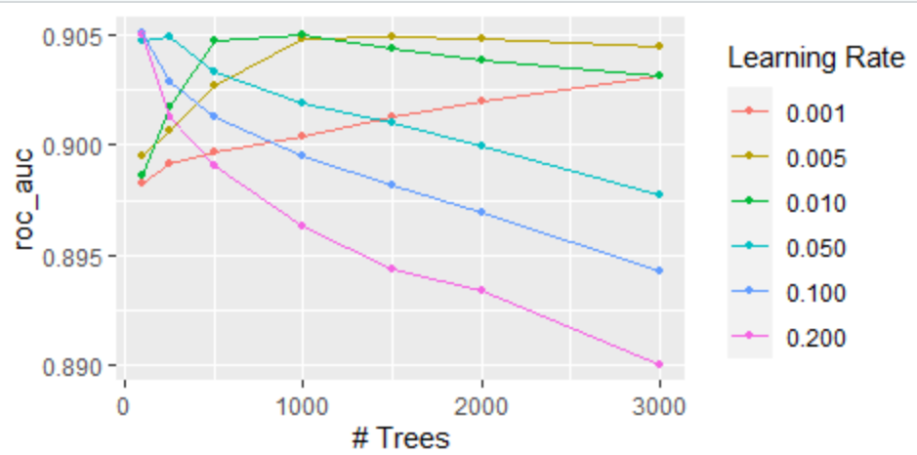
Step 6 - Collect_metrics in the test set.
1 sens binary 0.388 Preprocessor1_Model1
2 spec binary 0.973 Preprocessor1_Model1
3 accuracy binary 0.908 Preprocessor1_Model1
4 ppv binary 0.649 Preprocessor1_Model1
5 f_meas binary 0.486 Preprocessor1_Model1
6 npv binary 0.926 Preprocessor1_Model1
7 roc_auc binary 0.905 Preprocessor1_Model1

Step 7 - Importance of predictors

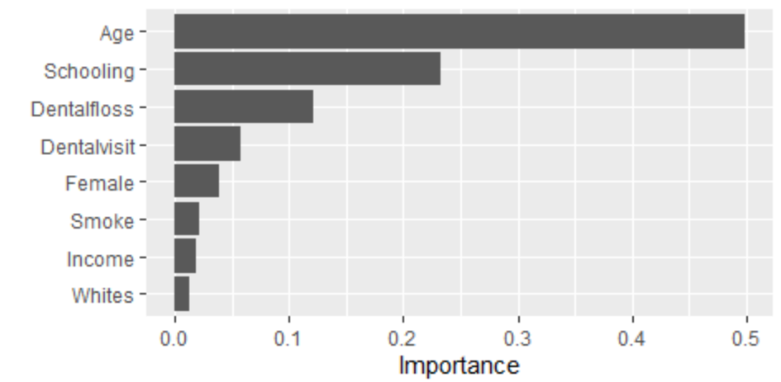

Step 8 – Roc –Curve
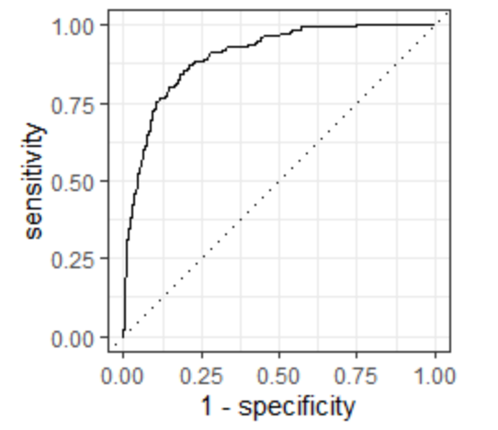

Midwest Region
Step 1 - Tunning trees and learning rate
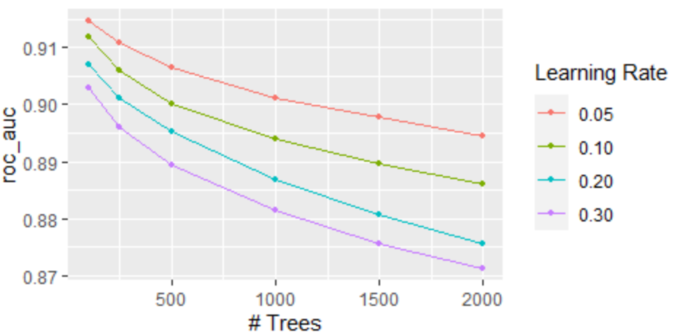

Step 2- Tunning tree Deph and Minimal node size
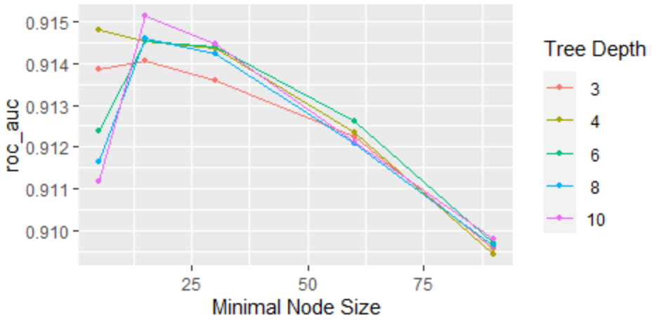

Step 3 Tunning minimal loss reduction
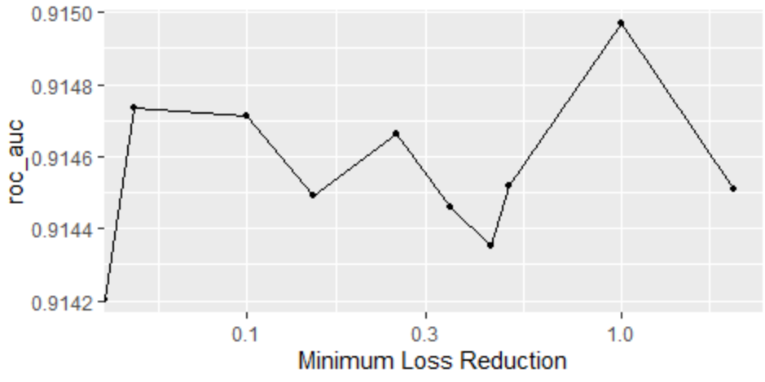

Step 4 Tunning mtry and Sample Size
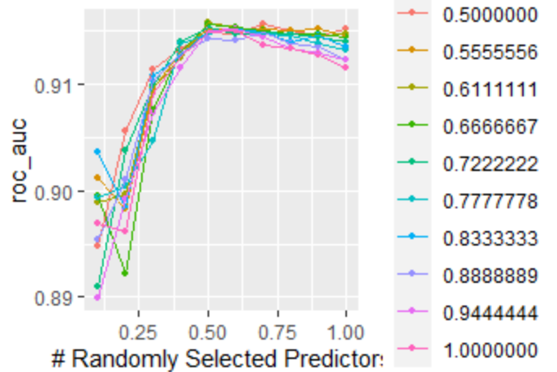

Step 5- Learning rate and trees final again
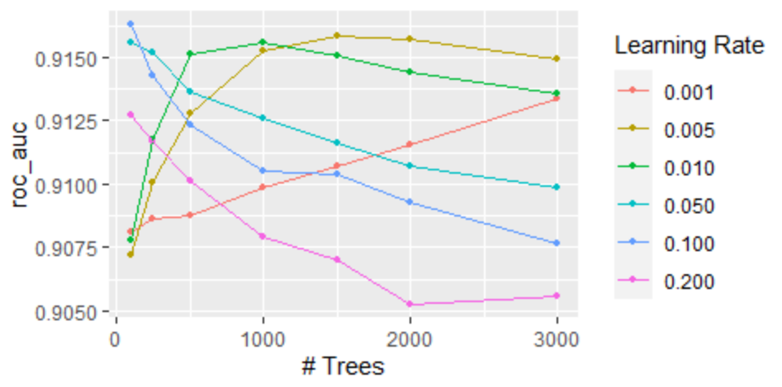
Step 6 - Collect_metrics in the test set.
1 sens binary 0.297 Preprocessor1_Model1
2 spec binary 0.970 Preprocessor1_Model1
3 accuracy binary 0.9 Preprocessor1_Model1
4 ppv binary 0.531 Preprocessor1_Model1
5 f_meas binary 0.381 Preprocessor1_Model1
6 npv binary 0.923 Preprocessor1_Model1
7 roc_auc binary 0.901 Preprocessor1_Model1

Step 7 - Importance of predictors
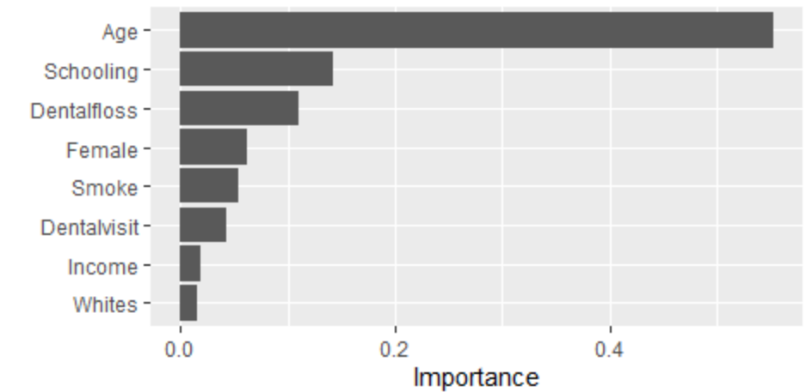
Step 8 – Roc –Curve
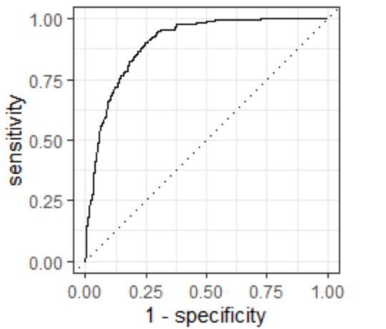

Northeast region
Step 1 - Tunning trees and learning rate
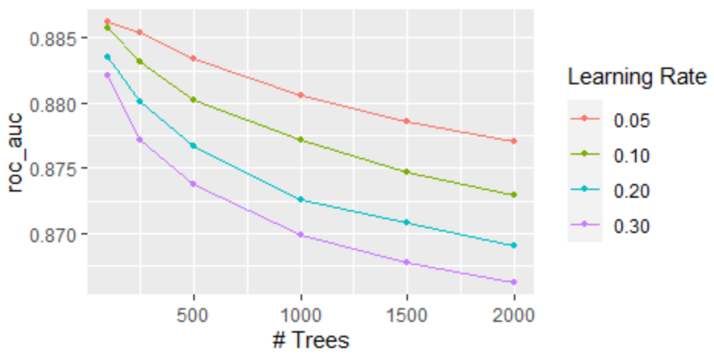
Step 2- Tunning tree Deph and Minimal node size
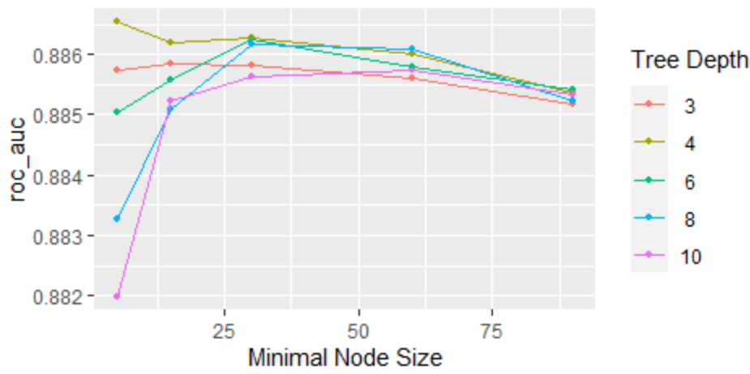
Step 3 Tunning minimal loss reduction
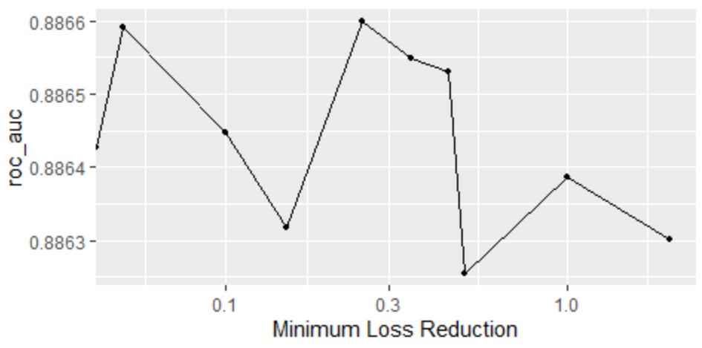
Step 4 Tunning mtry and Sample Size
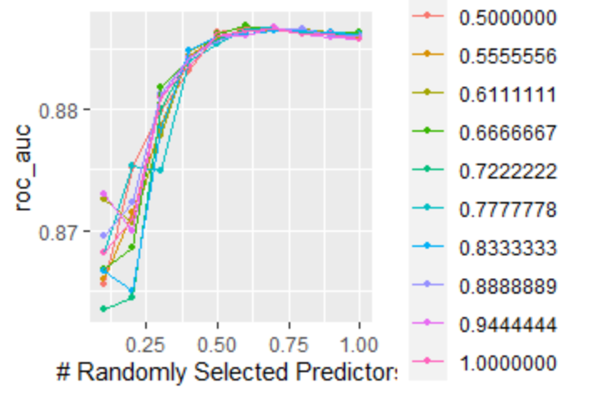
Step 5- Learning rate and trees final again
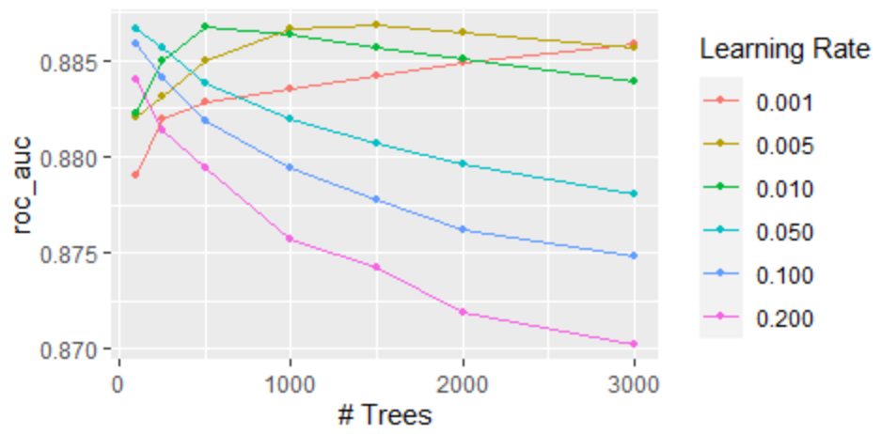

Step 6 – Collect metrics in the test set.
1 sens binary 0.412 Preprocessor1_Model1
2 spec binary 0.956 Preprocessor1_Model1
3 accuracy binary 0.875 Preprocessor1_Model1
4 ppv binary 0.620 Preprocessor1_Model1
5 f_meas binary 0.495 Preprocessor1_Model1
6 npv binary 0.903 Preprocessor1_Model1
7 roc_auc binary 0.884 Preprocessor1_Model1

Step 7 - Importance of predictors
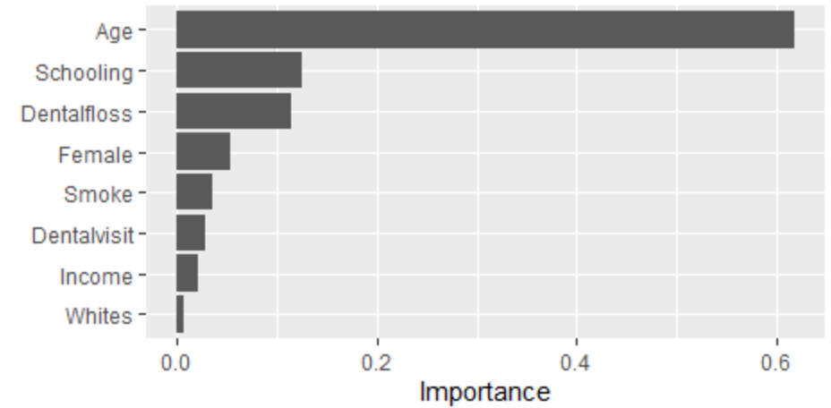
Step 8 – Roc –Curve
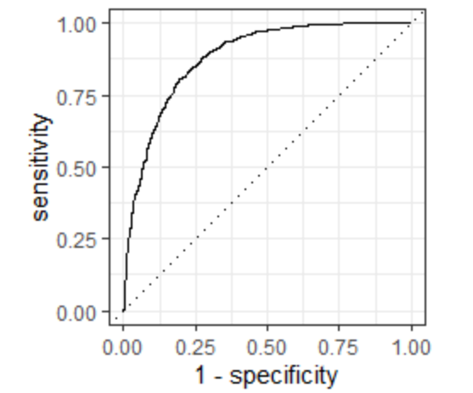

Older Adults
Southeast region
Step 1 - Tunning trees and learning rate

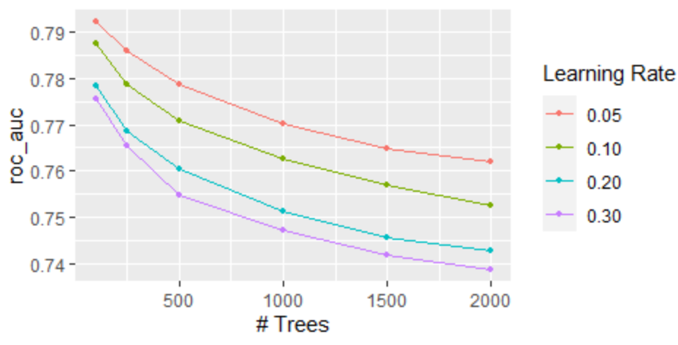
Step 2 Tunning tree Deph and Minimal node size
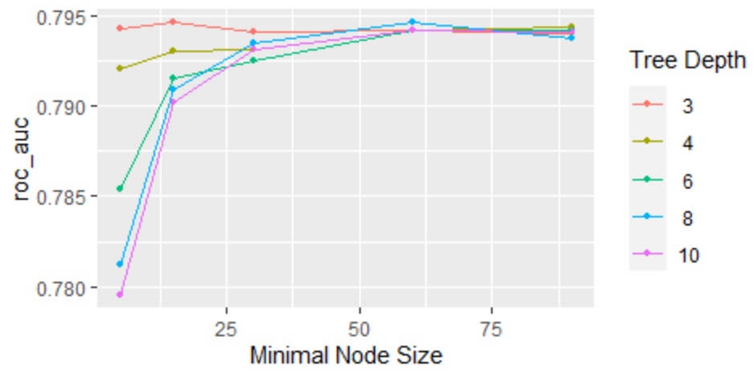
Step 3 tunning minimal loss reduction
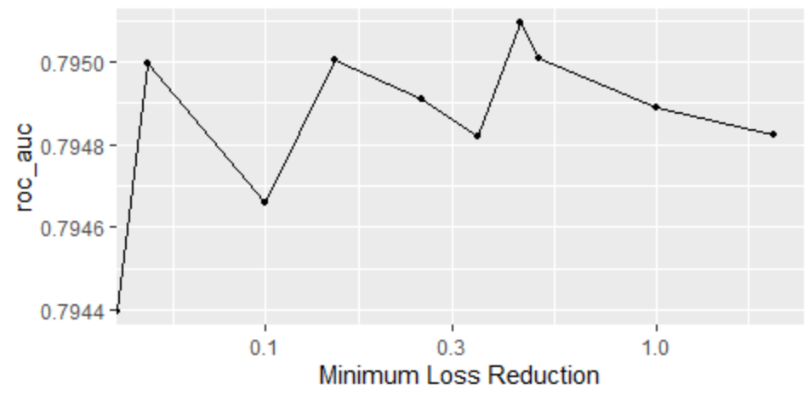

Step 4 Tunning mtry and Sample Size
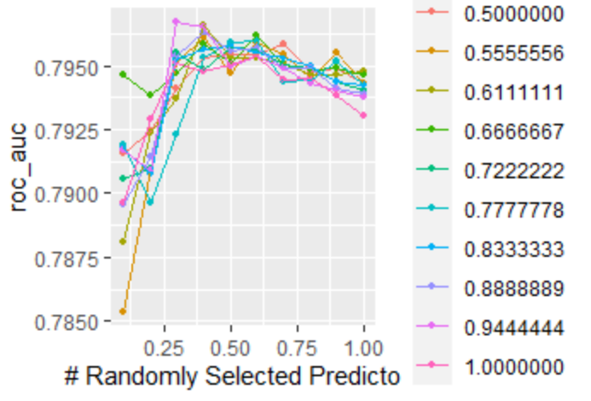
Step 5- Learning rate and trees final again
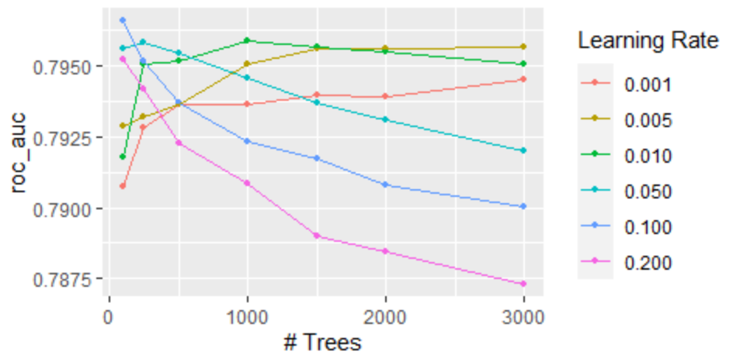

Step 6 - Collect_metrics in the test set.
1 accuracy binary 0.727 Preprocessor1_Model1
2 f_meas binary 0.760 Preprocessor1_Model1
3 ppv binary 0.740 Preprocessor1_Model1
4 npv binary 0.709 Preprocessor1_Model1
5 sens binary 0.782 Preprocessor1_Model1
6 spec binary 0.659 Preprocessor1_Model1
7 roc_auc binary 0.799 Preprocessor1_Model1

Step 7 - Importance of predictors
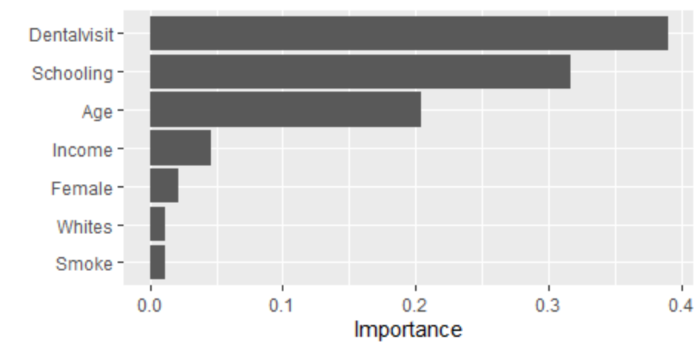
Step 8 – Roc –Curve
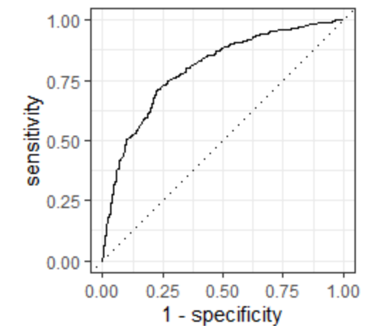

South Region
Step 1 - Tunning trees and learning rate
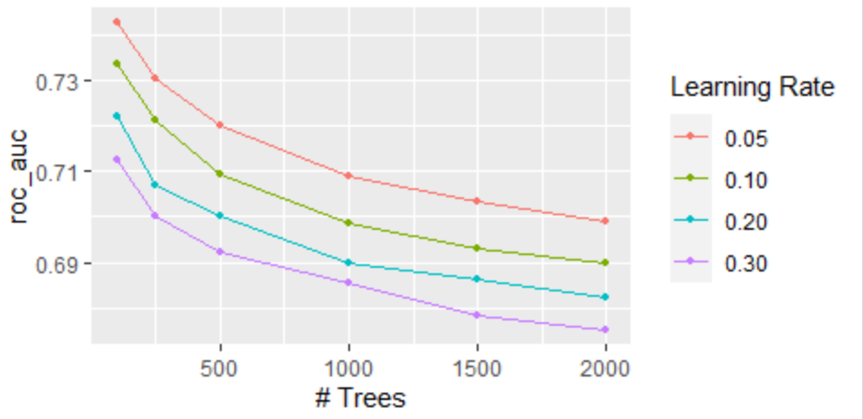
Step 2 Tunning tree Deph and Minimal node size
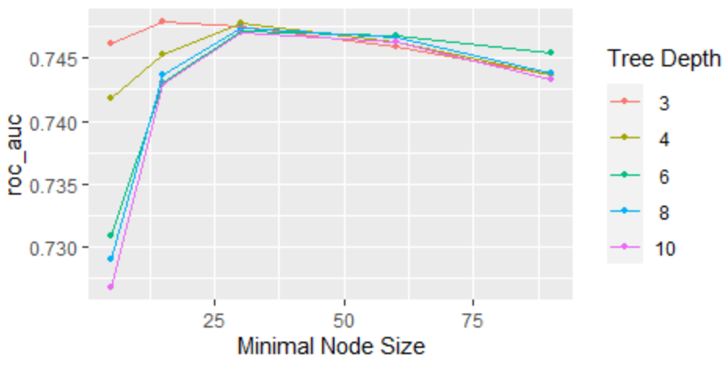
Step 3 tunning minimal loss reduction
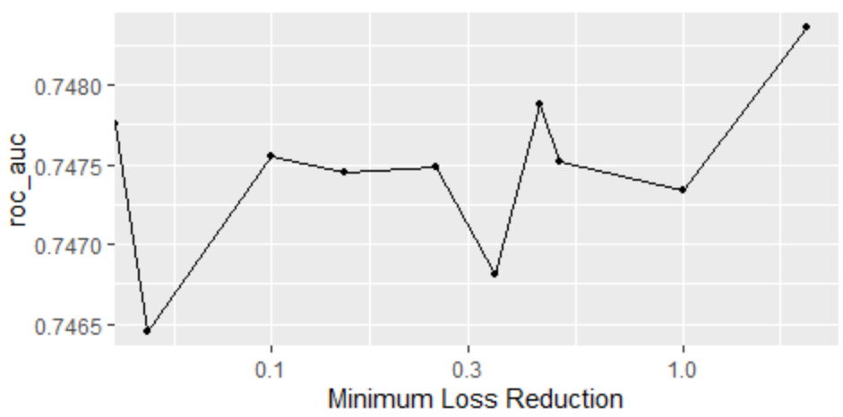

Step 4 Tunning mtry and Sample Size
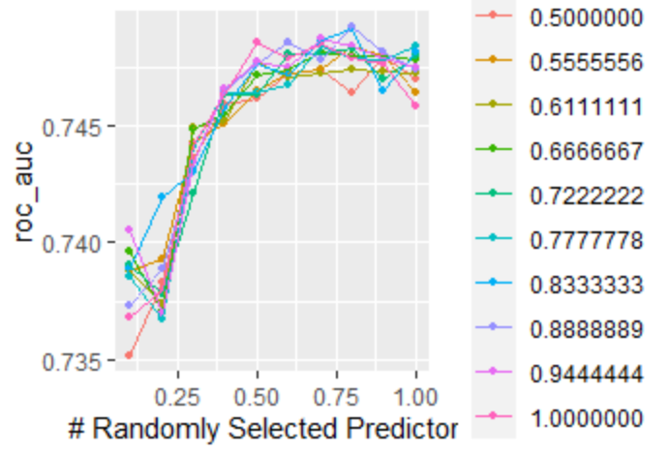

Step 5- Learning rate and trees final again
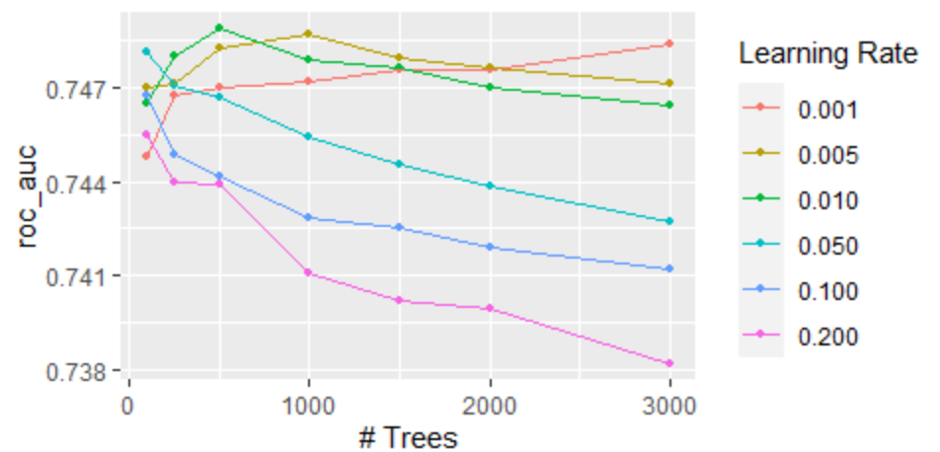

Step 6 - Collect_metrics in the test set.
1 accuracy binary 0.711 Preprocessor1_Model1
2 f_meas binary 0.755 Preprocessor1_Model1
3 ppv binary 0.717 Preprocessor1_Model1
4 npv binary 0.701 Preprocessor1_Model1
5 sens binary 0.799 Preprocessor1_Model1
6 spec binary 0.599 Preprocessor1_Model1
7 roc_auc binary 0.770 Preprocessor1_Model1

Step 7 - Importance of predictors
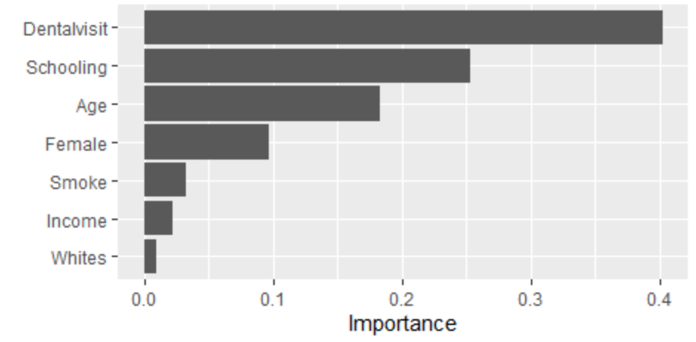
Step 8 – Roc –Curve
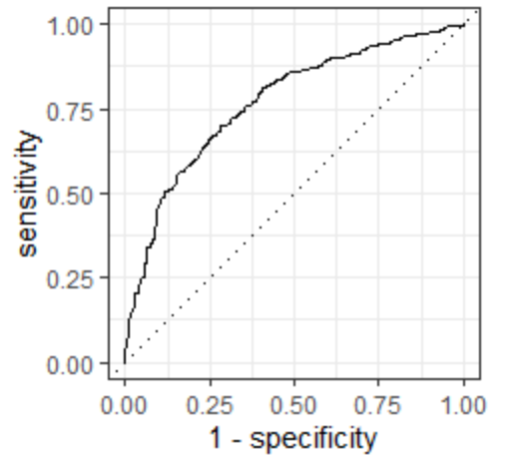

Midwest Region
Step 1 - Tunning trees and learning rate
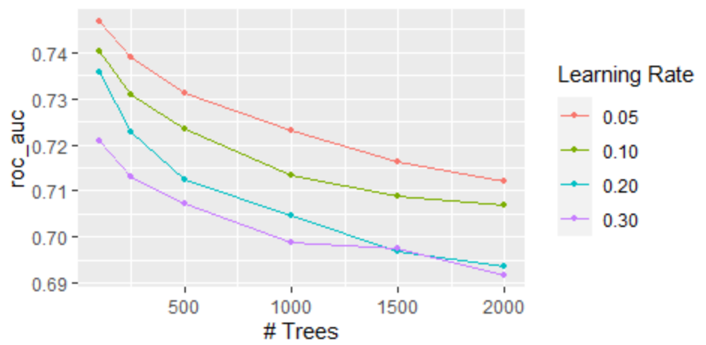
Step 2 Tunning tree Deph and Minimal node size
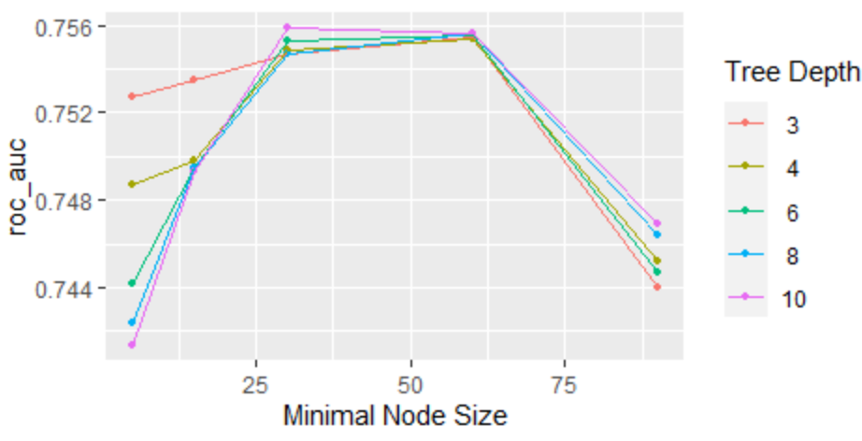
Step 3 tunning minimal loss reduction
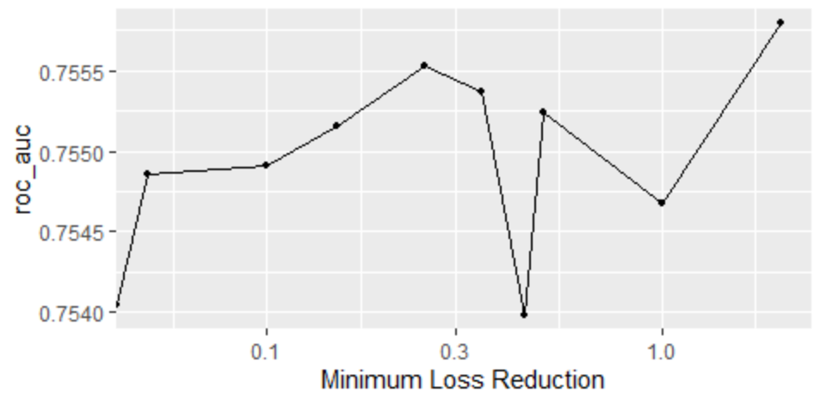
Step 4 Tunning mtry and Sample Size
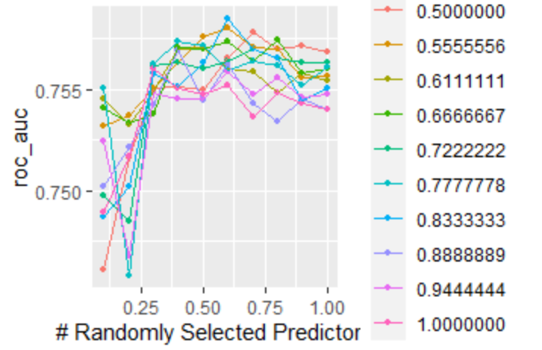
Step 5- Learning rate and trees final again
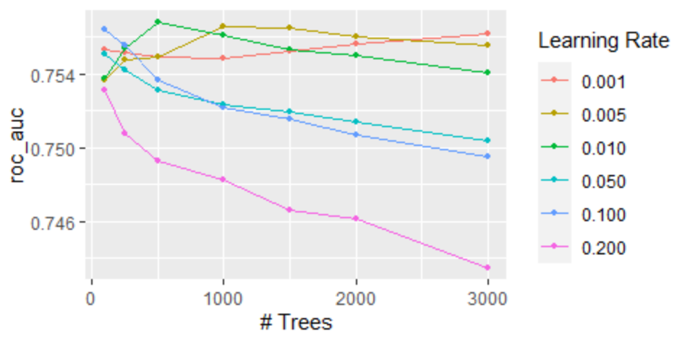
Step 6 - Collect_metrics in the test set.
1 accuracy binary 0.693 Preprocessor1_Model1
2 f_meas binary 0.712 Preprocessor1_Model1
3 ppv binary 0.705 Preprocessor1_Model1
4 npv binary 0.678 Preprocessor1_Model1
5 sens binary 0.719 Preprocessor1_Model1
6 spec binary 0.663 Preprocessor1_Model1
7 roc_auc binary 0.761 Preprocessor1_Model1

Step 7 - Importance of predictors
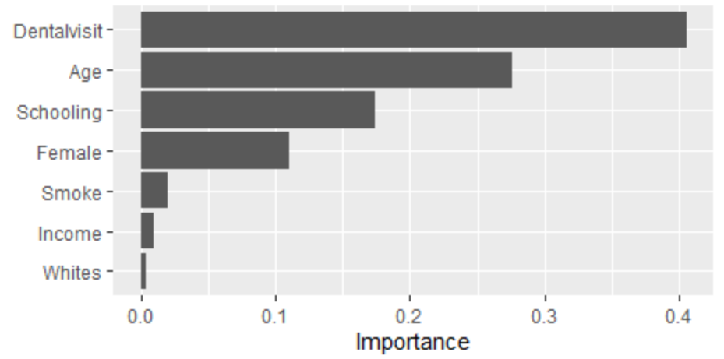
Step 8 – Roc –Curve
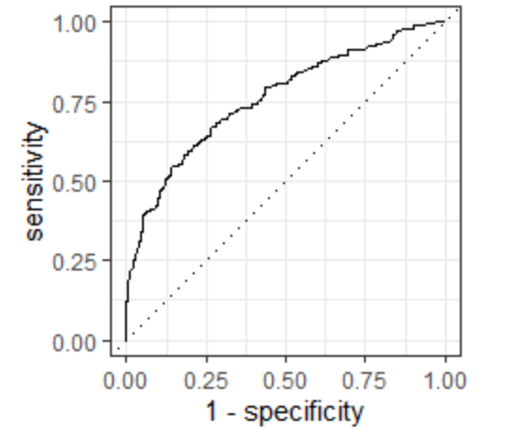

Northeast Region
Step 1 - Tunning trees and learning rate
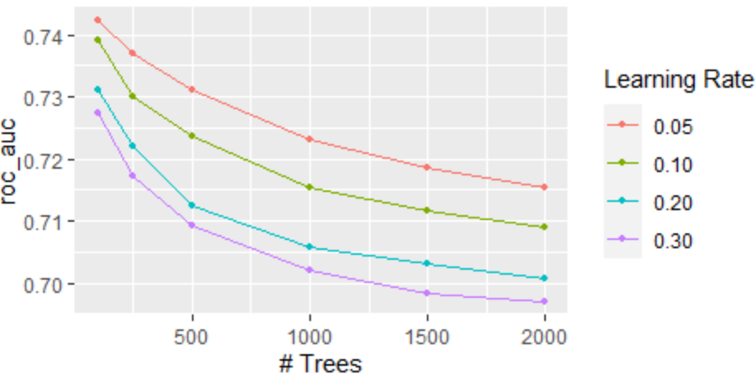
Step 2 Tunning tree Deph and Minimal node size
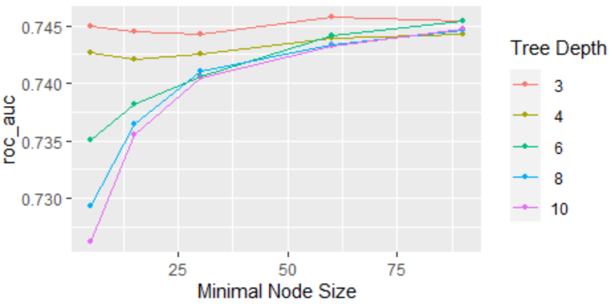
Step 3 tunning minimal loss reduction
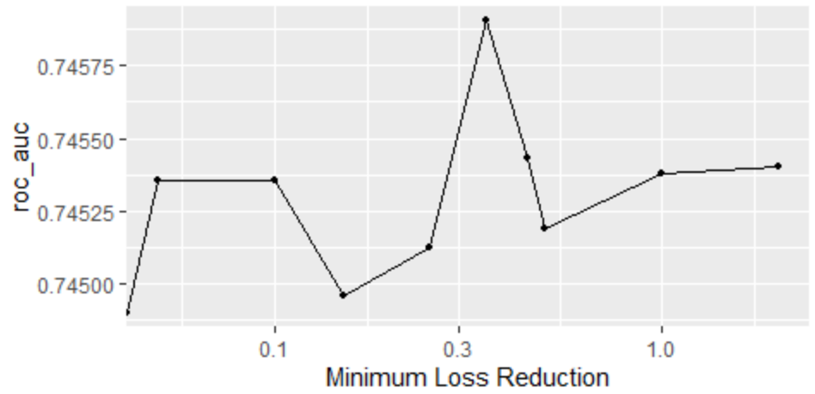
Step 4 Tunning mtry and Sample Size
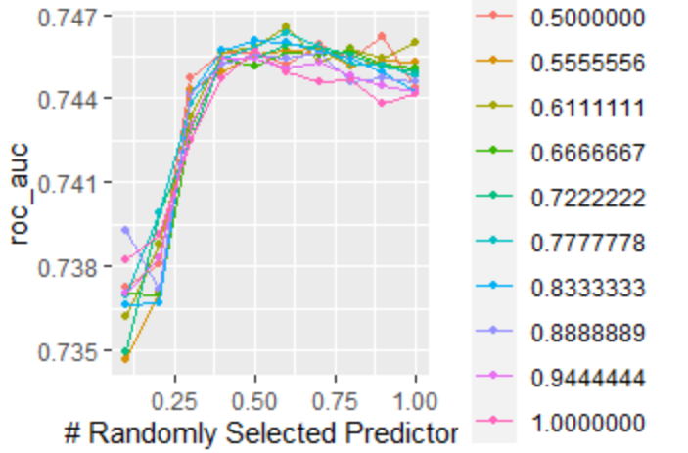
Step 5- Learning rate and trees final again

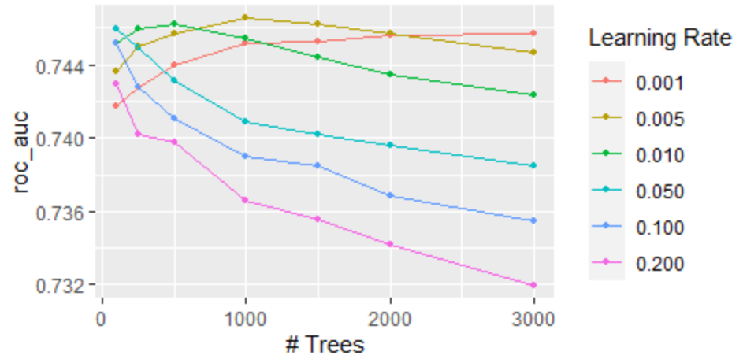

Step 6 - Collect_metrics in the test set.
1 accuracy binary 0.709 Preprocessor1_Model1
2 f_meas binary 0.637 Preprocessor1_Model1
3 ppv binary 0.690 Preprocessor1_Model1
4 npv binary 0.721 Preprocessor1_Model1
5 sens binary 0.592 Preprocessor1_Model1
6 spec binary 0.798 Preprocessor1_Model1
7 roc_auc binary 0.752 Preprocessor1_Model1

Step 7 - Importance of predictors
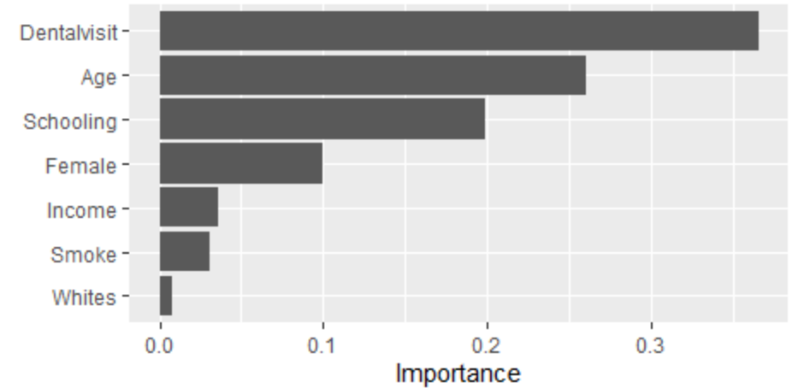
Step 8 – Roc –Curve
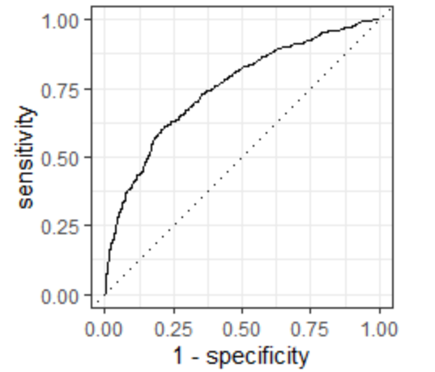

North Region
Step 1 - Tunning trees and learning rate
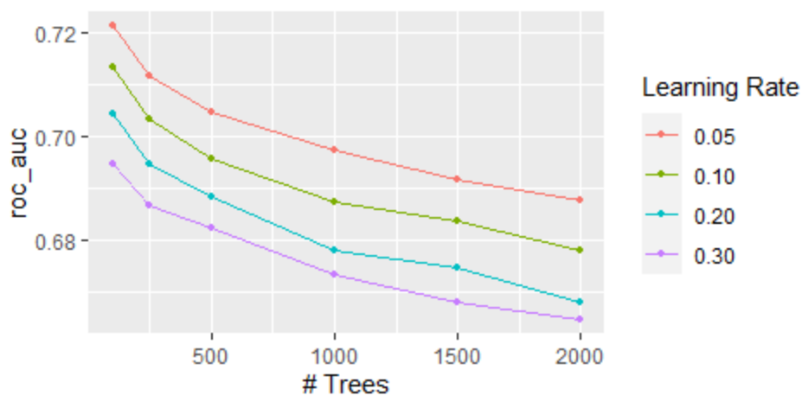
Step 2 Tunning tree Deph and Minimal node size
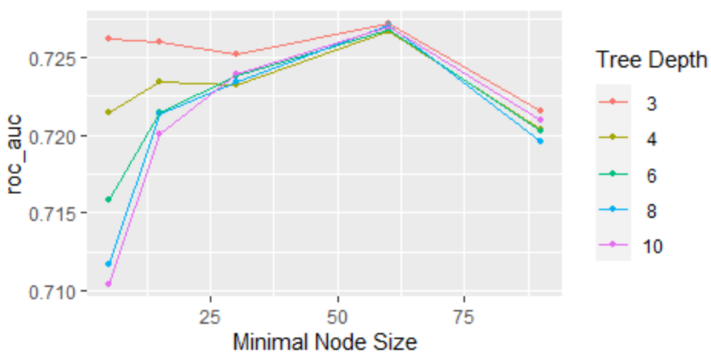

Step 3 tunning minimal loss reduction
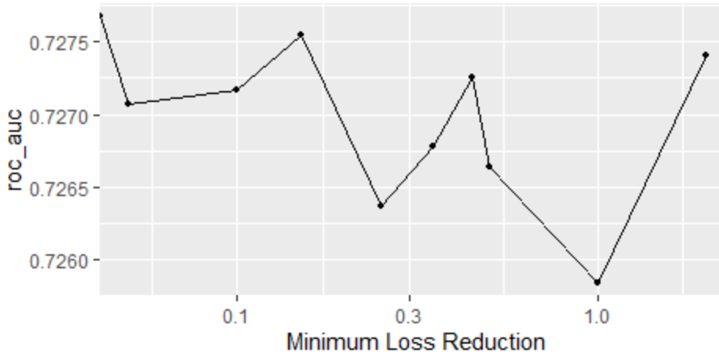

Step 4 Tunning mtry and Sample Size
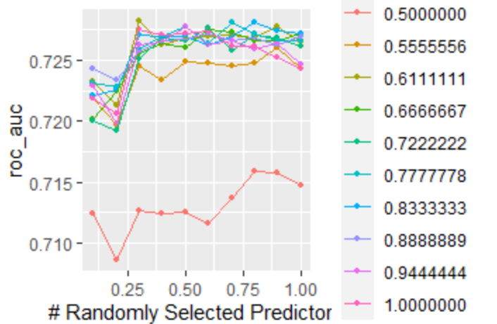
Step 5- Learning rate and trees final again
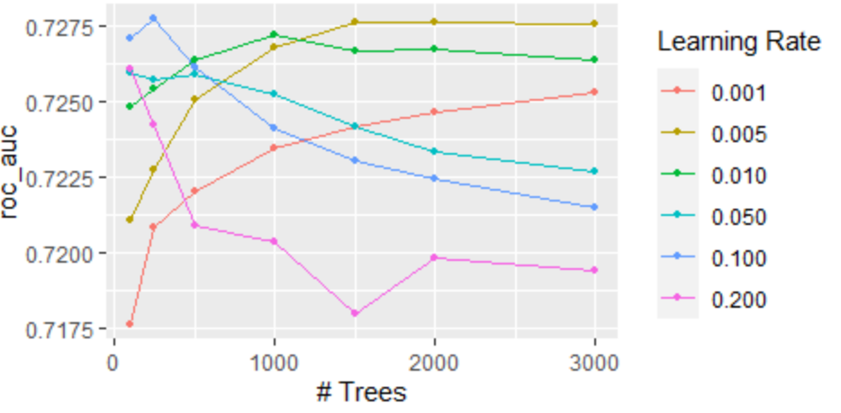
Step 6 - Collect_metrics in the test set.
1 accuracy binary 0.668 Preprocessor1_Model1
2 f_meas binary 0.621 Preprocessor1_Model1
3 ppv binary 0.673 Preprocessor1_Model1
4 npv binary 0.665 Preprocessor1_Model1
5 sens binary 0.577 Preprocessor1_Model1
6 spec binary 0.75 Preprocessor1_Model1
7 roc_auc binary 0.711 Preprocessor1_Model1

Step 7 - Importance of predictors
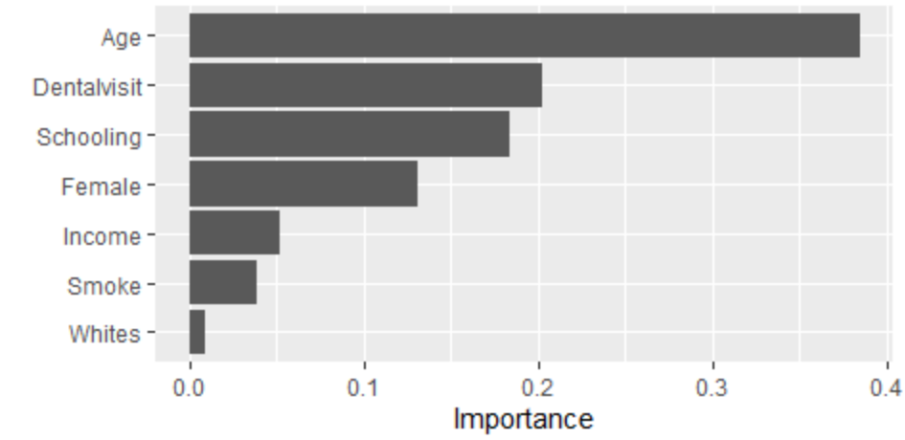
Step 8 – Roc –Curve
