Supplementary Information belonging to:

Effects of lifestyle risk behaviour clustering on cardiovascular disease among UK adults: latent class analysis with distal outcomes

Teketo Kassaw Tegegne, Shariful Islam, Ralph Maddison

The selected latent classes are highlighted in pink rectangle based on model fit statistics and interpretability of each latent class. A 50% or higher classification probabilities cut-off was considered for the most likely latent class membership in which each latent class describes a distinct and meaningful pattern.

Supplementary Information for CVD at risk data
Supplementary Table S1: Model fit summary statistics: CVD risk data
Latent class (LC) | AIC | BIC
LC 1 | 999473.260 | 999523.595
LC 2 | 995927.440 | 996038.176
LC 3 | 994994.211 | 995165.350
LC 4 | 994726.650 | 994958.190
LC 5 | 994710.971 | 995002.914

Supplementary Table S2: Latent class 1: Lifestyle risk behaviour probabilities of UK adults at risk of developing CVD
Variable | LC 1
Physically inactive | 0.432
Poor fruit & vegetable consumption | 0.676
High alcohol intake | 0.635
Poor sleep | 0.280
Prolonged sitting | 0.093

Supplementary Table S3: Latent class 2: Lifestyle risk behaviour probabilities of UK adults at risk of developing CVD
Variable | LC 1 | LC 2
Physically inactive | 0.474 | 0.346
Poor fruit & vegetable consumption | 1.000 | 0.000
High alcohol intake | 0.658 | 0.589
Poor sleep | 0.279 | 0.281
Prolonged sitting | 0.100 | 0.077

Supplementary Table S4: Latent class 3: Lifestyle risk behaviour probabilities of UK adults at risk of developing CVD
Variable | LC 1 | LC 2 | LC 3
Physically inactive | 0.537 | 0.341 | 0.468
Poor fruit & vegetable consumption | 0.830 | 0.000 | 1.000
High alcohol intake | 0.746 | 0.584 | 0.650
Poor sleep | 0.378 | 0.277 | 0.271
Prolonged sitting | 1.000 | 0.046 | 0.025

Supplementary Table S5: Latent class 4: Lifestyle risk behaviour probabilities of UK adults at risk of developing CVD
Variable | LC 1 | LC 2 | LC 3 | LC 4
Physically inactive | 0.322 | 0.000 | 0.486 | 0.578
Poor fruit & vegetable consumption | 0.000 | 0.546 | 0.868 | 0.815
High alcohol intake | 0.478 | 0.910 | 0.604 | 0.723
Poor sleep | 0.275 | 0.273 | 0.243 | 0.376
Prolonged sitting | 0.043 | 0.093 | 0.018 | 0.315

Supplementary Table S6: Latent class 5: Lifestyle risk behaviour probabilities of UK adults at risk of developing CVD
Variable | LC 1 | LC 2 | LC 3 | LC 4 | LC 5
Physically inactive | 0.365 | 0.585 | 0.197 | 0.000 | 0.490
Poor fruit & vegetable consumption | 0.117 | 0.835 | 0.000 | 0.509 | 0.805
High alcohol intake | 0.447 | 0.735 | 0.375 | 0.917 | 0.604
Poor sleep | 0.374 | 0.374 | 0.165 | 0.275 | 0.242
Prolonged sitting | 0.097 | 0.317 | 0.000 | 0.089 | 0.021

Supplementary Information for CVD outcome data
Supplementary Table S7: Model fit summary statistics: CVD outcome data
Latent class (LC) | AIC | BIC
LC 1 | 1831277.803 | 1831341.126
LC 2 | 1821668.248 | 1821805.448
LC 3 | 1818658.041 | 1818869.118
LC 4 | 1818009.643 | 1818294.596
LC 5 | 1817716.960 | 1818149.666
LC 6 | 1817803.478 | 1818162.307

Supplementary Table S8: Latent class 1: Lifestyle risk behaviour probabilities of UK adults with CVD outcome data
Variable | LC 1
Physically inactive | 0.446
Poor fruit & vegetable consumption | 0.673
High alcohol intake | 0.648
Poor sleep | 0.296
Smoking | 0.100
Prolonged sitting | 0.104

Supplementary Table S9: Latent class 2: Lifestyle risk behaviour probabilities of UK adults with CVD outcome data
Variable | LC 1 | LC 2
Physically inactive | 0.573 | 0.367
Poor fruit & vegetable consumption | 0.873 | 0.549
High alcohol intake | 0.772 | 0.571
Poor sleep | 0.342 | 0.268
Smoking | 0.205 | 0.035
Prolonged sitting | 0.169 | 0.063

Supplementary Table S10: Latent class 3: Lifestyle risk behaviour probabilities of UK adults with CVD outcome data
Variable | LC 1 | LC 2 | LC 3
Physically inactive | 1.000 | 0.543 | 0.000
Poor fruit & vegetable consumption | 0.668 | 0.851 | 0.551
High alcohol intake | 0.522 | 0.846 | 0.594
Poor sleep | 0.279 | 0.355 | 0.267
Smoking | 0.027 | 0.256 | 0.039
Prolonged sitting | 0.082 | 0.183 | 0.062

Supplementary Table S11: Latent class 4: Lifestyle risk behaviour probabilities of UK adults with CVD outcome data
Variable | LC 1 | LC 2 | LC 3 | LC 4
Physically inactive | 0.616 | 0.290 | 0.431 | 0.520
Poor fruit & vegetable consumption | 0.837 | 0.000 | 0.916 | 0.734
High alcohol intake | 0.775 | 0.648 | 0. 806 | 0.000
Poor sleep | 0.462 | 0.286 | 0.244 | 0.269
Smoking | 0.225 | 0.047 | 0.108 | 0.000
Prolonged sitting | 0.292 | 0.072 | 0.062 | 0.049

Supplementary Table S12: Latent class 5: Lifestyle risk behaviour probabilities of UK adults with CVD outcome data
Variable | LC 1 | LC 2 | LC 3 | LC 4 | LC 5
Physically inactive | 0.648 | 0.362 | 0.250 | 0.537 | 0.564
Poor fruit & vegetable consumption | 0.785 | 0.311 | 0.573 | 1.000 | 0.970
High alcohol intake | 0.730 | 0.455 | 1.000 | 0.590 | 0.888
Poor sleep | 0.464 | 0.282 | 0.270 | 0.247 | 0.379
Smoking | 0.139 | 0.035 | 0.111 | 0.052 | 0.733
Prolonged sitting | 0.367 | 0.053 | 0.091 | 0.050 | 0.161

Supplementary Table S13: Latent class 6: Lifestyle risk behaviour probabilities of UK adults with CVD outcome data
Variable | LC 1 | LC 2 | LC 3 | LC 4 | LC 5 | LC 6
Physically inactive | 0.553 | 0.095 | 0.656 | 0.461 | 0.648 | 0.224
Poor fruit & vegetable consumption | 0.878 | 0.568 | 0.769 | 0.451 | 0.889 | 0.473
High alcohol intake | 0.800 | 1.000 | 0.644 | 0.573 | 0.822 | 0.000
Poor sleep | 0.326 | 0.257 | 0.267 | 0.545 | 0.458 | 0.249
Smoking | 1.000 | 0.065 | 0.010 | 0.067 | 0.295 | 0.031
Prolonged sitting | 0.053 | 0.066 | 0.074 | 0.223 | 0.488 | 0.036

Supplementary Figure S1: Lifestyle risk behaviour among UK adults with CVD data by gender
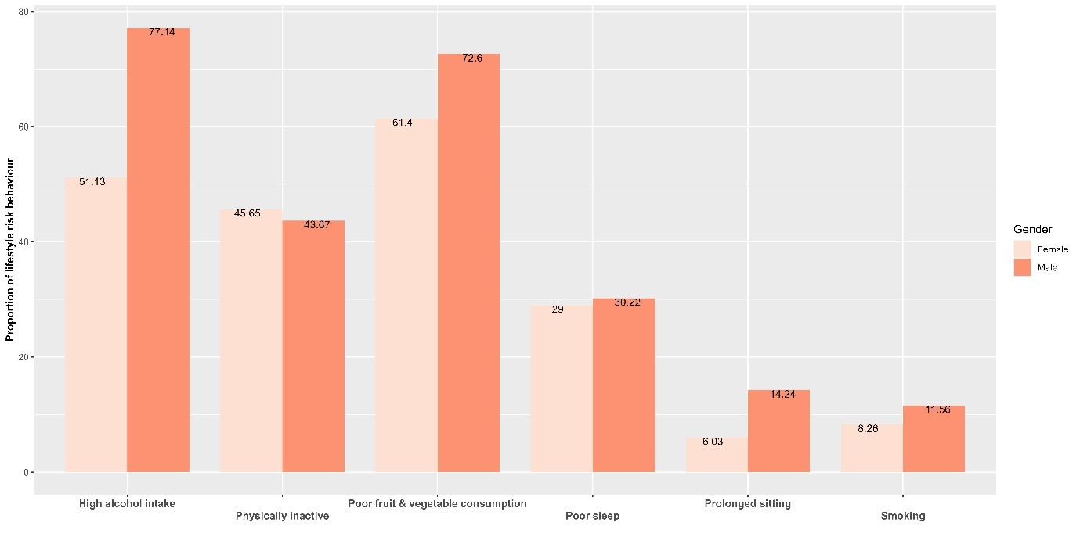

Supplementary Figure S2: Lifestyle risk behaviours among UK adults with CVD risk by gender
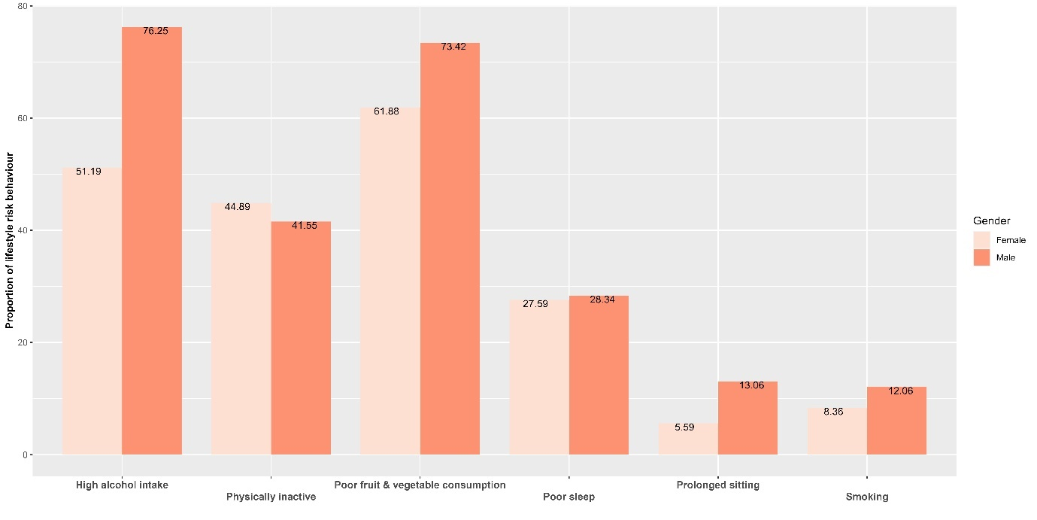

Supplementary Mplus Code S1: CVD risk
STEP 1 BCH CODE: CVD RISK
TITLE:
Step one BCH estimation - LCA with distal outcome (cvd risk).
DATA:
file = risk_score.csv;
VARIABLE:
names = id tsdi pa veg alcohol sleep seden frs;
classes = c(3);
usevar = pa-seden;
categorical = pa-seden;
idvariable = id;
auxiliary = tsdi frs;
ANALYSIS:
type=mixture;
estimator = mlr;
starts = 200 100;
processors = 8;
MODEL:
%overall%
%C#1%
[pa$1-seden$1];
%C#2%
[pa$1-seden$1];
%C#3%
[pa$1-seden$1];
SAVEDATA:
file = risk.txt;
save = bch;
STEP 2 BCH CODE: CVD RISK
title:
Nominal C, Continuous Y (where Y is FRS)
Using a latent class variable to represent C
Simulating x-c interaction effect on y by class-varying y on x (where X is TSDI)
Step 2: BCH approach on LCA with distal outcome - CVd Risk
DATA:
file=risk.txt;
! Predictor variable - X (TSDI)
! Mediator variable(s) – C
! Distal outcome variable - Y (FRS)
VARIABLE:
names = PA VEG ALC SL SED X Y
BCHW1 BCHW2 BCHW3 ID;
classes = c(3);
usevar = X Y BCHW1 BCHW2 BCHW3;
training = BCHW1-BCHW3(bch);
ANALYSIS:
type = mixture;
estimator = mlr;
processors = 8;
starts = 0;
MODEL:
%overall%
[c#1] (gamma01);
[c#2] (gamma02);
c#1 on x (gamma11);
c#2 on x (gamma12);
y on x; !direct effect
y; ! estimating variance

%c#1%
[y] (beta01); ! This is to estimate class-specific mean for y,
! and we coded this ‘beta01’ in parentheses for later use in the MODEL CONSTRAINT.

y on x (beta11); ! This is to estimate the effect of covariate x on the outcome variable y,
! and we coded this ‘beta11’ in parentheses for later use in the MODEL CONSTRAINT.
%c#2%
[y] (beta02); ! class-specific mean for y, coded ‘beta02’
y on x (beta12); ! effect of covariate x on the outcome variable y, coded ‘beta12’

%c#3%
[y] (beta03); ! class-specific mean for y, coded ‘beta03’
y on x (beta13); ! effect of covariate x on the outcome variable y, coded ‘beta13’

MODEL CONSTRAINT:
new(denom0 denom1 p10 p11 p20
p21 p30 p31 term11 term10
term01 term00
de tie total pie
m12 m32 !mean difference - LC membership effect on CVD risk
);
! index is x' for multinomial denominator
denom0=exp(gamma01)+exp(gamma02)+1;
denom1=exp(gamma01+gamma11)+exp(gamma02+gamma12)+1;
! first index is class, second x' for probabilities
p10=exp(gamma01)/denom0;
p11=exp(gamma01+gamma11)/denom1;
p20=exp(gamma02)/denom0;
p21=exp(gamma02+gamma12)/denom1;
p30=1/denom0;
p31=1/denom1;
! first index is x, second x', summing over class
term11=(beta01+beta11)*p11+(beta02+beta12)*p21+(beta03+beta13)*p31;
term10=(beta01+beta11)*p10+(beta02+beta12)*p20+(beta03+beta13)*p30;
term01=(beta01)*p11+(beta02)*p21+(beta03)*p31;
term00=(beta01)*p10+(beta02)*p20+(beta03)*p30;
de=term10-term00;
tie=term11-term10;
total=term11-term00;
pie=term01-term00;
m12 = beta01 - beta02;
!compute mean difference between m1 and m2 WHERE m2 (ALCOHOL ONLY) is REFERENCE
m32 = beta03 - beta02;
!compute mean difference between m3 and m2 WHERE m2 (ALCOHOL ONLY) is REFERENCE
OUTPUT:
CINTERVAL;

Supplementary Mplus Code S2: CVD outcome
STEP 1 BCH CODE: CVD OUTCOME
TITLE:
Step one of the BCH LCA with distal outcome analysis on lifestyle risk behviour.
DATA:
file = cvd_2.csv;
VARIABLE:
names = id gender age tsdi pa veg alcohol sleep smoke seden cvd;
classes = c(4);
usevar = pa-seden;
categorical = pa-seden;
idvariable = id;
auxiliary = gender age tsdi cvd;
ANALYSIS:
type=mixture;
estimator = mlr;
starts = 100 25;
MODEL:
%overall%
%C#1%
[pa$1-seden$1];
%C#2%
[pa$1-seden$1];
%C#3%
[pa$1-seden$1];
%C#4%
[pa$1-seden$1];
SAVEDATA:
file = cvd_step1.txt; save = bch;
STEP 2 BCH CODE: CVD OUTCOME
TITLE:
Step two of the BCH LCA with distal outcome analysis on lifestyle risk behviour.
DATA:
file = cvd_step1.txt;
VARIABLE:
names = PA VEG ALCOHOL SLEEP SMOKE SEDEN GENDER AGE TSDI CVD
BCHW1 BCHW2 BCHW3 BCHW4 ID;
classes = c(4);
usevar = GENDER AGE TSDI CVD BCHW1 BCHW2 BCHW3 BCHW4;
categorical = CVD;
training = BCHW1-BCHW4(bch);
DEFINE:
center gender (grandmean);
ANALYSIS:
type = mixture;
starts = 0;
estimator = mlr;
processors = 8;
MODEL:
%overall%
[c#1] (gamma01);
[c#2] (gamma02);
[c#3] (gamma03);
c#1 ON gender (gamma11);
c#1 ON age (gamma21);
c#1 ON tsdi (gamma31);
c#2 ON gender (gamma12);
c#2 ON age (gamma22);
c#2 ON tsdi (gamma32);
c#3 ON gender (gamma13);
c#3 ON age (gamma23);
c#3 ON tsdi (gamma33);
cvd ON gender age tsdi ;
%c#1%
[cvd$1] (beta01);
cvd on gender (beta11);
cvd on age (beta21);
cvd on tsdi (beta31);
%c#2%
[cvd$1] (beta02);
cvd on gender (beta12);
cvd on age (beta22);
cvd on tsdi (beta32);
%c#3%
[cvd$1] (beta03);
cvd on gender (beta13);
cvd on age (beta23);
cvd on tsdi (beta33);
%c#4%
[cvd$1] (beta04);
cvd on gender (beta14);
cvd on age (beta24);
cvd on tsdi (beta34);

MODEL CONSTRAINT:
new(denom0 denom1 denom2 denom3
p11_gender p11_age p11_tsdi
p21_gender p21_age p21_tsdi
p31_gender p31_age p31_tsdi
p41_gender p41_age p41_tsdi
p10 p20 p30 p40
term11_gender term11_age term11_tsdi
term10_gender term10_age term10_tsdi
term01_gender term01_age term01_tsdi
term00
pnde_gender pnde_age pnde_tsdi
tnie_gender tnie_age tnie_tsdi
total_gender total_age total_tsdi
pnie_gender pnie_age pnie_tsdi
orpnde_gender orpnde_age orpnde_tsdi
ortnie_gender ortnie_age ortnie_tsdi
orpnie_gender orpnie_age orpnie_tsdi
ortotal_gender ortotal_age ortotal_tsdi !odds ratio - total effect

p1 p2 p3 p4 !probabilities
odds1 odds2 odds3 odds4 !odds
or12 or32 or42 !odds ratio ! ref = class 2
or13 or23 or43 ! ref = class 3
or14 or24 or34 ! ref = class 4
diff12 diff32 diff42);

! mediator probabilities:
! index is x0 for multinomial denominator

denom0 = exp(gamma01) + exp(gamma02) + exp(gamma03) + 1;
denom1 = exp(gamma01 + gamma11) + exp(gamma02 + gamma12) +
exp(gamma03 + gamma13) + 1; !for gender
denom2 = exp(gamma01 + gamma21) + exp(gamma02 + gamma22)
+ exp(gamma03 + gamma23) + 1; !for age
denom3 = exp(gamma01 + gamma31) + exp(gamma02 + gamma32)
+ exp(gamma03 + gamma33) + 1; !for tsdi
! first index is class, second x0 for probabilities

p10 = exp(gamma01)/denom0;
p11_gender = exp(gamma01 + gamma11)/denom1;
p11_age = exp(gamma01 + gamma21)/denom2;
p11_tsdi = exp(gamma01 + gamma31)/denom3;

p20 = exp(gamma02)/denom0;
p21_gender = exp(gamma02 + gamma12)/denom1;
p21_age = exp(gamma02 + gamma22)/denom2;
p21_tsdi = exp(gamma02 + gamma32)/denom3;

p30 = exp(gamma03)/denom0;
p31_gender = exp(gamma03 + gamma13)/denom1;
p31_age = exp(gamma03 + gamma23)/denom2;
p31_tsdi = exp(gamma03 + gamma33)/denom3;

p40 = 1/denom0;
p41_gender = 1/denom1;
p41_age = 1/denom2;
p41_tsdi = 1/denom3;

! outcome probabilities:
! first index is x1, second x0, summing over class
term11_gender = (1/(1+exp(beta01-beta11)))*p11_gender +
(1/(1+exp(beta02-beta12)))*p21_gender +
(1/(1+exp(beta03-beta13)))*p31_gender +
(1/(1+exp(beta04-beta14)))*p41_gender;

term11_age = (1/(1+exp(beta01-beta21)))*p11_age +
(1/(1+exp(beta02-beta22)))*p21_age +
(1/(1+exp(beta03-beta23)))*p31_age +
(1/(1+exp(beta04-beta24)))*p41_age;

term11_tsdi = (1/(1+exp(beta01-beta31)))*p11_tsdi +
(1/(1+exp(beta02-beta32)))*p21_tsdi +
(1/(1+exp(beta03-beta33)))*p31_tsdi +
(1/(1+exp(beta04-beta34)))*p41_tsdi;

term10_gender = (1/(1+exp(beta01-beta11)))*p10 +
(1/(1+exp(beta02-beta12)))*p20 +
(1/(1+exp(beta03-beta13)))*p30 +
(1/(1+exp(beta04-beta14)))*p40;

term10_age = (1/(1+exp(beta01-beta21)))*p10 +
(1/(1+exp(beta02-beta22)))*p20 +
(1/(1+exp(beta03-beta23)))*p30 +
(1/(1+exp(beta04-beta24)))*p40;

term10_tsdi = (1/(1+exp(beta01-beta31)))*p10 +
(1/(1+exp(beta02-beta32)))*p20 +
(1/(1+exp(beta03-beta33)))*p30 +
(1/(1+exp(beta04-beta34)))*p40;
term01_gender = (1/(1+exp(beta01)))*p11_gender +
(1/(1+exp(beta02)))*p21_gender +
(1/(1+exp(beta03)))*p31_gender +
(1/(1+exp(beta04)))*p41_gender;

term01_age = (1/(1+exp(beta01)))*p11_age +
(1/(1+exp(beta02)))*p21_age +
(1/(1+exp(beta03)))*p31_age +
(1/(1+exp(beta04)))*p41_age;

term01_tsdi = (1/(1+exp(beta01)))*p11_tsdi +
(1/(1+exp(beta02)))*p21_tsdi +
(1/(1+exp(beta03)))*p31_tsdi +
(1/(1+exp(beta04)))*p41_tsdi;

term00 = (1/(1+exp(beta01)))*p10+(1/(1+exp(beta02)))*p20+
(1/(1+exp(beta03)))*p30 +(1/(1+exp(beta04)))*p40;

! effects:
!pure natural direct effect (PNDE):
pnde_gender = term10_gender - term00;
pnde_age = term10_age - term00;
pnde_tsdi = term10_tsdi - term00;

!total natural indirect effect (TNIE)
tnie_gender = term11_gender - term10_gender;
tnie_age = term11_age - term10_age;
tnie_tsdi = term11_tsdi - term10_tsdi;

total_gender = term11_gender - term00;
total_age = term11_age - term00;
total_tsdi = term11_tsdi - term00;

!pure natural indirect effect (PNIE)
pnie_gender = term01_gender - term00;
pnie_age = term01_age - term00;
pnie_tsdi = term01_tsdi - term00;

!pure natural direct effect (PNDE): odds ratio
orpnde_gender = (term10_gender/(1-term10_gender))/(term00/(1-term00));
orpnde_age = (term10_age/(1-term10_age))/(term00/(1-term00));
orpnde_tsdi = (term10_tsdi/(1-term10_tsdi))/(term00/(1-term00));

!total natural indirect effect (TNIE): odds ratio
ortnie_gender = (term11_gender/(1-term11_gender))/(term10_gender/(1-term10_gender));
ortnie_age = (term11_age/(1-term11_age))/(term10_age/(1-term10_age));
ortnie_tsdi = (term11_tsdi/(1-term11_tsdi))/(term10_tsdi/(1-term10_tsdi));

!pure natural indirect effect (PNIE): odds ratio
orpnie_gender = (term01_gender/(1-term01_gender))/(term00/(1-term00));
orpnie_age = (term01_age/(1-term01_age))/(term00/(1-term00));
orpnie_tsdi = (term01_tsdi/(1-term01_tsdi))/(term00/(1-term00));

!total effect: odds ratio
ortotal_gender = (term11_gender/(1-term11_gender))/(term00/(1-term00));
ortotal_age = (term11_age/(1-term11_age))/(term00/(1-term00));
ortotal_tsdi = (term11_tsdi/(1-term11_tsdi))/(term00/(1-term00));

!compute the probability at age, gender and tsdi level zero
!gender = 0
!age = 0
!tsdi = 0

p1 = 1/(1 + exp(beta01)); !t1 is replaced by beta01 - LC1
p2 = 1/(1 + exp(beta02)); !t2 is replaced by beta02 - LC2
p3 = 1/(1 + exp(beta03)); !t3 is replaced by beta03 - LC3
p4 = 1/(1 + exp(beta04)); !t4 is replaced by beta04 - LC4

odds1 = p1/(1-p1); !LC1
odds2 = p2/(1-p2); !LC2
odds3 = p3/(1-p3); !LC3
odds4 = p4/(1-p4); !LC4

!ref = latent class 2
or12 = odds1/odds2;
!No sysmmetric CI for or12 based on the estimate and SE of
!log or12 = log odds1 - log odds2 = -t1 - (-t2)
or32 = odds3/odds2;
or42 = odds4/odds2;

!ref = latent class 3
or13 = odds1/odds3;
!No sysmmetric CI for or12 based on the estimate and SE of
!log or12 = log odds1 - log odds2 = -t1 - (-t2)
or23 = odds2/odds3;
or43 = odds4/odds3;

!ref = latent class 4
or14 = odds1/odds4;
or24 = odds2/odds4;
or34 = odds3/odds4;

diff12 = -beta01 + beta02;
!diff12 is the same for gender = 1, age and tsdi because
!the slope cancels out
diff32 = -beta03 + beta02;
diff42 = -beta04 + beta02;

OUTPUT:
CINTERVAL;

