Preclinical platform using a triple-negative breast cancer syngeneic murine model to evaluate immune checkpoint inhibitors
Nahee Park^{1,†}, Kamal Pandey^{1,†}, Nar Bahadur Katuwal^{1,2,†}, Min Sil Kang¹, Sa Deok Hong^{1,2}, Mithun Ghosh^{1,2}, Seul-Gi Kim¹, Young Bin Cho¹, Jin Hur¹, Seung Ki Kim³*, Yong Wha Moon¹*

¹Hematology and Oncology, Department of Internal Medicine, CHA Bundang Medical Center, CHA University, Seongnam 13488, Korea;
skgml0413@naver.com (Nahee Park); kamal45@gmail.com (Kamal Pandey); narbahadurkatwal@gmail.com (Nar Bahadur katuwal);
rkdalstlf1097@gmail.com (Min sil Kang); duggy126@gmail.com (Sa Deok Hong); mithunghoshmg@gmail.com (Mithun Ghosh);
sophia311@chamc.co.kr (Seul-Gi Kim); ybyoungbin@naver.com (Young Bin Cho); hurjinz@naver.com (Jin Hur)
²Department of Biomedical Science, The Graduate School, CHA University, Seongnam 13620, Korea
³Department of Surgery, CHA Bundang Medical Center, CHA University, Seongnam 13620, Korea
*Correspondence: mdsky@cha.ac.kr (Seung Ki Kim); ymoon@cha.ac.kr (Yong Wha Moon)
Tel.: +82-10-4848-8131, Fax: +82-31-780-5266 (Seung Ki Kim); Tel.: +82-31-780-3436, Fax: +82-31-780-3929 (Yong Wha Moon)
† These authors contributed equally to this work.

Supplementary Figure
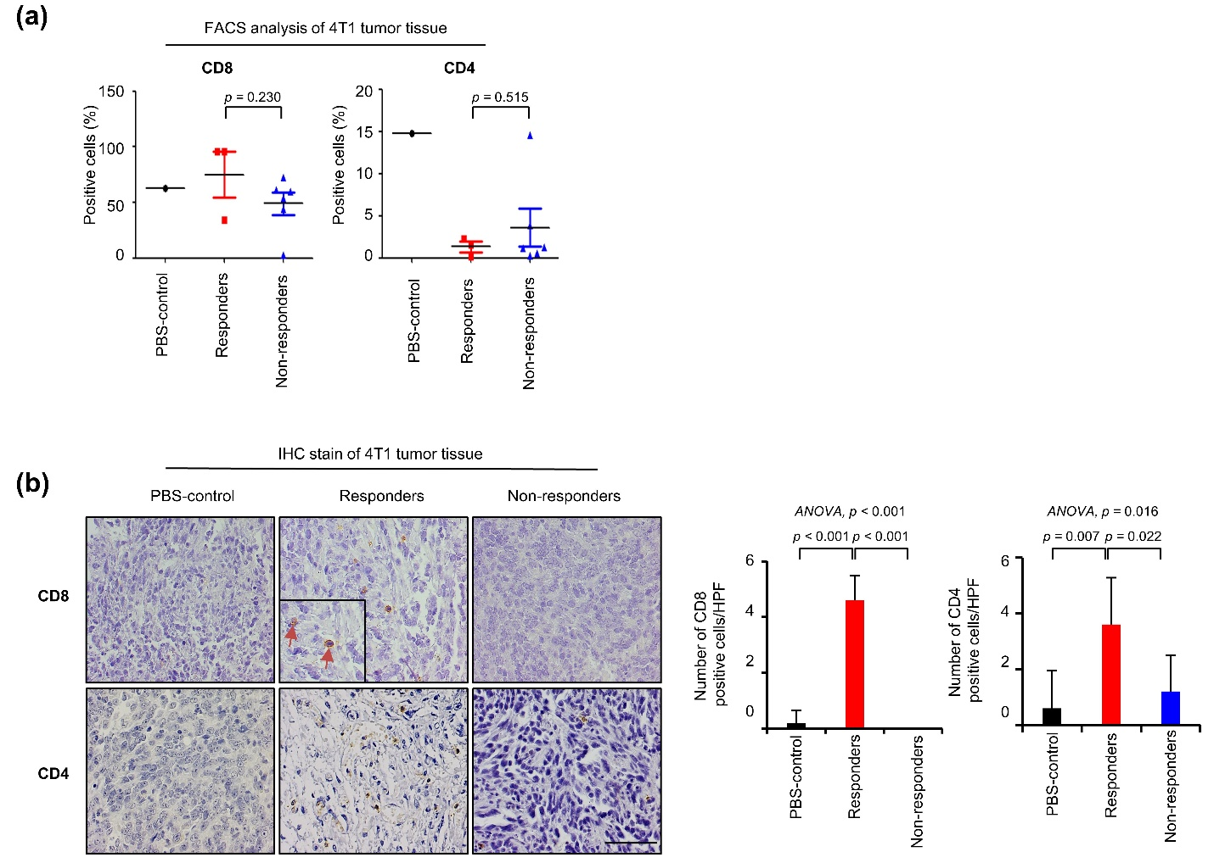
Supplementary Fig. s1 T cell expression in tumors of the 4T1 model
Tumor infiltrating T lymphocytes were analyzed using tumors of 4T1 syngeneic mice by flow cytometry and IHC.
(a) CD8+ and CD4+ T cells were analyzed by flow cytometry. The PBS-control graph has only one sample. It was not possible to calculate the p-value so we just calculated the p-value between the responder and nonresponder group by using the student;'s t-test. Data are presented as mean ± standard deviation.
(b) Representative IHC images in each group of 4T1 tumor tissues are shown, and bar graphs represent the average numbers of CD8+ and CD4+ T cells from each group in five random, nonoverlapped fields at ×400 magnification. The p-values were calculated using the ANOVA test (post hoc p-values; LSD). Data are presented as mean ± standard deviation.

Supplementary table
Supplementary Table 1. Primary antibodies used for flow cytometry
Antibody | Clone | Fluorescence | Company
mCD45 | 30-F11 | APC | e-Bioscience
mCD3 | 145-2C11 | FITC | e-Bioscience
mCD8 | 53-6.7 | perCP-Cy5.5 | e-Bioscience
mCD4 | RM4-5 | APC-ef780 | e-Bioscience
Ki67 | SoLA15 | PE | e-Bioscience

