Supplementary Information for:

Sub-10 fJ/bit Radiation-hard Nanoelectromechanical Non-volatile Memory
Yong-Bok Lee¹, Min-Ho Kang², Pan-Kyu Choi^{1,3}, Su-Hyun Kim^{1,4}, Tae-Su Kim¹,
So-Young Lee¹ and Jun-Bo Yoon¹*

¹School of Electrical Engineering, Korea Advanced Institute of Science and Technology (KAIST), 291 Daehak-ro, Yuseong-gu, Daejeon 34141, Republic of Korea
²National NanoFab Center (NNFC), 291 Daehak-ro, Yuseong-gu, Daejeon 34141, Republic of Korea
³Taiwan Semiconductor Manufacturing Company (TSMC) Ltd. Fab 21, Phoenix, Arizona, USA.
⁴SAMSUNG ELECTRONICS Co., Ltd. 1, Samsungjeonja-ro, Hwaseong-si, Gyeonggi-do 18448, Republic of Korea

*Corresponding author: Jun-Bo Yoon
Tel: +82-42-350-3476, Fax: +82-42-350-8565, E-mail: jbyoon@kaist.ac.kr

Table of contents
Supplementary Section 1: Limitations of the conventional NEM-NVM
Supplementary Section 2: Conformal contact FEM simulation
Supplementary Section 3: Programming energy calculation
Supplementary Section 4: An analytical stiffness model and operation design process
Supplementary Section 5: CMOS-compatible device fabrication on an 8-inch wafer
Supplementary Section 6: Estimation of the erase temperature
Supplementary Section 7: Stability of the NEM-NVM in harsh environments
References

Supplementary Section 1: Limitations of the conventional NEM-NVM
Figure S1a shows the structure and operation mechanisms of the conventional nanoelectromechanical non-volatile memory (NEM-NVM). It consists of a deformable beam and two in-plane electrodes for program and erase operations. For program operation, when an operating voltage is applied between the deformable beam and program electrode, the beam is deflected laterally by the electrostatic force generated from the program electrode and is held in contact by an adhesion force. In the case of the erase operation, similarly, the deformable beam is deflected in the opposite direction by the erase electrode. Figures S1b-c show cross-sectional transmission electron microscope (TEM) images of the initial state and the programmed state of the conventional NEM-NVM, respectively. This NEM-NVM was fabricated using a back-end-of-line process of the TSMC company, which is similar to the fabrication method used in previous studies^{1,2}. The in-plane electrode configuration makes the fabrication process very easy and simple. Fig. S1d shows the fabrication method of the conventional NEM-NVM with thr in-plane electrode configuration. First, a sacrificial layer and structural material are sequentially deposited on the Si wafer, and then a deformable beam and two in-plane electrodes are patterned through a photolithography and an etching process. Finally, the sacrificial layer is removed to release the deformable beam.
The conventional NEM-NVM has several issues related to the energy-efficiency. The first problem is the in-plane electrode configuration. The air gap and width of the deformable beam, the most important factors of the operating energy, are determined by the resolution of the photolithography tools. Therefore, this limits the effective scaling of the operating energy. The second problem is the electrostatic erase operation. It inevitably doubles the actuation air gap distance, which causes an increase in the operating energy and voltage starting with the second operation. Therefore, the conventional NEM memory devices typically have a long beam shape to reduce the operating energy and voltage. Additionally, the inclined sidewall of the in-plane electrode configuration is the main reason for performance degradation. As shown in Figs. S1b-c, the side wall, where the contact occurs, is fabricated to be inclined due to the limitation of the patterning process. The inclined sidewall makes it difficult to implement conformal contact between the beam and operation electrodes. This non-conformal contact can cause performance degradation such as high contact resistance, low reliability, and reduced retention performance.
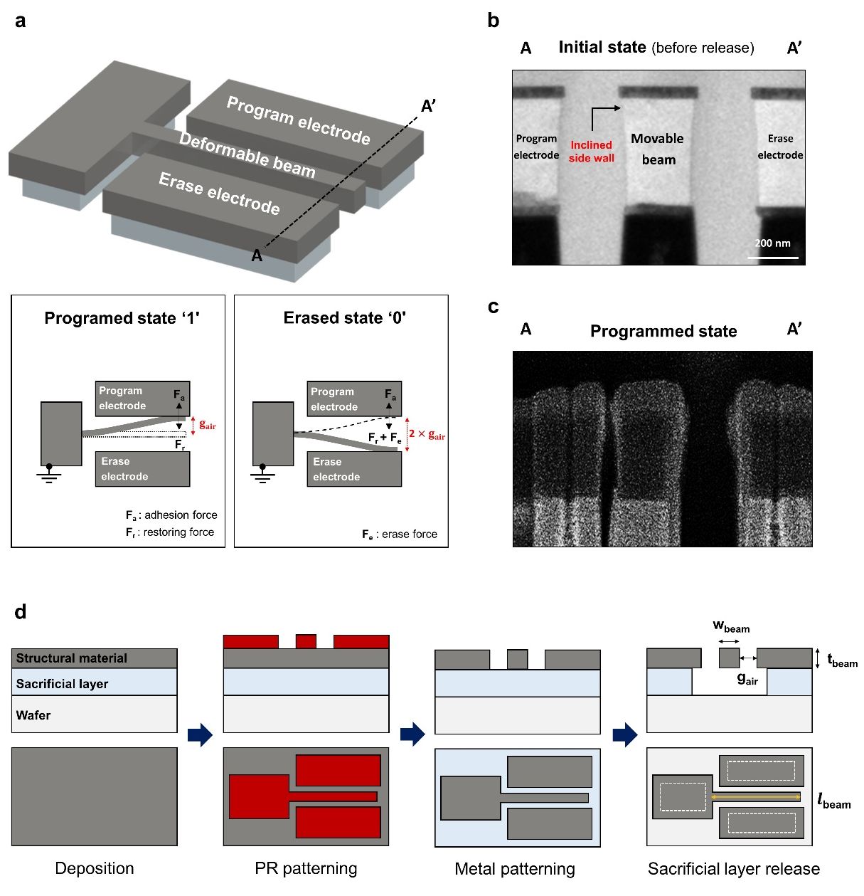
Fig. S1 | Structure, operation mechanisms, and fabrication method of the conventional NEM-NVM. a Conventional NEM-NVM with an in-plane electrode configuration and its operation mechanisms. b,c Cross-sectional TEM images before the release process and after program operation, respectively. d Fabrication process of the conventional NEM-NVM with an in-plane electrode configuration.
Supplementary Section 2: Conformal contact FEM simulation
Unlike the conventional NEM-NVM, the proposed NEM-NVM does not have an inclined sidewall issue because the contact interface is fabricated by a deposition process. Figure S2 shows a three-dimensional finite-element method (FEM) simulation result and extracted beam profile after program operation of the NEM-NVM. This result indicates that the conformal contact can be made at the contact interface.
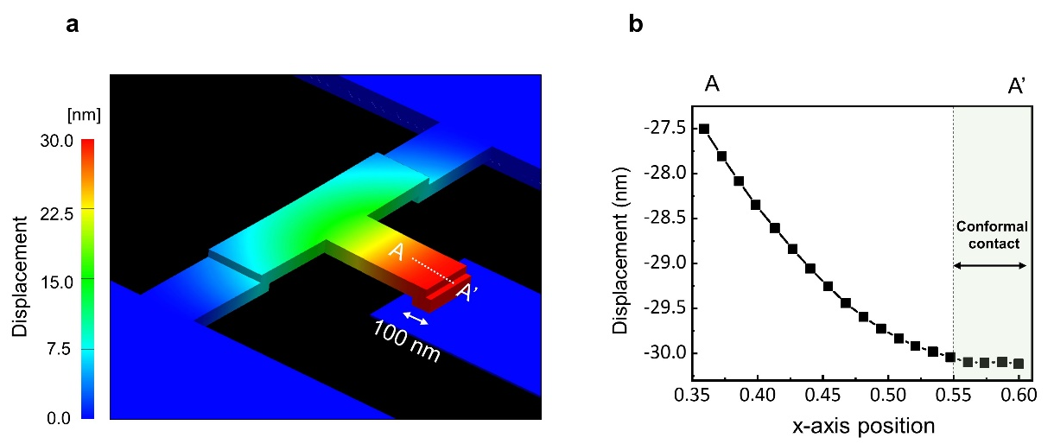
Fig. S2 | Three-dimensional FEM simulation result of program operation. a Displacement result of the NEM-NVM after program operation. b Extracted displacement profile of the bent cantilever.

Supplementary Section 3: Programming energy calculation
The energy consumed in the program operation of the NEM-NVM is calculated by the following equation³.
 | $$E_{total}=E_{electrical}+E_{mechanical spring}+E_{kinetic}+E_{damping}$$ | (1)

 | $= \frac{1}{2}CV^{2}$ $+{\frac{1}{2}kg}_{air}^{2}+$ $\frac{1}{2}mv^{2}$ $+\frac{3μA^{2}}{2πg^{3}}\int{v^{2}dt}$ $≈\frac{1}{2}CV^{2}+{\frac{1}{2}kg}_{air}^{2}$ | (2)

where $C$is the capacitance between the top and bottom electrodes, $V$ is the operating voltage, $k$ is the mechanical spring constant, $g_{air}$ is the actuation air gap, $m$ is the total mass of the top electrode, $v$ is the velocity related to the movement of the top electrode, and $μ$ is the viscosity of quasi-ideal gas at standard temperature and pressure. Since the kinetic energy and energy lost in damping are relatively very small, the mechanical spring energy and electrical energy are the dominant values in the total operation energy. The capacitance and operating voltage are calculated by the following equation³. Therefore, the total operation energy is determined by the actuation air gap and stiffness as shown in Fig. 1d.

 | $$C =\frac{ε_{0}A}{g_{air}}$$ | (3)

 | $$V^{2}=\frac{8kg_{air}^{3}}{27ε_{0}A}$$ | (4)

Supplementary Section 4: An analytical stiffness model and operation design process
For a successful program and erase operations, it is necessary to design an optimal structure that satisfies the conditions $F_{r}<F_{adh}<F_{th}+F_{r}$, where $F_{r}$ ($=g_{air}×k$) is the restoring force of the top electrode, $F_{adh}$ is the adhesion force between the top and bottom electrodes, and $F_{th}$ is thermal expansion force of the pipe-clip spring. First, to calculate the stiffness ($k$) of the complex mechanical structure accurately, we used Castigliano’s theorem in conjunction with the principle of virtual force as shown in Fig.S3. The bending moments and torsions by the virtual force at each simplified element of the top electrode were found, and the displacement and stiffness at the end of the bent cantilever were calculated using Castigliano’s theorem. Next, we calculated the adhesion force between the two contact surfaces using the well-established previous contact models^{4,5}, and the $F_{adh}$ in the area of $0.03 {μm}^{2}$ was found to be 0.96 μN. Figure S4a shows the restoring force with respect to the length of the bent cantilever and pipe-clip spring. To achieve the non-volatility, the device needs be designed in the range of the blue region which ensures the stiction. Thus, the length of the bent cantilever was determined to be 600 nm. Finally, for a stable erase operation, the thermal expansion force must be greater than the adhesion force. To calculate the thermal expansion force, we conducted an electro-thermal FEM simulation to derive the temperature profile of the pipe-clip spring (Fig.S4b) and applied it to the thermo-mechanical model⁶. Figure S4c shows the calculated thermal expansion force with respect to the length of the pipe-clip spring and operating temperature. This result indicates that with a higher temperature and the shorter the pipe-clip spring, a higher thermal expansion force can be obtained. However, this range also causes electromigration and high thermal stress in the pipe-clip structure. Thus, the length of the pipe-clip spring was determined to be 2200 nm considering the thermal force and thermal stress. Figure S5 shows the dimension information of the optimally designed NEM-NVM.
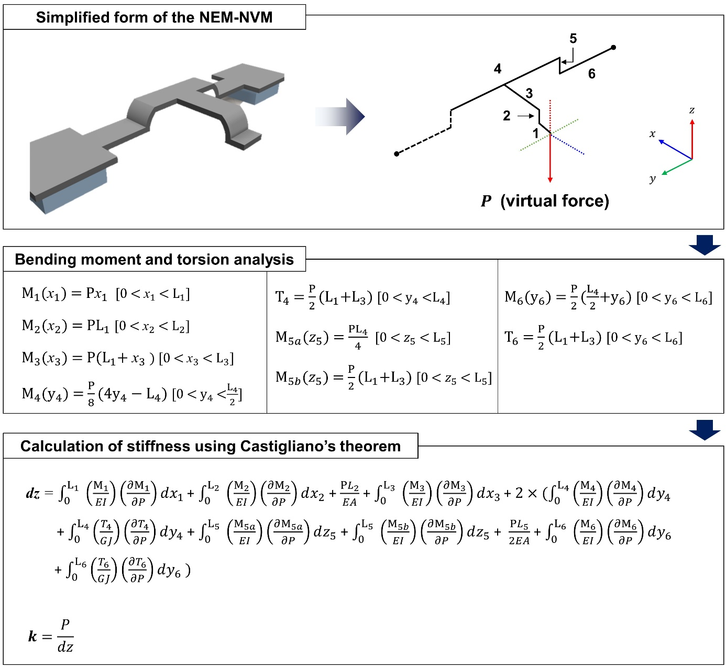
Fig. S3 | Analytical stiffness model of the NEM-NVM. Each part of the top electrode was simplified, and the bending moments and torsions by the virtual force were found. Through Castigliano’s theorem, the displacement at the end of the bent cantilever was calculated. The stiffness is the virtual force divided by the displacement.

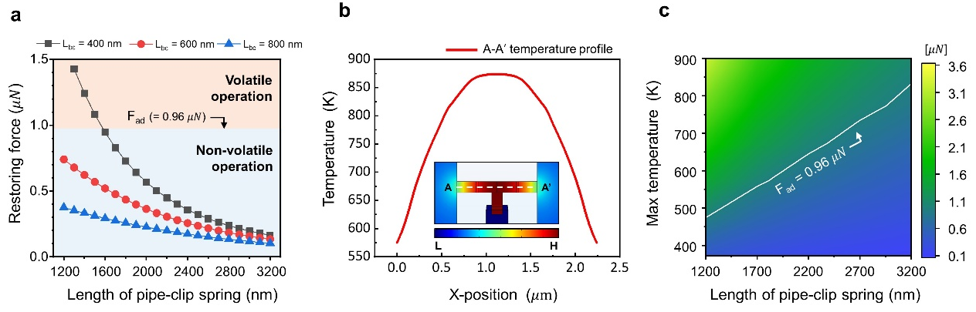
Fig. S4 | Determining the dimensions for stable program and erase operations. a Calculated restoring force with respect to the length of the bent cantilever and pipe-clip spring (air gap, g_{air} = 30nm; thickness, $t_{beam}$ = 70nm). b Three-dimensional resistive heating simulation result and derived temperature profile of the pipe-clip spring. c Calculated thermal expansion force with respect to the length of pipe-clip spring and operating temperature.

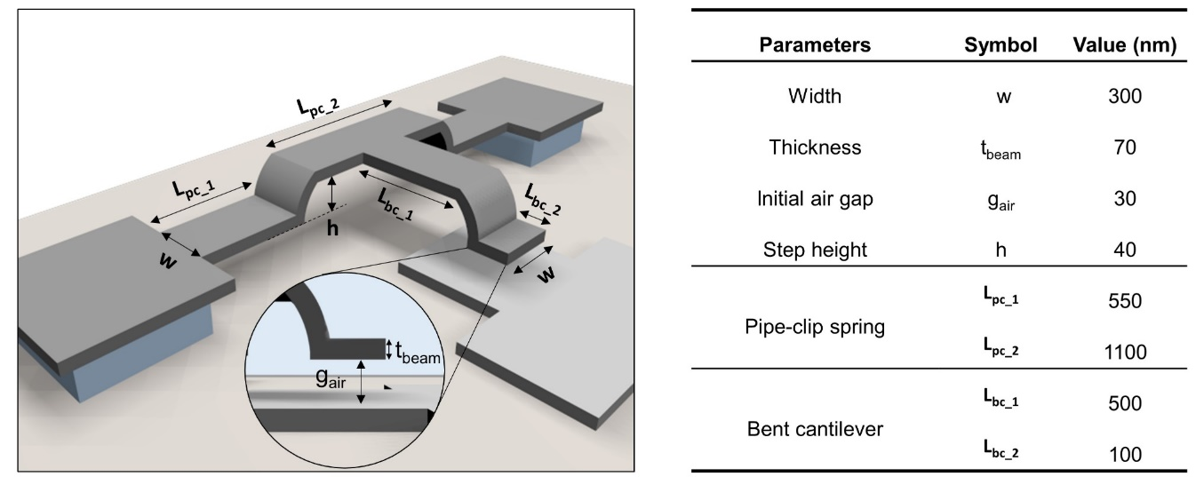
Fig. S5. Dimension information of the optimally designed NEM-NVM.

Supplementary Section 5: CMOS-compatible device fabrication on an 8-inch wafer
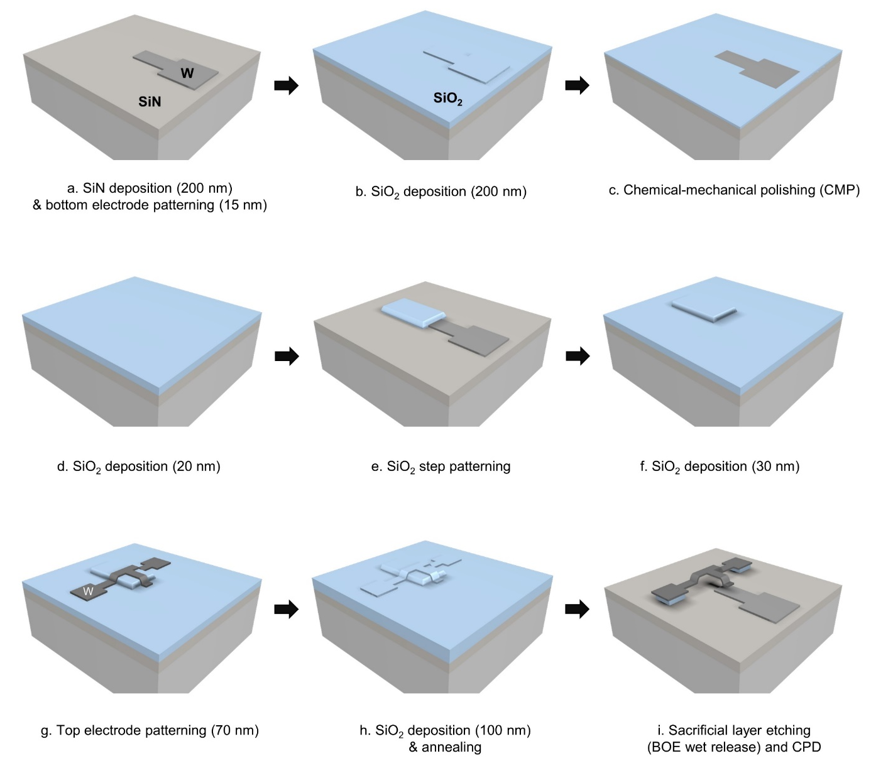
Fig. S6 | CMOS-compatible device fabrication using the well-established manufacturing process. a Silicon nitride deposition (200 nm) and bottom electrode formation (tungsten, 15 nm). b 1st silicon dioxide deposition (200 nm). c Chemical-mechanical polishing process. d 2nd silicon dioxide deposition (20 nm). e Silicon dioxide patterning. f 3rd silicon dioxide deposition (30 nm). g Top electrode formation (tungsten, 70 nm). h 4th silicon dioxide deposition (100 nm) and annealing process (500 $℃$, 30 min). i Sacrificial silicon dioxide etching using a BOE solution and critical point drying process.

Supplementary Section 6: Estimation of the erase temperature
A resistance-temperature detector (RTD) method and time-dependent FEM simulation were conducted to estimate the erase temperature of the NEM-NVM. First, the resistance of the pipe-clip spring was measured according to the temperature on an external hotplate. The exact temperature of the pipe-clip spring on the heated hotplate was measured by an IR thermometer. As shown in Fig. S7a, the resistance of the pipe-clip spring has a linear correlation with the temperature due to the stable thermal property of tungsten⁷. The extracted thermal coefficient of resistance (TCR) was 1750 ppm/$℃$. Using this result, we could predict the maximum temperature (1000.4 K) at the erase voltage (0.9 V). However, since this value is evaluated at a bulk time scale, the time-dependent FEM simulation should be supplemented to determine the temperature at 400 ns. Figure S7b shows the temperature of the pipe-clip spring with respect to the time, under the condition that the final temperature reaches 1000.4 K through resistive heating. The temperature at 400 ns was 873.1 K, which is the maximum temperature of the erase operation (the average temperature was 776.4 K)
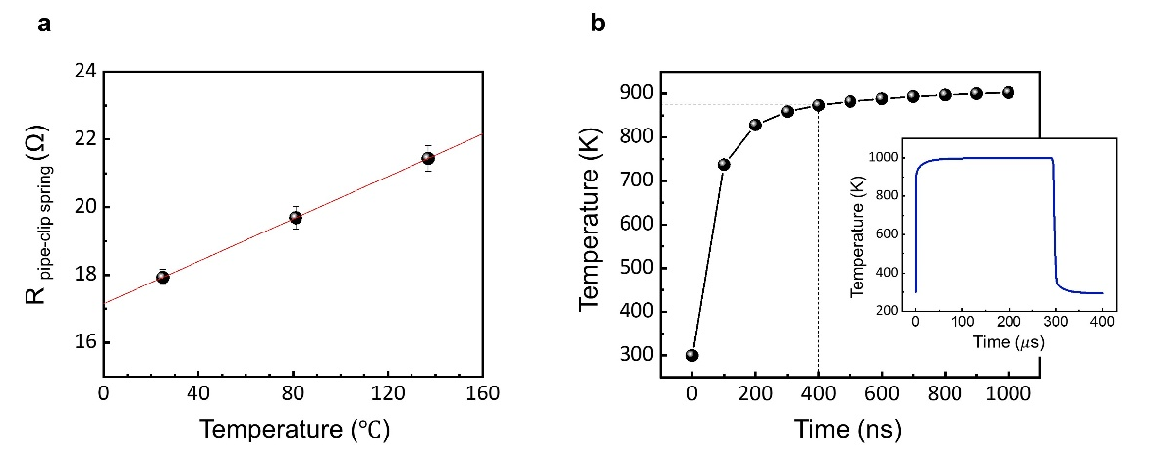
Fig. S7 | Evaluation of the erase temperature. a Measured resistance of the pipe-clip spring with respect to the temperature on an external hot plate. The error bars represent the standard deviations among the pipe-clip spring (𝑛 ≥ 8). b Time-dependent resistive heating simulation result.

Supplementary Section 7: Stability of the NEM-NVM in harsh environments
We prepared fixed-fixed tungsten beams, which are the same structure as the inset in Figure 2f, to evaluate the electrical conductivity of tungsten after the γ-ray irradiation. The resistance of the fixed-fixed tungsten beams was measured before and after gamma-ray irradiation. Figure S8 shows the resistance and extracted conductivity results according to the various total radiation doses (1 Mrad, 3 Mrad, and 5 Mrad). As a result, we confirmed that the differences in electrical conductivity after the irradiation in each condition were very small, 0.54%, 0.27%, and 0.40%, respectively. This excellent property of the tungsten helps the NEM-NVM to be robust to radiation. Figure S9 shows the I-V characteristics of the NEM-NVM after exposure to 1 Mrad radiation. The NEM-NVM retained excellent operation characteristics, namely, ultra-low off current (~100 fA), programming voltage (9.6 V), and steep sub-threshold swing (< 10 mV/dec), which are similar to those of the unexposed device.
Next, the mass of the NEM-NVM was calculated to analyze the mechanical characteristics according to the mechanical shock and vibration. The mass of the optimally designed NEM-NVM is $1.18×{10}^{-15} kg$, calculated as the product of the density of tungsten (19,300 $kgm^{-3}$) and the volume of the device. Then, the resulting displacement ($δ=F/k$) with respect to the acceleration (a) was calculated through Newton's law ($F=$ ma) and the stiffness ($k$). As shown in Fig S10a, a resulting displacement is predicted to be approximately 1 nm even when the acceleration is increased up to ${10}^{6}$G due to the ultra-small mass of the NEM-NVM. Figure S10b shows the resonance frequency (41.9 MHz) of the NEM-NVM obtained through the frequency domain FEM simulation.
Lastly, an evaluation of the high-temperature stability was performed under a vacuum probe station with a hot chuck controller. Figure S11 shows the HCRS and LCRS of the NEM-NVM as the temperature increases up to 400 K, which meets the requirement for automotive memory. Since the driving temperature of the erase operation is approximately 800 K, the LCRS can be retained at a temperature range lower than the erase operation. And, the HCRS can remain high even when the temperature increases due to a physically separated gap.

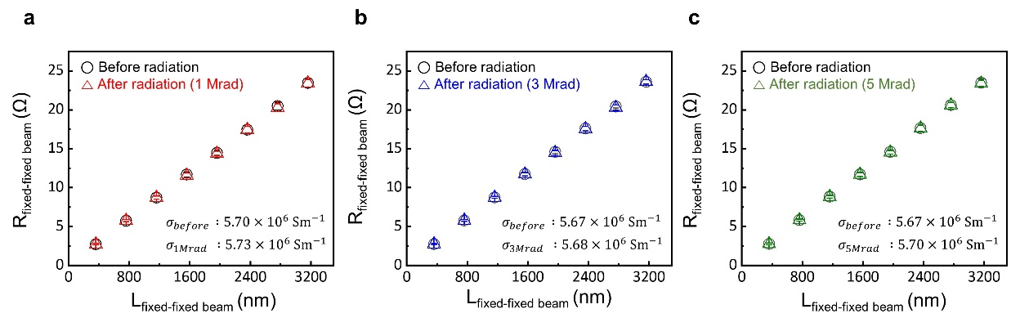
Fig. S8 | Robustness of nano-patterned tungsten to radiation. Comparison of the resistance of the fixed-fixed tungsten beams before and after the gamma-ray irradiation: a 1 Mrad. b 3 Mrad. c 5 Mrad. The error bars represent the standard deviations among the beams (𝑛 ≥ 6).

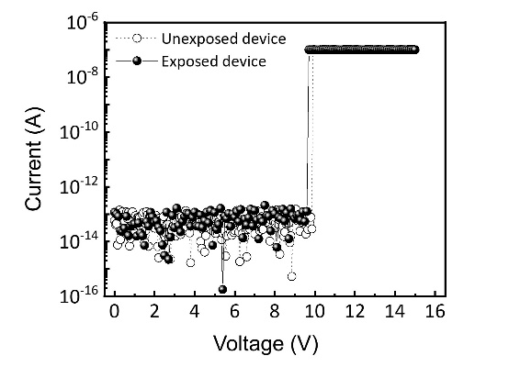
Fig. S9 | I-V characteristics of the NEM-NVM after exposed to radiation. The NEM-NVM retained its operation characteristics even after 1 Mrad gamma-ray irradiation (dashed curve is the same I-V characteristics shown in Fig 3a.).
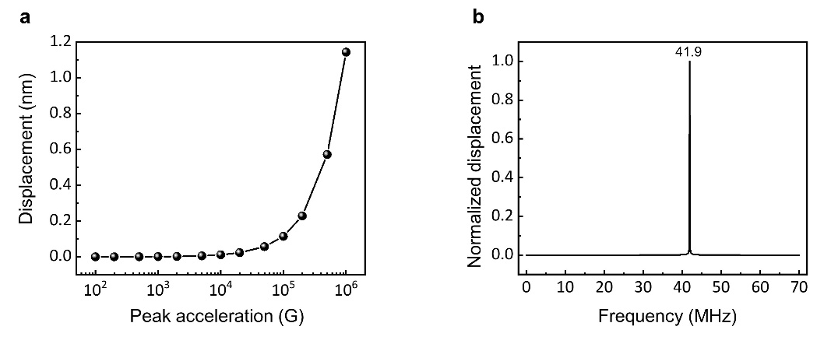
Fig. S10 | Robustness of the NEM-NVM to mechanical stimuli. a Calculated displacement of the NEM-NVM with respect to the acceleration. b Frequency domain simulation result of the NEM-NVM.

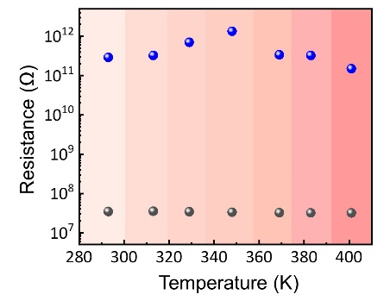
Fig. S11 | High temperature stability of mechanical bits. The HCRS and LCRS of the NEM-NVM retained their original states without degradation up to 400 K.

References
- Kwon, H. S., Kim, S. K. & Choi, W. Y. Monolithic three-dimensional 65-nm CMOS-nanoelectromechanical reconfigurable logic for sub-1.2-V operation. IEEE Electron Device Letters 38, 1317-1320 (2017).
- Sikder, U. et al. Toward Monolithically Integrated Hybrid CMOS-NEM Circuits. IEEE Transactions on Electron Devices 68, 6430-6436 (2021).
- Rebeiz, G. M. RF MEMS: theory, design, and technology. (John Wiley & Sons, 2004).
- DelRio, F. W. et al. The role of van der Waals forces in adhesion of micromachined surfaces. Nature materials 4, 629-634 (2005).
- Smith, C. G. et al. in MEMS/MOEMS Components and Their Applications IV. 646406 (International Society for Optics and Photonics).
- Guan, C. & Zhu, Y. An electrothermal microactuator with Z-shaped beams. Journal of Micromechanics and Microengineering 20, 085014 (2010).
- Cezairliyan, A. & McClure, J. High-speed (subsecond) measurement of heat capacity, electrical resistivity, and thermal radiation properties of tungsten in the range 2000 to 3600 K. Journal of Research of the National Bureau of Standards. Section A, Physics and Chemistry 75, 283 (1971).

