Figure S1. Locations of mapped reads across the two Malay genomes. More than 94% of the two genomes (blue and green bars) were covered by the NGS reads. The remaining regions were either unmapped (orange bars) or known gaps (yellow bars) in the reference genome. Large proportions of the unmapped regions fall on the centromere (red bars).

Figure S2. BLAST alignment of an ORF derived from de novo assembled contig against three primatal proteins. (A) The amino acid sequence of the de novo assembled contig and (B) BLAST alignment between of the encoded ORF with a putative zinc finger protein of rhesus macaque.

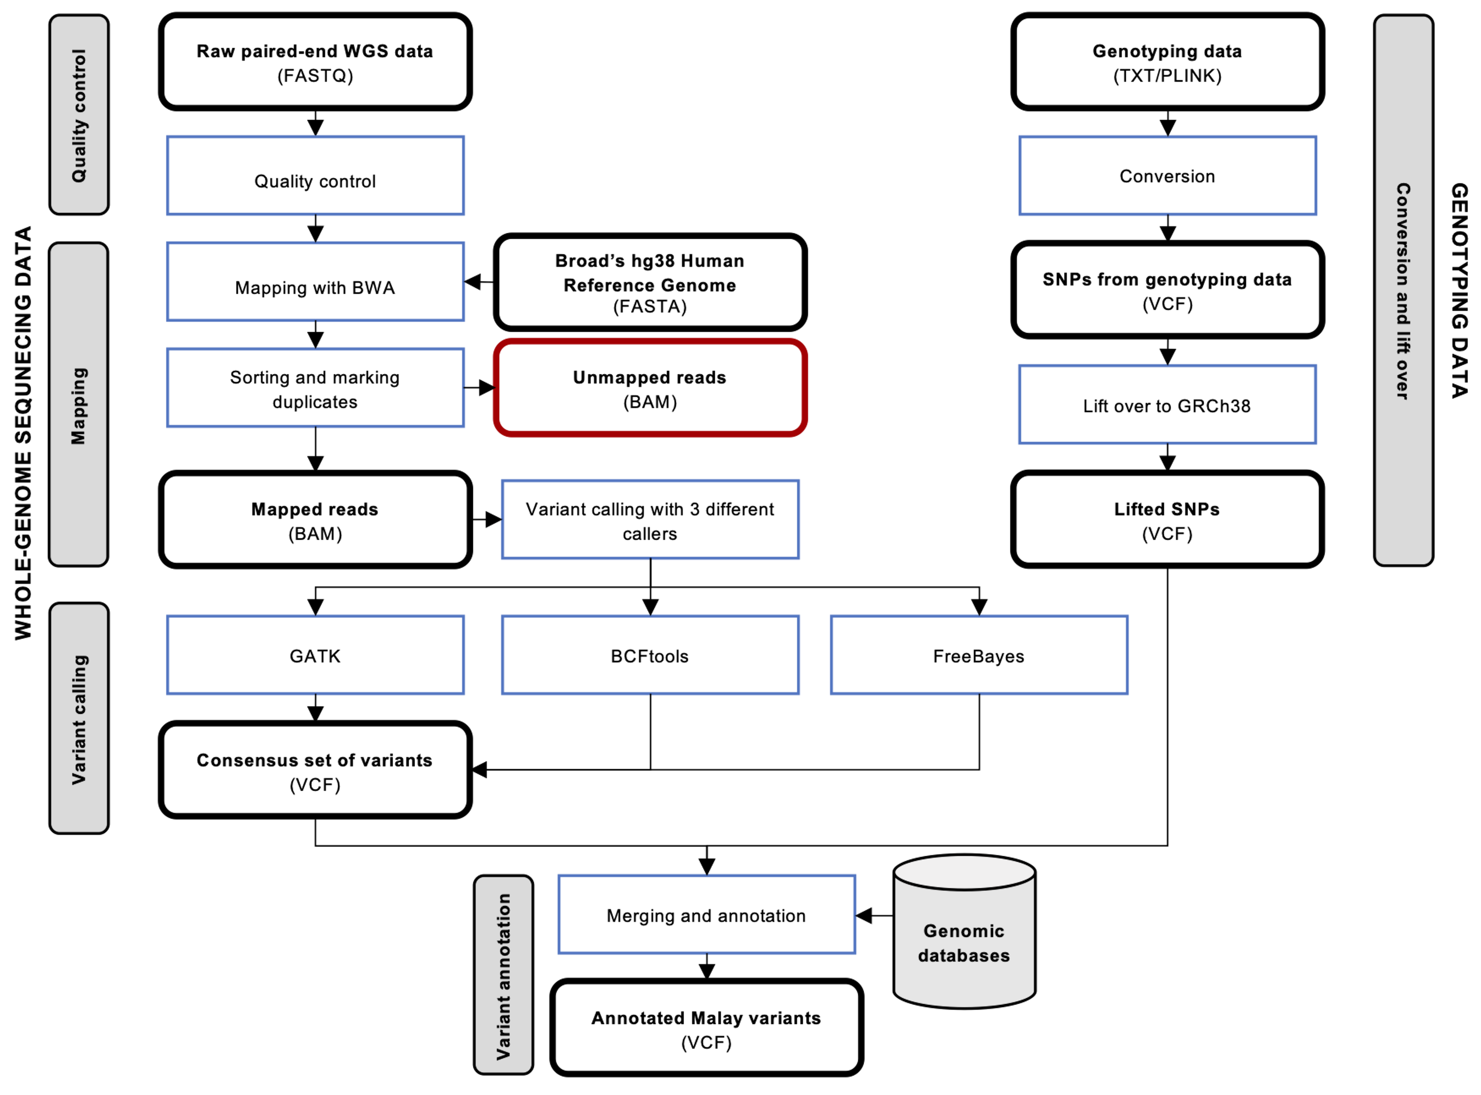

Figure S3. Workflow for processing WGS and genotyping data of 41 Brunei Malays. NGS reads from two individuals were first mapped against GRCh38 human reference genome before consensus variants called by three variant callers were obtained. Genotyping alleles were transformed to VCF file format and lifted-over to GRCh38. All variants were then merged and annotated.

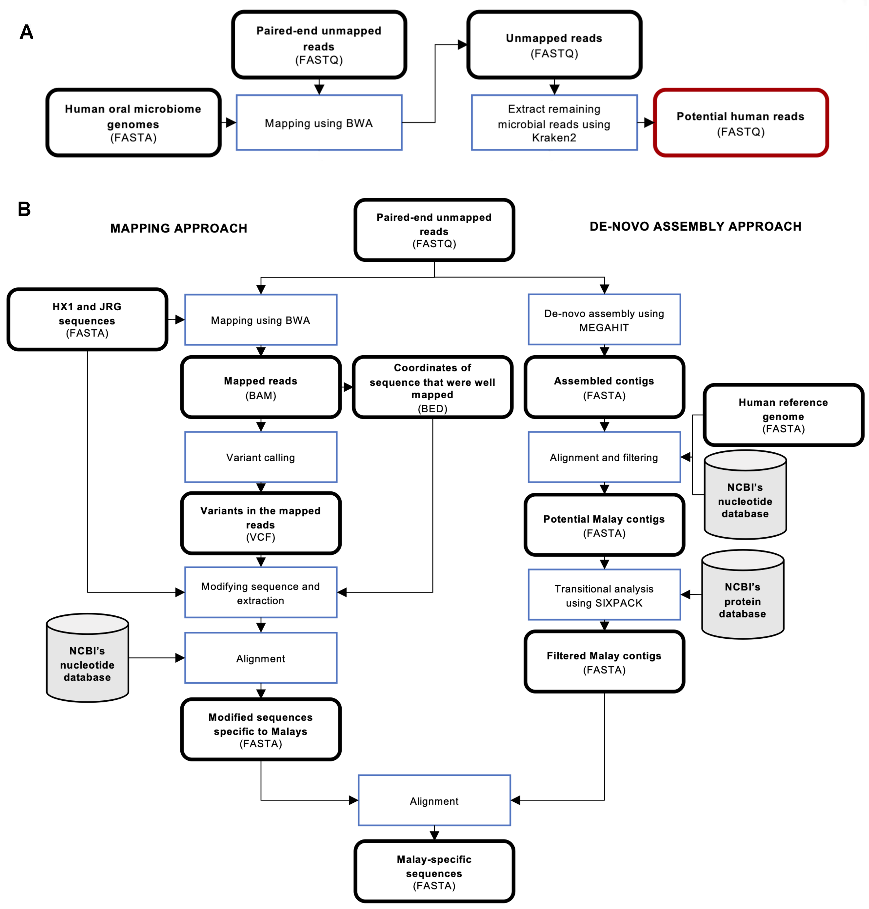

Figure S4. Workflow for discovering novel sequences in Bruneian Malays. (A) NGS reads which did not map to the human reference genome were fed into a microbial mapping and a metagenomic analysis pipeline to remove as much microbial sequences as possible. (B) The final unmapped reads were either mapped to the Chinese/Japanese novel contigs or de novo assembled.

