Supporting Information
for
Surface-coated polymer nanocomposites with z-aligned high-k nanowires as high-performance dielectrics at elevated temperatures
Sang Cheng, Yushu Li, Mingcong Yang, Jing Fu, Rui Wang, Jun Hu, Jinliang He and Qi Li*

State Key Laboratory of Power Systems, Department of Electrical Engineering, Tsinghua University, Beijing 100084, China
*Correspondence to qili1020@tsinghua.edu.cn (Q.L.)

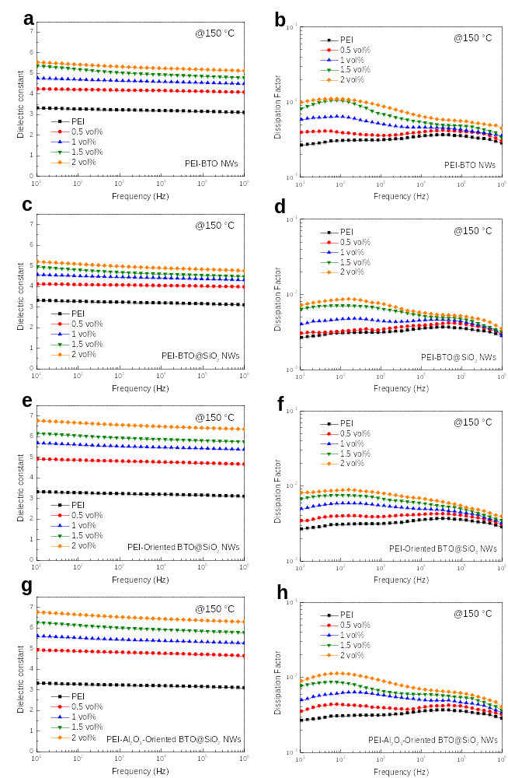
Fig. S1. Frequency-dependent dielectric constant of (a) PEI-BTO NWs, (c) PEI-BTO@SiO₂ NWs, (e) PEI-z-aligned BTO@SiO₂ NWs, (g) PEI-Al₂O₃-z-aligned BTO@SiO₂ NWs with different volume fraction of NWs at 150 °C. Frequency-dependent dissipation factor of (b) PEI-BTO NWs, (d) PEI-BTO@SiO₂ NWs, (f) PEI-z-aligned BTO@SiO₂ NWs, (h) PEI-Al₂O₃-z-aligned BTO@SiO₂ NWs with different volume fraction of NWs at 150 °C.

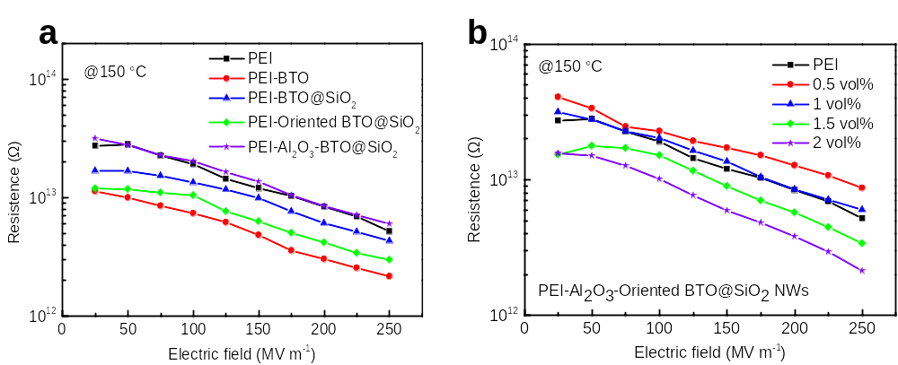
Fig. S2. Electrical resistance of (a) 4 types of nanocomposites with 1 vol% NWs, (b) PEI-Al₂O₃-z-aligned BTO@SiO₂ NWs with different volume fraction of NWs at 150 °C.

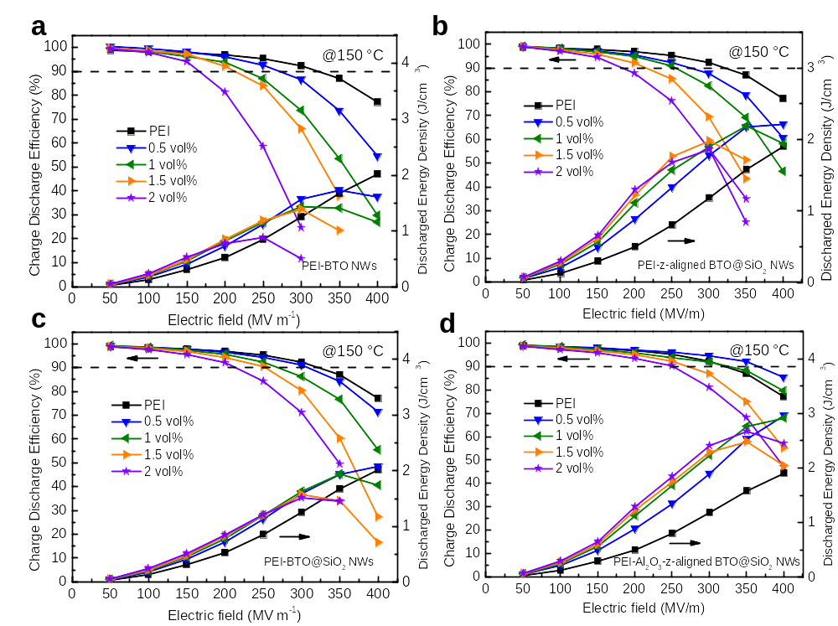
Fig. S3. Charge-discharge efficiency and discharged energy density of (a) PEI-BTO NWs, (b) PEI-BTO@SiO₂ NWs, (c) PEI-z-aligned BTO@SiO₂ NWs, (d) PEI-Al₂O₃-z-aligned BTO@SiO₂ NWs with different volume fraction of NWs at 150 °C.

