Data supplement VII: Publication bias assessment with funnel plot and Egger’s test.

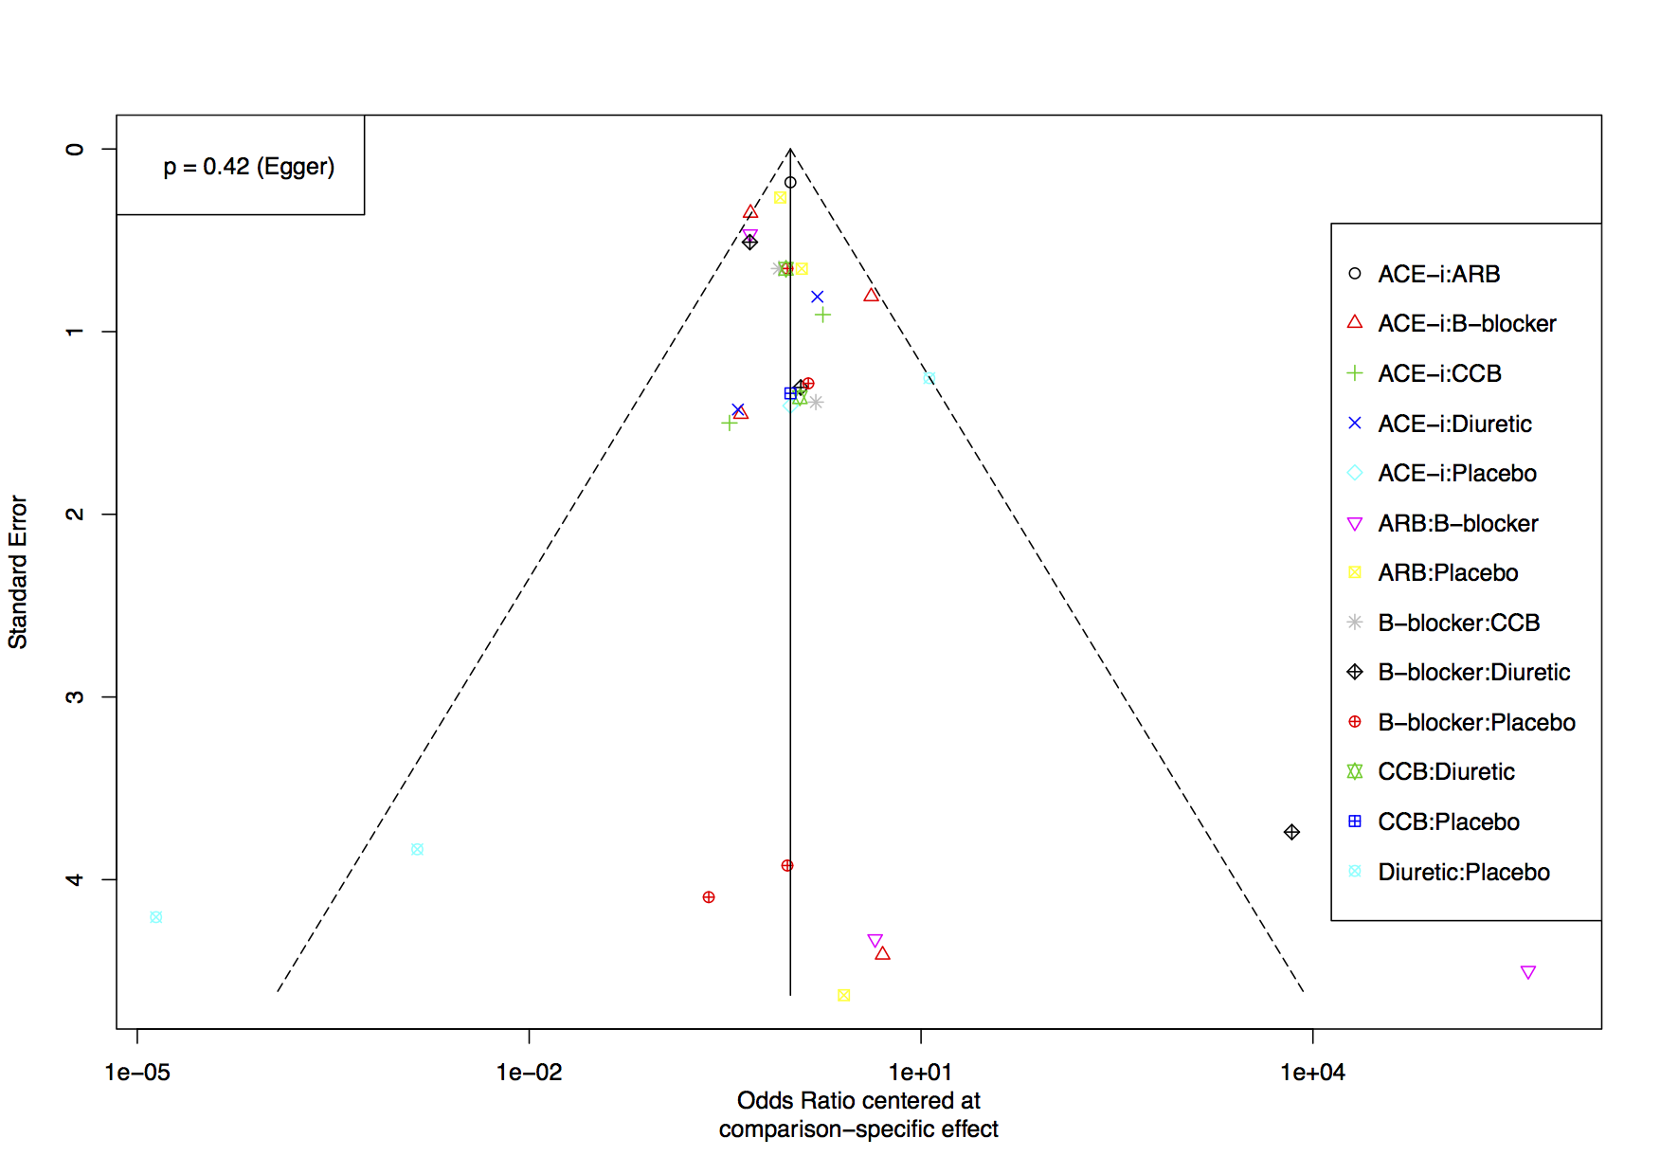
Figure S7.1. Funnel plot and Egger's test for publication bias assessment.

