Data supplement VIII: Network meta-analysis of vasodilatory versus non-vasodilatory β-blockers interventions.

Figure S8.1. Network graph of interventions in vasodilatory versus non-vasodilatory b-blockers network meta-analysis.

Figure S8.2. Forest plot of the effect of vasodilatory versus non-vasodilatory b-blockers on erectile function.

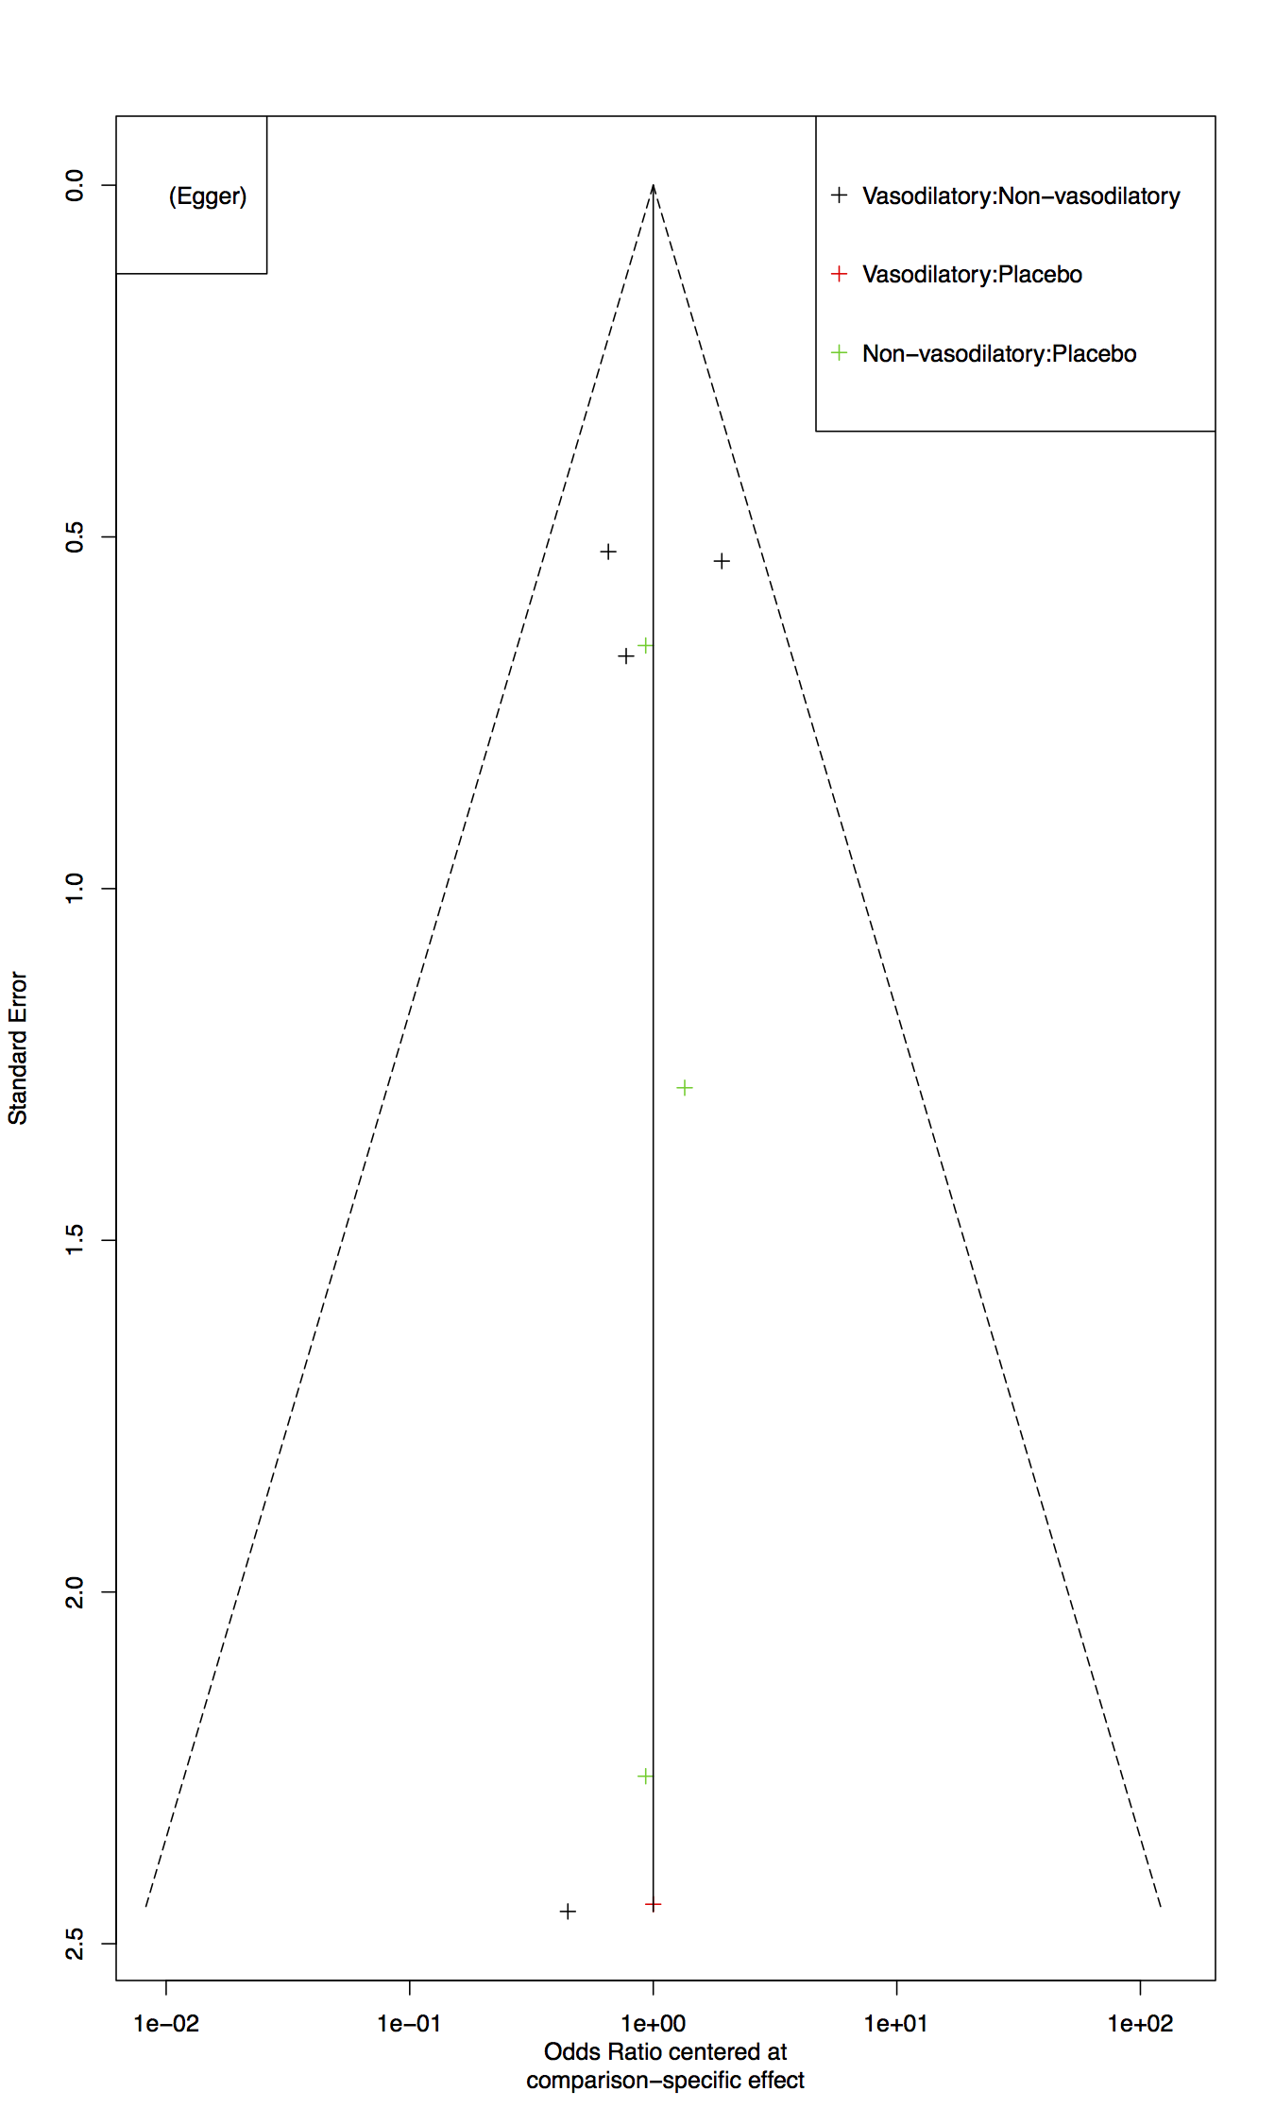
Figure S8.3. Funnel plot and Egger's test for publication bias assessment.

Table S8.1. Assessment of consistency of network meta-analysis model.
Comparison | k | prop | NMA | Direct | Indirect
Non-vasodilatory vs Placebo | 3 | 0.95 | 0.96 | 1.07 | 0.11
Non-vasodilatory vs Vasodilatory | 4 | 0.98 | 0.46 | 0.45 | 4.3
Vasodilatory vs Placebo | 1 | 0.07 | 2.07 | 0.25 | 2.41
*k: Number of studies providing direct evidence, prop: Direct evidence proportion, NMA: Estimated treatment effect (OR) in network meta-analysis, Direct: Estimated treatment effect (OR) derived from direct evidence, Indirect: Estimated treatment effect (OR) derived from indirect evidence

Table S8.2. League table of estimated treatment effect in network meta-analysis.
Non-Vasodilatory | 0.96  (0.32-2.82) | 0.46  (0.25-0.87)
1.04  (0.36-3.06) | Placebo | 0.48  (0.14-1.65)
2.16  (1.15-4.04) | 2.07  (0.61-7.1) | Vasodilatory
*treatment effect is reported as odds ratio (95% confidence interval).
**bold font indicates significant effect.

