Data supplement IV: Flow diagram of study selection process.

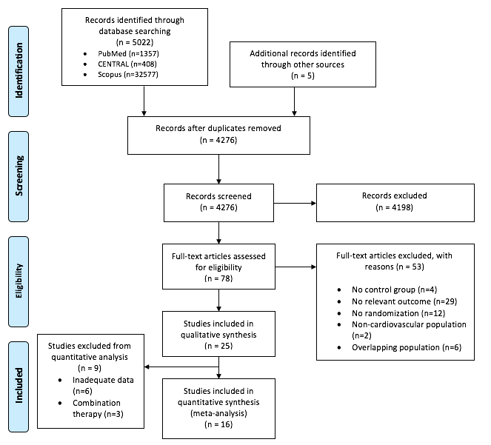
Figure S4.1. Flow diagram of study selection process.

