Data supplement V: Risk of bias in RCTs.

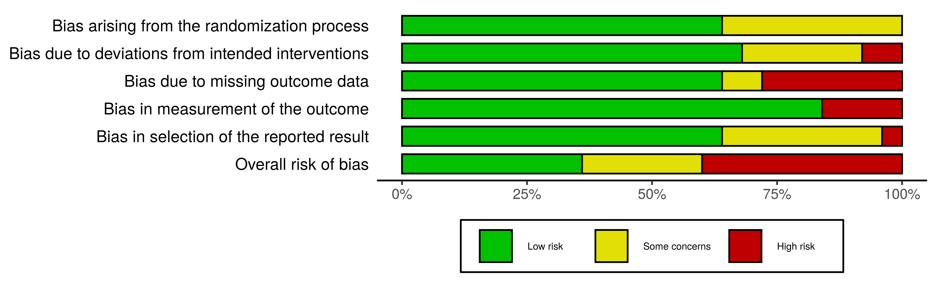
Figure S5.1. Overall risk of bias assessment.

Figure S5.2. Study-by-study risk of bias assessment.

