Data supplement IX: Network meta-analysis of nebivolol versus other vasodilatory versus non-vasodilatory β-blockers interventions.
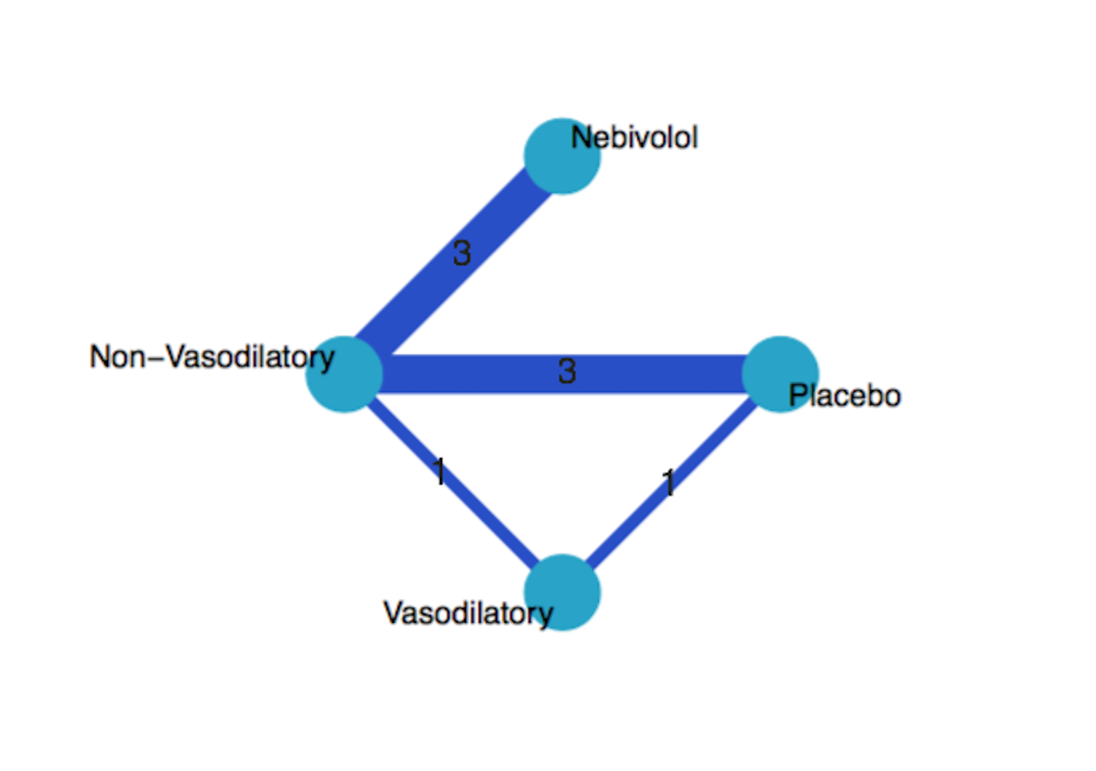
Figure S9.1. Network graph of interventions in nebivolol versus other vasodilatory versus non-vasodilatory b-blockers network meta-analysis.

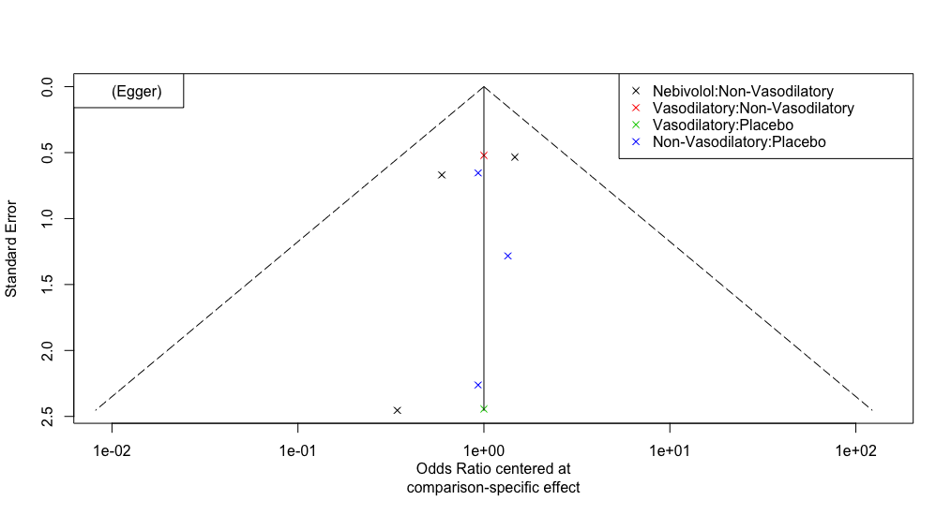
Figure S9.2. Funnel plot and Egger's test for publication bias assessment.

Table S9.1. Assessment of consistency of network meta-analysis model.
Comparison | k | prop | NMA | Direct | Indirect | RoR | z | p-value
Nebivolol : Non-vasodilatory | 3 | 1 | 2.92 | 2.92 | - | - | - | -
Nebivolol : Placebo | 0 | 0 | 2.87 | - | 2.87 | - | - | -
Nebivolol : Vasodilatory | 0 | 0 | 2.15 | - | 2.15 | - | - | -
Non-Vasodilatory : Placebo | 3 | 0.95 | 0.98 | 1.07 | 0.17 | 6.3 | 0.72 | 0.47
Non-Vasodilatory : Placebo | 1 | 0.96 | 0.74 | 0.68 | 4.3 | 0.16 | -0.72 | 0.47
Vasodilatory : Placebo | 1 | 0.09 | 1.33 | 0.25 | 1.57 | 0.16 | -0.72 | 0.47
*k: Number of studies providing direct evidence, prop: Direct evidence proportion, NMA: Estimated treatment effect (OR) in network meta-analysis, Direct: Estimated treatment effect (OR) derived from direct evidence, Indirect: Estimated treatment effect (OR) derived from indirect evidence, RoR: Ratio of Ratios (direct versus indirect), z: z-value of test for disagreement (direct versus indirect), p-value: p-value of test for disagreement (direct versus indirect)

Table S9.2. League table of estimated treatment effect in network meta-analysis.
Nebivolol | 2.92 (1.3-6.54) | 2.87 (0.75-11.04) | 2.15 (0.6-7.77)
0.34 (0.15-0.77) | Non-vasodilatory | 0.98 (0.33-2.89) | 0.73 (0.27-2)
0.35 (0.09-1.34) | 1.02 (0.35-3) | Placebo | 0.75 (0.18-3.15)
0.47 (0.13-1.68) | 1.36 (0.5-3.69) | 1.33 (0.32-5.61) | Vasodilatory
*treatment effect is reported as odds ratio (95% confidence interval)
**bold font indicates significant effect.

