Supplementary figures and tables
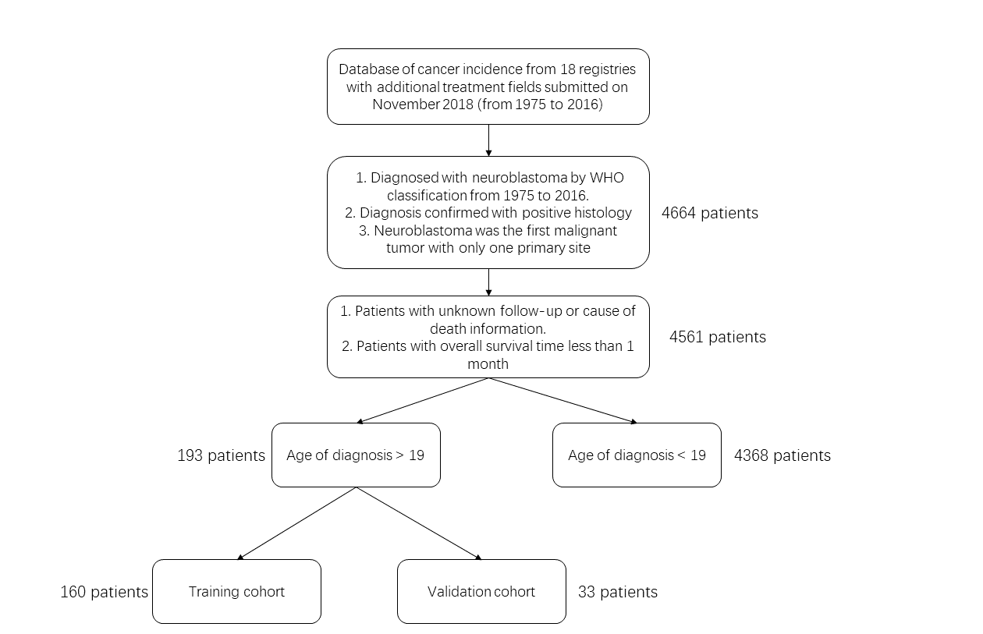
Supplementary Figure 1. Study design and work-flow of the analysis.
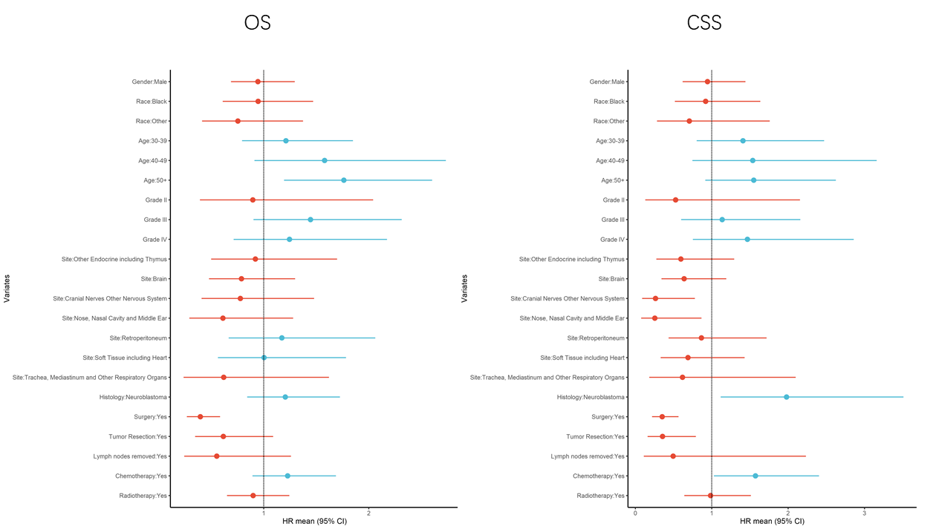
Supplementary Figure 2. Prognostic factors of univariate analysis of the overall survival (OS) and cancer-specific survival (CSS) in adult-onset neuroblastoma patients.

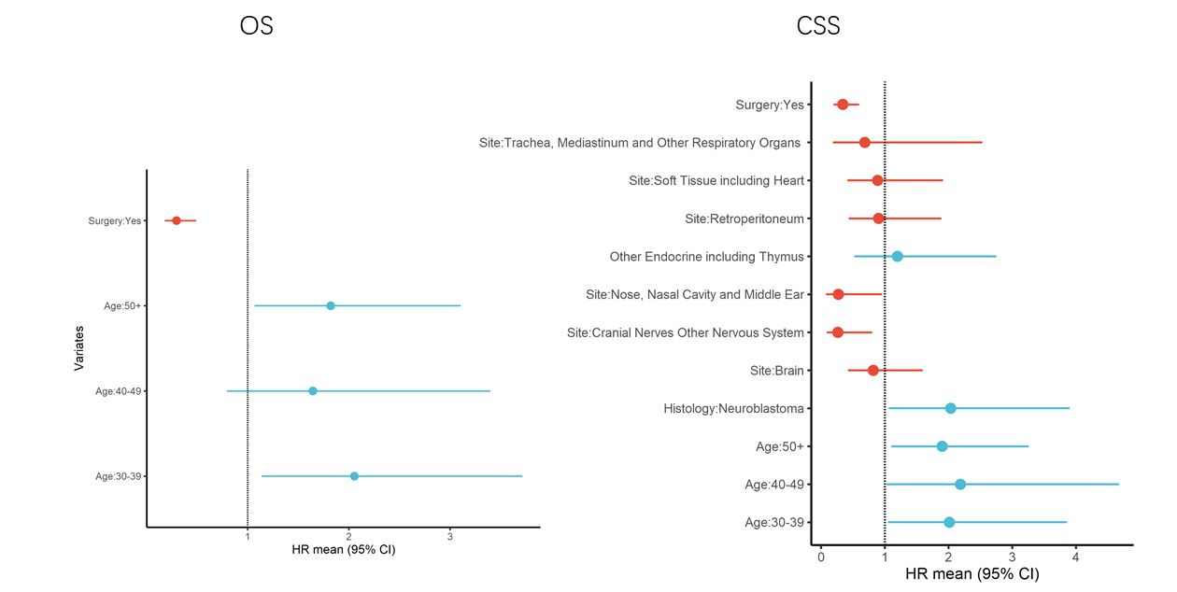
Supplementary Figure 3. Prognostic factors of multivariate analysis of the overall survival (OS) and cancer-specific survival (CSS) in adult-onset neuroblastoma patients.
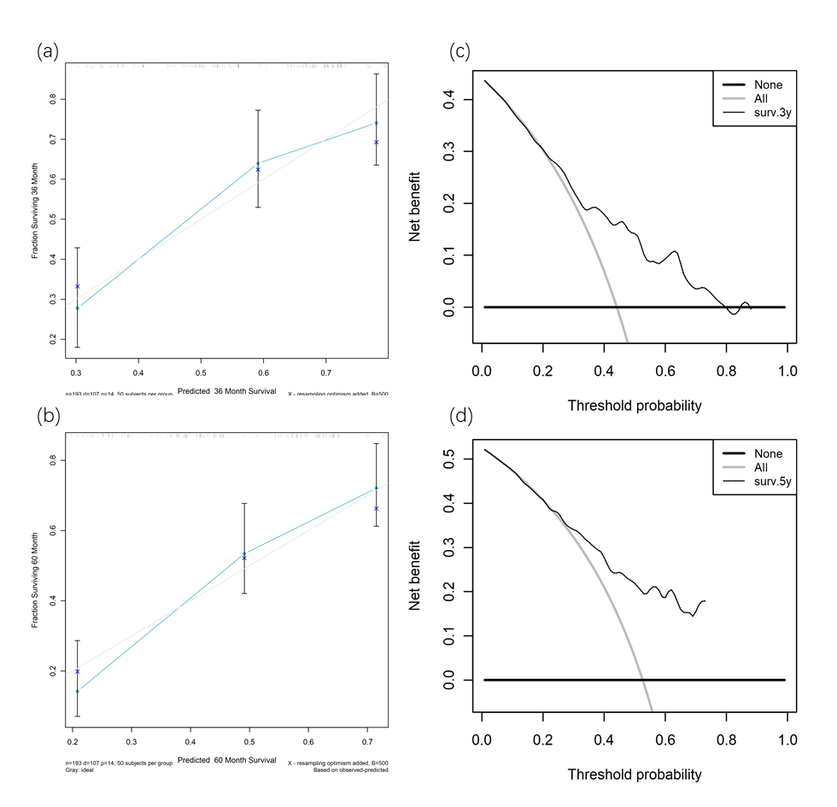
Supplementary Figure 4. (a, b) Calibration plot of the 3-year and 5-year nomogram predictions versus the actual observations in the validation group. (c, d) Decision curve analysis (DCA) of the 3-year and 5-year nomogram predictions and the net benefit of decision in the validation group.

Supplementary Table 1. Clinical characteristics of training group and validation group
 | training group | percent | validation group | percent
Total | 160 |  | 33
Gender
male | 82 | 51.3% | 17 | 51.5%
female | 78 | 48.8% | 16 | 48.5%
Race
Black | 24 | 15.0% | 5 | 15.2%
White | 123 | 76.9% | 24 | 72.7%
Other | 12 | 7.5% | 4 | 12.1%
Unknown | 1 | 0.6% | 0 | 0.0%
Grade(differentiation)
I(well-differentiated) | 0 | 0.0% | 1 | 3.0%
II(moderately-differentiated) | 6 | 3.8% | 4 | 12.1%
III(poorly-differentiated) | 21 | 13.1% | 7 | 21.2%
IV(undifferetiated) | 14 | 8.8% | 2 | 6.1%
unknown | 119 | 74.4% | 19 | 57.6%
Primary Site
Brain | 40 | 25.0% | 10 | 30.3%
Retroperitoneum | 24 | 15.0% | 4 | 12.1%
Soft Tissue including Heart | 22 | 13.8% | 4 | 12.1%
Other Endocrine including Thymus | 18 | 11.3% | 3 | 9.1%
Nose, Nasal Cavity and Middle Ear | 10 | 6.3% | 6 | 18.2%
Cranial Nerves Other Nervous System | 15 | 9.4% | 0 | 0.0%
Trachea, Mediastinum and Other Respiratory Organs | 5 | 3.1% | 1 | 3.0%
Others | 26 | 16.3% | 5 | 15.2%
Histology type
Neuroblastoma | 118 | 73.8% | 29 | 87.9%
Ganglioneuroblastoma | 42 | 26.3% | 4 | 12.1%
Surgery
yes | 115 | 71.9% | 23 | 69.7%
no/unknown | 45 | 28.1% | 10 | 30.3%
Tumor resection
yes | 58 | 36.3% | 12 | 36.4%
other/unknown | 102 | 63.8% | 21 | 63.6%
Nodes removal
yes | 7 | 4.4% | 0 | 0.0%
no/unknown | 153 | 95.6% | 33 | 100.0%
Nodes positive
yes | 9 | 5.6% | 3 | 9.1%
no/unknown | 151 | 94.4% | 30 | 90.9%
Chemotherapy
yes | 71 | 44.4% | 16 | 48.5%
no/unknown | 89 | 55.6% | 17 | 51.5%
Radiotherapy
yes | 60 | 37.5% | 13 | 39.4%
no/unknown | 100 | 62.5% | 20 | 60.6%

