Supplemental material

Supplementary Table 1. Descriptive detail data of reactive interpretation of T-SPOT.COVID

Supplementary Table 2. Missing data of reactive interpretation of T-SPOT.COVID

Supplementary Table 3. Details of the information and results of the previously infected participants

Supplementary Table 4. Descriptive data of reactive interpretation of T-SPOT.COVID

Supplementary Figure 1. Difference in anti-SARS-COV-2 IgG titer between non-reactive & borderline and reactive group of T-SPOT.COVID

Supplementary Table 1. Descriptive detail data of reactive interpretation of T-SPOT.COVID
Variables | N=1089 | Reactive Interpretation
 |  | Non-Reactive  (n =250) | Reactive  (n =700) | Borderline  (n =139)
Comorbidities
At least one | 616(56.4) | 182(72.8) | 355(50.7) | 79(56.8)
DETAILS
Hypertension | 295(27.0) | 102(41.0) | 152(21.8) | 41(29.5)
Dyslipidemia | 95(8.7) | 22(8.8) | 59(8.5) | 14(10.1)
Heart disease | 96(8.8) | 35(14.1) | 46(6.6) | 15(10.8)
Diabetes | 88(8.1) | 36(14.5) | 42(6.0) | 10(7.2)
Allergic disease | 54(4.9) | 9(3.6) | 39(5.6) | 6(4.3)
Asthma | 43(3.9) | 10(4.0) | 28(4.0) | 5(3.6)
Liver disease | 69(6.3) | 22(8.8) | 38(5.4) | 9(6.5)
Cancer | 42(3.8) | 17(6.8) | 19(2.7) | 6(4.3)
Gout | 23(2.1) | 9(3.6) | 10(1.4) | 4(2.9)
Thyroid disease | 30(2.7) | 5(2.0) | 22(3.2) | 3(2.2)
Lung disease | 23(2.1) | 10(4.0) | 11(1.6) | 2(1.4)
Mental disease | 20(1.8) | 11(4.4) | 6(0.9) | 3(2.2)
Rheumatism | 21(1.9) | 11(4.4) | 7(1.0) | 3(2.2)
Kidney disease | 8(0.7) | 2(0.8) | 4(0.6) | 2(1.4)
Anaphylaxis | 8(0.7) | 3(1.2) | 4(0.6) | 1(0.7)
Collagen disease | 8(0.7) | 3(1.2) | 3(0.4) | 2(1.4)
Immune deficiency | 4(0.4) | 1(0.4) | 2(0.3) | 1(0.7)
Others | 197(18.0) | 68(27.4) | 109(15.6) | 20(14.4)
Drug
At least one | 180(16.5) | 62(24.8) | 87(12.4) | 31(22.3)
DETAILS
Steroid | 32(2.9) | 15(6.1) | 14(2.1) | 3(2.2)
NSAIDs | 83(7.6) | 27(11.0) | 43(6.3) | 13(9.6)
Acetaminophen | 34(3.1) | 9(3.7) | 18(2.6) | 7(5.1)
Antihistamine | 50(4.6) | 16(6.5) | 27(3.9) | 7(5.1)
Biologics | 14(1.3) | 5(2.0) | 8(1.2) | 1(0.7)
Anticancer agent | 5(0.5) | 0(0) | 4(0.6) | 1(0.7)
Immunosuppressants | 4(0.4) | 2(0.8) | 2(0.3) | 0(0)
Adverse reaction after 2nd dose
At least once | 825(75.5) | 137(54.8) | 587(84.0) | 101(73.2)
DETAILS
Local Pain | 563(51.6) | 88(35.3) | 405(58.0) | 70(50.7)
Fever over 37.5 degree | 154(14.1) | 18(7.2) | 123(17.6) | 13(9.4)
Fever under 37.5 degree | 265(24.3) | 18(7.2) | 217(31.1) | 30(21.6)
Fatigue | 514(47.1) | 59(23.7) | 396(56.7) | 59(42.4)
Joint pain | 273(25.0) | 24(9.6) | 222(31.8) | 27(19.4)
Headache | 317(29.0) | 43(17.3) | 240(34.4) | 34(24.5)
Dizziness | 52(4.8) | 6(2.4) | 45(6.4) | 1(0.7)
Nausea | 46(4.2) | 3(1.2) | 38(5.4) | 5(3.6)
Diarrhea | 27(2.5) | 1(0.4) | 24(3.4) | 2(1.4)
Others | 55(5.0) | 10(4.0) | 36(5.2) | 9(6.5)
Adverse reaction after 3rd dose
At least once | 876(80.2) | 153(62.2) | 612(88.3) | 111(81.0)
DETAIL
Local Pain | 663(60.7) | 115(46.0) | 454(65.2) | 94(67.6)
Fever over 37.5 degree | 135(12.4) | 16(6.4) | 97(13.9) | 22(15.8)
Fever under 37.5 degree | 285(26.1) | 16(6.4) | 253(36.4) | 16(11.5)
Fatigue | 474(43.4) | 43(17.2) | 377(54.2) | 54(38.8)
Joint pain | 323(29.6) | 37(14.8) | 251(36.1) | 35(25.2)
Headache | 294(26.9) | 29(11.6) | 239(34.3) | 26(18.7)
Dizziness | 51(4.7) | 7(2.8) | 40(5.7) | 4(2.9)
Nausea | 46(4.2) | 4(1.6) | 36(5.2) | 6(4.3)
Diarrhea | 31(2.8) | 4(1.6) | 25(3.6) | 2(1.4)
Others | 69(6.3) | 5(2.0) | 57(8.2) | 7(5.0)
Number (percentage) are shown for continuous or categorical variables. Abbreviations; NSAIDs: Non-Steroidal Anti-Inflammatory Drugs.

Supplementary Table 2. Missing data of reactive interpretation of T-SPOT.COVID
Variables | Reactive Interpretation
 | Non-Reactive  (n =250) | Reactive  (n =700) | Borderline  (n =139)
Age | 0(0) | 0(0) | 0(0)
Sex | 0(0) | 0(0) | 0(0)
Blood type | 33(13.2) | 27(3.9) | 3(2.2)
Days between booster vaccination and blood collection | 0(0) | 0(0) | 0(0)
Vaccine type | 0(0) | 0(0) | 0(0)
Previous infection | 0(0) | 0(0) | 0(0)
IgG(S) | 0(0) | 0(0) | 0(0)
Smoking | 8(3.2) | 13(1.9) | 4(2.9)
Drinking Habits | 11(4.4) | 20(2.9) | 8(5.8)
Comorbidities | 0(0) | 0(0) | 0(0)
Drug | 0(0) | 0(0) | 0(0)
Adverse reaction after 2nd and 3rd dose vaccination | 4(1.6) | 8(1.1) | 3(2.2)
Adverse reaction after 2nd dose vaccination | 0(0) | 1(0.1) | 1(0.7)
Adverse reaction after 3rd dose vaccination | 4(1.6) | 7(1.0) | 2(1.4)
Number (percentage) are shown for continuous or categorical variables.

Supplementary Table 3. Details of the information and results of the previously infected participants
# | sex | age | comorbidity | AR after 2nd / 3rd dose | Days between booster vaccination and blood collection | T-SPOT.COVID | Nab (AU/ml) | IgG(S) (AU/ml)
1 | Female | 21 | - | +/+ | 57 | 3 | >500 | 9886
2 | Female | 68 | HTN, HD, CD | +/+ | 60 | 5 | >500 | 5372
3 | Female | 42 | DM | +/+ | 26 | 9 | >500 | 8657
4 | Female | 51 | - | +/+ | 58 | 28 | >500 | 5389
5 | Female | 39 | - | +/+ | 58 | 50 | >500 | 8853
Median [Inter Quartile] or number (percentage) are shown for continuous or categorical variables. AR adverse reaction, HTN hypertension, HD heart disease CD collagen disease, DM diabetes mellitus.

Supplementary Table 4. Descriptive data of reactive interpretation of T-SPOT.COVID
Variables | N=1089 |  | Reactive Interpretation
 |  |  | Non-Reactive  (n =250) |  | Reactive  (n =700) |  | Borderline  (n =139)
Age | 56[42-68]
-40 years old | 215(19.7) |  | 19(7.6) |  | 177(25.3) |  | 19(13.7)
40 – 65 years old | 543(49.7) |  | 93(37.2) |  | 388(55.4) |  | 62(44.6)
65- years old | 331(30.3) |  | 138(55.2) |  | 135(19.3) |  | 58(41.7)
Sex - Female | 737(67.5) |  | 151(60.4) |  | 487(69.6) |  | 99(71.2)
Blood type
A | 392(35.9) |  | 87(40.1) |  | 257(38.2) |  | 48(35.3)
B | 223(20.4) |  | 49(22.6) |  | 139(20.7) |  | 35(25.7)
O | 316(28.9) |  | 66(30.4) |  | 211(31.4) |  | 39(28.7)
AB | 95(8.7) |  | 15(6.9) |  | 66(9.8) |  | 14(10.3)
Days from booster vaccination | 53[29-65] |  | 54[30-65] |  | 52[29-65] |  | 54[29-64]
-30 days | 332(30.4) |  | 77(30.8) |  | 212(30.3) |  | 43(30.9)
30-60 days | 367(33.6) |  | 83(33.2) |  | 237(33.9) |  | 47(33.8)
60- days | 390(35.7) |  | 90(36.0) |  | 251(35.9) |  | 49(35.3)
Vaccine type
BNT162b2(Pfizer–BioNTech) | 682(62.5) |  | 131(52.4) |  | 459(65.6) |  | 92(66.2)
mRNA-1273(Moderna) | 407(37.3) |  | 119(47.6) |  | 241(34.4) |  | 47(33.8)
Previous infection- IgN≧10.0 | 11(1.0) |  | 1(0.0) |  | 9(0.8) |  | 1(0.0)
anti-SARS-COV-2 IgG titter (AU/ml) | 2221  [1376-3966] |  | 1593  [977.5-2603] |  | 2674  [1608-4418] |  | 1853  [1202-3606]
Smoking | 194(17.8) |  | 38(15.7) |  | 132(19.2) |  | 24(17.8)
Drinking Habits | 406(37.2) |  | 83(34.7) |  | 276(40.6) |  | 47(35.9)
Comorbidities - At least one | 616(56.4) |  | 182(72.8) |  | 355(50.7) |  | 79(56.8)
Drug - At least one | 180(16.5) |  | 62(24.8) |  | 87(12.4) |  | 31(22.3)
Adverse reaction after 2nd and 3rd dose vaccination
At least once | 930(85.2) | 175(71.1) |  | 636(91.9) |  | 119(87.5)
Adverse reaction after 2nd dose vaccination
At least once | 825(75.5) | 137(54.8) |  | 587(84.0) |  | 101(73.2)
Adverse reaction after 3rd dose vaccination
At least once | 876(80.2) | 153(62.2) |  | 612(88.3) |  | 111(81.0)
Median [Inter Quartile] or number (percentage) are shown for continuous or categorical variables.

Supplementary Figure 1. Difference in anti-SARS-COV-2 IgG titer between non-reactive & borderline and reactive group of T-SPOT.COVID
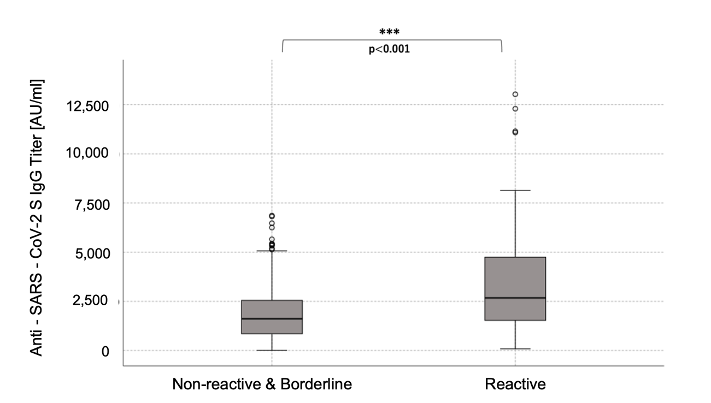
Box-and-whisker plots show the difference in anti-SARS-COV-2 IgG titer between non-reactive & borderline and reactive group of T-SPOT.COVID. In each box-and-whisker plot, the horizontal line represents the median, the top and bottom of the boxes the interquartile range, and the I bar the minimum and maximum values. Spots≧50 is scored as 50. Spots ≦4, 5-7, and ≧8 were considered as non-reactive, borderline and reactive respectively.

