Cyclic Expansion Microscopy: Expanding Biological Tissue through Multiple Cycles for Ultrastructure Imaging
Huizhong Xu^{1,2}*, Qin Xia¹, Lili Chen³, Aidong Wang³, Xiaolong Liu³, Qiu Chen⁴, Haijun Lv³, Tianyu Cai¹, Quan Li¹, Hangyuan Li¹, Zhiyang Yan¹, Jingjing Lu¹, Shipeng Hao¹, Guoyuan Lu⁵*, Jie Qin⁶*
¹School of Physical Science and Technology, Soochow University, Suzhou, Jiangsu, China
²Institute for Advanced Study, Soochow University, Suzhou, Jiangsu, China
³The Second Affiliated Hospital of Soochow University, Suzhou, Jiangsu, China
⁴School of Radiation Medicine and Protection, Medical College of Soochow University, Suzhou, Jiangsu, China
⁵The First Affiliated Hospital of Soochow University, Suzhou, Jiangsu, China
⁶Yancheng First Hospital, Affiliated Hospital of Nanjing University Medical School, Yancheng, Jiangsu, China
*Correspondence:
Huizhong Xu, Institute for Advanced Study and School of Physical Science and Technology, Soochow University, Suzhou 215006, Jiangsu, China. E-mail: hzxu@suda.edu.cn.
Guoyuan Lu, The First Affiliated Hospital of Soochow University, Suzhou 215006, Jiangsu, China. E-mail: sdfyylgy@163.com.
Jie Qin, Yancheng First Hospital, Affiliated Hospital of Nanjing University Medical School, Yancheng 224006, Jiangsu, China. E-mail: qinjieyc@163.com.
Funding information:
National Natural Science Foundation for Young Scholars of China (No. 32001072), and the startup fund (No. Q410800320) from Soochow University (to H.X.); Suzhou Health Commission Science and Technology Project (No. LCZX202002) (to G.L.); Suzhou Science and Technology Planning Project (No. SKJY2021091) (to L.C.); Youth Excellence Projects of CNNC (CNNC-2020) and Youth Excellence Projects of Suzhou Health (GSWS2019042 and GSWS2020031) (to X.L.).
Author contributions: H.X., Q.X., G.L., and J.Q. designed research; X.L., Q.C., H. Lv, G.L. and J.Q. provided biological tissue samples. H.X., Q.X., T.C., Q.L., H. Li, Z.Y., J.L., and S.H. performed expansion experiments; H.X., Q.X., L.C., A.W., and J.Q. performed imaging experiments; H.X. and Q.X. analyzed data; H.X. wrote the paper. All authors discussed the results and the manuscript.
The authors declare no conflict of interest.

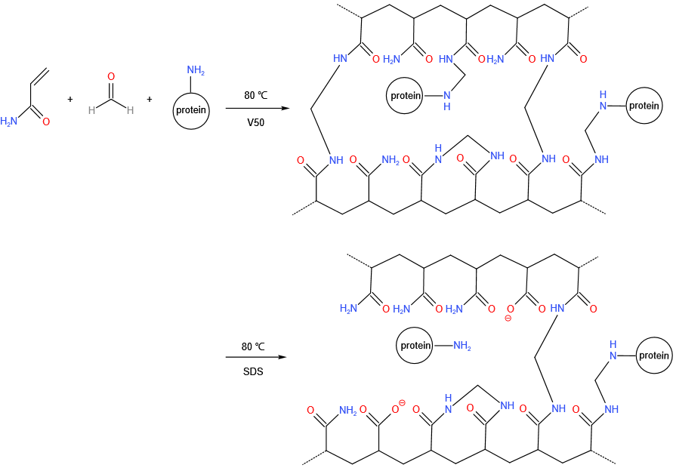
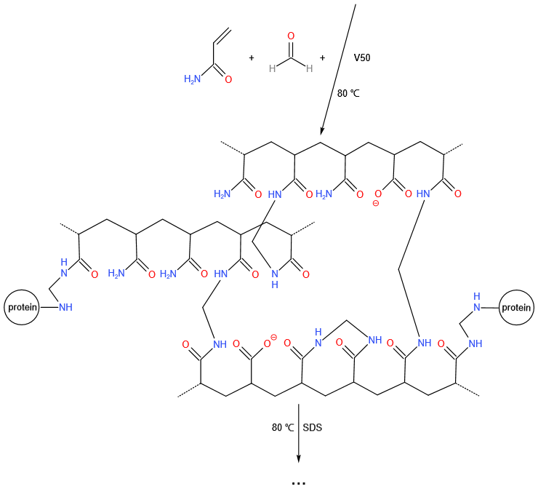
Supplementary Fig. 1 | Chemical principles of Cyc-ExM. The proteins in the tissue are linked to the polyacrylamide hydrogel through formaldehyde crosslinking. Heat denaturation of the sample denatures proteins, partially reverses the crosslinks and partially converts acrylamide into acrylic acid. Cycles of such incremental expansion of the sample is achieved by successive application of such gelation and heat denaturation processes.

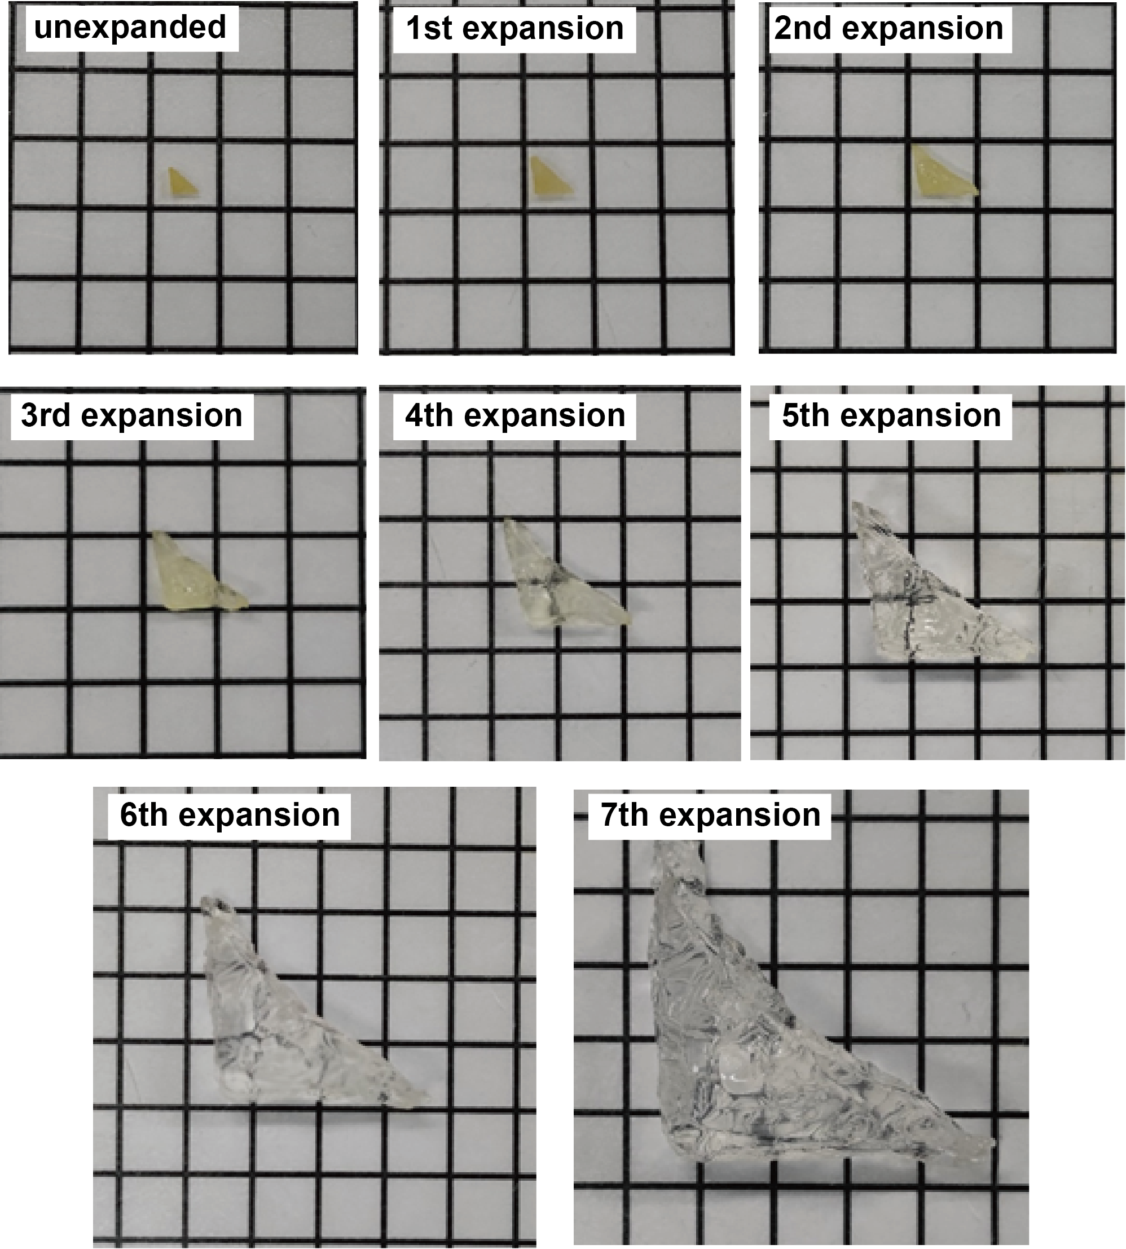
Supplementary Fig. 2 | Macroscopic tissue sizes after each cycle of Cyc-ExM. From top left to bottom right: photographs of a piece of porcine renal tissue (placed on top of 0.6 cm grid paper) before and after each cycle of expansion following Cyc-ExM protocol. The macroscopic linear expansion factors measured from these tissue sizes are 1.39, 1.87, 2.63, 3.85, 5.48, 6.86, and 9.44 from the 1st to the 7th cycle.

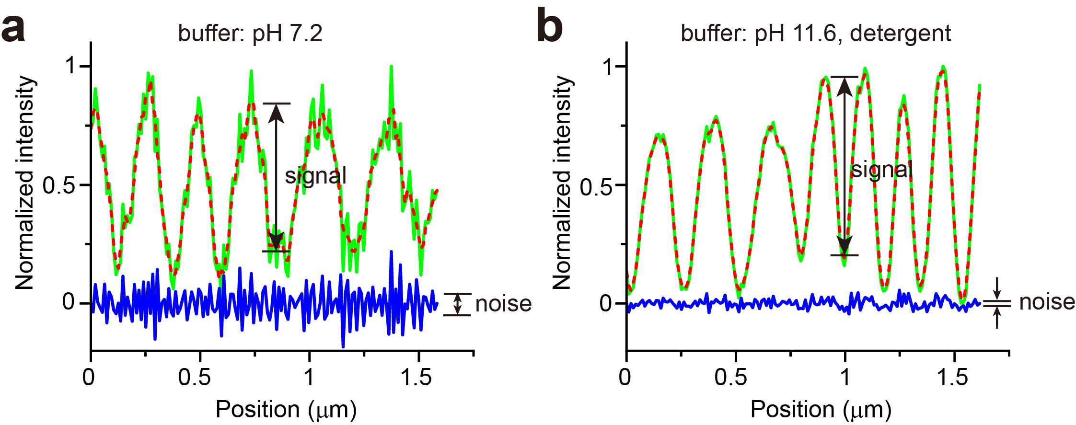
Supplementary Fig. 3 | Signal-to-noise ratio (SNR) calculations for Cyc-ExM samples with NHS ester staining in PBS (pH 7.2) (a) or in 0.1 M Na₂CO₃ (pH 11.6) and detergents (b). Line profile plots (green) shown in Fig. 2c and 2f were analyzed here. The red dashed curves represent 4-point (0.03 μm) moving average smoothing from the green curves. The noise curve (blue) can thus be calculated as the difference between the green and the red curves. The signal is defined as the intensity change between neighboring hill and valley in the smoothed traces and the noise is defined as the standard deviation of the noise traces. Thus, the SNR for (a) is 9.4 ± 2.1 from 5 measurements, and the SNR for (b) is 39 ± 12 from 5 measurements.

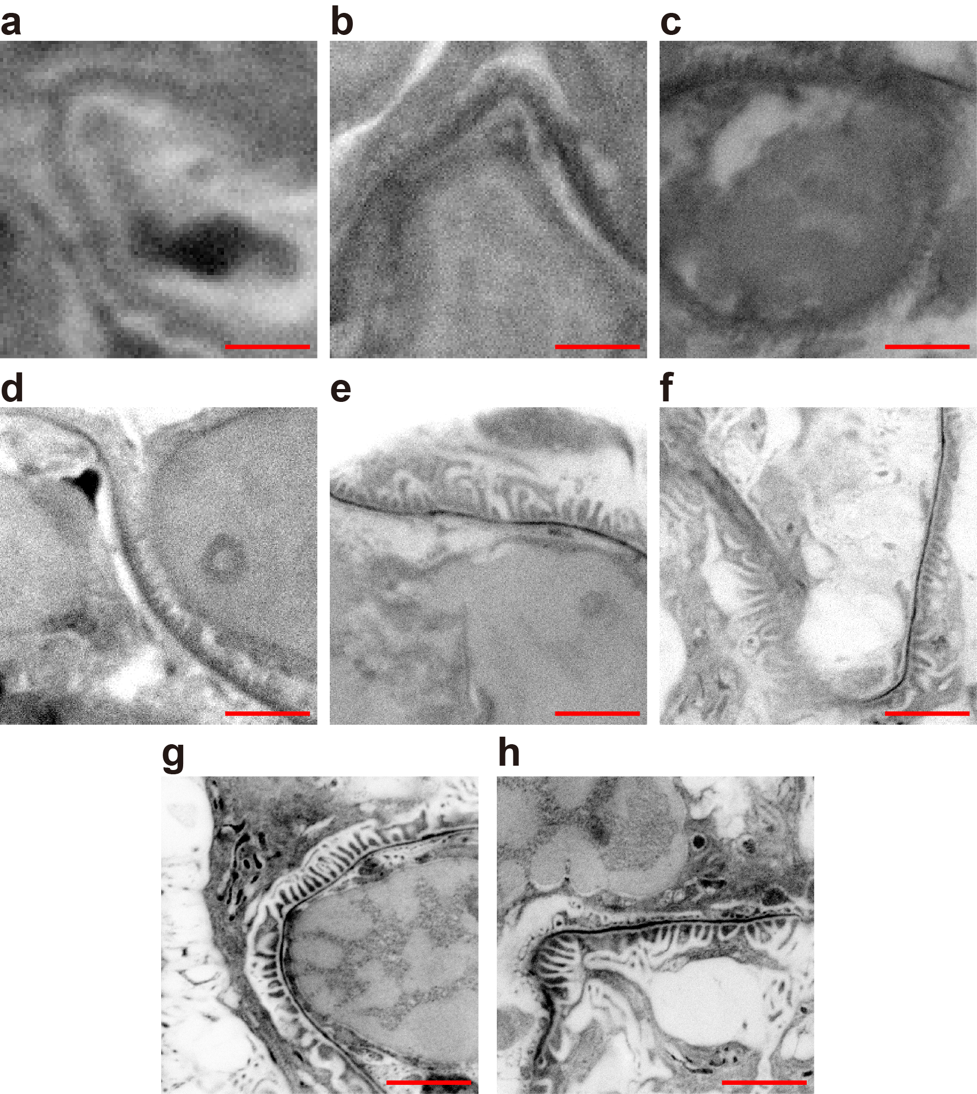
Supplementary Fig. 4 | Confocal fluorescence microscopy images of porcine glomerular capillary region in samples before and after each cycle of Cyc-ExM. (a) No expansion, (b) expanded once, (c) twice, … and (h) 7 times according to Cyc-ExM protocol. The signal represents fluorescently label by TAMRA NHS ester. All figures are displayed with a white-to-black color table to resemble that of TEM image. Scale bars: 2 μm. All distances are in pre-expansion units.

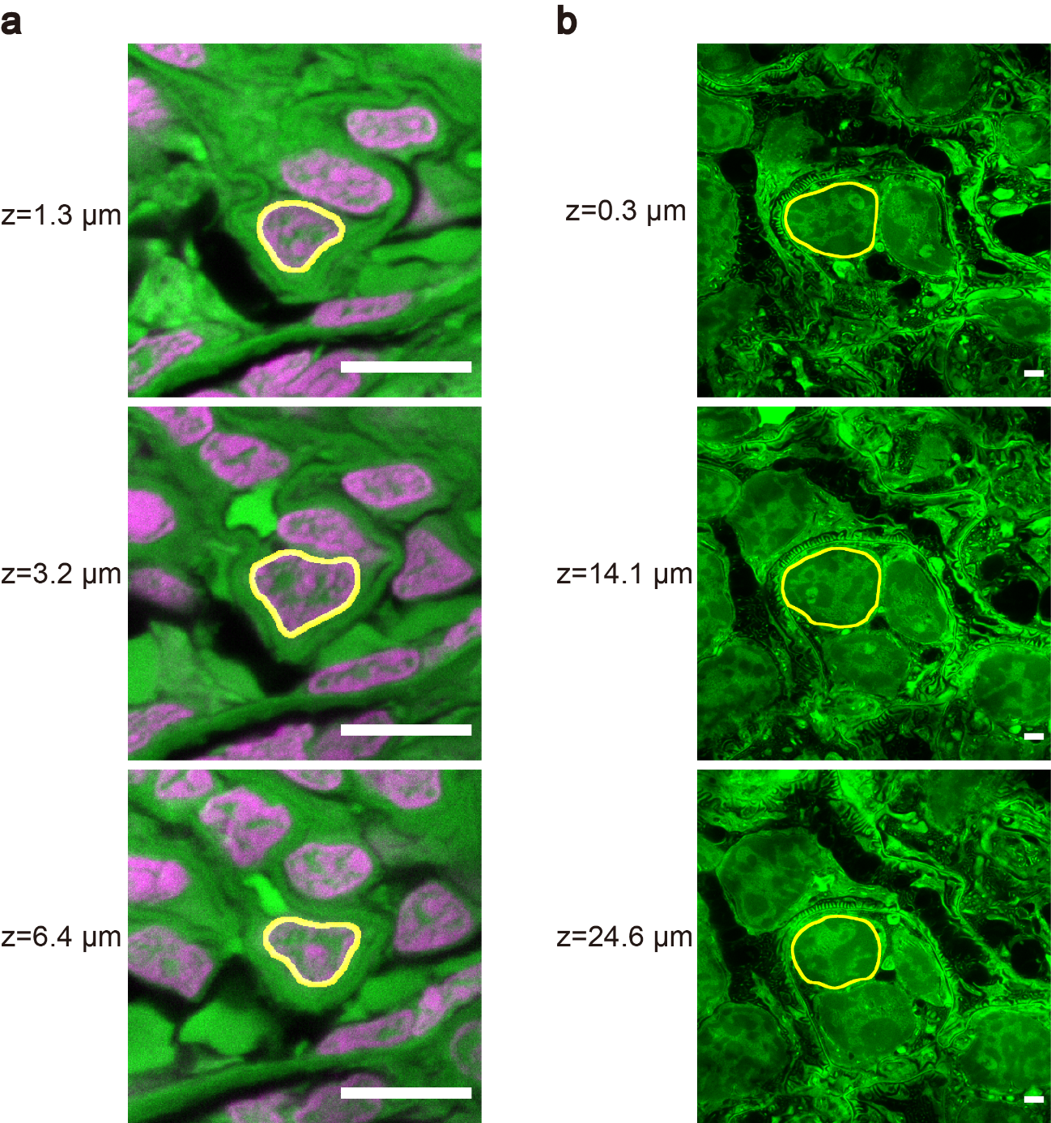
Supplementary Fig. 5 | Illustration of nuclear size measurements for expansion factor calculations. (a) three confocal z-slices of an unexpanded porcine kidney sample stained by NHS ester (green) and DAPI (magenta), among which the z=3.2 μm image was used since it exhibits the largest cross-sectional area (yellow outlines) for a glomerular endothelial cell. (b) three confocal z-slices of a 6-cycle expanded porcine kidney sample stained by NHS ester (green), among which the z=14.1 μm image was used since it exhibits the largest cross-sectional area (yellow outlines) for a glomerular endothelial cell. Scale bars represent 10 μm and are not corrected for the expansion factor. For each expansion sample, measurements of three different nuclear cross section areas before and after expansion was used to compute the expansion factor.

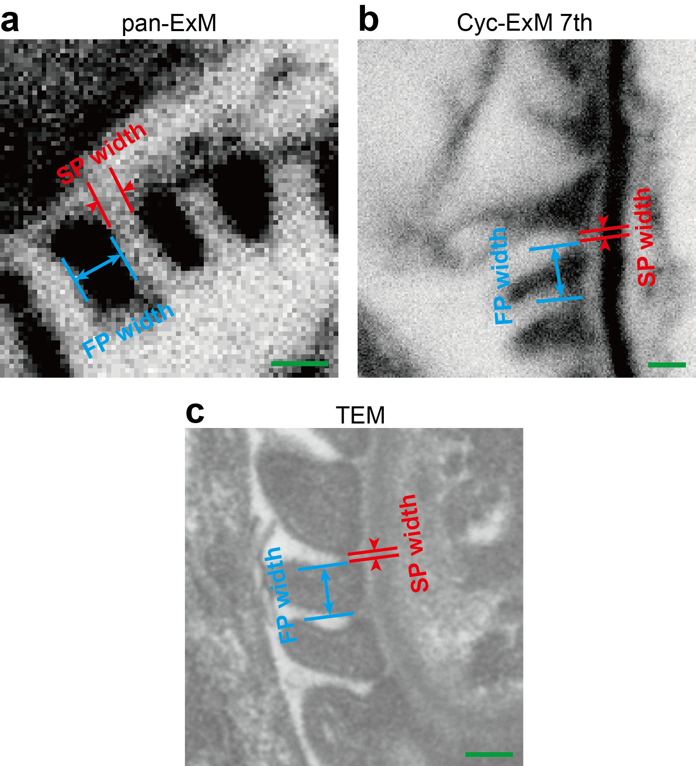
Supplementary Fig. 6 | Illustration of measurements of foot process (FP) width and slit pore (SP) width in expansion microscopy or TEM images. (a) Examples of FP width (blue arrows) and SP width (red arrow heads) in a confocal image of pan-ExM expanded and NHS ester stained porcine kidney sample. (b) Examples of FP width (blue arrows) and SP width (red arrow heads) in a confocal image of 7-cycle expanded and NHS ester stained porcine kidney sample. (c) Examples of FP width (blue arrows) and SP width (red arrow heads) in TEM image of porcine kidney sample. Scale bars: 200 nm. All distances are in pre-expansion units.

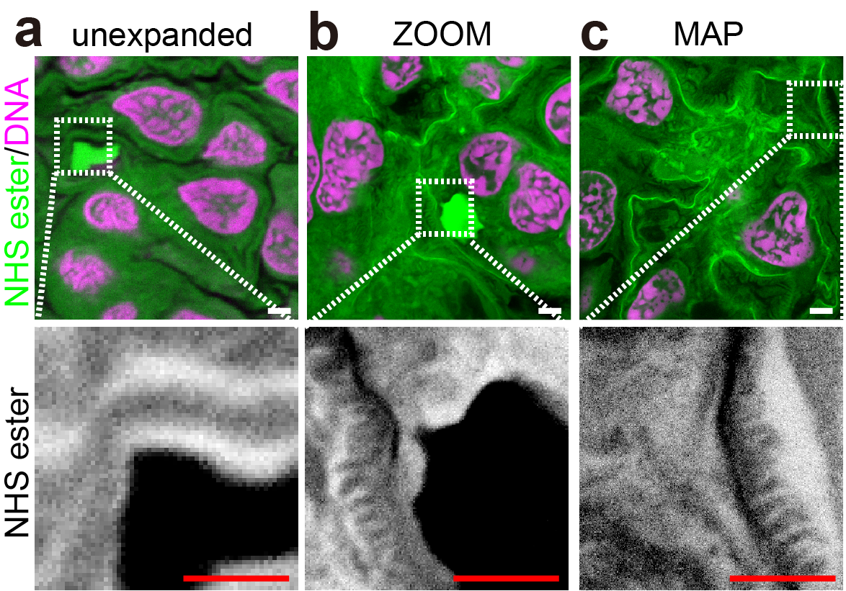
Supplementary Fig. 7 | ZOOM and MAP expanded porcine kidney tissue are unable to resolve the slit pores of glomeruli. Confocal images of porcine kidney samples (a) unexpanded, (b) expanded by ZOOM, or (c) expanded by MAP, with NHS ester (green or grey) and DNA (magenta) staining. Note that ZOOM and MAP expanded samples are able to resolve the foot processes, but not slit pores. Scale bars: 2 µm. All distances and scale bars are in pre-expansion units.

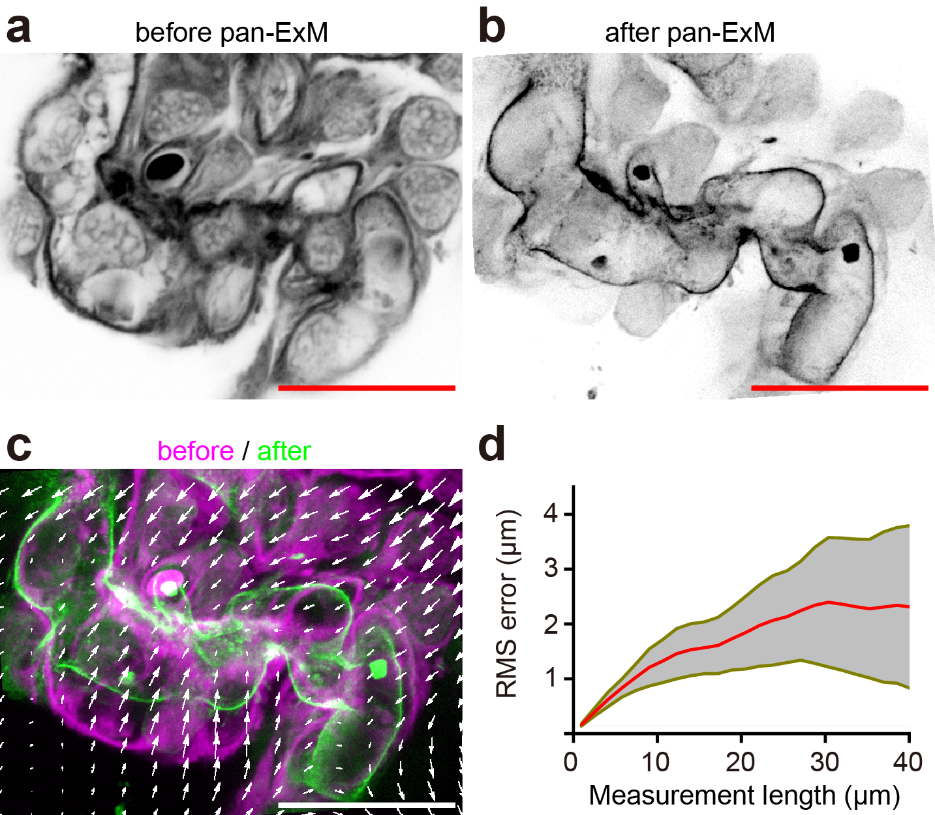
Supplementary Fig. 8 | Assessment of expansion isotropy for pan-ExM expanded porcine glomeruli. (a) One confocal (60× objective lens) image of pre-expansion image of a porcine glomerular region fluorescently labeled by CF 568 maleimide. (b) Confocal (20× objective lens) image of the same region of interest after pan-ExM. (c) Both pre- and post- expansion images aligned by similarity transformation, with distortion vector field shown by arrows. Similarity transformation yields expansion factor of 5.26 ± 0.32 from 3 different regions of interest. (d) Quantification of measurement errors as a function of measurement length shown as mean (red line) ± SD (grey shaded area) from 3 different regions of interest. Scale bars: 20 µm. All distances and scale bars are in pre-expansion units.

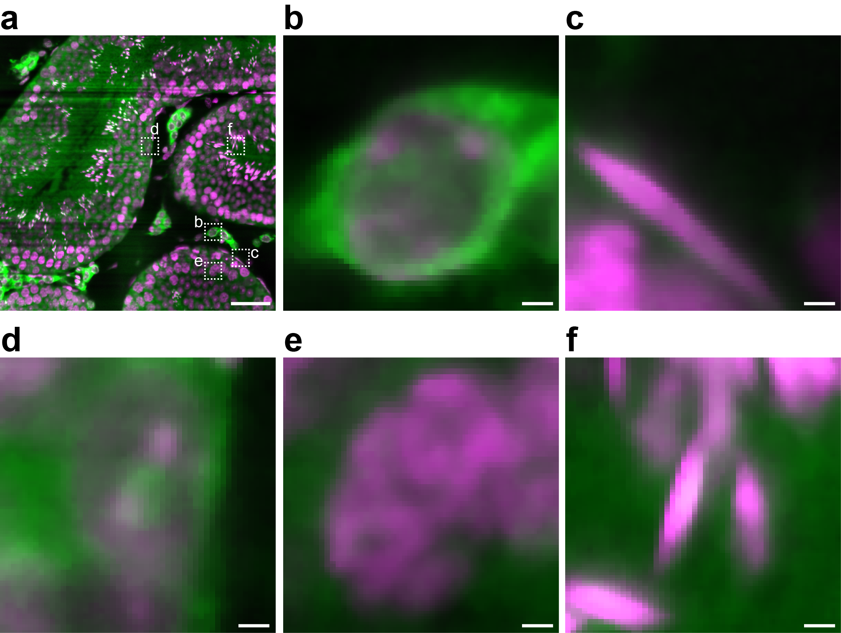
Supplementary Fig. 9 | Visualization of different types of testicular cells in light sheet microscopy image of Cyc-ExM expanded mouse testis samples. (a) One optical slice of a light sheet microscopy image of ~3-mm-thick Cyc-ExM expanded mouse testis tissue (expansion factor: 7.67 ± 0.49) in which NHS ester (green) and nuclei (magenta) show distinct distributions. (b-f) Zoomed-in views of the respective boxed regions in (a) showing different types of cells. (b) An interstitial cell (located outside tubules). (c) A smooth muscle cell (spindle-shaped nucleus, and located at the boundary of tubules). (d) A Sertoli cell (containing evident nucleoli and located near the periphery of the tubules). (e) A pathytene spermatocyte (large round nucleus with clumps of condensed DNA). (f) A sperm (elongated nucleus and located in the middle of tubules). Scale bars: 50 μm (a) and 2 μm (b-f). All distances are in pre-expansion units.

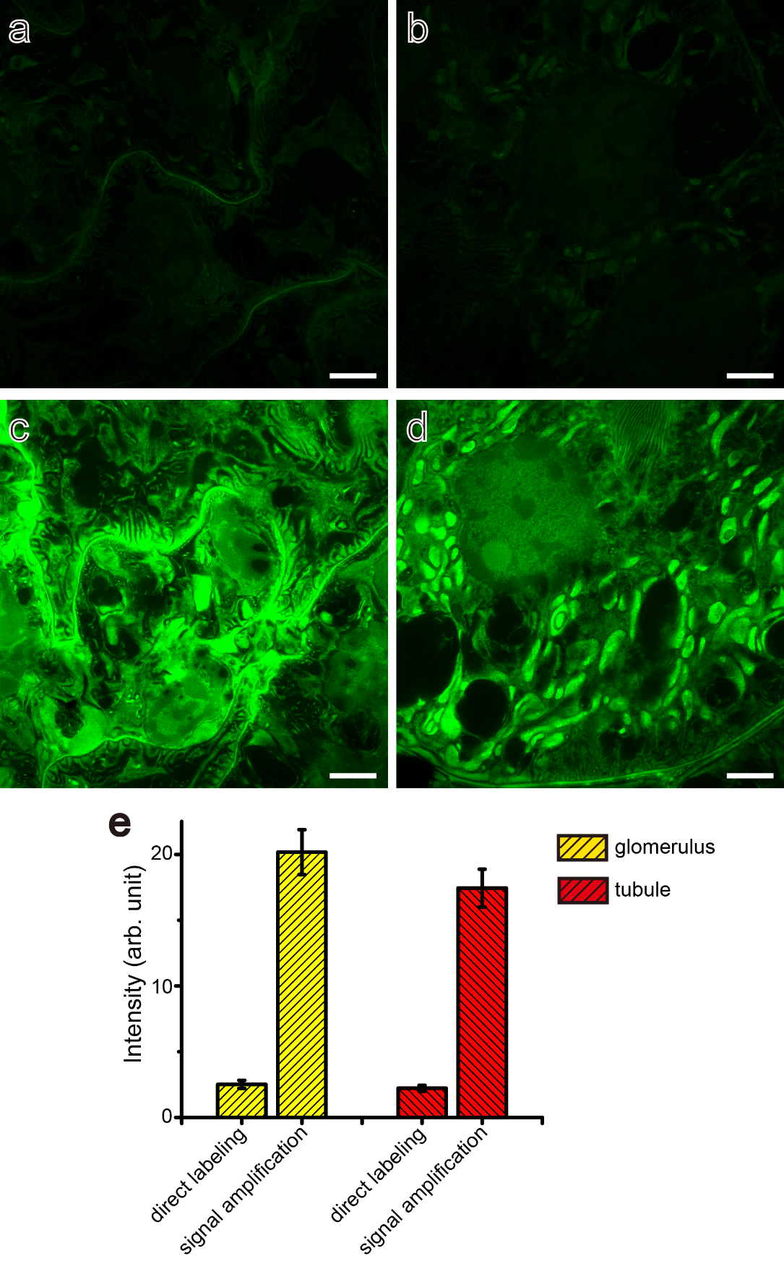
Supplementary Fig. 10 | Enhancement of signal intensity using biotin-streptavidin amplification method. (a) Confocal image of the glomerular region of an 8-cycle expanded porcine renal tissue directly labeled with TAMRA NHS ester. (b) Confocal image of the tubular region of the same sample directly labeled with TAMRA NHS ester. (c)(d) The glomerular and tubular images of the same expansion sample labeled with biotin NHS ester followed by TAMRA conjugated streptavidin. These confocal images were collected under identical setup and displayed with the same maximum and minimum intensity defined intervals. (e) Comparison of the mean intensities from 3 images in each of the above conditions, showing 8.0 ± 1.2 -fold increase due to signal amplification for glomerular images, and 7.9 ± 1.0 -fold increase due to signal amplification for tubular images. Scale bars: 2 μm. All distances are in pre-expansion units.

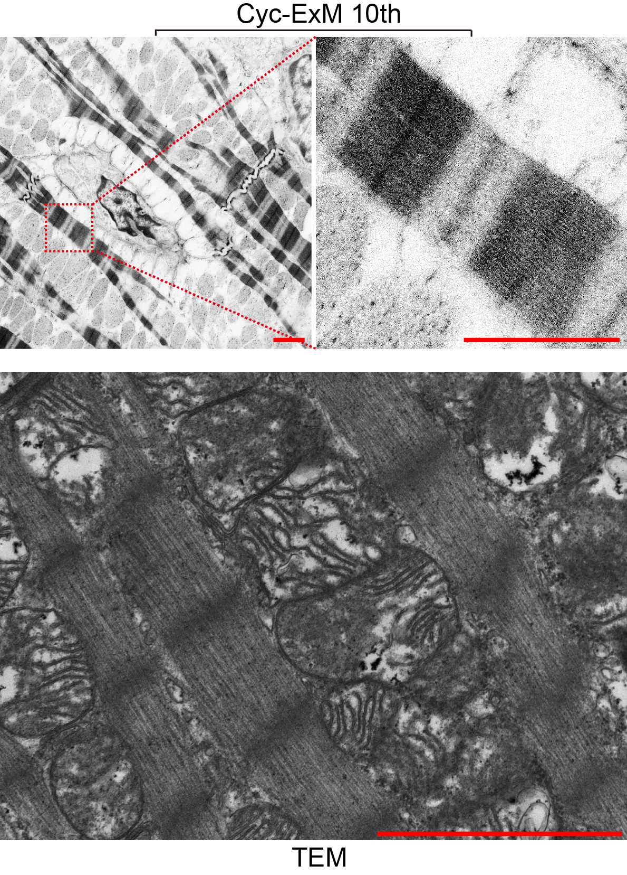
Supplementary Fig. 11 | Comparison of Cyc-ExM and TEM images of heart tissue samples. (Upper panels) Confocal images of muscle fibers in rat heart tissue after 10 cycles of Cyc-ExM. (Lower panel) TEM image of muscle fibers in rat heart tissue. Scale bars: 2 μm. All distances represent pre-expansion units.

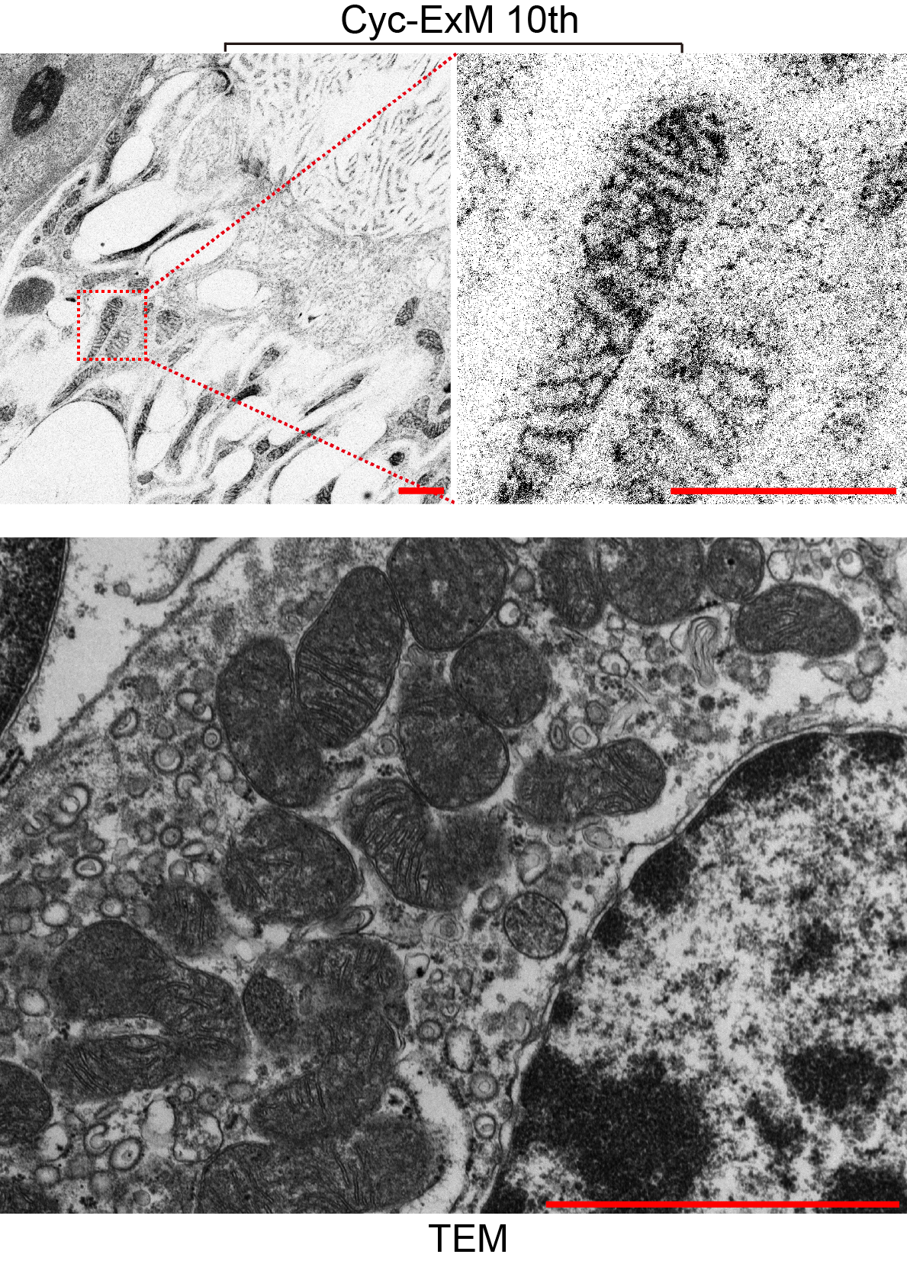
Supplementary Fig. 12 | Comparison of Cyc-ExM and TEM images of kidney tissue samples. (Upper panels) Confocal images of mitochondria in rat kidney tubules after 10 cycles of Cyc-ExM. (Lower panel) TEM image of mitochondria in rat kidney tubules. Scale bars: 2 μm. All distances represent pre-expansion units.
Supplementary Table 1. List of reagents used in this study.
Experimental step | Product name | Vendor | Product number
Fixation | 16% paraformaldehyde (PFA) | Yuanye Bio-Technology | R30422
Fixation | Acrylamide (AA) | Sangon Biotech | A501033-0500
Fixation | Glutaraldehyde (50%) | Aladdin Biochemical Technology | G105907-10ml
Gelation | V50 | Yuanye Bio-Technology | S15042-25g
Gelation | Sodium acrylate (SA) | Yuanye Bio-Technology | S25791-25g
Gelation | N,N′-Methylenebisacrylamide (BIS) | Yuanye Bio-Technology | S14002-25g
Gelation | N,N'-(1,2-Dihydroxyethylene)bisacrylamide (DHEBA) | Macklin | N863569-5g
Gelation | PBS 10x | Beyotime Biotechnology | ST476
Denaturation | 1M Tris-HCl (pH=6.8) | Solarbio | T1020-500
Denaturation | 1M Tris-HCl (pH=9.0) | Solarbio | T1160-500
Denaturation | Sodium dodecyl sulfate | Sangon Biotech | A500228-0001
Denaturation | Sodium chloride | Aladdin Biochemical Technology | C111547-500g
Denaturation | Sodium hydroxide | Aladdin Biochemical Technology | S111498-500g
Staining | 5(6)-Carboxy-tetramethylrhodamine N-succinimidyl ester (TAMRA NHS ester) | Yuanye Bio-Technology | S63718-100mg
Staining | NHS-biotin | Yuanye Bio-Technology | S13005-100mg
Staining | SYTOX Green | Thermofisher | S7020
Staining | Triton X-100 | Beyotime Biotechnology | ST795
Staining | Streptavidin (5mg/ml) | Yeasen Biotechnology | 35101ES60
Staining | sodium carbonate anhydrous | Aladdin Biochemical Technology | S111733-500g
Staining | 4',6-diamidino-2-phenylindole (DAPI) | Keygen Biotech | KGR0001
Staining | rabbit anti-actinin-4 antibody | Sigma-Aldrich | HPA001873
Staining | rabbit anti-podocin antibody | Sigma-Aldrich | P0372
Staining | Fab fragment goat anti-rabbit IgG (H+L) | Jackson ImmunoResearch | 111-007-003
Staining | NHS-Fluorescein | Thermofisher | 46410
Staining | 0.5M TCEP (pH 7.0) | Beyotime Biotechnology | ST049-1ml
Staining | CF568 maleimide | Sigma-Aldrich | SCJ4600026-1UMOL
Imaging | Sucrose | Beyotime Biotechnology | ST1672-1kg

Supplementary Table 2. Expansion factor (EF) calculations for different samples in this study. The sample size is indicated by n. Values are represented as mean ± standard deviation.
Sample condition | Structures used for EF determination | Pre-expansion size | Post expansion size | EF
Porcine kidney fixed in 4% PFA and 20% AA, expanded by ZOOM | Cross section of glomerular endothelial cell nuclei | 30.8 ± 3.3 μm²  (n = 5) | 199 ± 41 μm²  (n = 5) | 2.55 ± 0.29
Porcine kidney fixed in 4% PFA and 20% AA, expanded by MAP | Cross section of glomerular endothelial cell nuclei | 30.8 ± 3.3 μm²  (n = 5) | 616 ± 84 μm²  (n = 3) | 4.48 ± 0.39
Porcine kidney fixed in 4% PFA and 20% AA, expanded by pan-ExM | Cross section of glomerular endothelial cell nuclei | 30.8 ± 3.3 μm²  (n = 5) | 791 ± 197 μm²  (n = 7) | 5.07 ± 0.69
Porcine kidney fixed in 4% PFA and 20% AA, expanded by Cyc-ExM | Cross section of glomerular endothelial cell nuclei | 30.8 ± 3.3 μm²  (n = 5) | 1 cycle:  79.5 ± 7.3 μm²  (n = 5) | 1.61 ± 0.11
 | Cross section of glomerular endothelial cell nuclei | 30.8 ± 3.3 μm²  (n = 5) | 2 cycles:  200 ± 38 μm²  (n = 5) | 2.55 ± 0.28
 | Cross section of glomerular endothelial cell nuclei | 30.8 ± 3.3 μm²  (n = 5) | 3 cycles:  282 ± 56 μm²  (n = 5) | 3.03 ± 0.34
 | Cross section of glomerular endothelial cell nuclei | 30.8 ± 3.3 μm²  (n = 5) | 4 cycles:  518 ± 72 μm²  (n = 5) | 4.10 ± 0.36
 | Cross section of glomerular endothelial cell nuclei | 30.8 ± 3.3 μm²  (n = 5) | 5 cycles:  1000 ± 114 μm²  (n = 5) | 5.70 ± 0.45
 | Cross section of glomerular endothelial cell nuclei | 30.8 ± 3.3 μm²  (n = 5) | 6 cycles:  1794 ± 350 μm²  (n = 5) | 7.64 ± 0.85
 | Cross section of glomerular endothelial cell nuclei | 30.8 ± 3.3 μm²  (n = 5) | 7 cycles:  2337 ± 353 μm²  (n = 5) | 8.72 ± 0.81
 | Cross section of glomerular endothelial cell nuclei | 30.8 ± 3.3 μm²  (n = 5) | 8 cycles:  4564 ± 729 μm²  (n = 5) | 12.2 ± 1.2
Porcine kidney fixed in 4% PFA and 20% AA, stained by actinin-4 antibody, and expanded by 6 cycles of Cyc-ExM | Cross section of glomerular endothelial cell nuclei | 30.8 ± 3.3 μm²  (n = 5) | 4262 ± 626 μm²  (n = 3) | 11.8 ± 1.1
Porcine kidney fixed in 4% PFA and 20% AA, stained by podocin antibody, and expanded by 6 cycles of Cyc-ExM | Cross section of glomerular endothelial cell nuclei | 30.8 ± 3.3 μm²  (n = 5) | 4454 ± 797 μm²  (n = 3) | 12.0 ± 1.3
Rat intestine fixed in 4% PFA, expanded by Cyc-ExM | Cross section of mucosa cell nuclei | 36.7 ± 7.1 μm²  (n = 5) | 6 cycles:  2387 ± 687 μm²  (n = 5) | 8.1 ± 1.4
Mouse lung fixed in 4% PFA, expanded by Cyc-ExM | Cross section of pneumocyte cell nuclei | 30.1 ± 3.8 μm²  (n = 3) | 6 cycles:  3602 ± 349 μm²  (n = 3) | 10.95 ± 0.88
Rat heart fixed in 4% PFA, expanded by Cyc-ExM | Cross section of cardiac muscle cell nuclei | 66.5 ± 7.7 μm²  (n = 3) | 6 cycles:  3328 ± 433 μm²  (n = 3) | 7.07 ± 0.61
Rat heart fixed in 4% PFA, expanded by Cyc-ExM | Length of one sarcomere in cardia muscle | 1.83 ± 0.05 μm  (n = 3) | 10 cycles:  31.2 ± 1.9 μm  (n = 3) | 17.0 ± 1.1
Rat liver fixed in 4% PFA, expanded by Cyc-ExM | Cross section of hepatocyte nuclei | 74.6 ± 2.6 μm²  (n = 5) | 6 cycles:  4592 ± 1236 μm²  (n = 5) | 7.9 ± 1.1
Rat liver fixed in 4% PFA, expanded by Cyc-ExM | Width of mitochondria in hepatocytes | 0.763 ± 0.088 μm  (n = 6) | 10 cycles:  17.5 ± 1.7 μm  (n = 6) | 23.0 ± 3.5
Rat kidney fixed in 4% PFA, expanded by Cyc-ExM | Cross section of proximal tubule cell nuclei | 46.6 ± 9.0 μm²  (n = 5) | 6 cycles:  3115 ± 398 μm²  (n = 5) | 8.18 ± 0.95
Rat kidney fixed in 4% PFA, expanded by Cyc-ExM | Width of mitochondria in proximal tubules | 0.404 ± 0.031 μm  (n = 6) | 10 cycles:  10.8 ± 1.1 μm  (n = 6) | 26.7 ± 3.4
Mouse testis fixed in 4% PFA and 20% AA, expanded by 4 cycles of Cyc-ExM | Cross section of pachytene cell nuclei | 132 ± 12 μm²  (n = 5) | 7769 ± 710 μm²  (n = 5) | 7.67 ± 0.49

Supplementary Video 1. Z-stack view of the 3D confocal microscopy of porcine glomerular capillaries expanded by 7 cycles of Cyc-ExM and stained with TAMRA NHS ester. The images are displayed with a white-to-black color table. Total image volume is 10.8 μm × 10.8 μm × 3.6 μm (after being divided by the expansion factor). Scale bar: 2 μm.
Supplementary Video 2. Z-stack view of one 3D confocal microscopy image of mouse testis expanded by 4 cycles of Cyc-ExM and stained with TAMRA NHS ester (green) and Sytox Green (magenta). Total image volume is 26.4 μm × 26.4 μm × 4.2 μm (after being divided by the expansion factor). Scale bar: 2 μm.
Supplementary Video 3. Z-stack view of another 3D confocal microscopy image of mouse testis expanded by 4 cycles of Cyc-ExM and stained with TAMRA NHS ester (green) and Sytox Green (magenta). Total image volume is 26.4 μm × 26.4 μm × 4.2 μm (after being divided by the expansion factor). Scale bar: 2 μm.
Supplementary Video 4. Z-stack view of the 3D light sheet microscopy of mouse testis expanded by 4 cycles of Cyc-ExM and stained with TAMRA NHS ester (green) and Sytox Green (magenta). Total image volume is 351 μm × 351 μm × 521 μm (after being divided by the expansion factor). Scale bar: 50 μm.

