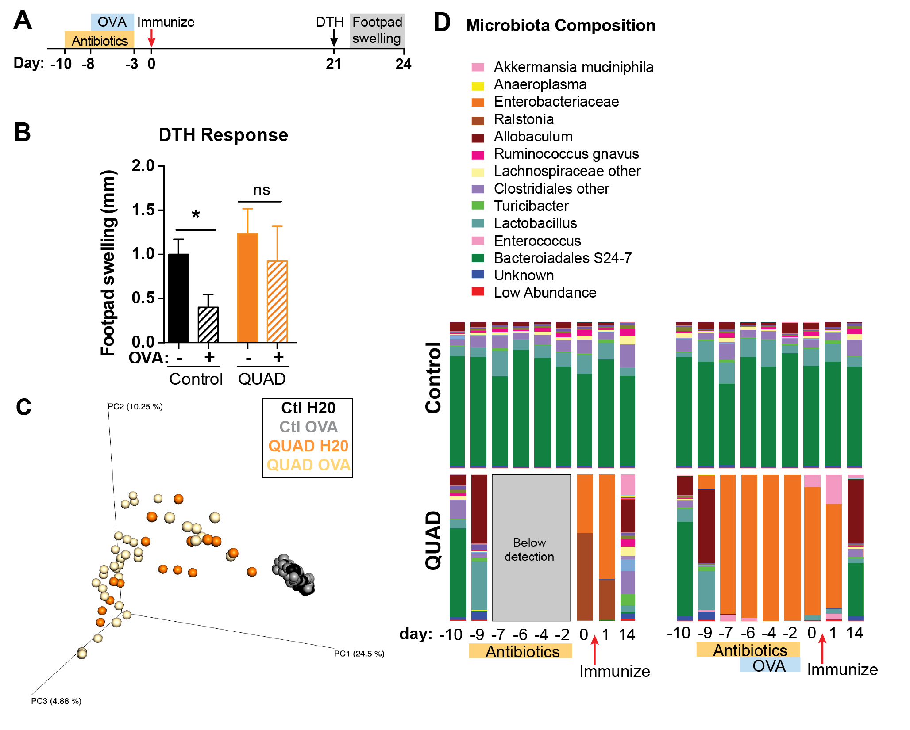
c
b
d
a

Supplemental Figure 1. Antibiotic specific effects on oral tolerance. (a) Microbiota was depleted with a combination of 4 antibiotics (QUAD) in the drinking water for 3 days, and control mice did not receive antibiotics (n=10 mice each). Two days later, half of each group were then fed OVA in the drinking water for 5 days. Antibiotics and OVA were stopped and two days later mice were immunized with OVA/CFA. (b) Responsiveness to OVA was measured by delayed type hypersensitivity by injecting OVA into the footpad 21 days after OVA/CFA immunization. Data are mean + SEM; n=5 mice/group; one-way ANOVA. (c) Principal coordinate analysis of unweighted UniFrac distances during OVA feeding and antibiotic treatment for days -9 through +1. (d) Fecal microbiota composition over 24 days.

c
b
a
d

Supplemental Figure 2. Cytokine expression in CD4 and CD8 T cells from the lamina propria of WT vs. γδ^{-/-} mice. (a-d) Small intestine lamina propria of naïve WT and γδ^{-/-} mice were collected and flow cytometric analysis performed for IL-10 (a) and IFN-γ (b) in CD4 T cells, and IFN-γ (c) and IL-17A (d) in CD8 T cells. Data are mean + SEM; n=4 mice/group; Student’s t-test. * p < 0.05. Results are representative of at least two independent experiments.

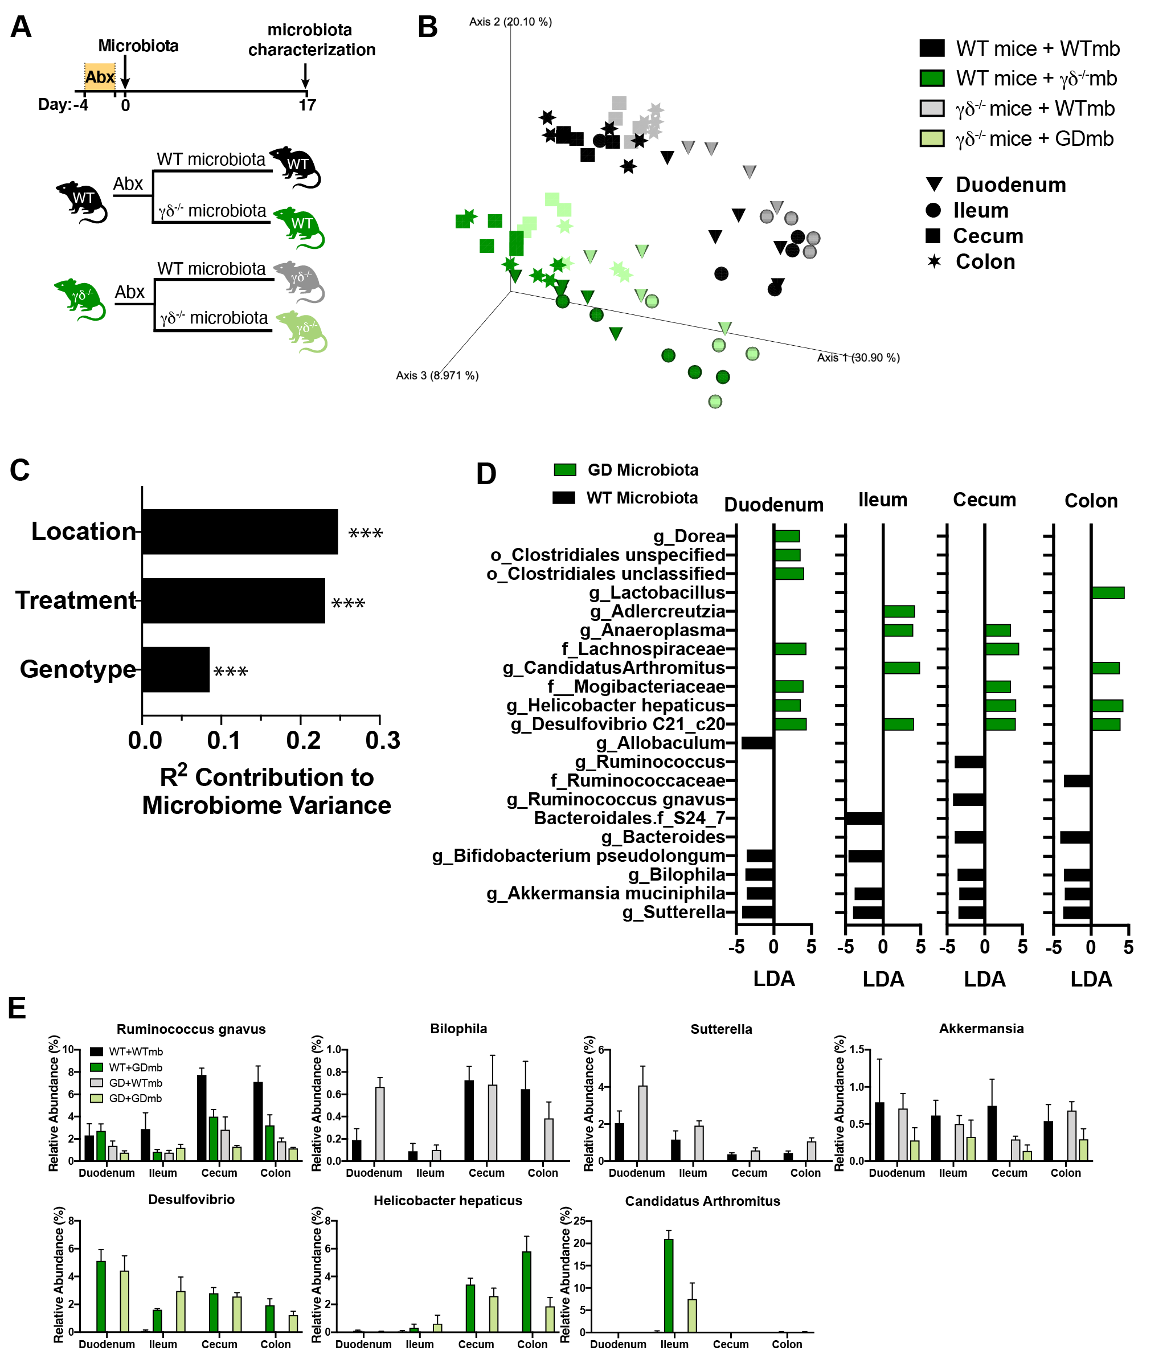
e
d
c
b
a

Supplemental Figure 3. Microbiota alterations associated with the loss of oral tolerance. (a) Microbiota was depleted with a combination of 4 antibiotics (ABX) in the drinking water for 3 days and one day later, microbiota from WT and γδ^{-/-} mice were swapped. Microbiota differences were characterized 17 days post colonization by 16S rRNA sequencing of the 16S rRNA gene. b) Principal coordinates analysis of unweighted UniFrac distances. c) ADONIS testing of unweighted UniFrac distances shows that composition varies by microbiota donor source (23.1%), genotype (8.50%), and anatomical location (24.7%), p < 0.001, ADONIS test. d) Bacteria elevated in γδ^{-/-} microbiota colonized mice (green) or WT microbiota colonized mice (black). Linear discriminant analysis (LEfSe) with microbiota source as set as the class and recipient genotype set as the subclass. e) Relative abundance of select taxa associated with γδ^{-/-} microbiota vs WT microbiota colonization.
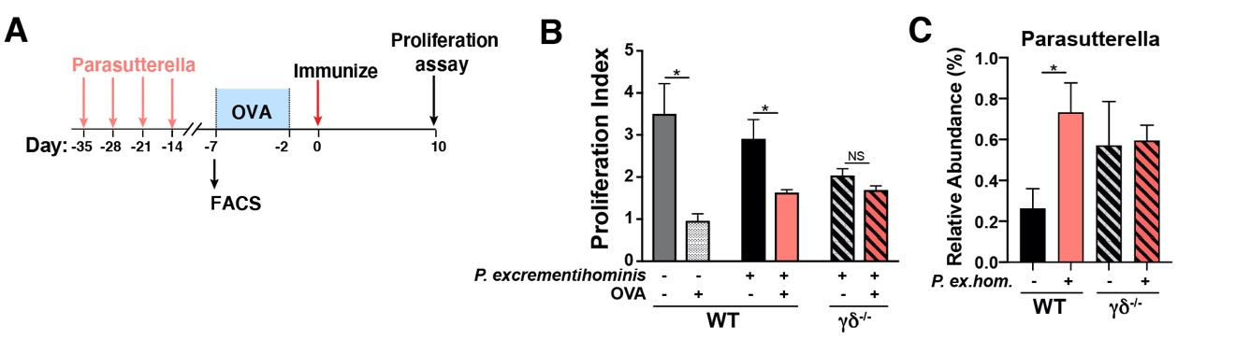
c
a
b
Supplemental Figure 4. P. excrementihominis does not impair oral tolerance. (a) WT and γδ^{-/-} mice were gavaged with P. excrementihominis once a week for 4 weeks. One week later, half of each group were fed OVA in the drinking water for 5 days. OVA continuous feeding was stopped and two days later mice were immunized with OVA/CFA. (b) Responsiveness to OVA was measured by splenocyte proliferation upon 100 mg/ml of OVA stimulation. Data are mean + SEM; n=5 mice/group; one-way ANOVA. (c) Relative abundance of P. excrementihominis in WT and γδ^{-/-} mice colonized with P. excrementihominis. Data are mean + SEM; n=10 mice/group; one-way ANOVA. NS=non-significant, * p < 0.05. Results are representative of at least two independent experiments.

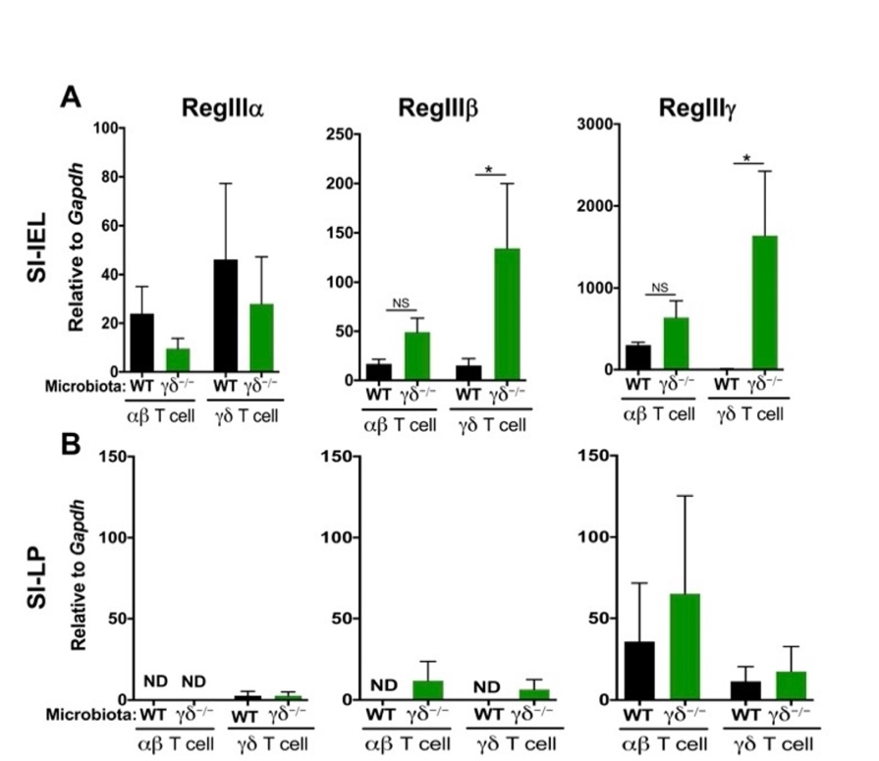
b
a

Supplemental Figure 5. γδ^{-/-} microbiota induces antimicrobial peptide production by γδ T cells. (a, b) Microbiota was depleted in WT recipient mice with a combination of 4 antibiotics in the drinking water for 3 days and one day later they were colonized with either WT or γδ^{-/-} microbiota. Mice were euthanized 2 weeks later, and αβ and γδ T cells from small intestine (SI) intraepithelial (IEL) layer (a) and lamina propria (LP; b) sorted for RT-qPCR analysis of the antimicrobial peptides RegIIIa, RegIIIb and RegIIIg mRNA expression. Data are mean + SEM; n=5 mice/group; one-way ANOVA. ND= not detected, NS=non-significant, * p < 0.05.

