Hybrid (dynamical-statistical) models to improve seasonal drought prediction: application to regional meteorological droughts in China
Zhiyong Wu^{1,2} · Hao Yin¹ · Hai He¹ · Yuan Li¹
¹College of Hydrology and Water Resources, Hohai University, Nanjing 210098, China
²Yangtze Institute for Conservation and Development, Hohai University, Nanjing 210098, China
Correspondence to: Zhiyong Wu (wzyhhu@gmail.com)
Supplementary Material
Supplement 1 Details about random forest
Random forest belongs to the Bagging class of algorithms, and Bagging is a method belonging to Ensemble Learning, which trains multiple weak models to pack together to form a strong model. In random forest, decision trees are chosen for the weak models. The RF used in this study is a packaged combination of multiple binary decision trees (Cart).
- Training process
The training process is shown in Fig. S1.
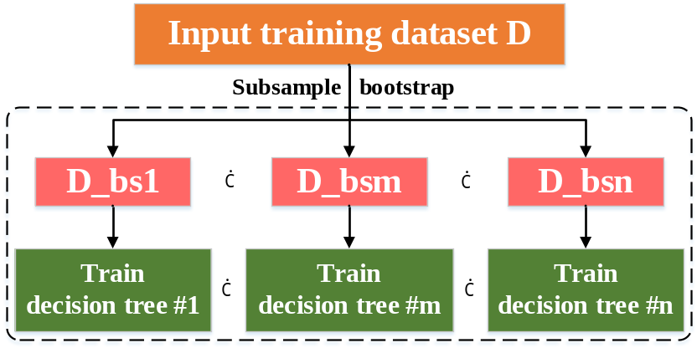
Fig. S1 RF training process. D represents the set of all daily samples from 1980-2011; each sample contains 5*51*76 units shown in Fig. 2; m represents the m^{th} subsample; D_bs represents the set of subsamples composed of one bootstrap; the size of subsample is the size N of D; the details of the decision tree are not described here
- Model output
The output result of RF is obtained by averaging the results of all Carts. The training process of Carts is mainly divided into the following steps.
Step1: For a certain input sample, starting from the root node of Cart, determine whether the current node is a leaf node; if yes, return the predicted value of the leaf node (i.e., the average value of the target variable of the sample in the current leaf), if not, go to the next step
Step2: According to the segmentation variable and segmentation value of the current node, compare the value of the corresponding variable in the sample with the node's segmentation value. If the sample variable value is less than or equal to the current node segmentation value, then visit the left child node of the current node; if the sample variable value is greater than the current node segmentation value, then visit the right child node of the current node.
Step3: Repeat step 2 until the leaf node is visited, and return the predicted value of the leaf node.
- Calculate feature importance
The importance of a feature indicates the degree of influence of a feature on the prediction result. The greater (less) the importance of a feature, the greater (less) the influence of the feature on the prediction result. The importance of a feature in RF is the average value of the importance of the feature in all decision trees. In the decision trees of this study, a unit represents a feature. The importance of a certain node k is:
$n_{k}=ω_{k}*G_{k}-ω_{left}*G_{left}-ω_{right}*G_{right}$ (S1)
Among them, $ω_{k}$,$ω_{left}$,$ω_{right}$ are the ratio of the number of training samples to the total number of training samples in node k and its left and right child nodes respectively, and $G_{k}$,$G_{left}$,$G_{right}$ are respectively the impurity of node k and its left and right child nodes. After calculating the importance of each node, the importance of a certain feature can be obtained by Eq. S2.
$f_{i}=\frac{\sum_{j∈nodes split on feature i}{n_{j}}}{\sum_{j∈all nodes}{n_{k}}}$ (S2)
In order to facilitate the sum of the importance of all features to equal 1, the importance of each feature needs to be normalized.
$f_{ni}=\frac{f_{i}}{\sum_{j∈all nodes}{f_{j}}}$ (S3)
According to Eq. S3, the importance of each of the 5*51*76 units can be calculated, and we set a threshold (0.5*median), and the units with importance greater than this threshold are selected, i.e., the n units in Fig. 2.
Supplement 2 Details about Lasso
Lasso adds a penalty function to the multiple linear regression model to compress some coefficients while setting some coefficients to 0. It retains the advantage of subset contraction and is a biased estimation for dealing with data with complex covariance. Lasso obtains a more realistic and reliable regression method for the regression coefficients at the cost of losing some information and reducing accuracy by giving up the least-square method's unbiasedness.
In the SPI3 prediction of this article, given the feature vector $x=(x_{1}, x_{2}, ⋯, x_{n})$ of n units with Supplement 1 output, where $x_{i}$ is the value of x on the i^{th} unit, the prediction SPI3 is performed by a linear combination of n units with the following equation:
$f\left(x\right)=ω_{1}x_{1}+ω_{2}x_{2}+⋯+ω_{n}x_{n}$ (S4)
where $ω=(ω_{1}, ω_{2}, ⋯, ω_{n})$ is the weight of each unit.
The loss function is defined as
$loss\left(ω\right)={∥f\left(x\right)-y∥}^{2}+α∥ω∥$ (S5)
where y denotes the observed SPI3, and $α∥ω∥$ is the regularization term. By minimizing $loss\left(ω\right)$, the model is learned to obtain $ω$, and thus the Lasso model is determined.
Supplement 3 Details about ANN
The ANN used in this study is a single-layer, 16-node neural network with the structure shown in Supplementary Fig. S2. The model is trained using the backpropagation algorithm.
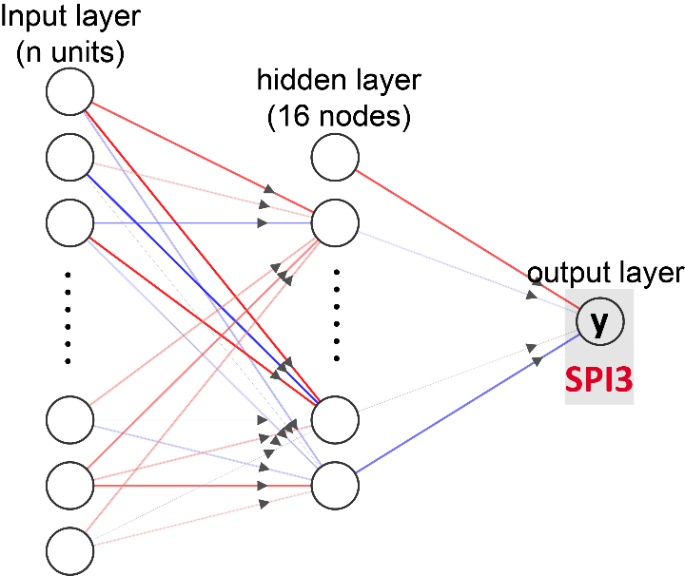
Fig. S2 ANN model structure. The input layer is the n units obtained from Supplement 1, and the hidden layer contains 16 nodes; the relu activation function is used between the input layer and the hidden layer; the hidden layer and the output layer are connected linearly
This study constructs a regression model, so the output layer does not have an activation function. The equations are as follows.
$y^{(1)}=W^{(1)}x+b^{(1)}$ (S5)
$y_{predict}=W^{\left(2\right)}φ_{1}(y^{(1)})+b^{(2)}$ (S6)
Where x is the feature vector composed of n units; $y^{(i)}$ is the input signal of the i^{th} hidden layer; $W^{(i)}$ is the connection weight from the (i-1)^{th} layer to the i^{th} layer ; $b^{(i)}$ is the connection deviation from the (i-1)^{th} layer to the i^{th} layer, $φ_{i}$ is the activation function of the i^{th} hidden layer; $y_{predict}$ (predicted SPI3) is the output signal of the output layer. The activation function for hidden layer neurons is relu, the equation is as follows:
$φ(z)=max⁡(0, z)$ (S7)
The optimization algorithm is Adam's algorithm, which is an extended form of stochastic gradient descent algorithm and it is quite robust for the choice of hyperparameters.
Supplement 4 Predicting drought processes in North and South
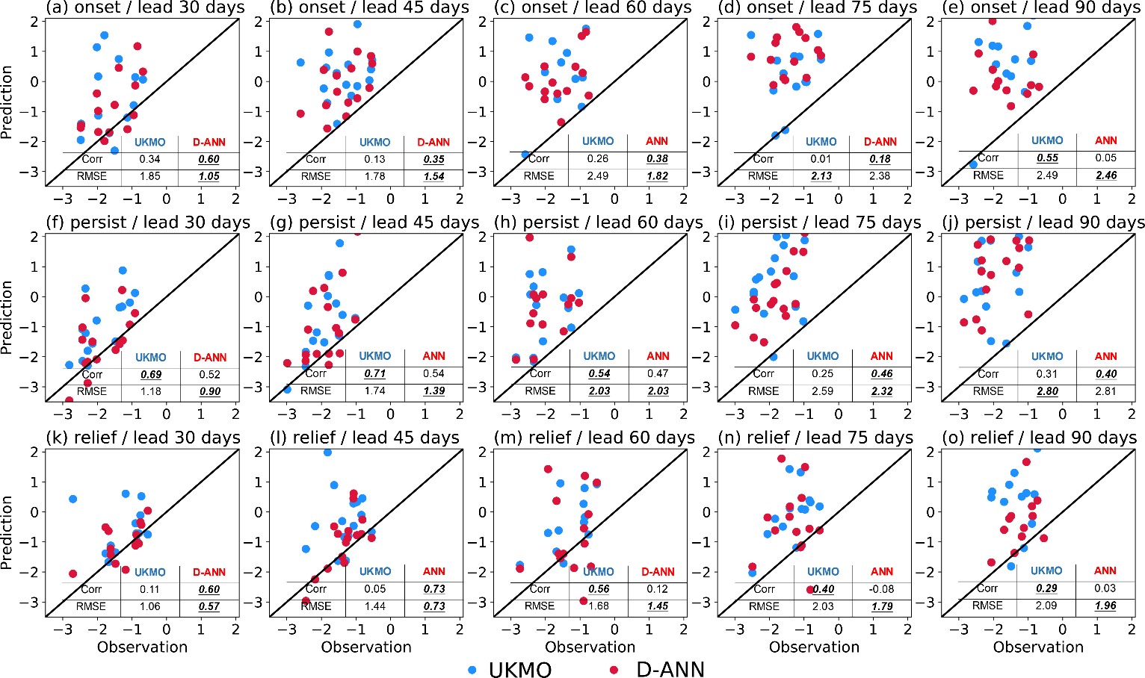
Fig. S3 Predictions of drought phases with different lead times (days) in the north study region of China: UKMO and D-ANN outputs are shown in blue and red, respectively; a–e, drought onset phase; f–j, drought persistence phase; k–o, drought relief phase. Corr and RMSE represent correlation coefficient and root-mean-square error, respectively
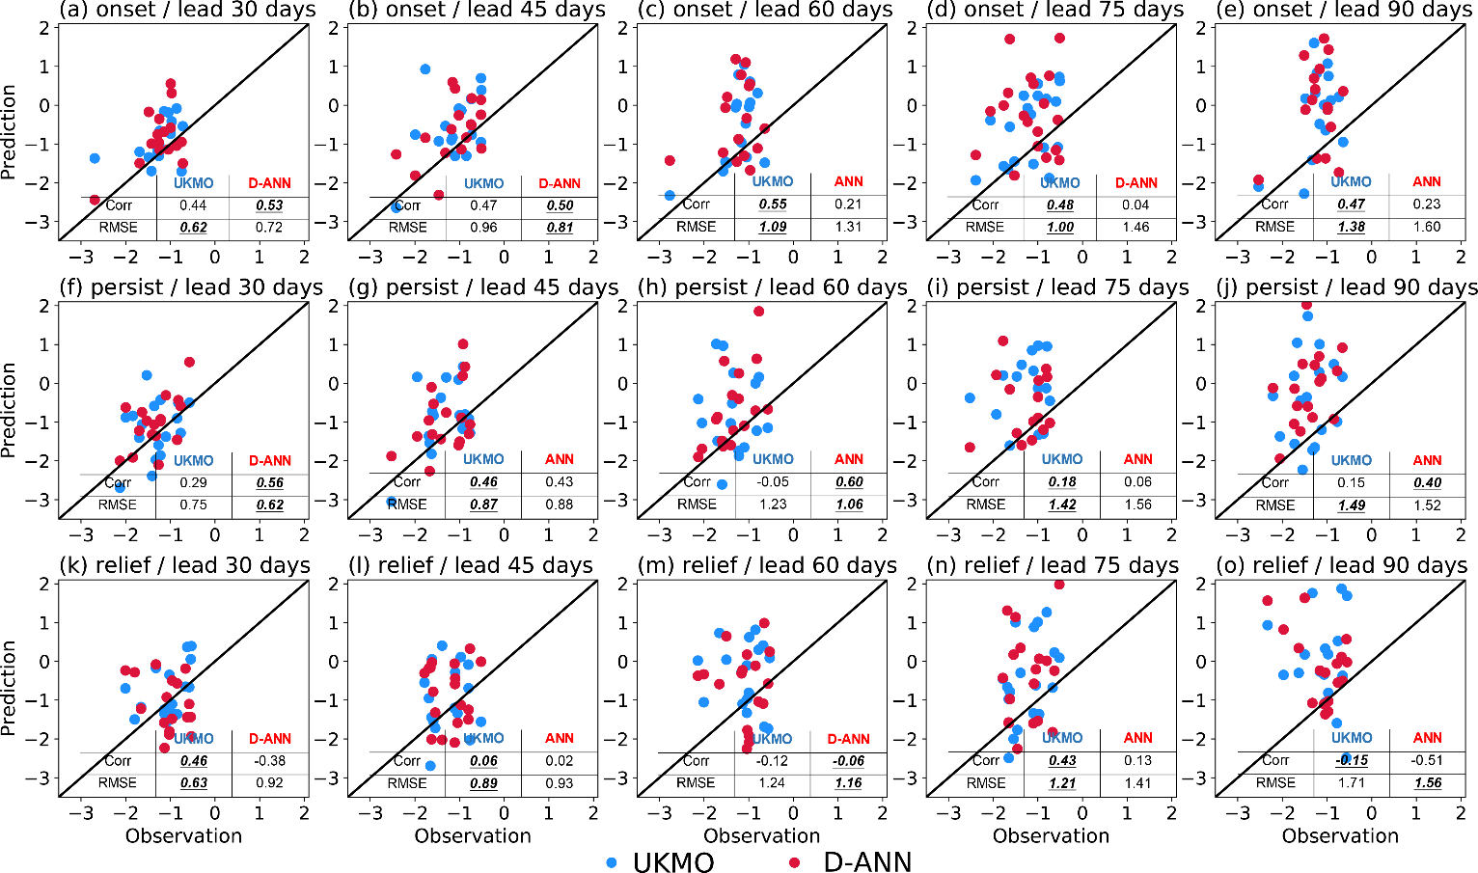
Fig. S4: Predictions of drought phases with different lead times (days) in the south study region of China: UKMO and D-ANN outputs are shown in blue and red, respectively; a–e, drought onset phase; f–j, drought persistence phase; k–o, drought relief phase. Corr and RMSE represent correlation coefficient and root-mean-square error, respectively

