SI 1. A sample of the HealthingU web-based survey report that we provided to cancer patients in this study
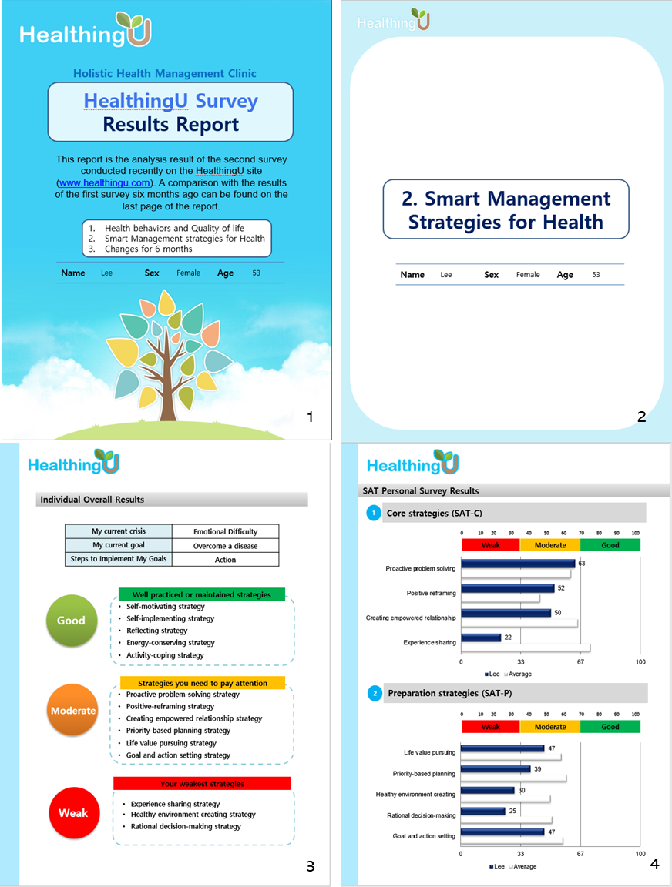

SI 2. Performance comparison of models 1, 2, and 3 for model selection
- Model 1: QoL predictive model based on sociodemographic and clinical variables alone
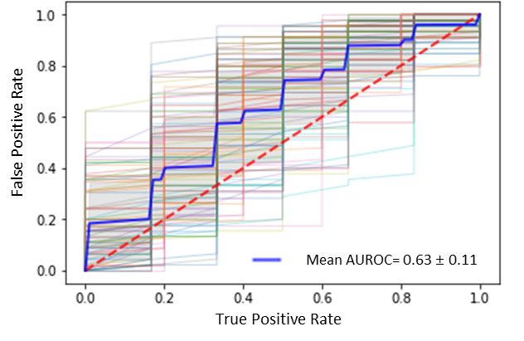
- Model 2: QoL predictive model based on sociodemographic and clinical variables plus SAT scores
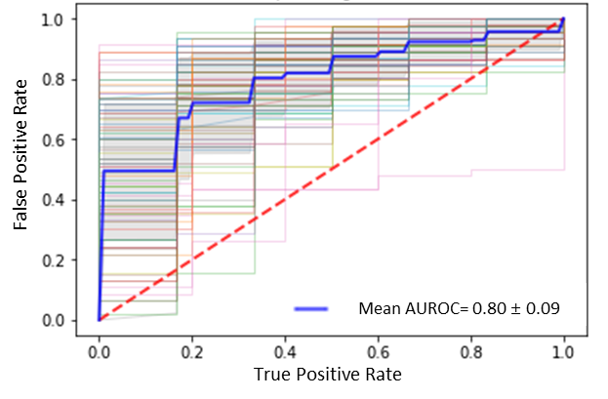
- Model 3: QoL predictive model based on SAT scores alone
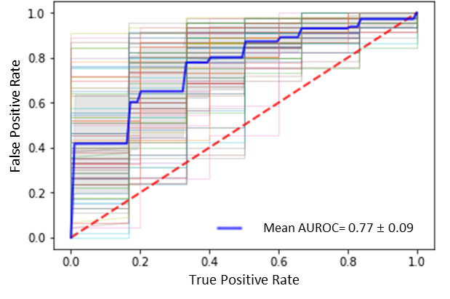

SI 3. The final tuned hyperparameters of the XGBoost model for predicting global QoL
Hyperparameters |  | Values
Number of trees (n_estimator) |  | 50
Maxinum tree depth (max_depth) |  | 3
Learning rate (learning_rate) | 0.06
Subsample proportion (subsample) |  | 0.89
Minimum sum of instance weight needed in a child node (min_child_weight) |  | 2
Minimal loss to expand on a leaf node (gamma) |  | 1.5

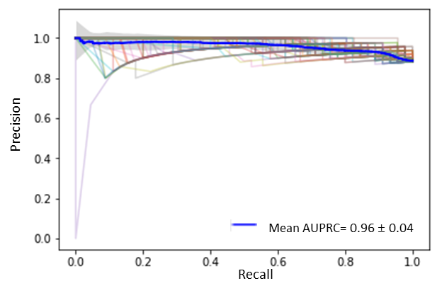
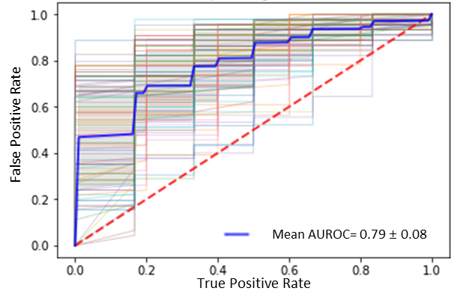
SI 4. Area under the receiver operator characteristic curve (AUROC) and area under the precision-recall curve (AUPRC) of different algorithms for predicting global QoL in the XGBoost model
AUROC | AUPRC
Decision Tree
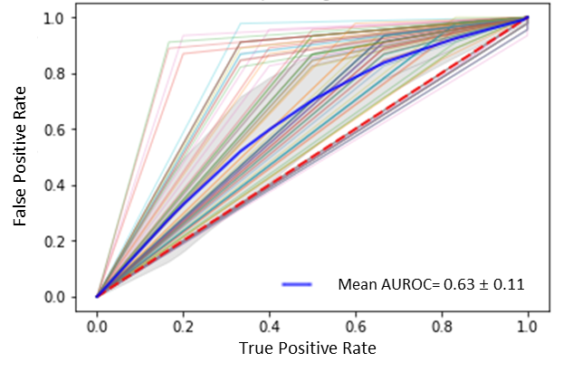 |  | 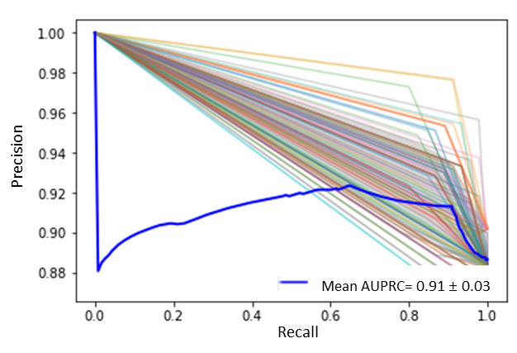
Random Forest
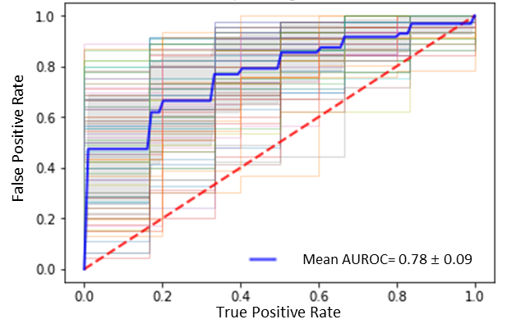 |  | 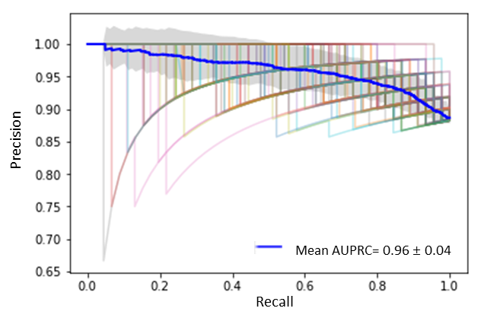
Gradient Boosting
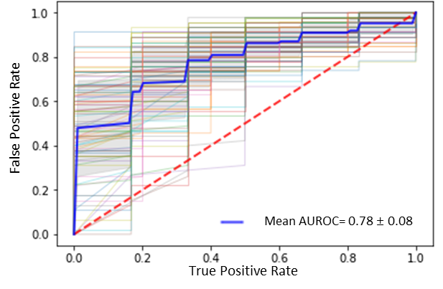 |  | 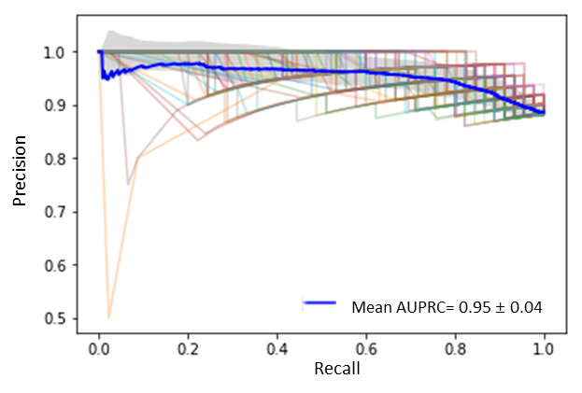
Spiritual health status
SI 5. Area under the receiver operator characteristic curve (AUROC) and area under the precision-recall curve (AUPRC) in the XGBoost model for predicting global QoL after the bootstrap validation

AUROC |  |  | AUPRC
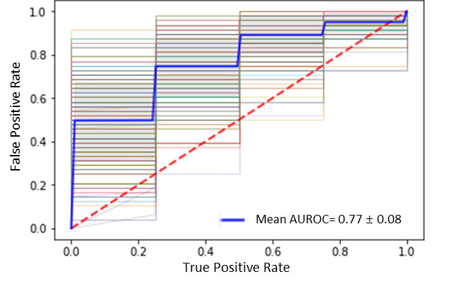 |  |  | 