Supplementary Material
The impact of migration-related characteristics on the risk of TORCH infections among women of childbearing age: A population-based study in southern China
Rui Li, Lu Han, Wenxue Xiong, Wenjuan Wang, Chaonan Fan, Mingzhen Li, Xiaohua Liu, Li Ling

Fig S1. Flowchart of Participant Selection
Fig S2. The associations between migration distance, the spouse’s migrant status, and the risk of TORCH infections stratified by age group and residential region.
Table S1. Sociodemographic characteristics of participants included or excluded from analysis due to missing information
Table S2. Covariables from multivariable logistic regression. Each column represents adjusted OR and corresponding CI displayed for each variable for each type of antibody

This supplementary material has been provided by the authors to give readers additional information about their work.

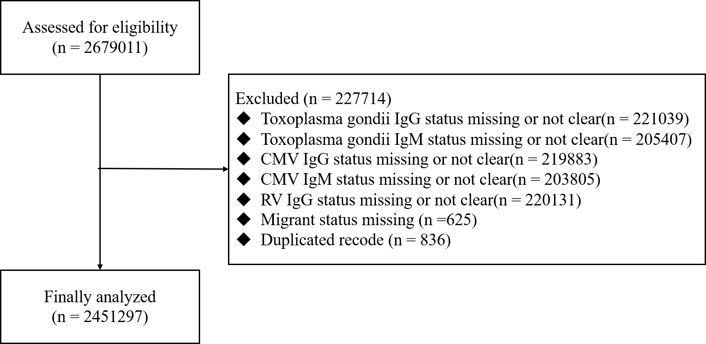
Fig S1. Flowchart of Participant Selection

Fig S2. The associations between migration distance, the spouse’s migrant status, and the risk of TORCH infections stratified by age group and residential region. Intra-provincial migrants and having a native spouse were the reference group respectively. a The figure shows multivariable-adjusted odds ratios of inter-provincial migrants and having a migrant spouse stratified by age groups. b The figure shows multivariable-adjusted odds ratios of inter-provincial migrants and having a migrant spouse stratified by residential region. Part of the upper limit of 95% CI was not shown because of out of bound.

Table S1. Sociodemographic characteristics of participants included or excluded from analysis due to missing information
 | Included participants |  |  | Excluded participants
 | n ª | % |  | n ª | %
All | 2451297 |  |  | 227011
Age
15-19 | 656 | 0.0 ^{b} |  | 147 | 0.1
20-24 | 671310 | 27.4 |  | 68261 | 30.1
25-29 | 1090449 | 44.5 |  | 94102 | 41.5
30-34 | 430235 | 17.6 |  | 39868 | 17.6
35-39 | 179213 | 7.3 |  | 16520 | 7.3
40-45 | 63110 | 2.6 |  | 6320 | 2.8
45-49 | 16324 | 0.7 |  | 1793 | 0.8
Ethnicity
Han | 2339318 | 99.0 |  | 187965 | 99.2
Minority | 22536 | 1.0 |  | 1510 | 0.8
Educational level
Primary school or below | 52482 | 2.4 |  | 3520 | 2.4
Junior high school | 701211 | 32.4 |  | 56457 | 38.4
Senior high school | 584370 | 27.0 |  | 38278 | 26.0
College or above | 826313 | 38.2 |  | 48782 | 33.2
Occupation
Workers | 555128 | 26.6 |  | 29662 | 21.6
Farmers | 512520 | 24.6 |  | 46392 | 33.7
Household | 82739 | 4.0 |  | 6579 | 4.8
Businesswomen | 108812 | 5.2 |  | 6163 | 4.5
Service industry | 219570 | 10.5 |  | 12924 | 9.4
Civil servant | 490068 | 23.5 |  | 28473 | 20.7
Others | 114197 | 5.5 |  | 7363 | 5.4
Residential region
Northern | 376262 | 15.3 |  | 38791 | 17.1
Eastern | 524938 | 21.4 |  | 40675 | 17.9
Western | 325149 | 13.3 |  | 41557 | 18.3
Pearl River Delta | 1224948 | 50.0 |  | 105988 | 46.7
Migration distance
Intra-provincial | 229001 | 51.6 |  | 18603 | 54.6
Inter-provincial | 214724 | 48.4 |  | 15452 | 45.4
Spouse’s migrant status
Native | 2086415 | 85.2 |  | 197844 | 87.2
Migrant | 363122 | 14.8 |  | 28930 | 12.8
ª Missing exists if the sum of n is less than N.
^{b} The proportion is less than 0.05 and has been rounded.

Table S2. Covariables from multivariable logistic regression. Each column represents adjusted OR and corresponding CI displayed for each variable for each type of antibody
Variables | Anti-TOX  IgG+/IgM- | Anti-TOX  IgM+/(IgG- or IgG+) | Anti-CMV  IgG+/IgM- | Anti-CMV  IgM+/(IgG- or IgG+) | Anti-RV IgG+  by natural infection
Age group
15-19 | Ref | Ref | Ref | Ref | Ref
20-24 | 1.24  (0.30-5.09) | 0.09***  (0.03-0.31) | 0.72  (0.36-1.43) | 0.23  (0.03-1.70) | 0.99  (0.55-1.77)
25-29 | 1.07  (0.26-4.38) | 0.10***  (0.03-0.32) | 0.80  (0.40-1.59) | 0.24  (0.03-1.72) | 1.24  (0.69-2.22)
30-34 | 1.03  (0.25-4.20) | 0.10***  (0.03-0.33) | 0.91  (0.46-1.82) | 0.24  (0.03-1.73) | 1.33  (0.75-2.38)
35-39 | 1.04  (0.25-4.28) | 0.11***  (0.03-0.35) | 1.06  (0.53-2.13) | 0.23  (0.03-1.65) | 1.29  (0.72-2.31)
40-45 | 1.04  (0.25-4.31) | 0.09***  (0.03-0.31) | 1.02  (0.51-2.05) | 0.26  (0.03-1.96) | 1.23  (0.68-2.20)
45-49 | 0.85  (0.20-3.63) | 0.08***  (0.02-0.34) | 0.94  (0.45-1.97) | 0.25  (0.03-2.30) | 1.33  (0.73-2.44)
Ethnicity
Han | Ref | Ref | Ref | Ref | Ref
Minority | 1.17***  (1.06-1.29) | 1.38***  (1.12-1.70) | 0.92***  (0.87-0.98) | 0.93  (0.68-1.27) | 0.94*  (0.90-0.99)
Educational level
Primary school or below | Ref | Ref | Ref | Ref | Ref
Junior high school | 0.90  (0.79-1.03) | 0.87  (0.62-1.23) | 0.95  (0.89-1.01) | 1.18  (0.77-1.80) | 1.03  (0.97-1.09)
Senior high school | 0.81***  (0.71-0.93) | 0.86  (0.61-1.21) | 1.12***  (1.05-1.20) | 1.08  (0.70-1.64) | 1.18***  (1.11-1.25)
College or above | 0.71***  (0.62-0.81) | 0.69*  (0.49-0.97) | 1.18***  (1.11-1.26) | 1.04  (0.68-1.60) | 1.20***  (1.13-1.28)
Occupation
Workers | Ref | Ref | Ref | Ref | Ref
Farmers | 1.04  (0.98-1.10) | 1.07  (0.92-1.25) | 1.04*  (1.01-1.07) | 0.92  (0.77-1.09) | 1.01  (0.99-1.04)
Household | 0.95  (0.87-1.05) | 1.29*  (1.05-1.59) | 1.22***  (1.16-1.29) | 0.84  (0.63-1.11) | 1.04  (1.00-1.09)
Businesswomen | 0.89***  (0.82-0.96) | 1.18  (0.98-1.41) | 1.17***  (1.12-1.23) | 0.95  (0.76-1.18) | 0.97  (0.93-1.00)
Service industry | 0.96  (0.91-1.02) | 0.81**  (0.69-0.95) | 1.20***  (1.16-1.24) | 0.73***  (0.61-0.87) | 1.15***  (1.11-1.18)
Civil servant | 0.91***  (0.86-0.95) | 0.78***  (0.68-0.89) | 1.44***  (1.40-1.49) | 0.69***  (0.59-0.80) | 1.24***  (1.21-1.27)
Others | 0.95  (0.88-1.03) | 1.01  (0.82-1.23) | 1.29***  (1.23-1.35) | 1.05  (0.85-1.30) | 1.08***  (1.04-1.12)
Residential region
Northern | Ref | Ref | Ref | Ref | Ref
Eastern | 0.61***  (0.56-0.67) | 2.14***  (1.5-3.05) | 0.99  (0.96-1.02) | 1.49***  (1.14-1.96) | 1.05***  (1.02-1.09)
Western | 0.80***  (0.71-0.89) | 1.08  (0.65-1.79) | 1.19***  (1.15-1.24) | 1.42*  (1.01-1.99) | 0.99  (0.95-1.03)
Pearl River Delta | 1.41***  (1.32-1.51) | 3.50***  (2.54-4.82) | 4.77***  (4.63-4.91) | 1.96***  (1.54-2.50) | 1.61***  (1.57-1.66)
Abbreviation: OR Odds ratio, CI Confidence interval, TOX Toxoplasma gondii, CMV Cytomegalovirus, RV Rubella virus, IgG Immunoglobulin G, IgM Immunoglobulin M.
Notes:
1) Adjusted ORs of the study year were not shown. *** represents P < 0.001; ** represents P < 0.01; * represents P < 0.05.
2) IgG+/IgM- indicated that the participant had been previously infected with pathogens, IgM+/(IgG- or IgG+) indicated that the participants had recently been infected with the pathogens.
3) Anti-RV IgG+ by natural infection was conducted among women who reported not having RV vaccination.

