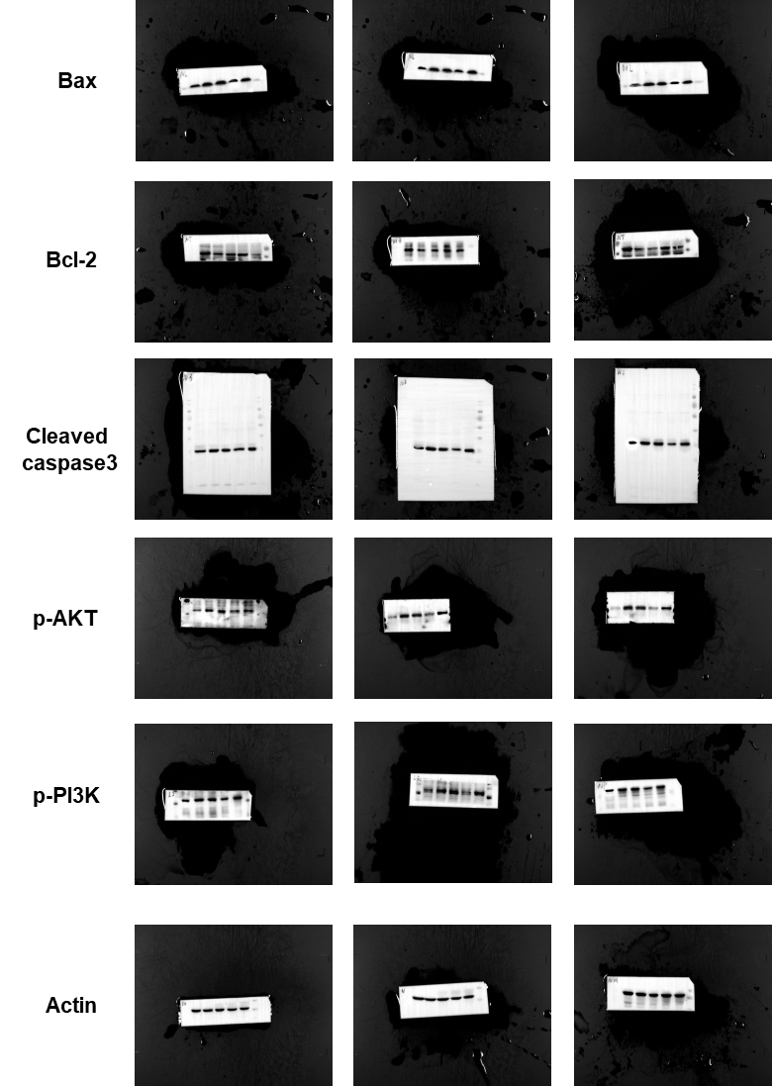
Supplementary figure 1. The complete plot of results in the Western Blot. The first column of pictures is shown in the manuscript.

