- Goodness of ﬁt values and best ﬁt values on 34 degrees of freedom after 2. Order polynomial regression using equation 8. Availability constrained to 50%, which is the average occupancy of dopamine at the age of 25. The rate of increase of availability, b, is equal to 0.1. All values within the regions does not diﬀer signiﬁcantly as determined from the four methods. In occipital cortex estimated with SRTM there is a statistical signiﬁcance with a p value of < 0.0001. SS: sums-of-squares, ERLiBIRD: Estimation of Reversible Ligand Binding and Receptor Density, Logan and Logan-Ichise: The tissue reference methods of Logan, SRTM: Simpliﬁed Reference Tissue Method
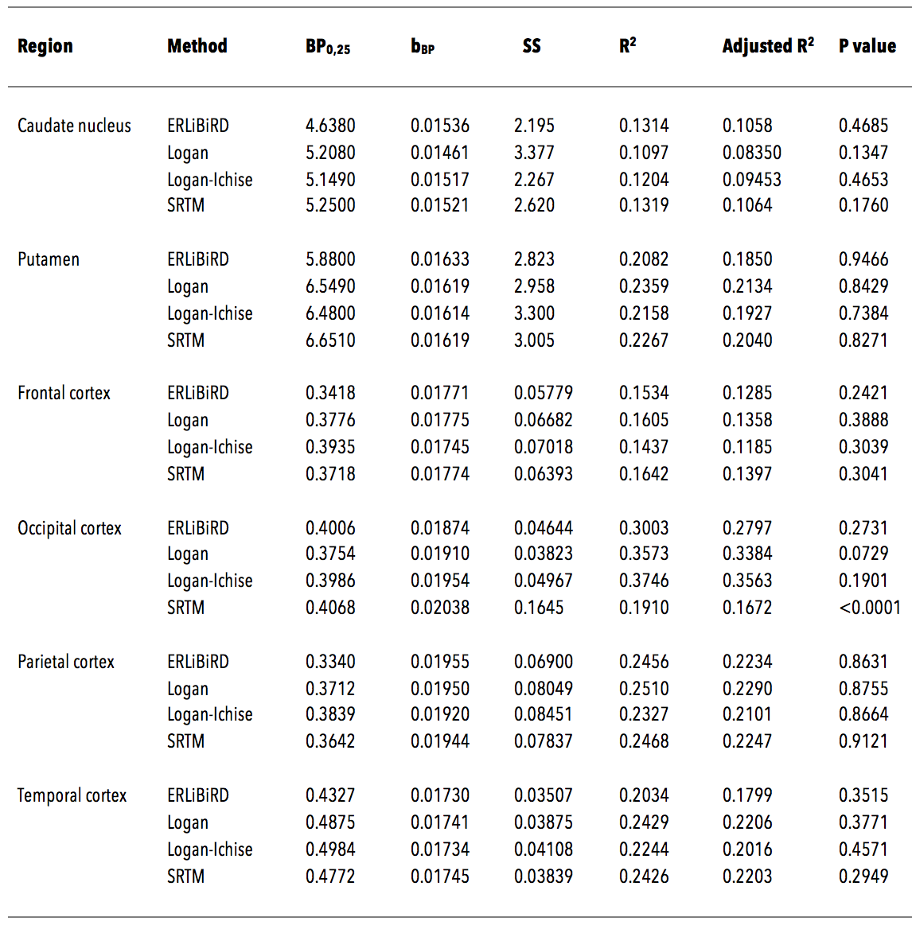

- Comparison of ﬁt between linear regression analysis and the second-order polynomial regression analysis by F test. p values < 0.05 were considered statistically signiﬁcant. Signiﬁcant diﬀerences is seen for caudate nucleus estimated with Logan, occipital cortex estimated with Logan-Ichise, and parietal cortex estimated by all four methods. ERLiBIRD: Estimation of Reversible Ligand Binding and Receptor Density, Logan and Logan-Ichise: The tissue reference methods of Logan, SRTM: Simpliﬁed Reference Tissue Method.
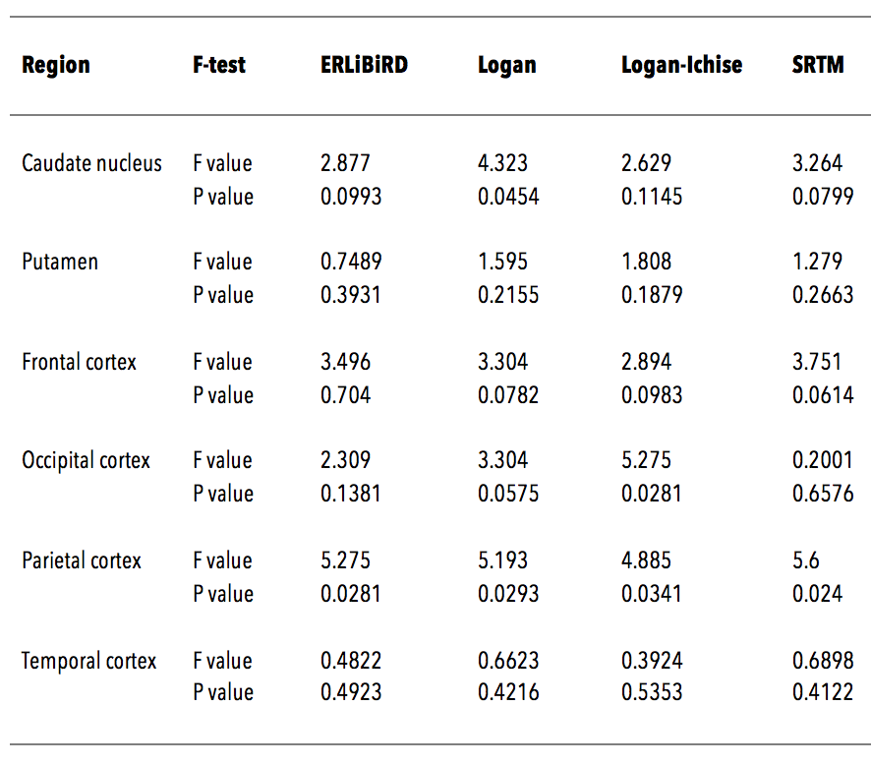

- Mean BP ND values obtained by four methods. Values are mean SEM. Values were estimated by two-way ANOVA with Bonferroni Post-hoc test. a . Caudate nucleus vs putamen with p < 0.001, b . ERLiBiRD vs Logan with p < 0.001, c . ERLiBiRD vs Logan-Ichise with p < 0.01, d . ERLiBiRD vs Logan-Ichise with p < 0.001, e. ERLiBiRD vs SRTM with p < 0.001, f . Frontal cortex vs temporal cortex with p < 0.001, g . Occipital cortex vs temporal cortex with p < 0.01 h . Parietal cortex vs temporal cortex with p < 0.001. ERLiBIRD: Estimation of Reversible Ligand Binding and Receptor Density, Logan and Logan-Ichise: The tissue reference methods of Logan, SRTM: Simpliﬁed Reference Tissue Method.
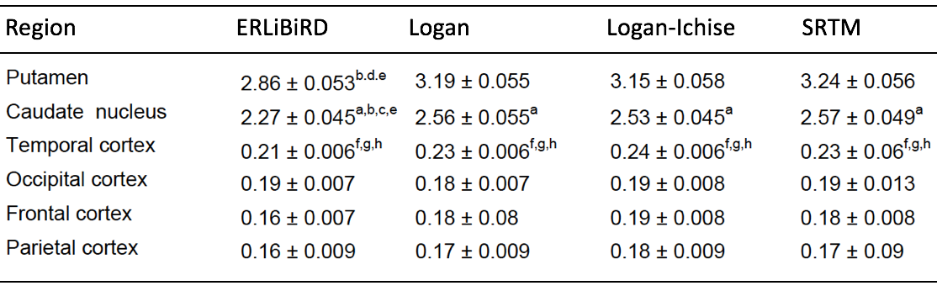

- Percentages of BP ND in caudate nucleus and cortices to putamen. Values are mean SEM.
