Supplementary Information
Suppression of stacking fault expansion in 4H-SiC PiN diodes by proton implantation to solve bipolar degradation
Masashi Kato*, Ohga Watanabe, Toshiki Mii, Hitoshi Sakane, Shunta Harada

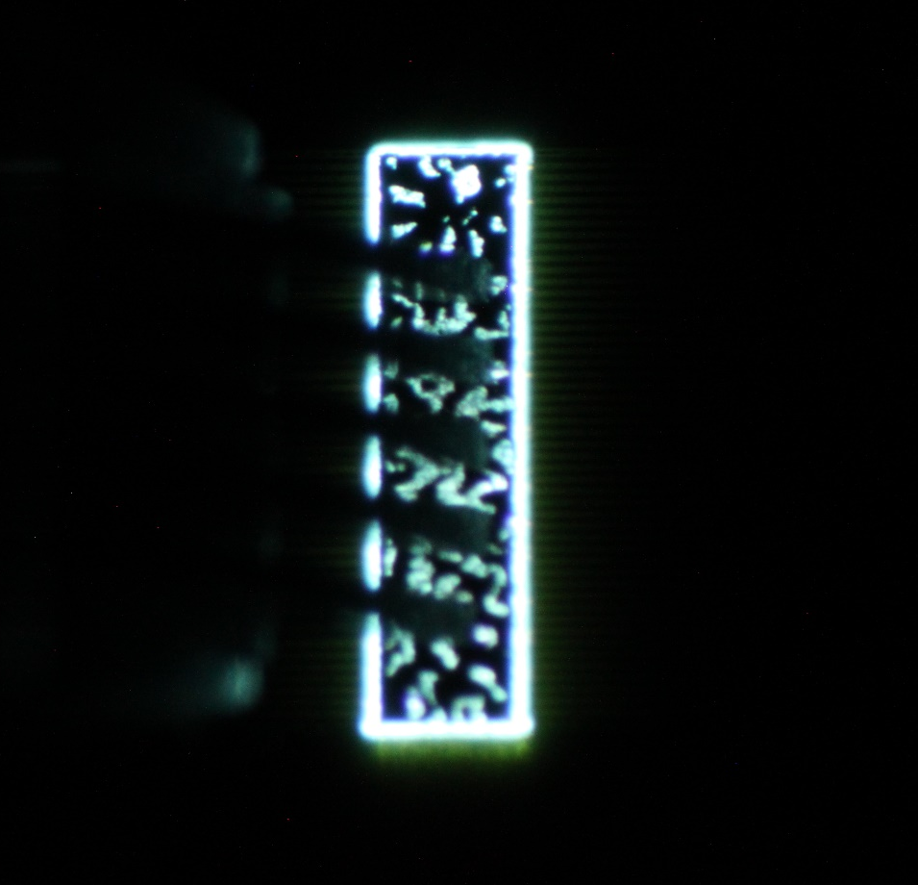
Fig. S1. EL images of PiN diode with proton implantation after PiN diodes fabrication processes at 125 A/cm².


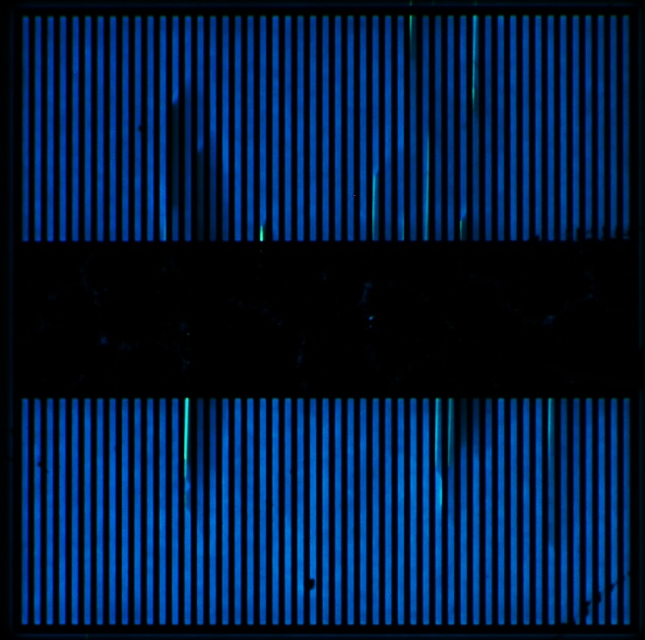
(b)
(a)

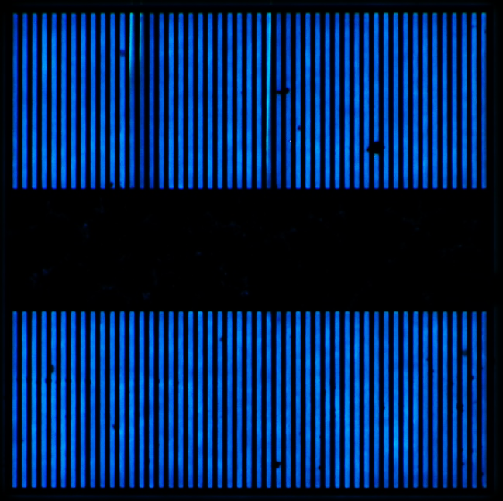
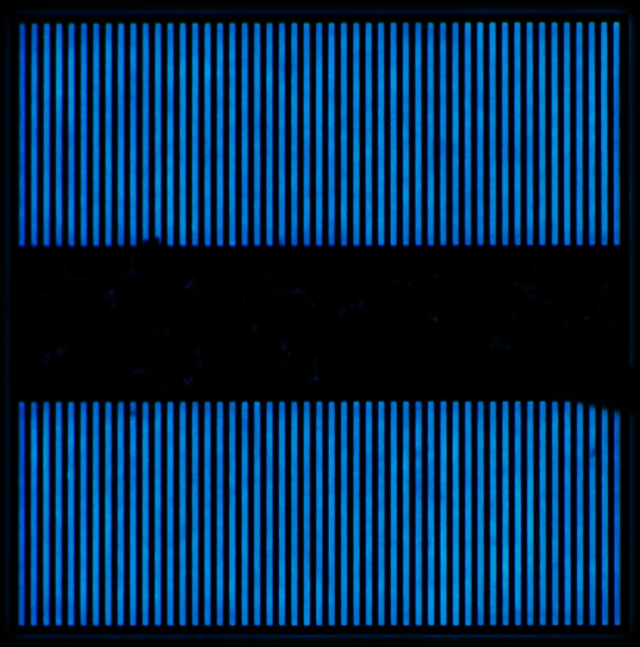
(d)
(c)

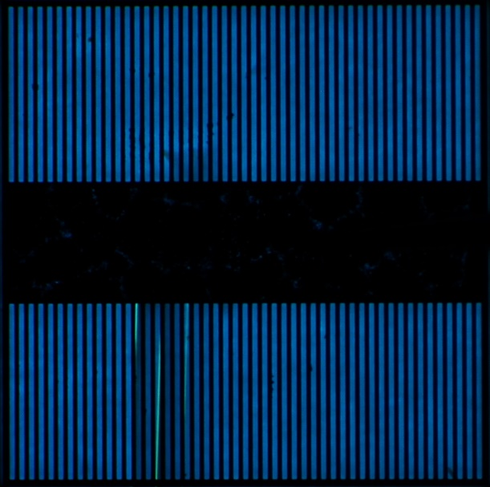
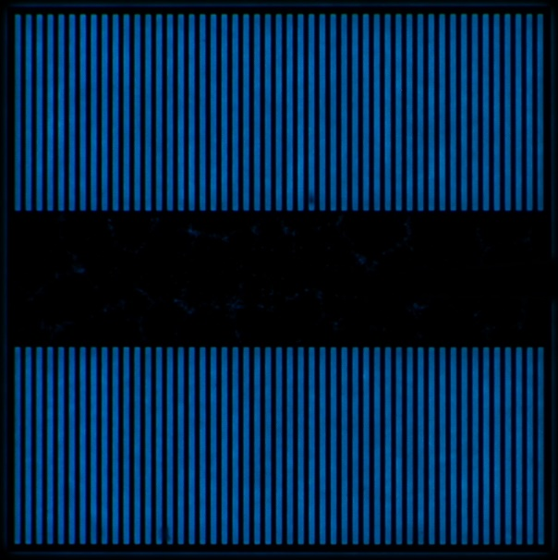
(f)
(e)

Fig. S2. EL images of PiN diodes w/o proton implantation at 25 A/cm²: before (a) and (c) and after (b) and (d) the electrical stress. (a) and (b) are for a first test chip, (c) and (d) are for a second test chip, (e) and (f) are for a third test chip, and (b) corresponds to Fig. 3(a). The wide dark region in (a) is due to presence of a probe, and, for other images, we employed a narrow probe to eliminate the dark region.
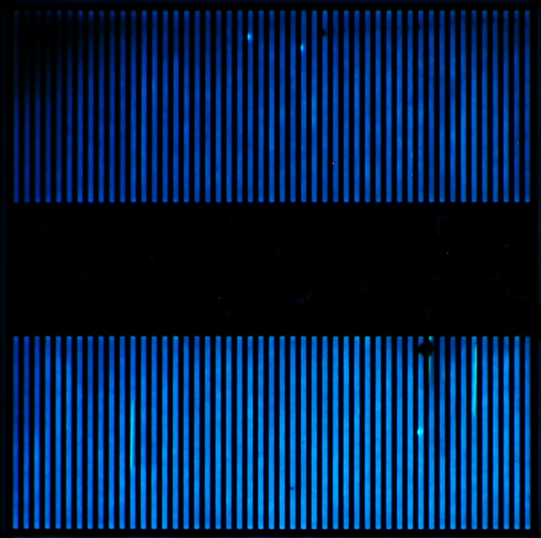

(b)
(a)

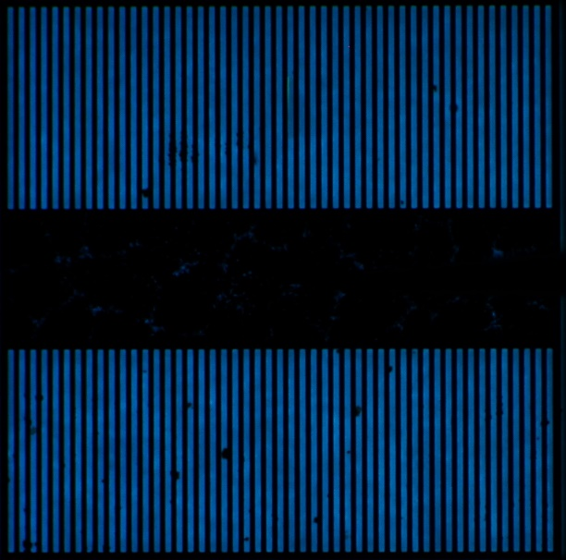
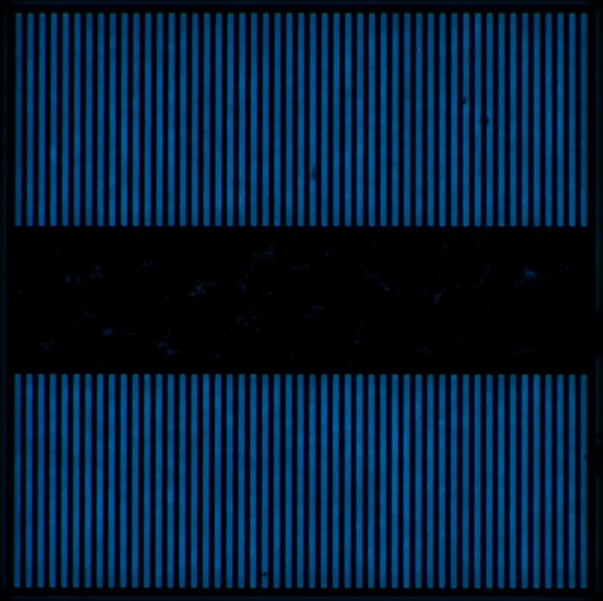
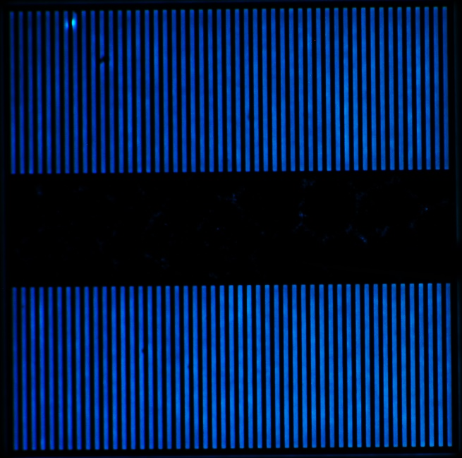
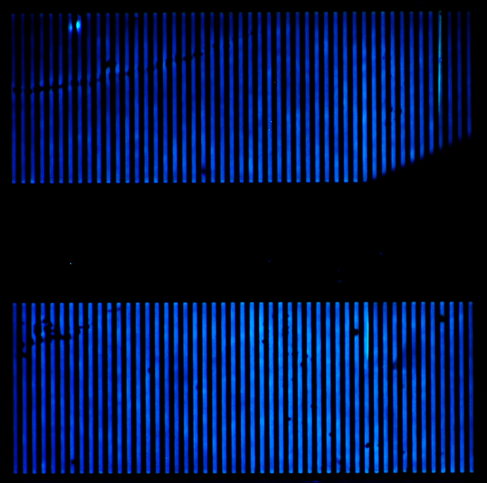
(c)
(d)

(f)
(e)

Fig. S3. EL images of PiN diodes with 10¹² cm⁻² proton implantation at 25 A/cm²: before (a) and (c) and after (b) and (d) the electrical stress. (a) and (b) are for a first test chip, (c) and (d) are for a second test chip, (e) and (f) are for a third test chip, and (b) corresponds to Fig. 3(b).

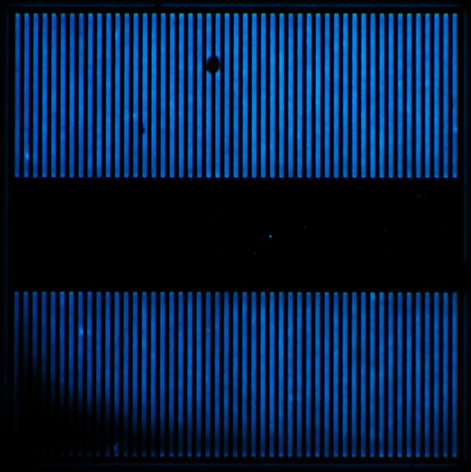

(b)
(a)

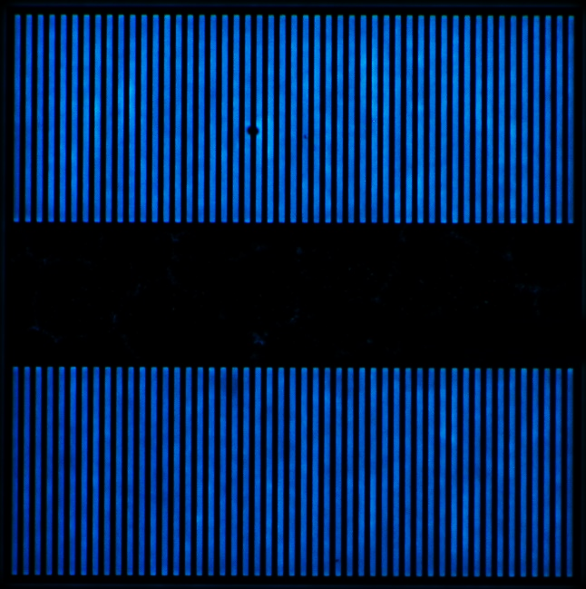
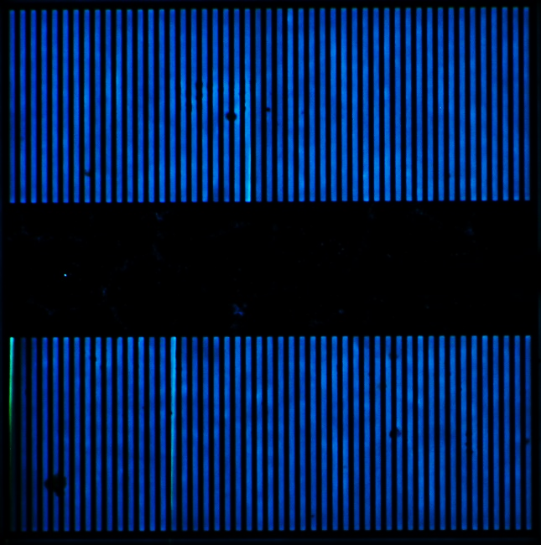
(d)
(c)

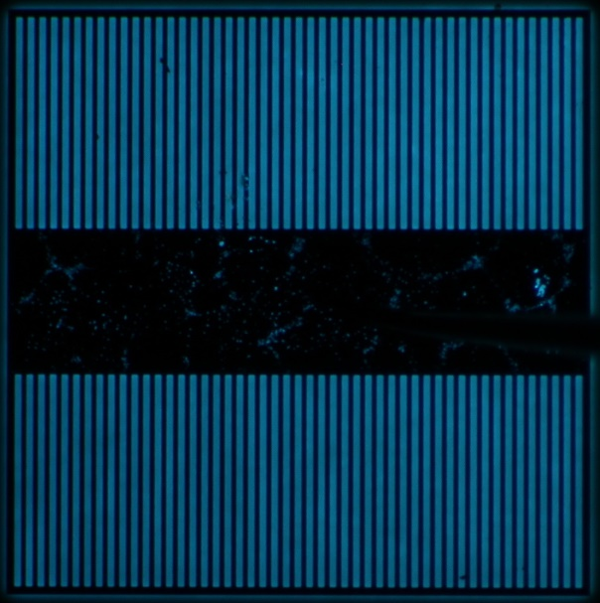
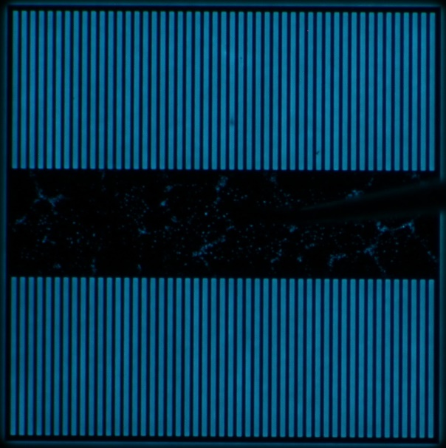
(f)
(e)

Fig. S4. EL images of PiN diodes with 10¹⁴ cm⁻² proton implantation at 25 A/cm²: before (a) and (c) and after (b) and (d) the electrical stress. (a) and (b) are for a first test chip, (c) and (d) are for a second test chip, (e) and (f) are for a third test chip, and (b) corresponds to Fig. 3(c).


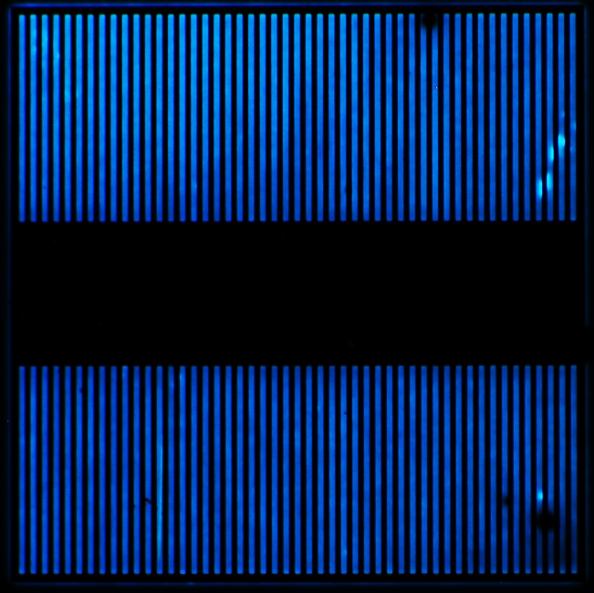
(b)
(a)

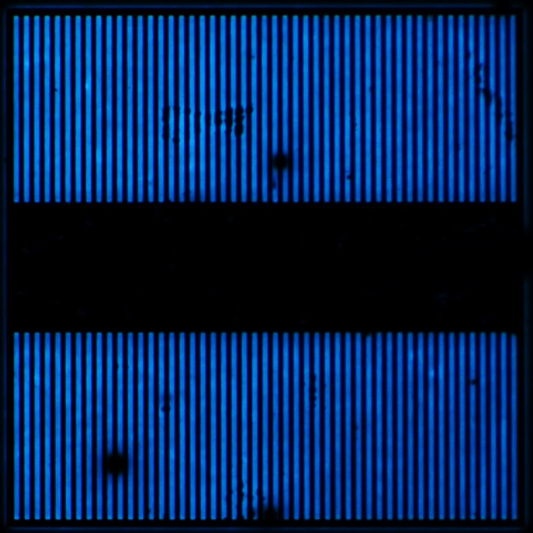
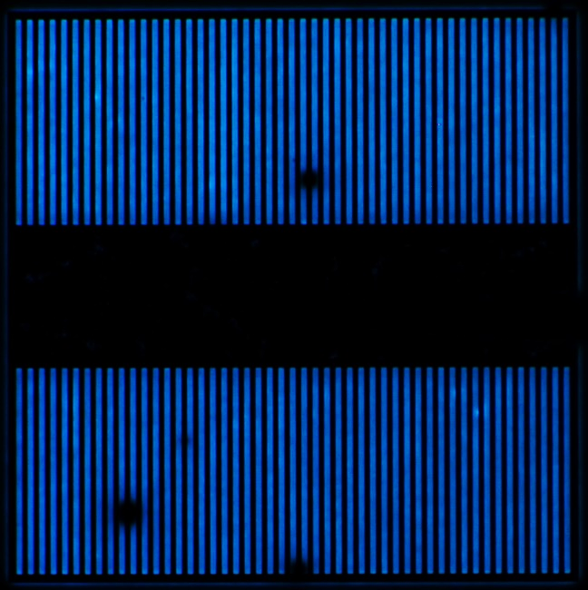
(c)
(d)

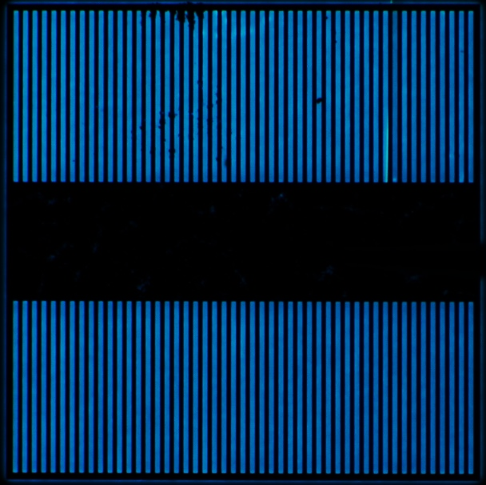
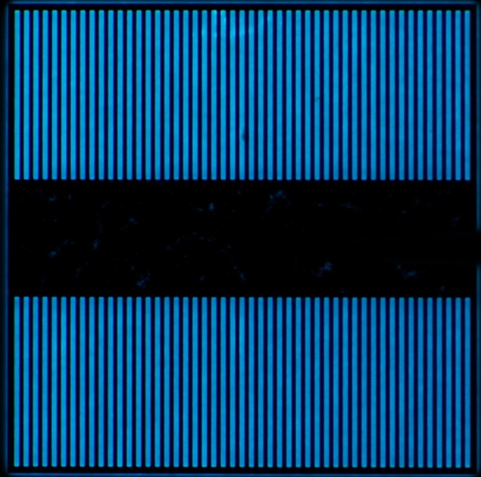
(e)
(f)

Fig. S5. EL images of PiN diodes with 10¹⁶ cm⁻² proton implantation at 25 A/cm²: before (a) and (c) and after (b) and (d) the electrical stress. (a) and (b) are for a first test chip, (c) and (d) are for a second test chip, (e) and (f) are for a third test chip, and (b) corresponds to Fig. 3(d).

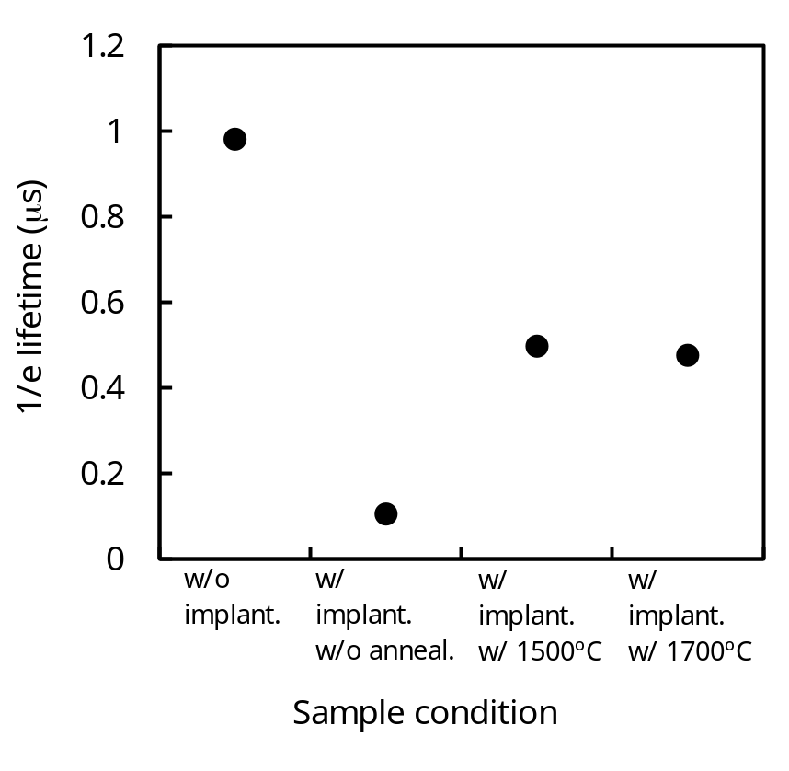
Fig. S6. Carrier lifetime (time from peak to 1/e of the microwave photoconductivity decay signal) observed from 60 μm epilayers with and without proton implantation and annealing. The proton implantation energy and dose were 1 MeV and 10¹⁴ cm⁻². The excitation wavelengths of 266 nm corresponding to photon penetration depth of 1.2 μm was employed in the measurements.

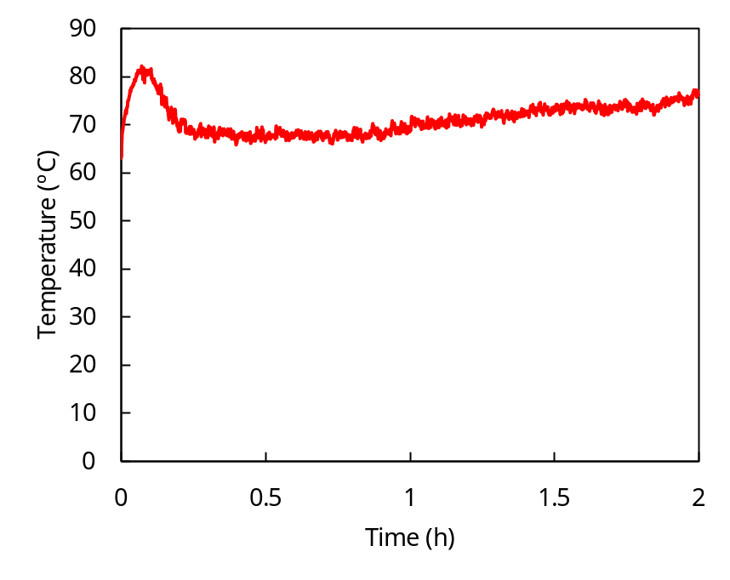
Fig. S7. Typical PiN diode temperature during application of the electrical stress measured by thermocouple on the diode.

