Table 1. The exploration of hydrosulfuration of ynamidesª
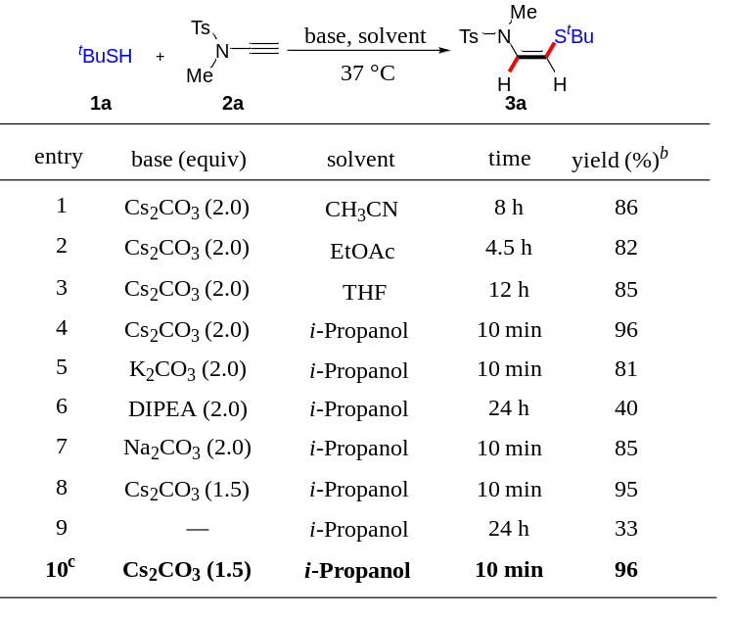
ªThe reaction was performed with 2a (0.2 mmol), 1a (0.4 mmol), and base (0.4 mmol) in solvent (1.0 mL) at 37 ˚C. ^{b}Isolated yields. Z:E > 99:1 (determined by crude ¹H NMR). ^{c}1.2 equiv of 1a was used. DIPEA: N,N-Diisopropylethylamine.

Table 2. Substrate scope of hydrosulfuration of ynamidesª
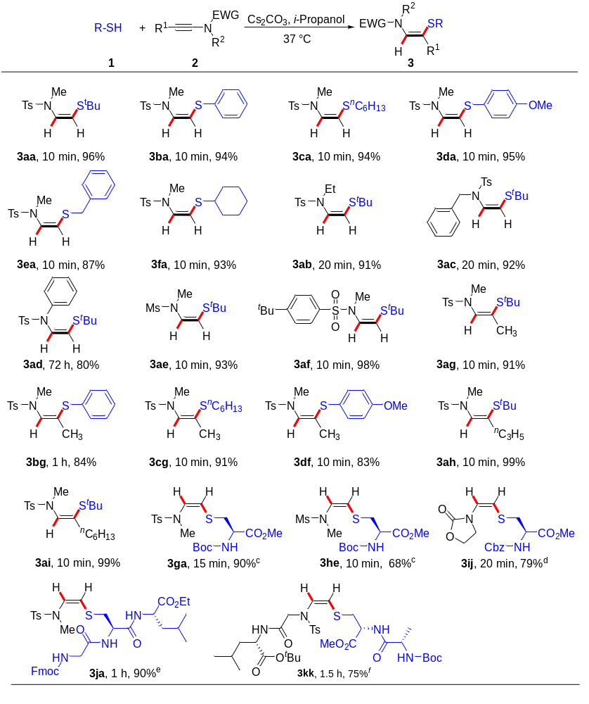
ªReaction conditions: 1 (0.2 mmol), 2 (0.24 mmol) and Cs₂CO₃ (0.3 mmol) in i-propanol (1 mL) at 37 ˚C, 10 min, unless otherwise specified. All the yields indicated were isolated yield. Z/E > 99:1 (determined by crude ¹H-NMR). ^{b}2 (0.4 mmol), in DMSO (1 mL) at 60 ˚C. ^{c}Cs₂CO₃ was replaced with Na₂CO₃ (0.3 mmol). ^{d}1 (0.4 mmol), 2 (0.2 mmol) and Na₂CO₃ (0.3 mmol) in DMSO (1 mL). ^{e}1 (0.4 mmol), 2 (0.2 mmol) and Na₂CO₃ (0.3 mmol). ^{f}2 (0.4 mmol), Na₂CO₃ (0.4 mmol), DMSO (1 mL).
Table 3. Rational design of ynamides for cysteine modificationª
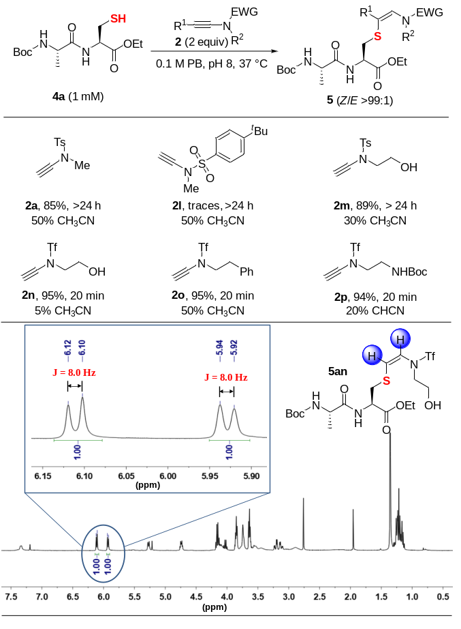
ªAll reactions were monitored by NMR, and the yields presented were isolated yields. PB = phosphate buffer. The zoom in ¹H NMR spectra (for the protons of characteristic alkene moiety colored by blue) for the crude reaction of 4a and 2n is provided.

Table 4. Optimization of the conjugation of ynamide with cysteine-containing peptide
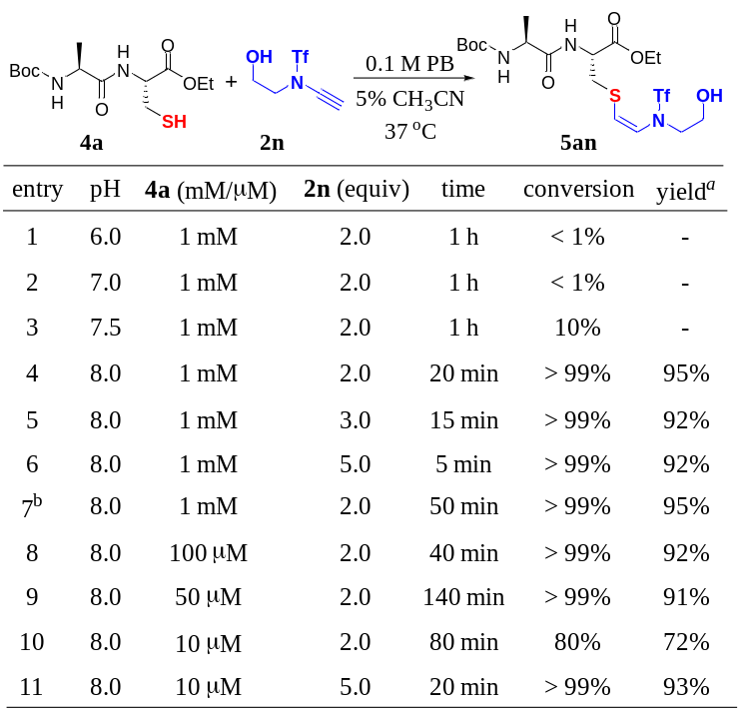
ªIsolated yield. ^{b}Room temperature.
Table 5. Systematic study of Cys modification by ynamides in the presence of other amino acid residuesª

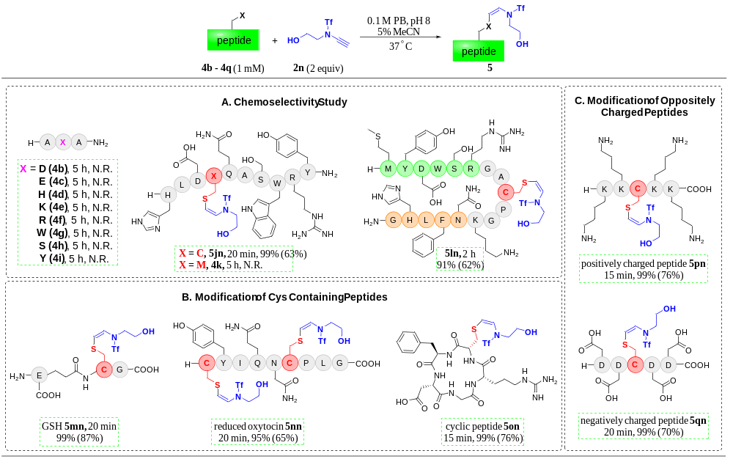
ªReaction conditions: peptides (4b – 4q, 1 mM), ynamide (2n, 2 equiv), in 0.1 M PB containing 5% MeCN, pH 8, at 37 °C. All yields presented were determined by integrated areas of HPLC peaks (at 220 nm), whereas isolated yields are in parentheses. GSH = reduced glutathione; N.R. = no reaction.
Table 6. Selective Cys modification of peptides with ynamides containing various biologically relevant tags and probesª

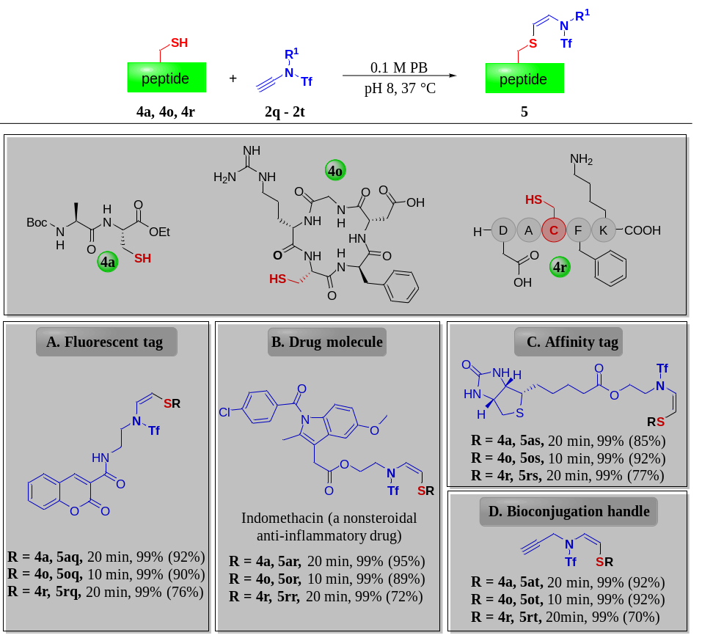

ªReaction condition: peptides 4a (1 mM)/4o (0.5 mM)/4r (1 mM), and ynamides 2q-2t (2 equiv), 0.1 M PB, pH 8, 37 °C; (A-B) 50% MeCN, (C) 5% MeCN; (D) 10% DMSO. All yields presented were determined by integrated areas of HPLC peaks (at 220 nm), whereas isolated yields were in parentheses.

