TOC
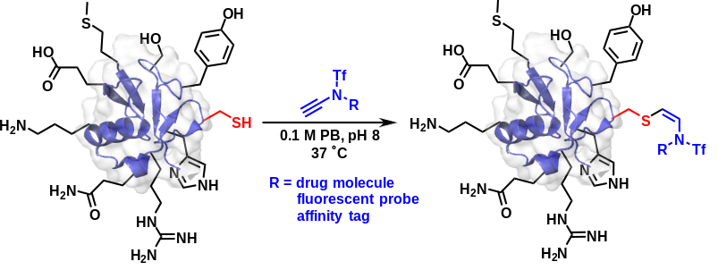
A highly efficient chemo-, regio- and stereoselective hydrosulfuration of ynamide was developed, which has been identified as an effective tool for peptide and protein Cys modification. This Cys modification strategy proceeded efficiently in a slightly basic aqueous conditions (pH 8) to provide exclusively the Z-isomer of the corresponding conjugates with superior stability and displayed a broad substrate scope including linear and cyclic peptides, proteins and antibody.

