SUPPLEMENTARY MATERIALS – SUPPLEMENTARY TABLES 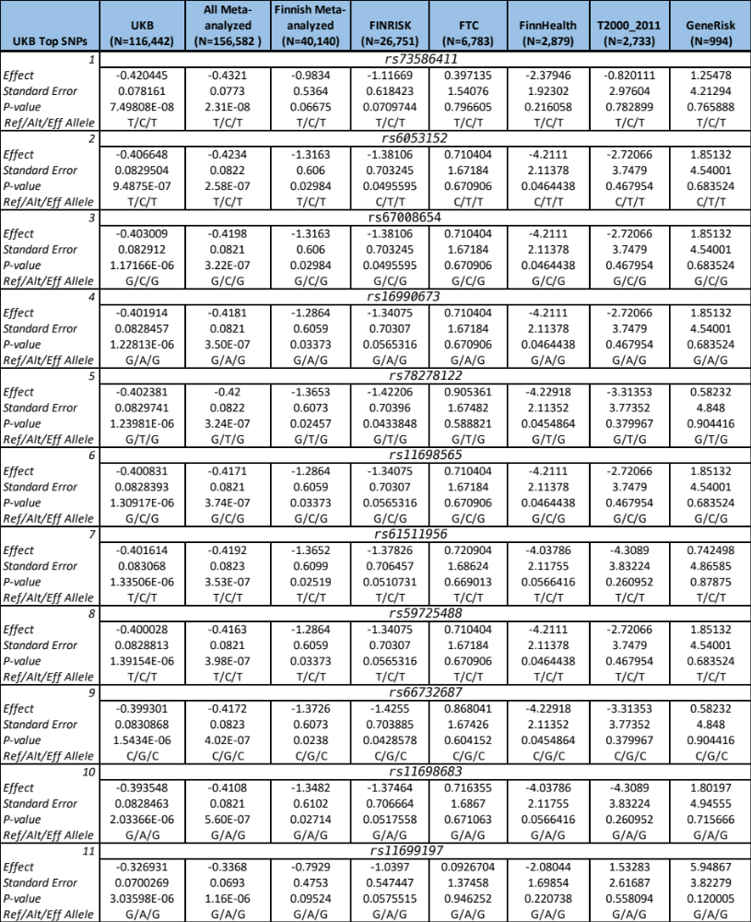
Table S1: Table summarizing the results from the rs16969968xSNP analysis for the UKB, Finnish subsets, as well as the results for meta-analyzing the Finnish subsets. These 11 SNPs found in chromosome 20 were nominally (p < 1x10⁻⁵) significant in the discovery analysis using the UK Biobank.

