SUPPLEMENTARY MATERIALS – SUPPLEMENTARY FIGURES
A) Raw Cigarettes per Day:
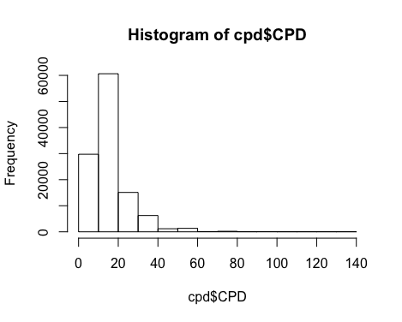
B) Log10-transformed Cigarettes per Day:
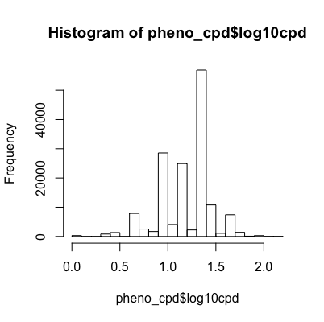
Figure S1: Histograms of our outcomes of interest: raw cigarettes per day and log10-transformed cigarettes per day. (A) Histogram of raw cigarettes per day count shows our phenotype is right skewed. (B) Histogram of log-transformed cigarettes per day count shows ameliorates the violation of the normality assumption.

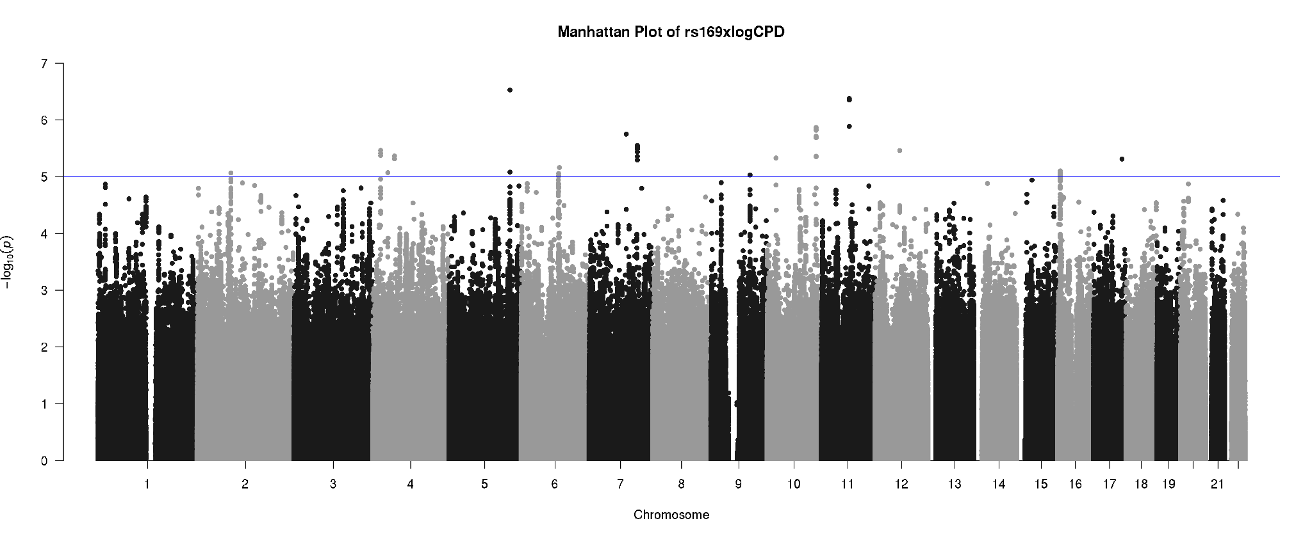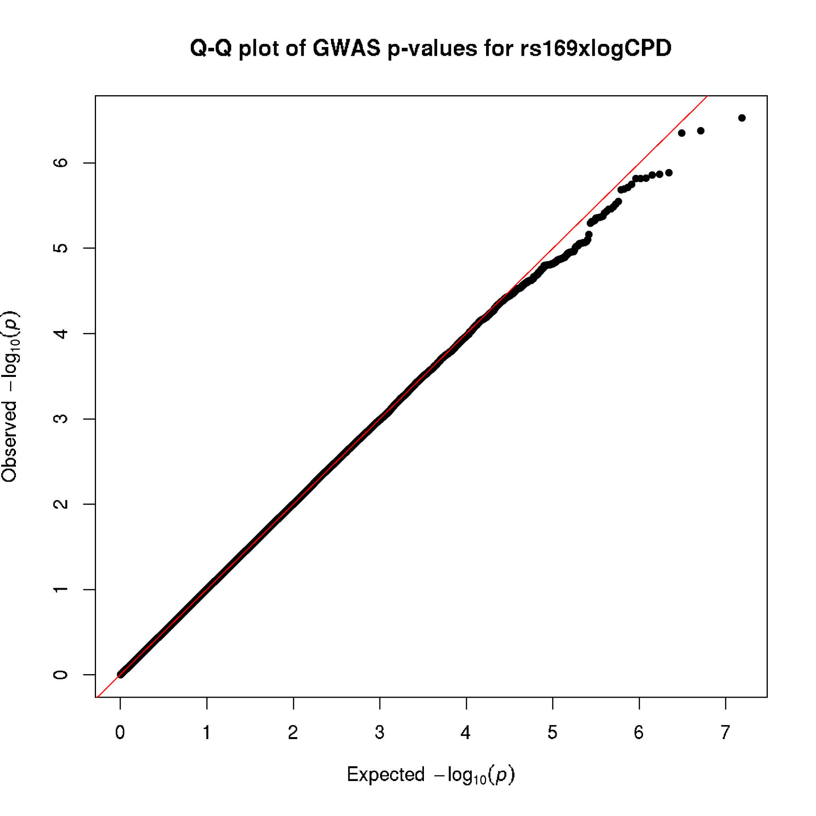
Figure S2: Manhattan and Q-Q plots of rs16969968 interacting with genome-wide loci to influence log10-transformed cigarettes per day in the UK Biobank. On the right, Manhattan plot of rs16969968 interacting with genome-wide loci to influence log-transformed cigarettes per day in the UK Biobank. Blue line denotes nominal significance (p <1x10⁻⁵). On the left, QQ plot of rs16969968 interacting with genome-wide loci to influence log-transformed cigarettes per day in the UK Biobank.

- Average number of cigarettes per day across genotypes for rs16969968 and rs73586411
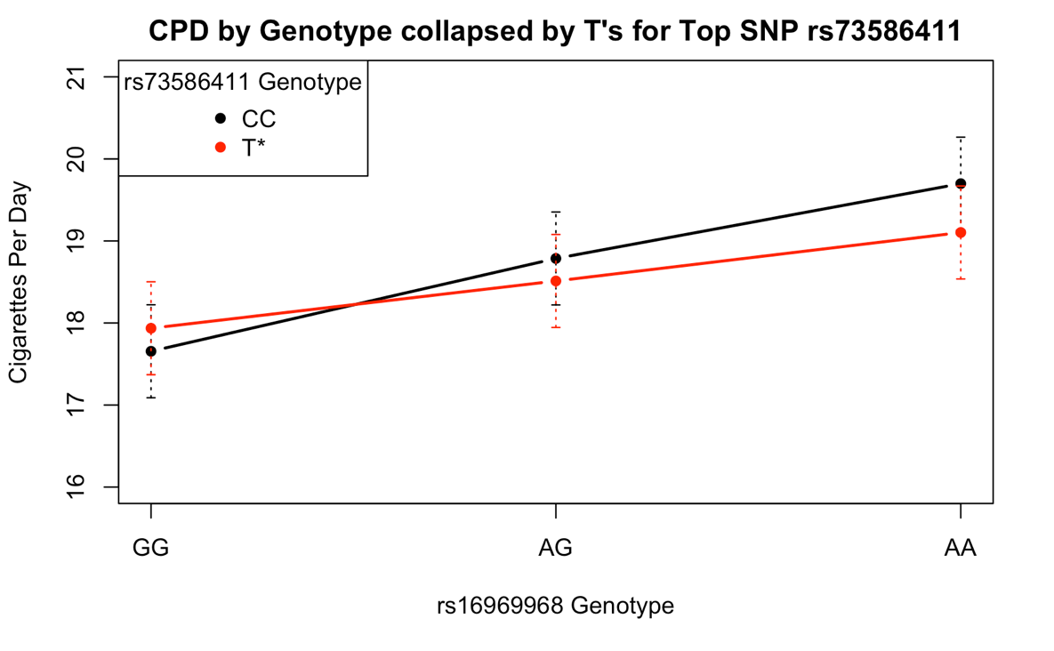
B) Genotypes across rs16969968 and rs73586411
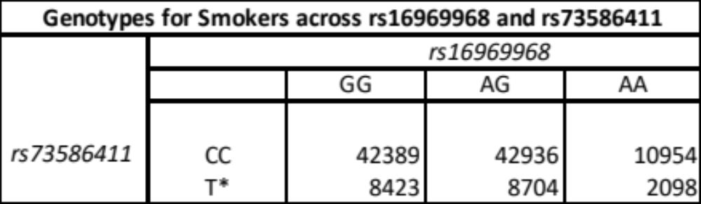
Figure S3: (A) Plot of the average number of cigarettes consumed (with 99% confidence interval) across genotypes for rs16969968 and rs73586411, our top SNP hit within the PCNA gene, which was significant in our rs16969968×Gene MAGMA analyses. We collapsed across the TC and TT genotypes due to modest sample size in the smallest cell (~2,000 combined) since the T allele is rare (MAF = 0.092). These trends suggest that the T allele in rs73586411 ameliorates the smoking-increase effect of the A allele of rs16969968. (B) Genotypes across rs16969968 and rs73586411

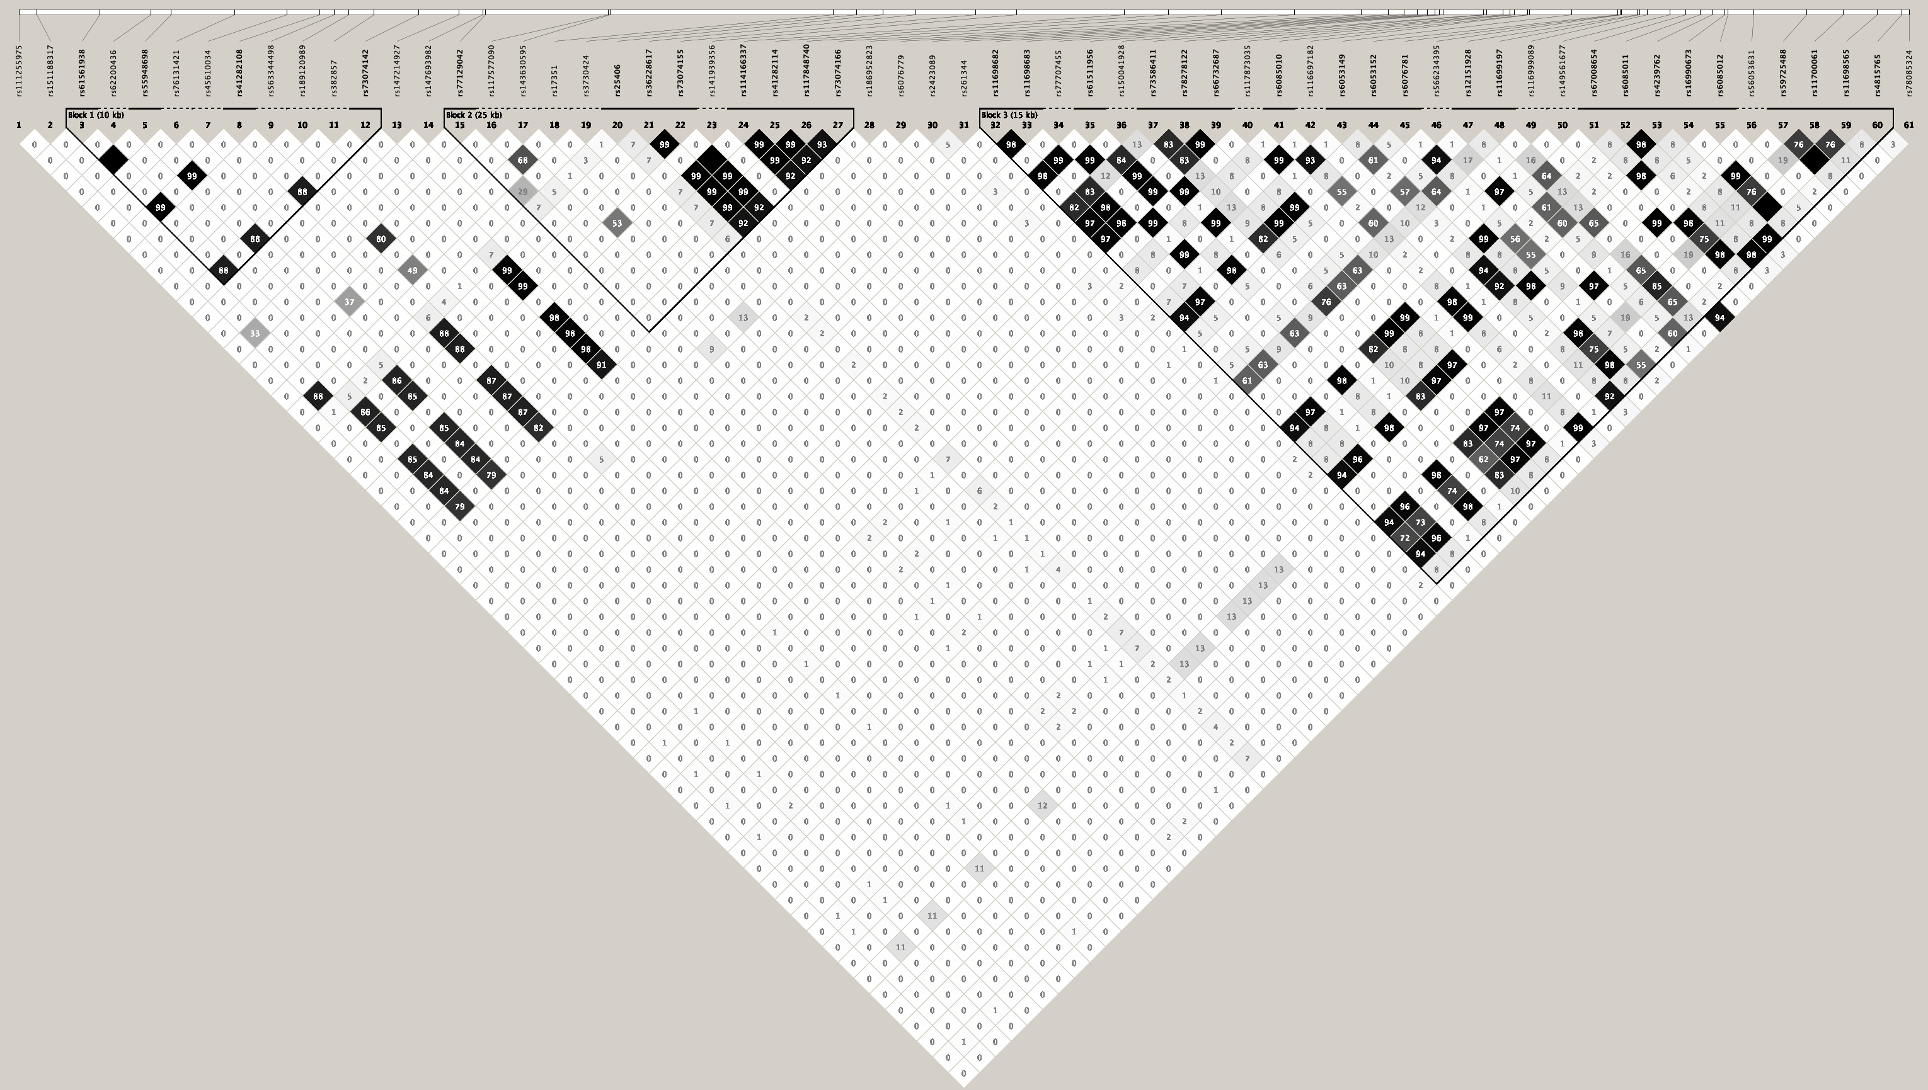
Figure S4: Linkage disequilibrium plot of the SNPs in the PCNA gene. All our nominally significant (p < 1x10e-5) SNPs from the rs16969968xSNP analyses are found in the third rightmost block.

A) SNP-wise Mean:
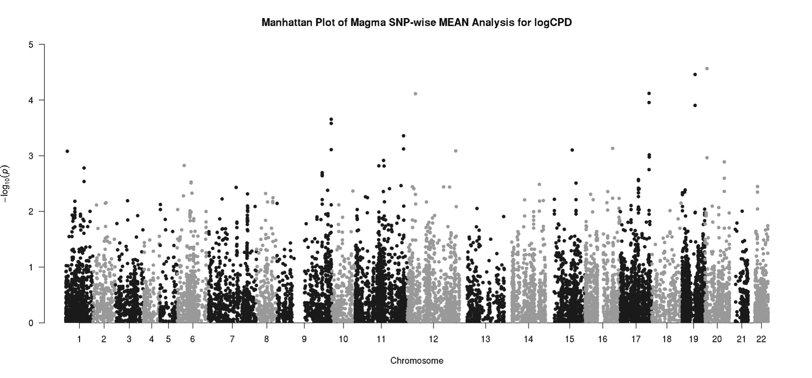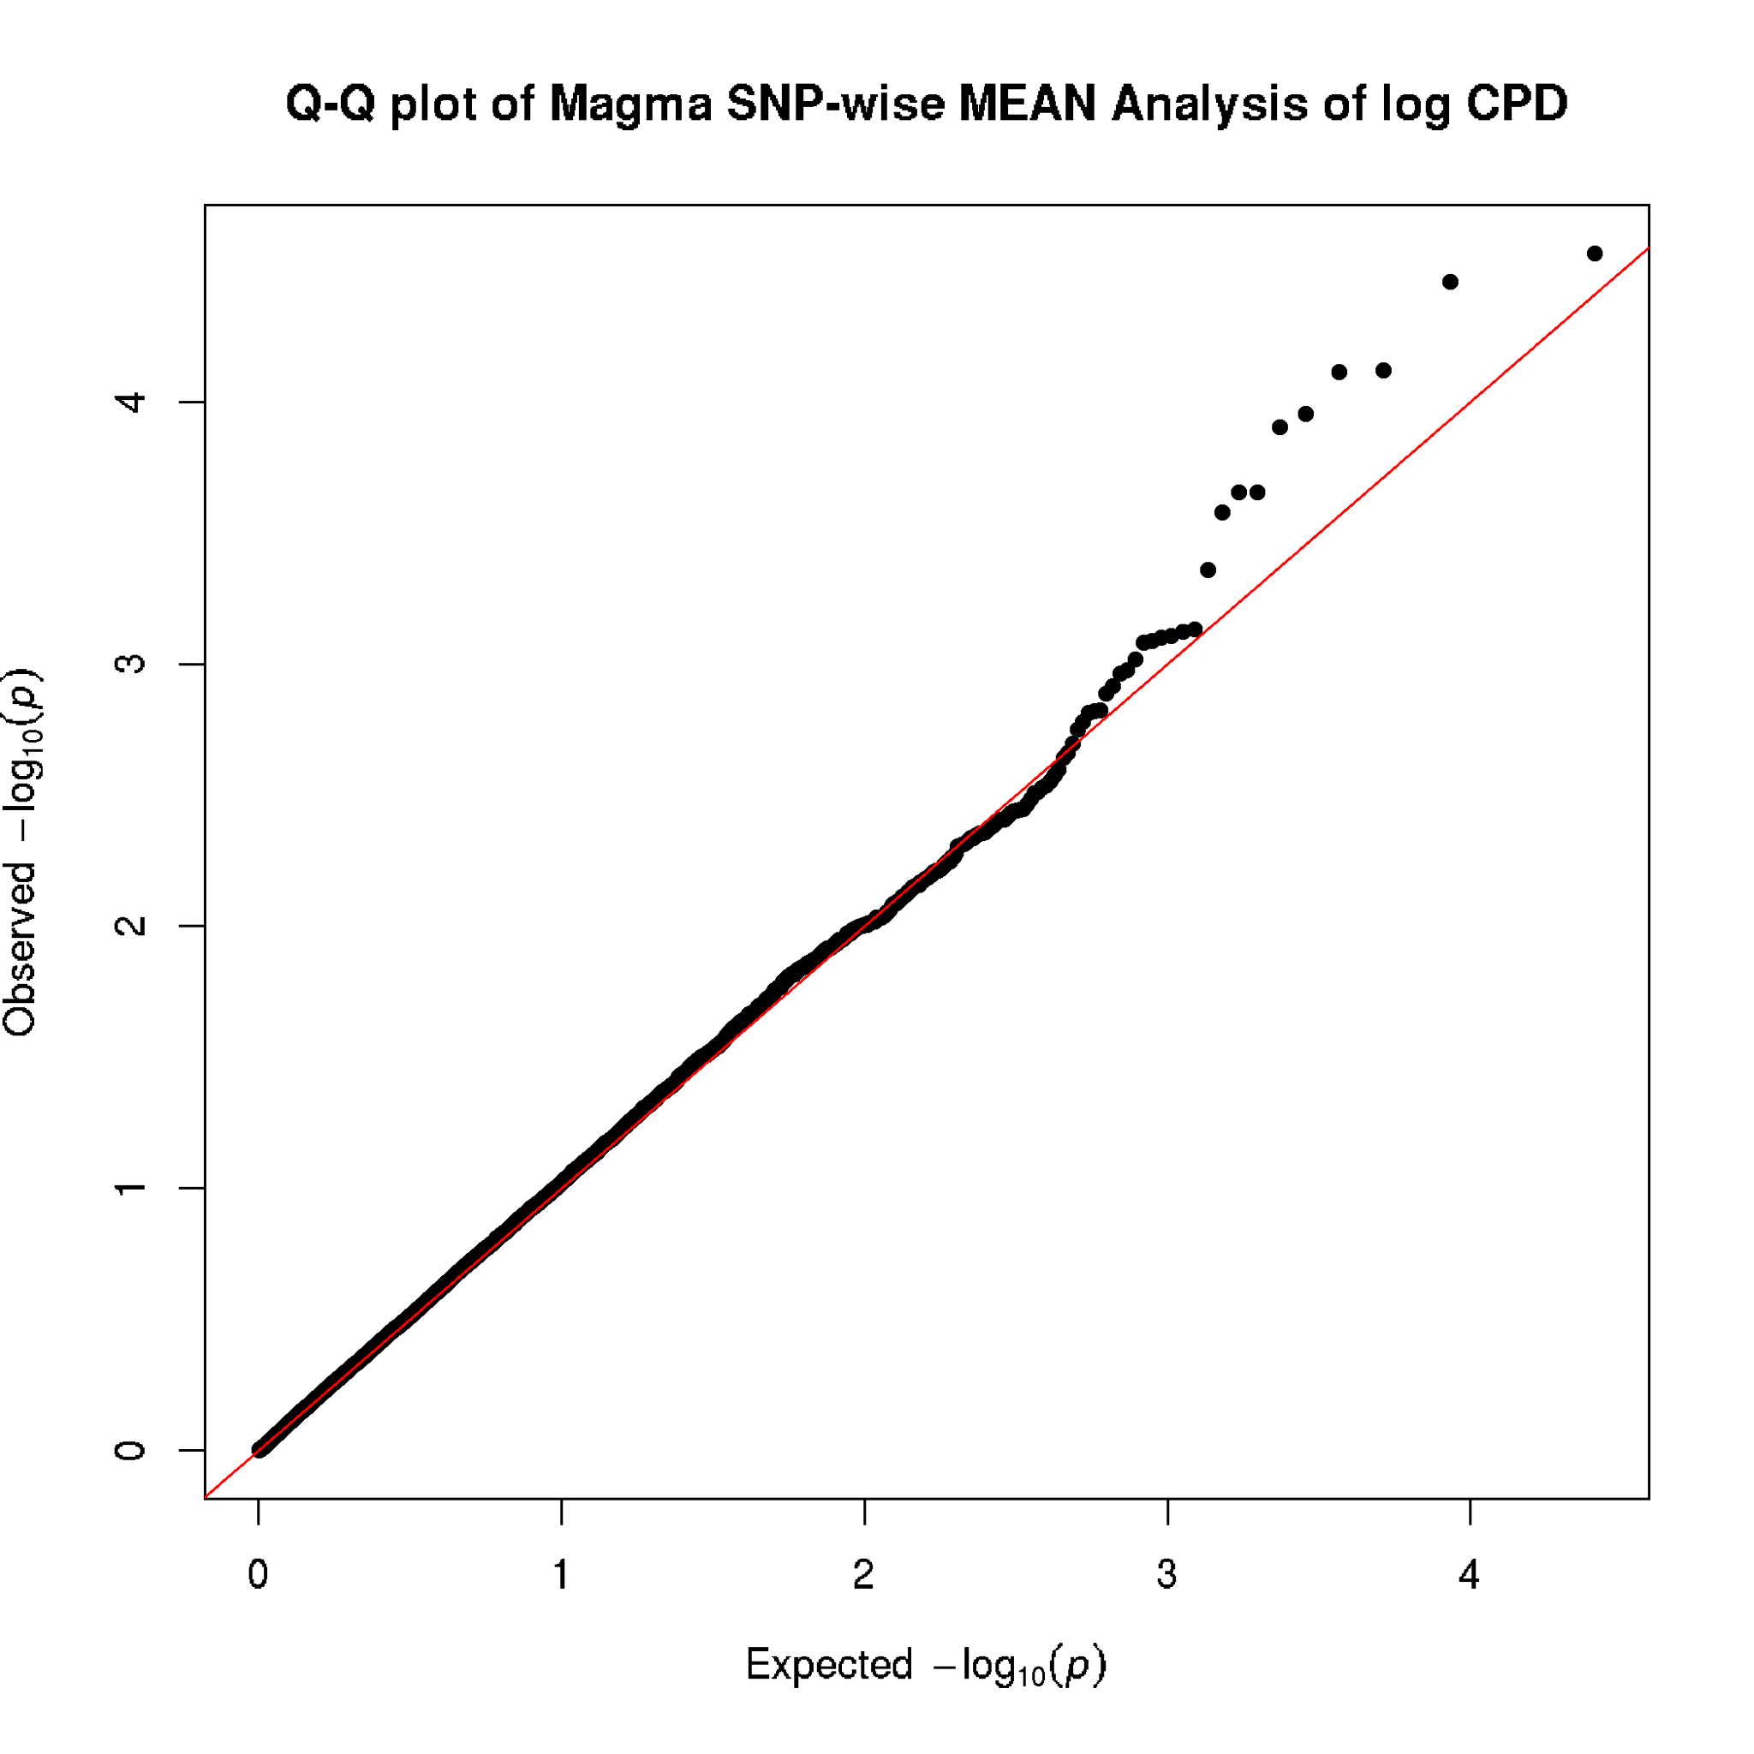
A) SNP-wise Top:
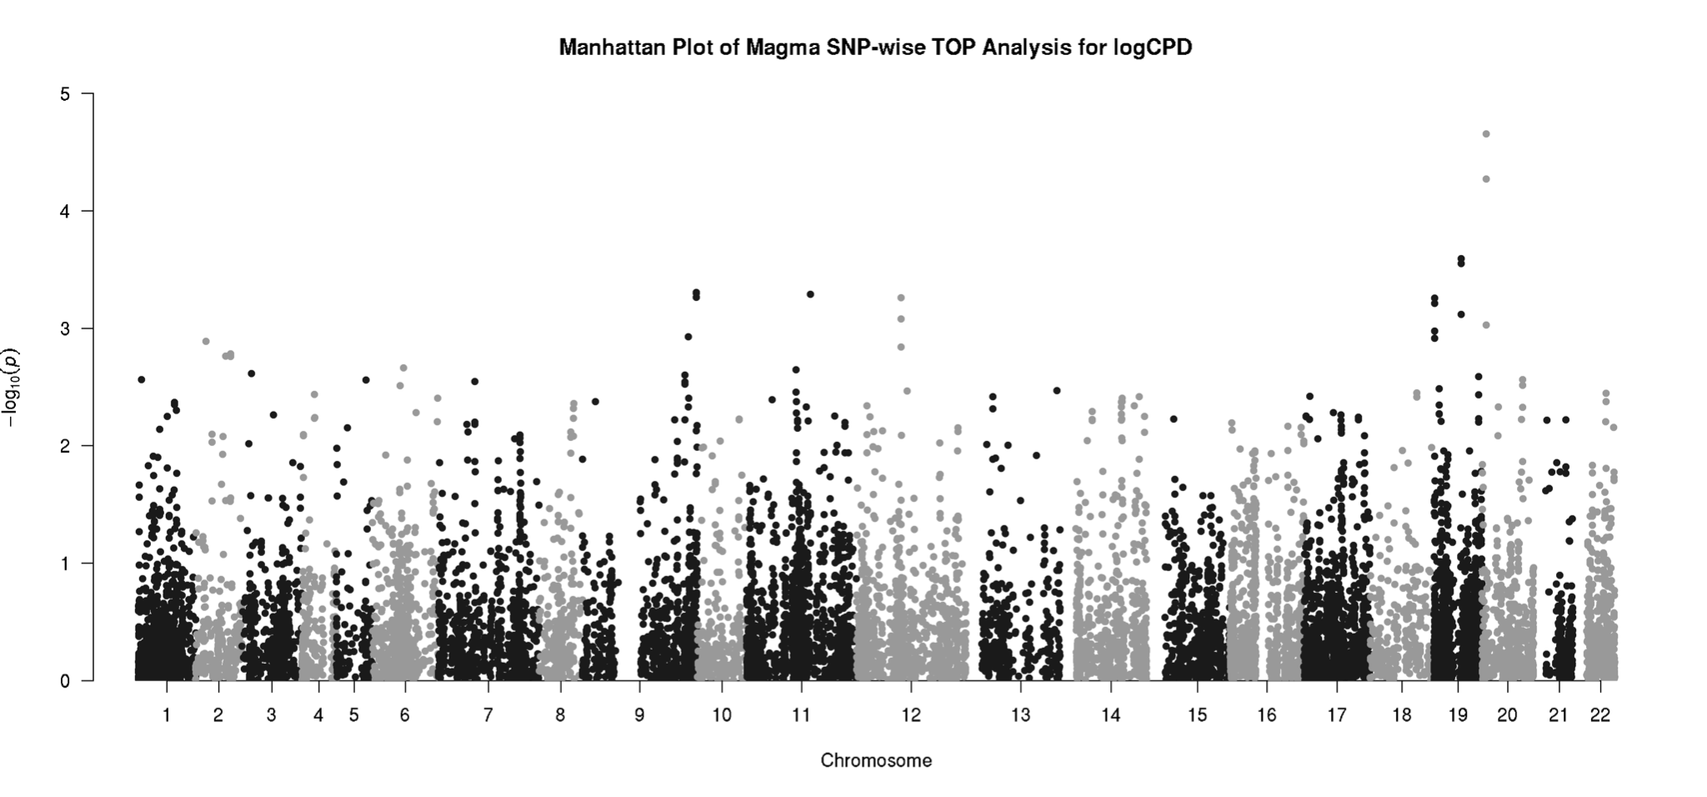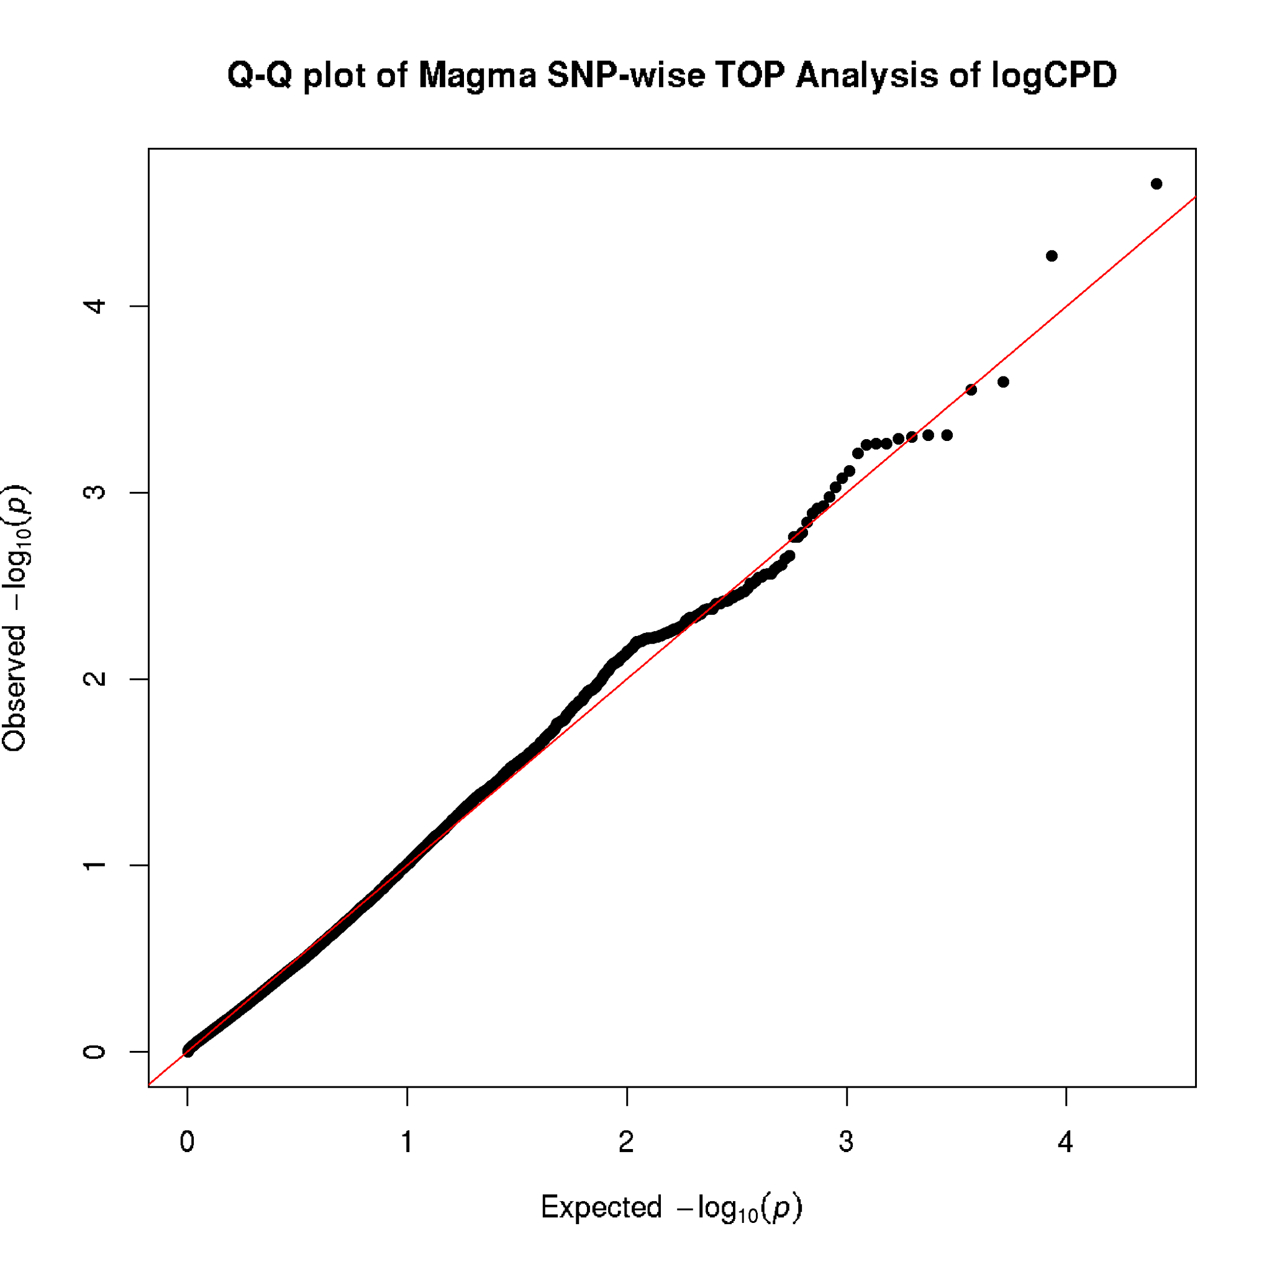
Figure S5: Manhattan and Q-Q plots of rs16969968 interacting with genes to influence log10-transformed cigarettes per day in the UK Biobank. (A) No gene reached significance for interacting with rs16969968 to influence log10-transformed CPD after adjusting for multiple testing when using the SNP-wise Mean model in MAGMA. (B) No gene reached significance for interacting with rs16969968 to influence log10-transformed CPD after adjusting for multiple testing when using the SNP-wise Top model in MAGMA.

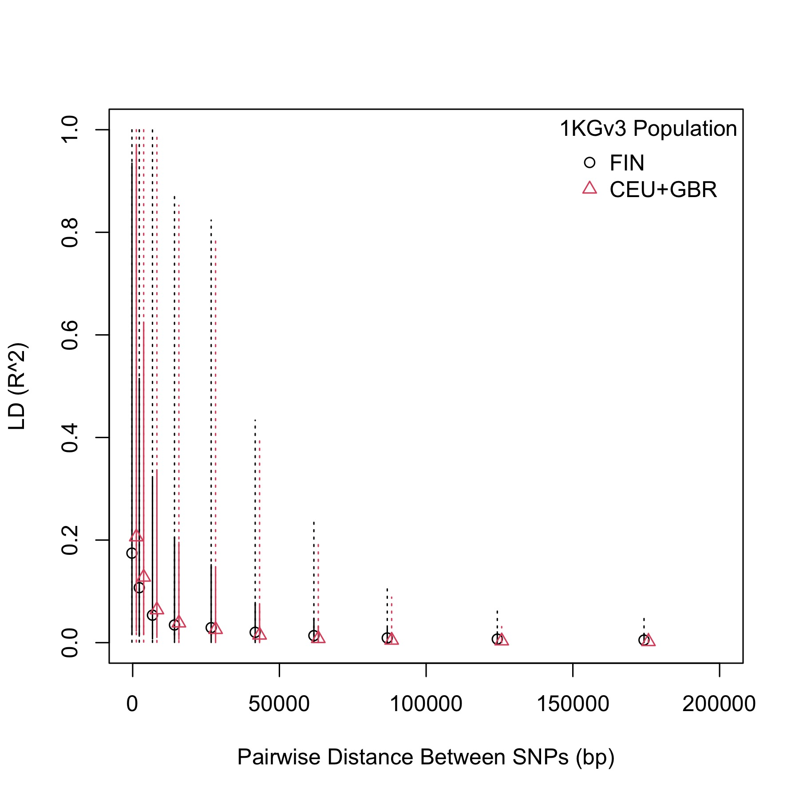
Figure S6: LD decay for variants within PCNA for Finnish is like that of British European ancestry, suggesting the Finnish samples are suitable replication sample for our present study. We combined Central European (CEU) and British in England and Scotland (GBR) populations in the 1,000 Genomes reference as a proxy for European ancestry in the United Kingdom. For Finnish, we used the Finnish population in the 1,000 Genomes repository. We then plotted the decay of linkage disequilibrium as a function of distance to compare their LD decay patterns within our region of interest of the PCNA gene.

- SNP-level SNP×rs16969968:
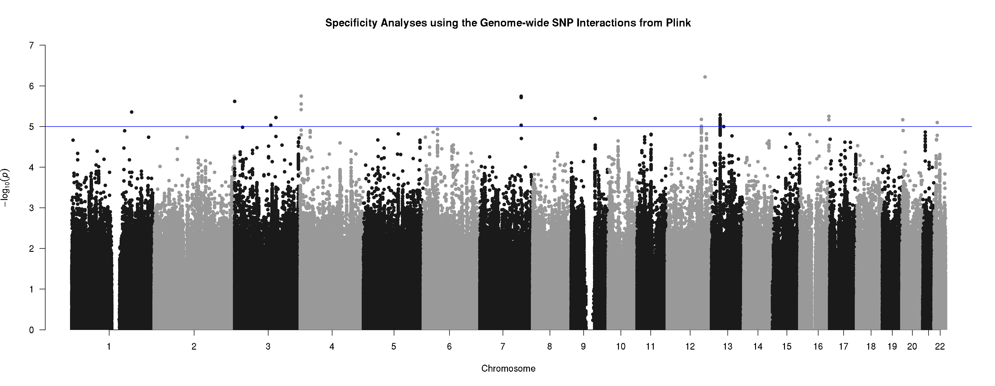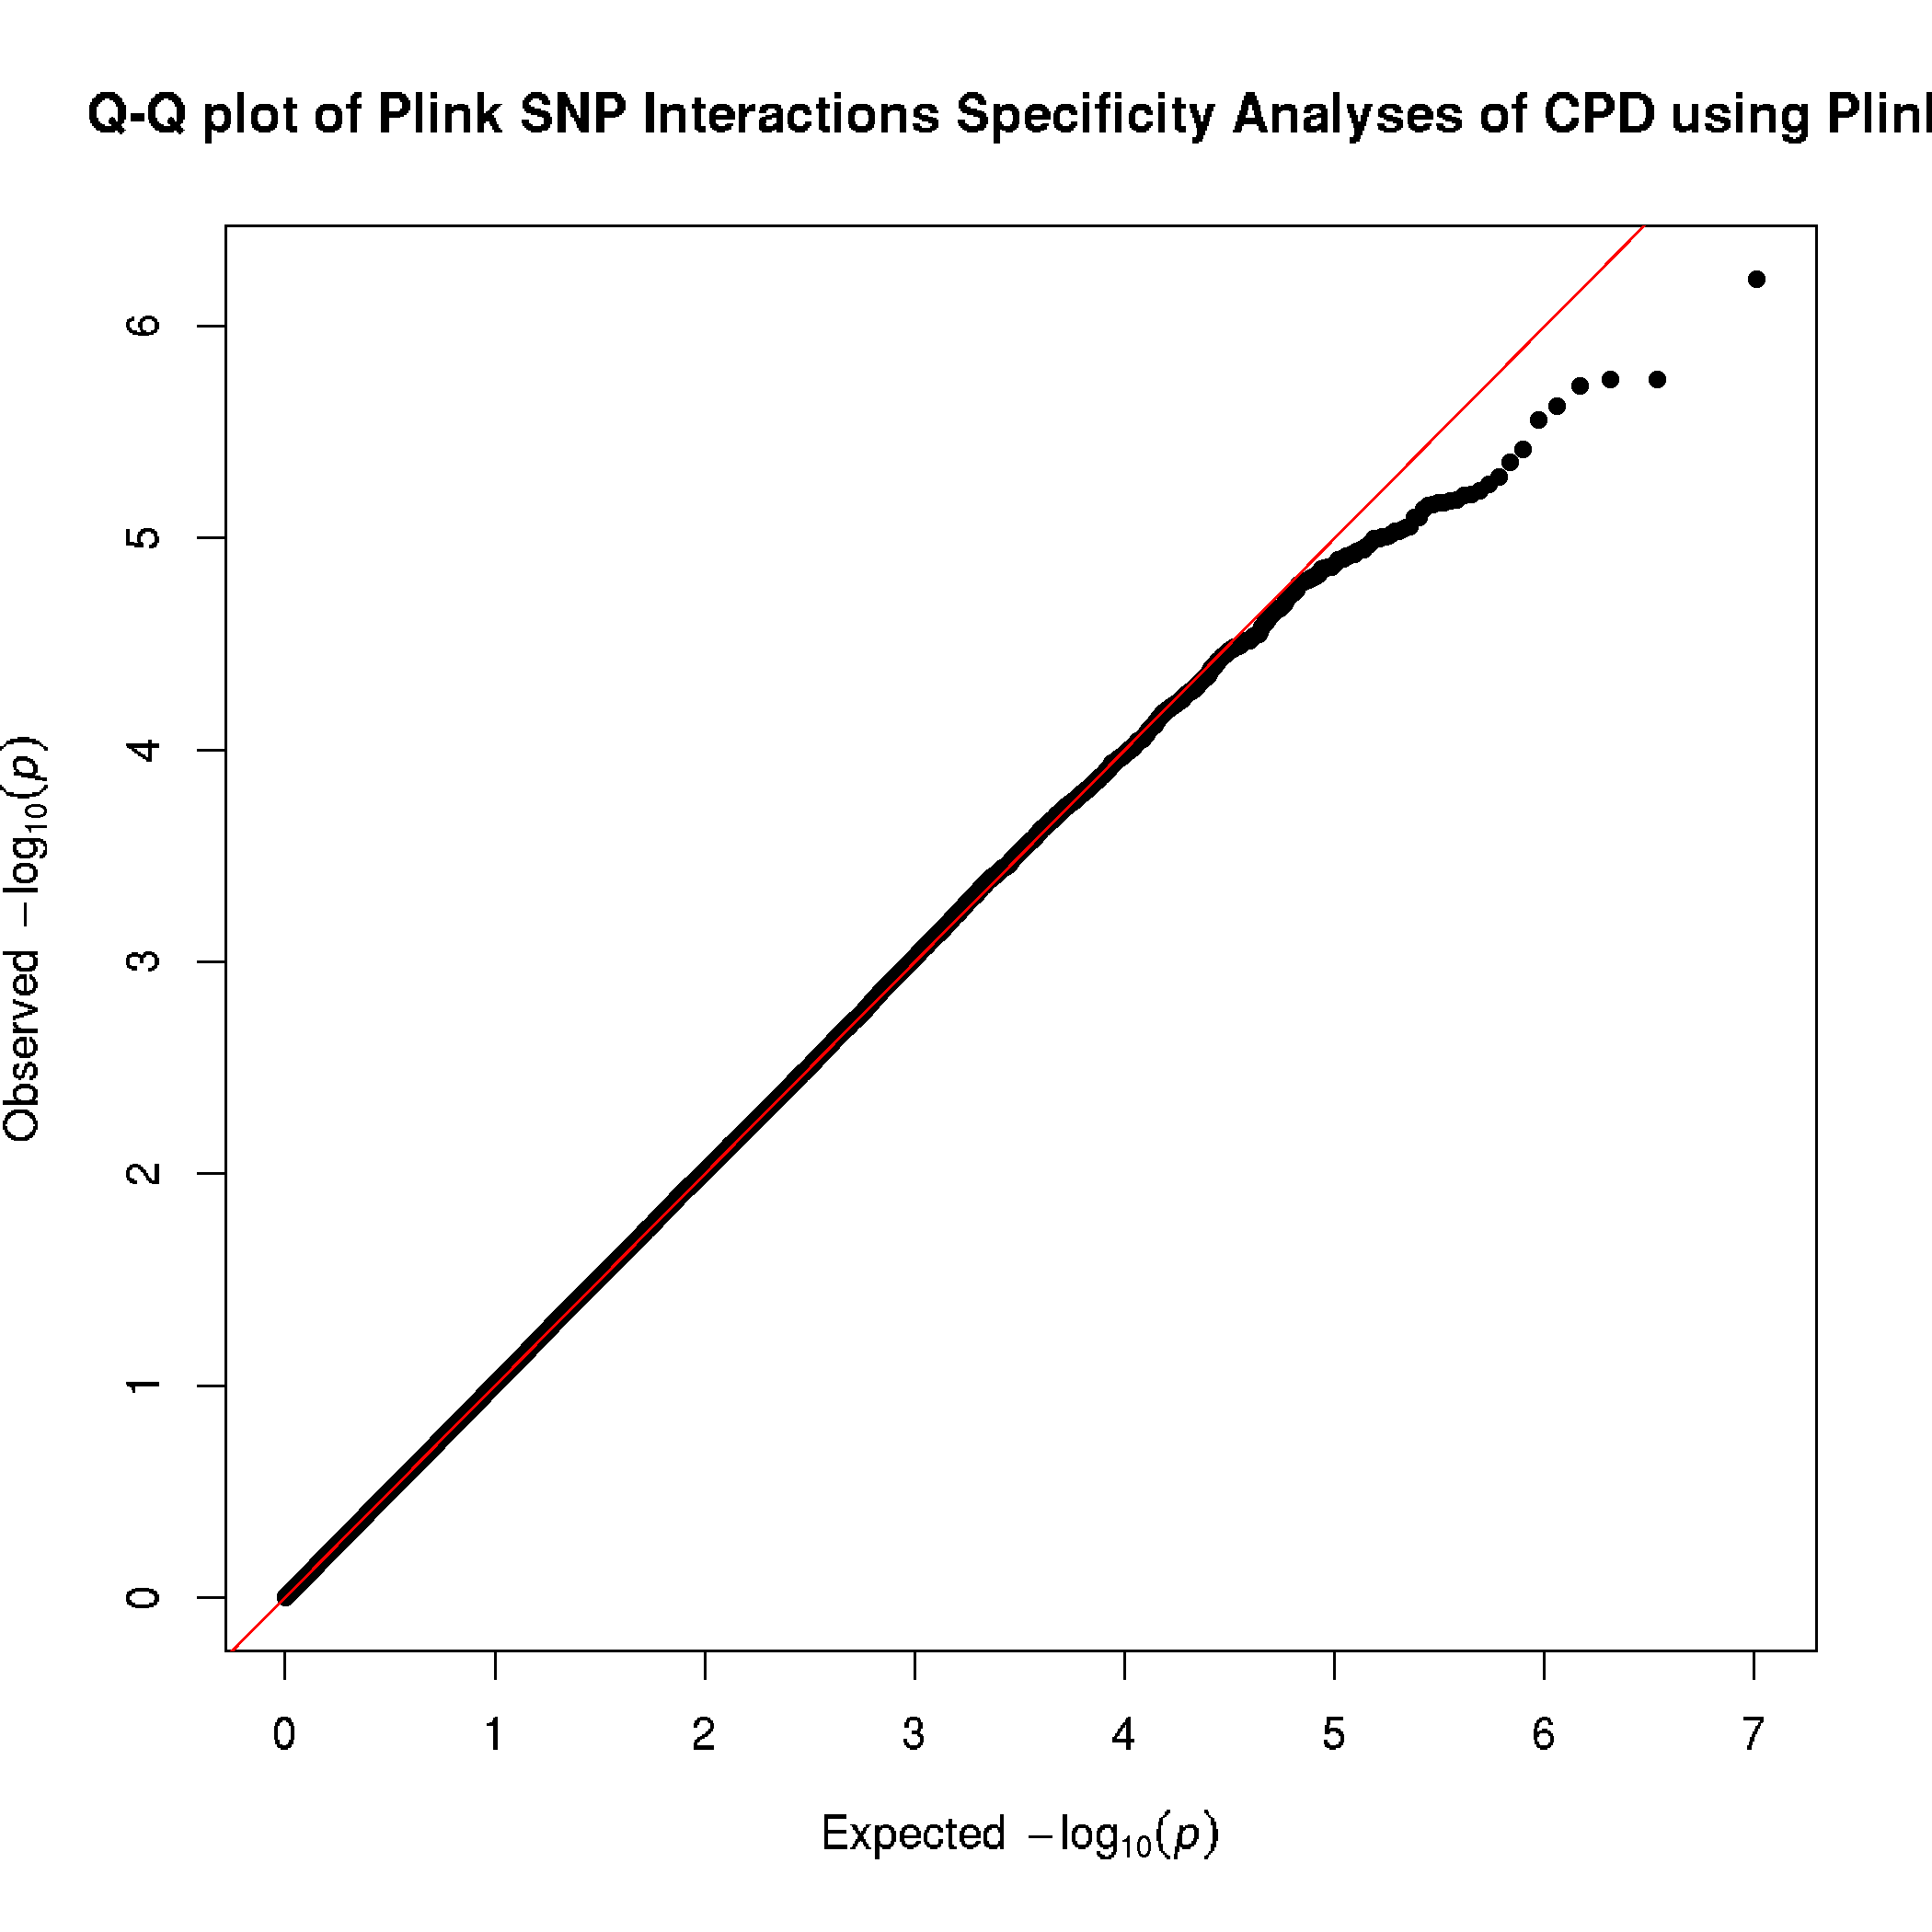
- SNP-wise Mean:
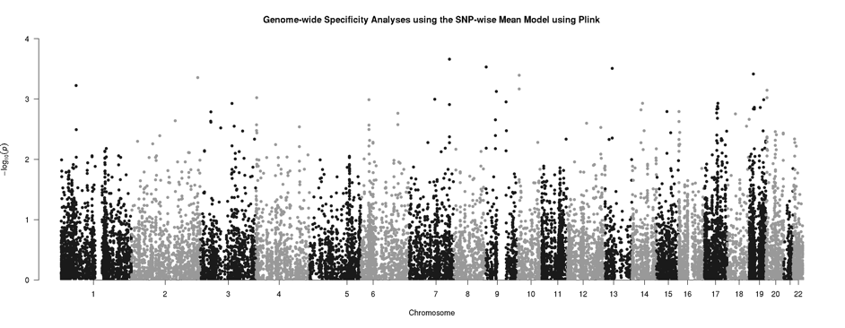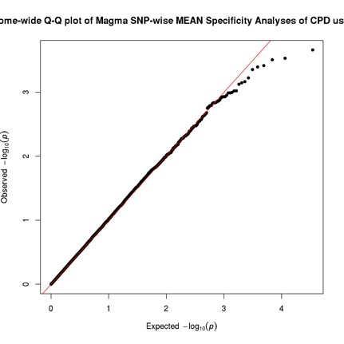
- SNP-wise Top:
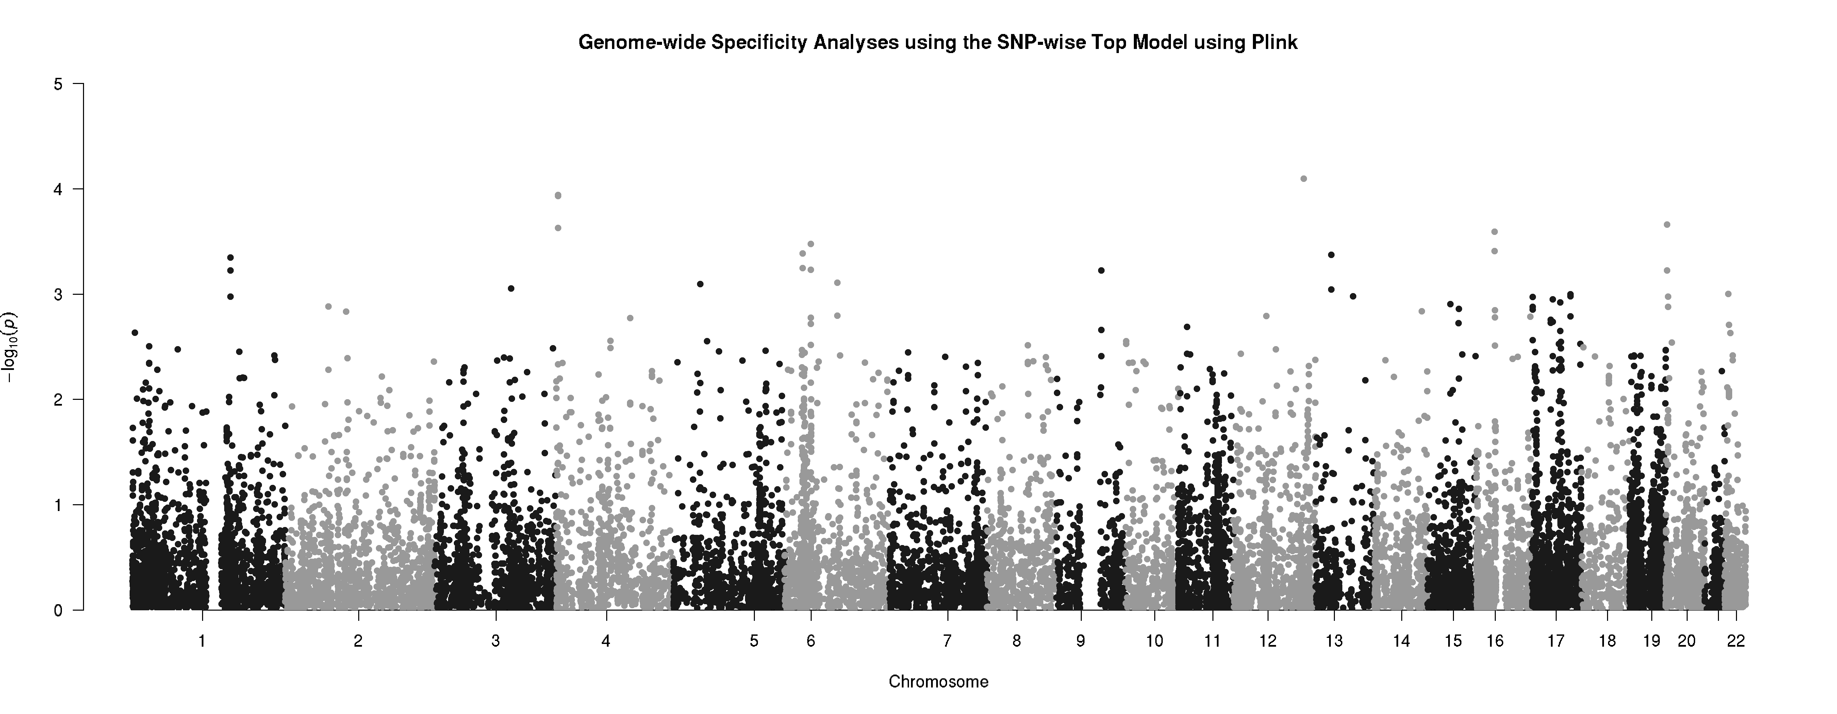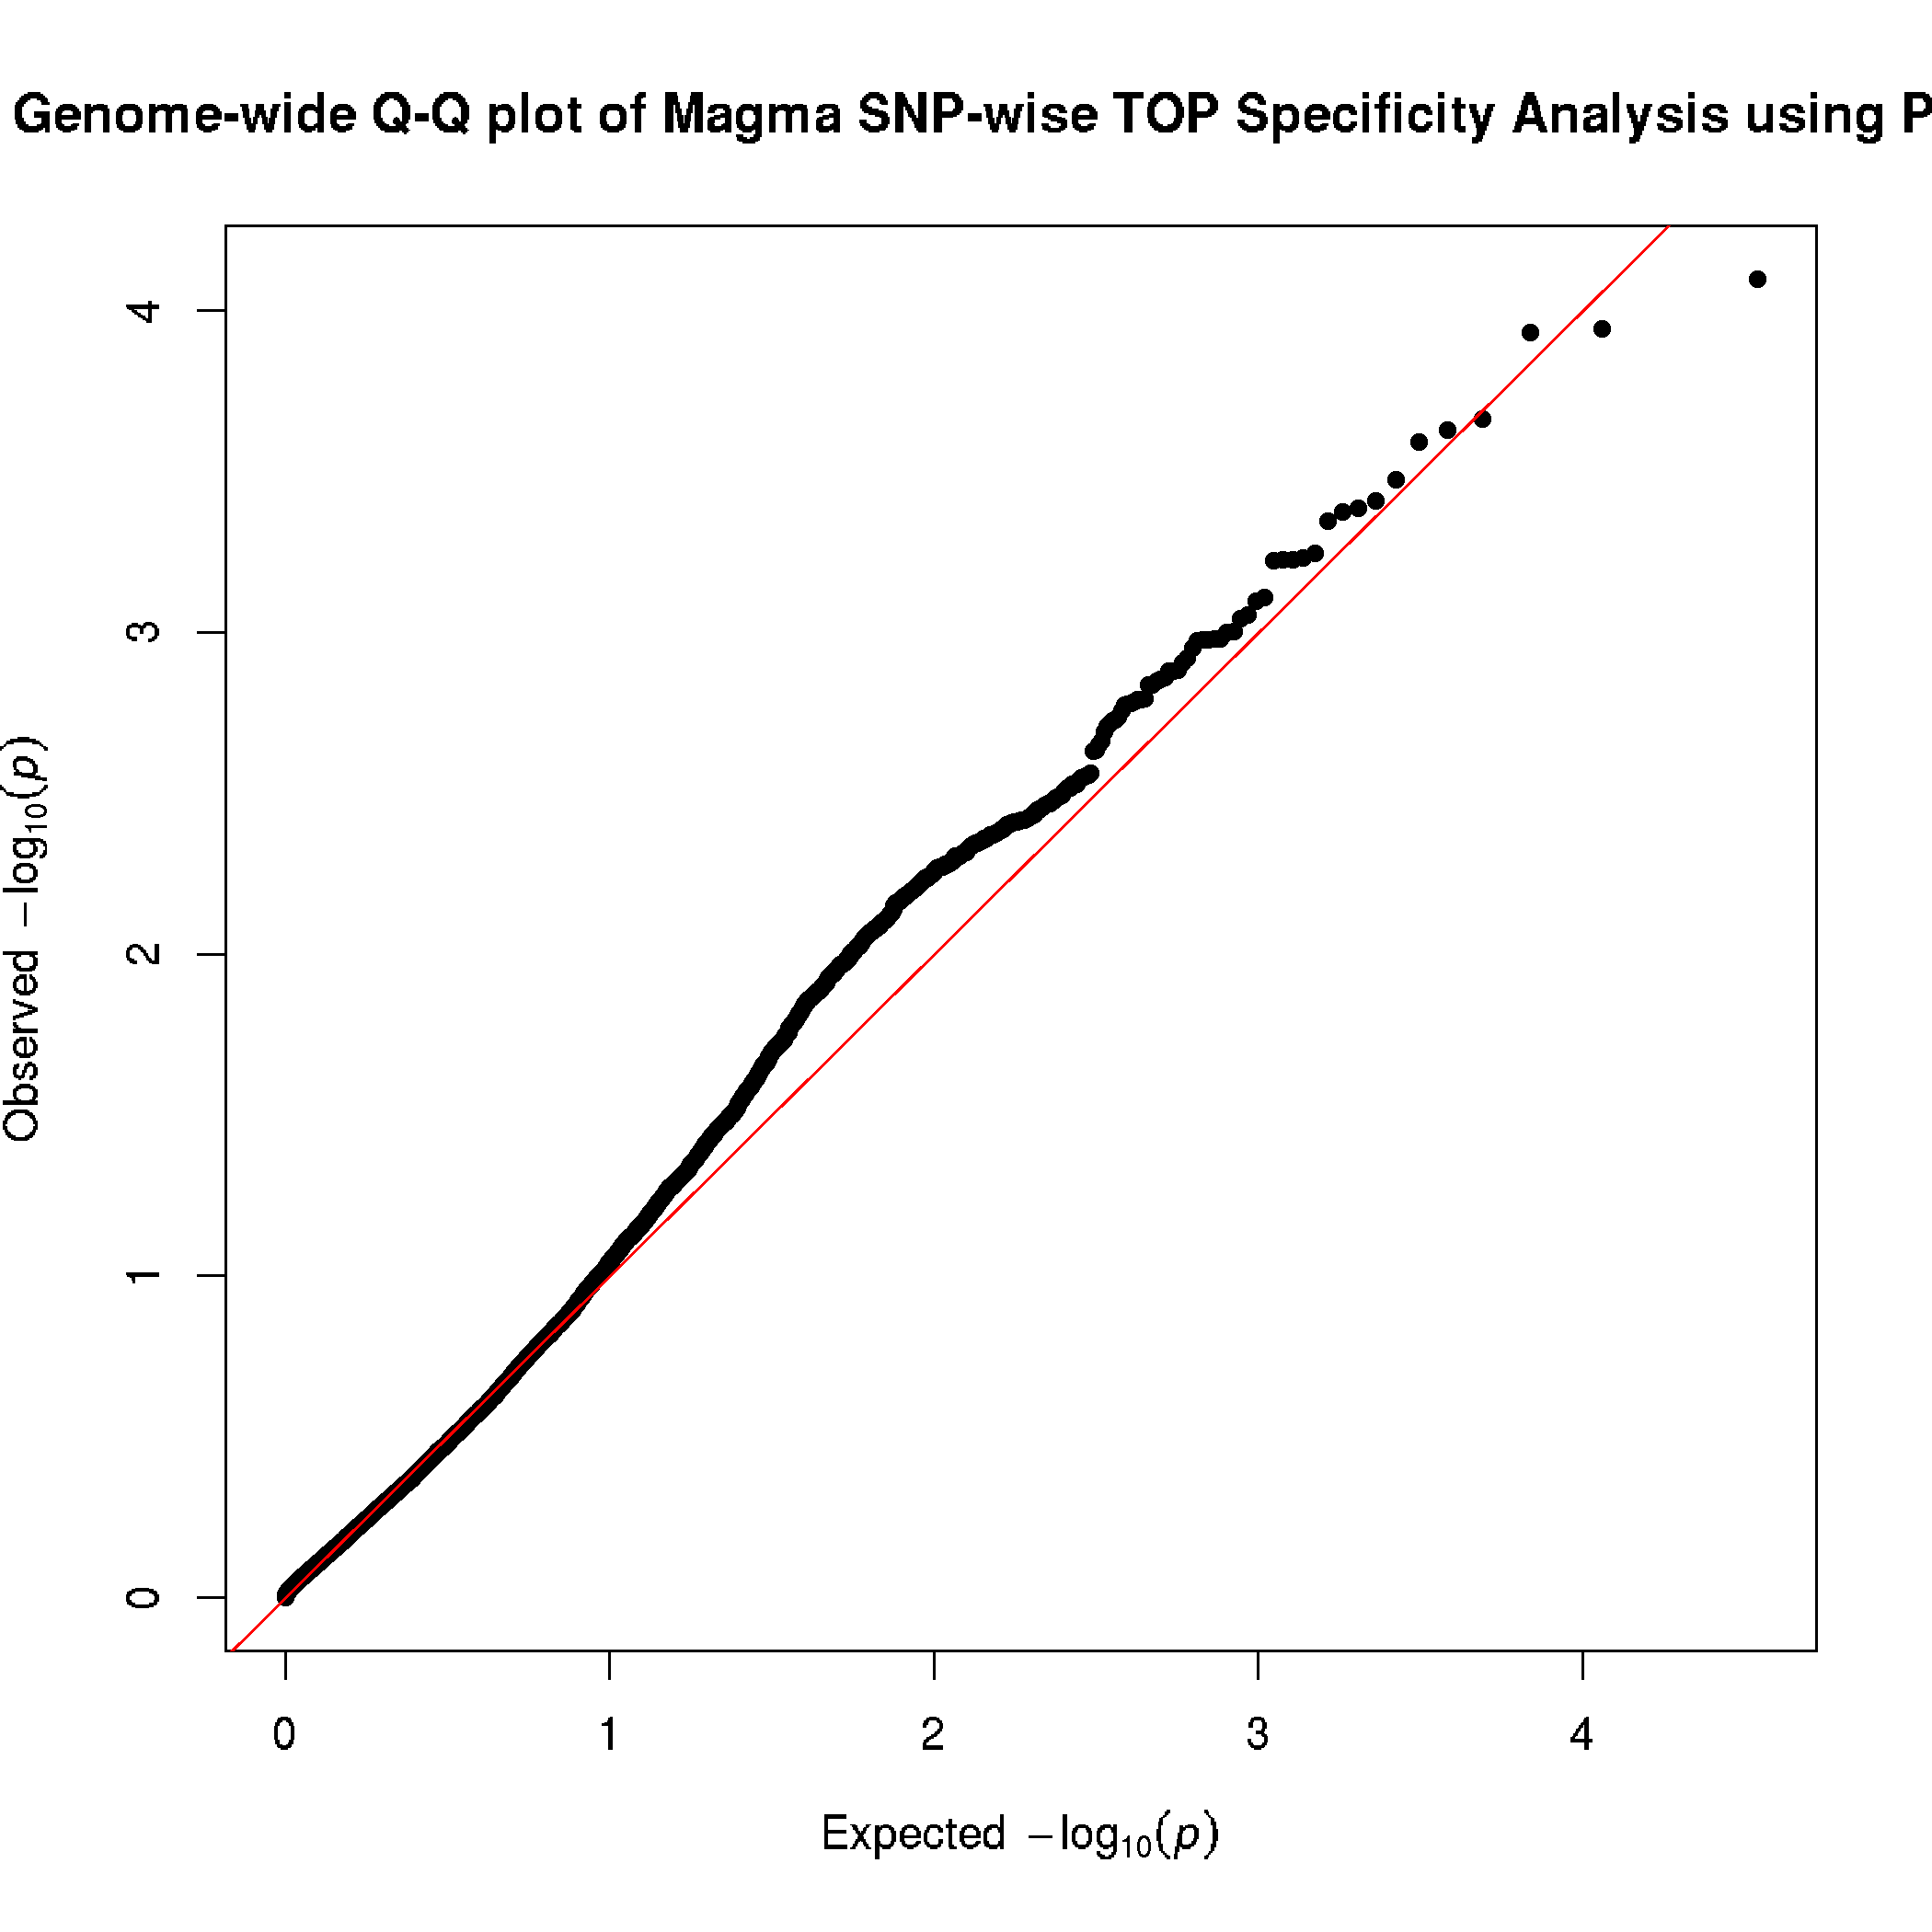
Figure S7: Manhattan and QQ plots for specificity analyses of MAGMA’s SNP-wise Mean and SNP-wise Top Models. (A) PLINK results of the SNPxrs16969968 interactions used as input for MAGMA’s mean and top models. Blue line denotes suggestive significance of p < 1x10⁻⁵, red line denotes genome-wide significance p < 5x10⁻⁸ (B) Type I error was properly controlled for using the SNP-wise Mean model when the true interaction effect was set to 0 when using a Bonferroni correction. (C) The SNP-wise Top model showed some signs of improperly controlling for false positives; however, after controlling for multiple testing, no gene was significant.

