Supplementary Information for: Characterizing the landscape of viral expression in cancer by deep learning

Supplementary Tables

Supplementary Table 1. Average model scores assigned to different human viruses plotted in Figure 1d. Model scores were averaged across all 48 bp segments for each virus, using 2bp window size.

Supplementary Table 2. TCGA sample information of 7272 samples from 14 cancer types used throughout this study

Supplementary Table 3. RefSeq viruses identified in 7272 TCGA samples from 14 cancer types, together with tumor mutation burden (TMB), chromosome level copy number alterations (CNA) overall survival time and death (0=survival, 1=death) for each TCGA sample considered in this study.

Supplementary Table 4. Human endogenous viruses identified in 7272 TCGA samples from 14 cancer types. The ERV identifier can be mapped via Supplementary Table 5 to the hg19 genomic interval that contains the ERV.

Supplementary Table 5. Intact retroviral genes, chromosomal location (hg19 assembly) and human gene and distance (measured as minimum between the number of bp from the start and end of each gene, where intronic HERVs are not distinguished) of each HERV to the nearest gene identified in TCGA tumor samples. The distance from the nearest SNP (dist_from_SNP) and the phenotype associated with the nearest SNP (SNP distance) are provided, and -1 values are assigned if no disease associated SNP was found located near a HERV.

Supplementary Table 6. Associations between HERV presence and tumor mutation burden or chromosomal aneuploidy across the 14 cancer types from TCGA. The values correspond to one sided Wilcoxon rank-sum p-values. TMB_greater and TCNA_greater test whether the TMB or CNA is greater in the presence of each HERV, and TMB_less and TCNA_less test whether the TMB or CNA is lower in the presence of each HERV.

Supplementary Table 7. Hyper-geometric enrichment p-values evaluating enrichment between somatic mutations in 10 frequently mutated cancer driver genes, and the expression of 36 HERVs that were found frequently expressed in cancer tissues.

Supplementary Table 8. Somatic mutations in frequently mutated cancer driver genes for cancer types in which HERV expression was associated with poor survival, and HERVs identified in TCGA samples within these cancer types.

Supplementary Table 9. Divergent unexpected viruses found expressed in 7272 samples from 14 cancer types from TCGA used throughout this study.

Supplementary Table 10. The IIV31 proteins identified in endometrial cancer (UCEC) samples with the tumor mutation burden and chromosomal aneuploidy scores. -1 values are assigned to samples with RNA sequencing data that did not have mutation or copy number information to evaluate the TMB or CNA.

Supplementary Figures
Supplementary Figure 1. The proportions of TCGA samples that are identified as virus-positive by viRNAtrap that were also verified as virus-positive through TCGA clinical information. From left to right: HR-HPV-positive in CESC, HR-HPV-positive in HNSC, HBV-positive in LIHC and HCV-positive in LIHC. HR-HPV: high-risk human papilloma virus; HBV: hepatitis B virus; HCV: hepatitis C virus.

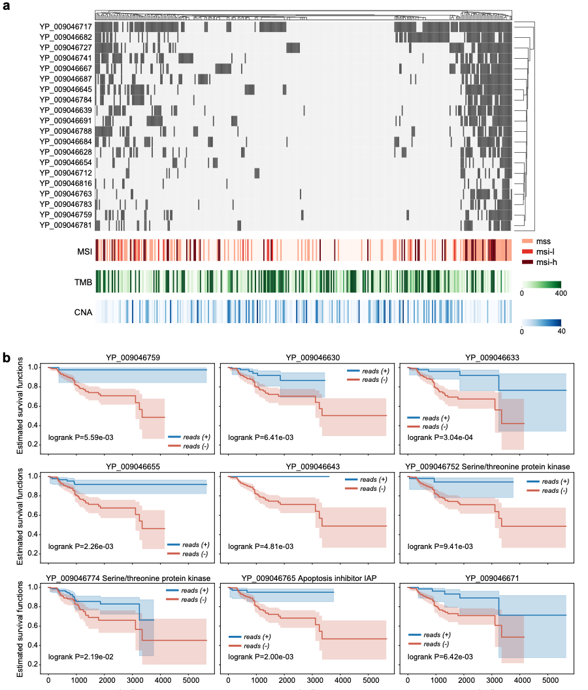
Supplementary Figure 2. Clinical and genomic correlates of Armadillidium vulgare iridescent virus (IIV31) expression in endometrial cancers.
(a) Heatmaps showing IIV31 proteins expressed in different tumors, microsatellite instability, chromosomal aneuploidy, and tumor mutation burden (TMB) across endometrial cancer samples.
(b) Kaplan-Meier survival curves comparing survival based on presence (blue) or absence (red) of different IIV31 proteins in endometrial cancer samples.

