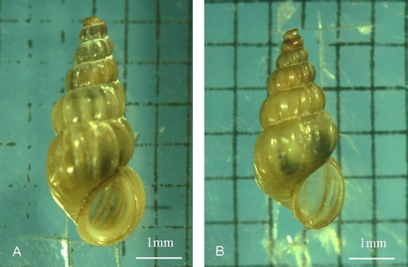
Supplementary figure1. Comparison of shell shape changes after 12 generations of O. hupensis snails in the Weishan Lake region. Compared with the Jiangsu snails, the body size of the Shandong snails in the Weishan Lake region decreased, and their shells became thinner. (A) Jiangsu snail; (B) Shandong snail.
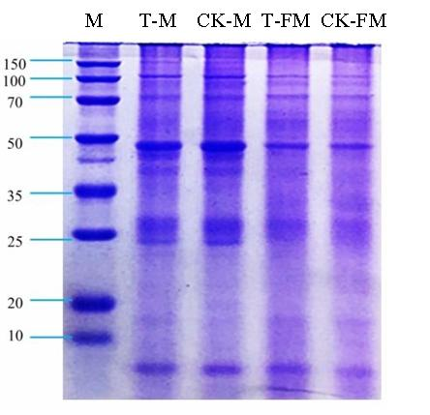
Supplementary figure 2. SDS-PAGE of adult S. japonicum worm proteins. T-M: Male adult worms (Shandong); CK-M: Male adult worms (Jiangsu); T-FM: Female adult worms (Shandong); CK-FM: Female adult worms (Jiangsu).
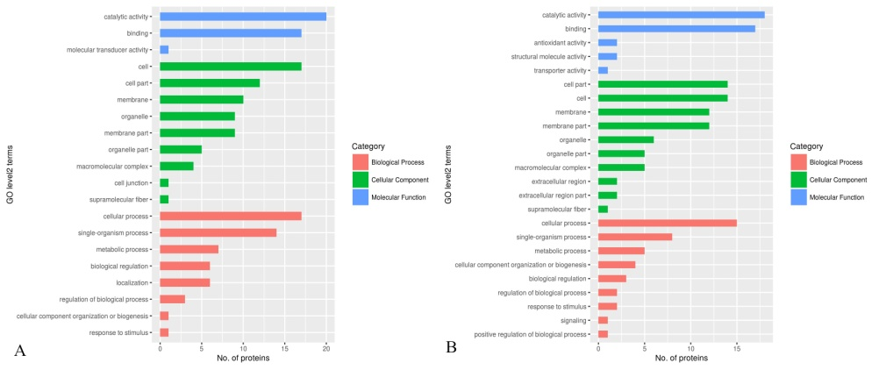
Supplementary figure 3. GO term analysis of DEPs in the T_FM-vs-CK_FM and T_M-vs-CK_M groups. (A) The x-axis shows the number of female adult worm DEPs; the y-axis shows the GO level 2 terms enriched among the DEPs. (B) The x-axis shows the number of male adult worm DEPs; the y-axis shows the GO level 2 terms enriched among the DEPs. The GO term categories included were biological process, cellular component, and molecular function.
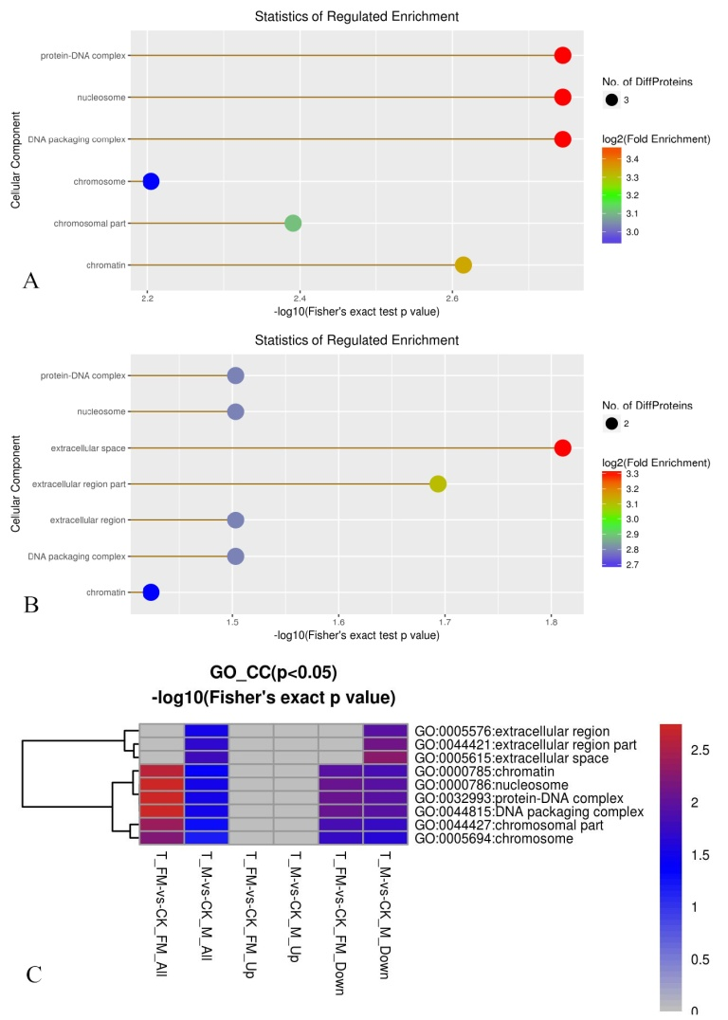
Supplementary figure 4. GO enrichment analysis for cellular components in the T_FM-vs-CK_FM (A) and T_M-vs-CK_M (B) groups, and the ratios (C) of regulated proteins. (A) and (B): The x-axis shows the -log10(Fisher’s exact test p value) and the y-axis shows the cellular component. The color indicates the score of the log2(Fold Enrichment); the circle size represents the number of DEPs. (C) The x-axis shows the -log10(Fisher’s exact test p value＜0.05) ratio of the T_FM-vs-CK_FM and T_M-vs-CK_M groups and the y-axis shows the GO cellular component score.
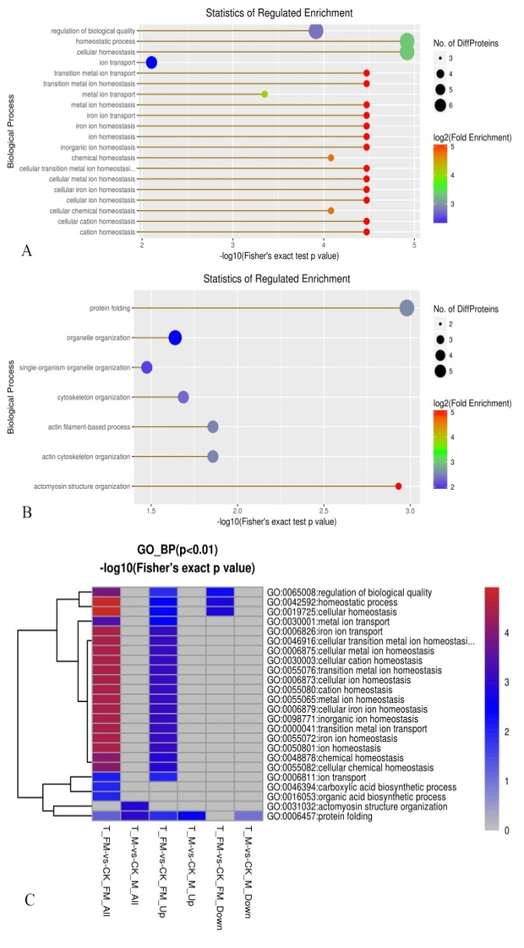
Supplementary figure 5. GO enrichment analysis for biological processes in the T_FM-vs-CK_FM (A) and T_M-vs-CK_M (B) groups, and the ratios (C) of regulated proteins. (A) and (B): The x-axis shows the -log10(Fisher’s exact test p value) and the y-axis shows the biological process score. The color indicates the score of the log2(Fold Enrichment); the circle size represents the number of DEPs. (C) The x-axis shows the -log10(Fisher’s exact test p value＜0.01) ratio of the T_FM-vs-CK_FM and T_M-vs-CK_M groups and the y-axis shows the GO biological process score.
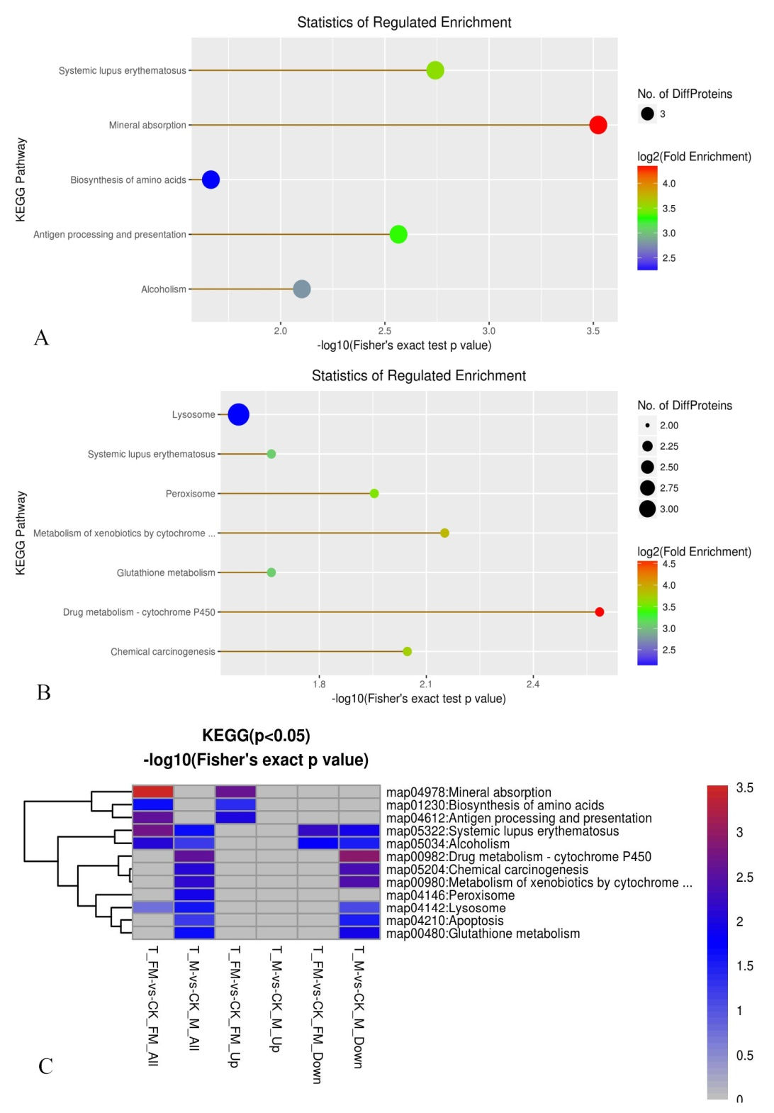
Supplementary figure 6. GO enrichment analysis for KEGG in female (A) ,male (B) and it’s ratio (C) adult worms.
(A) and (B):The x-axis shows the –log10 (Fisher’s exact test p value) ; the y-axis shows the KEGG score; The color shows the score of log2 (Fold Enrichment) ; the circle size stand for the number of DEPs. (C) The x-axis shows the -log10 (Fisher’s exact test p value＜0.01) ratio of T_FM-vs-CK_FM and T_M-vs-CK_M; the y-axis shows the KEGG score.
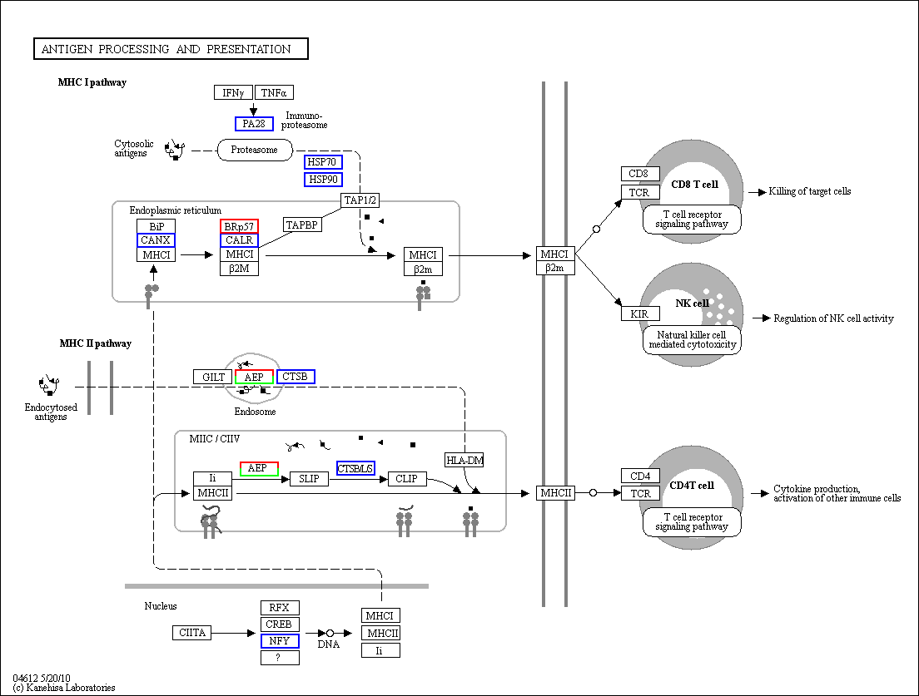
Supplementary figure 7. Representative KEGG pathway of upregulated antigen processing and presentation (T_FM-vs-CK_FM, map04612). The rectangular nodes in the figure represent gene products. The blue borders indicate background proteins, and white boxes indicate proteins not identified in this experiment. The red/green borders in the figure indicate the DEPs detected in this study, with red representing upregulated proteins and green representing downregulated proteins. Half red and half green borders indicate gene products with both upregulated and downregulated proteins.

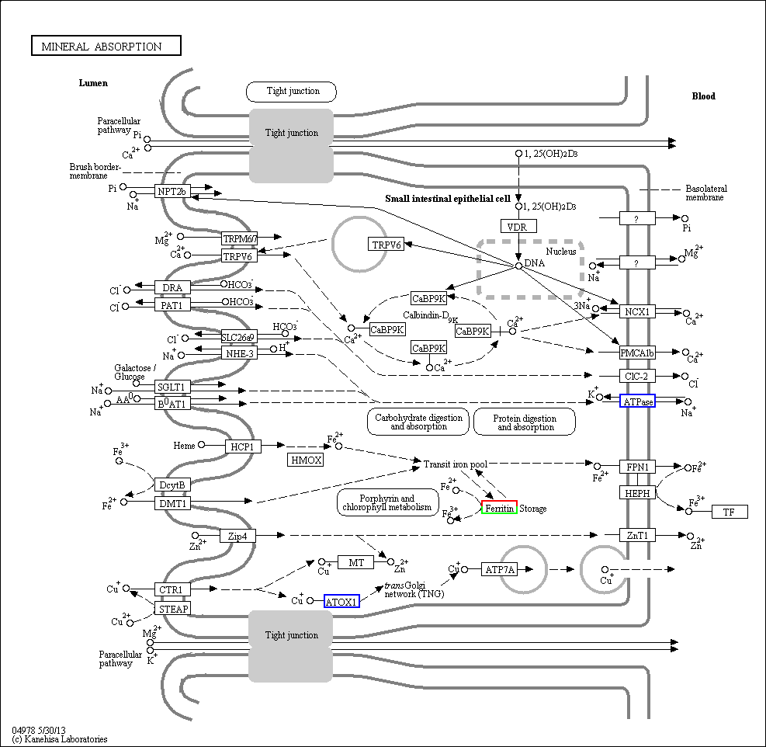
Supplementary figure 8. Representative KEGG pathway of upregulated mineral absorption (T_FM-vs- CK_FM, map04978). The rectangular nodes in the figure represent gene products. The blue borders indicate background proteins, and white boxes indicate proteins not identified in this experiment. The red/green borders in the figure indicate the DEPs detected in this study, with red representing upregulated proteins and green representing downregulated proteins. Half red and half green borders indicate gene products with both upregulated and downregulated proteins.

