Supplementary Data – Abdominal obesity, rather than overall obesity, is a causal risk factor for pancreatic cancer
Supplementary Methods.
Type 2 diabetes definition in UK Biobank (UKBB)
To determine the role of type 2 diabetes (T2D) in the relationship between obesity and pancreatic cancer, we sought to first define the genetic correlation between T2D and pancreatic cancer. Secondly, we included T2D as an additional covariate in our polygenic scores (PGS) analyses. A T2D case in UKBB was defined if a participant self-reported a diabetes diagnosis made by a doctor, were on insulin medication one year post-diagnosis and were at least 40 years old by the time the diagnosis was made. T2D controls included individuals who did not meet the case criterion. From both cases and controls, we excluded individuals with gestational diabetes (UKBB field 4041, code=1), individuals on insulin medication within the first year of diagnosis (UKBB field 2986) and individuals who were younger that 40 years old at the time of diagnosis (UKBB field 2976). In total, we had 19,344 cases and 463,641 controls of European ancestry.
Genetic correlation estimation in UKBB
We used the LDSC regression tool¹ to estimate the genetic correlation between BMI, WHRadjBMI and pancreatic cancer in UKBB. UKBB GWAS summary statistics were filtered based on the following parameters: imputation score > 0.9, minor allele frequency (MAF) > 0.01 and 0.1 ≥ P-value > 0. Strand ambiguous, duplicated SNPs and variants that did not represent SNPs (e.g., indels) were removed. The Bonferroni corrected significance threshold to determine significant genetic correlation estimates was set as P<0.025 (0.05/2, the number of genetic correlation tests done in our analyses; one for BMI and one for WHRadjBMI). Nominal significance threshold was set at 0.05 ≥ P > 0.025.
Polygenic scores
The SNP lists for BMI and WHRadjBMI were obtained from GIANT consortium’s meta-analyses^{2,3}. The meta-analyses included previous GIANT studies^{4,5} and UKBB. Since we used the UKBB as the target data (testing cohort for our PGS), we use the weights from the studies that did not include UKBB in the meta-analyses. The workflow for PGS analyses is shown in Supplementary Figure 1 below.
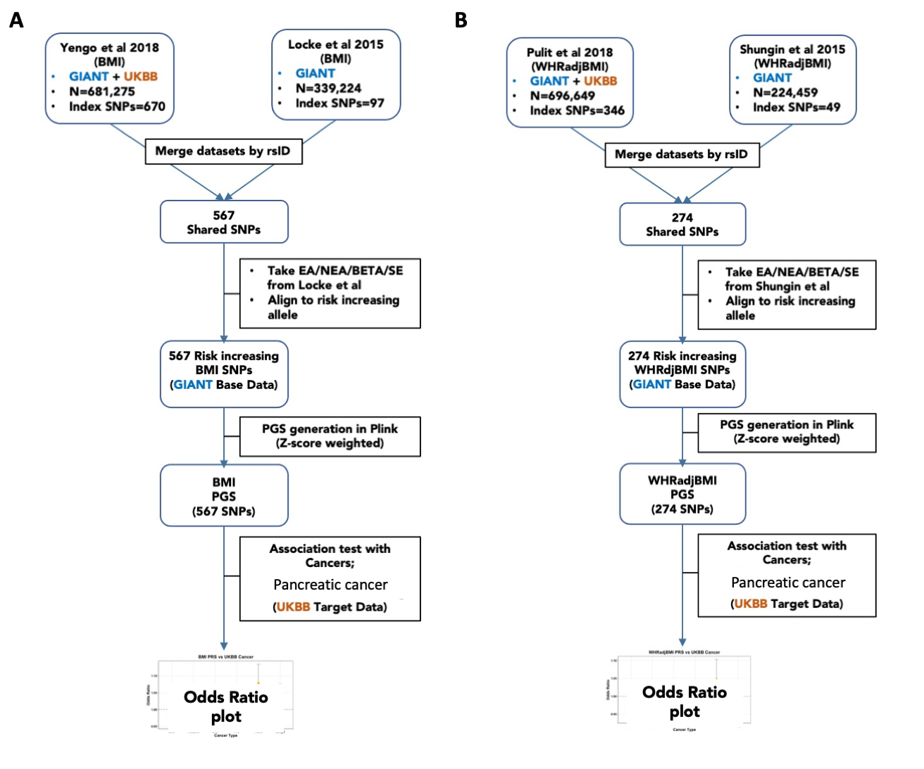
Supplementary Figure 1. (A) BMI and (B) WHRadjBMI polygenic score analyses pipeline. A two-sample approach was used to construct our PGS base data. The SNPs used for the PGS were from GIANT’s latest BMI and WHRadjBMI meta-analyses. Since the meta-analyses comprised of the UK Biobank (our target data), we used weights from the non-UK Biobank study in GIANT’s meta-analyses.
Mendelian randomization (MR)
We assessed the causal relationships between BMI, WHRadjBMI and pancreatic cancer using bi-directional MR. The TwoSampleMR R package⁶ was used for this analysis. We tested the effect of obesity (BMI and WHRadjBMI) as an exposure for pancreatic cancer (outcome), and the reverse direction with pancreatic cancer as a risk factor for obesity (BMI and WHRadjBMI) using summary statistics from independent datasets. The genetic instruments for BMI (670 SNPs) and WHRadjBMI (346 SNPs) were obtained from GIANT consortium^{2,3}. Additionally, the pancreatic cancer genetic instruments (22 SNPs) were obtained from a recent large-scale meta-analysis by Klein et al⁷.
REFERENCES:
1. Bulik-Sullivan, B. et al. LD Score regression distinguishes confounding from polygenicity in genome-wide association studies. Nature Genetics 2015 47:3 47, 291–295 (2015).
2. Yengo, L. et al. Meta-analysis of genome-wide association studies for height and body mass index in ∼700000 individuals of European ancestry. Human Molecular Genetics 27, 3641–3649 (2018).
3. Pulit, S. L. et al. Meta-analysis of genome-wide association studies for body fat distribution in 694 649 individuals of European ancestry. Human Molecular Genetics 28, 166–174 (2019).
4. Locke, A. E. et al. Genetic studies of body mass index yield new insights for obesity biology. Nature (2015) doi:10.1038/nature14177.
5. Shungin, D. et al. New genetic loci link adipose and insulin biology to body fat distribution. Nature 2015 518:7538 518, 187–196 (2015).
6. Hemani, G. et al. The MR-base platform supports systematic causal inference across the human phenome. Elife 7, (2018).
7. Klein, A. P. et al. Genome-wide meta-analysis identifies five new susceptibility loci for pancreatic cancer. Nature Communications 2018 9:1 9, 1–11 (2018).

Supplementary Tables
Supplementary Table 1. Genetic correlation results between adiposity measures, type 2 diabetes and pancreatic cancer in UKBB
 | BMI |  |  | WHRadjBMI |  |  | Type 2 diabetes
Cancer | rG  (SE) | Z score | P | rG  (SE) | Z score | P | rG  (SE) | Z  Score | P
Pancreatic | 0.472  (0.667) | 0.708 | 0.479 | 0.098  (0.230) | 0.425 | 0.671 | -0.0139  (0.287) | -0.0484 | 0.961
Legend: rG(SE)=genetic correlation estimate and the standard error, Z score=rG/SE

Supplementary Table 2. Detailed results of the Mendelian randomization results between adiposity phenotypes and pancreatic cancer
Exposure | Outcome | MR Method | NSNPs | OR(95%CI) | P value | Q statistic  (P value)
BMI | PanC | MR Egger | 566 | 0.999 (0.997-1.001) | 0.389 | 500.41 (0.974)
BMI | PanC | Weighted median | 566 | 1.000 (0.999-1.002) | 0.561 | NA
BMI | PanC | Inverse variance weighted | 566 | 1.001 (1.000-1.001) | 0.090 | 502.99 (0.971)
BMI | PanC | Simple mode | 566 | 1.001 (0.997-1.004) | 0.714 | NA
BMI | PanC | Weighted mode | 566 | 1.000 (0.998-1.002) | 0.802 | NA
WHRadjBMI | PanC | MR Egger | 278 | 1.001 (0.999-1.003) | 0.268 | 258.035 (0.774)
WHRadjBMI | PanC | Weighted median | 278 | 1.001 (1.000-1.003) | 0.095 | NA
WHRadjBMI | PanC | Inverse variance weighted | 278 | 1.00095 (1.00011-1.0018) | 0.027 | 258.078 (0.787)
WHRadjBMI | PanC | Simple mode | 278 | 1.000 (0.997-1.003) | 0.927 | NA
WHRadjBMI | PanC | Weighted mode | 278 | 1.001 (0.999-1.003) | 0.417 | NA
PanC | BMI | MR Egger | 16 | 0.444 (0.000-11023.55) | 0.877 | 99.368 (6.27x10-15)
PanC | BMI | Weighted median | 16 | 58.105 (3.997-844.69) | 0.003 | NA
PanC | BMI | Inverse variance weighted | 16 | 58.526 (0.301-11367.20) | 0.130 | 108.025 (3.86x10-16)
PanC | BMI | Simple mode | 16 | 70.019 (3.66-1341.18) | 0.013 | NA
PanC | BMI | Weighted mode | 16 | 91.921 (7.73-1092.50) | 0.003 | NA
PanC | WHRadjBMI | MR Egger | 16 | 21.142 (0.00-64574354.85) | 0.695 | 32.171 (3.79x10E-03)
PanC | WHRadjBMI | Weighted median | 16 | 0.070 (0.000-74.001) | 0.454 | NA
PanC | WHRadjBMI | Inverse variance weighted | 16 | 0.143 (0.000-222.403) | 0.604 | 33.487 (4.018x10-03)
PanC | WHRadjBMI | Simple mode | 16 | 1.057 (0.000-11211.818) | 0.991 | NA
PanC | WHRadjBMI | Weighted mode | 16 | 0.137 (0.000-99.21) | 0.563 | NA
Legend: PanC=pancreatic cancer, NSNPs=number of SNPs/genetic instruments used to estimate causality, OR(95%CI)=Odds ratio and the lower and upper 95% confidence intervals (CI).

