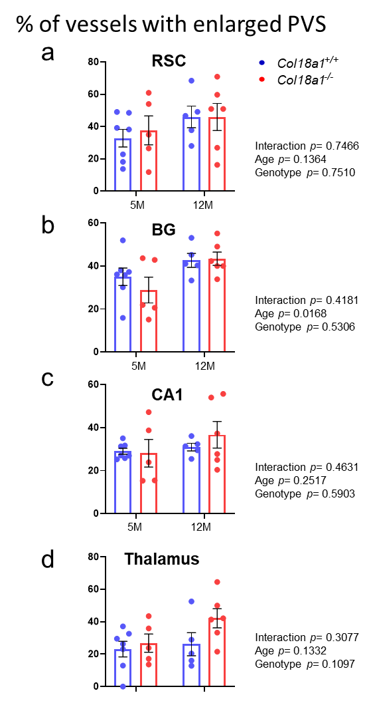
Suppl. Fig. 1 Enlarged perivascular spaces in the brains of 5-month-old and 12-month-old Col18a1^{-/-} mice.
a-d, Percentages of arterioles with enlarged PVS per animal across all brain regions (RSC, BG, CA1 and thalamus) in 5- and 12-month-old animals. Each dot represents one animal. Bar graphs show the mean ± SEM values between Col18a1^{+/+} (5-month-old animals: N=7; 12-month-old animals, N=5) and Col18a1^{-/-} mice (5-month-old animals: N=5; 12-month-old animals: N=6) using two-way ANOVA and Sidak's multiple comparisons test. BG, basal ganglia; CA1, the CA1 region of the hippocampus; CC, corpus callosum; FOV, field of view; M, months; PVS, perivascular spaces; RSC, retrosplenial cortex. Scale bar = 50 µm.

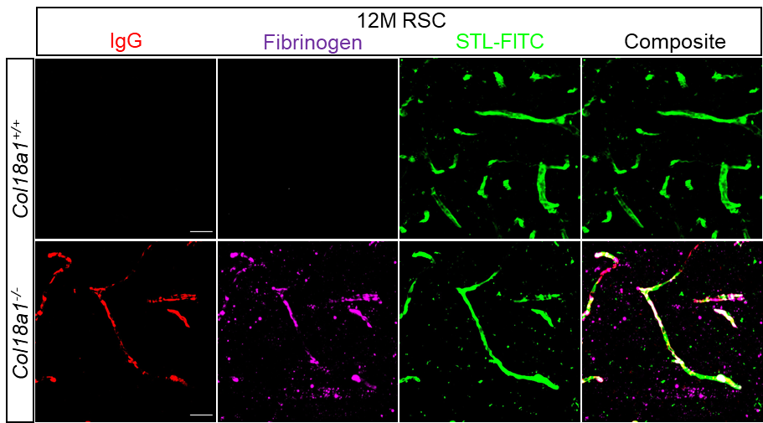

Suppl. Fig. 2 Leakage of plasma fibrinogen into the brain parenchyma in Col18a1^{-/-} mice.
Representative 40x image of the RSC of 12-month-old Col18a1^{-/-}and Col18a1^{+/+} mice stained with antibodies against mouse IgG, fibrinogen and STL-FITC. Visualization of IgG (red), fibrinogen (magenta) and blood vessels (STL-FITC, green) within the RSC area indicates significant colocalization between these three markers in Col18a1^{-/-} mice. IgG, immunoglobulin G; RSC, retrosplenial cortex; STL, Solanum tuberosum lectin- fluorescein isothiocyanate (endothelial marker). Scale bars = 20 µm.

