Supplementary Information
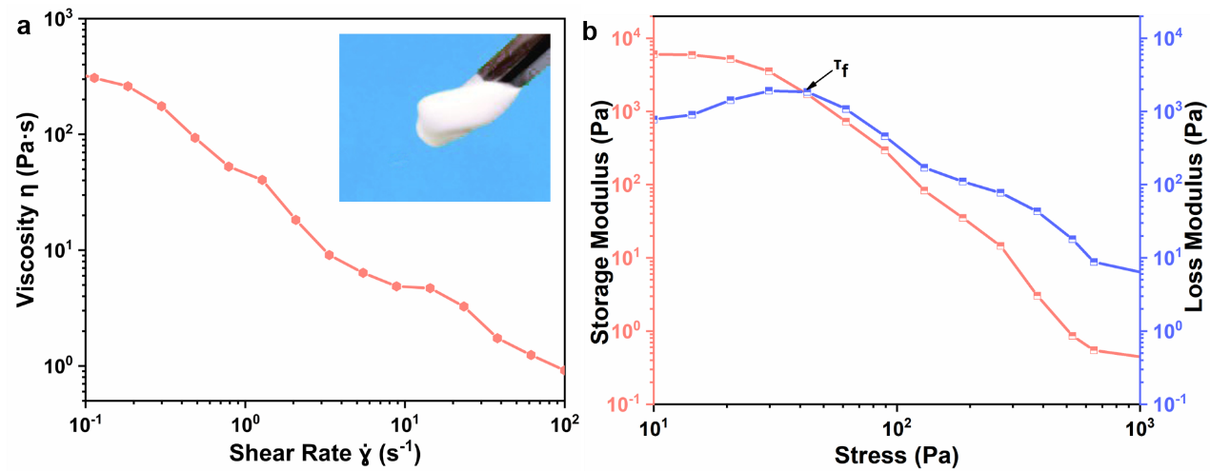
Supplementary Figure 1. Rheological properties of alumina slurry. a Complex viscosity of the printing alumina slurry under different oscillation frequencies. b Shear modulus G' and G'' of the printing slurry under different shear stress.
Supplementary Figure 2. Spectral matching. Overlap of the absorption spectra of the photoinitiator BAPO and 0.1% 200 nm alumina in dimethylformamide and the emission spectrum of UCPs in hexane
Supplementary Figure 3. Curing performance of alumina slurry under UV light. In order to make the extruded filaments fast curing, the UV lamp was operated at maximum power. The depth of the photocured slurry as a function of different exposure times at a constant UV power of 38 mW/cm².
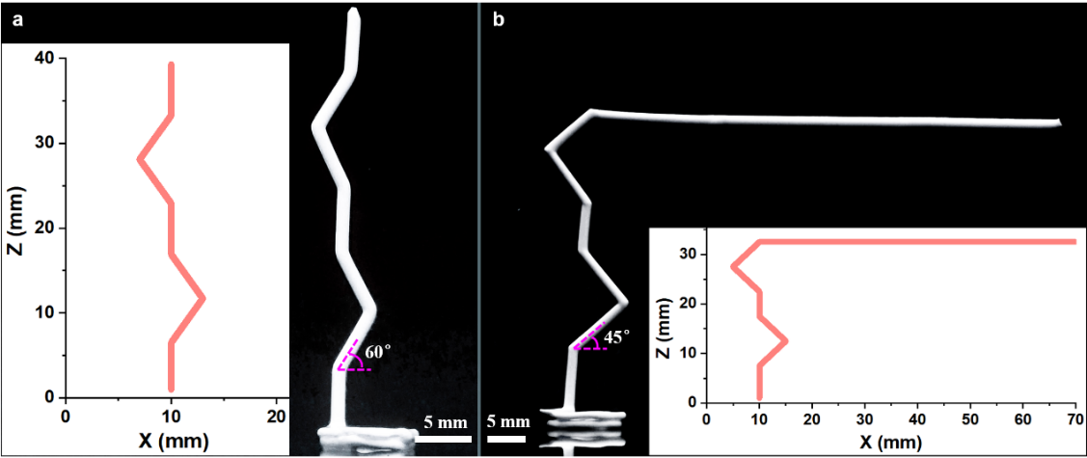
Supplementary Figure 4. Models and corresponding three-dimensional curved structures are printed with NIR-DIW through 1.25 mm nozzle. a To print curved structures with tilt angles θ_{s} of 60°. b To print curved structures with tilt angles θ_{s} of 45°, and then print 60.00 mm cantilever filaments along the X axis. The scale bar is equivalent to 5 mm.

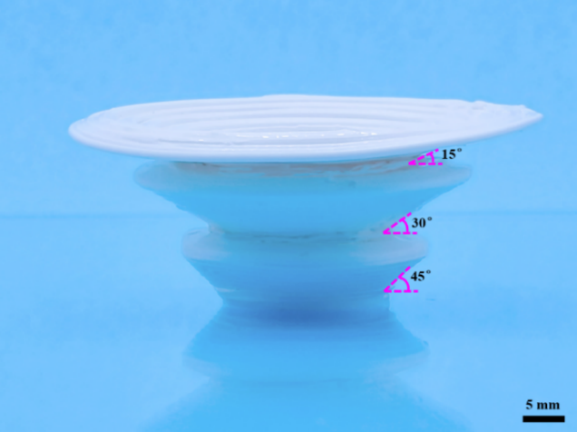
Supplementary Figure 5. Printed inclined-plane samples through 1.25 mm nozzle. The beveled green body were printed with tilt angles θs of 15°, 30° and 45°. The scale bar is equivalent to 5 mm.
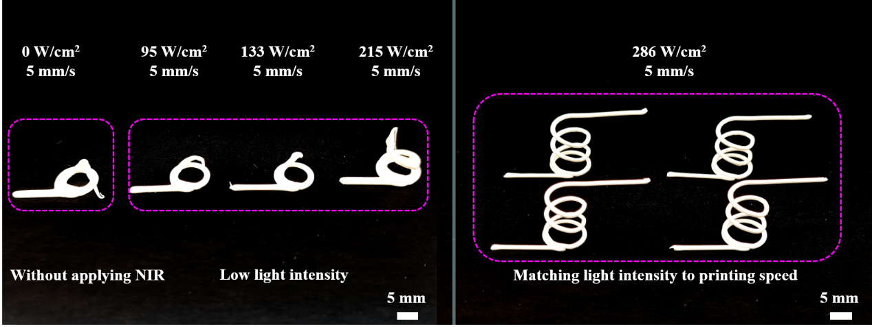
Supplementary Figure 6. Influence of NIR light intensity on conformal properties. The effect of NIR light intensity on printing performance with 1.25 mm nozzle for torsion spring structures. The scale bar is equivalent to 5 mm.

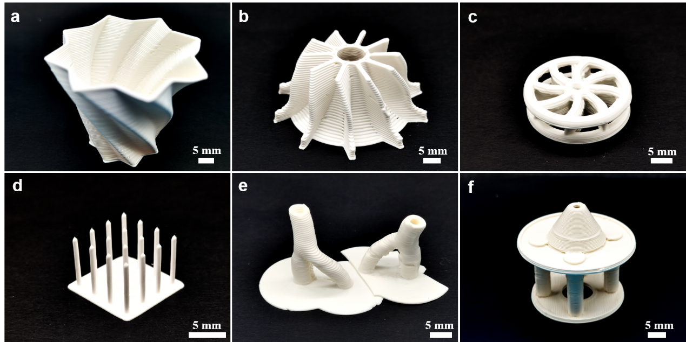
Supplementary Figure 7. Photographs of 3D structures printed by NIR-DIW. Different architectures of a flower-shaped container, b impeller, c wheel, d freestanding pillar arrays, e shaped diverter and f gazebo were printed with 0.60 mm nozzle. The scale bar is equivalent to 5 mm.
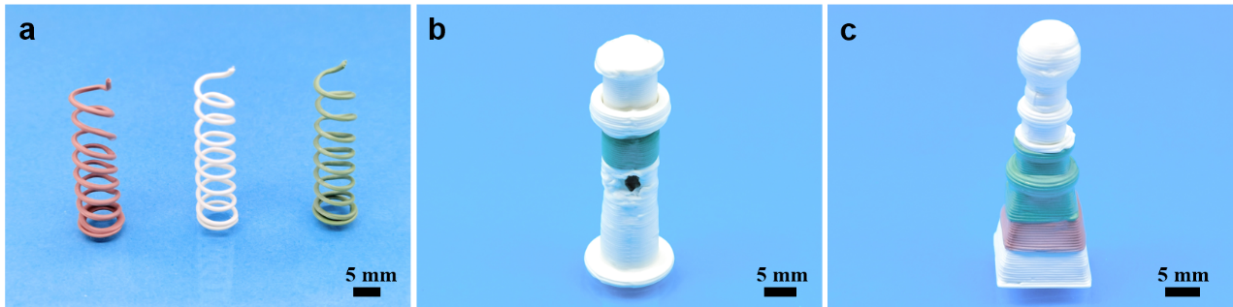
Supplementary Figure 8. Photographs of printing multi-material 3D structures by NIR-DIW. Different architectures of a Multi-color spring structures, b multi-material open-hole lighthouse and c multi-material gradient spherical tower were printed with 0.60 mm nozzle. The scale bar is equivalent to 5 mm.
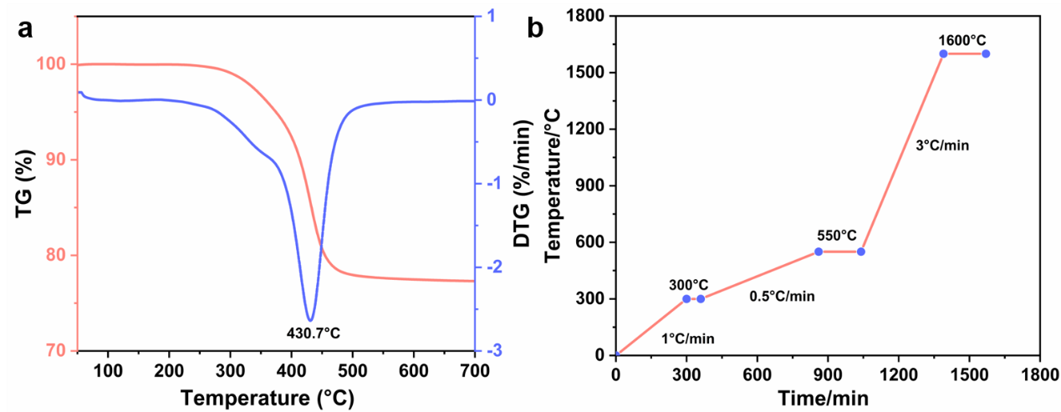
Supplementary Figure 9. Thermogravimetric analysis and sintering process of alumina green body. a TG/DTG curves, and b schedule for debinding and sintering of the printed green body. The weight loss of the green body was characterized by Thermogravimetric Analyzer (TGA, 1100SF, Switzerland) at the range of 40°C to 700°C. The heating rate was 15°C/min.
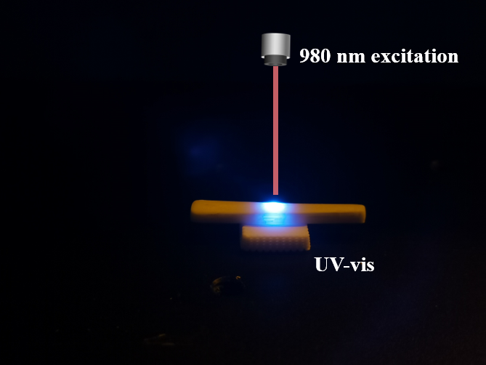
Supplementary Figure 10. Luminescence images of sintered alumina ceramics containing UCPs under 980 nm NIR laser excitation.

Supplementary Movie 1. Printing of three-dimensional curved structures used a 0.60 mm nozzle (played at 5x speed).
Supplementary Movie 2. Printing of three-dimensional curved structures used a 1.25 mm nozzle (played at 5x speed).
Supplementary Movie 3. Printing of three-dimensional curved structures used a 3.50 mm nozzle (played at 5x speed).
Supplementary Movie 4. Printing of cantilever filaments used a 2.45 mm nozzle (played at 5x speed).
Supplementary Movie 5. Printing of flat bridges used a 1.25 mm nozzle (played at 3x speed).
Supplementary Movie 6. Printing of freestanding pillar arrays used a 0.60 mm nozzle (played at 1x speed).

