Supplementary Materials for
Unexpected high NO_{X} emissions from lakes on Tibetan Plateau under rapid warming

Hao Kong¹, Jintai Lin^{1*}, Yuhang Zhang¹, Chunjin Li¹, Chenghao Xu¹, Lu Shen¹, Xuejun Liu², Kun Yang^{3,4}, Hang Su^{5,6}, Wanyun Xu⁷
¹Laboratory for Climate and Ocean-Atmosphere Studies, Department of Atmospheric and Oceanic Sciences, School of Physics, Peking University, Beijing 100871, China
²College of Resources and Environmental Sciences, National Academy of Agriculture Green Development, China Agricultural University, Beijing 100193, China
³Ministry of Education Key Laboratory for Earth System Modeling, Department of Earth System Science, Tsinghua University, Beijing 100084, China
⁴National Tibetan Plateau Data Center, State Key Laboratory of Tibetan Plateau Earth System and Resource Environment, Institute of Tibetan Plateau Research, Chinese Academy of Sciences, Beijing 100101, China
⁵Multiphase Chemistry Department, Max Planck Institute for Chemistry, Mainz 55128, Germany.
⁶Department of Environmental Engineering, Tsinghua University, Beijing 100084, China
⁷State Key Laboratory of Severe Weather & Key Laboratory for Atmospheric Chemistry of CMA, Institute of Atmospheric Composition, Chinese Academy of Meteorological Sciences, Beijing, 100081, China
*Corresponding author. Email: linjt@pku.edu.cn
This file includes Figures. S1 to S7, References S1 to S4

Other Supplementary Materials for this manuscript include Table S1.xlsx

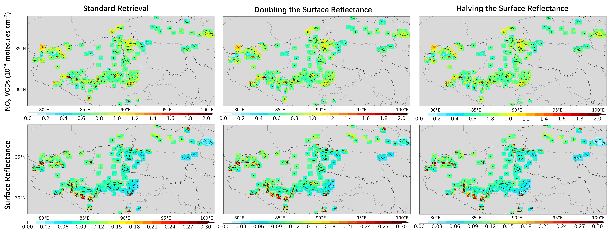Figure S1. Sensitivity test of NO₂ retrieval for July 2019. Left column: standard retrieval. Middle column: retrieval by doubling the surface reflectance. Right column: retrieval by halving the surface reflectance.
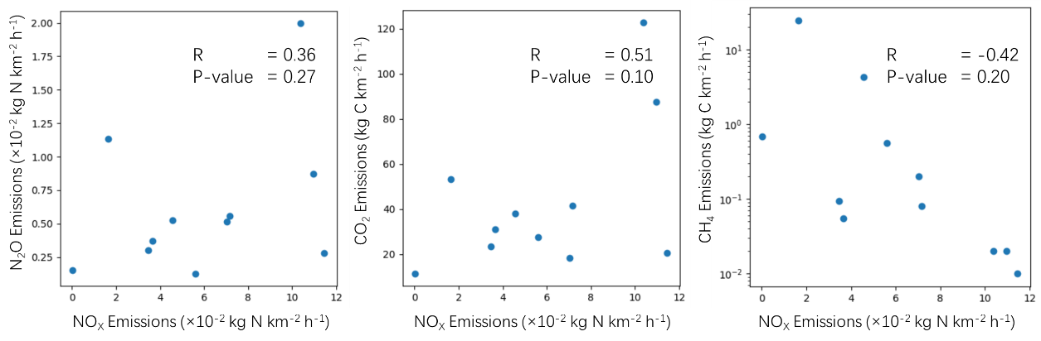

Figure S2. Relating NOx emissions to greenhouse gas fluxes for 11 lakes. Greenhouse gas data are taken from Yan et al^{S1}.
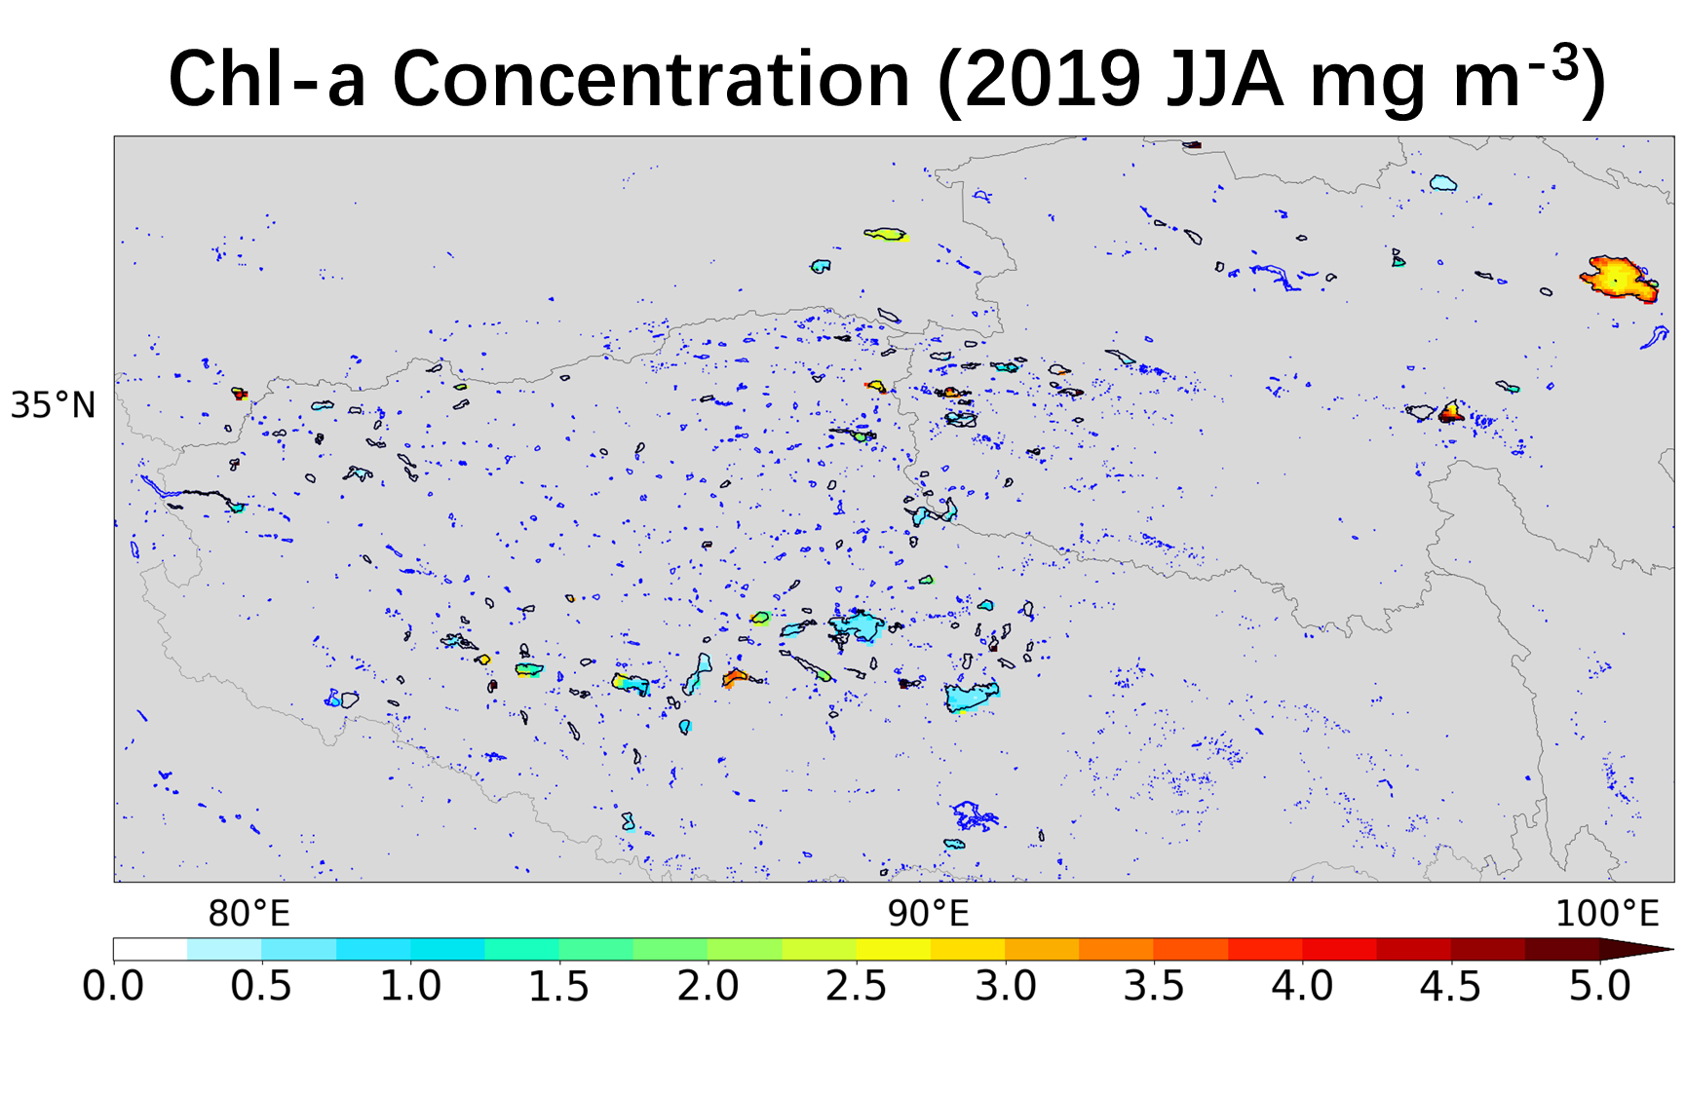

Figure S3. Chl-a concentrations in summer 2019 from MODIS. Data are adopted from the MODIS dataset by the NASA Ocean Biology Processing Group^{S2} (last access: 12/02/2021).
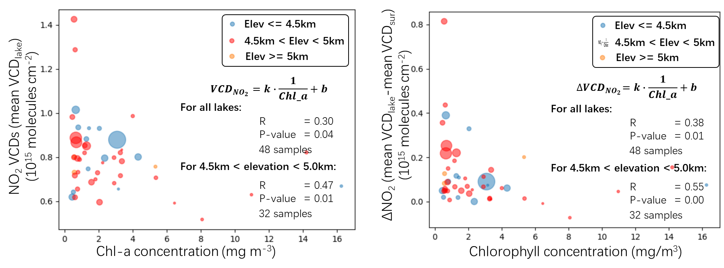

Figure S4. Relating NO₂ VCDs over lakes to Chl-a concentrations. (a) The scatter plot of the mean NO₂ VCDs over the lakes and the mean Chl-a concentrations. (b) The scatter plot of the differences between the mean NO₂ VCDs over the lakes and the mean NO₂ VCDs over the surroundings (mean(VCD_{lake}) – mean(VCD_{sur})) and the mean Chl-a concentrations.
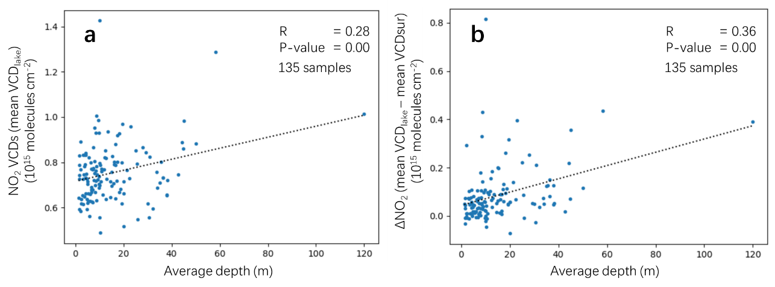

Figure S5. Relating NO₂ VCDs over lakes to lake depths. (a) The scatter plot of the mean NO₂ VCDs over the lakes and the average lake depths. (b) The scatter plot of the differences between the mean NO₂ VCDs over the lakes and the mean NO₂ VCDs over the surroundings (mean(VCD_{lake}) – mean(VCD_{sur})) and the average lake depths.
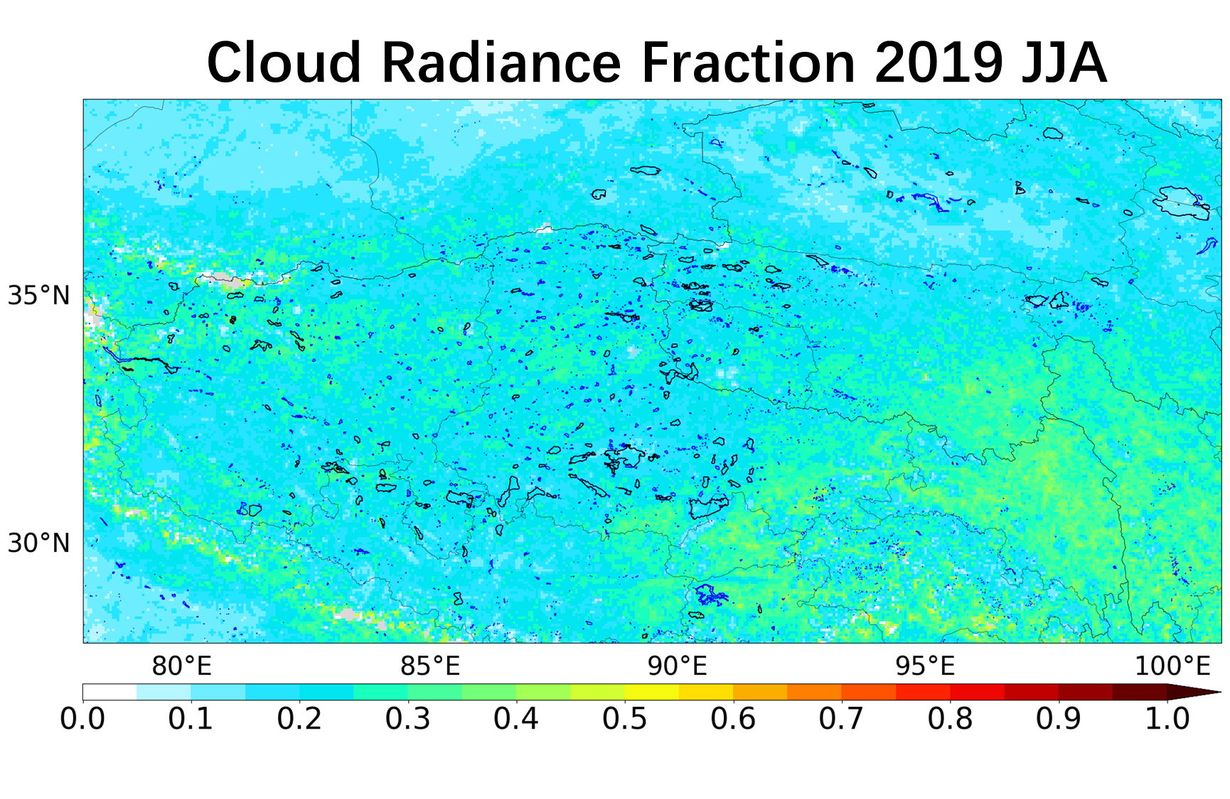

Figure S6. Distribution of cloud radiance fraction in summer 2019^{S3}. (The 135 lakes in the study are shown with black boundaries and other lakes are shown with blue boundaries).
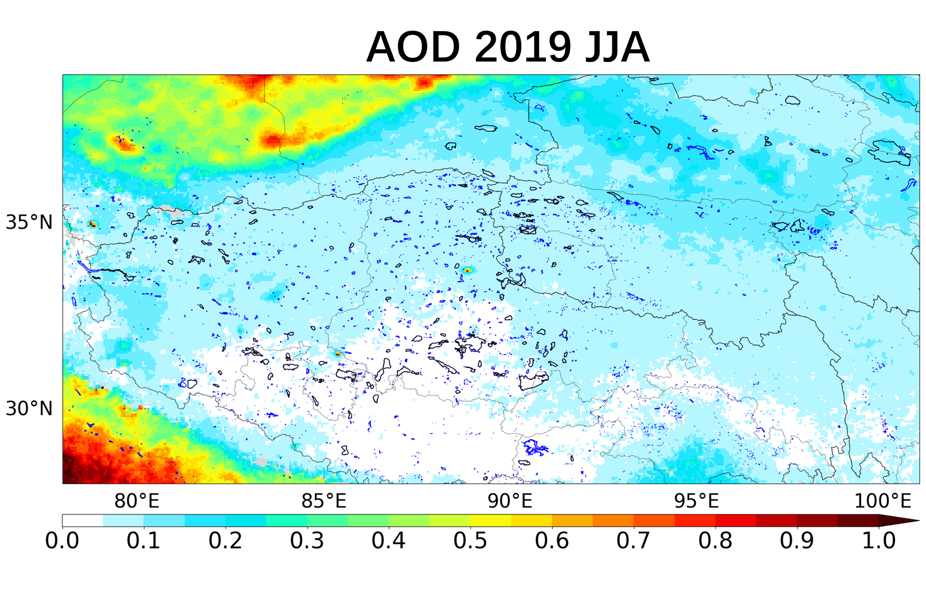

Figure S7. Distribution of AOD in summer 2019. Data are taken from MODIS Atmosphere L2 Aerosol Product^{S4} (MYD04 Collection 6.1, last access: 12/03/2019).

References
S1 Yan, F. et al. Lakes on the Tibetan Plateau as Conduits of Greenhouse Gases to the Atmosphere. Journal of Geophysical Research: Biogeosciences 123, doi:10.1029/2017JG004379 (2018).
S2 Hu, C., Lee, Z. & Franz, B. Chlorophyll aalgorithms for oligotrophic oceans: A novel approach based on three-band reflectance difference. Journal of Geophysical Research: Oceans 117, doi:https://doi.org/10.1029/2011JC007395 (2012).
S3 Liu, M. et al. A new TROPOMI product for tropospheric NO₂ columns over East Asia with explicit aerosol corrections. Atmos. Meas. Tech. 13, 4247-4259, doi:10.5194/amt-13-4247-2020 (2020).
S4 Levy, R. & Hsu, C. (ed USA Goddard Space Flight Center) (2015).

