Supplementary material

Table S1 Geometric information of the bus
Brand | Power type | Length (m) | Width (m) | Height (m) | Seat numbers | Maximum capacity
Jiefang City Bus CA6125URN33 | LNG | 11.96 | 3.35 | 3.4 | 31 | 85

Table S2 The name of each stop on the route (outbound journey)
Stops number | 1 | 2 | 3 | 4 | 5 | 6 | 7 | 8 | 9 | 10 | 11 | 12
Stops name | Baihe Villa | Dayou Tianyuan | Wangjia Village | Lingshui Town | Polytechnic University | South Lingshui Road | Maritime University | light industry school | Xueyuan Square Subway Station | Heishijiao | Xinghai Bath | Yida Eryuan
Stops number | 13 | 14 | 15 | 16 | 17 | 18 | 19 | 20 | 21 | 22 | 23 | 24
Stops name | Chemical Institute | Xinghai Square | Exhibition Center | Heping Square | Taiyuan Street | Wansui Street | Yongjing Street | Olympic Plaza | Yunshan Street | Yierjiu Street | Xiwang Square | -
Table S3 The name of each stop on the route (return journey)
Stops number | 1 | 2 | 3 | 4 | 5 | 6 | 7 | 8 | 9 | 10 | 11 | 12 | 13
Stops name | Xiwang Square | Tangshan Street | Yunshan Street | People Square | Olympic Plaza | Yongjing Street | Wansui Street | Taiyuan Street | Malan River Bridge | Heping Square | Exhibition Center | Xinghai Square | Chemical Institute
Stops number | 14 | 15 | 16 | 17 | 18 | 19 | 20 | 21 | 22 | 23 | 24 | 25 | 26
Stops name | Yida Eryuan | Xinghai Bath | Heishijiao | Xueyuan Square Subway Station | light industry school | Maritime University | South Lingshui Road | Polytechnic University | Lingshui Town | Wangjia Village | Dayou Tianyuan | Baihe Villa | -

Table S4 Measuring instrument specifications and accuracy
Instrument | Range | Resolution | Accuracy
179dt DTH Temperature and humidity recorder | -40–80 ℃  0–100% RH | 0.01 ℃  0.01% RH | ±0.4 ℃  ±3% RH
Korno GT-1000 composite pollutant mass concentration detector | 0–500 μg/m³ | 1 μg/m³ | ≤ ±3%
Korno GT-1000 composite pollutant quantitative concentration detector | 0–9,999,999 PC/L | 1 PC/L | ≤ ±3%
WEZY-1 CO₂ recorder | 0–5,000 ppm | 1 ppm | ±75 ppm

Table S5 Outdoor weather parameters during the test period
Date | Time | Maximum temperature (℃) | Minimum temperature (℃) | Average temperature (℃) | Average RH (%) | Minimum RH (%)
2021-03-20 | 15:00-18:00 | 5.6 | 3.5 | 4.4 | 76 | 75
2021-03-21 | 15:00-19:00 | 6.8 | 5.0 | 5.82 | 24.6 | 21
2021-03-23 | 15:00-19:00 | 15.9 | 13.1 | 14.7 | 28.5 | 23
2021-03-24 | 15:00-19:00 | 11.2 | 7.9 | 9.48 | 60 | 60
2021-10-27 | 15:00-19:00 | 18.1 | 14.4 | 16.08 | 52.8 | 34
2021-10-30 | 16:00-20:00 | 16.4 | 13.2 | 14.56 | 86.6 | 76
2021-11-03 | 15:00-19:00 | 16.5 | 13.3 | 14.14 | 73.2 | 61
2021-11-06 | 15:00-20:00 | 16.5 | 6.2 | 10.57 | 80.5 | 74
Table S6 Air quality index statistics of Dalian during the test
Date | Air quality index (AQI) | Date | Air quality index (AQI)
2021-03-20 | 84 | 2021-10-27 | 52
2021-03-21 | 45 | 2021-10-30 | 83
2021-03-23 | 88 | 2021-11-03 | 124
2021-03-24 | 89 | 2021-11-06 | 65
Table S7 Correlation analysis among PM with different diameters
Independent variable | Dependent variable | R | p-value
Mass concentration of PM_{2.5} | Mass concentration of PM_{0.3} ª | 0.944 | <0.001
Mass concentration of PM_{2.5} | Mass concentration of PM_{1.0} ª | 0.953 | <0.001
Mass concentration of PM_{2.5} | Mass concentration of PM₁₀ ª | 0.964 | <0.001

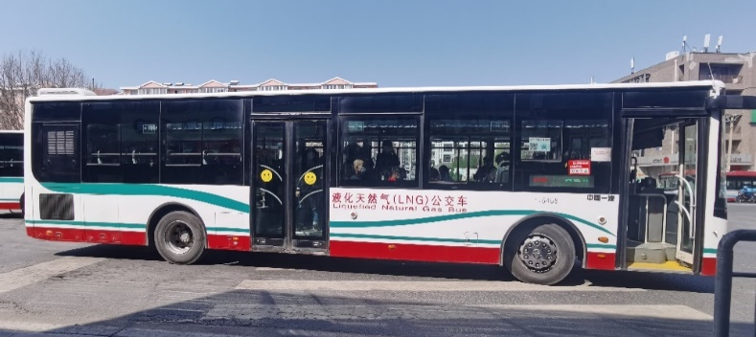
Fig. S1 A picture of a bus of route No. 406
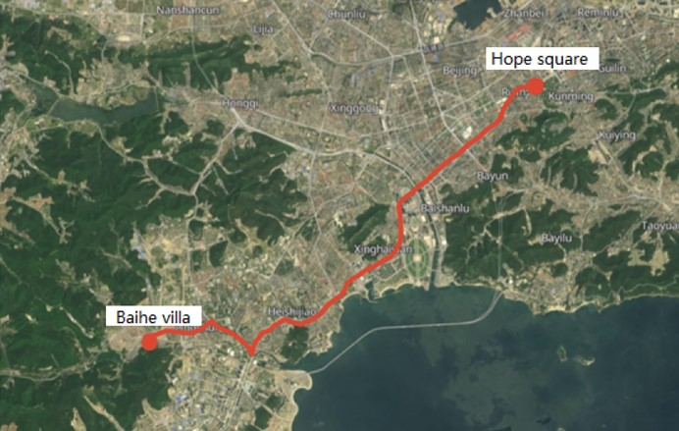
Fig. S2 A satellite map of the tested route
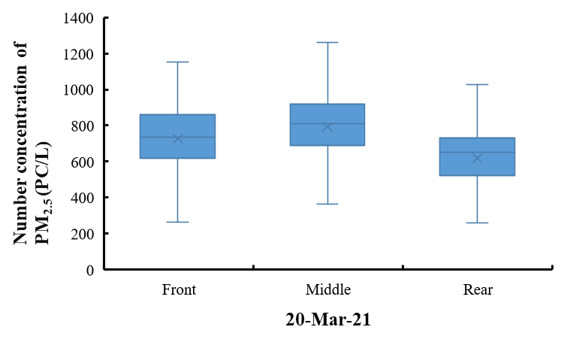
- March 20,2021
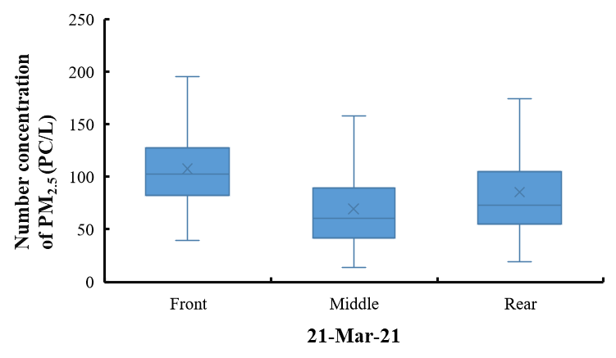
- March 21, 2021
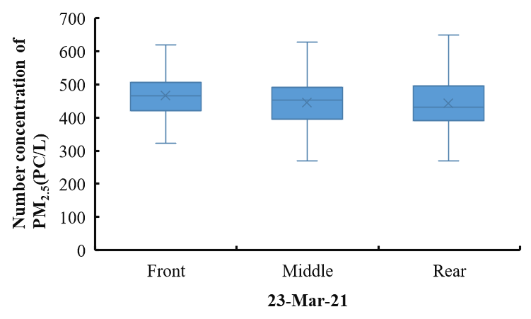
c) March 23, 2021
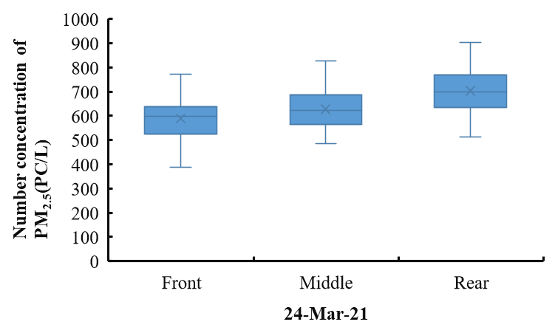
d) March 24, 2021
Fig. S3 Distribution of PM_{2.5} number concentration during the test in spring
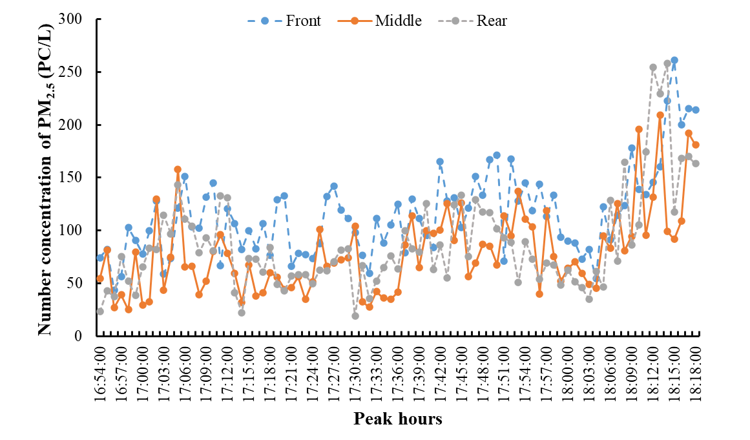
a) Peak hours
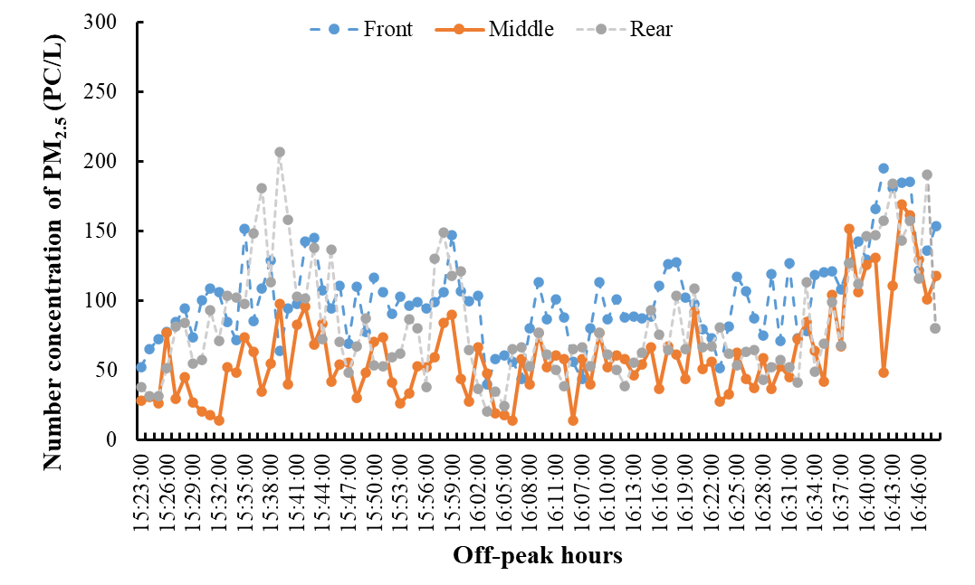 b) Off-peak hours
Fig. S4 Distribution of PM_{2.5} number concentration during the test on March 21, 2021
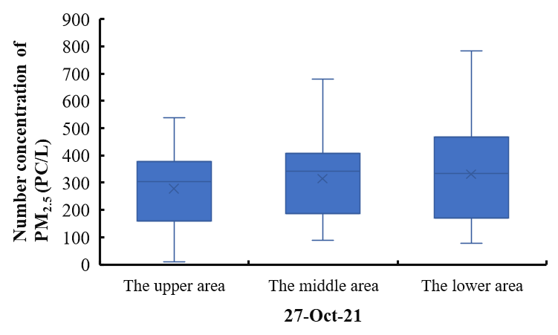
a) October 27, 2021
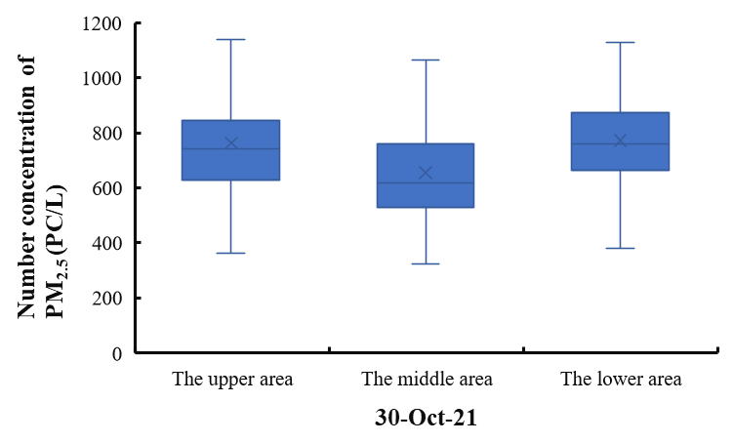
b) October 30, 2021
Fig. S5 Distribution of PM_{2.5} number concentration on vertical direction during the test in autumn
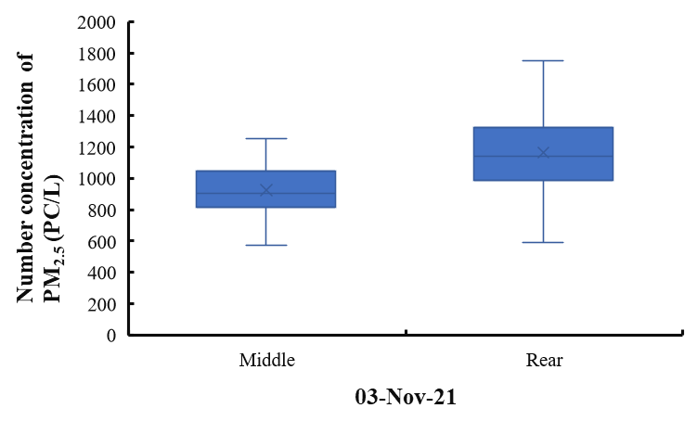
a) November 3, 2021
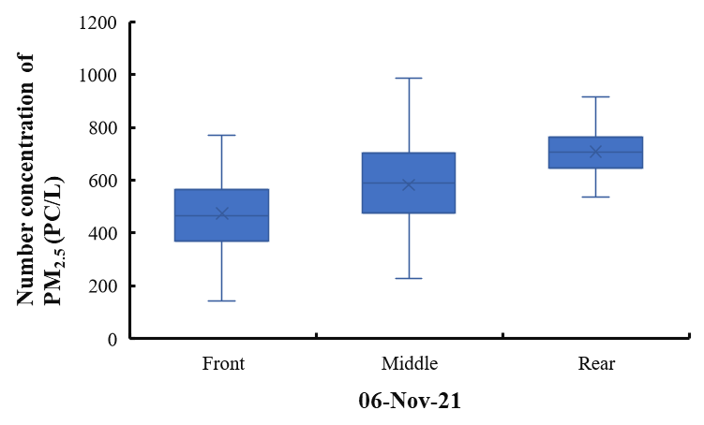
b) November 6, 2021
Fig. S6 Distribution of PM_{2.5} number concentration on horizontal direction during the test in autumn
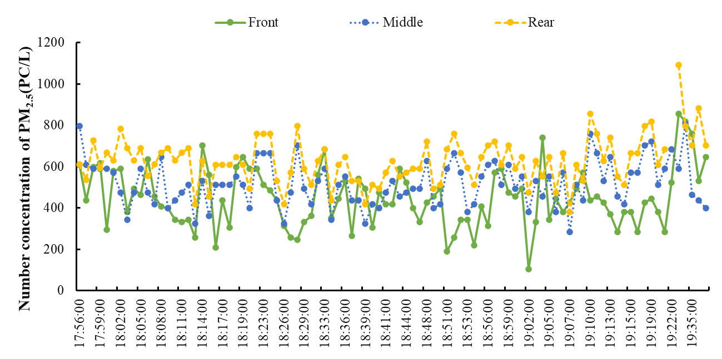
- Peak hours
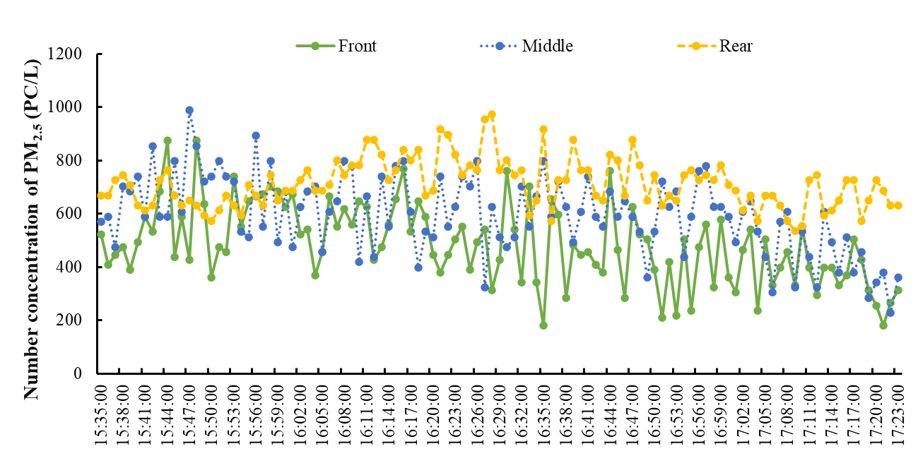
b) Off-peak hours
Fig. S7 Distribution of PM_{2.5} number concentration on horizontal direction during the test on November 6, 2021
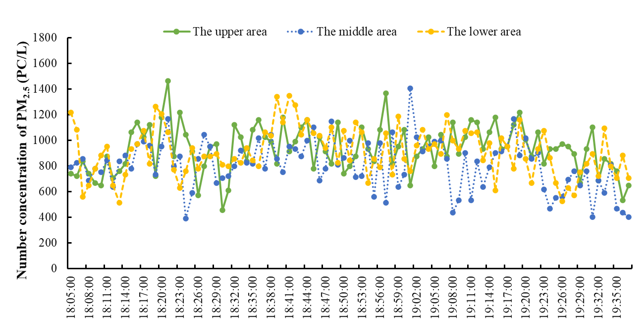
- Peak hours
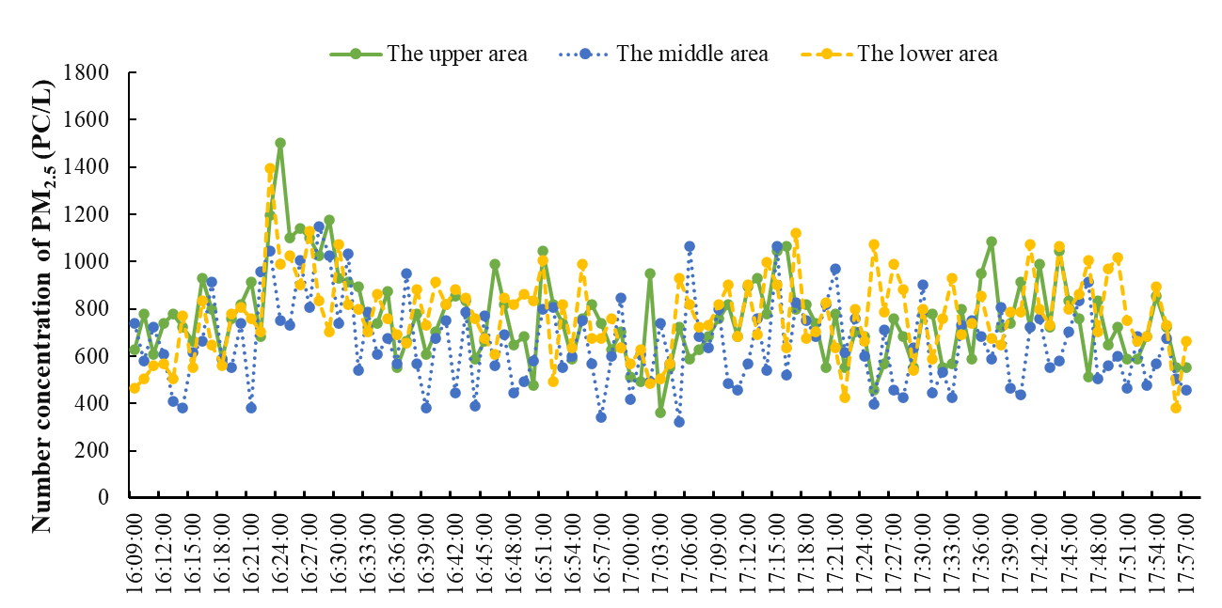
b) Off-peak hours
Fig. S8 Distribution of PM_{2.5} number concentration on vertical direction during the test on October 30, 2021

