Supporting Information
Reversible Flowering of CuO Nanoclusters via Conversion Reactions for Dual-Ion Li Metal Batteries
Siying Li^{1,2}, Jung-Hun Lee², Soo Min Hwang^{2, *}, and Young-Jun Kim ^{2,3 *}
¹ School of Mechanical and Automotive Engineering, Guangxi University of Science and Technology, Liuzhou 545616, China
² SKKU Advanced Institute of Nanotechnology (SAINT), Sungkyunkwan University, Suwon 16419, Republic of Korea
³ Department of Nano Engineering, Sungkyunkwan University, Suwon, 16419, Republic of Korea

Natural activation reactions
Main reaction:
$3CuO+2LiAlCl_{4}→3CuCl_{2}+2LiCl+Al_{2}O_{3}$
$∆G^{°}=-342.48 kJ mol^{-1}$ (S1)
Side reactions:
$$CuO+LiAlCl_{4}+\frac{1}{2}SO_{2} → CuCl+\frac{1}{2}Li_{2}SO_{4}+AlCl_{3}$$
${∆G}^{°}=-61.22 kJ mol^{-1}$ (S2)
$3Li_{2}SO_{4}+2AlCl_{3}→6LiCl+{Al}_{2}(SO_{4})_{3}$
$∆G^{°}=-562.2 kJ mol^{-1}$ (S3)
$3CuO+2AlCl_{3}→3CuCl_{2}+Al_{2}O_{3}$.
$∆G^{°}=-570.86 kJ mol^{-1}$ (S4)
$$CuCl_{2}+\frac{1}{3}Al_{2}O_{3}+\frac{1}{2}SO_{2} → CuCl+\frac{1}{3}AlCl_{3}+{\frac{1}{6}Al}_{2}(SO_{4})_{3}$$
$∆G^{°}=-60.8 kJ mol^{-1}$ (S5)

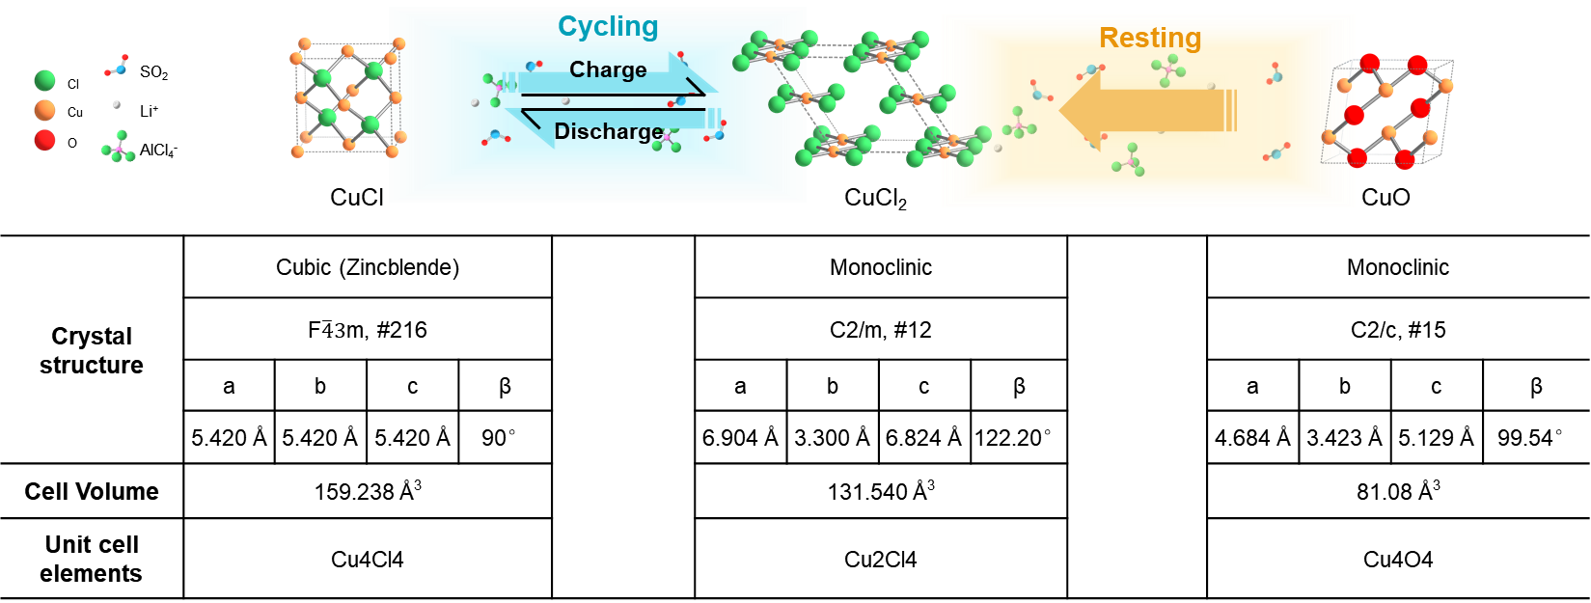
Figure S1 Schematic of conversion reaction for the cathode active materials during resting and cycling. Crystal structure and parameters of CuO, CuCl, and CuCl₂ are illustrated.
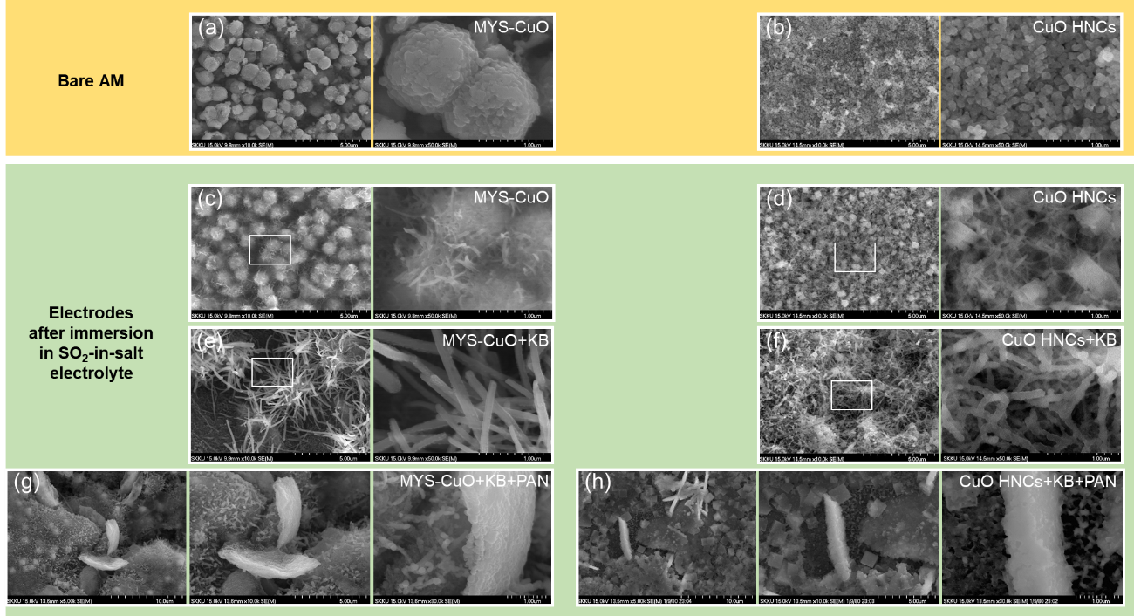
Figure S2 FE-SEM images of as-prepared (a) MYS-CuO and (b) CuO hollow nanocubes (HNCs). (c-h) FE-SEM images for electrodes after immersion in electrolyte, including no carbon electrodes with (c) MYS-CuO and (d) CuO HNCs, KB containing electrodes (CuO : KB : PTFE = 6 : 2 : 2) with (e) MYS-CuO (MYS-CuO+KB) and (f) CuO HNCs (CuO HNCs+KB), and cyclized PAN containing electrodes (CuO : KB : PAN : PTFE = 6 : 2 : 1 : 1) with (g) MYS-CuO (MYS-CuO+KB+PAN) and (h) CuO HNCs (CuO HNCs+KB+PAN)

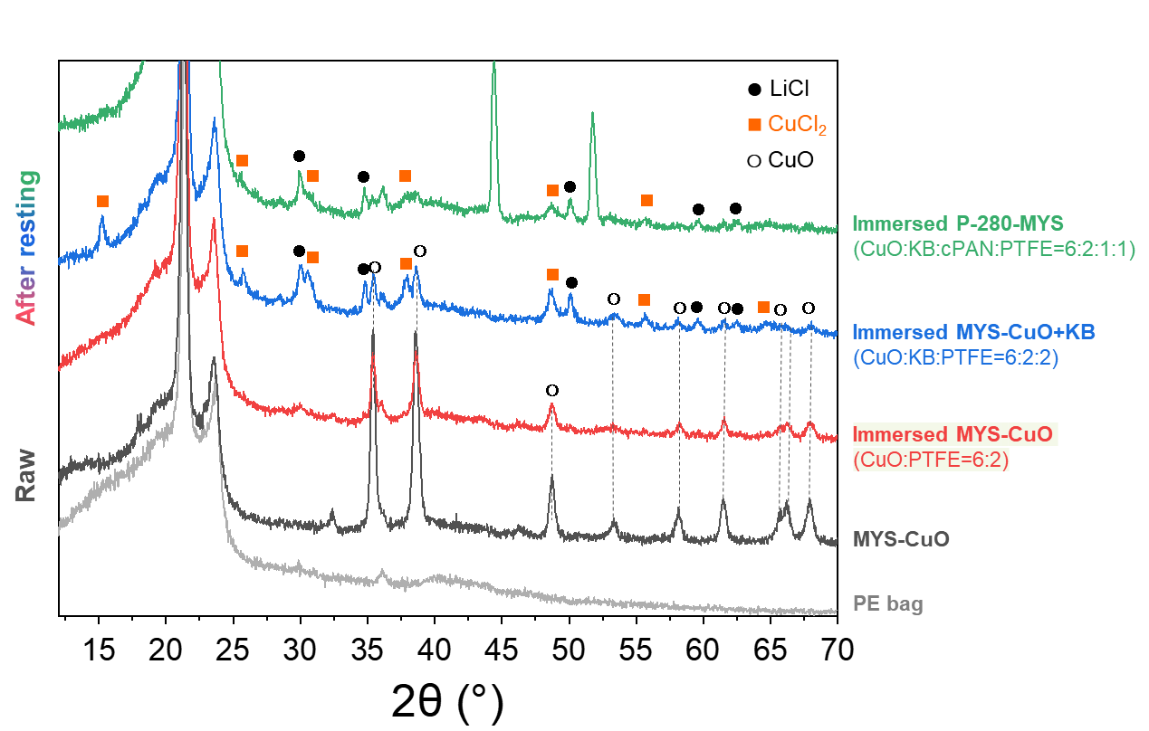
Figure S3 XRD patterns of as-prepared MYS-CuO, and electrodes with different compositions after immersion in electrolyte.

As shown in Figure. S2c-f and Figure. S3, after immersion in the electrolyte, more, thicker and longer CuCl₂ nanorods or nanowires were observed on CuO cathodes containing 0-D KB compared to carbon-free CuO cathodes, indicating that KB promoted the conversion of CuO to CuCl₂. In the absence of KB, well-dispersed nano-sized CuO HNCs were converted to needle-like CuCl₂ more rapidly compared to 1-μm MYS-CuO.

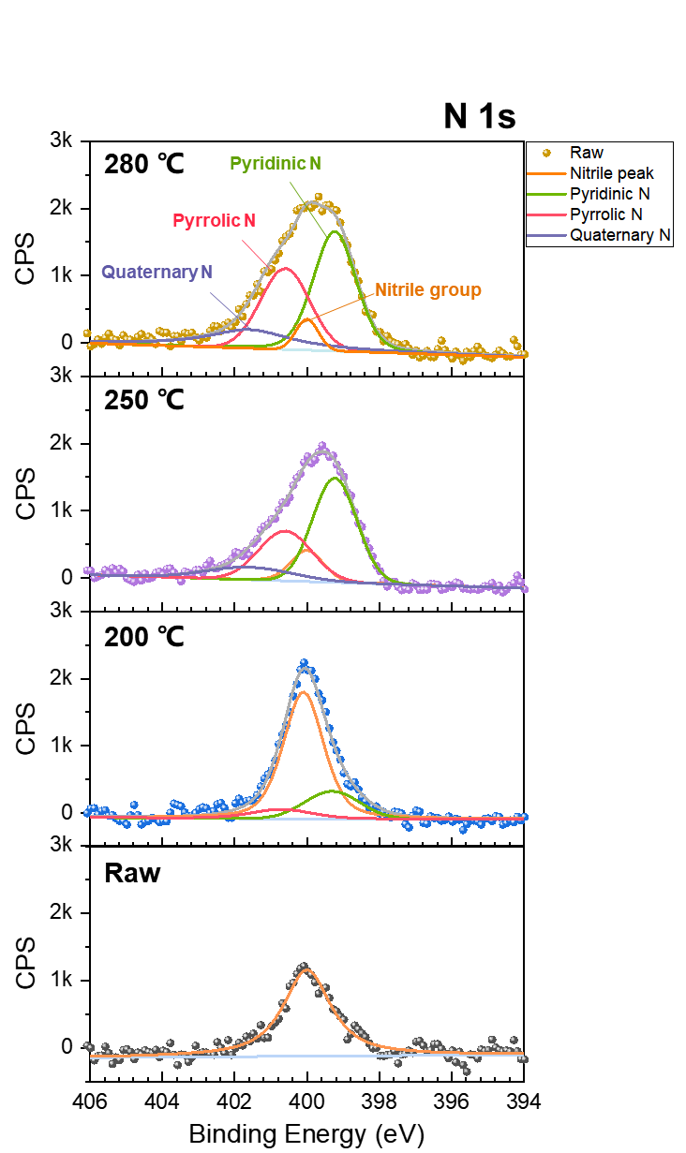
Figure S4 N 1s XPS profiles for MYS-CuO electrode with PAN cyclized at different temperatures.

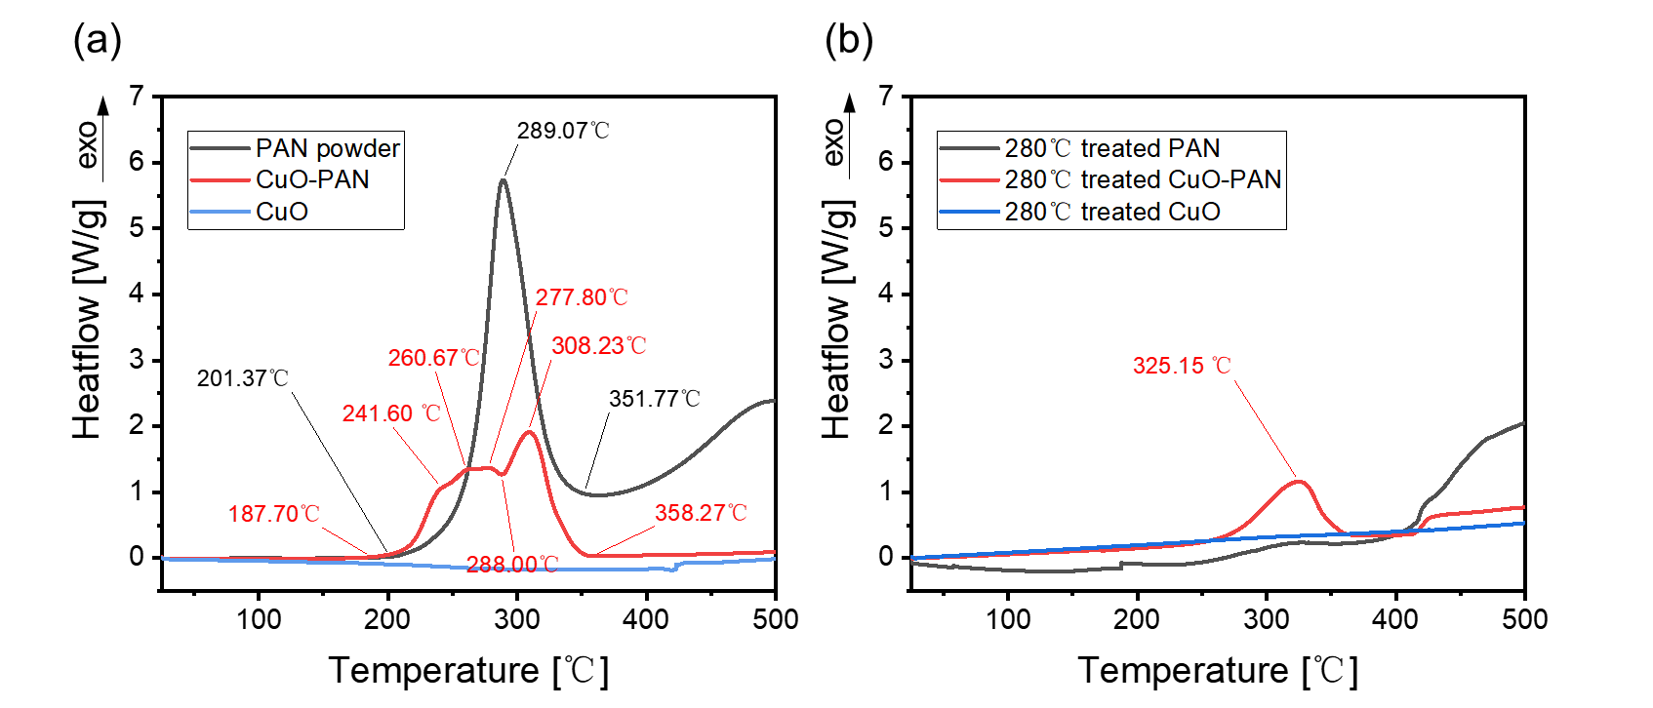
Figure S5 Differential scanning calorimetry thermograms of PAN powder, PAN-coated MYS-CuO, and bare MYS-CuO (a) before and (b) after heat treatment at 280 ℃ from 25 to 500℃ with air flowing at a heating rate of 2 ℃ min⁻¹。

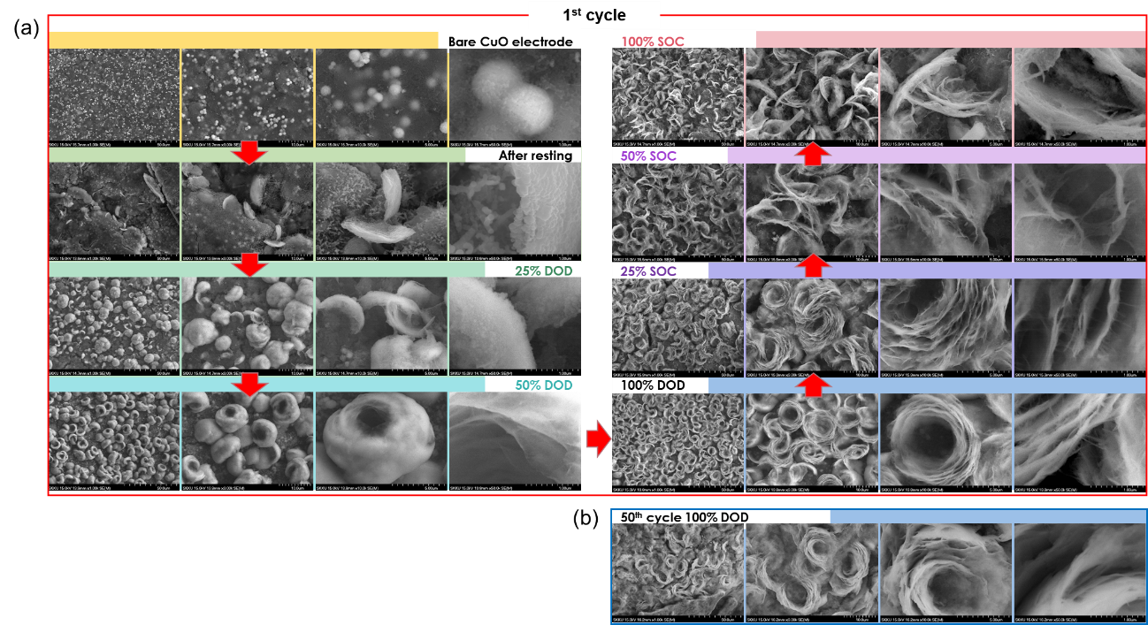
Figure S6 (a) FE-SEM images of bare P-280-MYS electrode and P-280-MYS electrodes after resting and 1st discharge and charge. (b) FE-SEM images of P-280-MYS electrode after 50th discharge.

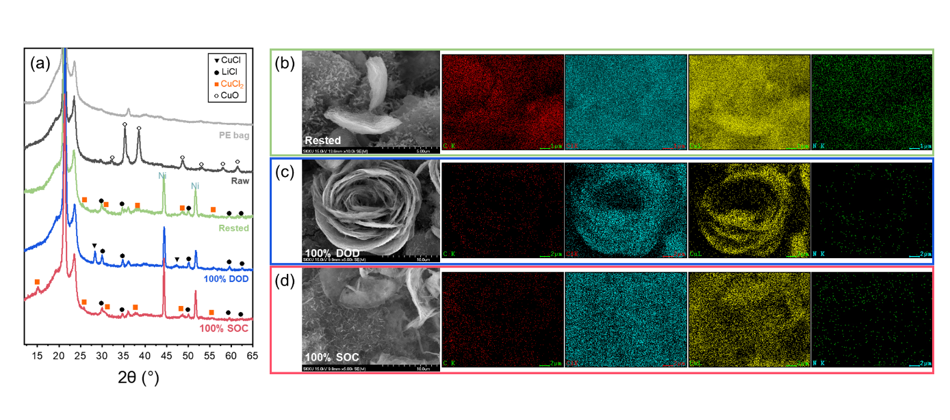
Figure S7 (a) XRD patterns for raw, rested, discharged, and charged P-280-MYS electrodes. FE-SEM and EDS mapping images of (b) rested, (c) fully discharged, and (d) fully charged P-280-MYS electrodes.

