Evaluation of interactions between the hepatitis C virus NS3/4A and sulfonamidobenzamide based molecules using molecular docking, molecular dynamics simulations and binding free energy calculations
Jinhong Ren^{a,↑}, Tasneem M. Vaid^{a,↑}, Hyun Lee^{a,b}, Isabel Ojeda ª, and Michael E. Johnson^{a,*}

a Center for Biomolecular Sciences and Department of Pharmaceutical Sciences, University of Illinois at Chicago, 900 S. Ashland Ave, Chicago, IL 60607, USA
b Biophysics Core at Research Resource Center, University of Illinois at Chicago, 1100 S. Ashland Ave, Chicago, IL, 60607, USA
↑ Authors providing equal contributions.
*Corresponding author.
Email address: Michael E. Johnson: mjohnson@uic.edu
ORCID: Jinhong Ren: 0000-0003-0328-702X, Tasneem M. Vaid: 0000-0001-9825-9026, Hyun Lee: 0000-0003-2570-8120, Isabel Ojeda: 0000-0002-1737-168X, Michael E. Johnson: 0000-0002-8246-4081

Figure S1: Overlapping the docking pose (sky blue) of F9K with its crystal binding pose (PDB ID 4A92, hot pink). HCV NS3/4A is shown in light gray surface.

Figure S2: The hydrogen bond interactions between the sulfonamide moiety of F9K and HCV NS3/4A in the crystal structure (PDB ID 4A92). Hydrogen bond interactions are shown in dashed lines and HCV NS3/4A is shown in a light gray surface.

Binding free energy calculations by MM/PBSA and MM/GBSA approaches based on 20-ns MD simulations and correlation with experimental results.
Our calculations reveal that MM/PBSA with bondi radii showed good correlation with experimental data for the 12 inhibitors (Fig. 4B) based on the 20-ns MD simulations. In addition, different atomic radii sets, including mbondi, mbondi2, and PARSE, were also used to explore their ability to calculate the solvation contributions in PB model. For GB model, atomic radii of bondi was used in GB^{Neck}, mbondi was used in GB^{HCT}, mbondi2 was used in GB^{OBC} and GB^{OBC2}, which was recommended by Amber tutorial to extensively explore the binding free energies for the inhibitors with HCV NS3/4A.
A slight difference occurred with different atomic radii parameters in the MM/PBSA approach. Bondi radii exhibit the best predictive ability in MM/PBSA calculation with an R² of 0.92, which is marginally better than that of mbondi and mbondi2, whose R² is 0.90. PARSE shows the lowest prediction in MM/PBSA with an R² of 0.82 between predicted and experimental binding free energy. Although MM/GBSA shows slightly lower coefficient of determination (R²) values compared with those of MM/PBSA, the predictive ability (R² = 0.90) was retained by choosing bondi for atomic radii in the GB^{Neck} model. In comparison, the GB^{HCT}, GB^{OBC}, and GB^{OBC2} models do not perform as well as the PB model, since the R² is relatively lower than the corresponding atomic radii of the PB model (Fig. S3).
Figure S3: The coefficient of determination (R²) between the experimental binding free energy and predicted binding free energy based on 20-ns MD simulations. The R² values from MM/PBSA and MM/GBSA are shown in red and black colors, respectively.
Since the bondi radii with MM/PBSA shows the best predictive results for the full 20-ns calculations, it was selected to probe the predictive ability as a function of the simulation time. We can see that the R² values gradually improved with little fluctuation during the MD simulation time from 1 ns to 14 ns and then maintained good performance of R² = 0.92 until 20 ns (Fig. S4), which further validates the docking results and the reliability of the MM/PBSA for this system. Even in the first ns of MD simulation, the R² is higher than that predicted from GOLD ChemPLP score (R² = 0.56) (Fig. 4A), which can be attributed to the incorporation of solvent effects in the MM/PBSA calculation. It can be easily observed that remarkable improvement was achieved by MM/PBSA calculation by considering the full 20-ns MD simulations (Fig. 4B) compared with the docking score evaluation (Fig. 4A).
Figure S4: The coefficient of determination (R²) between calculated (MM/PBSA) and experimental binding free energy for the twelve compounds with HCV NS2B/NS3 protease during the 20-ns MD simulations.
Figure S5: The NMR spectrum for F0325-0077.
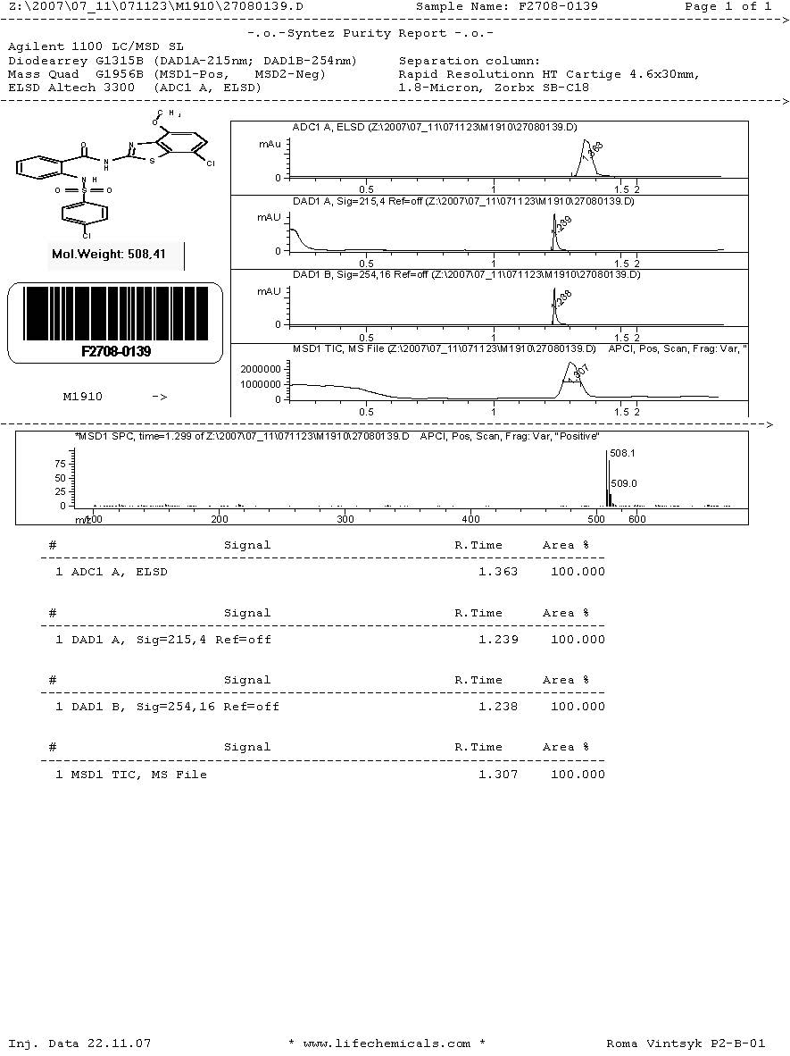
Figure S6: The MS spectrum for F2708-0139.
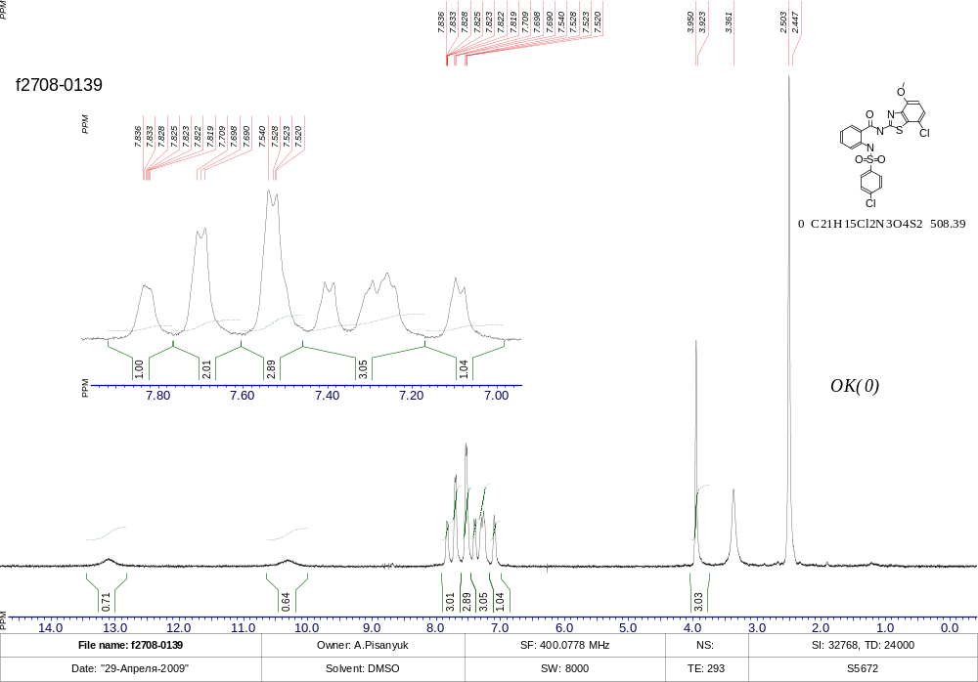
Figure S7: The NMR spectrum for F2708-0139.
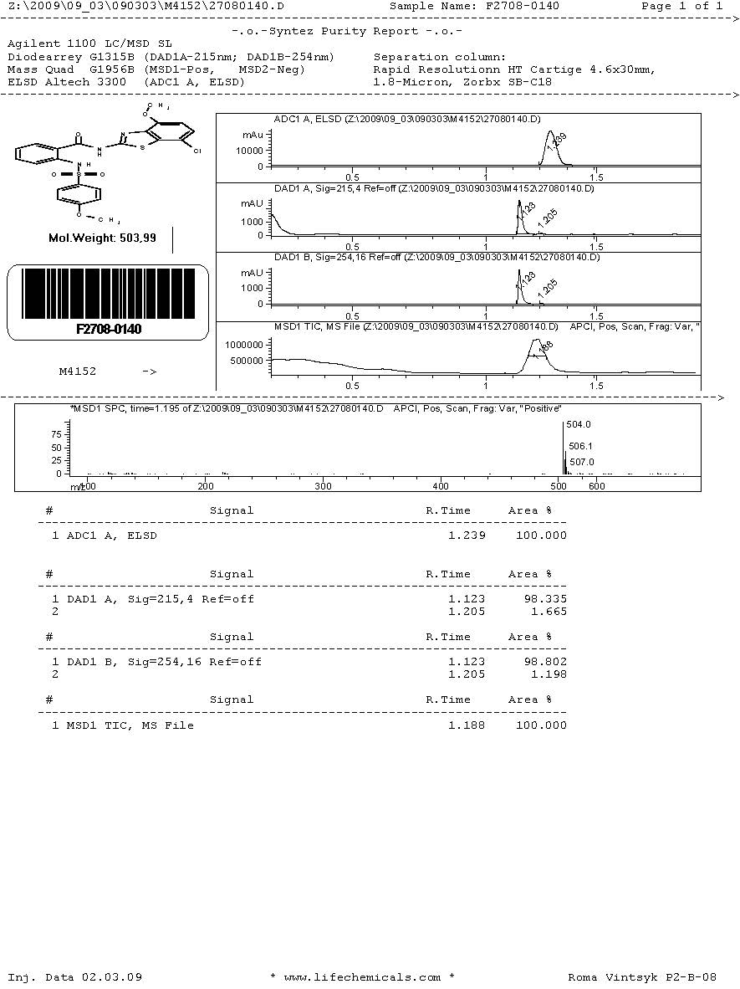
Figure S8: The MS spectrum for F2708-0140.

