Supplementary information: Factor analyses of key variables

Components of a Solid Carbon project
Scale items and factor loadings on concern with components of a potential Solid Carbon project, from not at all concerned=1 to extremely concerned=5. Factors’ loadings in bold indicate that they have been selected in a factor. Items for which the scores were reversed are shown.
 | Part 1  (Fossil fuel-equivalent parts; 𝛼=0.87, variance explained = 0.36) | Part 2 (Renewable-equivalent parts; 𝛼=0.84, variance explained =0.33)
Capturing CO2 from the atmosphere using direct air capture | 0.733 | 0.269
A direct air capture system located on an ocean-floating platform | 0.798 | 0.362
Wind turbines located on an ocean-floating platform | 0.706 | 0.241
Drilling into the seafloor to prepare the injection site | 0.365 | 0.667
Injection of CO2 into seabed porous rock | 0.239 | 0.968
Liquid CO2 turning into solid rock through mineralization | 0.389 | 0.677

Climate severity and urgency scale

Scale items and factor loadings for the climate severity and urgency scale. Factors’ loadings in bold indicate that they have been selected in a factor.

Climate severity and urgency (𝛼=0.83, Variance explained = 0.51) | Loadings
The human causes of climate change need to be addressed immediately. | 0.839
Human impacts are causing changes at a planetary scale that are destabilizing the Earth’s systems. | 0.824
Hundreds of years from now a future scientist will see this period as a great extinction event, this one caused by climate change. | 0.672
The suggestion that climate change will cause large-scale ecosystem changes is overblown. [REVERSE] | 0.565
Climate change does not pose any risk to the environment. [REVERSE] | 0.619

Views on nature

Scale items and factor loadings of the items of the views on nature. Factors’ loadings in bold indicate that they have been selected in a factor. Items for which the scores were excluded when calculating the scale are shown.

 | Loadings
Views on nature | Factor 1: Sense of responsibility for nature (𝛼=0.62, Variance explained =0.25) | Factor 2: Sense of separation from nature (𝛼=0.53, Variance explained = 0.10)
My personal identity is more linked to living in the city than to landscapes outside the city. |  | 0.411
My health, the health of my family and the health of others who I care about is not dependent on the natural environment. |  | 0.628
I have strong feelings about nature (including all plants, animals, the land, etc.). These views are part of who I am and how I live my life. | 0.725 | 0.193
Plants and animals, as part of the interdependent web of life, are like 'kin' or family to me. | 0.725
I often think of some wild places whose fate I care about and strive to protect, even though I may never see them myself. | 0.658 | 0.141
Humans have a responsibility to account for our own impacts to the environment because they can harm other people. | 0.494 | 0.295
People should take only what they need from nature and leave the rest behind for other nonhuman beings. | 0.473 | 0.211
Even though we are human animals, I think people and nature are very separate from each other. |  | 0.486
I think of animals not as groups such as a herd of deer, but as individual animal ‘persons’, each with their own personality. | 0.596
I think of ecosystems as made up of humans and animals living well in relation to each other. [EXCLUDED] | 0.375 | 0.141

Risks of Solid Carbon

Scale items and factor loadings of the items of views on how potential outcomes increase their perceived risks of Solid Carbon, from does not increase my perceived risk=1 to very strongly increase my perceived risk=5. Factors’ loadings in bold indicate that they have been selected in a factor. Items for which the scores were reversed are shown.
 | Risk 1 (Biophysical) (𝛼=0.90, variance explained = 0.35 ) | Risk 2 (moral hazard) (𝛼=0.82, variance explained = 0.25)
Solid Carbon might increase the probability of earthquakes. | 0.652 | 0.267
Solid Carbon might lead to an explosive discharge of CO2 from solid rock. | 0.737 | 0.296
Solid Carbon might affect deep ocean ecosystems. | 0.812 | 0.215
Solid Carbon might have negative consequences for human health. | 0.702 | 0.327
Solid Carbon might lead to unnoticed leakage of CO2 from the porous rock to the surface. | 0.697 | 0.393
Solid Carbon might cause pollution in the ocean. | 0.745 | 0.28
Solid Carbon might divert money that could be better used elsewhere. | 0.217 | 0.66
Solid Carbon might encourage the continued burning of fossil fuels. | 0.335 | 0.64
Solid Carbon might be much more expensive than other climate solutions. | 0.264 | 0.732
Solid Carbon might provide an excuse for slowing the development of renewable energy. | 0.312 | 0.68

Benefits of Solid Carbon

Scale items and factor loadings of the items of views on how potential outcomes increase their perceived benefits of Solid Carbon from does not increase my perceived benefit=1 to very strongly increase my perceived benefit=5. Items for which the scores were reversed are shown.
 | Benefit (𝛼=0.95, variance explained =0.67)
Solid Carbon could benefit future generations. | 0.660
Solid Carbon could go a long way to addressing the problem of escalating CO2 emissions. | 0.868
Solid Carbon could provide skilled employment for people formerly employed in the oil and gas industry. | 0.819
Solid Carbon could be an important component of a ‘green’ economy'. | 0.852
Solid Carbon could reduce the cost of addressing climate change. | 0.836
Solid Carbon could be effective for reducing concentration of CO2 in the atmosphere | 0.849
Solid Carbon could provide a way to remove CO2 from the atmosphere independently of onshore industrial facilities or sites. | 0.830
Solid Carbon could be a safe solution for addressing climate change | 0.831
Solid Carbon could be a good use of revenues from carbon taxes. | 0.783
Solid Carbon could keep us from having to convert vast amounts of land to forestland. | 0.666

Supplementary Information: Online survey text

Start of Block: Introduction

Thank you for agreeing to participate in this survey, which will require approximately 15 minutes to complete. This study is being conducted by researchers from the University of British Columbia and is funded by the Pacific Institute for Climate Solutions. The purpose of the survey is to understand your views on a novel technology aimed at removing a key greenhouse gas (carbon dioxide, or CO2) from the atmosphere. CO2 is known to be partially responsible for climate change. Questions will proceed from the very general to more specific questions about this technology. There are no right or wrong answers; we are interested only in your opinions.
All information received will remain confidential. The results of this study will be published in journal articles and reports and presented at conferences. No risk is anticipated from your participation in this study. By completing the questionnaire, you are consenting to participate in this research. Your participation in this study is voluntary and you have the right to refuse to participate. You do not need to answer any questions that you are not comfortable answering. If you decide to take part, you may choose to exit the study at any time without giving a reason and without any negative consequence.
If you have any concerns or complaints about your rights as a research participant and/or your experiences while participating in this study, please contact the Research Participant Complaint Line in the UBC Office of Research Ethics at 604-822-8598 or, if long distance, e-mail RSIL@ors.ubc.ca or call toll free 1-877-822-8598. The Ethics ID number for this study is H20-03077.
Please do not hesitate to contact us if you have any questions regarding our research project or how the results will be used.
--
Terre Satterfield, Principal investigator and Professor, Institute for Resources Environment and Sustainability, University of British Columbia. Ph: 604-822-2333; email: terre.satterfield@ires.ubc.ca
Guillaume Peterson St-Laurent, Postdoctoral fellow, Faculty of Forestry and Institute for Resources Environment and Sustainability, University of British Columbia. Ph: 778–828–7968; Email: guillaume.peterson@ubc.ca

End of Block: Introduction

Start of Block: Quotas_Geographic

Q1 Q. What region do you live in?
- Province of British Columbia (Canada
- Washington state (USA)
- Other

End of Block: Quotas_Geographic

Start of Block: Quota_demographics
Display This Question:
If Q. What region do you live in? = Province of British Columbia (Canada)

Q2_BC Q. Do you live in coastal British Columbia (including the Greater Vancouver area)?
- Yes (1)
- No (2)
- Prefer not to answer (5)

Display This Question:
If Q. What region do you live in? = Washington state (USA)

Q2_WA Q. Do you live in coastal Washington State, or what is known as Western Washington (including the Greater Seattle area)?
- Yes (1)
- No (2)
- Prefer not to answer (4)

Display This Question:
If Q. What region do you live in? = Province of British Columbia (Canada)

Q3_BC Q. What is your gender?
- Male (1)
- Female (2)
- Prefer to self-describe: (3) ________________________________________________
- Prefer not to answer (4)

Display This Question:
If Q. What region do you live in? = Washington state (USA)

Q3_WA Q. What is your gender?
- Male (1)
- Female (2)
- Prefer to self-describe: (3) ________________________________________________
- Prefer not to answer (4)

Display This Question:
If Q. What region do you live in? = Province of British Columbia (Canada)

Q4_BC Q. What is your age?
▼ 18 or less (2) ... Prefer not to answer (84)

Display This Question:
If Q. What region do you live in? = Washington state (USA)

Q4_WA Q. What is your age?
▼ 17 or less (1) ... Prefer not to answer (84)

End of Block: Quota_demographics

Start of Block: Climate change

Climate change
To begin, we are interested in your views about climate change. Climate change refers to the global increase in average temperature and change in weather patterns, especially in the last century. Climate change is due to higher concentrations of greenhouse gases, including carbon dioxide (CO2), in the atmosphere.

Q5 Q. Do you think that climate change is...
- Caused mostly by human activities (1)
- Caused mostly by natural changes in the environment (2)
- Caused equally by natural changes in the environment and human activities (3)
- Not caused by natural or human activities, because climate change isn’t happening (4)
- Other, please specify: (5) ________________________________________________
- I don’t know/no answer (6)

Q6 Q. Please indicate whether you strongly disagree, disagree, neither agree nor disagree, agree or strongly agree with the following statements about climate change.
 | Strongly disagree  (-2) (1) | Disagree  (-1) (2) | Neither agree nor disagree  (0) (3) | Agree  (+1) (4) | Strongly agree  (+2) (5) | I don't know/no answer (6)
Climate change does not pose any risk to the environment. (1)
Human impacts are causing changes at a planetary scale that are destabilizing the Earth’s systems. (2)
Hundreds of years from now a future scientist will see this period as a great extinction event, this one caused by climate change. (3)
The suggestion that climate change will cause large-scale ecosystem changes is overblown. (4)
The human causes of climate change need to be addressed immediately. (5)

End of Block: Climate change

Start of Block: NETs_Likert

Removing CO2 from the atmosphere
In addition to reducing CO2 emissions from human and industrial activities, scientists agree that we also need to remove existing volumes of CO2 from the atmosphere to avoid catastrophic climate change. Different strategies are being proposed to enable that removal. Some involve supporting natural processes, and some include engineered and/or technological solutions.
The following section asks for your views about a list of these potential solutions for removing CO2 from the atmosphere. We realize that people will have very different levels of familiarity with these technologies. We just want to know your ‘gut’ comfort level with each option as it is described below.

Q7.1 Q. Please indicate whether you are very uncomfortable, uncomfortable, neutral, comfortable or very comfortable with:
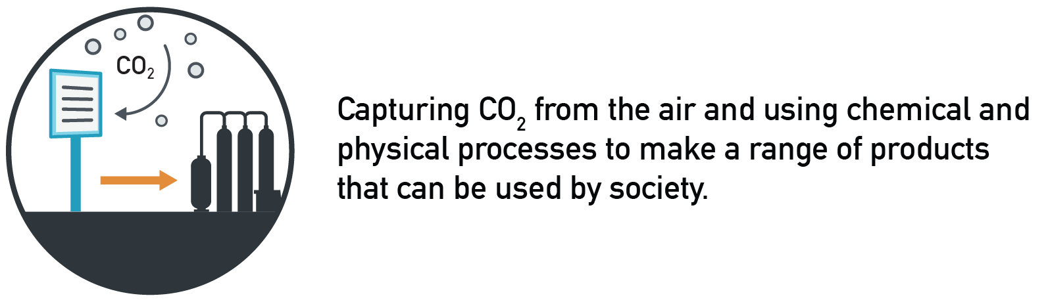
- Very uncomfortable (-2)
- Uncomfortable (-1)
- Neutral (0)
- Comfortable (+1)
- Very comfortable (+2
- I don't know/no answer

Q7.2 Q. Please indicate whether you are very uncomfortable, uncomfortable, neutral, comfortable or very comfortable with:
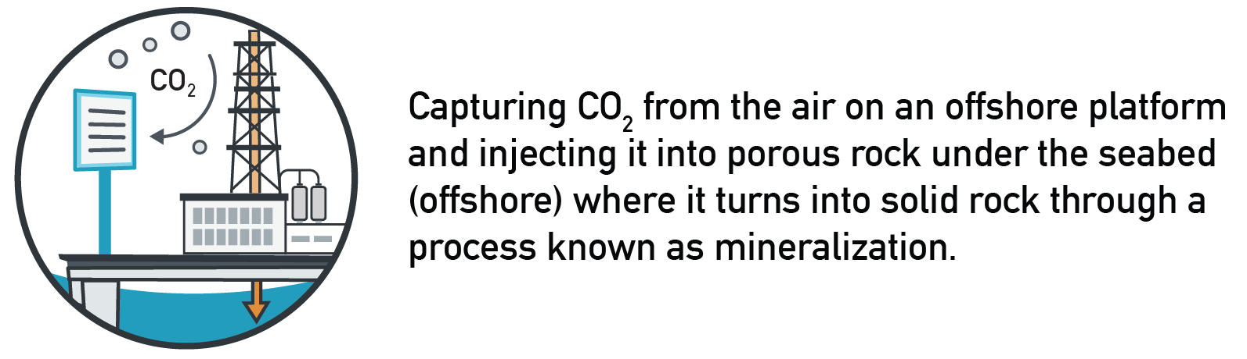
- Very uncomfortable (-2) (1)
- Uncomfortable (-1) (2)
- Neutral (0) (3)
- Comfortable (+1) (4)
- Very comfortable (+2) (5)
- I don't know/no answer (6)

Q7.3 Q. Please indicate whether you are very uncomfortable, uncomfortable, neutral, comfortable or very comfortable with:
​​
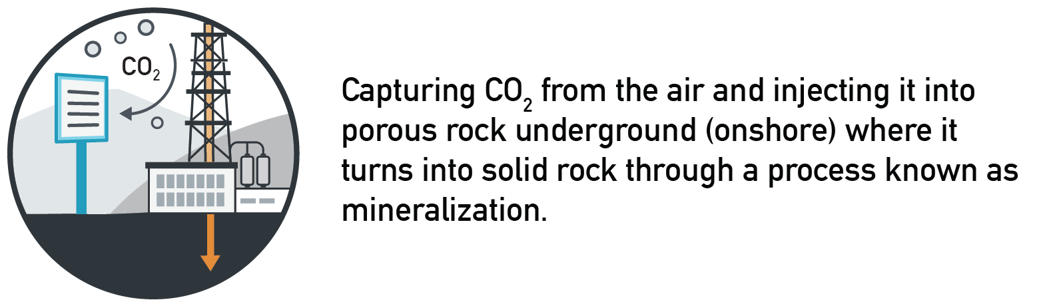
- Very uncomfortable (-2) (1)
- Uncomfortable (-1) (2)
- Neutral (0) (3)
- Comfortable (+1) (4)
- Very comfortable (+2) (5)
- I don't know/no answer (6)

Q7.4 Q. Please indicate whether you are very uncomfortable, uncomfortable, neutral, comfortable or very comfortable with:
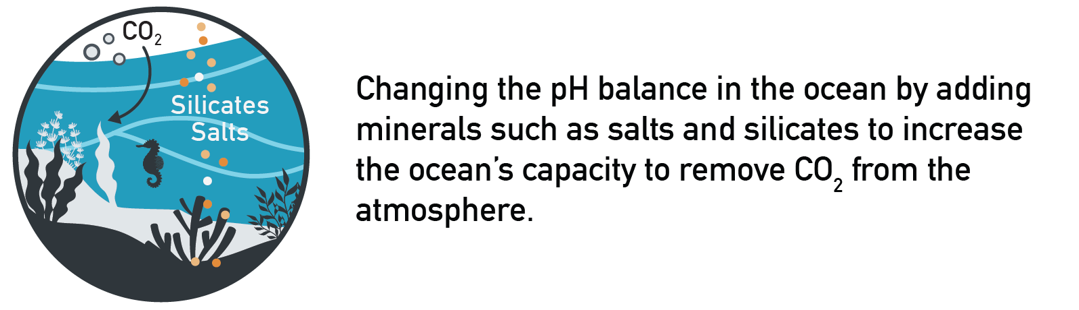
​​​​​​​
- Very uncomfortable (-2) (1)
- Uncomfortable (-1) (2)
- Neutral (0) (3)
- Comfortable (+1) (4)
- Very comfortable (+2) (5)
- I don't know/no answer (6)

Q7.5 Q. Please indicate whether you are very uncomfortable, uncomfortable, neutral, comfortable or very comfortable with:
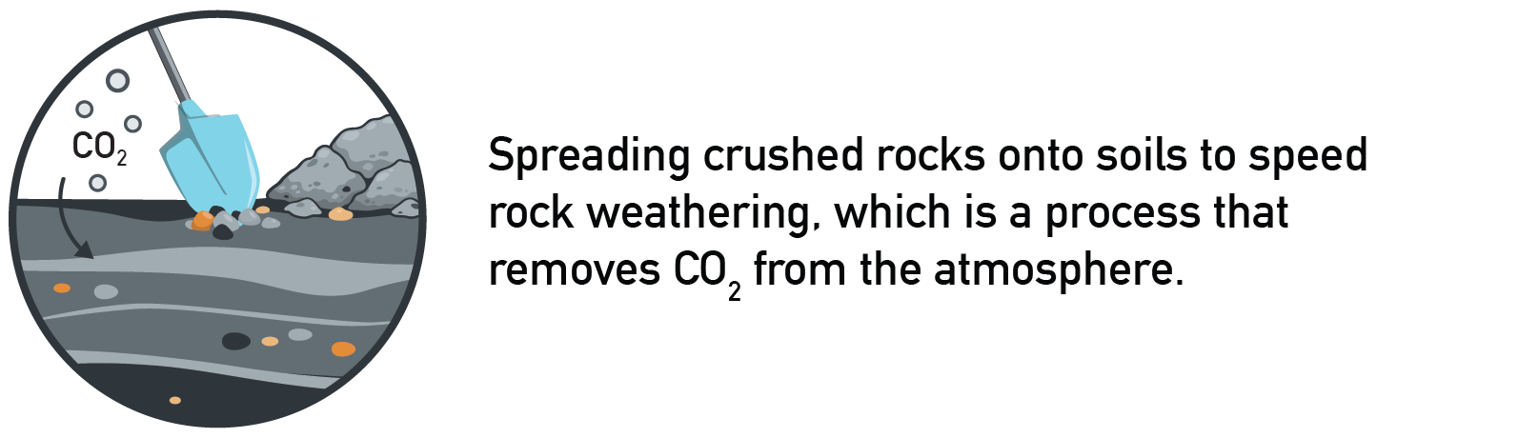
- Very uncomfortable (-2) (1)
- Uncomfortable (-1) (2)
- Neutral (0) (3)
- Comfortable (+1) (4)
- Very comfortable (+2) (5)
- I don't know/no answer (6)

Q7.6 Q. Please indicate whether you are very uncomfortable, uncomfortable, neutral, comfortable or very comfortable with:
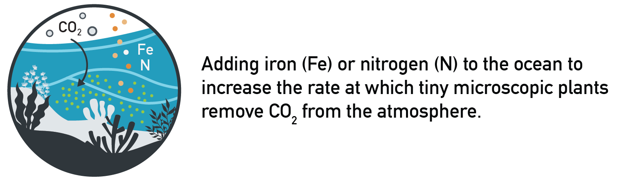
- Very uncomfortable (-2) (1)
- Uncomfortable (-1) (2)
- Neutral (0) (3)
- Comfortable (+1) (4)
- Very comfortable (+2) (5)
- I don't know/no answer (6)

Q7.7 Q. Please indicate whether you are very uncomfortable, uncomfortable, neutral, comfortable or very comfortable with:
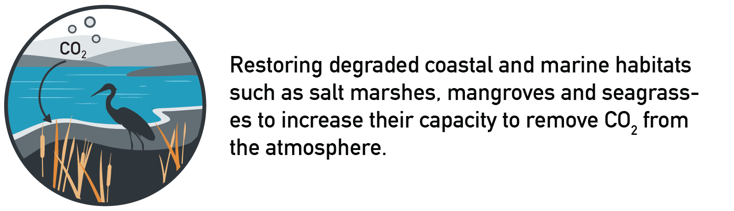
- Very uncomfortable (-2) (1)
- Uncomfortable (-1) (2)
- Neutral (0) (3)
- Comfortable (+1) (4)
- Very comfortable (+2) (5)
- I don't know/no answer (6)

Q7.8 Q. Please indicate whether you are very uncomfortable, uncomfortable, neutral, comfortable or very comfortable with:
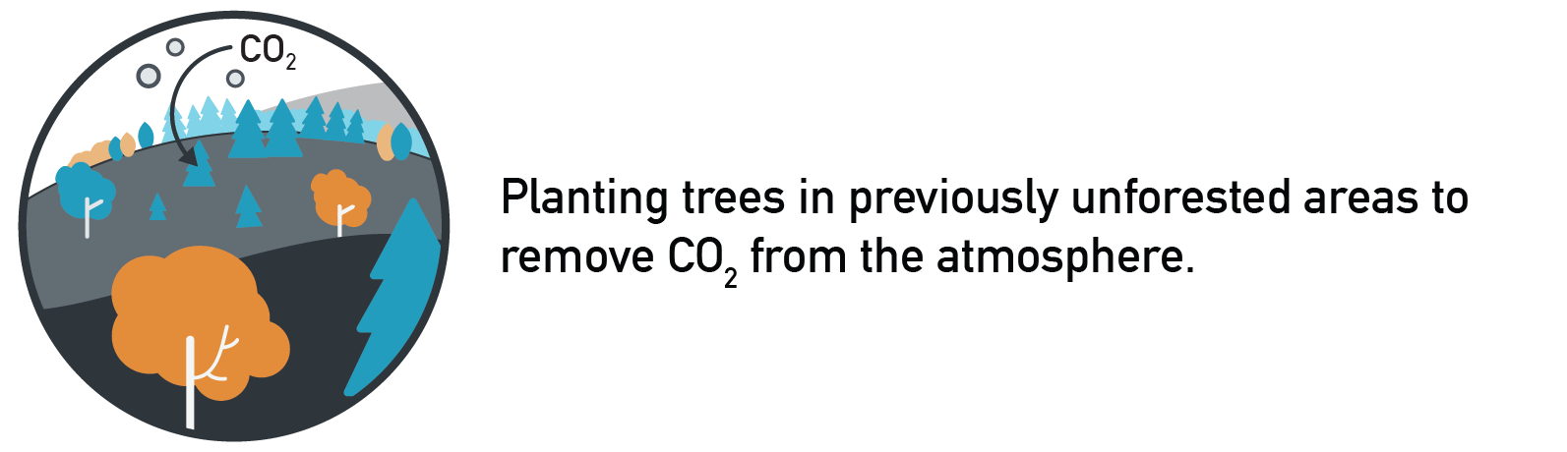
- Very uncomfortable (-2) (1)
- Uncomfortable (-1) (2)
- Neutral (0) (3)
- Comfortable (+1) (4)
- Very comfortable (+2) (5)
- I don't know/no answer (6)

Q7.9 Q. Please indicate whether you are very uncomfortable, uncomfortable, neutral, comfortable or very comfortable with:
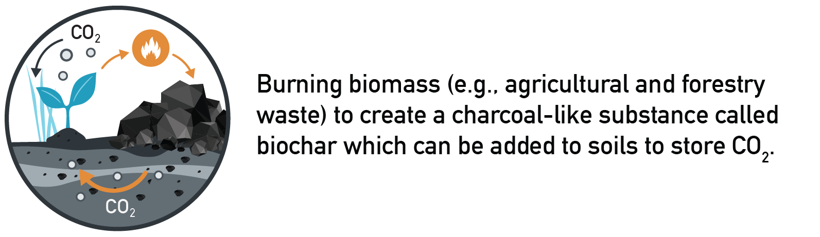
- Very uncomfortable (-2) (1)
- Uncomfortable (-1) (2)
- Neutral (0) (3)
- Comfortable (+1) (4)
- Very comfortable (+2) (5)
- I don't know/no answer (6)

Q7.10 Q. Please indicate whether you are very uncomfortable, uncomfortable, neutral, comfortable or very comfortable with:
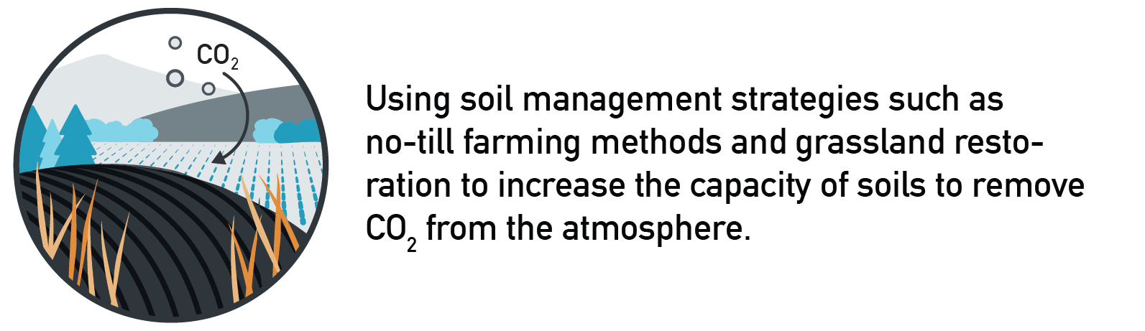
- Very uncomfortable (-2) (1)
- Uncomfortable (-1) (2)
- Neutral (0) (3)
- Comfortable (+1) (4)
- Very comfortable (+2) (5)
- I don't know/no answer (6)

Q7.text Q. Please use the space below if you have any additional comments on any of the strategies.
________________________________________________________________
________________________________________________________________
________________________________________________________________
________________________________________________________________
________________________________________________________________

End of Block: NETs_Likert

Start of Block: Solid Carbon

Solid Carbon Technology
Now we would like to talk about a technology known as: Solid Carbon.
Solid Carbon is a type of direct air capture and storage technology. Direct air capture and storage technologies capture CO2 from the air, convert it to a liquid form and injects it into porous rock either underground (onshore) or under the seabed (offshore) where it settles and turns into solid rock.

Q8_BC Q. Before today, have you ever heard of direct air capture and storage?
- No (1)
- Yes, but I don't really know what it is (2)
- Yes, and I know what it is (5)
- Prefer not to answer (6)

Solid Carbon brings together different technologies into a fully integrated system using the following process:
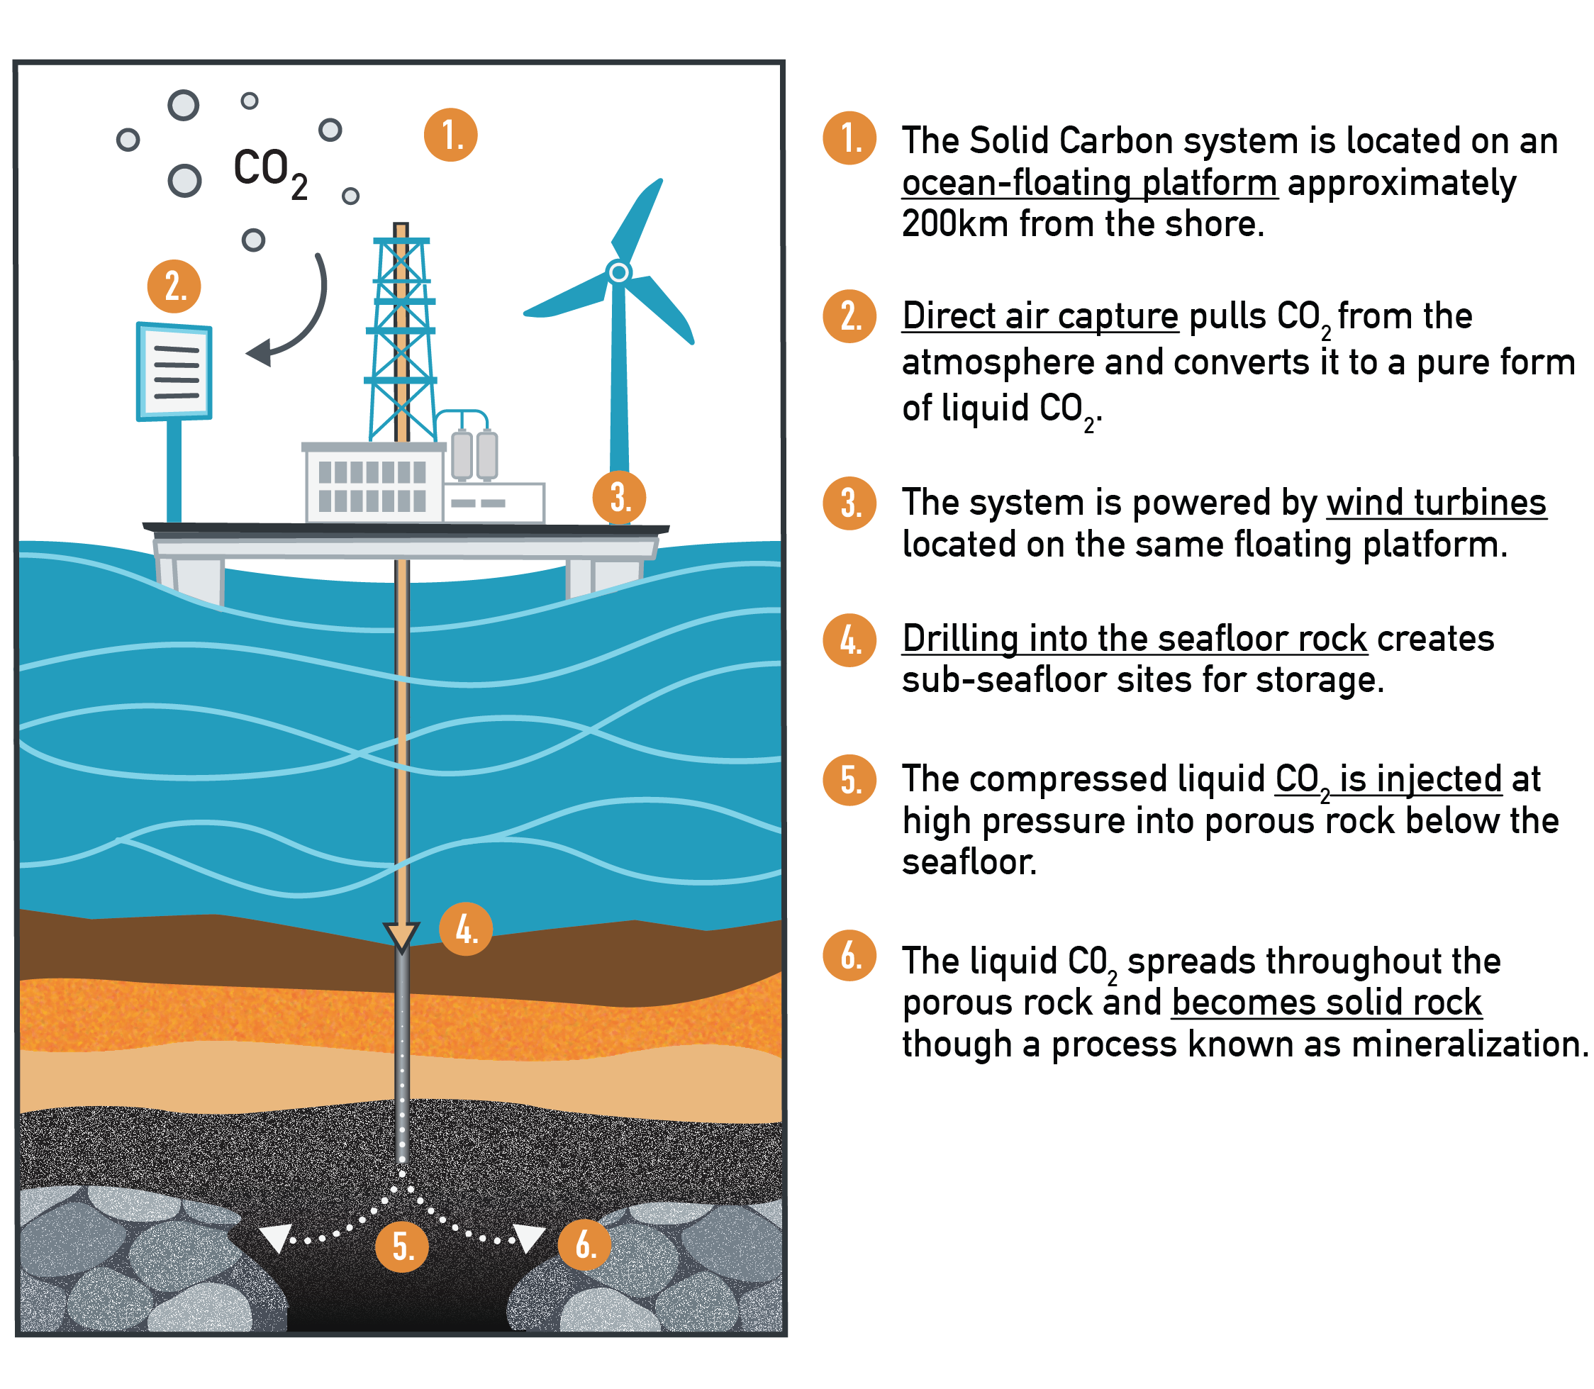

Display This Question:
If Q. What region do you live in? = Province of British Columbia (Canada)

BC One Solid Carbon platform is designed to remove 1 million tonnes of CO2 per year from the atmosphere (or 2% of British Columbia’s annual emissions). This would achieve the same CO2 removal as planting trees on 1000 square kilometres of available unforested land (about 1.5 times the area of New York city). You can also think of this as equivalent to converting over 200,000 family cars to zero-emission vehicles.
Display This Question:
If Q. What region do you live in? = Washington state (USA)

WA One Solid Carbon platform is designed to remove 1 million tonnes of CO2 per year from the atmosphere (or 1% of Washington state’s annual emissions). This would achieve the same CO2 removal as planting trees on 1000 square kilometres of available unforested land (about 1.5 times the area of New York city). You can also think of this as equivalent to converting over 200,000 family cars to zero-emission vehicles.

Display This Question:
If Q. What region do you live in? = Province of British Columbia (Canada)

Q9_BC Q. In general, please indicate whether you would strongly oppose, oppose, neither oppose nor support, support or strongly support the construction of a Solid Carbon project in British Columbia to help meet the province's climate targets?
- Strongly oppose(-2) (1)
- Oppose(-1) (2)
- Neither oppose nor support(0) (3)
- Support(+1) (4)
- Strongly support(+2) (5)
- I don't know/no answer (6)

Display This Question:
If Q. What region do you live in? = Washington state (USA)

Q9_WA Q. In general, please indicate whether you would strongly oppose, oppose, neither oppose nor support, support or strongly support the construction of a Solid Carbon project in Washington to help meet the state's climate targets?
- Strongly oppose(-2) (1)
- Oppose(-1) (2)
- Neither oppose nor support(0) (3)
- Support(+1) (4)
- Strongly support(+2) (5)
- I don't know/no answer (6)

Display This Question:
If Q. What region do you live in? = Province of British Columbia (Canada)

Q9_text_BC Q. In a few words, please explain the reason(s) why you support or oppose the construction of a Solid Carbon project in British Columbia.
________________________________________________________________
________________________________________________________________
________________________________________________________________
________________________________________________________________
________________________________________________________________

Display This Question:
If Q. What region do you live in? = Washington state (USA)

Q9_text_WA Q. In a few words, please explain the reason(s) why you support or oppose the construction of a Solid Carbon project in Washington state.
________________________________________________________________
________________________________________________________________
________________________________________________________________
________________________________________________________________

Display This Question:
If Q. What region do you live in? = Province of British Columbia (Canada)

Q10_BC Q. Which of the following statements best describes your views about the potential implementation of a Solid Carbon project in British Columbia?
- A Solid Carbon project should be implemented right now with ongoing research and monitoring. (1)
- We need further research before being able to implement a Solid Carbon project. (2)
- A Solid Carbon project should be avoided because there are too many unknowns (5)
- Other, please specify: (9) ________________________________________________
- I don't know/no answer (6)

Display This Question:
If Q. What region do you live in? = Washington state (USA)

Q10_WA Q. Which of the following statements best describes your views about the potential implementation of a Solid Carbon project in Washington state?
- A Solid Carbon project should be implemented right now with ongoing research and monitoring. (1)
- We need further research before being able to implement a Solid Carbon project. (2)
- A Solid Carbon project should be avoided because there are too many unknowns (5)
- Other, please specify: (9) ________________________________________________
- I don't know/no answer (6)

Q11 Q. Please tell us how concerned you are about the following components of a potential Solid Carbon project.
 | Not at all concerned  (1) (1) | Slightly concerned  (2) (2) | Moderately concerned  (3) (3) | Very concerned  (4) (4) | Extremely concerned  (5) (5) | I don't know/no answer (6)
Capturing CO2 from the atmosphere using direct air capture (1)
A direct air capture system located on an ocean-floating platform (2)
Wind turbines located on an ocean-floating platform (3)
Drilling into the seafloor to prepare the injection site (4)
Injection of CO2 into seabed porous rock (5)
Liquid CO2 turning into solid rock through mineralization (6)

End of Block: Solid Carbon

Start of Block: Benefits and risks

Benefits and risks

Q12 These next questions ask about how different possibilities affect your perception of the risks of Solid Carbon. Please read each statement and tell us whether it very strongly, strongly, moderately, slightly or does not increase your perceived risk of solid carbon.
 | Does not increase my perceived risk (1) (1) | Slightly increases my perceived risk (2) (2) | Moderately increases my perceived risk (3) (3) | Strongly increases my perceived risk (4) (4) | Very strongly increases my perceived risk (5) (5) | I don't know/no answer (6)
Solid Carbon might increase the probability of earthquakes. (1)
Solid Carbon might lead to an explosive discharge of CO2 from solid rock. (2)
Solid Carbon might affect deep ocean ecosystems. (3)
Solid Carbon might have negative consequences for human health. (4)
Solid Carbon might lead to unnoticed leakage of CO2 from the porous rock to the surface. (5)
Solid Carbon might cause pollution in the ocean. (6)
Solid Carbon might divert money that could be better used elsewhere. (8)
Solid Carbon might encourage the continued burning of fossil fuels. (10)
Solid Carbon might be much more expensive than other climate solutions. (11)
Solid Carbon might provide an excuse for slowing the development of renewable energy. (12)

Q13 Q. These next questions ask about how different possibilities affect your perception of the benefits of solid carbon. Please read each statement and tell us whether it very strongly, strongly, moderately, slightly or does not increase your perception of the benefits of solid carbon.
 | Does not increase my perceived benefit (1) (1) | Slightly increases my perceived benefit (2) (2) | Moderately increases my perceived benefit (3) (3) | Strongly increases my perceived benefit (4) (4) | Very strongly increases my perceived benefit (5) (5) | I don't know/no answer (6)
Solid Carbon could be a safe solution for addressing climate change (1)
Solid Carbon could be effective for reducing concentration of CO2 in the atmosphere (2)
Solid Carbon could be a good use of revenues from carbon taxes. (4)
Solid Carbon could provide skilled employment for people formerly employed in the oil and gas industry. (5)
Solid Carbon could benefit future generations. (6)
Solid Carbon could go a long way to addressing the problem of escalating CO2 emissions. (7)
Solid Carbon could reduce the cost of addressing climate change. (8)
Solid Carbon could be an important component of a ‘green’ economy'. (9)
Solid Carbon could keep us from having to convert vast amounts of land to forestland. (12)
Solid Carbon could provide a way to remove CO2 from the atmosphere independently of onshore industrial facilities or sites. (13)

Display This Question:
If Q. What region do you live in? = Province of British Columbia (Canada)

Q14_BC Q. Now that we have discussed a few more things, please indicate whether you would strongly oppose, oppose, neither oppose nor support, support or strongly support the construction of a Solid Carbon project in British Columbia to meet the province's climate targets?
- Strongly oppose(-2) (1)
- Oppose(-1) (2)
- Neither oppose nor support(0) (3)
- Support(+1) (4)
- Strongly support(+2) (5)
- I don't know/no answer (6)

Display This Question:
If Q. What region do you live in? = Washington state (USA)

Q14_WA Q. Now that we have discussed a few more things, please indicate whether you would strongly oppose, oppose, neither oppose nor support, support or strongly support the construction of a Solid Carbon project in Washington to meet the state's climate targets?
- Strongly oppose(-2) (1)
- Oppose(-1) (2)
- Neither oppose nor support(0) (3)
- Support(+1) (4)
- Strongly support(+2) (5)
- I don't know/no answer (6)

Q15 Q. Please use the space below if you have any additional comments on Solid Carbon technology.
________________________________________________________________
________________________________________________________________
End of Block: Benefits and risks

Q16 Q. Please indicate whether you strongly distrust, distrust, neither trust nor distrust, trust or strongly trust the following groups to provide accurate information about Solid Carbon technology?
 | Strongly distrust  (-2) | Distrust  (-1) | Neither trust nor distrust  (0) | Trust  (+1) | Strongly trust  (+2) | I don't know/no answer
The energy industry (1)
The industry that operates Direct Air Capture and Storage technologies (2)
Scientists working for the energy industry (3)
The federal government (4)
Display This Choice:
If Q. What region do you live in? = Province of British Columbia (Canada)
The provincial government (5)
Display This Choice:
If Q. What region do you live in? = Washington state (USA)
The state government (12)
Environmental organizations (6)
Scientists working for universities (7)
Scientists working for government (8)
Journalists knowledgeable on this topic (9)
Display This Choice:
If Q. What region do you live in? = Province of British Columbia (Canada)
First Nation leaders from communities located nearby potential Solid Carbon sites (10)
Display This Choice:
If Q. What region do you live in? = State of Maine (USA)
Or Q. What region do you live in? = Washington state (USA)
Native American leaders from communities located nearby potential Solid Carbon sites (11)

Q17 Q. Please indicate whether you strongly disagree, disagree, neither agree nor disagree, agree or strongly agree with the following statements.
 | Strongly disagree  (-2) (1) | Disagree  (-1) (2) | Neither agree nor disagree  (0) (3) | Agree  (+1) (4) | Strongly agree  (+2) (5) | I don't know/no answer (6)
The government will adequately regulate Solid Carbon technology. (1)
The regulation of Solid Carbon technology is not in safe hands with the government. (2)
The current laws and regulation are sufficient to regulate the Solid Carbon technology. (3)
The government can be trusted with making the proper decisions to address any risks from a Solid Carbon project. (4)
Display This Choice:
If Q. What region do you live in? = Province of British Columbia (Canada)
The government can be trusted to carefully consult with First Nation communities located nearby potential Solid Carbon sites. (5)
Display This Choice:
If Q. What region do you live in? = State of Maine (USA)
Or Q. What region do you live in? = Washington state (USA)
The government can be trusted to carefully consult with Native American communities located nearby potential Solid Carbon sites. (6)

End of Block: Trust

Start of Block: Attitudes

We are nearing the end of the survey--thank you for your patience. We’re now going to ask you some general questions about your views on nature, the environment and technology.

Q18 Q. Please indicate whether you strongly disagree, disagree, neither agree nor disagree, agree or strongly agree with the following statements about the marine environment?
 | Strongly disagree  (-2) (7) | Disagree  (-1) (8) | Neither agree nor disagree  (0) (9) | Agree  (+1) (10) | Strongly agree  (+2) (11) | I don't know/no answer (12)
The marine environment is very adaptable and will recover from harm caused by people. (1)
With good management, we can prevent human impacts on the marine environment. (2)
The marine environment is very fragile: even very slight human interference can cause unanticipated consequences. (3)
No matter what we do, the marine environment will change in unpredictable ways both for the better and worse. (4)

Q19 Q. Please indicate whether you strongly disagree, disagree, neither agree nor disagree, agree or strongly agree with the following statements about nature and the environment.
 | Strongly disagree  (-2) (1) | Disagree  (-1) (2) | Neither agree nor disagree  (0) (3) | Agree  (+1) (4) | Strongly agree  (+2) (5) | I don't know/no answer (6)
My personal identity is more linked to living in the city than to landscapes outside the city. (1)
My health, the health of my family and the health of others who I care about is not dependent on the natural environment. (2)
I have strong feelings about nature (including all plants, animals, the land, etc.). These views are part of who I am and how I live my life. (3)
Plants and animals, as part of the interdependent web of life, are like 'kin' or family to me. (4)
I often think of some wild places whose fate I care about and strive to protect, even though I may never see them myself. (5)
Humans have a responsibility to account for our own impacts to the environment because they can harm other people. (6)
People should take only what they need from nature and leave the rest behind for other nonhuman beings. (7)
Even though we are human animals, I think people and nature are very separate from each other. (8)
I think of animals not as groups such as a herd of deer, but as individual animal ‘persons’, each with their own personality. (9)
I think of ecosystems as made up of humans and animals living well in relation to each other. (10)

Q20 Q. Please indicate whether you strongly disagree, disagree, neither agree nor disagree, agree or strongly agree with the following statements about technology in general.
 | Strongly disagree  (-2) (1) | Disagree  (-1) (2) | Neither agree nor disagree  (0) (3) | Agree  (+1) (4) | Strongly agree  (+2) (5) | I don't know/no answer (6)
Hope for the future lies more in people than in technology. (1)
The bad effects of technology outweigh its advantages. (2)
Future resource shortages will be solved by technological advances. (3)
A country’s progress can be measured by its technological development. (4)
We are worse off than ever, because of the burden of new technologies. (5)
Display This Choice:
If Q. What region do you live in? = Province of British Columbia (Canada)
New technologies have done more harm than good to most First Nation communities. (6)
Display This Choice:
If Q. What region do you live in? = State of Maine (USA)
Or Q. What region do you live in? = Washington state (USA)
New technologies have done more harm than good to most Native American communities. (7)

Q21 Q. Please use the space below if you have any additional comments.
________________________________________________________________
________________________________________________________________
________________________________________________________________

End of Block: Attitudes

Start of Block: Demographics

FINAL INFORMATION
Almost done! We only have a few final questions for you. Please remember that all information provided will remain confidential.

Q22 Q. Where would you place yourself on the following political spectrum?
- Very liberal (1)
- Liberal (2)
- Centrist (3)
- Conservative (4)
- Very conservative (5)
- Prefer not to answer (6)

Q23 Q. Please indicate whether you strongly disagree, disagree, neither agree nor disagree, agree or strongly agree with the following statements.
 | Strongly disagree  (-2) (1) | Disagree  (-1) (4) | Neither agree nor disagree  (0) (3) | Agree  (+1) (6) | Strongly agree  (+2) (2) | I don't know/no answer (7)
The government interferes far too much in our everyday lives. (1)
It's not the government's business to protect people from themselves. (2)
The government should stop telling people how to live their lives. (3)
We have gone too far in pushing equal rights in this country. (4)
Society as a whole has become too feminine. (5)
It seems like many groups don't want equal rights, they want special rights. (6)
The government should do more to advance society's goals, even if it means limiting the freedom and choices of individuals. (7)
Sometimes government needs to make laws that keep people from hurting themselves. (8)
Government should put limits on the choices individuals can make so they don't get in the way of what's good for society. (9)
Discrimination against minorities is still a very serious problem in our society. (10)
Our society would be better off if the distribution of wealth was more equal. (11)
We need to dramatically reduce inequalities between the rich and the poor, whites and people of color, and men and women. (12)

Q24 Q. What is the highest level of education you have completed or the highest degree you have received?
- Less than high school degree (1)
- High school diploma or equivalent including GED (2)
- Some college but no degree (3)
- College, CEGEP and other non-university certificates or diplomas (4)
- Bachelor's degree (5)
- Master's degree (6)
- Doctoral degree (7)
- Professional degree (JD, MD) (8)
- Other, please specify (9) ________________________________________________

Q25 Q. Do you have any final comments about our survey?
________________________________________________________________
________________________________________________________________
________________________________________________________________
________________________________________________________________
________________________________________________________________

End of Block: Demographics

