Supplementary Sheet
Table 1a Physio-Chemical Properties of Jatropha curcas biodiesel and its blends with diesel
Properties | Test Method | J5 | J10 | J15 | J20 | J40 | J60 | J80 | J100 | Diesel
Density (Kg/m³) | ASTM D1298 | 842 | 842.5 | 844.3 | 845.5 | 853.5 | 861 | 869 | 875 | 840
Viscosity (mm²/s) | ASTM D445 | 3.52 | 3.54 | 3.56 | 3.6 | 3.73 | 3.81 | 4.04 | 4.1 | 3.5
Calorific Value (MJ/Kg) | ASTM D240 | 42.39 | 42.3 | 42.24 | 42.17 | 41.7 | 41.5 | 41.1 | 40.85 | 42.5
Pour Point (°C ) | ASTM D97 | -8 | -7 | -6 | -3 | -2 | 3 | 4 | 6 | -20
Cloud Point (°C ) | ASTM D2500 | 1.7 | 2.8 | 3.6 | 4.8 | 6.4 | 9 | 12.5 | 13 | -5
Flash Point (°C ) | ASTM D93 | 58 | 83 | 83.5 | 84 | 108 | 126 | 148 | 171 | 55

Table 1b Physio-Chemical Properties of Madhuca longifolia biodiesel and its blends with diesel
Properties | Test Method | M5 | M10 | M15 | M20 | M40 | M60 | M80 | M100 | Diesel
Density (Kg/m³) | ASTM D1298 | 836 | 839.5 | 840.5 | 844 | 850 | 860 | 865 | 870 | 840
Viscosity (mm²/s) | ASTM D445 | 3.53 | 3.56 | 3.59 | 3.61 | 3.8 | 3.9 | 4.05 | 4.2 | 3.5
Calorific Value (MJ/Kg) | ASTM D240 | 42.3 | 42.25 | 42.15 | 42.03 | 41.6 | 41.4 | 40.6 | 40.20 | 42.5
Pour Point (°C ) | ASTM D97 | -7 | -6 | -5 | -3 | -1 | 2 | 4 | 6 | -20
Cloud Point (°C ) | ASTM D2500 | 1 | 2 | 3 | 4 | 6 | 8 | 11 | 12 | -5
Flash Point (°C ) | ASTM D93 | 58 | 62 | 70 | 75 | 101 | 124 | 147 | 169 | 55

FTIR
Table 2a Area under curve for Jatropha curcas biodiesel
J5 |  | J10 |  | J15 |  | J20 |  | J40 |  | J50 |  | J60 |  | J80 |  | J85 |  | J90 |  | J95 |  | J100 |  | Diesel
Peak | A | Peak | A | Peak | A | Peak | A | Peak | A | Peak | A | Peak | A | Peak | A | Peak | A | Peak | A | Peak | A | Peak | A | Peak | A
532.35 | 0.401 | 586.36 | 1.4 | 582.5 | 1.579 | 590.22 | 13.743 | 586.36 | 2.302 | 597.93 | 2.418 | 590.22 | 2.668 | 590.22 | 0.999 | 590.22 | 5.681 | 597.93 | 4.321 | 597.93 | 7.352 | 586.36 | 2.534 | 540.07 | 493.78
721.38 | 3.206 | 725.23 | 9.361 | 725.23 | 12.937 | 721.38 | 36.386 | 725.23 | 13.811 | 721.38 | 18.439 | 721.38 | 18.012 | 721.38 | 12.119 | 721.38 | 26.131 | 725.23 | 33.134 | 721.38 | 29.38 | 721.38 | 31.171 | 725.23 | 51.097
810.1 | 3.608 | 813.96 | 3.773 | 810.1 | 3.234 |  |  | 813.96 | 1.972 | 848.68 | 6.366 | 848.68 | 5.857 | 848.68 | 3.689 | 848.68 | 8.928 | 848.68 | 9.339 | 848.68 | 9.255 | 844.82 | 9.661 | 810.1 | 17.289
875.68 | 3.316 | 879.54 | 6.297 | 875.68 | 5.221 |  |  | 875.68 | 3.325 |  |  |  |  |  |  | 875.68 | 5.585 | 875.68 | 5.629 | 875.68 | 6.027 | 879.54 | 4.881
 |  |  |  |  |  |  |  |  |  |  |  |  |  |  |  | 910.4 | 3.49 |  |  |  |  | 914.26 | 2.951
964.41 | 2.46 |  |  |  |  |  |  |  |  |  |  |  |  |  |  |  |  |  |  |  |  |  |  | 964.41 | 33.571
1018.41 | 2.632 | 1022.27 | 7.433 | 1018.41 | 10.375 |  |  | 1018.41 | 11.276 | 1018.41 | 12.962 | 1018.41 | 13.815 | 1014.56 | 9.679 | 1018.41 | 18.902 | 1018.41 | 22.038 | 1018.41 | 23.943 | 1014.56 | 21.706 | 1161.15 | 34.189
 |  |  |  |  |  |  |  |  |  |  |  |  |  |  |  |  |  |  |  |  |  |  |  | 1373.32 | 43.694
1168.86 | 7.605 | 1168.86 | 13.771 | 1168.86 | 13.843 | 1176.58 | 33.840 | 1168.86 | 14.851 | 1168.86 | 12.962 | 1168.86 | 17.308 | 1168.86 | 13.958 | 1168.86 | 22.946 | 1168.86 | 34.349 | 1168.86 | 26.207 | 1172.72 | 32.099
 |  |  |  |  |  |  |  | 1195.87 | 11.894 |  |  | 1195.87 | 14.186 | 1195.87 | 11.529 | 1195.87 | 18.781 |  |  |  |  | 1195.87 | 28.701
 |  | 1246.02 | 8.447 | 1246.02 | 8.976 |  |  |  |  | 1242.16 | 21.955 | 1242.16 | 17.845 | 1242.16 | 14.636 | 1242.16 | 25.822 | 1246.02 | 39.284 | 1242.16 | 30.218 | 1246.02 | 35.516
1377.17 | 13.773 | 1373.32 | 13.223 | 1373.32 | 12.113 | 1377.17 | 21.690 | 1373.32 | 13.324 | 1369.46 | 16.219 | 1369.46 | 13.76 | 1365.6 | 9.871 | 1369.46 | 18.209 | 1365.6 | 24.637 | 1365.6 | 19.405 | 1361.74 | 22.172
 |  |  |  |  |  |  |  |  |  |  |  |  |  |  |  |  |  |  |  |  |  | 1435.04 | 19.631
1458.18 | 30.919 | 1458.18 | 27.231 | 1458.18 | 25.109 | 1462.04 | 30.539 | 1458.18 | 29.701 | 1458.18 | 33.948 | 1458.18 | 30.606 | 1458.18 | 11.642 | 1458.18 | 21.498 | 1442.75 | 22.195 | 1458.18 | 22.5 | 1462.04 | 24.623 | 1458.18 | 69.963
1604.77 | 4.646 | 1604.77 | 5.098 | 1604.77 | 4.662 |  |  | 1604.77 | 2.944 | 1600.92 | 3.69 | 1604.77 | 3.497 |  |  | 1604.77 | 4.013 |  |  |  |  |  |  | 1600.92 | 25.542
 |  |  |  |  |  |  |  | 1651.07 | 1.851 |  |  | 1654.92 | 2.83 | 1654.92 | 2.03 | 1654.92 | 3.965 | 1654.92 | 4.457 | 1654.92 | 4.902 | 1654.92 | 4.534
1743.65 | 10.442 | 1743.65 | 15.05 | 1743.65 | 15.723 | 1751.36 | 41.810 | 1743.65 | 24.8 | 1743.65 | 32.096 | 1743.65 | 31.276 | 1743.65 | 24.597 | 1743.65 | 39.874 | 1743.65 | 51.644 | 1743.65 | 45.029 | 1747.51 | 52.025
 |  |  |  |  |  |  |  |  |  |  |  |  |  |  |  |  |  |  |  |  |  |  |  | 1886.38 | 14.422
 |  |  |  | 2036.83 | 3.98 |  |  |  |  | 2040.69 | 5.233 | 2044.54 | 7.352 |  |  | 2040.69 | 7.902 | 2040.69 | 6.861 | 2040.69 | 7.945 | 2040.69 | 5.928 | 2032.97 | 10.402
 |  |  |  |  |  |  |  |  |  |  |  |  |  |  |  |  |  |  |  |  |  |  |  | 2187.28 | 13.581
 |  |  |  |  |  |  |  |  |  |  |  |  |  | 2333.87 | 4.068
 |  |  |  |  |  |  |  | 2357.01 | 1.741 | 2360.87 | 3.332 |  |  |  |  | 2357.01 | 5.331 |  |  |  |  |  |  | 2360.87 | 9.123
 |  |  |  | 2673.34 | 16.104 |  |  | 2673.34 | 10.46 |  |  | 2673.34 | 15.635 | 2677.2 | 10.68 | 2677.2 | 16.847 |  |  |  |  | 2677.2 | 10.629 | 2669.48 | 70.972
2727.35 | 5.522 | 2727.35 |  | 2727.35 | 5.312 |  |  | 2727.35 | 10.46 |  |  |  |  | 2727.35 | 2.783 | 2731.2 | 5.021 |  |  |  |  |  |  | 2727.35 | 22.58
2854.65 | 49.915 | 2854.65 | 38.969 | 2854.65 | 37.004 | 2862.36 | 34.482 | 2854.65 | 43.563 | 2854.65 | 47.19 | 2854.65 | 40.354 | 2854.65 | 31.04 | 2854.65 | 44.664 | 2854.65 | 56.345 | 2854.65 | 46.986 | 2854.65 | 53.786 | 2866.22 | 79.601
2931.8 | 49.894 | 2927.94 | 39.869 | 2927.94 | 40.475 | 2939.53 | 13.092 | 2931.8 | 51.02 | 2931.8 | 79.165 | 2927.94 | 67.001 | 2927.94 | 54.618 | 2931.8 | 68.498 | 2935.66 | 88.097 | 2931.8 | 69.606 | 2935.66 | 83.94 | 2951.09 | 100.251
 |  |  |  |  |  | 3005.10 | 26.257 |  |  |  |  |  |  | 3005.1 | 13.307 | 3005.1 | 26.997 | 3005.1 | 31.944 |  |  | 3005.1 | 28.72
 |  |  |  |  |  |  |  |  |  |  |  |  |  |  |  |  |  |  |  |  |  |  |  | 3159.4 | 22.608
 |  |  |  | 3468.01 | 2.116 |  |  | 3468.01 | 1.742 | 3468.01 | 2.251 | 3468.01 | 3.459 | 3464.15 | 2.454 | 3468.01 | 2.468 | 3464.15 | 2.772 | 3468.01 | 3.242 | 3464.15 | 2.428 | 3332.99 | 8.406

Table 2a Area under curve for Madhuca longifolia biodiesel
M5 |  | M10 |  | M15 |  | M20 |  | M40 |  | M50 |  | M60 |  | M80 |  | M85 |  | M90 |  | M95 |  | M100 |  | Diesel
Peak | 5% | Peak | 10% | Peak | 15% | Peak | 20% | Peak | 40% | Peak | 50% | Peak | 60% | Peak | 80% | Peak | 85% | Peak | 90% | Peak | 95% | Peak | 100 | Peak | A
540.07 | 2.277 |  |  | 586.36 | 1.651 | 586.36 | 3.935 | 578.64 | 1.213 | 590.22 | 2.17 | 586.36 | 3.626 | 594.08 | 3.101 | 594.08 | 3.567 | 594.08 | 3.891 | 586.36 | 2.663 | 594.08 | 4.413 | 540.07 | 493.78
729.09 | 32.977 | 725.23 | 10.236 | 729.09 | 21.395 | 725.23 | 32.216 | 721.38 | 30.485 | 725.23 | 13.593 | 721.38 | 20.392 | 721.38 | 16.331 | 721.38 | 27.64 | 721.38 | 17.678 | 721.38 | 17.505 | 721.38 | 20.041 | 725.23 | 51.097
810.1 | 10.765 | 810.1 | 3.156 | 810.1 | 5.937 |  |  |  |  |  |  |  |  |  |  |  |  |  |  |  |  |  |  | 810.1 | 17.289
 |  |  |  |  |  |  |  |  |  | 848.68 | 10.268 |  |  | 848.68 | 11.504 |  |  |  |  | 848.68 | 6.759
 |  |  |  |  |  |  |  |  |  |  |  |  |  |  |  | 860.25 | 17.43 | 867.97 | 13.295
883.4 | 16.572 |  |  | 879.54 | 8.621 | 879.54 | 15.277 | 879.54 | 1.398 |  |  | 875.68 | 3.725 |  |  |  |  |  |  |  |  | 871.82 | 15.487
964.41 | 14.864 |  |  |  |  |  |  |  |  |  |  |  |  |  |  |  |  |  |  |  |  |  |  | 964.41 | 33.571
 |  | 1018.41 | 11.5 | 1018.41 | 17.221 | 1018.41 | 28.992 | 1018.41 | 10.739 | 1014.56 | 11.738 | 1014.56 | 11.016 | 1014.56 | 14.188 | 1010.7 | 22.744 | 1014.56 | 16.033 | 1014.56 | 17.17 | 1018.41 | 16.128 | 1161.15 | 34.189
1026.13 | 14.608 |  |  |  |  |  |  |  |  |  |  | 1118.71 | 4.038 |  |  |  |  |  |  |  |  | 1114.86 | 16.047
1165 | 24.209 | 1168.86 | 10.936 | 1168.86 | 37.978 | 1168.86 | 66.533 | 1168.86 | 7.944 | 1168.86 | 30.947 | 1168.86 | 10.668 |  |  |  |  |  |  | 1168.86 | 22.243
 |  |  |  |  |  |  |  |  |  |  |  |  |  | 1176.58 | 41.674 | 1180.44 | 76.695 | 1176.58 | 47.481 |  |  | 1172.72 | 27.778
 |  |  |  | 1246.02 | 15.119 |  |  | 1246.02 | 3.942 | 1242.16 | 14.126 | 1246.02 | 4.705 | 1242.16 | 25.296 |  |  | 1242.16 | 29.136 | 1246.02 | 25.953 | 1242.16 | 24.454
1373.32 | 42.949 | 1373.32 | 17.266 | 1373.32 | 27.891 | 1369.46 | 37.835 | 1377.17 | 17.932 | 1369.46 | 13.514 | 1377.17 | 6.8 | 1361.74 | 15.819 | 1361.74 | 27.832 | 1361.74 | 16.165 | 1365.6 | 17.601 | 1361.74 | 14.272 | 1373.32 | 43.694
1462.04 | 68.572 | 1458.18 | 36.993 | 1458.18 | 48.731 | 1454.33 | 61.773 | 1465.9 | 35.952 | 1454.33 | 25.305 | 1462.04 | 16.71 | 1450.47 | 28.801 | 1450.47 | 47.196 | 1450.47 | 32.34 | 1458.18 | 19.901 | 1454.33 | 28.065 | 1458.18 | 69.963
1604.77 | 15.581 | 1604.77 | 5.839 | 1604.77 | 6.852 | 1604.77 | 8.285 | 1604.77 | 10.007 |  |  |  |  |  |  |  |  |  |  |  |  |  |  | 1600.92 | 25.542
1743.65 | 17.782 | 1743.65 | 17.003 | 1743.65 | 25.52 | 1743.65 | 40.327 | 1743.65 | 54.246 | 1743.65 | 24.014 | 1743.65 | 46.704 | 1743.65 | 35.451 | 1743.65 | 56.337 | 1743.65 | 41.613 | 1743.65 | 40.924 | 1743.65 | 36.574
1886.38 | 3.224 |  |  |  |  |  |  |  |  |  |  |  |  |  |  |  |  |  |  |  |  |  |  | 1886.38 | 14.422
2032.97 | 2.469 |  |  |  |  | 2036.83 | 3.752 | 2036.83 | 1.727 |  |  | 2044.54 | 0.524 |  |  | 2040.69 | 10.512 | 2044.54 | 10.27 | 2044.54 | 7.41 | 2036.83 | 9.64 | 2032.97 | 10.402
 |  |  |  |  |  |  |  |  |  |  |  |  |  |  |  |  |  |  |  |  |  |  |  | 2187.28 | 13.581
2310.72 | 9.358 |  |  |  |  | 2306.86 | 5.937 |  |  |  |  |  |  |  |  |  |  |  |  |  |  | 2353.16 | 2.837 | 2360.87 | 9.123
2403.3 | 8.398 |  |  |  |  | 2399.45 | 6.128 | 2399.45 | 0.391 |  |  | 2372.44 | 3.086
 |  |  |  |  |  |  |  | 2677.2 | 4.637 |  |  |  |  |  |  | 2677.2 | 20.804 |  |  |  |  | 2677.2 | 17.667 | 2669.48 | 70.972
2723.49 | 18.484 |  |  |  |  | 2727.35 | 13.872 | 2727.35 | 4.091 |  |  |  |  |  |  |  |  |  |  |  |  |  |  | 2727.35 | 22.58
2870.08 | 91.397 | 2858.51 | 54.734 | 2858.51 | 62.889 | 2870.08 | 84.198 | 2854.65 | 3.213 | 2858.51 | 33.009 | 2854.65 | 18.776 | 2858.51 | 37.249 | 2858.51 | 58.168 | 2854.65 | 40.025 | 2854.65 | 44.804 | 2854.65 | 30.807 | 2866.22 | 79.601
 |  |  |  |  |  |  |  | 2927.94 | 0.662 | 2927.94 | 65.182 | 2927.94 | 9.571 | 2927.94 | 83.048 | 2943.37 | 115.306 | 2927.94 | 87.6 | 2931.8 | 69.937 | 2924.09 | 38.886
2966.52 | 122.992 | 2954.95 | 56.513 | 2954.95 | 112.198 | 2958.8 | 111.727 |  |  |  |  |  |  |  |  |  |  |  |  |  |  |  |  | 2951.09 | 100.251
 |  |  |  |  |  |  |  |  |  |  |  |  |  |  |  |  |  |  |  |  |  |  |  | 3159.4 | 22.608
 |  |  |  |  |  | 3468.01 | 1.017 | 3468.01 | 6.055 |  |  |  |  | 3464.15 | 8.24 | 3464.15 | 7.913 | 3464.15 | 7.994 |  |  | 3468.01 | 8.157 | 3332.99 | 8.406

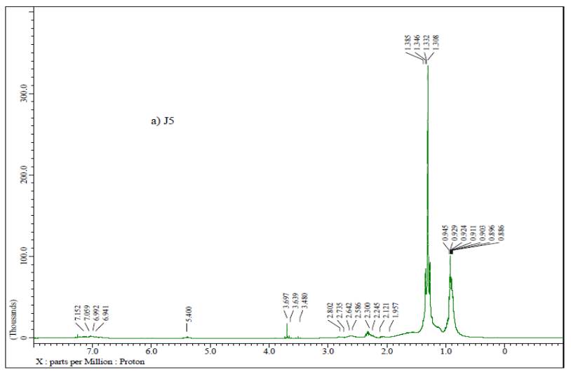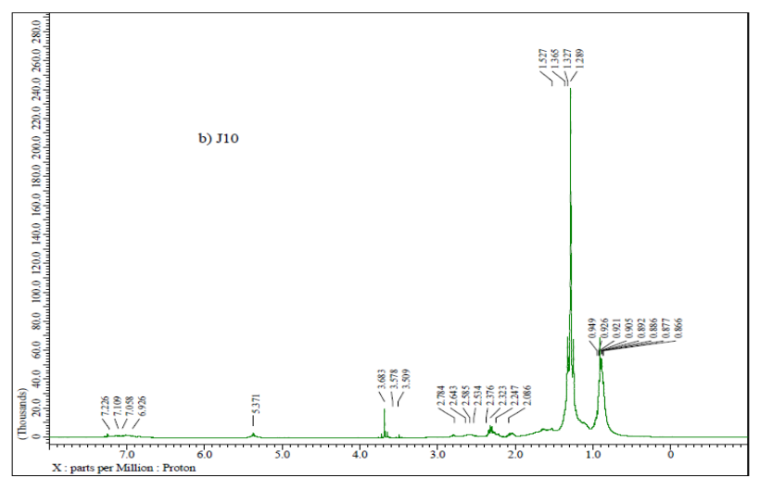
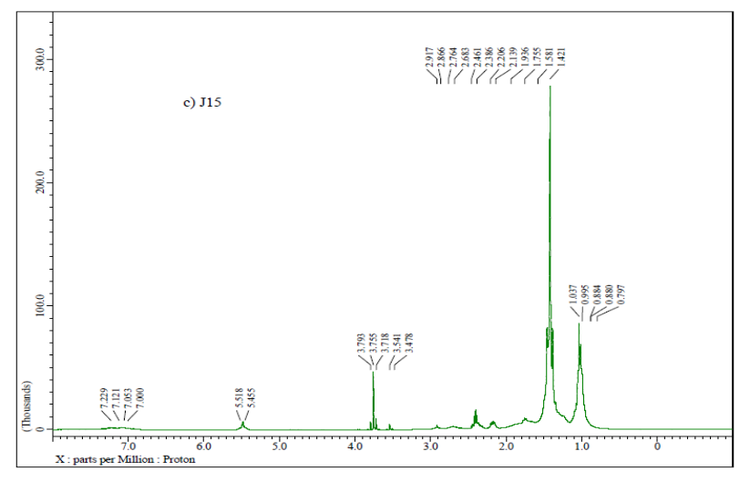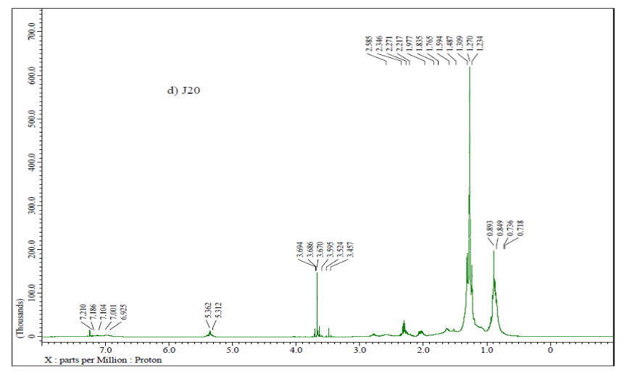
H¹NMR spectra of blending samples of JB with diesel (J5-J20)

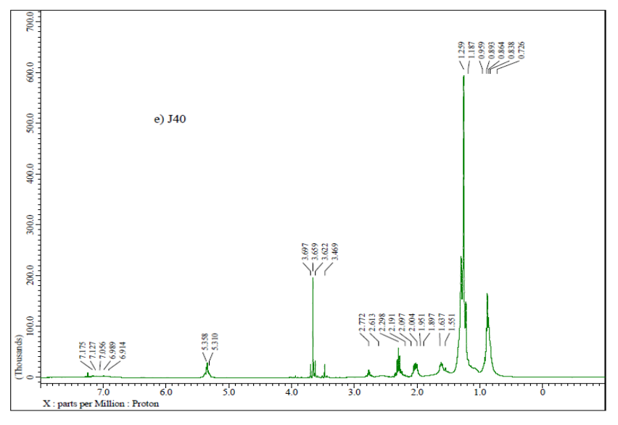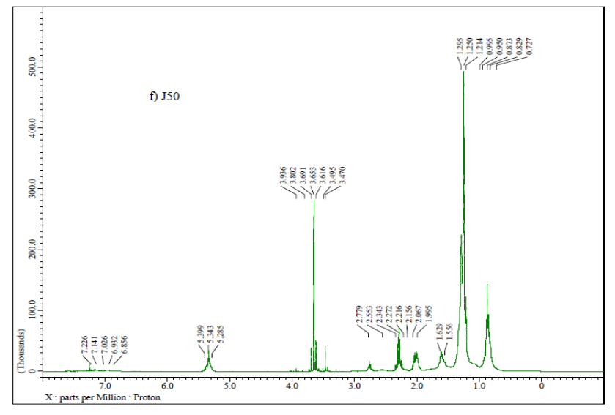
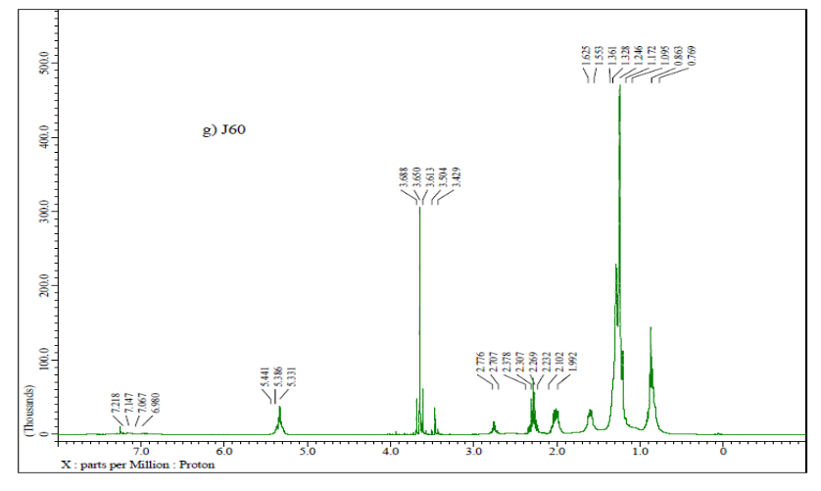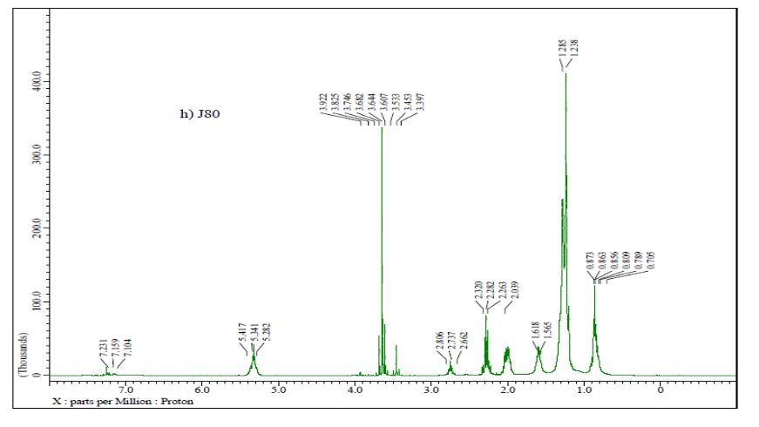
H¹NMR spectra of blending samples of JB with diesel (J40-J80)

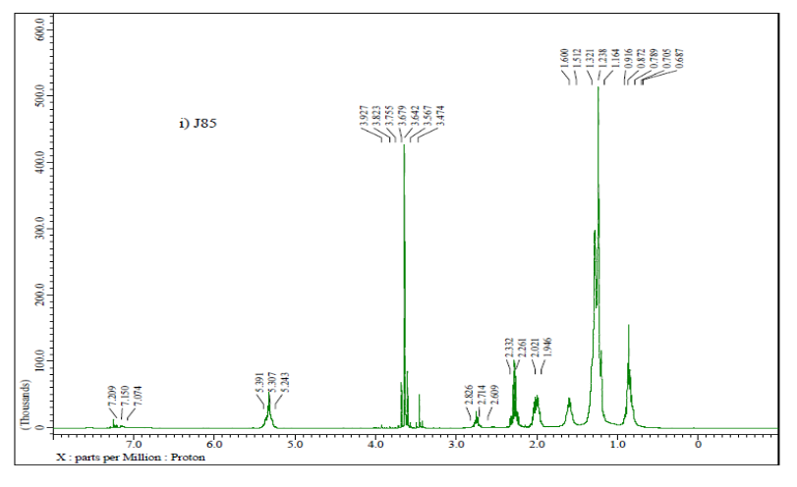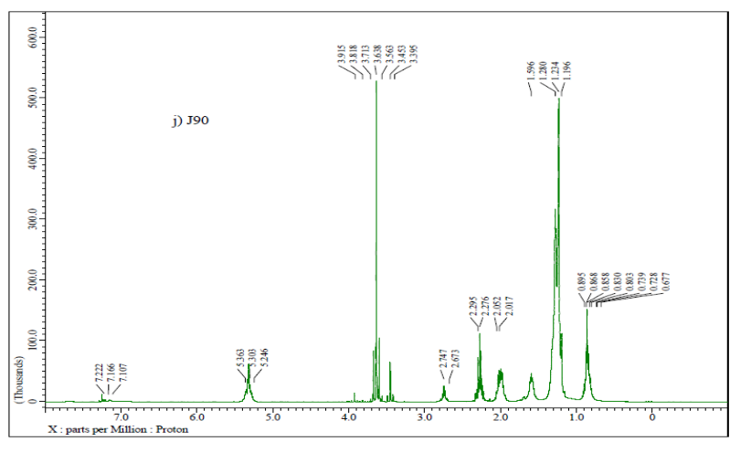
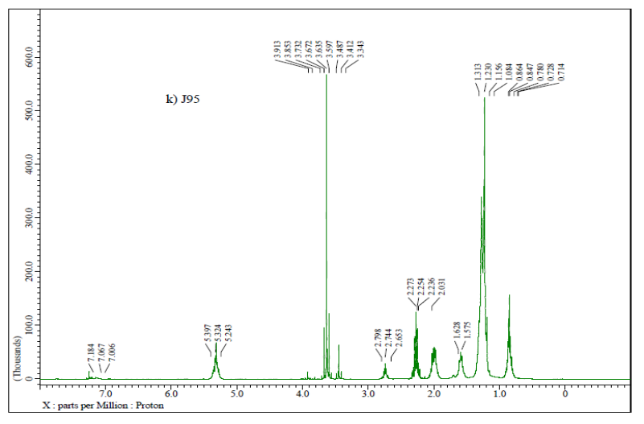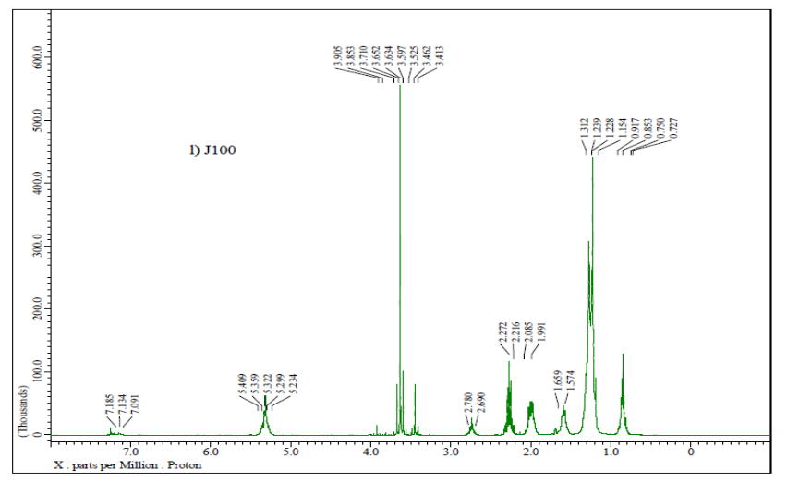
H¹NMR spectra of blending samples of JB with diesel and JB (J85-J100)

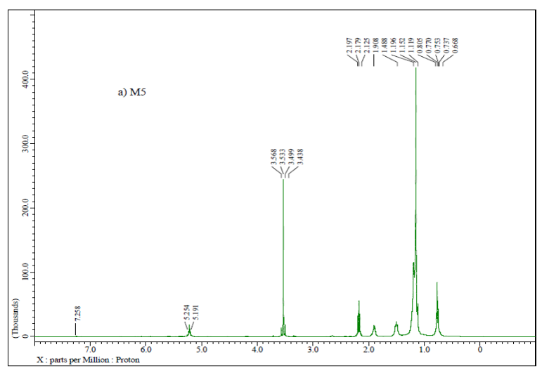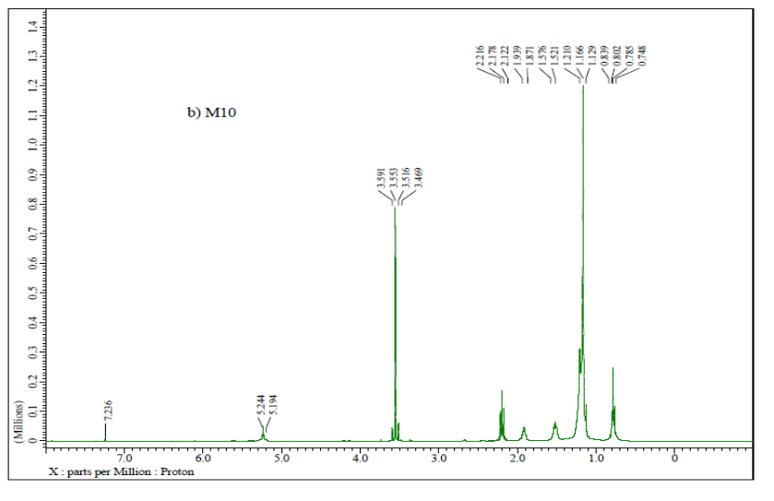
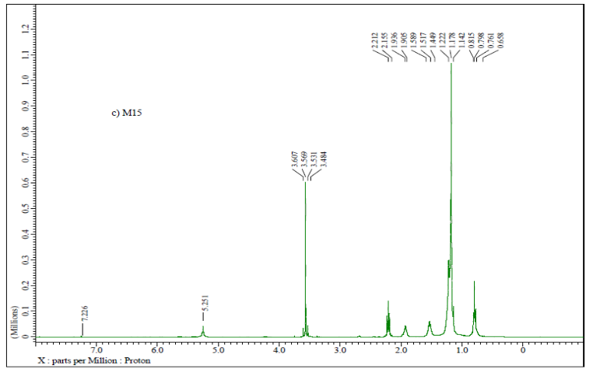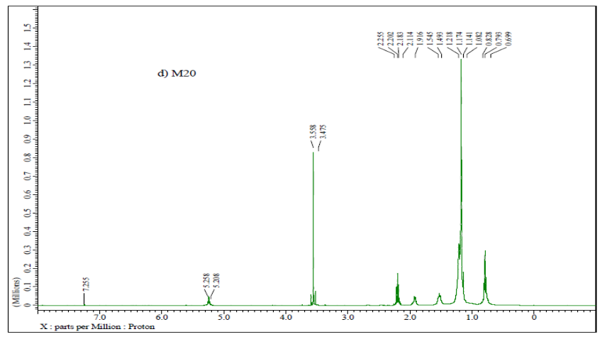
H¹NMR spectra of blending samples of MB with diesel (M5-M20)
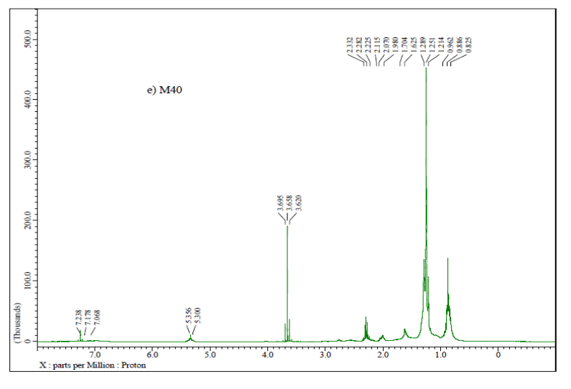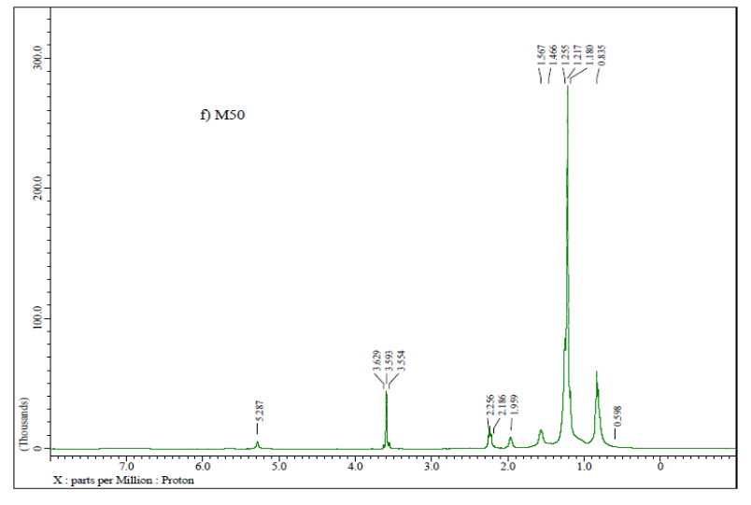
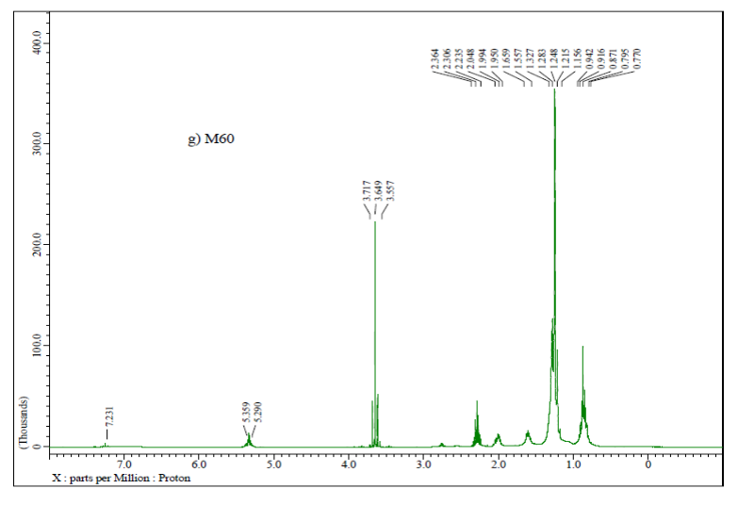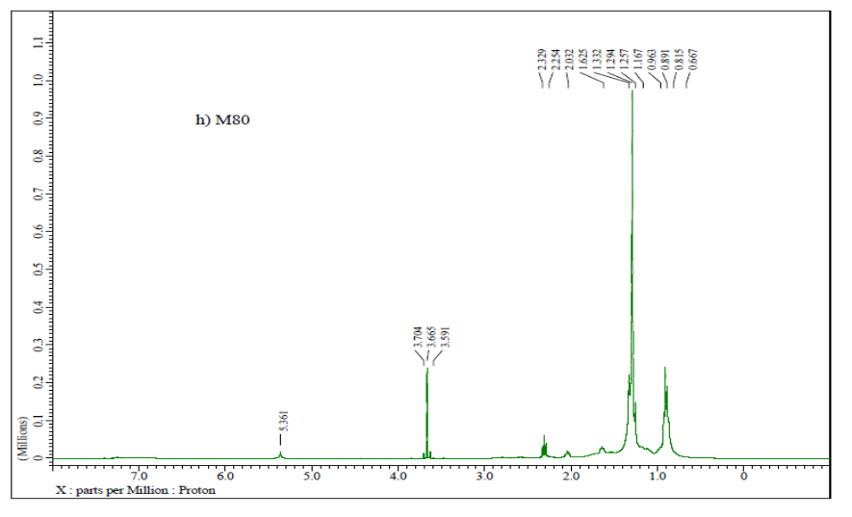
H¹NMR spectra of blending samples of MB with diesel (M40-M80)

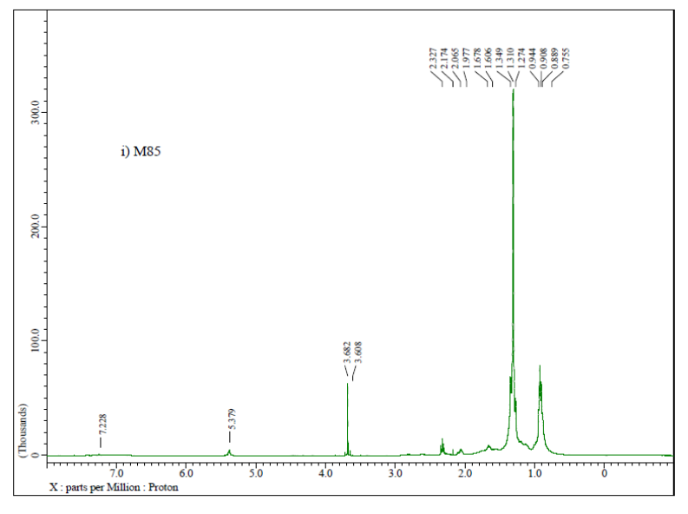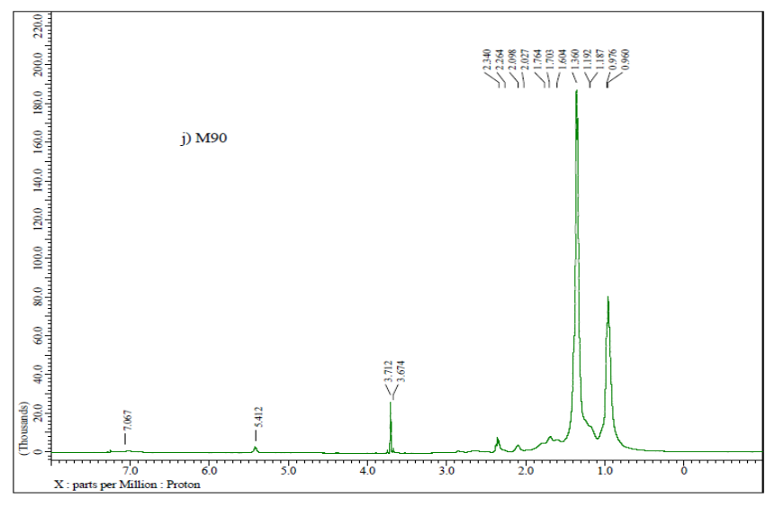
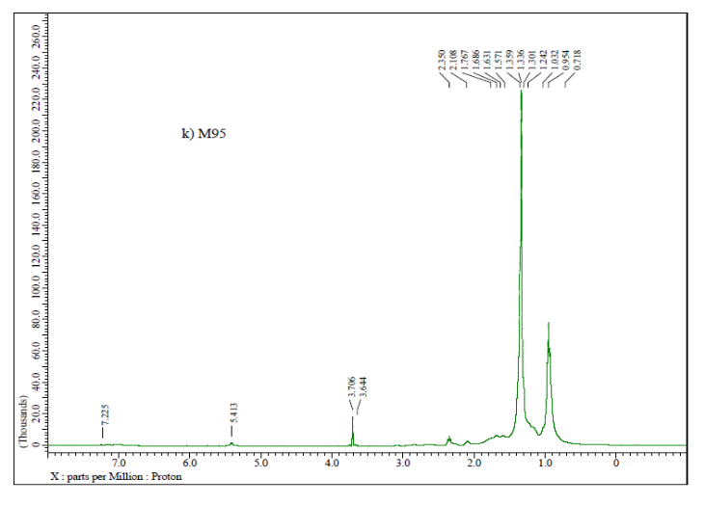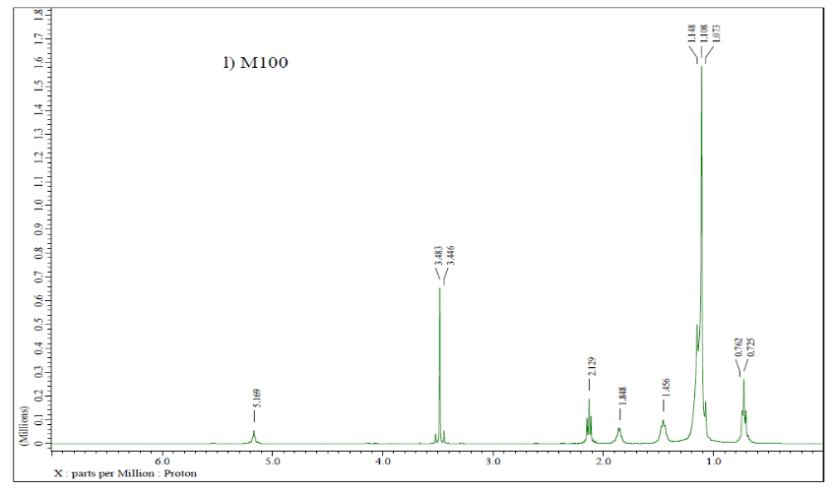
H¹NMR spectra of blending samples of MB with diesel and MB (M85-M100)

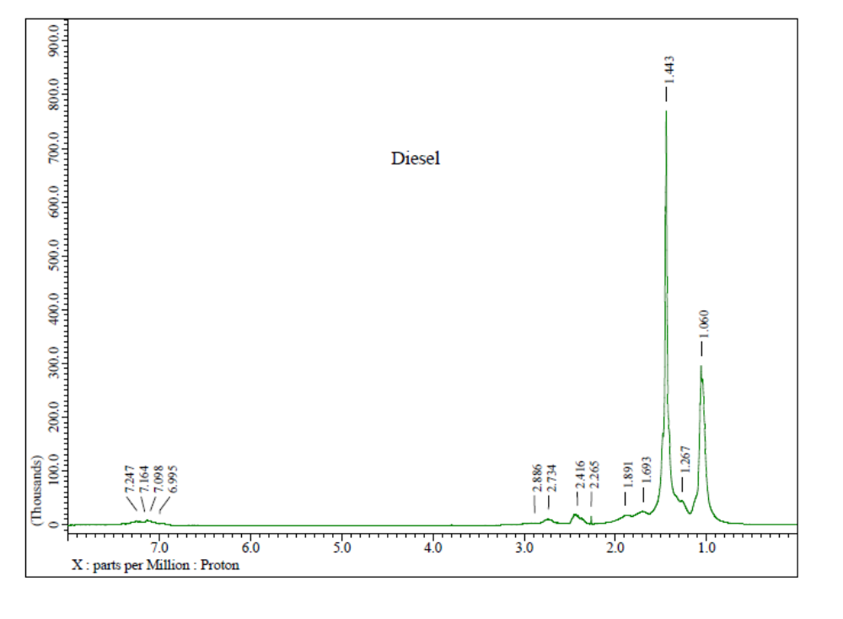
H¹NMR spectra of diesel

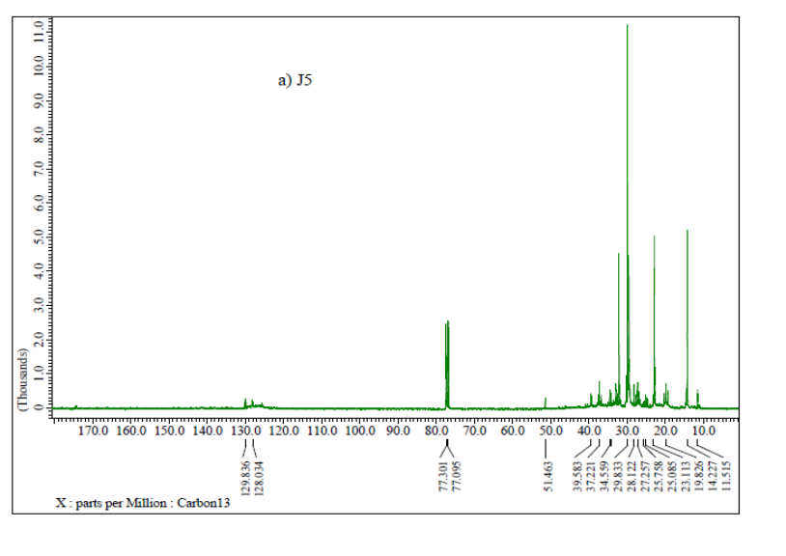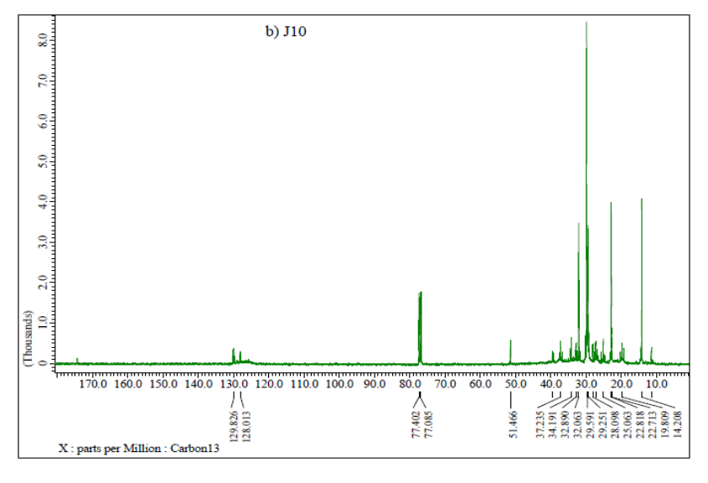
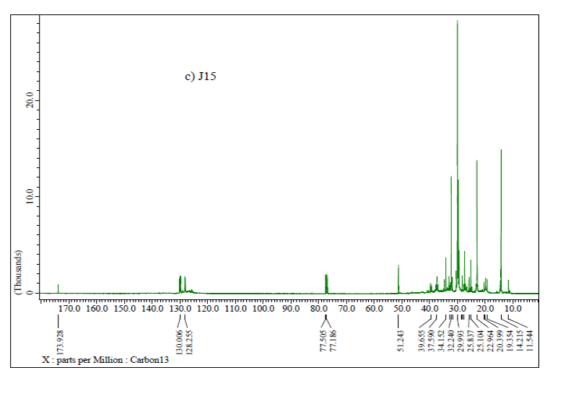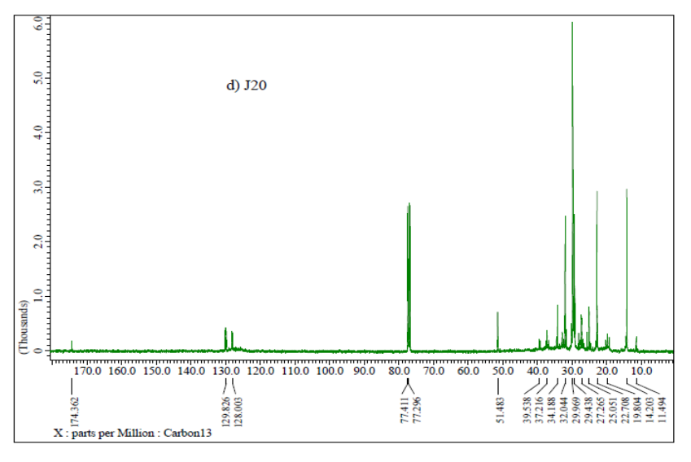
¹³C NMR spectra of blending samples of JB with diesel (J5-J20)
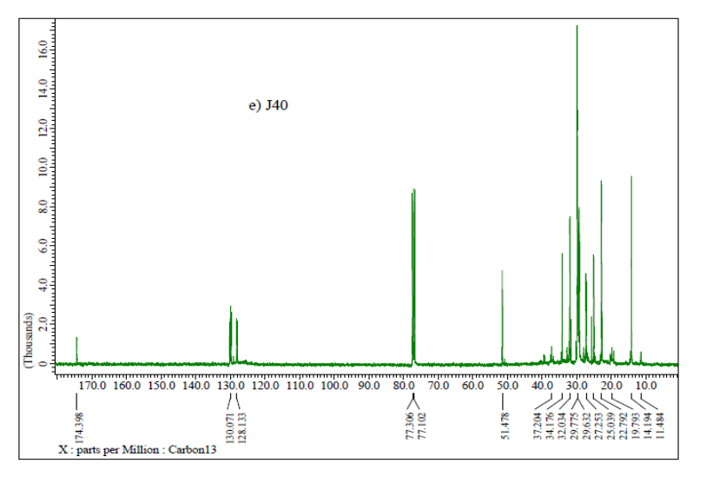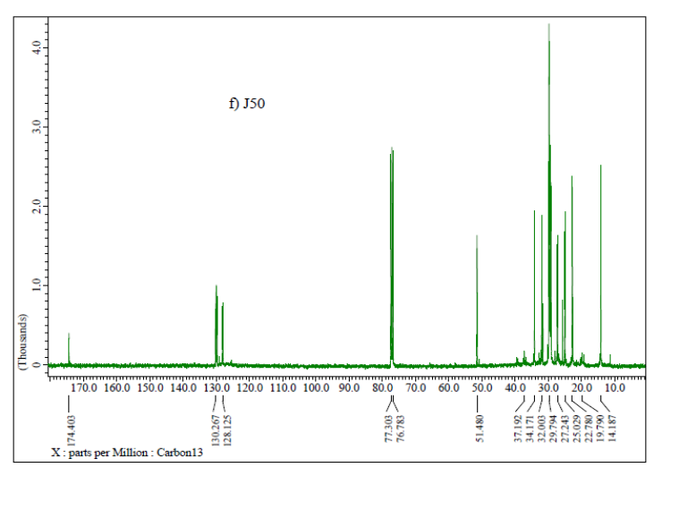
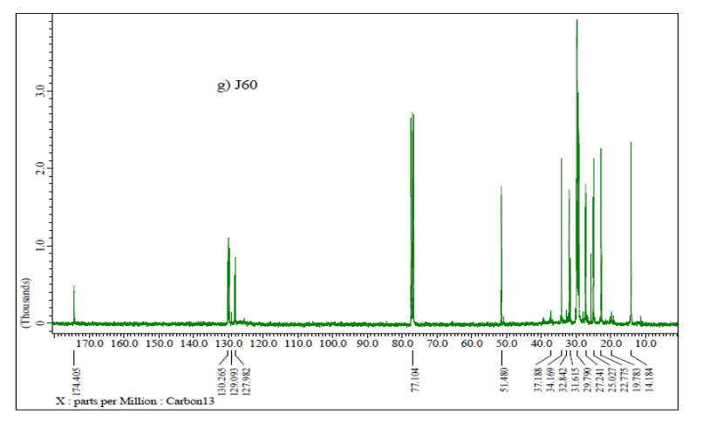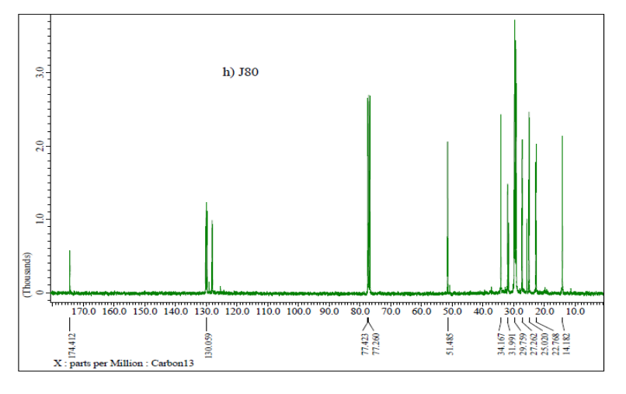
¹³C NMR spectra of blending samples of JB with diesel (J40-J80)

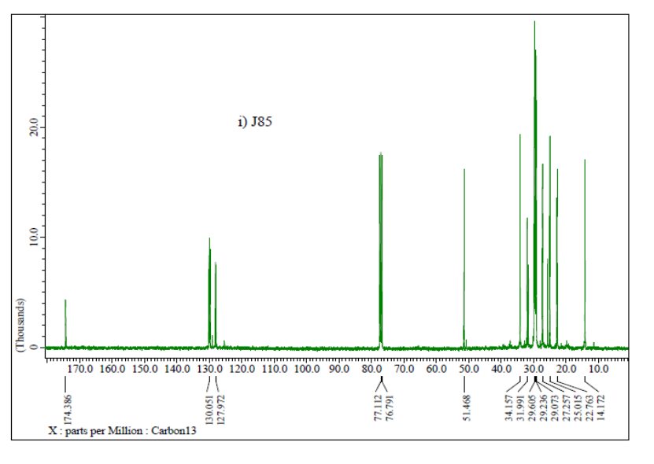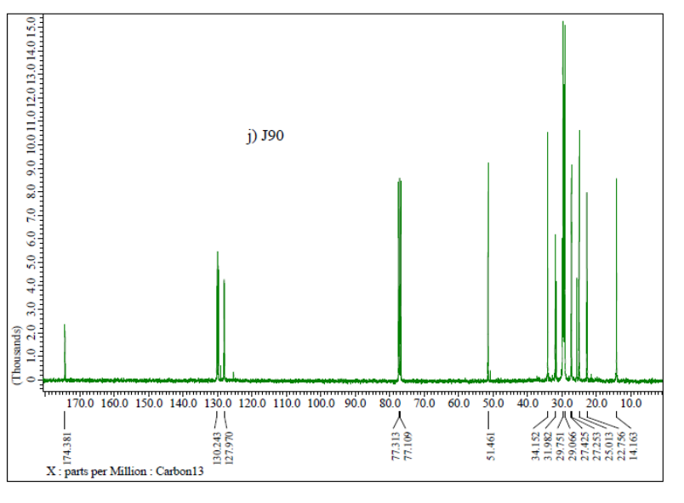
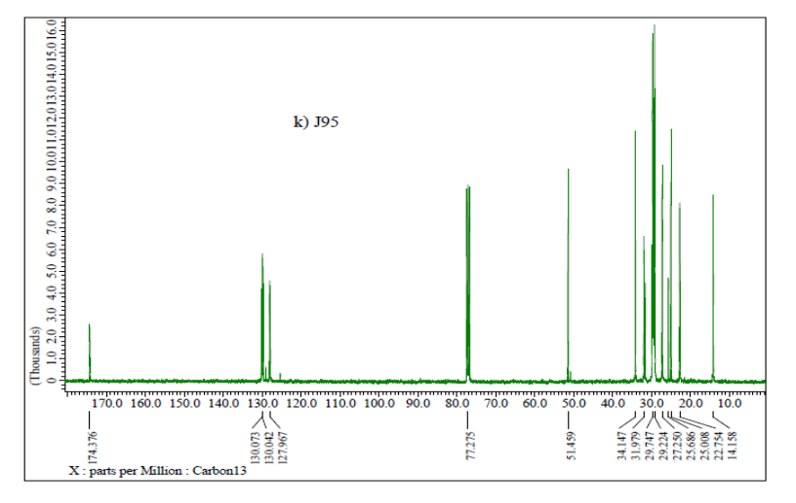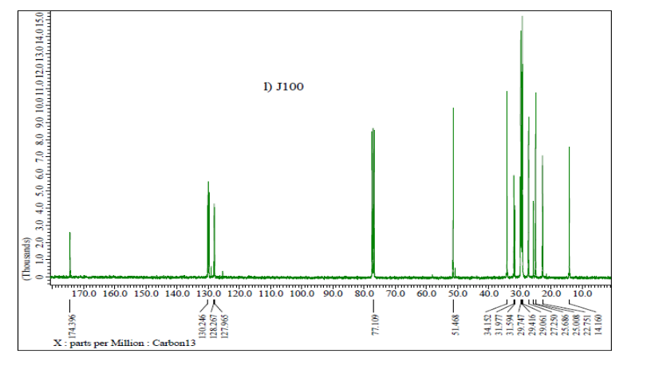
¹³C NMR spectra of blending samples of JB with diesel (J85-J100)
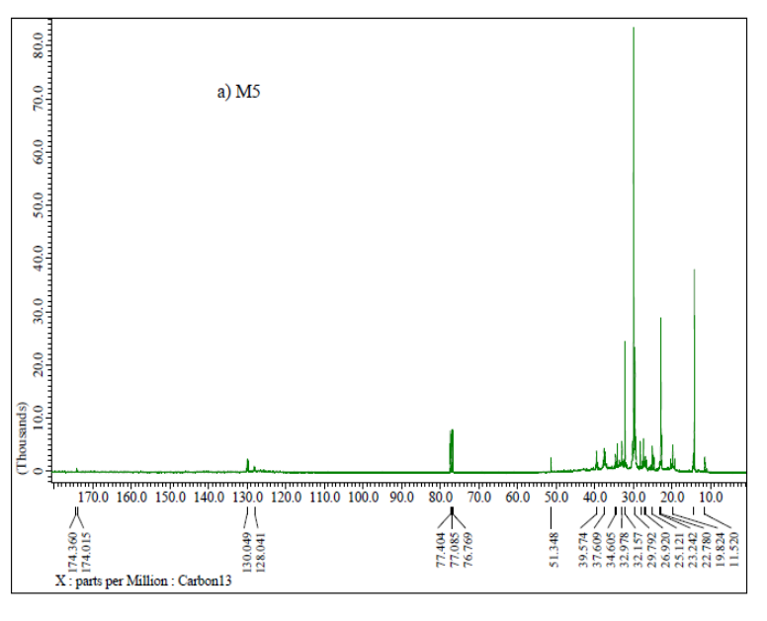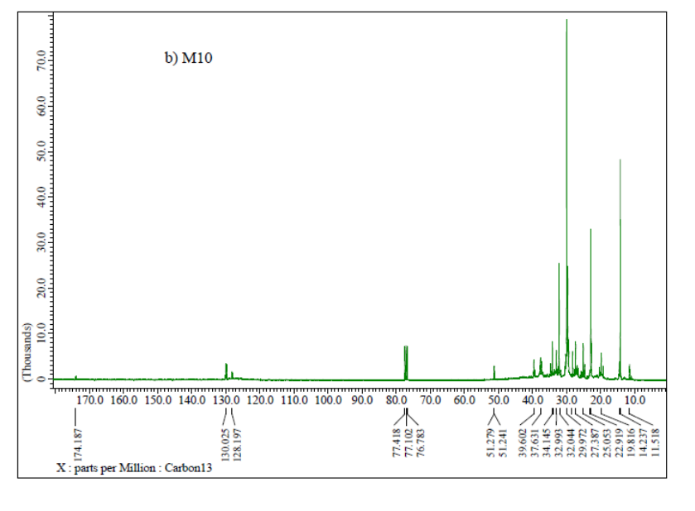
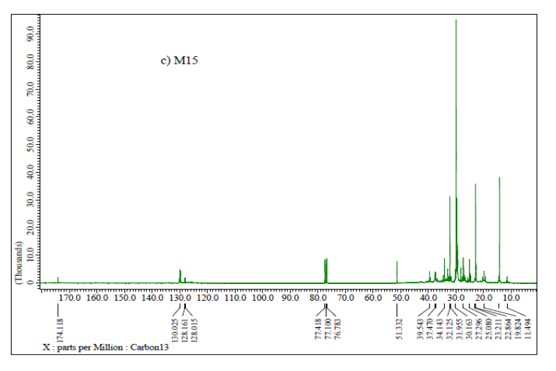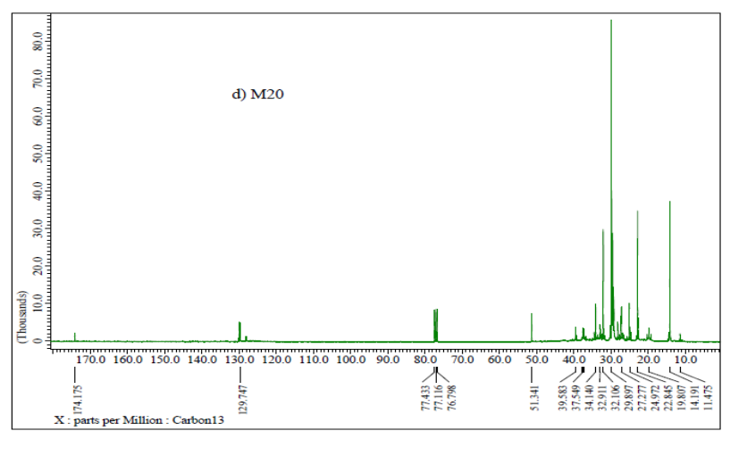
¹³C NMR spectra of blending samples of MB with diesel (M5-M20)
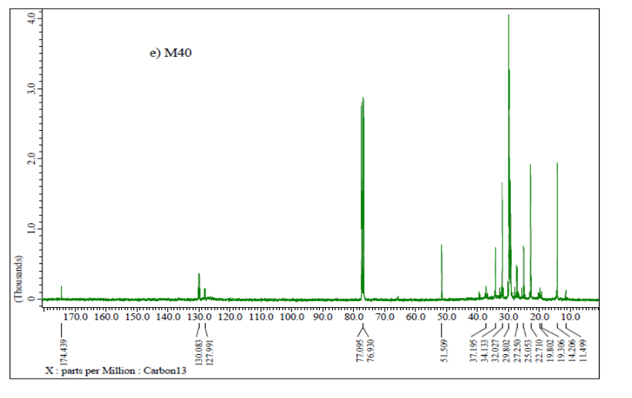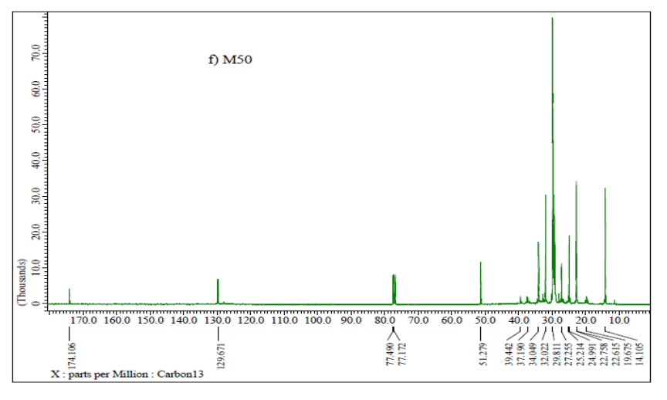
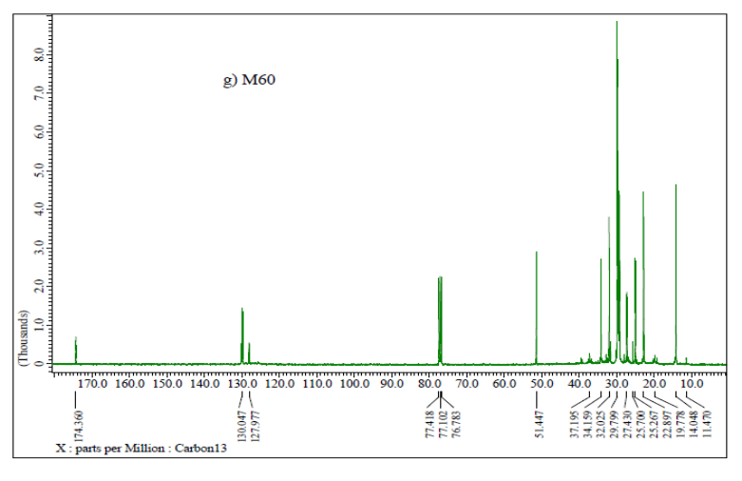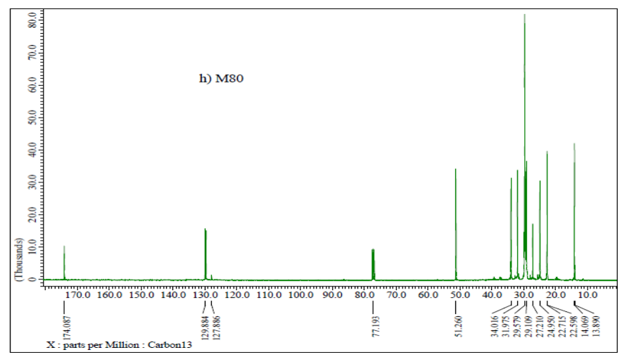
¹³C NMR spectra of blending samples of MB with diesel (M40-M80)

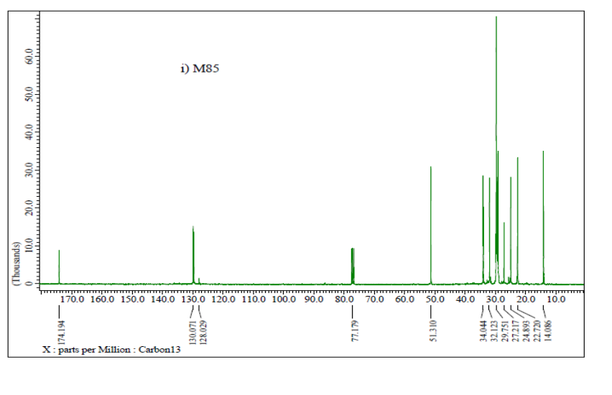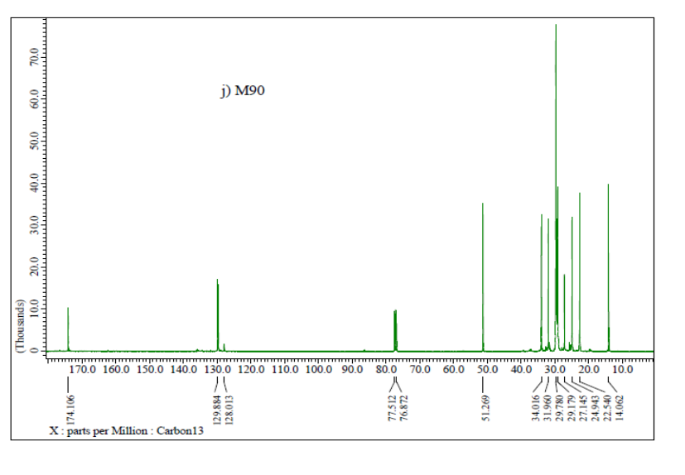
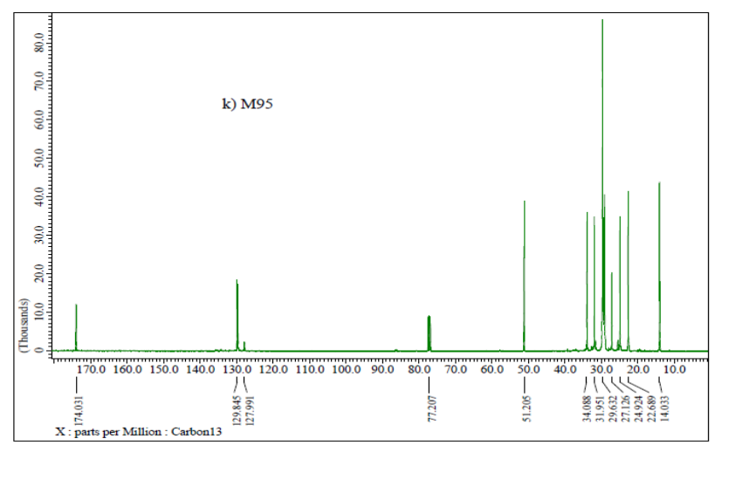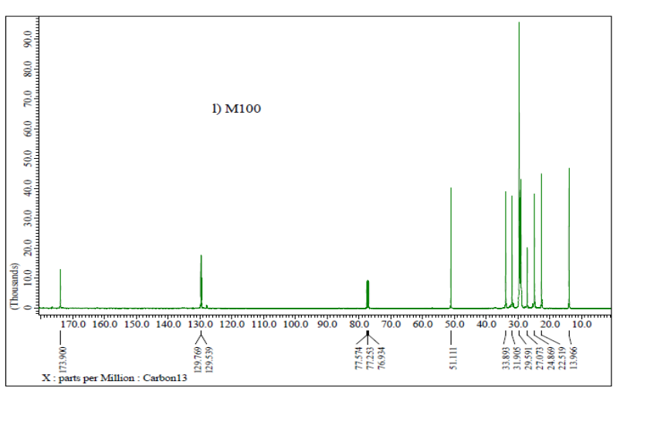
¹³C NMR spectra of blending samples of MB with diesel and MB (M85-M100)
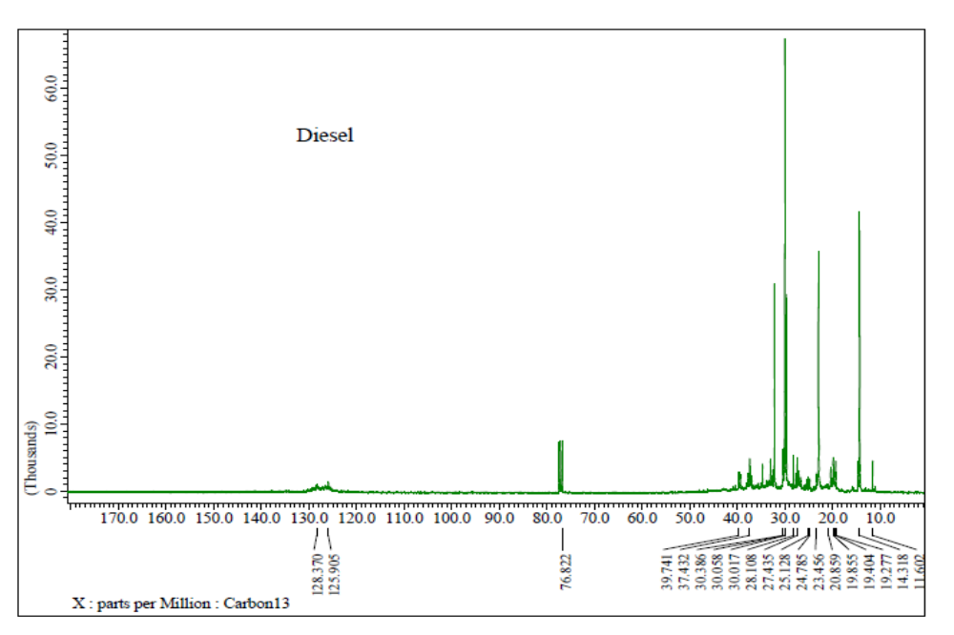
¹³C NMR spectra of diesel

