Depression and anxiety symptoms in older adults: a joint association study of candidate genes
Isabela Ferreira de Moraes¹, Thais Chile¹, Vanessa de Jesus Rodrigues de Paula¹, Clóvis Alexandrino-Silva², Geraldo Busatto², Helena Paula Brentani¹, Homero Vallada¹

¹Departamento e Instituto de Psiquiatria, Faculdade de Medicina da Universidade de São Paulo (FMUSP), São Paulo, SP, Brazil.
²Programa Terceira Idade (PROTER), Departamento de Psiquiatria, Universidade de São Paulo, São Paulo, SP, Brazil.

Tables:

Table 1. Candidate genes with the 27 polymorphisms and their respective alleles selected for the study.
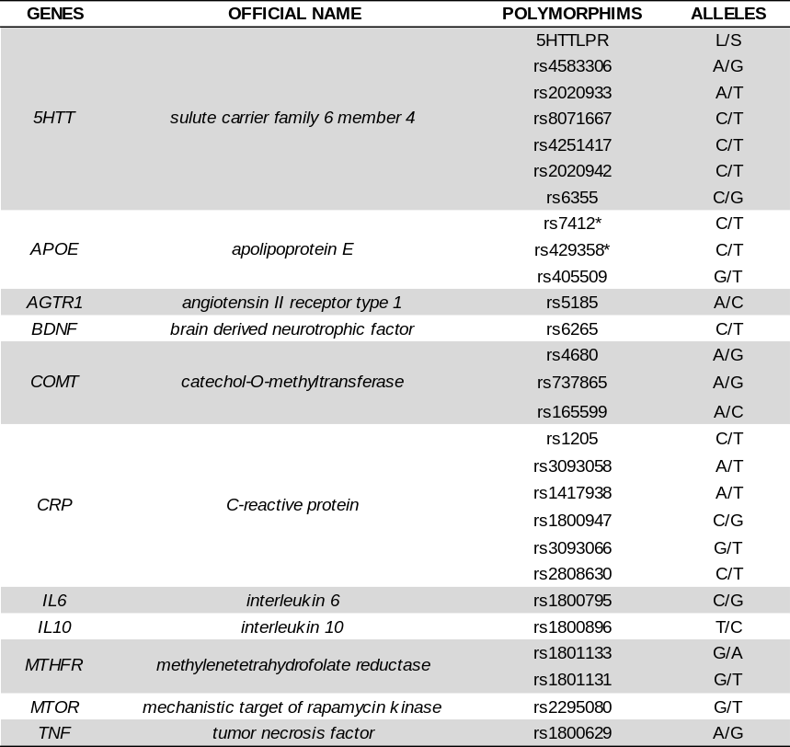
* The combination of the alleles of the rs7412 and rs429358 polymorphisms of the APOE gene results in the alleles e2, e3 and e4.

Table 2. Categorical values of the median of the applied scales CES-D, GAI, and MMSE.
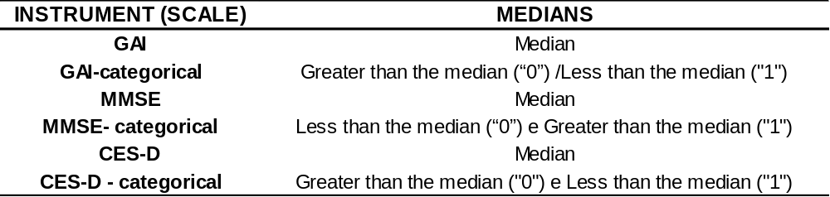

Table 3. The possible combinations of categorical values for CES-D, GAI, and MMSE scales.

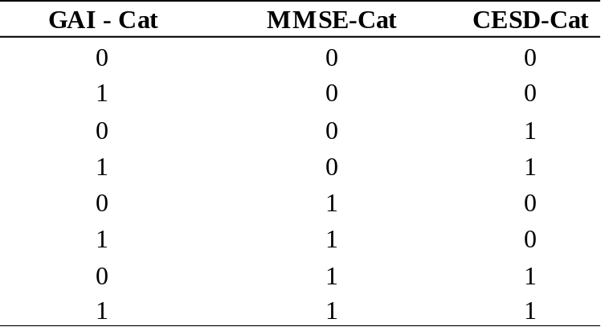

Table 4. Total valid samples for each genetic marker.
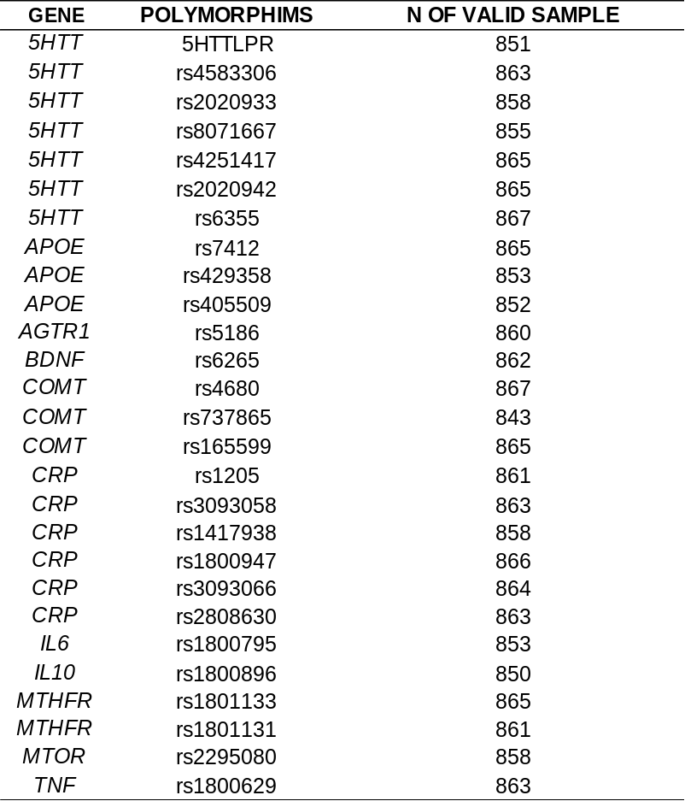

Table 5. Categorization of the medians of the GAI, MMSE, and CES-D scales.
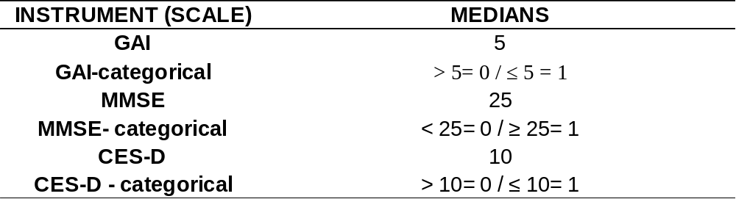

Table 6. Depressive and/or Anxious Symptomatology Groups (DASG).
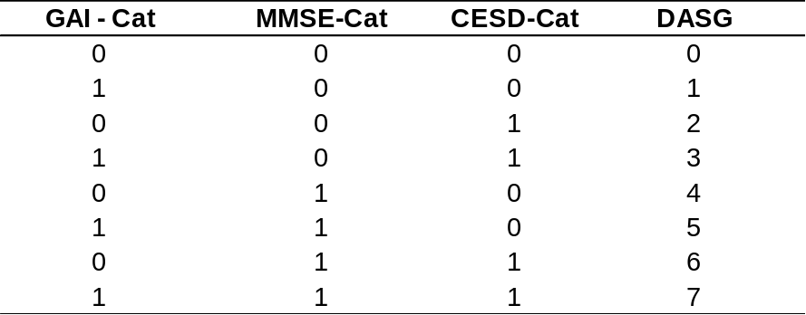

Table 7. Total older adults for the eight Depressive and/or Anxious Symptomatology Groups (DASG).
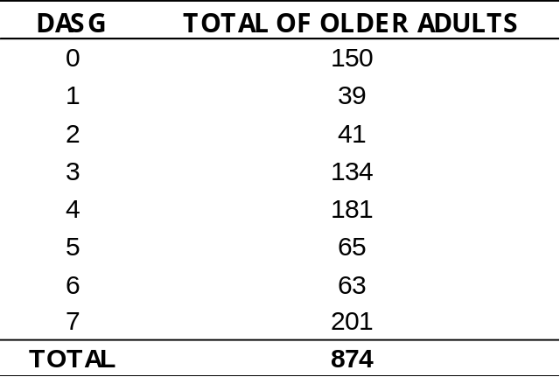

Table 8. 5HTT gene variant rs2020933: probability of the most frequent allele and distribution of genotypes by DASG group.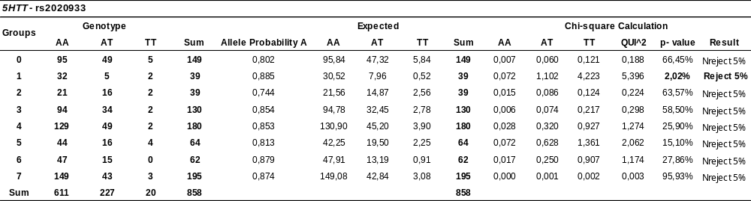

Table 9. 5HTT gene variant rs8071667: probability of the most frequent allele and distribution of genotypes by DASG group.
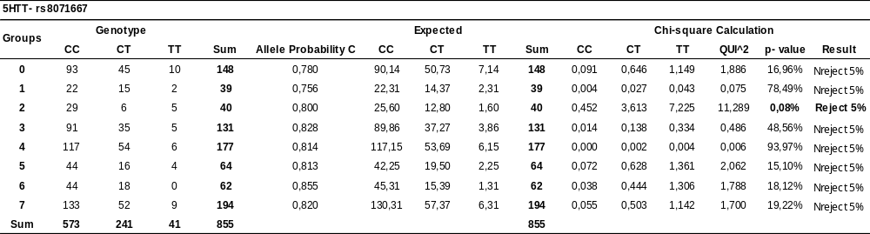

Table 10. AGTR1 gene variant rs5186: probability of the most frequent allele and distribution of genotypes by DASG group.
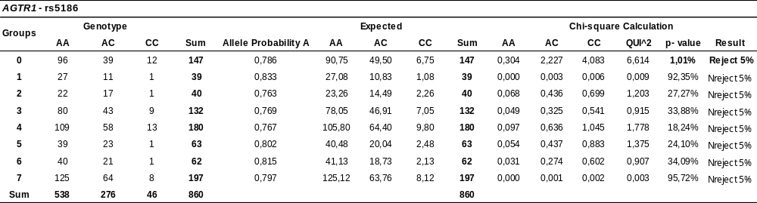

Table 11. BDNF gene variant rs6265: probability of the most frequent allele and distribution of genotypes by DASG group.
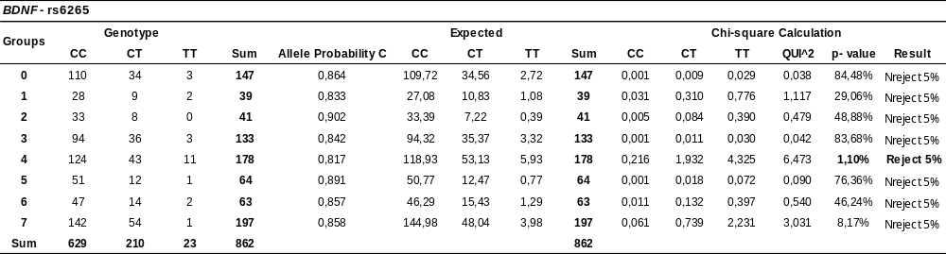

Table 12. COMT gene variant rs165599: probability of the most frequent allele and distribution of genotypes by DASG group.
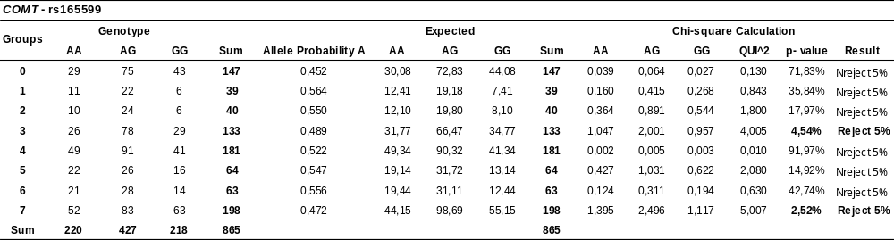

Table 13. CRP gene variant rs1417938: probability of the least frequent allele and distribution of genotypes by DASG group.
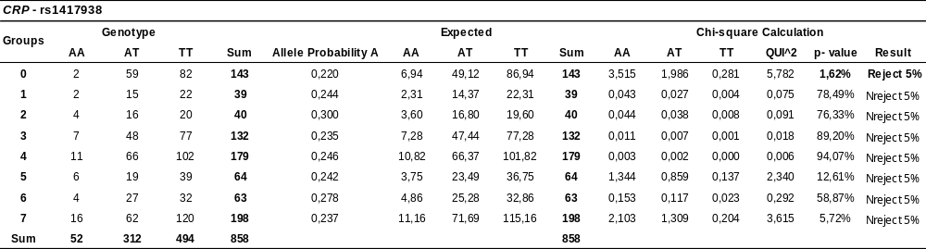

Table 14. IL6 gene variant rs1800795: probability of the least frequent allele and distribution of genotypes by DASG group.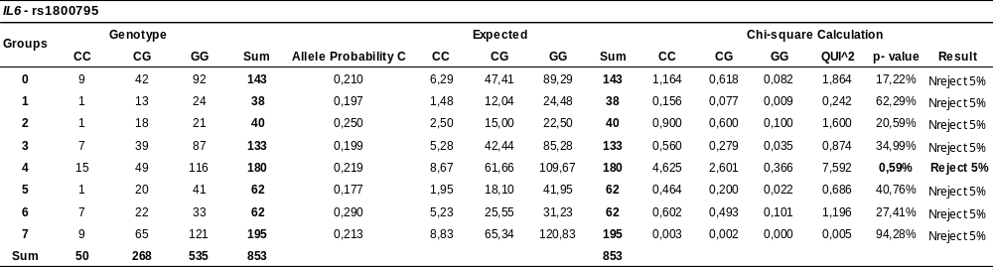

Table 15. IL10 gene variant rs1800896: probability of the least frequent allele and distribution of genotypes by DASG group.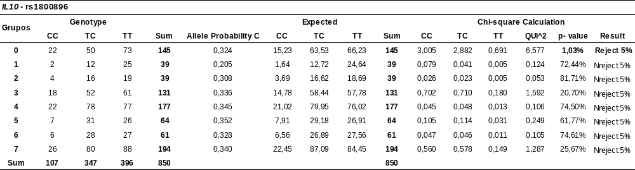

Table 16. MTOR gene variant rs2295080: probability of the least frequent allele and distribution of genotypes by DASG group.
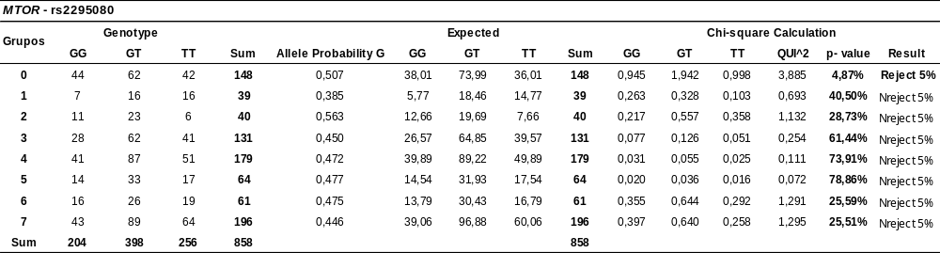

Table 17. 5HTT gene variant rs8071667: significant DASG group (group 2) compared to non-significant group (complement).
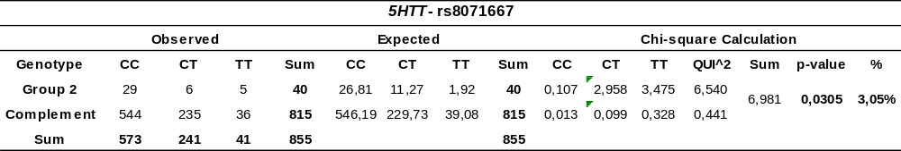

Table 18. BDNF gene variant rs6265: significant DASG group (group 2) compared to non-significant group (complement).
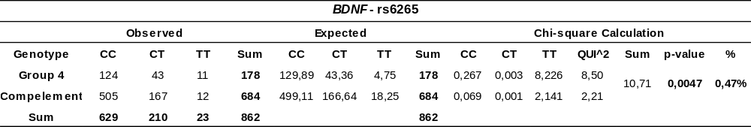

Table 19 COMT gene variant rs165599: comparison between the two significant DASG groups (groups 3 and 7).
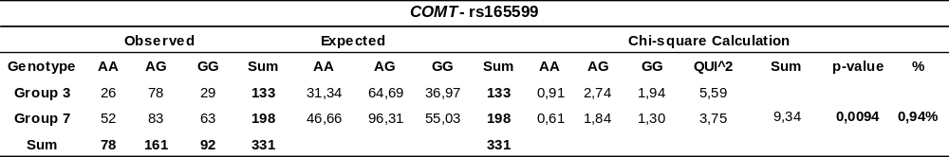

Table 20. COMT gene variant rs165599: significant DASG groups (groups 3 and 7) compared to non-significant group (complement).
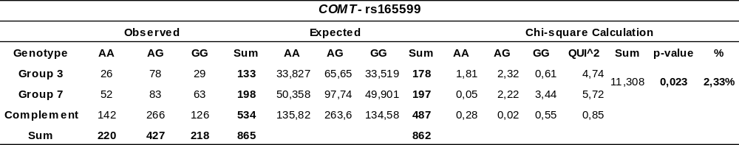

Table 21. CRP gene variant rs1417938: significant DASG group (group 0) compared to non-significant group (complement).
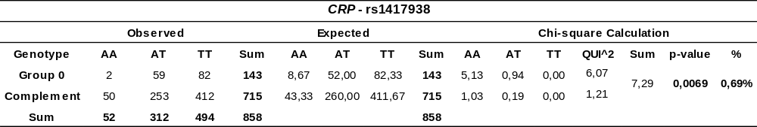

Table 22. APOE (rs429358 and rs7412) genotypes and alleles in association with DASG groups.
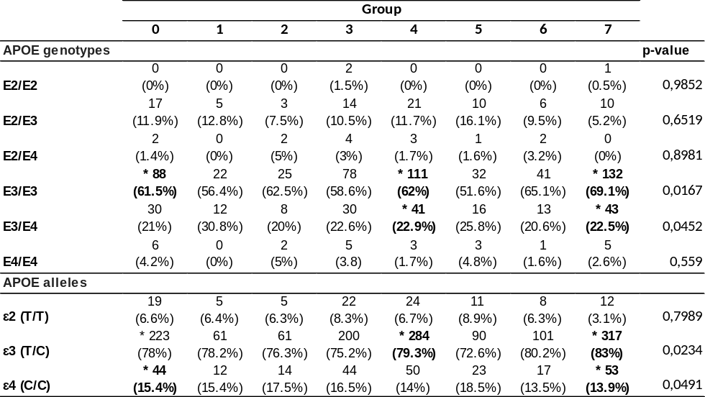

Table 23. Joint association of polymorphisms rs165599 (COMT) and rs1417938 (CRP).