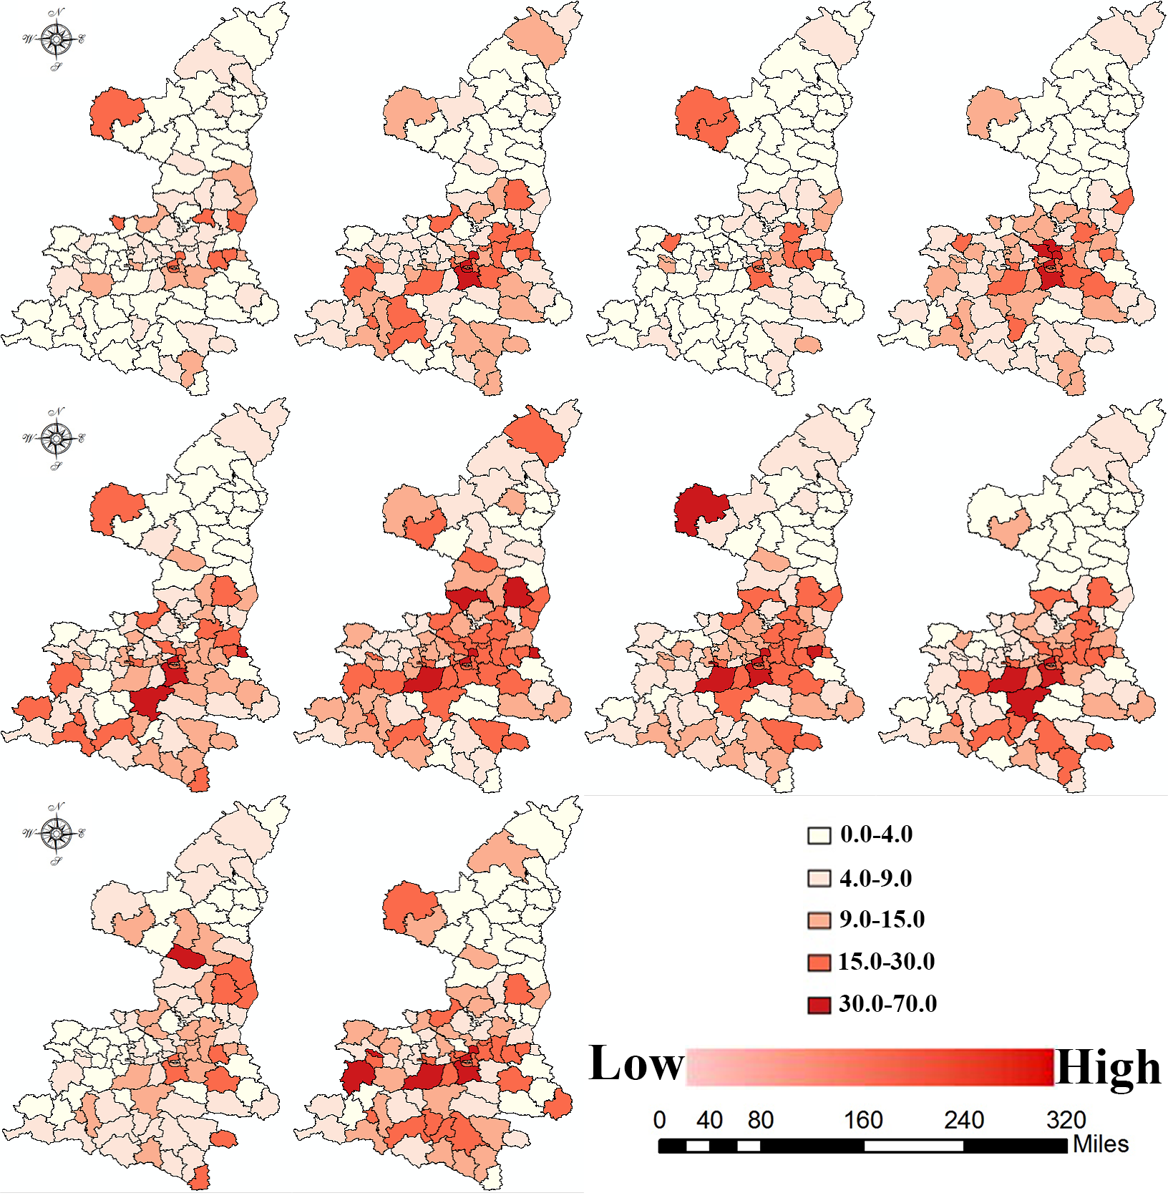
Appendix 3 Map showing the hierarchy of the incidence rates for HFMD

