Supplementary Information: A power-efficient integrated lithium niobate electro-optic comb generator

Ke Zhang1,†, Wenzhao Sun1,2,3,†, Yikun Chen1, Hanke Feng1, Yiwen Zhang1, Zhaoxi Chen1, Cheng Wang1,*
1 Department of Electrical Engineering & State Key Laboratory of Terahertz and Millimeter Waves, City University of Hong Kong, Kowloon, Hong Kong, China
2 Centre of Internet of Things, City University of Hong Kong Dongguan Research Institute, Dongguan, China
3 Centre of Information and Communication Technology, City University of Hong Kong Shenzhen Research Institute, Shenzhen, China
† These authors contributed equally
* Corresponding author: cwang257@cityu.edu.hk

I. Optical loss evaluation of waveguide crossing
To evaluate the waveguide crossing’s contribution to the total on-chip optical loss, we design and fabricate several straight waveguides, where different numbers of crossings (0, 10, 20) are cascaded for cut-back measurements. Optical loss is then extracted by contrasting the optical losses of these waveguides. Since refractive index difference in in y-crystal and z-crystal direction of LN, waveguides of different directions are designed, fabricated, and calculated separately. Below (Fig. S1) shows the average losses induced by 10 or 20 waveguide crossings, in y-crystal direction (left) or z-crystal direction (right) of LN, respectively. Our fitting results (red lines) indicate an average loss of 0.18 dB in y-crystal direction and 0.10 dB in z-crystal direction, leading to a total of 0.28 dB optical loss in the full device.
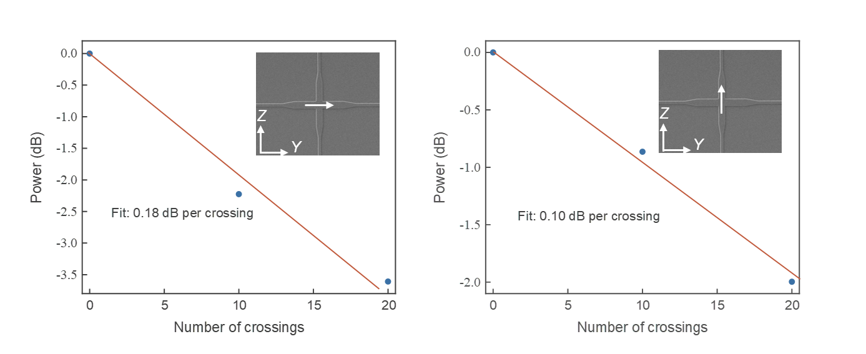
Fig. S1 Optical loss of waveguide crossing. (a) Measured optical loss (blue dots) with different numbers of waveguide crossings, and the corresponding fitting curve (red line), showing a low optical loss of 0.18 dB per crossing. Inset shows the SEM image and the y-crystal direction of LN. (b) Measured optical loss (blue dots) with different numbers of waveguide crossings, and the corresponding fitting curve (red line), showing a low optical loss of 0.10 dB per crossing. Inset shows the SEM image and the z-crystal direction of LN.

II. Mode multiplexer simulation
Adiabatic mode multiplexer is important to the performance of our device. Here we calculate the index differences of different avoided crossings by changing the coupling-waveguide gap, waveguide width, sidewall angle and cladding material, as shown in Fig. S2. By reducing coupling gap and waveguide width, the index difference sees an increase due to a better mode overlap of our coupled-waveguide system. Here, we choose a 500-nm coupling gap to realize a better mode coupling, which can be further reduced but is limited by the resolution of our UV Stepper by now. The total width is chosen to be 2.7 μm, which ensure a relative high mode overlap, while maintaining a low optical transmission loss of waveguide. Further reducing waveguide width (blue curve) benefits little to the improvement but will induce more optical loss. Sidewall here is set to be 67°, while a lower sidewall angle is also calculated to fit different fabrication process, such as metal mask process^{1,2}. Furthermore, compared to air cladding, SiO₂ cladding will greatly increase index difference, leading to a higher mode overlap and in turn a larger mode conversion efficiency. The black star shows the final choice of our design, which shows an index difference of ~0.01. Note that values of index difference in the middle region (such as 0.006) do not result in a low mode conversion performance. In fact, even the low value of ~0.002 could ensure an excellent mode conversion². On the other hand, the total length of our coupling region is about 550 μm, which is efficiently long to guarantee a high mode conversion efficiency. In summary, our adiabatic mode multiplexer is robust against variations in waveguide coupling gap, cladding material, waveguide width, and sidewall angle.
Fig. S2 Effective index differences of avoided crossings with different coupling gaps, waveguide width, sidewall angle, and cladding materials.

III. Optical transmission of MZI
To characterize the frequency response of our EO comb generator at different RF frequencies, we specially design and fabricate a MZI structure, which is formed by two identical multi-loop phase modulators on the two arms. Electrical signals are directly added to one of the two phase modulators, therefore translating into amplitude modulation, allowing us to directly measure the EO response and RF Vpi of our multi-loop phase modulator. Here, the premise is that the optical power of these two arms of MZI are in the same level, ensuring an efficient interference output from port 2. Before we measure the EO response, optical transmissions of three ports are tested necessarily, as shown in Fig. S3. The measured results (un-normalized) demonstrate a standard interference profile. Besides, optical transmissions of port 1 and port 3 are in the same level as we expect, which together lays the foundation to the subsequent EO response measurement.

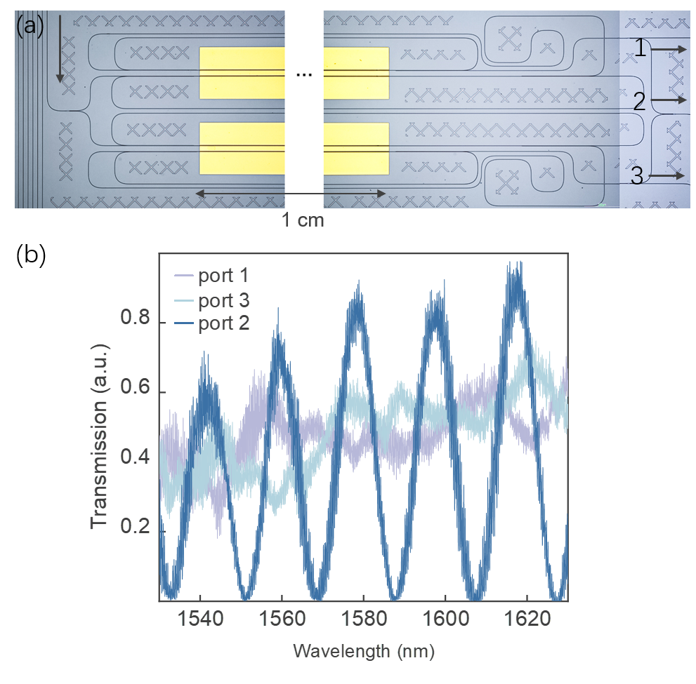
Fig. S3 (a) MZI structure with one in-light port and three output ports. (b) Measured optical transmission of MZI, showing excellent interference profile.

Reference:
1 Zhang, K. et al. High-Q lithium niobate microring resonators using lift-off metallic masks [Invited]. Chin. Opt. Lett. 19, (2021).
2 Chen, Z. et al. Broadband adiabatic polarization rotator-splitter based on a lithium niobate on insulator platform. Photonics Res. 9, (2021).

